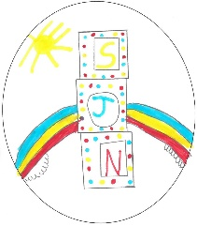
What are we doing to improve our school and nursery this year? 2023-2024

Wellbeing & Nurture
Priority 3 – Equity & Equality
- Work towards Gold Rights Respecting School Award
- Focus on learning about Racism and how we can tackle it.
- Re-visit our school and nursery values.
- Re-visit our Rationale – What makes us who we are?

Priority 2 – Closing the Attainment Gap and improving skills and school-leavers destinations.
- Explore the skills our young people need to develop to be successful when they leave school.
- Improve whole school attendance from 91% to 93%
- Celebrate achievements of all pupils in school and beyond.

Priority 1 – Improving attainment in literacy & numeracy
- What does a good St. Joseph’s lesson look like?
- Focus on quality Listening & Talking skills development.
- Joined up quality assurance between school and nursery class.
- Review of maths assessment across all stages

We are aiming to work more closely with parents again this year through:
- Assemblies
- PATPAL (Pupils as Teachers – Parents as Learners)
- Stay & Play Sessions
- Parent’s Group
- Coffee Mornings/Afternoons

- Continue to develop play and outdoor learning across the whole school

Kindness Friendship Honesty Respect

- Look at Health & Wellbeing Curriculum
- Improve our Whole School Nurture approach
- Learn about Trauma and how it can affect our children’s learning
- New wellbeing plans for every child.

