
St John’s Primary School & Nursery Class
Standards and Quality 2025-26

Context of the Establishment

Our Establishment
St John’s Primary School and Nursery Class is the oldest Primary School in Port Glasgow serving Lower Port Glasgow, the East of Greenock and the Parish of St John the Baptist. The school roll continues to rise steadily, from 190 pupils in 2017 to the current roll of 302 pupils across 12 classes, including 24 in our Nursery Class.

St John’s Primary School and Nursery Class is within an area of regeneration. We have 58% of pupils living within SIMD 1-2 with 42% living within SIMD 3-10. Around 25% of our pupils are in receipt of Free School Meals which contradicts the numbers of SIMD 1-2 pupils. This may be explained by the recent regeneration within the catchment area and Free School Meals being provided to all children within nursery, therefore families are not applying for the grant.

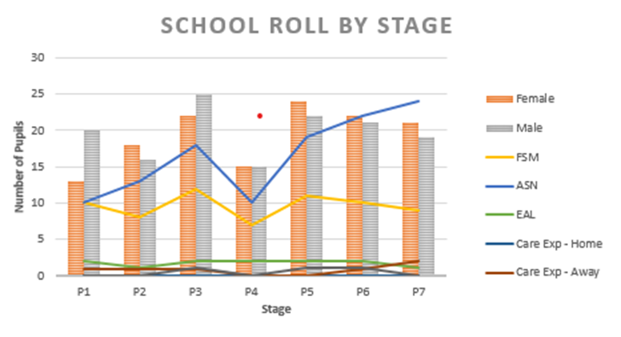Pupil Equity Funding is used to further enhance additional support for those pupils whose attainment and wellbeing is impacted by poverty.

We have 15.1 members of teaching staff, including the Head Teacher, Depute Head Teacher, Principal Teacher, Class Teachers and 0.5FTE Learning Support teacher. The school is supported by FTE Pupil Support Assistants 5.51 FTE plus 2 PEF funded, 2 Clericals and a Janitor.

In our Nursery, we have 24 pupils with 16 of them transitioning to Primary 1. We had 2 child accessing wrap around care with all children attending nursery on model 1. They were supported by the Depute of the Nursery Class, 3 EYECOS, 1 EYSA and a Clerical. We have experienced staffing changes this year in the EYSA post and the Clerical post. Since December 2025, due to staffing shortages across other establishments, the Depute of the Nursery has had limited management time due to floor commitment.

Our Cluster includes St Stephen’s High School, St Michael’s Primary School, St Francis’ Primary School and Nursery Class, Gibshill Children’s Centre and Rainbow Family Centre.

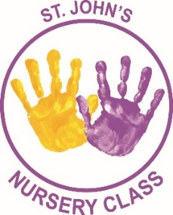


Vision
Learning and growing together through faith, hard work and love, to go safely on our way.
Values:
Respect, Ambition, Love, Patience, Honesty

Aims:
Together we will:
- Respect each other, all faiths and the world around us.
- Provide opportunities to develop pupils’ personalities, talents and physical abilities in a variety of settings allowing them to reach their fullest potential in school and the wider Community.
- Create a caring and happy environment where we can develop our God given talents.

- Demonstrate patience and understanding to all in a supportive way.
- Establish an ethos of honesty in our words and actions.

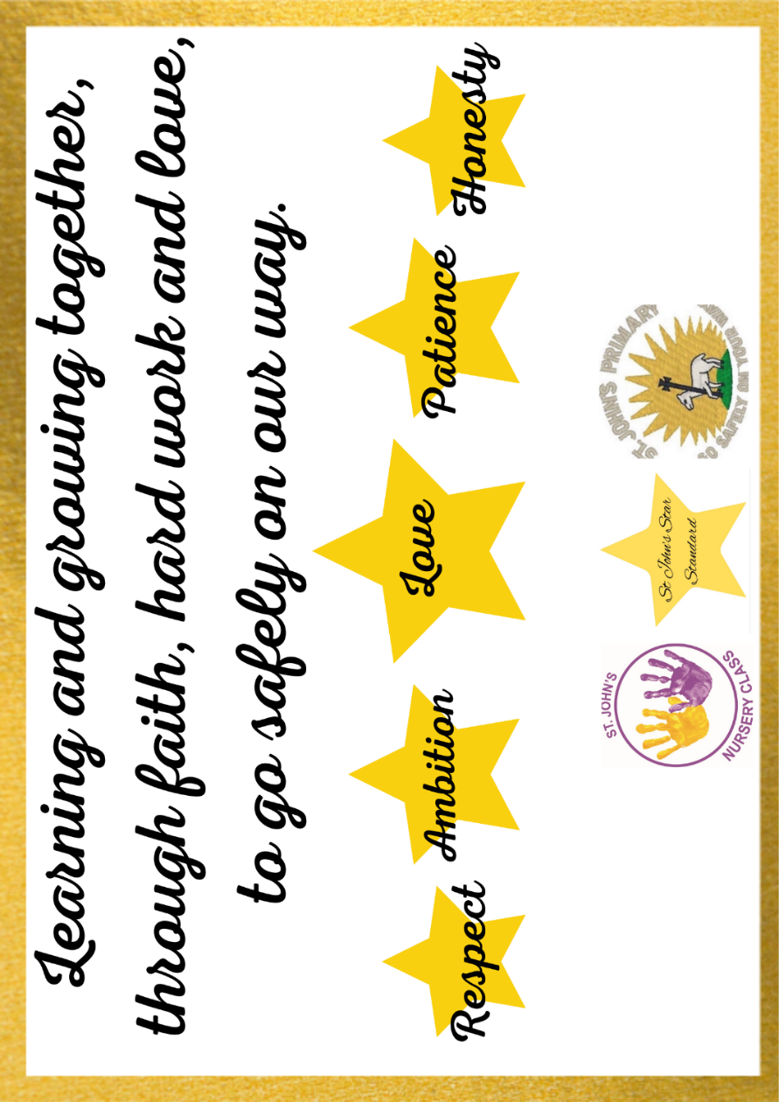

Establishment priority 1

NIF Priority  Closing the attainment gap between the most and least disadvantaged children and young people  Improvements in attainment, particularly in literacy and numeracy  NIF Driver  Assessment of children's progress  School Improvement | HGIOS/ELC QIs  3.2 Raising attainment and achievement  3.2 Securing Children's Progress  UNCRC  Article 28: (Right to education):  Article 29 (Goals of education):
Outcome:
Writing
- By June 2026, the Poverty Related Attainment gap for pupils in SIMD 1+2 in writing will be below 5% on average.
- By June 2026, writing attainment in Primary 1 will exceed 80%.
- By June 2026, writing attainment in Primary 2 will exceed 83%.
- By June 2026, writing attainment in Primary 3 will exceed 82%
- By June 2026, writing attainment in Primary 4 will exceed 87%.
- By June 2026, writing attainment in Primary 5 will exceed 82%.
- By June 2026, writing attainment in Primary 6 will exceed 84%.
- By June 2026, writing attainment in Primary 7 will exceed 85%.
Reading
- By June 2026, we will become a Gold Reading School with increased opportunities for reading for pleasure.
- By June 2026, reading attainment in primary 3 will exceed 80%.
Attendance
- By June 2026, attendance will exceed 95% across the school.
- By June 2026, attendance will improve by 10% for a targeted group of pupils.
- By June 2026 an attendance policy will be embedded across the establishment.
Nursery
- By June 2026, Numeracy attainment will exceed 80%.
- By June 2026, all children will be tracked across other curricular areas.

PEF used to support closing the gap:
1.4 PSA to support interventions across school (£24,000).
HWB Coach (£15,000)

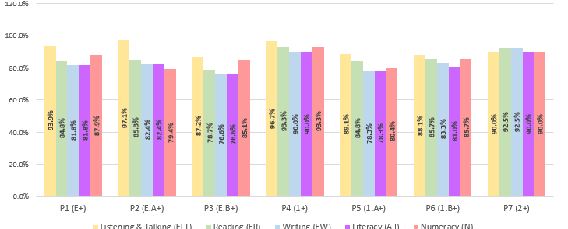

Progress and impact of outcomes for learners:
Writing
- 3 out of 7 year groups (P1, P4, and P7) successfully met or exceeded their writing attainment targets. P7 was a standout highlight, beating the target by 7.5%.
- 4 out of 7 year groups (P2, P3, P5, and P6) fell short. While P2 and P6 missed by less than 1%, P3 shows the largest gap, missing the mark by 5.4%. This can be explained by the significant changes of roll within the P3 cohort throughout the year.
- With a focus on writing interventions throughout the school, we have endeavoured to ensure support is timely and targeted, especially with our pupils in SIMD 1+2. This has proven successful in most stages with an overall reduction in the Poverty Related Attainment Gap from 12.9% in 2023/24 to 5.9% in session 2025/26. Interventions have been delivered by class teachers, additional teaching staff and additional PSA hours allowing for widespread support. Although the overall gap has remained stable from last year, there are still gaps of concern, especially in P1.

Reading:
- Our journey towards becoming a Gold Reading School remains in process. This is taking longer than anticipated and is a much more difficult process than first thought. This will continue next session with a Reading Schools/Reading for Pleasure Working Party being set up. Reading attainment in Primary 3 remains behind expectation due to the number of changes within the cohort throughout this session, with 6 new pupils joining Primary 3, all behind expectation.

Attendance:
- This year St Stephen’s Cluster have worked together to create a Cluster Attendance Policy in line with Authority guidance. This has led to all staff following robust procedures throughout the year to support positive attendance. Procedures have also been put in place to track and monitor late coming as well as early collections and appointments. Our attendance for 2025-2026 is 94.3% which falls short of our 95% attendance this year.

Nursery:
- Good progress has been made across both target areas this session. In numeracy, 75% of children achieved or exceeded their expected milestones. While this was 5% short of our 80% target, it still represents a positive outcome given the significant level of additional support needs (ASN) within this cohort. Furthermore, the target to track children across the wider curriculum was fully achieved. Through the embedded use of "Area Cards" and "Wow Moments" within Learning Journals, all children were provided with broad learning opportunities, and their progress was successfully recorded.
Next steps
- A focus on listening and talking throughout the curriculum, following the principles of Dialogic Teaching.
- A focus on Reading for Pleasure to support reading attainment across the school and nursery. This will be aided by the opening of our new library space.
- Gold Reading Schools journey will remain into next session, with a working party established to help support this.
- Continue our robust attendance procedure to maintain high levels of attendance.

Establishment priority 2

NIF Priority  Placing the human rights and needs of every child and young person at the centre of education  Choose an item  NIF Driver  School Improvement  Choose an item. | HGIOS/ELC QIs  1.3 Leadership of change  3.1 Ensuring wellbeing, equality and inclusion  UNCRC  Article 2 (Non-discrimination):  Article 4 (Protection of rights):
Outcome:
Building Racial Literacy
- By June 2026, all children will have experienced learning opportunities related to multicultural content.
- By June 2026 all staff will have incorporated the Anti-Racist Critical Thinking Model into IDL plans.
- By June 2026, most families will have an increased awareness of racism and its effects in our community and wider society.
Trauma Informed Practice
- By June 2026, all staff will have completed STILT training.
- By June 2026, all families will have the opportunity to engage in trauma informed information sessions to increase community awareness.
Play Pedagogy
- By October 2025, all staff will have audited their classroom environment to enhance play opportunities for children.
- By June 2026 all E’s & O’s that are achievable through play experiences will be clearly identified.
Anti-Bullying Policy and Promoting Positive Relationships Policy
- By June 2026 an Anti-Bullying Policy will be implemented in line with Inverclyde’s revised Anti-Bullying Policy.
- By June 2026 all children, families and staff will have an increased knowledge of the revised St John’s Anti-Bullying Policy.
- By June 2026 all children, families and staff will have had opportunities to review St John’s Promoting Positive Relationships policy.
Signs of Safety
- By June 2026 all SLT will have undertaken Signs of Safety Training provided by HSPC.
Nursery
- By June 2026, all children will have access to a calm/quiet area outdoors to regulate their emotions (Zen Den)

PEF used to support closing the gap:
Enquiry Based Learning Resources for indoors and outdoors (£5,000)

Progress and impact of outcomes for learners:
- Over the past 2 sessions, all staff have undertaken a full suite of training on Building Racial Literacy, led by HT Leanne Cannon. Mrs Cannon led this training due to her accreditation of being an Education Scotland trained Anti-Racist Mentor. These sessions allowed staff to fully appreciate the impact racism, and inclusivity has across our curriculum and how we can ensure our children see themselves in our within our school and our curriculum offer. Examples of change have included Primary 5 to Primary 7 completing novel studies which have a focus on diversity. All staff have undertaken CLPL on ‘Windows & Mirrors’ within our curriculum and have participated in self-evaluation activities using James Bank Model of Multi-Cultural Education.
- All staff have successfully put the Anti-Racist Critical Thinking Model into their IDL plans by using books by a wider range of diverse authors, looking at topics through different cultural viewpoints, and teaching pupils how to recognise and question bias and unfairness in the world. The creation of the Anti-Racist Pupil group (The Kindness Krew) has supported with this.
- Families have been involved in the creation of the Equalities Policy. While we have made steady progress in raising awareness of racism and its effects through school showcases and family communications, we have not quite achieved our target of reaching the majority of our families by June 2026. Moving forward, we will focus on finding more direct, accessible ways to engage with our wider parent community and gather their feedback to better support this vital work.
- All staff have taken part in STILT training this year and are refreshed in Trauma Informed Practice.
- Play Pedagogy is now an integrated part of our curriculum from Nursery to Primary 7. Teaching staff conducted an audit of resources allowing for more resources to be used across the establishment and new resources to be purchased using PEF. All appropriate Es & Os have been identified from Early to Second level.
- HT Mrs Cannon has undertaken Signs of Safety this session. Both HT & DHT have since been involved in LAC Reviews following the new format for Signs of Safety.
- Through previous questionnaires, we gained an insight into parents’ knowledge of trauma across our cluster. We had planned on hosting a cluster wellbeing event with a focus on trauma. For various reasons, this event has been postponed and will hopefully take place in session 2026/2027.
- The "Zen Den" has been successfully established in the outdoor area, ensuring all children have consistent access to a dedicated calm and quiet space for emotional regulation. Initial observations and monitoring indicate that the space is having its intended positive impact on emotional wellbeing. It has proven particularly effective as a targeted intervention for children with additional support needs (ASN), providing them with a safe, accessible environment to self-regulate during outdoor play.
Next steps
- Continue to embed our BRL journey and ensure all staff are kept abreast of all important and necessary information and move from stage 2 to stage 3 of the James Bank Multicultural Curriculum Framework while continuing to focus on decolonising the curriculum.
- Ensure all children and families are fully aware of racism, inclusivity and the role they play in this through the newly developed equalities policy.
- All staff will engage in training to enhance outdoor learning opportunities across all stages. We will utilise the expertise of our nursery colleagues to ensure progression from Early level through to Second.
- The school will follow the lead of our nursery colleagues to try and provide more quality outdoor learning experiences following the success of Nurturing Nature over the last few years in the nursery. Primary staff will learn from nursery staff as well as take part in training from outside agency, Learning Through Landscapes.
- Continue to use the Learning Journal Cohort Tracking to analyse gaps in particular curricular areas.
- Engaging with parents around the use of the Zen Den and how they can support emotional wellbeing.

Establishment priority 3

NIF Priority  Improvements in attainment, particularly in literacy and numeracy  Closing the attainment gap between the most and least disadvantaged children and young people  NIF Driver  School Improvement  School leadership | HGIOS/ELC QIs  1.3 Leadership of change  2.2 Curriculum  UNCRC  Article 29 (Goals of education):  Choose an item.
Outcome:

Curriculum Rationale
- By June 2026, we will have a new curriculum rationale that reflects everyone in our community and links to our vision, values and aims.

Meta Skills
- By June 2026, almost all pupils will be able to articulate the meta-skills needed to support successful learning appropriate to their stage of development.

Wider Curriculum
By June 2026 all children living in SIMD 1&2 will have had opportunities to participate in extra-curricular activities.

PEF used to support closing the gap:
£3000 for residential experiences for 40 P6 and P7 pupils who reside in SIMD 1+2.

Progress and impact of outcomes for learners:

- While significant groundwork has been completed, we recognise that our draft rationale is not yet fully representative of our entire school community. Moving into the next session, it is necessary to refine and expand this work. Our immediate priority is to deepen our engagement strategies to ensure that all stakeholder voices—including parents, partners, and marginalised groups—are heard, valued, and actively contribute to the final curriculum design.
- Meta Skills have been paired with our own Learning Dispositions (Learning Powers). The have been integrated into our daily reflections, posters and ‘Pupil of the Week’ awards and children are beginning to make those links for themselves. This will continue to be embedded across all classes and nursery next session.
- Qualitative data from pupil voice indicates a highly positive shift in attitudes toward physical health, with a target group demonstrating the most significant gains in physical wellbeing. This session, the establishment of a robust tracking and monitoring system for all pupils' extra-curricular activity led by the HWB coach—both within and outside of school—allowed for the accurate identification of gaps in participation. This data directly informed the targeted deployment of our Health and Wellbeing coach. Through tailored playground engagement and small-group/individual interventions, identified pupils were successfully integrated into daily games and activities. Furthermore, collaboration with Active Schools provided enhanced club provisions both during and after the school day for most pupils, with targeted pupils successfully prioritised for attendance. This data-driven approach has proven highly effective and will be sustained next session.
Next steps
- Develop and implement a refreshed St John’s Curriculum Rationale that reflects our unique school identity, including our Catholic faith, commitment to racial literacy, play, outdoor learning, learning powers and the needs of our diverse community. This rationale will guide the redesign of our curriculum to ensure coherence, progression, and equity, enabling all learners to make the best possible progress and supporting the development of digital learner profiles.
- Ensure the inclusivity and diversity are apparent within the curriculum.
- Our nursery team will engage with the new Quality Improvement Framework for the Early Learning and Childcare Sectors.
- In partnership with the Diocese, we will refresh and strengthen our Religious Education curriculum to ensure it is coherent, progressive, and reflective of our school community. The updated curriculum will permeate all four contexts for learning, enabling children and young people to encounter Christ, deepen their faith, and live out Gospel values through service to God and neighbour. This work will align with and inform the development of the new St John’s Curriculum Rationale.

Data

Key Strengths:
School/Nursery class
Percentage of Pupils On Track/Beyond
Class/Subject | L&T | Reading | Writing | Literacy | Numeracy
Primary 1 | 93.9 | 84.8 | 81.8 | 81.8 | 87.9
Primary 2 | 97.1 | 85.3 | 82.4 | 82.4 | 79.4
Primary 3 | 89.4 | 78.7 | 76.6 | 76.6 | 83.0
Primary 4 | 96.7 | 93.3 | 90.0 | 90.0 | 93.3
Primary 5 | 89.1 | 84.8 | 78.3 | 78.3 | 80.4
Primary 6 | 90.5 | 88.1 | 83.3 | 81.0 | 85.7
Primary 7 | 90.0 | 92.5 | 92.5 | 90.0 | 92.5
Overall | 92.3 | 86.8 | 83.6 | 83.2 | 86.0
Nursery | 75% | 75% | 75% | 75% | 75%

- High Attainment in P4 and P7: Across all areas of literacy and numeracy, Primary 4 and Primary 7 demonstrate highly robust performance. Notably, P4 achieves 90.0% or above in every single measure, peaking at 96.7% in Listening & Talking. Similarly, P7 shows strong mastery with 92.5% on track in Reading, Writing, and Numeracy. The access to SNSA data may have supported in these stages to make these accurate professional judgements.
- Listening & Talking (ELT) Excellence: Listening & Talking is consistently the strongest curricular component across the school. In five out of seven stages (P1, P2, P4, P6, P7), attainment sits securely at or above 90.0%, highlighting a widespread, successful focus on oral language development. However, ensuring accurate judgements against the national standards for talking and listening is a priority for next year.
- Primary 3 Attainment Dip: The data highlights a distinct dip in attainment across Primary 3, particularly in literacy. Reading (78.7%), Writing (76.6%), and Overall Literacy (76.6%) represent the lowest percentages across the entire school profile. This may be explained by the significant changes in the P3 cohort roll throughout the year.
- Primary 2 Numeracy: P2 shows an unusual inversion of the typical school pattern; while their literacy scores are strong (exceeding 82%), Numeracy falls to 79.4%, making it the lowest numeracy score in the school.
- The Literacy Gap (Reading vs. Writing): In almost every year group (with the exception of P7 where they are identical), writing attainment lags behind reading attainment. This trend suggests that while decoding and comprehension strategies are well-embedded, further focus is required to translate those skills into expressive, written output across the primary stages.
- Nursery: While the consistent 75% attainment level falls short of our target, it represents a highly positive outcome given the complex cohort profile—which includes seven children (29%) on a GIRFEC pathway and six (25%) with English as an Additional Language (EAL)—alongside significant staffing shortages and inconsistencies since December 2025.

Key Priorities:
School/ Nursery class

- Although the PRAG has closed across all areas on average, a focus on particular year groups will be necessary especially in Primary 4 and Primary 5 of next session.
- Intervention work and targeted PEF support will focus on those children in SIMD1+2 who are behind expectation.
- Overall Literacy attainment in next session’s Primary 3 will be a priority.
- Attendance will be closely monitored, especially for targeted pupils in SIMD1+2 and those children with attendance lower than 80% to ensure all supports necessary are in place in order to make expected progress.
- Interventions will remain a key priority, using data to identify support for key groups of children in Nursery and Primary using research-based pedagogies and tools.
- Targeted interventions on listening and talking, which is projected to have a positive secondary impact on raising attainment across all curricular areas.

National Improvement Framework Quality Indicators
1.3 Leadership of change
Very Good

Key Strengths:

- Children, staff, parents/carers and partners contributed to a review of the school and nursery vision, values and aims in 2022. This is due to be revised this session. The aims reflect the Gospel values and the school’s commitment to the Catholic faith. Almost all children show a high level of understanding of the school values and model them well. As a result, the school values are embedded in the life and the work of the school. The values are reflected in the working ‘St John Star Standard’ document which sets out clear expectations for positive relationships and approaches to learning and teaching. Staff and children are proud of their collaborative work in the creation and ongoing review of the ‘St John Star Standard’. This is supporting everyone to understand agreed high standards.

- The school improvement plan reflects a clear strategic direction, aspirational aims and measures to support evaluation of progress. Senior leaders use a range of quantitative and qualitative data very well to identify and act on areas for improvement. Senior leaders carefully monitor work on school and nursery improvement priorities. This is ensuring that the pace of change is manageable and leads to sustainable improvements in outcomes for children.

- Senior leaders have established effective assurance processes to oversee the quality of teaching and learning. These include regular classroom observations and termly tracking and monitoring meetings. Staff receive constructive feedback to support the development of their practice and approaches. Consequently, these quality assurance measures are contributing to improved standards and greater consistency in high-quality teaching and learning.

Key Priorities:

- To capitalise on the new additions to the school management team by fostering a culture of collaborative leadership, ensuring all staff work collectively to implement robust quality assurance practices that guarantee continued high-quality progression, continuity, and equity in learning across all stages.

- To finalise, launch, and embed our newly drafted Curriculum Rationale by actively engaging all stakeholders—including staff, pupils, parents, and community partners—to ensure it fully reflects our shared vision, values, and distinct context, driving continuous improvement and consistency in our learning and teaching.

- To empower nursery staff to lead and embed high-quality outdoor learning across the entire establishment, using their developed specialist knowledge to drive positive, changes in practice throughout the wider school.

- Implement a programme of professional learning and collaborative self-evaluation to ensure all nursery staff develop confidence and consistency in using the new shared Quality Improvement Framework for Early Learning and Childcare. Staff will engage in framework familiarisation sessions, quality indicator discussions, and moderation activities, applying the framework to evaluate practice and identify areas for improvement.

2.3 Learning, teaching and assessment
Very Good

Key Strengths:

- Staff consistently apply the ‘St John’s Star Standard’, a shared framework of expectations that promotes high-quality and consistent learning and teaching practices across the school. This has proven particularly beneficial in supporting new staff as they become familiar with St John’s approaches. Building on this, staff have collaboratively developed a learning visit proforma, based on HGIOS and Realising the Ambition as part of quality assurance processes. This is encouraging teachers to reflect on their practice and continuously seek improvement.

- Children are highly motivated by a range of engaging and creative learning contexts, which support the development of a broad set of knowledge and skills. In almost all classes, learners are given opportunities to take the lead in aspects of their learning, particularly within interdisciplinary studies. In the nursery, children benefit from access to stimulating, open-ended resources that foster curiosity, creativity, and inquiry, especially in outdoor environments. Practitioners carefully plan a variety of experiences to support early literacy and numeracy development, often incorporating targeted interventions. They also provide meaningful real-life learning opportunities, such as woodwork and cooking.

- The introduction of a Health and Wellbeing Coach has enhanced pupils’ experiences by providing additional opportunities for outdoor learning in the playground, including the use of loose parts and participation in cooking activities.

- At the early level, children’s learning is effectively supported through play-based approaches, with a strong balance between child-led and adult-initiated experiences. Learning environments, interactions, and resources align well with national guidance and support positive learning outcomes. This approach has been successfully extended across all stages of the school, contributing to increased enthusiasm and readiness to learn. In the nursery, children regularly access a well-resourced and stimulating outdoor area. Practitioners have carefully developed this space to offer rich learning experiences across the curriculum and adopt a solution-focused approach to overcoming any challenges related to outdoor access. Play in the second level has been recognised as an area of good practice by Education Scotland.

- The curriculum has been successfully refreshed in the upper stages to include a wider range of diverse texts. This includes a focus on decolonising novel studies to ensure a more inclusive representation of race and culture.

Key Priorities:

- To drive a comprehensive curriculum refresh that explicitly centres on learning, teaching, and play practices with a focus on decolonising the curriculum; we will empower staff to critically adapt classroom delivery, resource selection, and outdoor learning and play environments

- To embed Dialogic Teaching approaches across all stages to enhance pupils' listening and talking skills, using structured classroom talk and collaborative discussion as a deliberate bridge to improve the quality, vocabulary, and structure of their independent writing.

3.1 Ensuring wellbeing, equity and inclusion
Very Good

Key Strengths:

- Children report that staff know them well, and almost all feel confident about who they can approach if they are worried or upset. Older pupils further support this by taking on responsible roles such as ‘buddies’ and peer mediators, providing additional support beyond the classroom. Children demonstrate care and support for one another, contributing to a positive and inclusive playground environment. As a result, almost all children say they feel safe at school.

- The successful appointment of a Health and Wellbeing Coach has led to a more active and engaging playground, with the introduction of new games and activities. Children in P3–P7 report that they are happier during break times, and there has been a noticeable reduction in playground incidents being referred to senior leaders. The Health and Wellbeing Coach has also provided valuable opportunities for children to develop their understanding of nutrition through practical cooking sessions.

- In the nursery, practitioners and senior leaders place a strong emphasis on the wellbeing of children, their families, and each other. Children are relaxed, confident, and feel safe and secure within the environment. A strong sense of community and belonging is evident both within the nursery and across the wider school. This is underpinned by highly positive relationships between children, practitioners, families, and senior leaders. These relationships are a particular strength of the nursery.

- All staff demonstrate a sound understanding of the wellbeing indicators and use these effectively to monitor and track children’s wellbeing. This information informs targeted interventions, which are planned and reviewed during termly Getting it Right for Every Child (GIRFEC) screening meetings involving class teachers and senior leaders. Some teachers also analyse this data to identify emerging patterns, which are then addressed within the classroom context. As a result, the wellbeing needs of almost all children are being effectively met.

- Senior leaders work collaboratively with a range of partners to support the wellbeing of targeted children. Clear pathways are in place to provide bereavement and emotional support for children and their families. The Depute Head Teacher, trained in the LIAM programme, has successfully delivered targeted support to several pupils over the past two years.

- Attendance rates have improved significantly, due to robust procedures to monitor and have contributed positively to children’s wellbeing and an increase in parental engagement.

- This year, the school achieved reaccreditation of the Gold Sports Award and was also awarded the 5-Star MISSIO Schools Award.

- The creation of the outdoor Zen Den within the nursery garden has ensured all children have access to a calm/quiet area outdoors to regulate emotions.

Key Priorities:

- To continue to sustain and deepen our commitment to anti-racist education. We will focus on moving to systemic change by empowering a core working group leaders to deliver professional learning, create policies through a racial equity lens, and foster authentic anti-racist dialogue across our wider school community.

- To embed Outdoor Learning across all primary stages by developing a progressive, curriculum-linked framework that enhances learner engagement, supports well-being, and provides high-quality, practical contexts for applying Literacy, Numeracy, and STEM skills in the natural environment.

3.2 Raising attainment and achievement/Securing children’s progress
Choose an item.
Very Good

Key Strengths:

- Across the school, most children are achieving expected national standards in literacy and numeracy, with a minority exceeding these expectations at all stages. Children who require additional support are making good progress towards their individual learning targets. In the nursery, almost all children are making very good progress in early language and communication, as well as in numeracy and mathematics.

- At early level, most children are beginning to create increasingly detailed drawings to support and illustrate their ideas and stories. They demonstrate their developing writing skills both through play-based learning and in focused writing activities. At first level, most children are able to link sentences using common conjunctions and apply grammatical features to add interest and detail to their writing. Across first and second levels, most children show a strong understanding of the features and styles of different genres. At second level, children demonstrate creativity and confidence in their writing, particularly during opportunities such as ‘free write’ Fridays.

- In numeracy, at early level, almost all children can sequence numbers forwards and backwards to 20 and confidently add and subtract within 10. At first level, most children use correct notation when working with common fractions and can accurately record time using the 12-hour clock. At second level, almost all children can calculate simple percentages and apply this knowledge effectively to solve real-life problems, such as those involving profit and loss.

- Across the wider curriculum, staff ensure appropriate coverage and progression through effective tracking, with meaningful links made to play-based learning experiences.

Key Priorities:

- Senior leaders should build on processes to monitor children’s progress across all areas of the curriculum as well as monitoring wider achievement and ensuring this informs planning across the year.

- SLT to ensure intervention work is targeted on closing PRAG and ensure that additional staffing is used effectively.

Other quality indictors evaluated from 3 year plan
1.1 Self-evaluation for self-improvement
2.6 Transitions
Key Strengths:
1.1:
- A culture of continuous self-evaluation is firmly embedded across the school, using HGIOS! 4 challenge questions and robust triangulation of evidence, including pupil voice, to directly shape our improvement priorities.
- Staff display high levels of data literacy, confidently using our robust tracking systems to interrogate academic and wellbeing data, ensuring learning gaps are instantly identified and met with targeted support.
A rigorous, year-round Quality Assurance calendar and regular, school, cluster and authority moderation activities ensure that teacher judgements regarding Curriculum for Excellence (CfE) levels are highly consistent, accurate, and dependable.
- Our relentless evaluative focus on equity has ensured that targeted interventions are reducing the attainment gap, while high-quality learner conversations empower pupils to lead their own next steps in learning.

2.6
- Highly effective professional dialogue and robust data-sharing between stages and sectors ensure seamless continuity in the curriculum, allowing learners to build progressively on their prior achievements.
- Well-planned, transition programs are firmly established for learners with enhanced transitions for learners with Additional Support Needs.
- Strong, collaborative working relationships with partners, including early years establishments, St Stephen’s High School, cluster schools and external agencies, have resulted in a community-wide approach to supporting learners' journeys.
- A comprehensive universal transition program—complemented by high-quality parental engagement initiatives—ensures that almost all children and their families feel confident, safe, and fully informed during key milestone moves.

Key Priorities:
School
:
- Further develop the role of pupils and parents in the self-evaluation process by creating regular, structured opportunities for them to co-design school improvement priorities, ensuring their voices actively evaluate the direct impact of these changes.
- Enhance staff data literacy by focusing on the predictive use of tracking data, ensuring interventions for targeted cohorts are planned to maximise impact on closing the attainment gap.
- Digital sharing of learner profiles, targets, and progressive data during transition points.
- Collaborate more deeply with cluster partners to design shared transition learning blocks.

Key Achievements of the Establishment

At St John’s Primary School and Nursery Class, we are extremely proud of our achievements. We work hard at creating an environment where success is celebrated by all and every member of our community has a vital part in that success.

- A thorough programme of Parental involvement including Meet the Teacher, Parents’ Nights, Review Meetings, Play Sessions, Showcases, Sporting events, Masses and Breakfast Meetings.
- Very successful transition programme for all N5 and P7 pupils as well as pupil and class passports for all stages.
- A very successful year for 24 new nursery children and their families.
- Continuation of the successful Nurturing Nature programme in Nursery.
- The nursery finally saw the completion of the Zen Den within the garden area.
- The continuation of Buddy Programme between Primary 5 & Nursery, Primary 6 & Primary 1 and Primary 7 & Primary 2.
- Play being used throughout the establishment in our successful Discovery Time sessions.
- All school children and staff part of their own pupil voice group, affecting change at school and local level.
- Primary 4 pupils received the Sacraments of Reconciliation and Eucharist.
- Primary 7 pupils received the Sacrament of Confirmation.
- Very Successful year of collaboration with the Parish of St John’s and Canon Joe.
- Third successful year of Choral Music from Diocesan Choral Director of Music.
- All Primary 4 pupils had swimming lessons.
- Almost all Primary 6 pupils enjoyed a residential trip to Dalguise.
- Almost all Primary 7 pupils enjoyed a residential trip to Largs.
- Participation in Inverclyde Sportshall Athletics Championship.
- Participation in Primary Heptathlon.
- P6 Handball Team represented Inverclyde at the National Championship in Motherwell.
- The retention of the Port Glasgow Shield for the 5th year.
- All classes in school involved in fundraising for SCIAF and MISSIO.
- Successful Christmas Showcase for Parents including a Nursery show and an upper school Pantomime.
- Implementation of new Mass schedule for all upper classes, including Class Mass in school.
- An active Parent Council with various activities throughout the year.
- Successful Sports Day with parents as part of our health week.
- Celebration of out of school achievements through the ST John’s Star Display – being accessed regularly by families.
- The introduction of the class Sways to share weekly learning experiences with families.

