
St Stephen’s Cluster
Attendance Policy
2025

Maximising Attendance and Minimising Absence Policy

Attendance is important because:
- it supports wellbeing, social connections, social competency, and social cohesion
- it gives us the opportunity to access and engage with learning (in and out of the classroom)
- it provides opportunities to develop skills and confidence, to contribute to and be part of a wider community, and to demonstrate that we can be responsible citizens now and, in the future,

Other benefits of attendance include things like providing us with a:
- a safe, calm, caring, learning environment
- a place to make and meet friends
- somewhere to develop and learn about ourselves, our emotions, and how we relate to, and respect, others

Every day of absence is a day of lost learning –> 1 day absent per fortnight = 1 year of lost learning by S3

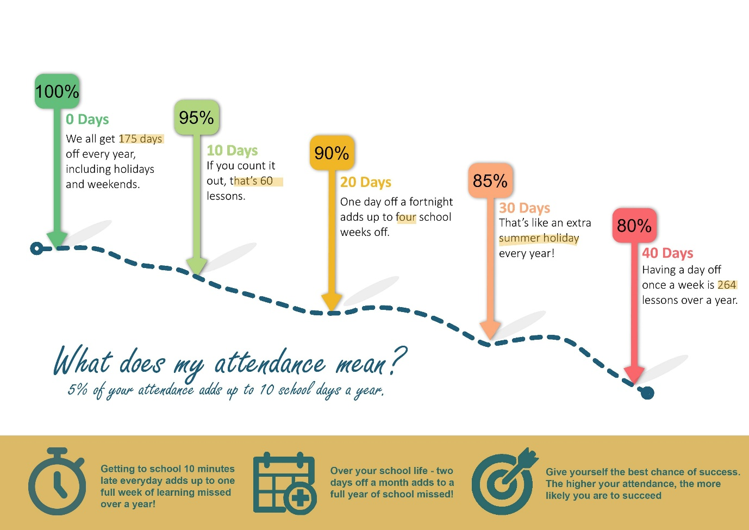

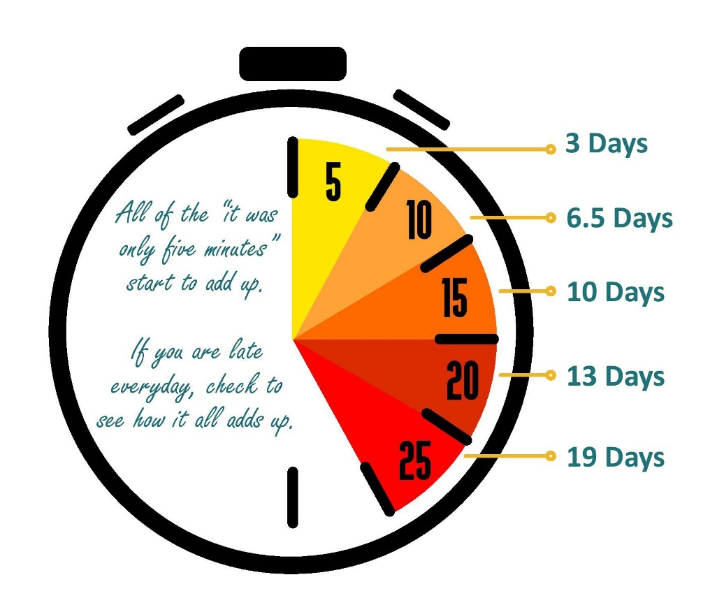

Rationale

This policy is underpinned by Inverclyde Attendance Policy (December 2024). Statistics and research have consistently demonstrated that children and young people’s progress, attainment and achievements can be negatively impacted by any absence. Evidence suggests that attendance that falls below 90% impacts negatively on progress, with the higher the absence, the greater the impact on attainment.

School attendance is a complex area of need, and involvement from other services/professionals can be helpful, appropriate and, at times, necessary. However, the aim of the current guidance is to support early and effective school attendance procedures and practice at a school level. The Scottish Government’s (2019a) Included, Engaged and Involved (Part 1) document states that attendance should not be considered in isolation and that work within schools, establishments and Local Authorities should be built upon a foundation of positive relationships, and an inclusive ethos and culture which promotes attendance.

Aims:
The aims of this policy are designed to reflect the overall aims of the Inverclyde Attendance Policy (October 2024). This attendance policy outlines our commitment to promoting regular attendance, punctuality, and engagement for all pupils. As a school, we aim to work in partnership with parents, carers and partners to ensure that all pupils attend school regularly and punctually, with support available when needed.

We aim:

- To provide guidance on procedures that support attendance and reduce absence in St Stephen’s Cluster.
- To outline the processes, we follow to maximise attendance in St Stephen’s Cluster
- To provide supporting guidance that can be implemented with greater flexibility, based on our unique contexts.
- To encourage full attendance and punctuality among all.
- To foster a positive culture where every child feels valued and supported.
- To work collaboratively with parents, carers, and external agencies to address and overcome any barriers to attendance.
- To ensure that all absences are accurately recorded and addressed in a timely manner.

Attendance is everyone’s responsibility – what’s your role?
Learners should as appropriate:
- take personal responsibility for attending as often as possible
- try not to be late
- engage in all aspects of the life of the school including learning and other social activities
- contribute to the daily life of the school and encourage peers to attend

Parents and carers should:
- ensure their child understands the importance of education and attendance
- support their child to attend as often as possible
- notify the school as soon as possible when their child is unexpectedly absent,by phone, Parents Portal, text 07860004806.
- work with staff to minimise absence and reduce any barriers to attendance
- book medical appointments outside school hours where possible and give advance notice if an absence is unavoidable
- keep the school up to date with telephone numbers and emergency contacts
- Ensure that where one child does require to be absent, siblings still attend
- Consult NHS guidance where unsure: NHS: Is my child too ill for school?

Staff should (appropriate to their context):
- proactively develop respectful and supportive relationships that support a positive ethos and culture
- regularly promote good attendance through lessons, assemblies, informal and formal conversations, and events
- make learning interesting and relevant and support learner engagement using a range of strategies
- keep regular and accurate records of attendance for every learner
- share concerns about a learner's engagement, attendance or wellbeing, at the earliest stage
- respond sensitively to learners and parent/carers when exploring attendance concerns

Senior Leaders should:
- prioritise attendance and punctuality
- promote attendance through policies, procedures, training, meetings and communications
- aim to improve overall attendance and reduce lateness through supportive interventions
- follow-up on all absences and identify and investigate patterns of absence
- ensure consistency in practice that supports attendance and engagement

Partners will:
- Work with learners, parents/carers and staff to maximise learner participation in education

We promote attendance in our establishments by:
- building relationships and prioritising wellbeing and care
- being inclusive and rights respecting
- involving learners in all aspects of learning and the life of the establishment including improvement planning and policy making
- having a curriculum which is relevant, engaging, and meets the needs of all our learners
- using a range of pedagogical approaches that cater for different learning styles
- all adults promoting attendance as well as having specific adults to help learners and families who may need a little bit of extra support
- treating parents and carers as partners in supporting attendance

When absence becomes a concern then the school will begin an assessment process, in consultation with learners and parents or carers, to explore the reasons behind the absence and to offer supportive interventions if appropriate. To contact parent/carers we may use text, email, phone call or letter.
When absence becomes a concern, we support learners and their families in the following ways:
Support for attendance may include preventative strategies within the everyday classroom
and school environment, alongside more targeted approaches planned with learners and families. Strategies may include: mentoring, check-ins with a trusted adult, safe spaces or short-term withdrawal for targeted work.

Where more support is required, schools may work with partners such as Educational Psychology, health professionals, community services to create a tailored package of support.

In some cases, highly individualised programmes may be put in place to support attendance.

For more information or help:
Talk to your child’s key contact or Head of Establishment.

Procedures

Home | Class Teacher | School Admin Staff | Senior Leadership Team
- If your child is unable to come to school, due to illness, Parents/Carers should contact the school before 09:30am.  - Send a text message to 07860004806 with details about the absence.  - If you need to speak to the office then call 01475 715728 after 9am.  - You can also upload your absence on ParentsPortal. | - Class Teacher should accurately record attendance at the beginning of each day by 9:15am and after lunch.  - Attendance should be recorded in SEEMIS Click & Go  - Review daily attendance data, identifying any concerning patterns.  - Report any concering patterns to SLT as appropriate . | - Monitor absence notifications from parents/carers and update each pupil registration  - Check for unexplained absences by 10AM each day  - Send Groupcall messages to parents / carers of children / young people with unexplained absences  - If still unexplained after Groupcall messages are sent:  - Notify PT / DHT / HT of any concerns so they can consider further phone call or home visit where appropriate  - Update SEEMiS with reasons for absence when obtained  - Where possible, all TBC codes should be updated to the correct absence code by the end of the school day  - If no reason can be obtained by the end of the school day, any outstanding TBC codes should be changed to UNA (unexplained absence) at the end of the school day  - If parental contact has not been achieved by 11.30am, then emergency contacts should be phoned for clarification of absence  - If contact remains unsuccessful, SLT should follow the Inverclyde Decision Making Tree for Unexplained Absence (Appendix 1).  Lateness  - Record late arrivals in SEEMiS using appropriate codes  - Monitor patterns of lateness  - Communicate concerns to SLT as appropriate | - SLT should review the Attendance Tracker spreadsheet regularly.  - Monitor on current trends in attendance.  - Monitor the impact of strategies in place on improving attendance.  - Track the attendance of targeted groups (young people impacted by poverty, CEYP, high risk list etc.) to identify any concerns and monitor the effectiveness of interventions.  - Regular Attendance meetings will review and examine the impact of the interventions put in place and discuss trends in particular groupings.

Flow Chart for Maximising Attendance & Letter Templates
Flowchart supporting improving attendance
The following flowchart is designed to maximise attendance and support absence. At all stages the children and families context should be considered alongside any identified actions.
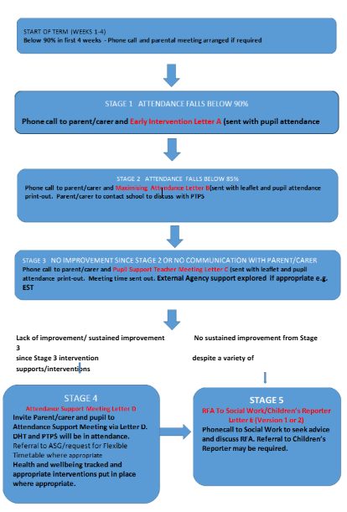

Sample letters are provided below to support the process:

A referral to SCRA re non-school attendance should only be considered when all of the above criteria to refer to RFA has been exhausted, and SW have been consulted so that no referrals are being submitted to SCRA for a child that has not been flagged to SW.
A referral to SCRA should only be considered where there are clear indicators that the family are not engaging on a voluntary basis or where the reason for a child’s sustained absence is due to environmental/parental factors e.g. not due to a child’s diagnosis or mental health issue.
St John’s Nursery

Children’s Absence in Nursery

Staffs Roles and Responsibilities

- Staff take registers as children arrive and complete again after lunch
- All staff are responsible for recording information they receive regarding appointments, holidays and illness from parents into the diary, then passing the information to the child’s key worker.
- If there is no contact from parents by 9.15am about the child’s absence, and there is no record in the diary of an absence, then the Depute will make telephone contact, or where appropriate social worker, health visitor, or any other support services involved.
- If there is persistent non-attendance without explanation SLT will investigate the reasons for this and contact outside agencies if required.
- If parents/carers give a change of detail or family circumstances this should be recorded in the child’s Personal Plan and reported to nursery clerical to adjust records.

Head Teacher / Depute responsibilities

- In cases of unexplained absence - If there are known concerns about the safety or well being of a child, follow the child protection procedures without delay.
- If there are serious or urgent concerns re the safety of a child, it is appropriate to contact the police.
- Try to contact the family and try to establish the whereabouts of the child and their expected date of return.
- Keep the nursery staff up to date with any information they receive

Monitoring

On a daily basis or using the procedures in place this is monitored and implemented by nursery staff, Head teacher and Depute

Review

This will be shared with all staff who will sign to acknowledge they have read and understood the contents.

As required or part of the three year review.

Appendix 1: Decision Making Tree for Unexplained Absence

If a parent has not advised the school that the pupil will be absent, then it must be assumed that the parents are unaware of the absence and that the child is missing or truanting. If the school has been unable to establish contact with the parents, action must be taken to satisfy the school and the education authority that the child or young person is safe and well.
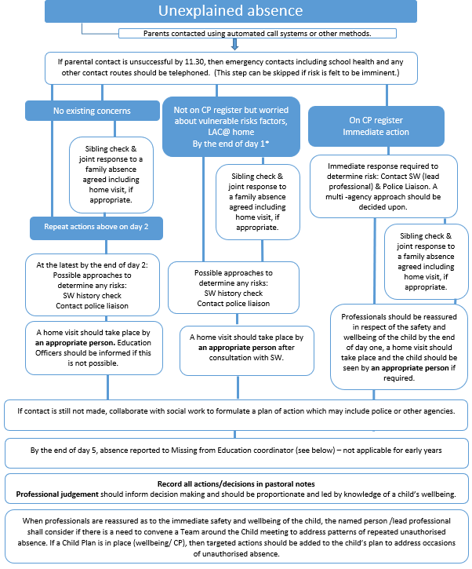
Appendix 2: Letter Raising Awareness (Primary)
Head Teacher: Leanne Cannon

Tele No: 01475 715728

Email: office@st-johns.inverclyde.sch.uk
DATE

ATTENDANCE MATTERS

Dear Parent,

This is a raising awareness letter, which we send out to all parents every year.

Attendance at school is important for many reasons. These include; supporting our children to grow in confidence and self-esteem, to experience success in their learning and understand responsibility.

Our local authority attendance target is 95%. Low attendance can lead to social and emotional difficulties as well as impact progress in learning however, we understand that there are times when your child cannot attend school, including if they are ill or attending medical appointments.

If you are experiencing difficulty getting your child into school, please contact the school office and ask for an appointment to speak with a member of the Leadership Team.
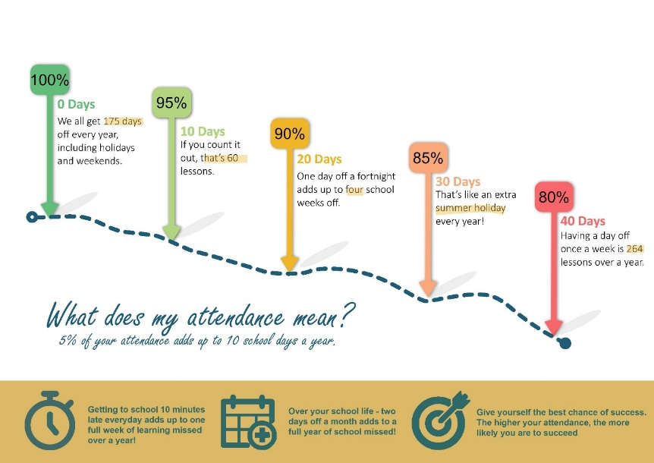

Please find enclosed a copy of our authority’s Attendance Matters information flyer for parents as well as this graphic below outlining the impact of days missed.

Kindest regards,

Head Teacher

Sample Letter A (Primary)

Appendix 3: Stage 1 Attendance Awareness Letter 1 (Primary)

Head Teacher: Leanne Cannon

Tele No: 01475 715728

Email: office@st-johns.inverclyde.sch.uk

Date

ATTENDANCE MATTERS: Stage 1 Attendance Awareness Letter 1

Child’s Name: Name
Class: PX

Dear Parent,

Attendance at school is important for many reasons. These include supporting our children to grow in confidence and self-esteem, to experience success in their learning and to build positive relationships in a variety of differing settings with peers and adults.

We understand that there are many different reasons for a child not attending school and we would like to work with you to support (insert child’s forename) towards an improved attendance pattern, and ultimately, greater wellbeing and achievement.

(insert child’s forename) has missed ____ days in Primary_.

The class average for days missed is____.

Over the next 6 weeks, we will closely monitor this and keep you updated regarding (insert child’s forename) attendance.

Please continue to keep us informed if (insert child’s forename) cannot attend school, either by calling the school or via ParentsPortal.

If you are experiencing difficulty getting your child into school, please contact the school office and ask for an appointment to speak with the Leadreship Team.

Kindest regards,

Leanne Cannon
Head Teacher
Appendix 4: Stage 2 Attendance Awareness Follow- up Letter (Primary)

Head Teacher: Leanne Cannon

Tele No: 01475 715728

Email: office@st-johns.inverclyde.sch.uk

DATE
ATTENDANCE MATTERS: Stage 2 Attendance Awareness Follow-up Letter

Child’s Name: NAME
Class: PX
Dear Parent,
We wrote to you recently and let you know that we wanted to help you support (insert child’s forename) in improving their attendance. We have noticed that (insert child’s forename) has missed a further ____ days from school.
Our Depute Head Teacher ____________ will be in contact to discuss ways we can work together to support (insert child’s forename) attendance. If (insert child’s forename) attendance does not improve, we will arrange a meeting in person to plan how we can work together to support you.
We understand that there are times when your child cannot attend school, including if they are ill or attending a medical appointment. We appreciate you contacting us to make us aware of reasons for non-attendance.

Kindest regards,

Leanne Cannon

Head Teacher

Appendix 5: Stage 3 Attendance Meeting Invite (Primary)
Head Teacher: Leanne Cannon

Tele No: 01475 715728

Email: office@st-johns.inverclyde.sch.uk

DATE

ATTENDANCE MATTERS: Stage 3 Attendance Meeting Invite

Child’s Name: Name
Class: PX

Dear Parent,

We are committed to working with parents/carers and our young people to ensure they are fully supported in all aspects of school life. We believe that (insert child’s forename) would benefit from extra support to help improve their attendance as there has been no significant improvement since our previous communication.

Current attendance now stands at (insert percentage) and this is [X amount] days of missed learning.

I would like to invite you to a meeting at the school to discuss the support available to help improve attendance. This will allow us to work together to address any issues and put appropriate supports in place.

Please attend on (DAY/DATE) at (TIME) and call the office on 01475 715728to confirm your attendance or arrange a more convenient time.

Kindest regards,

Leanne Cannon

Head Teacher

