St Stephen’s Cluster Anti-Bullying Policy

January 2026

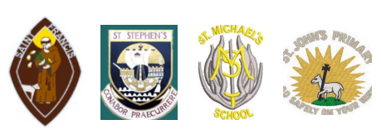

The St Stephen’s Cluster serves the community of Port Glasgow in the west of Scotland. As part of Inverclyde Council, the cluster prioritises the wellbeing of children and young people in its education establishments, recognising that this is central to the creation of responsible citizens, successful learners, confident individuals and effective contributors — key tenets of Curriculum for Excellence (Scottish Executive, 2001).
This prioritisation has recently been strengthened through the commitment to embed trauma-informed and trauma-responsive practices, building on a long history of supporting relationally based approaches within the local authority. This forms the wider context within which the cluster’s strategy for anti-bullying exists.
This Cluster Anti-Bullying Policy has been developed in consideration of Inverclyde Council’s 2025 Anti-Bullying Policy and aligns with the Scottish Government document Respect for All (2024).

Definition of Bullying
Saint Stephen’s cluster has adopted the national definition of bullying, as set out in Respect for All; the national approach to anti-bullying for Scotland’s children and young people.
“Bullying is face to face and/or online behaviour which impacts on a person’s sense of physical and emotional safety, their capacity to feel in control of their life and their ability to respond effectively to the situation they are in.
The behaviour does not need to be repeated, or intended to cause harm, for it to have an impact. Bullying Behaviour can be physical, emotional or verbal and can cause people to feel hurt, threatened, frightened and left out.”
The St Stephen’s Cluster recognises that there are times when disagreements between children and young people do not meet the criteria for bullying behaviour.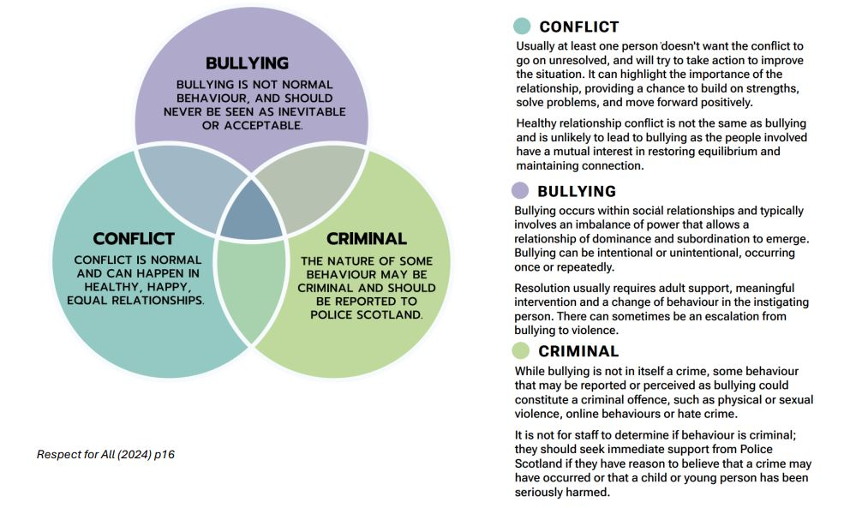

St Stephen’s cluster stance, scope and aims of this policy:
Bullying behaviour is unacceptable in all circumstances. All children and young people have the right to learn in environments where they feel safe and free from abuse, bullying and discrimination. Prevention is the most effective way to reduce bullying, and as such, preventative approaches will be central to our work across the St Stephen’s Cluster.
Bullying is recognised as a violation of children’s rights as set out in the United Nations Convention on the Rights of the Child (UNCRC), including Articles 3, 12, 13, 19, 29 and 39.
The Inverclyde Anti-Bullying Policy (2025) applies to school-aged children and young people, and supports a preventative approach beginning in early years settings through social skill-building, although the concept of “bullying” is not introduced in early years.
Consultation with St Stephen’s Cluster families was undertaken and informs this policy.

Preventing and Responding to Bullying
Prevention is the most effective intervention when it comes to bullying and is supported by the creation of inclusive learning/leisure environments. Thereafter, effective responses that are meaningful to children and young people can reduce long-term impact and restore well-being.
Across our cluster schools, we work hard to create a positive, respectful and caring environment so that bullying is less likely to happen. We do this by:
- Teaching children about kindness, respect and relationships as part of Health & Wellbeing, Religious & Moral Education, and whole-school assemblies.
- Using restorative and nurturing approaches to help children build social skills such as sharing, taking turns, understanding feelings and solving disagreements.
- Listening to children’s voices through pupil councils, pupil leadership groups, surveys and class discussions.
- Celebrating difference and diversity, helping children understand that everyone is valued for who they are.
- Working in partnership with families so parents know how to raise concerns and understand how we handle issues.
- Promoting digital safety so children know how to behave kindly and safely online.
- Focusing on mental health and wellbeing so children feel secure, included and supported.
- Making sure staff know children well, including their interests, worries and friendships, helping us spot changes quickly.
These preventative approaches help create school communities where children feel safe, included and confident to speak up.
How We Respond When Bullying Concerns Are Raised
If bullying does happen, we take it seriously and deal with it quickly.
Across our cluster, we:
- Listen carefully to the child or parent who raises a concern.
- Check what has happened, speak to those involved and gather information.
- Support the child who has been affected, helping them feel safe and confident again.
- Work with the child displaying bullying behaviour to help them understand the impact of their actions and make positive changes.
- Use restorative approaches where appropriate to rebuild relationships and repair harm.
- Keep things under review to make sure the situation improves and does not start again.
- Keep parents informed throughout the process so everyone knows what actions are being taken.
We recognise that some situations may involve friendship issues or conflict rather than bullying. In these cases, we still support children to learn how to solve problems, talk about their feelings and manage disagreements safely.

Children’s Rights
St Stephen’s Cluster firmly upholds every child’s right to safety, dignity, and respect. Bullying in any form is a violation of children’s rights and is completely incompatible with the principles of the United Nations Convention on the Rights of the Child (UNCRC), which is now enacted in Scots Law.
We recognise that all children have the right to be protected from all forms of physical or mental violence, injury, or abuse, and the right to education that promotes respect for others and equality.
Bullying behaviour breaches these rights. The school is committed to ensuring that our policies, practices, and culture actively promote children’s rights, foster positive relationships, and create a safe and inclusive learning environment for all.

Equality Duties
Children and young people should never be treated unfairly because of who they are. Schools in the St Stephen’s Cluster follow national equality laws, including the Equality Act 2010, which protect people from discrimination. This means we work to make sure everyone has equal opportunities and that we build a community where children learn to respect and value each other.

The Equality Act 2010 protects people from discrimination based on certain characteristics. These are called Protected Characteristics and include:

- Age
- Disability
- Gender reassignment
- Marriage or civil partnership
- Pregnancy or maternity
- Race
- Religion or belief
- Sex
- Sexual orientation

Other Groups We Also Support

Alongside the groups protected by law, our cluster recognises that bullying can happen for many different reasons. We work to ensure children are supported and included, and that they are not treated unfairly because of things such as:

- Additional support needs
- Asylum seeker or refugee status
- Body image or physical appearance
- Being care experienced
- Family or household circumstances
- Family imprisonment
- Forces children (e.g. parents in the armed forces)
- Mental health
- Sectarian attitudes
- Financial hardship or poverty
- Being a young carer

Our Commitment to Families

We work with families, children and staff to create school environments where:

- Everyone is treated with dignity and respect
- Differences are understood and valued
- Children feel supported and included
- Bullying, discrimination and prejudice are addressed promptly and sensitively

Expectations and responsibilities of staff/volunteers, children and young people and parents to support and uphold the policy aims
Expectations and responsibilities of staff/volunteers, children and young people and parents to support and uphold the policy aims
Working Together to Prevent Bullying
Everyone has a part to play in making our schools safe, respectful and welcoming places. Children, parents and staff all have responsibilities that help us prevent and respond to bullying.
Children and Young People
We support children to:
- Be aware of the anti-bullying policy
- Understand that bullying behaviour is a violation of children’s rights
- Treat others with kindness and respect
- Speak to a trusted adult if they are worried
- Help create a positive atmosphere in school
- Challenge bullying behaviour where safe to do so
- Take part in pupil-friendly anti-bullying activities
Parents and Carers
We ask parents to:
- Listen to their child and take concerns seriously
- Share worries with the school as early as possible
- Be aware of how the school responds to bullying and how to raise complaints if needed
- Model respectful behaviour in all interactions, including with school staff
- Have a voice in the creation of their school’s anti-bullying policy
Staff and Volunteers
Staff and volunteers will:
- Follow school and local authority anti-bullying policies
- Listen to children and take concerns seriously
- Share concerns with the right people and seek support if needed
- Help children understand what bullying is and how to report it
- Promote equality, diversity and children’s rights
- Model respectful relationships at all times

Respectful Behaviour
Children do best when they learn in a school that feels calm, caring and respectful. Research shows that a positive school culture helps children achieve better, feel happier, and reduces bullying. Schools in St Stephen’s Cluster focus on building positive relationships between children, staff and families.
For this reason, the General Teaching Council for Scotland Standards for registration emphasise that teaching staff should:
- Promote health and wellbeing of self, colleagues and the children and young people in their care.
- Build warm, respectful relationships across the community
- Respect the rights of all learners as outlined in the United Nations Convention on the Rights of the Child (UNCRC)
- Treat everyone fairly and equally, whatever their background or identity
- Value and celebrate cultural, religious and family differences
- Include and encourage all learners, and remove barriers where possible
- Demonstrate a commitment to supporting learners who are experiencing or who have experienced trauma, children and young people from a care experienced background and understanding responsibilities as a corporate parent.
- Challenge discrimination and prejudice, including anything covered by the Equality Act 2010

Labelling
Research shows that labelling people can be harmful. When children are given labels such as “bully”, “victim” or “perpetrator”, they may start to believe that this label defines who they are.
This can:
- Make it harder for them to change their behaviour
- Make it more difficult for them to recover from bullying
- Give an unwanted status or role in school
- Be disempowering for everyone involved
Because of this, the focus in our schools is on the behaviour, not on labelling the child.
Instead of using labels, adults will:
- Look at what actually happened
- Talk about the impact on others
- Help children understand how to make better choices next time
- Support everyone involved to move forward positively
This approach helps children learn, reflect and rebuild relationships, rather than feeling stuck with a label.
For this reason, this policy avoids labelling language. Instead of calling someone a “bully” or “victim”, we use phrases such as:
- “a child displaying bullying behaviour”
- “a child experiencing bullying behaviour”

Reporting, Recording and Monitoring
This section of the policy sets out the three stepped approach to the management of alleged incidents of bullying behaviour, namely Reporting, Recording and Investigating. It is important that that all members of a school’s community are aware of and follow these processes. The complaints procedure is also cited at the bottom of this section should there be dissatisfaction in respect of the process or outcome.
Step 1: Reporting
There are different ways in which an establishment or organisation may become aware of
potential bullying behaviour.
- It may be raised by the child or young person who believes they are being bullied.
- It could be raised by another child or young person who has witnessed behaviour they perceive as bullying.
- It could be raised by a parent or other family member.
- It could be observed by a member of staff or adult volunteers/youth leaders.
Education establishments should listen to their children and young people and, as a result of this, be creative in how they generate opportunities for reporting incidents of alleged bullying.
Furthermore, it is crucial that each school ensures that children, young people and their parents have a full understanding of the mechanisms regarding how concerns can be raised. This includes provision being made to ensure that there are discreet or anonymous reporting mechanisms for pupils. Therefore, all education establishments must ensure that their antibullying policy has clear information relating to the processes through which allegations of bullying behaviour can be reported.
Step 2: Recording the incident/concern
It is recommended that once an incident or concern has been raised, this should be logged on the SEEMIS Bullying and Equalities system as soon as possible by a key staff member and that the investigation should commence in a timely manner. It is not necessary for an allegation to be substantiated before it is recorded. Rather details of the reported incident should be recorded, capturing information about the behaviour that took place, who was involved, where and when it is reported to have happened, any potential underlying prejudice, including details of any protected characteristics, and whether the impact indicates any wellbeing concerns or the need for additional support. An investigation into the incident should follow, as set out in the Section 3, with the recording system being updated throughout the process on the outcome of this investigation, and any action taken as a result.
What information should be recorded?
It is important that a thorough picture of the bullying incident be recorded. When recording
potential bullying incidents, the following information must be included:
  - the children and young people involved, as well as staff/volunteers or any other adults who witnessed the incident or were involved in the initial response;
  - where and when bullying has taken place;
  - the type of bullying experienced, e.g. name-calling, rumours, threats;
  - any prejudice-based attitudes or behaviour presenting;
  - details of any protected characteristic(s);
  - consideration of personal or additional support needs and wellbeing concerns;
  - the outcome, including if the issue was resolved, not resolved or unfounded;
  - the impact of the incident, including consideration of personal or additional support needs and wellbeing concerns;
  - and actions taken including resolution at an individual or organisational level.
In line with the UNCRC (including Article 12), children and young people have the right to an opinion and for it to be listened to and taken seriously, and Article 16, children and young people have the right to a private life), where possible, the content of this record should be agreed with the child or young person.
Step 3: Investigation
In Inverclyde’s education establishments it is recommended, that investigations should be concluded within three working days with the outcomes communicated to all those involved i.e. children, young people and their parents. All allegations of bullying behaviour must be investigated. Bullying is a combination of behaviour and impact and should be addressed with compassion and professional curiosity when investigating incidents. Although bullying is often persistent, a single incident can have a significant impact on the health and wellbeing of children and young people and instil a fear that it might happen again. Impact on the individual/group’s health and wellbeing and/or learning and school environment can be established through an investigation of alleged, observed or reported bullying incidents. The National Guidance for Child Protection in Scotland 2021 (updated 2023) makes clear that individual agencies are responsible for ensuring that their staff are competent and confident in carrying out their responsibilities for safeguarding and promoting children’s wellbeing. We expect teachers and all those working with children and young people to identify and act on any concerns to ensure the safety and wellbeing of the child or young person concerned, in line with their local child protection procedures. A helpful approach would be to ask:
  - what was the behaviour?
  - what impact did it have?
  - what does the child or young person want to happen?
  - what do I need to do about it – for example, is there a child protection concern?
  - what attitudes, prejudices or other factors may have influenced the behaviour?
Once an investigation has concluded, the SEEMIS Bullying and Equalities Module should be updated with the outcome. This should include whether the incident was considered to be resolved, not resolved or unfounded. Where an incident is found to be bullying, schools should record what supports/interventions were put in place for both for individuals/groups affected by the behaviour and those displaying the behaviour. If the incident is not bullying, but due to other factors such as changing friendship groups or interpersonal conflict, it can still be difficult for a child or young person and their parents. In these situations, it is important for those involved to understand that even though the incident is not bullying there will still be a response from staff who can work with the child or young person and potentially peers to improve the situation.
Adapted from (Respect for All, 2024)
It is the aim for all establishments to resolve investigations into allegations of bullying behaviour amicably for all involved. However, on occasion, this may not be the case. In these
circumstances, schools should signpost to complaints process.
https://www.inverclyde.gov.uk/council-and-government/complaint

Evidence of Children and Young People’s Involvement
Children and young people played an important part in shaping this policy. As part of Inverclyde’s consultation process, St Stephen’s Cluster schools were involved alongside other establishments across the authority. In total, over 300 pupils took part in consultation workshops to share their views and experiences.
These sessions were supported by Inverclyde’s Health and Social Care Partnership’s Children’s Rights Officer and the Children and Young People’s Engagement and Development Officer from Your Voice, Inverclyde.
In addition, Respect Me, Scotland’s national anti-bullying service, led further pupil focus groups to explore how children and young people experience bullying and how they would like schools to respond. Our Children’s Rights Officer also held additional focus groups within the St Stephen’s Cluster to gather more in-depth feedback from our own pupils.

Parental Consultation
During session 2025/2026 parents in all cluster schools were consulted and asked to share their views prior to the development of this policy.

Staff & Volunteer Consultation
A variety of staff and partners across the cluster have been involved in the production of the policy. Once in draft form, all staff will be consulted and asked to share their views.

Policy Review & Communication Plan
The policy will be reviewed on a 3 yearly basis with consultation to gather the views of all stakeholders.
All cluster schools will communicate the policy in the following ways:
- Email to all families
- Publication on school websites
- Promoted during school assemblies
- Pupil Leadership Groups
- Staff and relevant partners issued with policy
- Policy revisited annually during staff meetings

Training and Supporting Staff and Volunteers
Respect Me, Scotland’s national anti-bullying service, provides a range of high-quality training and resources for education establishments, which can be accessed at: www.respectme.org.uk. These materials support schools to understand, prevent and respond to bullying using national guidance such as Respect for All (2024).
Within the St Stephen’s Cluster, we will:
- Signpost staff to national Respect Me training, resources and guidance
- Use a cluster approach, at the point of policy launch, to ensure staff understand the policy and how to implement it
- Provide annual updates to refresh staff knowledge and respond to emerging needs or changes in national/local guidance
This approach ensures that staff and volunteers remain confident and informed in supporting children and young people across the cluster.

