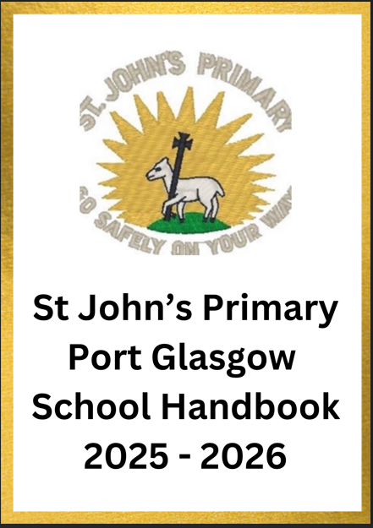
Contents

From the Head Teacher 3
Authority Strategic Statement 4
Vision, Values and Aims 5
School Information 6
School Staff 7
Mrs Cannon DHT Remit 8
School/Nursery Hours 9
The School Year 10
St John’s Primary School Nursery Class 11
Breakfast Club 14
Enrolment for School 14
School Improvements / Concern/Compliments/Inverclyde Complaints Procedure 15
The Curriculum 16
Religious Observation in the Catholic School 26
Assessment & Reporting 27
Homework 28
Additional Support Needs 29
Equal Opportunities 30
Inclusion & Equalities/Child Protection 31
Home/School & Community Links 32
Transitions 33
Attendance at School 34
Children Absent from School through Ill-Health /Medical Health Care/Information in Emergencies 35
Positive Relationships 36
Playground Supervision 37
Extra–Curricular Activities 38
Clothing and Uniform 39
School Meals and Health Promotion 41
Transport 42
Parent Forum and Parent Council 43
Parent Teacher Association (PTA)/Parental Involvement 45
Parentzone 46
Pupil Involvement 47
Data Protection Act 1998/Important Addresses 48
Glossary of Terms Used in the School Handbook 49


Dear Parents,
Welcome to St John's Primary School and Nursery Class, a Catholic school with a non-denominational Nursery at the heart of the Port Glasgow community. We are an integral part of the St John the Baptist parish community, and we would like to extend our warmest welcome to you.
Our school and nursery aims to provide an environment where every child can thrive and reach their full potential. We value each child and strive to support their wellbeing needs, fostering a positive ethos of respect, ambition, love, patience and honesty.
We want to establish a happy and stimulating learning environment that encourages effort and high expectations for all our pupils. We believe in working collaboratively with parents and partners to develop strong partnerships between home and school, supporting your child's growth and development.
If you have any questions, please do not hesitate to contact us. We are always happy to have a chat and discuss any matter.

Yours sincerely
Leanne Cannon

Leanne Cannon
Head Teacher

Authority Strategic Statement

Building Inverclyde through excellence, ambition and regeneration.

Goals and Values

Our Core values are: Respect, Honesty and Tolerance.

Our vision for the children and young people of Inverclyde is that they should be ambitious for themselves and be successful learners, confident individuals, responsible citizens and effective contributors.

To achieve our ambition of building Inverclyde through excellence, ambition and regeneration our children must be:

Safe: protected from abuse, neglect and harm by others at home, school and in the community.

Healthy: enjoy the highest attainable standards of physical and mental health, with access to healthy lifestyles.

Achieving: have access to positive learning environments and opportunities to develop their skills, confidence and self-esteem to the fullest potential.

Active: active with opportunities and encouragement to participate in play and recreation including sport.

Respected and responsible: involved in decisions that affect them, have their voices heard and be encouraged to play an active and responsible role in their communities.

Included: have access to high quality services when required and should be assisted to overcome the social, educational, physical, environmental and economic barriers that create inequality.

Nurtured: educated within a supportive setting.

Our Vision, Values and Aims
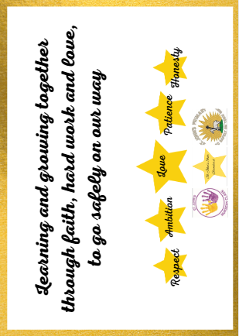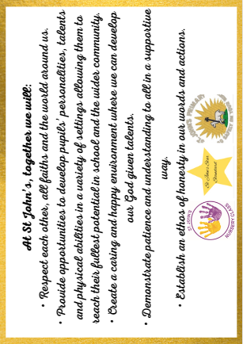

Curriculum Rationale:
In keeping with the principles of Getting it Right for Every Child, we aim to provide a happy, safe and inclusive learning environment that encourages ambition in all our pupils, and fosters respect and tolerance for others.

As a Catholic Primary School, we place a particular emphasis on developing our Christian faith and Gospel values. Through the support of parents and our parish community, we aim to develop a genuine love of God and a deep understanding of social justice in our children’s lives.

We aim to deliver a broad general education which provides opportunities for all our pupils to develop Literacy and Numeracy skills enabling them to access the wider curriculum and understand what is required for learning, life and work. Through working in partnership with the community, we foster a thirst for learning and build creative thinking incorporating digital learning. Working closely with families we develop sound knowledge of all aspects of Health & Wellbeing leading to informed choices, Rights Respecting and pupil resilience.

Our Curriculum is broad, balanced, stimulating and challenging and provides opportunities which meet the needs of all pupils. Staff continually develop quality pedagogical approaches to learning and teaching ensuring pupil/family/community engagement opportunities. We provide quality feedback leading to a deeper understanding of pupil progress and improvement. We track and monitor our pupils’ progress three times per year and formally report to parents recognising the importance of parents as partners in their child’s learning. We provide leadership opportunities for pupils and staff ensuring a whole school consistent approach to self-evaluation leading to school/nursery improvement.

Within our Nursery Class, and throughout the school, we recognise that Play is one of our main pedagogies. We value childhood development and aim to meet each child developmentally to ensure their learning is catered for and nurtured.
School and Nursery Information

Name St John’s Primary School and Nursery Class

Address Mary Street, Port Glasgow, PA14 5AL

Telephone (01475) 715728

E-mail office@st-johns.inverclyde.sch.uk
Website http://www.st-johns.inverclyde.sch.uk
X (formally Twitter) @StJohnsPG @StJohns_Nursery

Present School Roll

N4 | N5 | P1 | P2/1 | P2 | P3 | P3/4 | P4 | P5 | P5/6 | P6 | P7/6 | P7
2 | 21 | 21 | 23 | 25 | 27 | 25 | 26 | 27 | 23 | 29 | 24 | 28

Nursery-24 | P1 – 34 | P2 – 35 | P3 – 46 | P4 – 32 | P5 – 47 | P6 – 43 | P7 – 41 | Total -301

Stages covered: Capacity of the School: Capacity of the Nursery:

Nursery 4 – Primary 7 Planning capacity -350 Planning capacity - 24
Working capacity -305 Working capacity - 24

Parents should note that the working capacity of the school may vary dependent upon the number of pupils at each stage and the way in which the classes are organised.

St John’s Primary is a Roman Catholic Co-educational Primary School. St John’s Primary does not provide teaching in Gaelic.

Our Associated Pre-5 Establishments are:

- St John’s Nursery Class
- Gibshill Pre-5 Establishment
- Newark Pre-5 Establishment
- Rainbow Family Centre

Particulars on school letting may be obtained from:

Booking Office
Inverclyde Leisure
Greenock Sports Centre
20d Nelson Street
Greenock
PA15 1QH

Tel: (01475) 213131

The Building

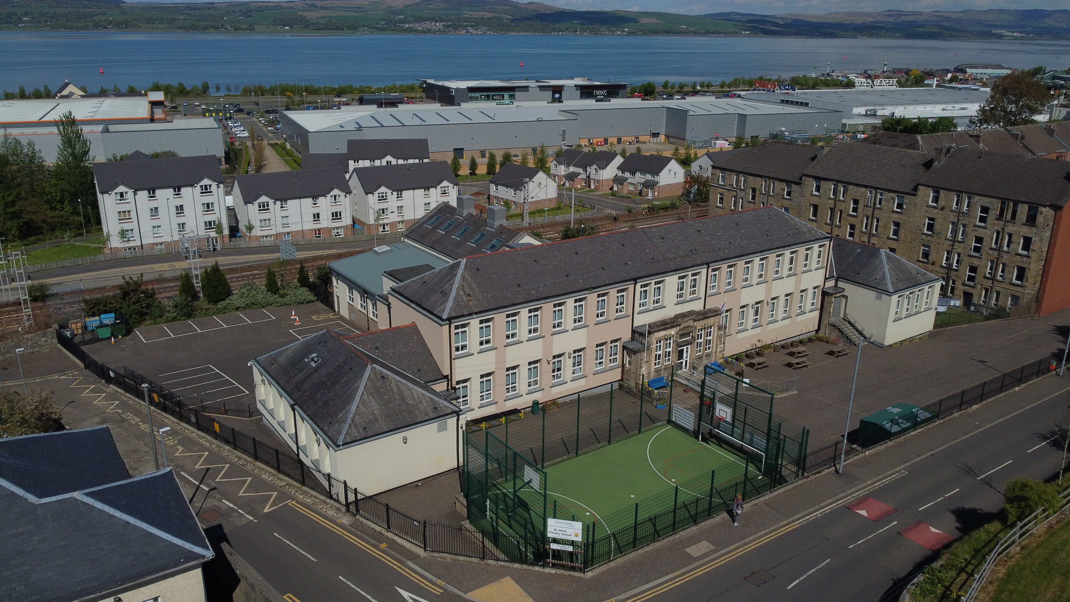

St John’s Primary School and Nursery Class was refurbished in 2016. The accomodation offers:
- An Office area
- 11 classrooms
- A Nurture room
- A canteen
- A Nursery Class
- Multi-Use Games Area (MUGA)
- Playgrounds to the front and rear of the building

The school and nursery both comply with disability access legislation.

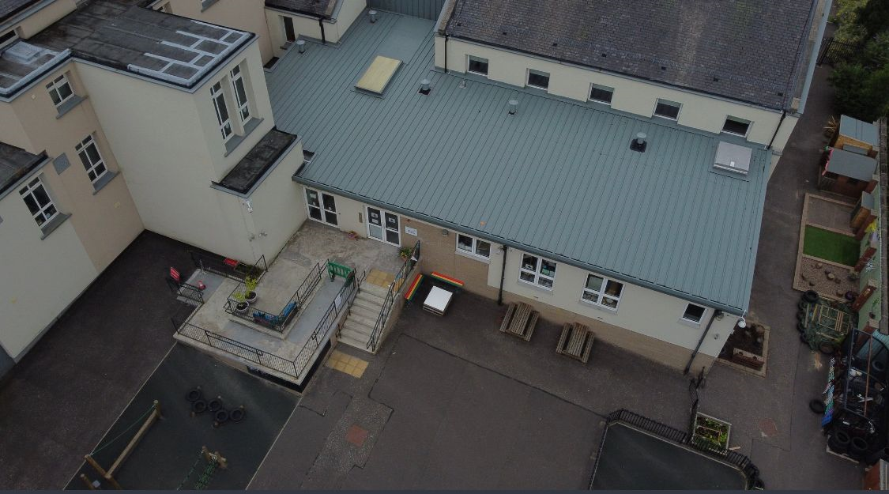
Staff

Head Teacher Mrs Leanne Cannon
Depute Head Teacher Miss Jennifer McGachy
Principal Teacher Mrs Gillian Tipling

Depute Head of Nursery Miss Donna Buirds

EYECO Mrs Jelena Finnie

EYECO Mrs Kim Bryce/Mrs Collette Murdoch

EYECO Miss Emma McLean

EYSA Miss Sarah-Jayne Colley

P1 Miss Sinead Sinclair
P2/1 Miss Erin Toland and Mrs Claire Scott
P2 Mrs Pauline Paul and Mrs Caroline Rodger
P3 Miss Caitlyn Docherty
P3/4 Mrs Pauline Walker
P4 Mrs Lisa MacDonald
P5 Mrs Linda Isaksen
P6 Mrs Ashleigh Coll & Mrs Jacqueline Morris
P6/7 Mrs Gillian Tipling & Miss Lucy Tierney
P7 Miss Danielle McGachy
NCCT cover Mrs Claire Scott and
Mrs Jacqueline Morris

Senior Clerical Mrs Caroline Gillan
Clerical/PSA Mrs Lesley Gallacher
PSA Mrs Karen Johnstone (0.6)
PSA Mrs Gillian Hutton
PSA Mrs Fiona Taylor (0.8)
PSA Mrs Lorna Reid
PSA Miss Danielle Sheekey
PSA (PEF) Miss Maureen Gemmell
PSA (PEF) Mrs Janice Cabrie
Janitor Mr Mark McKee

Woodwind Instruction 0.1 Mrs Victoria Douglas
Pipes Instruction 0.1 Mr Blair Wishart
Brass Instruction 0.1 Mr Andrew Foden
Active Schools Mr Brad Cathie

School Hours

Opening | 9.00am
Morning Break | 10.30am-10.45am
Lunch | 12.15pm-1.00pm
Close | 3.00pm

- At Christmas and Spring Break, school will normally close at 2.30 pm.
- End of School Year, school will normally close at 1.00 pm.

Nursery Hours

Nursery Hours
St John’s Nursery offers Model 1 placements (6 hours a day over 5 days during the school term). Our core opening hours are outlined below. If these core hours do not suit you please speak to a member of staff.
Nursery session begins: 8.55am
Nursery session ends: 2.55pm
Please note:
- At Christmas and Spring break nursery will normally close at 2.30pm
- End of the nursery year, nursery will normally close at 1.00pm

Children are entitled to 1140 hours of early learning and childcare (ELC) pro rata depending on their birth date. The table below outlines our Admission Intake Timeline which follows Inverclyde Council’s Admissions Policy

Admission Intake Timeline
Date of birth | Month due to start
March - July | August
August | September
September | October
October | November
November | December
December | January
January | February
February | March
The School Year

THE SCHOOL YEAR 2025-26
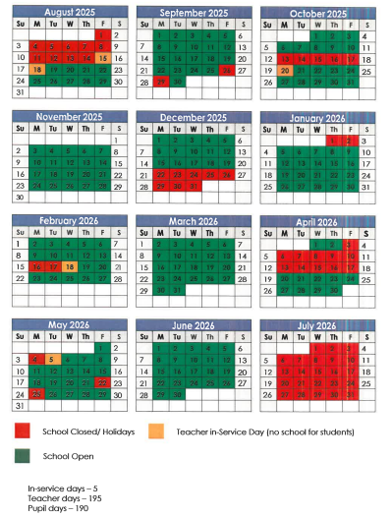

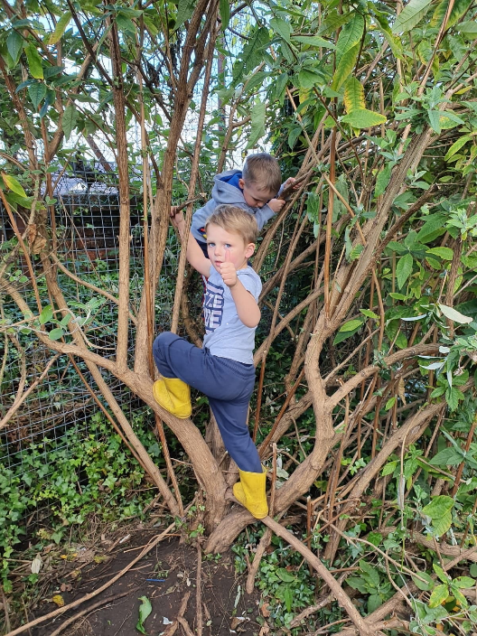
St John’s Primary School Nursery Class

St John’s Nursery offers high quality early learning and childcare for children aged between 3 – 5 years in a safe and welcoming environment. Children’s individual needs are at the heart of what we do. We recognise and value each child’s unique development and strive to get it right for every child in our care.

Curriculum in the Nursery
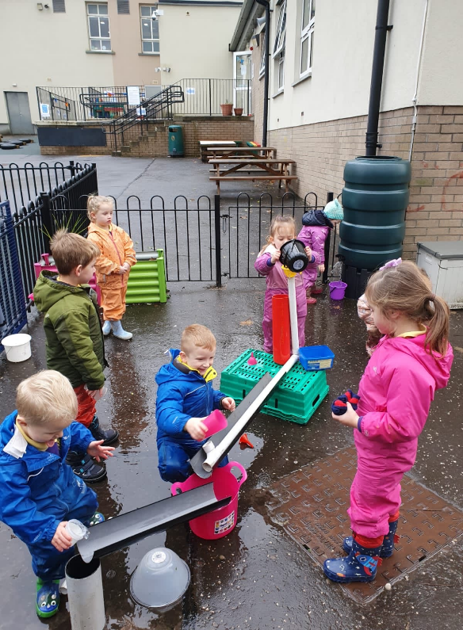
We value that children learn best through play in an environment of quality interactions, interesting spaces and when the experiences on offer are set in meaningful contexts. We recognise that children learn best in environments that inspire them to be curious and creative therefore children are given time to play throughout the day to follow their own line of enquiry or individual interests. Through play, children learn to answer questions, learn new skills and to work collaboratively with others. Our staff provide, through responsive and intentional planning, a blend of child initiated and adult initiated learning experiences based on the early level of Curriculum for Excellence which connects with and extends children’s interests and motivations. Particular focus is placed on developing children’s skills in literacy, maths and health and wellbeing. Children will also experience a range of experiences in expressive arts, science, social studies and religious and moral education.

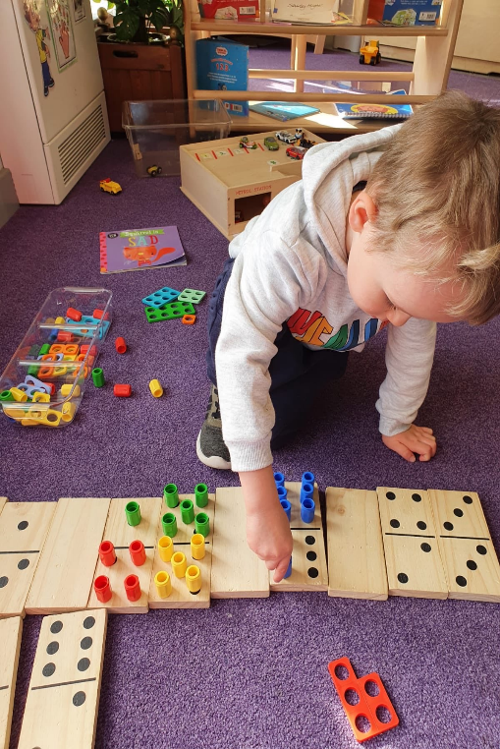
Assessment and Reporting in Nursery
Every child has a profile which is a comprehensive record of their progress during their time in nursery. These are updated regularly with staff observations, photos and pieces of children’s work which highlight the development of key skills. We meet with parents on a regular basis to share profiles, to discuss each child’s progress and to set individual next steps. At the end of their pre-school year profiles are sent home for parents to keep as a record of the child’s time in nursery. An “ELC/Primary Transition Record” is also completed at the end of the pre-school year and this record is passed on to the school the child in transferring to. It outlines achievements and progress made during the child’s time in nursery.

Attendance
It is important that absences from nursery are kept to a minimum as education is a continuous process and children benefit from regular attendance. We ask that parents contact the nursery before 9.15am if a child will be absent from nursery.

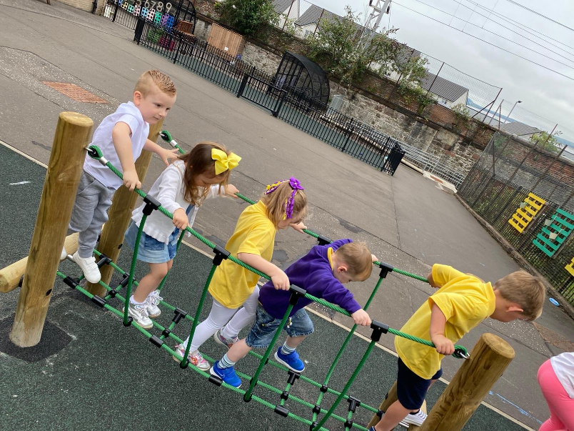
Home Links
Our nursery has an open door policy based on mutual trust and respect. We aim to develop positive relationships between home and nursery and we recognise that by working in partnership we can achieve the best outcomes for our children. We regularly update our parents with letters outlining nursery events and our intended learning for the block. In addition we run some very successful home link initiatives, such as our Lending Library.

Clothing
In St John’s Nursery children learn through play and this can often be a very messy business. We encourage children to become independent learners and this includes providing opportunities to play in mud, make their own playdough and pour their own paint. Children can choose to play indoors and outdoors (in all weathers) every day. For this reason we encourage you to wear suitable clothing to nursery which will allow children to participate in all the activities on offer.

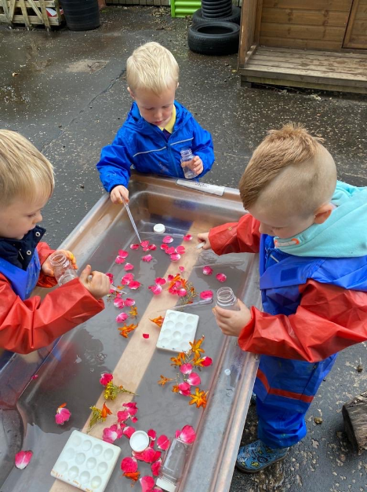
Snacks and Lunches
St John’s Nursery is a health promoting establishment with a healthy eating policy based on current guidance from “Setting the Table – Nutritional Guidance and Food Standards for Early Years Childcare Providers in Scotland”. Healthy snacks and lunches are provided every day free of charge as part of our delivery of 1140 hours. Menus are provided in advance so you can support your child in making choices for the day ahead.

Collecting Children
It is of paramount importance that our children are kept safe at times therefore we ask that staff are aware of who will be collecting children at the end of the day. We have a password system in place that ensures staff can be confident if someone new has to come to collect your child.

Transition to School
We recognise that the key to an effective transition is effective communication between nursery, school and parents. Our transition programme is well planned and is an ongoing process which has strong links between all our feeder schools. Our children participate in a wide range of relevant activities and visits during their pre-school year which aims to ensure our children feel safe and secure as they move on the next part of their learning journey.

Care Inspectorate
Our nursery is regulated by the Care Inspectorate. This organisation inspects our service to ensure the level of care and support provided to our children and families is of high quality. Inspections can be planned or unannounced. Our latest inspection report can be found at

If you wish to contact the Care Inspectorate for any information you can do so at:
careinspectorate.com/index.php/care-services?detail=CS2015336313&q=johns&fq=!(ServiceStatus:$Cancelled$)AND(CareService:$Day Care of Children$)AND((AccomPostCodeCity:*port\ glasgow*)(AccomPostCodeNo:$port glasgow$))&sort=&startr=0&message=<b>Results for:</b> , Daycare of Children, port glasgow&sCondition=null

Care Inspectorate (Paisley Office)
Renfrewshire House
Cotton Street
Paisley
PA1 1BF
Tel – 0345 600 9527

At St John’s Nursery we strive to provide the very highest quality of care and education to your children. If you have any concerns or complaints about any aspect of the nursery service please speak with us so can work together and solve any issues or concerns you may have.

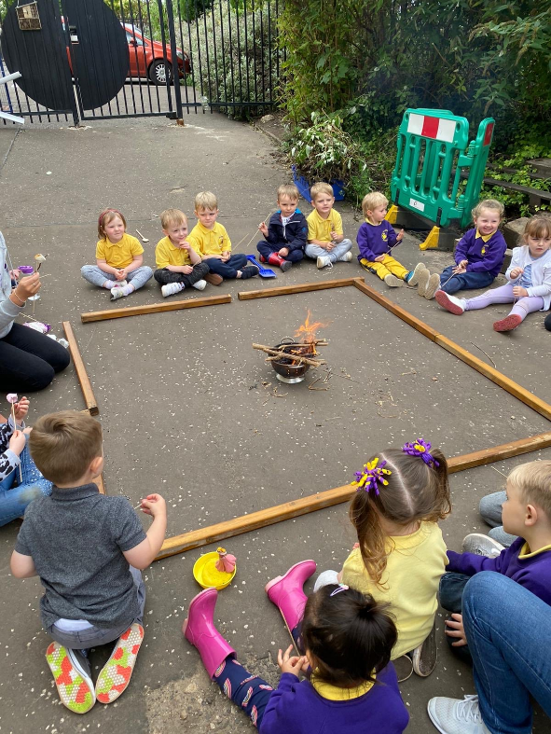

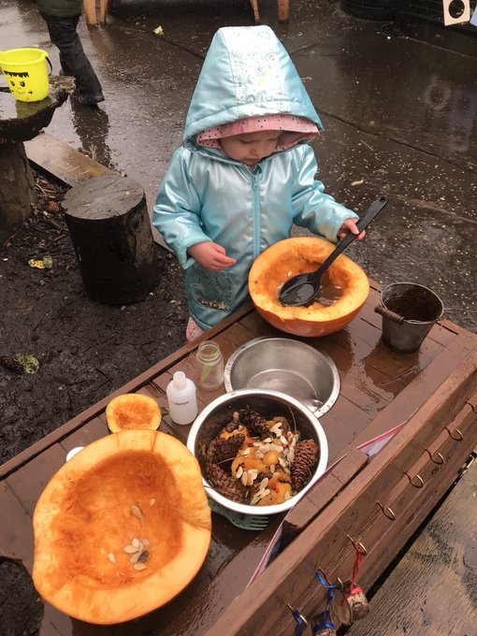
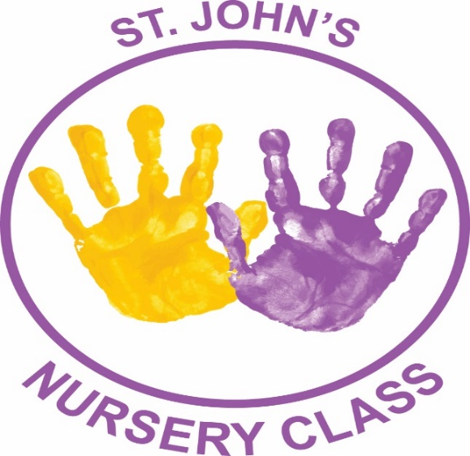
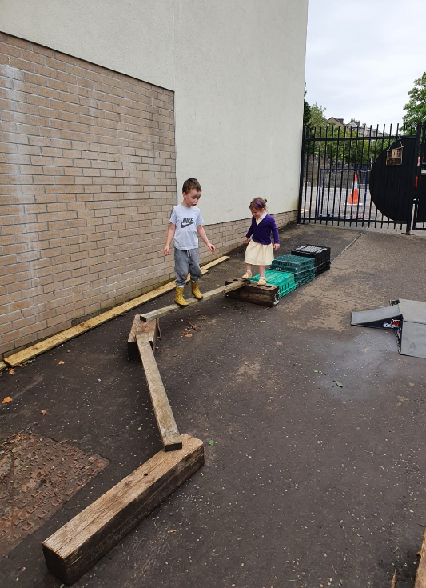

Breakfast Club

The School operates a Breakfast Club costing £1 per day. Pupils enjoy breakfast in a relaxed atmosphere promoting a healthy start to their day.

Pupils can attend the Breakfast Club, which is supervised by adults at the following times:

Monday: 8.00am – 8.45am
Tuesday: 8.00am – 8.45am
Wednesday: 8.00am – 8.45am
Thursday: 8.00am – 8.45am
Friday: 8.00am – 8.45am

At 8.45 am pupils will be escorted into the playground where they will be supervised till
9.00 am when they begin classes.

Enrolment
Inverclyde Council has changed the way in which children register for primary school. This process will now be undertaken by completing an online application form which can be found on the Inverclyde Council website at School Session 2026-2027 - Inverclyde Council
It’s vitally important that parents follow the online registration process to register their child for a Primary 1 place in an Inverclyde school.
Children who reach the age of five years between 1 March 2026 and 28 February 2027 are due to start Primary 1 at the beginning of the new school term in August 2026. Parents are asked to register their child in their chosen denominational or non-denominational catchment primary school, from Monday 5th January until Friday 9th January.
Once parents have completed the Primary 1 registration, they will have the choice to complete a placing request application to a school other than the catchment primary Inverclyde Council Online Forms (This includes Primary 1 Gaelic Medium education at Whinhill Primary School).
No documents will be required at this stage; however, we may have to contact you, should we require further information. Parents will be notified by 30 April 2026 confirming their child’s place in school.
Parent who do not have internet access to apply online are asked to contact their child’s current Early Years establishment for assistance.

DEFER ENTRY

A deferred entry application is also available to parents considering deferring their child’s entry to Primary 1 in August 2026. Defer entry applications for the school term starting August 2026 are open until 1 February 2026. To make an application you should have registered your child for Primary 1 between 5th – 9th January 2026 Inverclyde Council Online Forms. Parents will be advised of the outcome of their application no later than 30 April.

PLACING REQUEST

The Education Authority does not provide transport for those pupils in receipt of a placing request other than in exceptional circumstances. In the case of under age placing requests, if the child is offered a place in his/her catchment area school, transport will be provided in accordance with Council policy.

ARRANGEMENTS FOR PUPILS WITH ADDITIONAL SUPPORT NEEDS

Inverclyde Council has a policy on inclusion and equality which incorporates the assumption that all children will routinely be educated within their own community. Transitional arrangements for children with additional support needs, moving from nursery to primary or primary to secondary, are discussed at a child’s review meeting. Any child or young person with additional support needs who requires more specialist support will be discussed at Inverclyde’s Additional Support Needs Monitoring Forum. The Forum will make recommendations related to resources, support and necessary specialist placements.

PRE-SCHOOL PROGRAMME

This scheme is ongoing throughout the year. Children, parents and carers will have opportunities to join with our school community during the session.
Parents will receive a letter advising of the dates/times of these sessions.

The opportunity is always available for all prospective parents to visit and be shown round the school before any final decision is made.

TRANSFER FROM PRIMARY TO SECONDARY SCHOOL
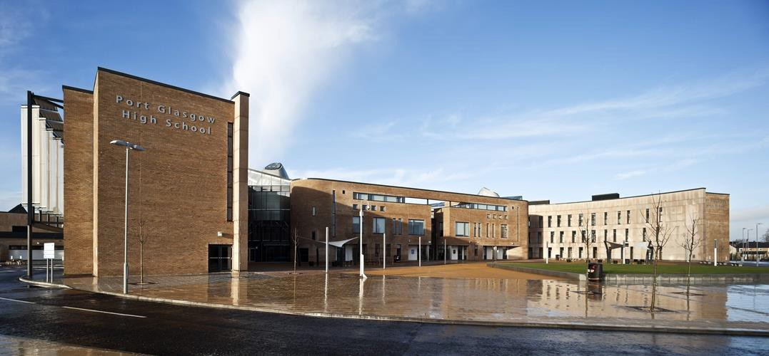

Pupils normally transfer to secondary school between the ages of 11½ and 12½ so that they will have the opportunity to complete at least four years of secondary education. Parents will be informed of the arrangements no later than December of year preceding the date of transfer at the start of the new session.

Pupils living within the catchment area normally transfer to St Stephen’s High School, Port Glasgow Community Campus, Kilmacolm Road, Port Glasgow – telephone 01475 715300.

During the session, Primary 7 participate in various aspects of the curriculum at St Stephen’s and St Stephen’s school staff also visit the children at St John’s during the year.

Mrs Jennifer McDonald, DHT of St Stephen’s, has responsibility for primary/ secondary liaison. She attends our twice yearly Parents’ Evenings for an informal chat or to discuss any concerns.

School Improvements

As a school it is important that we continually strive to improve everything we do. The school plans are monitored carefully to ensure that improvements are targeted to meet specific needs. Further details of identified improvement plans can be found in the School Improvement Plan. This document can be accessed via the schools website.

Improvement Plans are carefully monitored for impact. The Standards and Quality Report for the school indicates what progress we have made with the identified improvements. The Standards and Quality Report is also available on the school website.

A list of Local and National Policies are also available to view on the school and Council websites.

The School Website can be found at the following URL address:

https://blogs.glowscotland.org.uk/in/stjohns/

Concerns/Compliments

Positive and open relationships are important and key to us as a school and nursery. We are always keen to ensure that parents/carers are aware of how we would prefer to handle situations when things maybe haven’t gone as any of us would have liked.
Our initial hope is that we can resolve matters swiftly and informally. In the first instance, and where appropriate, we would ask that you contact the member of staff concerned. However, there may be occasions when the matter needs to be drawn to the attention of the principal teacher, Mrs Tipling. Please get in touch with her via the main office on 01475 715729 or through emailing office@st-johns.inverclyde.sch.uk
Thereafter, if a resolution is not reached then the matter can be raised with the Depute Headteacher, Miss McGachy, via the contact details above.
Ultimately, if you remain dissatisfied, please get in touch with me, Mrs Cannon, directly via the main office. I would hope that we would be able to resolve any concerns or complaints at school and nursery level, however if not, please refer to the council complaints process and contact Education Headquarters at: admin.educationhq@inverclyde.gov.uk : How to make a complaint - Inverclyde Council

Everyone likes compliments and schools are the same – if you have anything positive to say about the school, please do not hesitate to contact the Head Teacher.

Inverclyde Complaint Procedure
Inverclyde Council is committed to providing high quality customer services. We value complaints and use information from them to help us improve our services. If something goes wrong, or you are dissatisfied with our services, please tell us. Details can be found using the link below;

How to make a complaint - Inverclyde Council https://www.inverclyde.gov.uk/council-and-government/complaint

The Curriculum
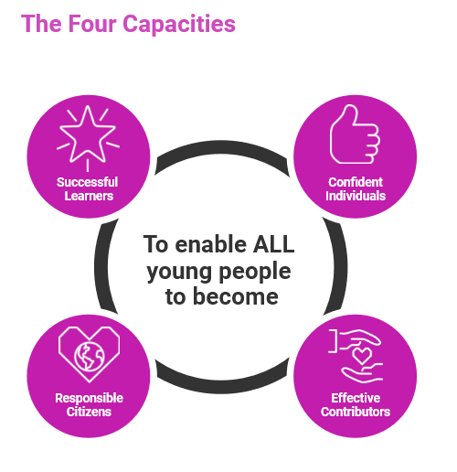
A curriculum framework for all Scottish educational establishments 3 - 18, called Curriculum for Excellence, will offer better educational outcomes for all young people and will provide more choices and more chances for those young people who need them.

The aims of Curriculum for Excellence are that every child and young person should:

- Know they are valued and will be supported to become a successful learner, an effective contributor, a confident individual and a responsible citizen;

- Experience a traditionally broad Scottish curriculum that develops skills for learning, skills for life and skills for work, with a sustained focus on literacy and numeracy, that encourages an active, healthy and environmentally sustainable lifestyle and builds an appreciation of Scotland and its place in the world.

The experiences and outcomes under Curriculum for Excellence are written at five levels, with progression to qualifications described under the senior phase.

Early Level - the pre-school years and P1, or later for some

First level - to the end of P4, but earlier for some

Second level – to the end of P7, but earlier for some

Third and Fourth – S1 to S3, but earlier for some

Senior phase - S4 to S6 and college or other means of study.

Staff in St John’s work closely with Local Authority Education Advisors to ensure “A Curriculum for Excellence” is successfully implemented.

Further information regarding CfE can be viewed on the Education Scotland Website at www.educationscotland.gov.uk

Literacy & English
This aspect of the curriculum is divided into 4 main areas:

- Listening & Talking
- Writing
- Reading

Listening & Talking: Our children are encouraged at the earliest opportunity to listen and concentrate, to take part in discussions and are given the opportunity on a regular basis to develop their skills in debating and reasoning through talk.

Writing: all children are taught Functional forms of written language e.g. letter writing, form filling and writing instructions. Children also develop Imaginative written language skills through poetry and story writing as well as further incorporating Personal writing, expressing their thoughts clearly and extending their communication. Handwriting, phonics, spelling, punctuation and grammar are taught regularly and systematically. Children are trained to appreciate the importance of accuracy and neatness in their written work. Children are provided opportunities to evaluate their own work as well as the work of others through self and peer assessment.

Reading: The curriculum is supported by the use of Bug Club Reading scheme which is used to further develop comprehension and understanding of the written word in a variety of contexts. Novel studies also supplement pupils’ experience of reading and enhances their vocabulary. Great emphasis is placed on the enjoyment gained through reading.

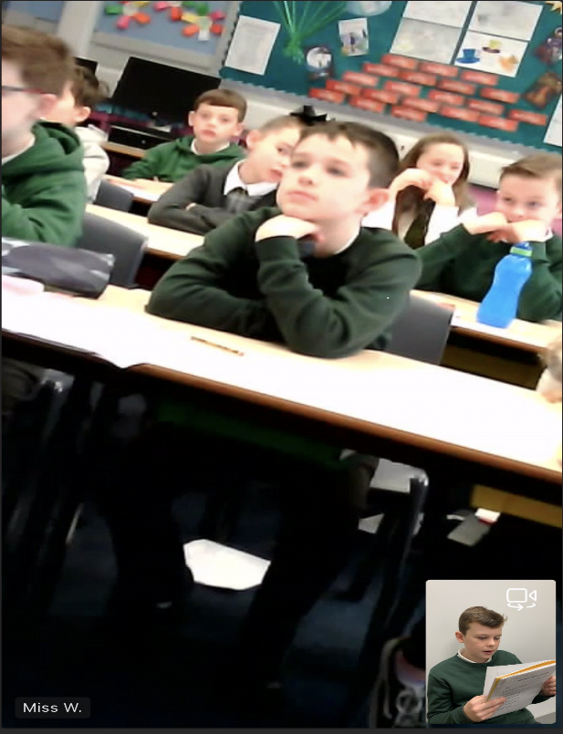
Main Resources:

Reading P1 – P3 Bug Club.
Language Programme – North Lanarkshire Active Literacy Programme
NL Writing /Big Write P1 – P7 – Whole school writing programme

Appropriate use will be made of the school’s many resources to help the child practice their skills and so become competent and confident to use them in all walks of life. The learning programmes will be tailored to suit your child’s needs.

Modern Language Training: Pupils will engage with French from Primary 1 through to Primary 7 in line with National Guidelines as we proceed with the implementation of the Languages 1 + 2 approach. The upper school also engage with Spanish.

Presenting our Writing!

PARENTZONE SCOTLAND

Parentzone Scotland is a unique website for parents and carers in Scotland, from early years to beyond school. The website provides up-to-date information about learning in Scotland, and practical advice and ideas to support children’s learning at home in literacy, numeracy, health and wellbeing and science. Information is also available on Parentzone Scotland regarding additional support needs, how parents can get involved in their child’s school and education.

Parentzone Scotland also has details about schools, including performance data for school leavers from S4-S6 and links to the national, local authority and school level data on the achievement of Curriculum for Excellence levels.

READ, WRITE, COUNT

Read, Write, Count with the First Minister is a programme that aims to support parental engagement in literacy and numeracy. Gift bags are distributed annually to all Primary 2 and Primary 3 pupils in Scotland by Scottish Book Trust. The gift bags contain literacy and numeracy materials to support children’s learning, as well as advice and support to parents.

Studies show a direct link between a strong family learning environment and progress in reading, writing and counting. In addition to the activity booklet included in the bag Scottish Book Trust offers a range of hints, tips and advice to help parents engage in their child’s learning on the website.

BOOKBUG

Bookbug is Scotland’s universal early years book gifting programme and aims to inspire a love of stories, songs and rhymes from birth. Bookbug gives every child in Scotland four free bags of books as babies, toddlers, three and five year olds. The bags contain books and other resources for sharing songs and rhymes that are suited to their age. Gaelic Bookbug Bags are also available.

The Bookbug Explorer Bag is gifted to all 3 year olds at their childcare setting. It includes three lovely books, an activity book, pencils, and postcards to encourage mark making.
‘The Bookbug Primary 1 Family Bag encourages families to share books and activities to inspire a lifelong love of reading, writing and counting. These are gifted during Book Week Scotland in November every year!’

Check out the website for booklists, book sharing videos, activity ideas and much more.

Numeracy & Mathematics
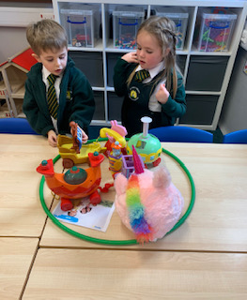
The school policy is to develop mathematical skills and concepts, and to apply them practically and mentally through a programme of structured experiences.

Your child will experience a wide range of mathematical topics:

- Problem Solving and Enquiry.
- Number, Money and Measurement.
- Information Handling.
- Shape, Position and Movement.

It is in these topics and through these topics that the school will foster an enquiring attitude and engender an enjoyment of the subject. An integral part of the programme is the transference of skills into real-life situations and also integration of other curricular areas.

The use of the Interactive Smartboard resources ensures engagement and enthusiasm, leading to enjoyment and a better understanding of the key concepts and skills. Active learning at all stages extends Mathematics in realistic contexts.

The development of our pupils’ knowledge and understanding is further enhanced by integrating it, where appropriate, within other relevant areas of the curriculum.

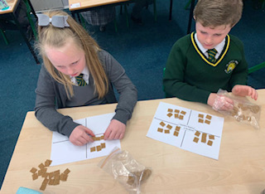

Social Studies
Through social studies, children and young people develop their understanding of the world by learning about other people and their values, in different times, places and circumstances; they also develop their understanding of their environment and of how it has been shaped.

As they mature, children and young people’s experiences will be broadened using Scottish, British, European and wider contexts for learning, while maintaining a focus on the historical, social, geographic, economic and political changes that have shaped Scotland. Children and young people learn about human achievements and about how to make sense of changes in society, of conflicts and of environmental issues. With greater understanding comes the opportunity and ability to influence events by exercising informed and responsible citizenship.

Children and young people as they participate in experiences and outcomes in social studies will:

- develop their understanding of the history, heritage and culture of Scotland, and an appreciation of their local and national heritage within the world
- broaden their understanding of the world by learning about human activities and achievements in the past and present
- develop their understanding of their own values, beliefs and cultures and those of others
- develop an understanding of the principles of democracy and citizenship through experience of critical and independent thinking
- explore and evaluate different types of sources and evidence
- learn how to locate, explore and link periods, people and events in time and place
- learn how to locate, explore and link features and places locally and further afield
- engage in activities which encourage enterprising attitudes
- develop an understanding of concepts that encourage enterprise and influence business
- be encouraged to plan and lead aspects of learning

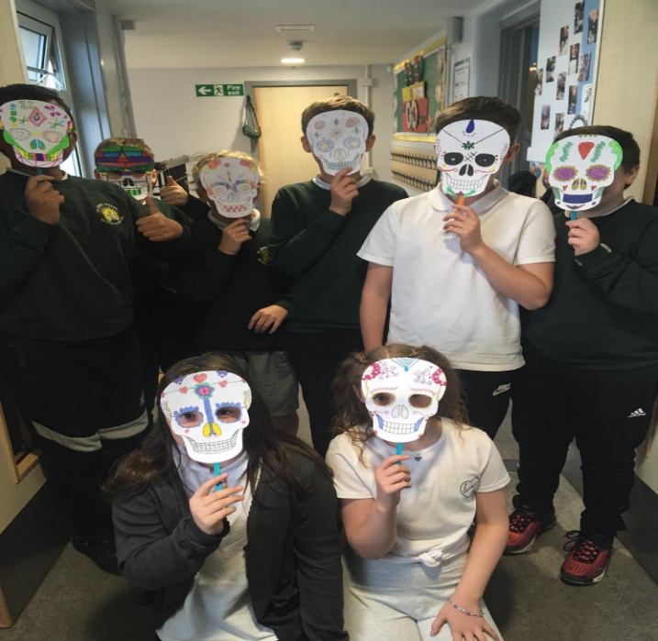
Children also develop research skills as they are regularly provided opportunities to work collaboratively and cooperatively. The children present their findings in a variety of ways and to a variety of audiences.

Children will have their learning enriched through participation on educational visits both locally and further afield.

We also like to involve partner agencies and members of the community by inviting them into the school to work with pupils.

If any parent/carer has a particular skill that can be shared with the children, then we would be delighted to hear from you!

P7 – Dia de los Muertos
Health & Wellbeing
Health & Wellbeing includes experiences and outcomes for personal & social development, understanding of health, physical education and physical activity, and elements of home economics.
Physical education is a regular part of the school curriculum encouraging the children to express themselves through movement, gymnastics, games and sporting activities. The pupils in St. John’s Primary have 2 hours of quality physical education per week, in line with current legislation.

The Health programme contributes greatly to the promotion of a healthy lifestyle for all.

Learning through health & wellbeing promotes confidence, independent thinking and positive attitudes and dispositions. Health and wellbeing also includes sensitive aspects of learning such as: relationships, sexual health and drugs awareness. Parents/Carers will be informed via school newsletters when these aspects of sensitive learning will be taking place.
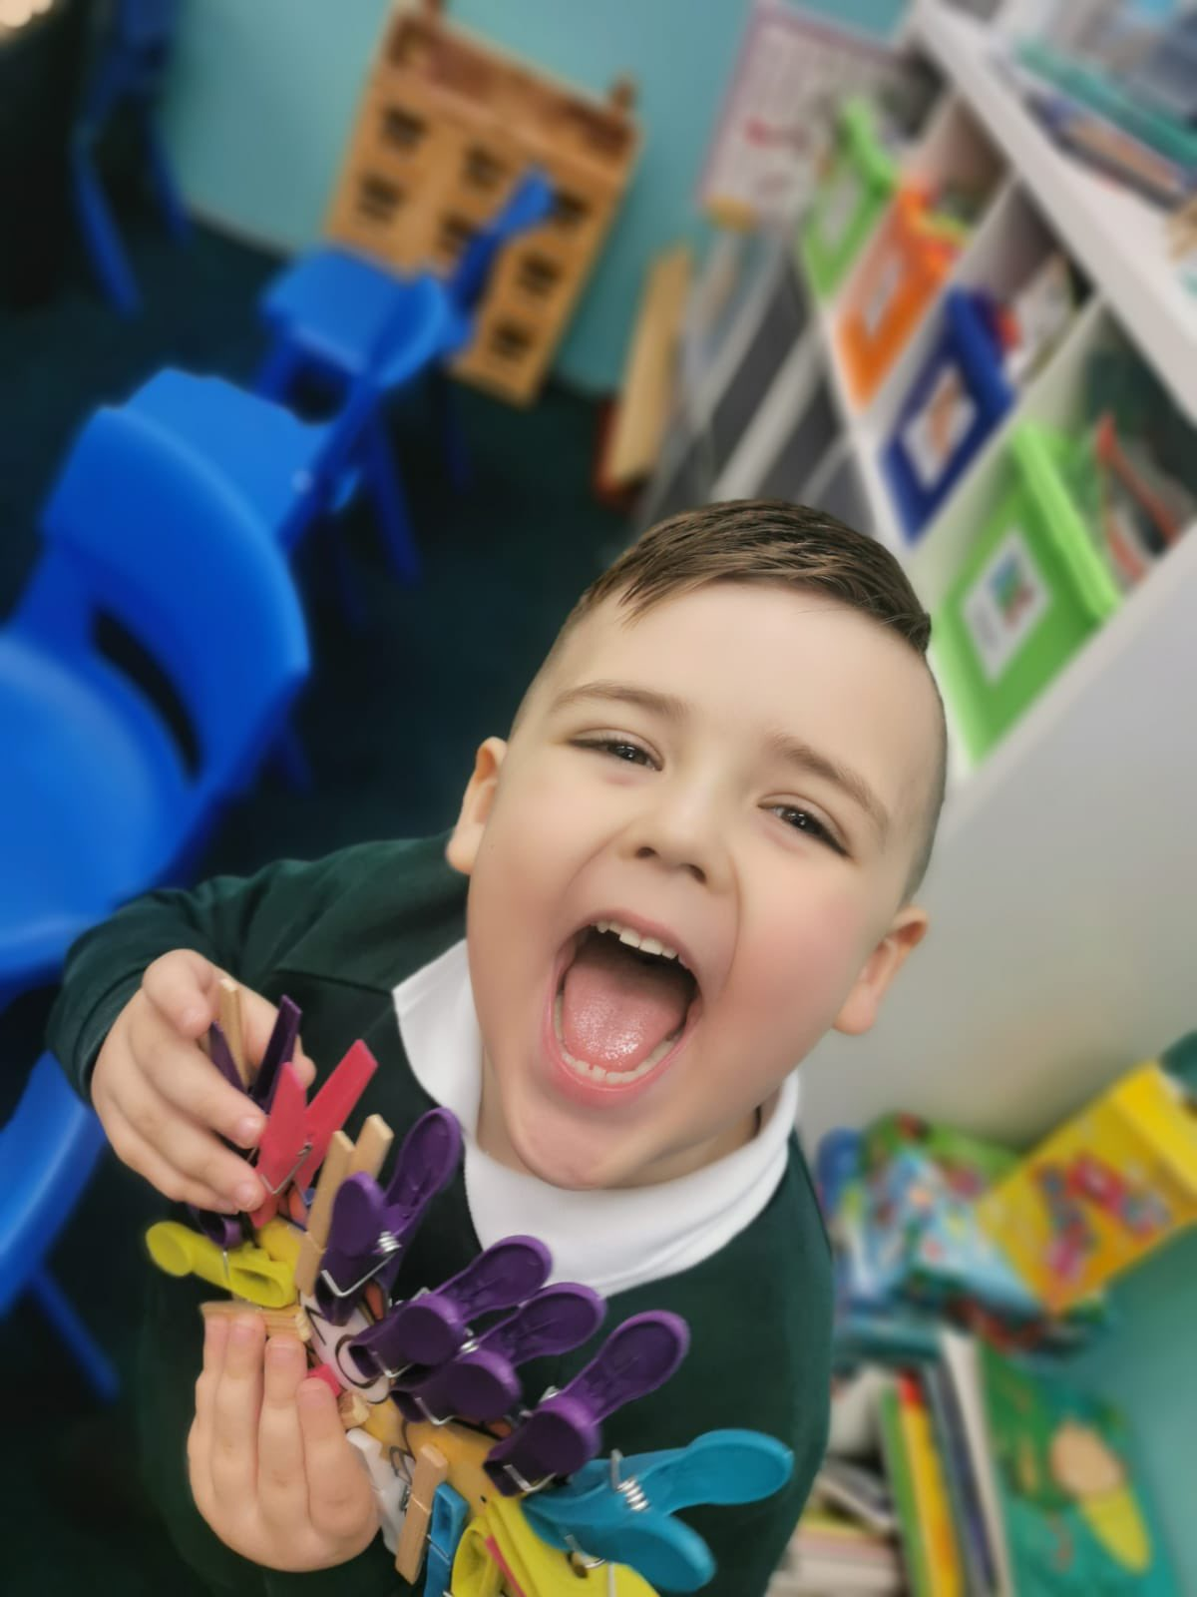

Science

Science is an important part of our heritage and we use its applications every day in our lives at work, at leisure and in the home. Science and the application of science are central to our economic future and to our health and wellbeing as individuals and as a society.

Scotland has a long tradition of scientific discovery, of innovation in the application of scientific discovery, and of the application of science in the protection and enhancement of the natural and built environment. Children and young people are fascinated by new discoveries and technologies and become increasingly aware of, and passionate about, the impact of science on their own health and wellbeing, the health of society and the health of the environment.

Through learning in the sciences, children and young people develop their interest in, and understanding of, the living, material and physical world. They engage in a wide range of collaborative investigative tasks, which allows them to develop important skills to become creative, inventive and enterprising adults in a world where the skills and knowledge of the sciences are needed across all sectors of the economy.

The key concepts have been clearly identified using five organisers:

- Planet Earth
- Forces, electricity and waves
- Biological systems
- Materials
- Topical science

Technologies

Learning in the technologies enables children and young people to be informed, skilled, thoughtful, adaptable and enterprising citizens, and to:

- develop understanding of the role and impact of technologies in changing and influencing societies
- contribute to building a better world by taking responsible ethical actions to improve their lives, the lives of others and the environment
- gain the skills and confidence to embrace and use technologies now and in the future, at home, at work and in the wider community
- become informed consumers and producers who have an appreciation of the merits and impacts of products and services
- be capable of making reasoned choices relating to the environment, to sustainable development and to ethical, economic and cultural issues
- broaden their understanding of the role that information and communications technology (ICT) has in Scotland and in the global community
- broaden their understanding of the applications and concepts behind technological thinking, including the nature of engineering and the links between the technologies and the science

In St John’s we have interactive whiteboards in all of the classrooms and laptops available to support the teaching of ICT Skills. The pupils are actively involved in learning through this stimulating educational resource.
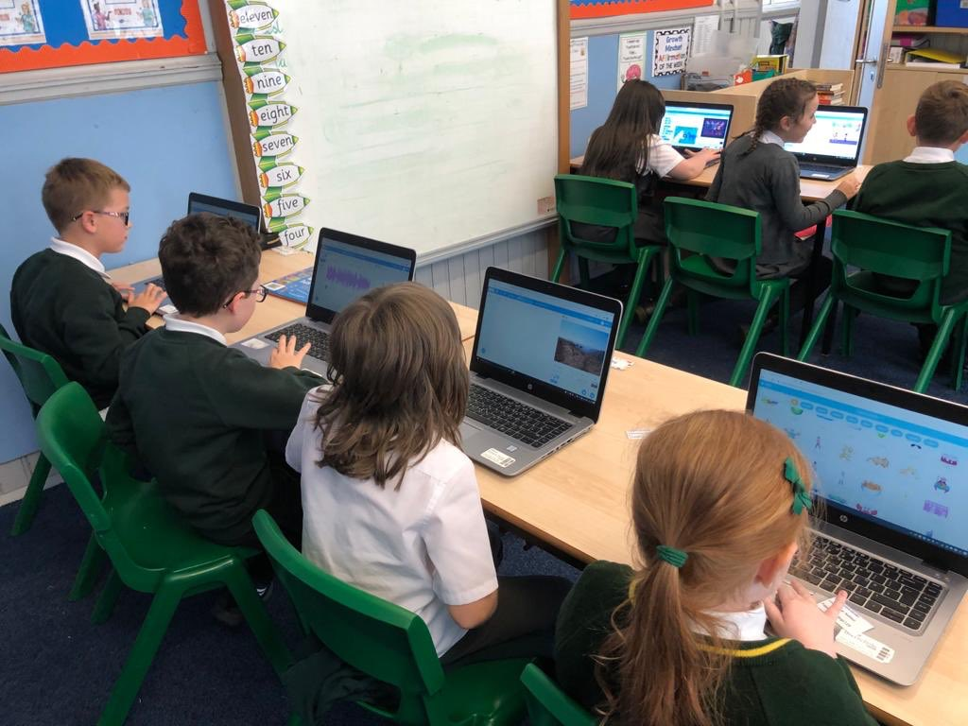
Expressive Arts

Expressive Arts consist of elements of the following:

- Art and Design
- Music
- Drama
- Dance

In Art and Design, the children will be given the opportunity to work with a variety of materials, encouraging creativity and self-expression. Music should essentially be an enjoyable experience wherein the child will sing and have the opportunity to make music. The playing of instruments is a feature of the upper part of the school. Drama is seen as valuable in that it allows for the input of the child’s own personal resources which are put to use imaginatively. It involves the interaction of speech and movement. Dance is incorporated through Drama and Physical Activity.

Many of our children have particular gifts or talents in these areas and in St John’s Primary we provide opportunities for our pupils to showcase their talents. We celebrate their achievements in many ways.

We are fortunate to have visiting specialists who support and enhance the learning opportunities for both pupils and staff.
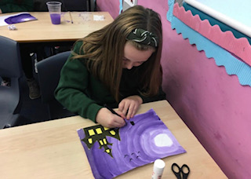
We love to be creative!
Religious & Moral Education

In accordance with the wishes of the Diocese of Paisley, we use the This Is Our Faith Religious Education Programme, which covers doctrine, study of the Old and New Testament, the importance of prayers and hymns, the preparation for, and the reception of the Sacraments, God’s love for mankind, the relevance of His presence in our lives, how it should affect our service to Him and to others as members of His family.

Imparting the knowledge of our faith is only one aspect of religious education and we are dependent on parents to ensure that their children have the opportunity, encouragement and, most of all, the example they need to practice their faith and observe God’s laws.

The Curriculum in Roman Catholic Schools builds on the openness of Catholic Schools to other young people regardless of denominations and faiths.

Learning through religious education enables children and young people to:

- develop their knowledge and deepen their understanding of the Catholic faith
- investigate and understand the relevance of the Catholic faith to questions about truth and the meaning of life
- highlight, develop and foster the values, attitudes and practices which are compatible with a positive response to the invitation to faith
- develop the skills of reflection, discernment, critical thinking, and deciding how to act in accordance with an informed conscience when making moral decisions
- nurture the prayer life of the individual and of the school community
- understand and appreciate significant aspects of other Christian traditions and major world religions
- make a positive difference to themselves and the world by putting their beliefs and values into action.

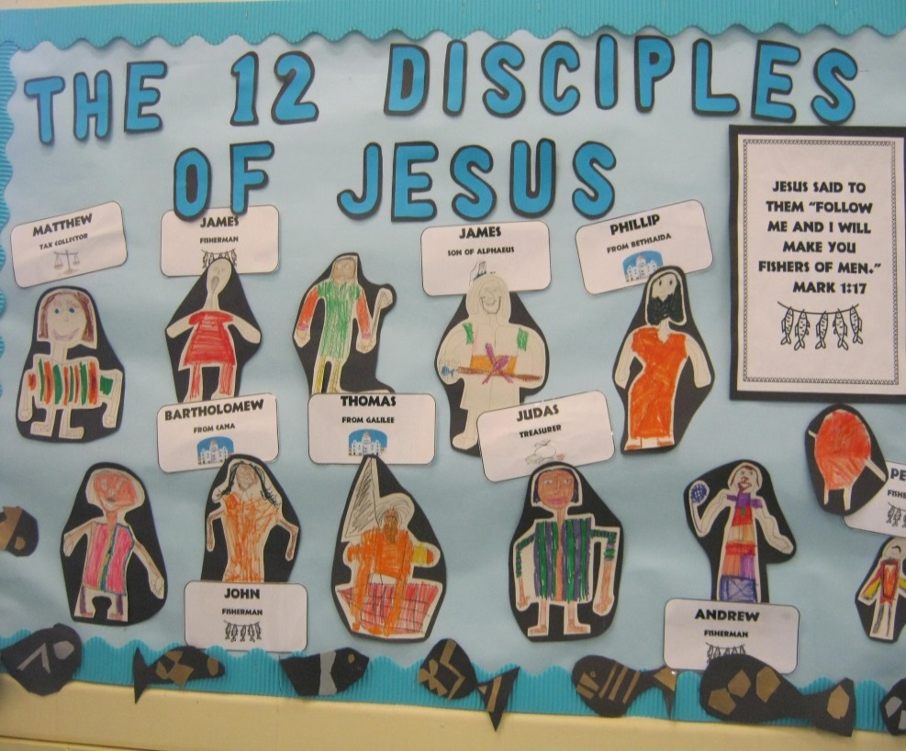
In addition to developing their understanding of the Catholic faith, children and young people will also learn respect for, and understanding of, other Christian traditions. They will also come to an appreciation of significant aspects of major world religions, recognising and respecting the sincere search for truth which takes place in other faiths. Where appropriate they will learn similarly about stances for living which are independent of religious belief.

The process of learning in religious education in the Catholic school can be seen as a journey of faith, a quest for personal growth and response within the community of
faith.
This Is Our Faith

Religious Observance in Catholic Schools

The Education (Scotland) Act 1980 imposes a statutory duty on local authorities to provide “Religious Observance” in Scottish Schools. This is defined in a national R.O. Review Group report published in 2004 as comprising: “community acts which aim to promote the spiritual development of all members of the school’s community and express and celebrate the shared values of the school community”.

In a letter of guidance by the Scottish Government in February 2011, it is acknowledged that Catholic schools take a distinctive approach to the provision of Religious Observance:

Scottish Government Ministers welcome the tradition that, in Roman Catholic denominational schools, Catholic Liturgy will largely shape the nature and frequency of religious observance activities in the classroom and in the wider school community. So, at times, children and young people will be invited to participate in, and sometimes to lead prayer and reflection in classrooms and at assemblies. At other times, to honour particular occasions or feasts, chaplains will lead school communities in the celebration of Mass and other forms of liturgical celebration.

Catholic schools follow the customs and practices of the Church in order to nourish the spirituality and faith of pupils and staff. Our Catholic tradition is enriched by ancient rites, prayers and devotions which help young people to become aware of, and show reverence to, the sacred presence of the living God, Father, Son and Holy Spirit. Guided by this tradition, we celebrate various seasons and special feast days to honour God, Mary his Mother and the Saints.

Pupils are invited to pray with their teachers at times in classrooms and assemblies, as well as in liturgical services. Usually a classroom will display a Crucifix on the wall; in some classrooms and other areas of the school, a sacred space will feature a copy of the Bible and will be decorated with signs and symbols that reflect the changing seasons of the Church Calendar Year i.e., Advent, Christmas, Lent, Easter and Pentecost.

This regular practice of Prayer is complemented by religious services conducted, sometimes as part of an Assembly, to mark special occasions e.g., the distribution of Ashes on Ash Wednesday, the seasons of Advent or Lent. To mark special Feast Days and Holy Days of Obligation, Holy Mass will be celebrated by the school chaplain, with the school community, in school buildings or in local parishes. Some pupils, at certain stages, may be able to participate in retreats and pilgrimages to places of special significance within the Catholic tradition.

While Religious Education is governed by separate Church guidance, it is complemented by Religious Observance practices and, together, these experiences help pupils to develop their understanding of the Catholic faith, to experience opportunities for spiritual growth and to commit to beliefs, values and actions in a positive response to God’s invitation to faith.

In terms of pupil participation in R.O. Scottish Government guidance makes it clear that it makes an important contribution to pupils’ development and that it promotes the ethos of a school by bringing pupils together and creating a sense of community. However, it also makes clear that parents have the right to withdraw children from participation in religious observance and that this right should always be made known to parents and their wishes respected. The Scottish Government also recognizes that:

Where a parent chooses a denominational school for their child’s education, they choose to opt in to the school’s ethos and practice which is imbued with religious faith and religious observance. In denominational schools, it is therefore more difficult to extricate a pupil from all experiences which are influenced by the school’s faith character.

Assessment and Reporting

Staff in St John’s implement strategies aimed at improving assessment through ensuring better feedback for pupils, parents and professionals leading to improved achievement.

The school has a system of on-going assessment whereby the teacher exercises and records professional judgement in gauging how well each child is progressing. There are effective quality assurance procedures in place to ensure quality learning and teaching supports pupil progress.

At the beginning of the year, you will be invited to meet the teacher and find out more about the year ahead. At the start of Term 2, 3 and 4, a class newsletter will be shared with you to let you know what learning will take place that term. There will be an opportunity to visit the class at our open doors early in the year. You can also meet teachers formally at our Pupils’ Progress Evenings, once in October and once in March. You will receive an end of year report in June. For various reasons, there may be a need to meet more often. This will be arranged in plenty of time.

Of course parents are welcome at any time to discuss their child. (Making an appointment ensures that someone will be available).

Homework

In line with our current homework policy, children are expected to complete homework regularly. The majority of homework tasks will consist of spelling, reading and maths work which will act as reinforcement and consolidation of the work currently being done in class.

Homework for other curricular areas would be set as and when appropriate to class work. Homework should not exceed 15/20 minutes per night. Homework will be given out on a Monday to complete for the week with a return to school on a Friday. They should help families organise their week.

The importance of parental involvement with homework cannot be overstated. It has been proven to help a child’s progress and encourage a positive, enthusiastic attitude.
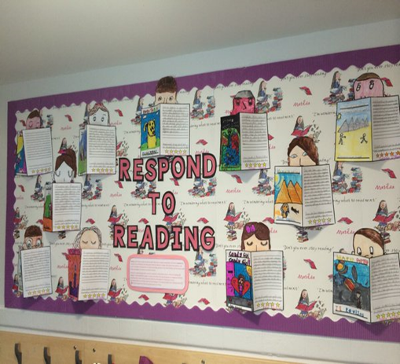

Independent Learning Homework Task

Additional Support Needs

All children and young people need support to help them learn. The main sources of support in early years and in schools are the staff who, through their normal practice, are able to meet a diverse range of needs. With good quality teaching and learning and an appropriate curriculum most children and young people are able to benefit appropriately from education without the need for additional support.

Every teacher has a responsibility to support the learning of all pupils in their class. The type of support offered will vary according to the needs of pupils. This includes consideration given to children who have a disability, children with social, emotional and behavioural difficulties, children with learning difficulties of a specific or general nature, children who are exceptionally able, those who demonstrate underachievement relating to gender issues, children whose learning has been interrupted through absence or illness, bilingual children who have English as an additional language, travelling children whose family circumstances impact on attendance and learning.

If your child experiences any barriers to learning, whether short or longer-term (for example because of health, bereavement, bullying, sensory impairment or communication problems), they may require additional support at times of transition. In these instances, the school and local authority must assess the extent of their support needs and prepare a plan to help ease that transition especially major transitions.

A child or young person’s needs are identified at the earliest possible stage and can be met in a number of ways, for example by adaptations to the curriculum or learning environment, as well as input from the Support for Learning Teacher and on occasion support from visiting specialists. The appropriateness of the support is determined through a process of assessment, planning and monitoring, working jointly with parents and carers, and is regularly reviewed.

We also have a Nurture Room led by a Nurture Teacher supporting pupils in an environment that meets their emotional and social wellbeing while at the same time raises attainment.

Learning outcomes for children and young people with additional support needs are set out in a plan and all educational establishments hold regular review meetings with parents and carers to determine needs and the most appropriate supports. Everyone’s views are equally important in order to consider what is currently working and how to determine next steps.

Children and young person’s needs are identified in a number of ways, and the process of assessment is an ongoing, shared process with partnerships with parents and carers at the forefront. On some occasions health service staff or other partner agencies make children known to Education Services. Other additional support needs may be notified to Education Services by parents themselves or identified by one of a range of staff working closely with the child.

Some children and young people will have additional support needs arising from complex or multiple factors which require a high degree of co-ordination of support from both education and other agencies in order that their needs can be met. In these cases, the school will hold a meeting to decide whether the child or young person meets the criteria for a coordinated support plan.

The coordinated support plan is a statutory document which ensures regular monitoring and review for those children and young people who have one.
You have the right to ask the education authority to establish whether your child needs a coordinated support plan. Your child can make this request themselves, if they are aged 16 or over. You and your child, if they want to, will attend a meeting with staff at their school. Other professionals from different agencies who may be involved in providing support for your child will also attend. If your child does not want to attend meetings or feels unable to, their views must still be sought and considered.

Inverclyde’s mediation service can be accessed by contacting Tony McEwan, Head of Culture, Communities & Educational Resources at the address below:

The officer or officers of the authority from whom parents of children having additional support needs, and young persons having such needs, can obtain advice and further information about provision for such needs.

For further advice please telephone 01475 712850

Or write to;
Education Services
Wallace Place
Greenock
PA15 1JB

If a parent considers that his or her child has additional support needs and wishes to make enquiries on this they should contact the head teacher.

Parents may find the following websites useful:

Children in Scotland: Working for Children and Their Families, trading as “Enquire – the Scottish advice and information service for additional support for learning”, a charitable body registered in Scotland under registration number SC003527;

Scottish Independent Advocacy Alliance, a charitable body registered in Scotland under registration number SC033576; and

Scottish Child Law Centre, a charitable body registered in Scotland under registration number SC012741.

www.enquire.org.uk
www.siaa.org.uk
www.sclc.org.uk

Equal Opportunities

‘Inverclyde Education Service is committed to ensuring that no children or members of staff or service users receive less favourable treatment on any ground including gender, race, disability, age, sexual orientation, religion or belief. We have a moral, social and legal obligation to mainstream and put equality at the heart of everything we do. We aim to promote a culture in which equality of opportunity exists for all. We are opposed to all forms of discrimination, direct or indirect, and aim to eliminate all discriminatory practices. We will ensure that, in our schools and other educational establishments, equality permeates the curriculum and underpins all our policies and practices in terms of access to education. We must ensure that all our children achieve their full potential to develop physically, emotionally and academically. Finally, we believe that equality and inclusion should be a given right, where everyone is valued and treated with respect.’

Inclusion and Equalities

Inverclyde Council Education Service aims to:

- Offer education of the highest quality to all young people within a developing culture of inclusion
- Endorse the principles of inclusion, entitlement and equality of opportunity in the development of best practice
- Value the diversity of interests, qualities and abilities of every learner
- Believe that every child and young person is entitled to educational opportunities which enable the achievement of success and further development of the individual’s learning potential within the least restrictive environment
- Affirm the right of all young people to have access to the highest quality of educational provision which is appropriate to learning needs, is supportive of the young person and is delivered in partnership with young people, parents and the wider community
- In meeting the needs of all of our pupils we will demonstrate no discrimination on the basis of race, gender, disability, sexual orientation, religion or belief. This encompasses curricular, extra-curricular and classroom activities and is foremost in the attitudes which we develop in our pupils.

Child Protection

Inverclyde Council Education Services has Child Protection Guidelines and Procedures which all schools and establishments are required to follow. Education Services work very closely with other agencies namely Strathclyde Police, Social Work Services, NHS Greater Glasgow and Clyde and the Children’s Reporter to support children. Common responsibilities of all staff are to protect children from abuse and exploitation, to respond appropriately when abuse is identified, and to ensure whenever possible that all children are able to exercise their right to be raised in a warm, stimulating and safe environment with the support of staff, their families and carers.

“Getting it Right for Every Child (GIRFEC) is the new model framework set out by the Scottish Government to ensure we put the child at the center of our practice.”

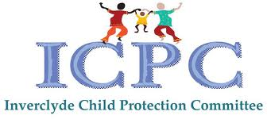

Home/School Links

The aim of the school is to provide an environment where teachers and pupils work together to create a secure, happy and disciplined atmosphere. It is important to encourage and foster supportive parental attitudes and interests, where the parents and the school work in harmony towards agreed objectives the children will achieve. To facilitate these links there are a number of strategies; parents may call the school anytime to make an appointment to have an informal discussion about their child; open evenings are held when parents are welcome to visit the school and their child’s teacher; parents assist with class events/outings; frequent letters are dispatched, keeping parents up-to-date with events affecting their child; there are strong and friendly links between the school and the Parent Council.

Information is also available on the school website at http://www.st-johns.inverclyde.sch.uk Parents are essential partners in their child’s schooling.

School / Community Links

The school is an important part of the community. Pupils are taken to various local attractions and to meet local people and these reinforce the work done in the school. Visitors from the local community are welcome in the school and often enhance the work done by the children in the classroom. Various charities and appeals are supported throughout the year. We regularly work with SCIAF, Missio and St Vincent de Paul charities to support vulnerable families. We also work closely with local libraries, Enterprise Centre, Eco Schools and local businesses as well as the Community Learning & Development Team.

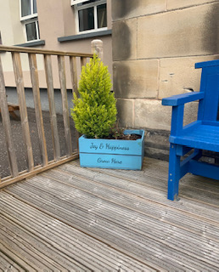

Supporting our families
Transitions

Transitions are the moves children and young people make from home to nursery, nursery to primary, stage to stage, from primary to secondary, between schools and from secondary to further education and beyond.

Transitions and changes are part of everyone’s life. The vast majority of children and young people look forward to moving on. However transitions can be challenging and support from parents and school staff can help the transitions go more smoothly.

What Can Parents do?
It helps children and young people at all transitions if parents:
- talk with them about what is going to happen
- encourage them to ask questions
- encourage them to talk about any enrolments they may have
- listen carefully to their concerns and consider sharing them with other relevant people
- help them to become familiar with the new setting and what will be expected of them

Pre-School Transition
Your child’s pre-school experience is very valuable and must be considered when planning ahead for primary one. Therefore, we have fostered very strong links with all our associated pre-school agencies. The pre-school programme is continuous and mutually beneficial to parents, staff and of course your child.

Throughout the year staff from St. John’s and the associated Pre-5 establishments meet to discuss various issues in a Pre-5/primary forum. This endeavours to achieve continuity in experience from pre-school to P1.

Pre-5 staff will visit P1 throughout the year and P1 staff will visit the nursery children at various times.
In June both yourselves and the children are invited to visit again to meet the class teacher and discuss many necessary issues. When your child starts school you are welcome to visit at any time to see the progress they are making. Formal workshops focusing on mathematics and language will enable you to participate in your child’s learning and support them effectively.

Transfer from Primary to Secondary
Pupils are normally transferred between the ages of 11½ and 12½ years, so that they will have the opportunity to complete at least four years secondary education. Parents will be informed of the arrangements no later than December of the year proceeding the date of transfer at the start of a new session.

Parents should be advised that if they wish their child to transfer to this school they must live within the catchment area otherwise a placing request must be submitted.

Associated Secondary School: St Stephen’s High School
Port Glasgow Community Campus
Kilmacolm Road
Port Glasgow
PA14 6PP
Tel: 715300

Attendance at School

Parents should inform the school by telephone or text on the first morning of an absence and provide a reason for the pupil’s absence. (Text Number - 07860004806) The school will contact the pupil’s family and thereafter other emergency contacts if no explanation is given for the pupil’s absence. This contact will be made before 10.00 am on the first morning of an absence and early after the restart after lunch in the case of an afternoon absence. On return to school parents should provide a note explaining the reasons for absence.

Other agencies may be contacted if no contact with the pupil’s family can be achieved and if there are continuing or emerging concerns about a pupil’s safety and wellbeing.

Parents should keep the school informed of any changes of address or telephone numbers, both their own and those of the emergency contacts.

Section 30 of the 1980 Education Act lays a duty on every parent of a child of ‘school age’ to ensure that their child attends school regularly. Attendance must be recorded twice a day, morning and afternoon.

Regulation 7 of The Education (School and Placing information) (Scotland) amendment, etc Regulations 1993 requires each child’s absence from school to be recorded in the school register as authorised: i.e. approved by the authority and unauthorised: i.e. unexplained by the parent (truancy) or temporarily excluded from school.

The Scottish Government has provided guidance on the management of attendance and absence in Scottish schools in its publication Included, Engaged and Involved – part 1: Attendance in Scottish Schools. Every effort should be made to avoid family holidays during term time as this both disrupts the child’s education and reduces learning time. It has been clarified that family holidays should not be recorded as authorised absence, except in exceptional domestic circumstances, where a family needs time together to recover from distress, or where a parent’s employment is of a nature where school-holiday leave cannot be accommodated (e.g. armed services or emergency services).
It is for local authorities and schools to judge when these circumstances apply and authorise absence, accordingly.

The categorisation of most term-time holidays as unauthorised absence has been a contentious issue for some families, many of whom are concerned at the higher cost of holidays during school holiday periods. The Scottish Government has no control over the pricing decisions of holiday companies or flight operators. Our main focus is to encourage parents and pupils to recognise the value of learning and the pitfalls of disrupting learning for the pupil, the rest of the class and the teacher.

Clearly where an absence occurs with no explanation from the parent, the absence is unauthorised.

Schools investigate unexplained absence, and Education Services has the power to write to, interview or prosecute parents, or to refer pupils to the Children’s Reporter, if necessary.

It cannot be over-emphasised that when children are required to attend a clinic, a dentist, a doctor or a hospital during the school day, it is the parent’s duty to collect the child as he/she will not be permitted to leave school unaccompanied.

Absence rates are calculated as a percentage of the total number of possible attendance for all pupils in the school in the stage shown, each morning and afternoon of each school day being a separate possible attendance.

Children Absent from School through Ill-health

Young people of school age may be unable to attend school for a wide range of reasons including illness, accidents or long term medical conditions. In general there will be an automatic referral by the school for education out with school after 15 days of continuous or 20 working days of intermittent absence, within a single session, for verifiable medical reasons.

Medical & Health Care

During the course of a child’s first year at primary school, he/she will be seen by the School Health Service. During the years that follow, there are routine hygiene examinations, sight and hearing tests and dental inspections. At certain ages in the child’s school life, injections are given. At no time would this be done without a parent’s prior written permission. Visits to the school clinic for the treatment of eye, ear, teeth and skin problems can be arranged.

On enrolment to school the following information is requested for school records: Name and address of family doctor, the name and telephone number of two emergency contacts and some medical information concerning the child. This is updated annually and enables action to be taken immediately if a child becomes ill or has an accident at school.

Information in Emergencies

We make every effort to maintain a full educational service, but on some occasions circumstances arise which lead to disruption. Schools may be affected by, for example, severe weather, temporary interruption of transport, power failures or difficulties of fuel supply. In such cases we shall do all we can to let you know about details of closures and reopening. We shall keep you in touch by using letters, e-mails, TWITTER, texts, notices in local shops and community centres, announcements in local churches and announcements in the press and on local radio. In the event of an emergency the school will implement the emergency action plan as per council guidelines.

Positive Relationships

“Curriculum for Excellence cannot be delivered without good relationships and positive behaviour. Children and young people should feel happy, safe, respected and included in the learning environment and all staff should be proactive in promoting positive behavior in the classroom, playground and wider learning community. (Underpinning this is the emotional health and wellbeing of staff).” Curriculum for Excellence

The development of a positive learning environment is essential if effective learning and teaching is to take place within St John’s Primary. Effective learning and teaching is also dependent on the nurturing of positive relationships through the daily interactions between staff and learners and between learners themselves.

The Positive Relationships Policy is based on three approaches – Preventative, Partnerships and being Responsive. When children and young people are nurtured, guided and encouraged, they learn to behave appropriately and in a variety of social and educational settings and develop positive relationships.

Relationships lie at the heart of the learning process and are fundamental to improving outcomes for all our young children and young people.

From P1 – P7 we want children to have a positive regard for self and others, to develop life skills to enable them to participate effectively and safely in society and take increasing responsibility for their own lives.

Children are made aware of the need for rules and the importance of keeping them. Each teacher supported by the management team is responsible for the discipline within his/her own class and follows the strategies outlined within the discipline policy.

Bullying is dealt with swiftly and effectively with support for both the bullied child and the bullying child. Children are made explicitly aware of how to deal with bullying through the use of Bully proofing Our School at assemblies and we have a separate policy on bullying. We rely on the co-operation of parents who can obtain a copy of the full Relationships Policy from the school on request.

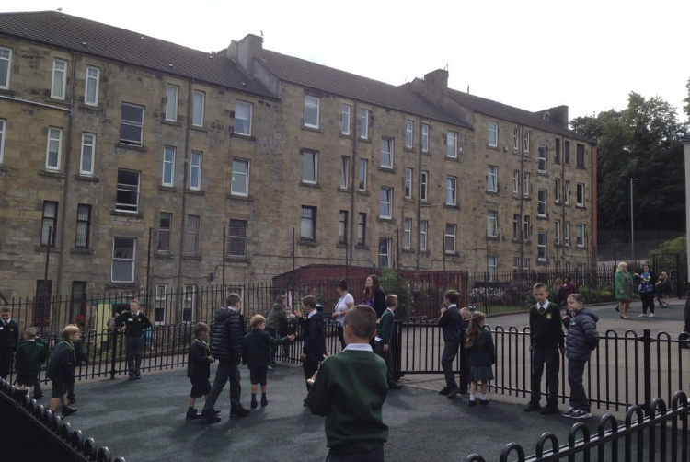

Playing Together Safely

Playground Supervision
An adult presence is provided in playgrounds at break times in terms of the Schools (Safety and Supervision of Pupils) (Scotland) Regulations 1990.

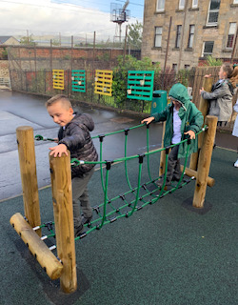

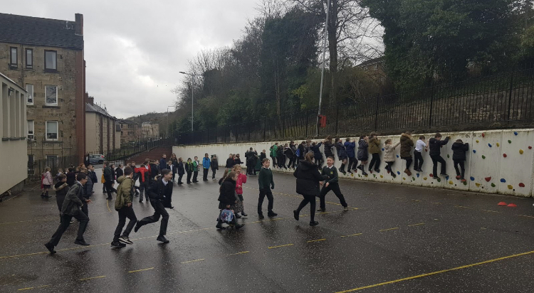

Fun in the Playground!!

Extra–Curricular Activities
Through our programme of Out of School Hours Learning, we encourage children to use their own particular talents and skills to the best of their ability. Visits to places/productions of educational and cultural interests are encouraged. Any parents who feel they can contribute to any of these activities or has a particular skill they would like to pass on may contact the school. These activities deepen achievement in its widest sense.

Parents should note that the activities the pupils may become involved in may be restricted because health and safety requirements state that jewellery of any kind must not be worn where pupils are undertaking games or physical activities. This includes jewellery worn as a result of body piercing. Physical activities include activities undertaken within physical education (P.E.) classes.

Our current diet of extra-curricular activities includes:

Athletics Netball Football Bowls
Choir Arts & Crafts Gymnastics Glee Club

Residential Trips: Primary 6 - Dalguise Primary 7 – Sportscotland, Largs

Clothing & Uniform

Given that there is substantial parental and public approval of uniform, schools in Inverclyde are free to encourage the wearing of school uniform. In encouraging the wearing of uniform, account is taken in any proposals to prevent any direct or indirect discrimination on the grounds of race or gender. Any proposals will be the subject of widespread consultation with parents and pupils. Against this background it should be noted that it is the policy of the Education & Lifelong Learning Committee not to insist on pupils wearing uniform or having specialist items of clothing as a prerequisite to their attending and engaging in all of the activities of the curriculum.

There are forms of dress which are unacceptable in school, such as items of clothing which:
- potentially encourage faction (such as football colours)
- could cause offence (such as anti-religious symbolism or political slogans)
- could cause health and safety difficulties such as loose fitting clothing dangling earrings or clothing made from flammable materials for example shell suits in practical classes
- could cause damage to flooring
- carry advertising, particularly for alcohol or tobacco;
- could be used to inflict damage on other pupils or be used by others to do so.

The council is concerned at the level of claims being received regarding the loss of children’s clothing and/or personal belongings. Parents are asked to assist in this area by ensuring that valuable items and unnecessarily expensive items of clothing are not brought to the establishment. Parents should note that the authority does not carry insurance to cover the loss of such items and any claims submitted are likely to be met only where the authority can be shown to have been negligent.

Parents should note that the activities the children may become involved in may be restricted because health and safety requirements state that jewellery of any kind must not be worn where children are undertaking physical activities. This includes jewellery worn as a result of body piercing.

Parents of children receiving one of the following benefits will normally be entitled to monetary grants for footwear and clothing for their children:

- Income Support
- Income-based Job Seekers Allowance (JSA)
- Child Tax Credit, but not working Tax Credit, and where income is less than £16,105 (in 2020/21 as assessed by HMRC)
- An Asylum seeker receiving support under Part VI of the Immigration and Asylum Act 1999
- Employment and Support Allowance (Income Related) (ESA)
- Parent or carer who is in receipt of Working Tax Credit and/or Child Tax Credit with Annual Gross Earnings of no more than £11,665
- Universal Credit – where your take home pay does not exceed £951, as shown on your monthly Universal Credit statement proval of any requests for such grants made by parents in different circumstances are at the discretion of the Director of Education and Communities. Information and application forms may be obtained from the schools and from Inverclyde Council, Customer Service Centre, Municipal Buildings, Clyde Square, Greenock, PA15 1LY from the end of June.

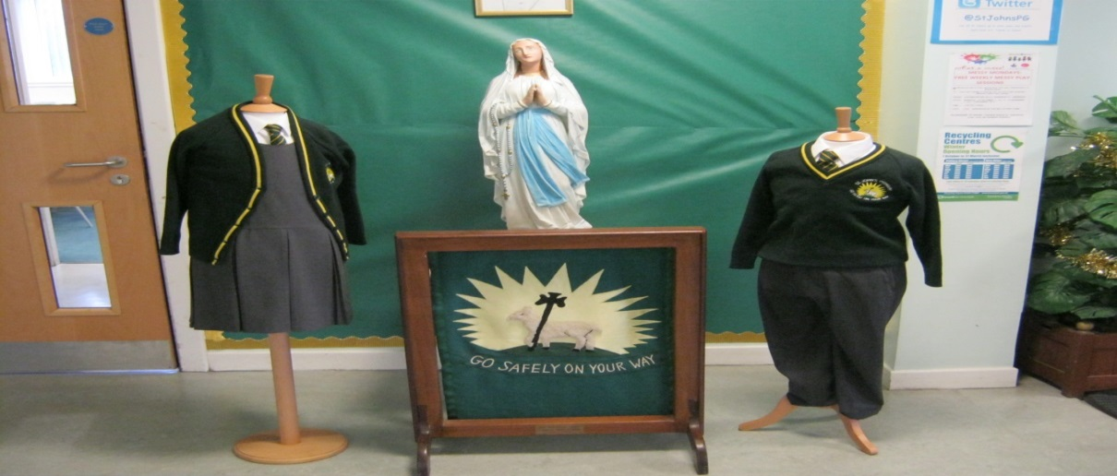

We Are Proud of our UNIFORM!

School Meals & Health Promotion

In recent years we have seen a decline in the number of families completing the Clothing Grant and Free Meals application. This may be due to the fact that all children in P1 – P5 are now entitled to a free meal every day. Please ensure you complete your application which, if successful, will give you two payments per year towards school uniform, and free meals for children in P6 and P7. For each successful application made, the school receives a grant known as Pupil Equity Funding (PEF) which is used to support children in their learning.

Children of parents in receipt of one of the following benefits are entitled to a free midday meal and clothing grant:

- Income Support (IS);
- Income based Job Seekers Allowance (JSA);
- income related Employment and Support Allowance (ESA);
- Child Tax Credit, but not Working Tax Credit, and your income is less than £16,105 (in 2021/2022) as assessed by HMRC;
- Working Tax Credit and/or Child Tax Credit and have an income of no more than £11,916; as assessed by HMRC or
- Universal Credit, where your take home pay does not exceed £970, as shown on your most recent monthly Universal Credit Statement.
- or
- You are seeking asylum and, receiving support under part VI of the Immigration and Asylum Act 1991;
- or
- You look after a child/children as part of a formal Kinship Care agreement, registered by Social Work Services

Information and application forms for free school meals may be obtained from schools and Education Services, Wallace Place, Greenock PA15 1JB. It is also available online Clothing Grant & Free School Meals 2021/2022 - Inverclyde Council In addition, such children will be entitled to free milk. If you do not have access to the internet, please call 01475 712894 0r 01475 712890 and someone will be able to help you.

Our school canteen does not accept cash payments. Payments for meals are made via a system called ParentPay. Payments are made online at https://www.parentpay.com/ or at a Pay Point located within many of our local shops.

The cost of a meal is currently £2.20. Pupils selecting a main meal may have 5 items, eg. Dish of the day, vegetable/salad, potato/starchy, drink and soup or dessert. A snack option consists of 4 items, eg. Sandwich/roll, salad/fruit, soup or dessert and drink. A copy of the menu is issued annually and can also be viewed on our school website, Twitter account or Inverclyde Council website. If a special diet, eg. Diabetic, gluten free, is required, this can be arranged. Children who bring packed lunches are also accommodated in our dining room. Picnic benches are available for use outside when weather permits.
Each morning, the children will order in class what they would like for lunch that day. They are issued with a coloured band which lets the canteen staff know which option the child has selected and gives them their preferred choice accordingly.

Please note that all P1 – P7 pupils are eligible for Free School Meals.

Health Promotion
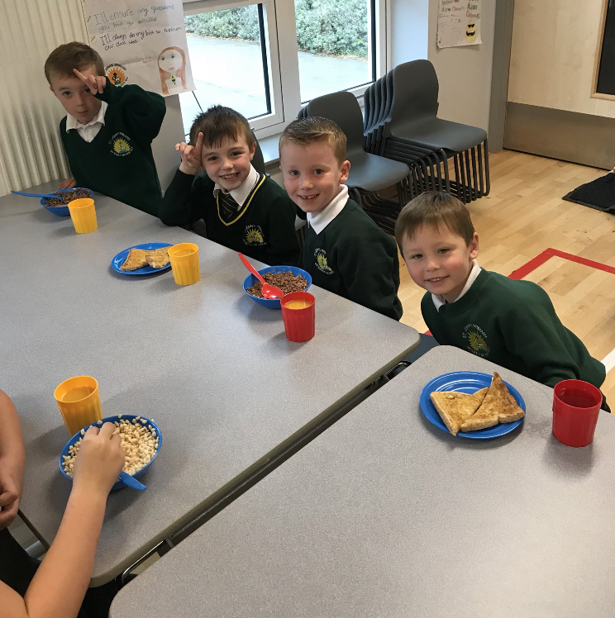
In line with Inverclyde Council’s health policies, we include all aspects of health education within the curriculum. The four issues of nutrition education, drug education, sex education and road safety are comprehensively addressed from P1 – P7, in conjunction with partner health professionals. We have a health calendar which highlights input from our health partners.

In the wider life of the school we endeavour to promote a healthy lifestyle through healthy eating initiatives, such as a healthy snack bar and healthy choices at lunchtime. We have an annual ‘Health Day’ which pulls together various aspects of health and encourages participation by all stakeholders.

Transport

The Council currently has a policy of providing free transport to all primary pupils who live more than one mile from their local school by the recognised shortest walking route. This policy is more generous than the law requires. This means that the provision of transport could be reviewed at any time. Parents who consider they are eligible should obtain an application form from the school or Education Offices at Wallace Place, Greenock PA15 1JB. These forms should be completed and returned before the end of February for those pupils beginning school in August to enable the appropriate arrangements to be made.

Applications may be submitted at any time throughout the year but may be subject to delay whilst arrangements are made. The appropriate officer has discretion in special circumstances to grant permission for pupils to travel in transport provided by the authority where spare places are available and no additional costs are incurred.

PICK-UP POINTS

Where free transport is provided, it may be necessary for pupils to walk a certain distance to the vehicle pick-up point. Walking distance in total including the distance from home to the pick-up point and from the drop-off point to the school in any one direction will not exceed the authority’s limits (see above paragraph). It is the parent’s responsibility to ensure that their child arrives at the pick-up point in time. It is also the parent’s responsibility to ensure the child behaves in a safe and acceptable manner whilst boarding, travelling in and alighting from the vehicle. Misbehaviour could result in a child losing the right to free transport.
If you wish to change travel arrangements for your child ie they are not travelling by bus, it is essential that parents and carers notify our office staff.

PLACING REQUESTS

Education Services does not provide transport for those pupils in receipt of a placing request other than in exceptional circumstances. In the case of under-age placing requests, if the child is offered a place in his/her catchment area school, transport will be provided in accordance with Council policy stated above.

Road Safety

Throughout the school year children are reminded about road safety. Parents are asked to assist by ensuring responsible parking around the school.

Parking in the staff car park cannot be permitted. Such action may result in a child being seriously injured.

Parents who drive their children to school are requested to drop them off on Ardgowan Road and walk them to school via the underpass.

Please do not park on the Keep Clear signs, this enables our children to cross the road safely.

Our JRSO (Junior Road Safety Officers) assist in supporting positive routes to school via presenting at Whole School Assemblies, reporting to parents/carers and gathering information on safer routes to school.

Parent Forum & Parent Council

Scottish Schools (Parental Involvement) Act 2006 led to the establishment of Parent Councils in primary, secondary and special schools. The Act recognises the vital role that parents play in supporting their children’s learning. It places a duty on authorities to promote the involvement of parents in children’s education and the wider life of the school. It aims to help parents to be:

- Involved with their child’s education and learning
- Welcomed as an active participant in the life of the school
- Encouraged to express their views on school education generally

Information must be provided on whether or not a Parent Council has been established and the reason(s) given for the non establishment or disestablishment of a board.Information should be given about the members of the council. Details of where/how the Parent Forum can access minutes of meetings and constitution should be given. Procedures for electing parent representatives should be set out.

The Parent Council, as a statutory body, has the right to information and advice on matters which affect children’s education. Parents who are involved on a regular basis in schools should undertake an enhanced disclosure through Disclosure Scotland.

Parents and carers are the most important influence throughout a child’s education and parental involvement in learning makes a real difference to children’s achievements. Everyone benefits (children, parents and teachers) when parents and schools work effectively together to support learning.

Parent Councils help parents and carers to become more actively and effectively involved in their children’s learning. They were established under the Scottish Schools (Parental Involvement) Act 2006 in recognition of the important role that parents can play, both in their own children’s learning, and in the life of a school. Parent Forum is the collective name for every parent, carer or guardian at a school. The Act gives each school’s Parent Forum the right to set up a Parent Council.

Both Act and Guidance can be found on the Parents’ page of the Scottish Government website:
https://education.gov.scot/parentzone

Under the 2006 legislation the role of the Parent Council is to:
- Support the school in its work with pupils
- Represent the views of parents and carers
- Encourage links between the school, parents and carers, pupils, pre-school groups and the wider community
Parent Councils are designed to be flexible – to ensure they can effectively represent their own school community and interests. It is for parents to decide what is most important for their Parent Council to work on.
Parent Councils can:
- Provide a voice for parents in schools and in their local authority on issues that are important to them and their children
- Help the school to understand how to most effectively involve parents in their children’s learning and in the life of the school
- Support the school and Head Teacher in developing strong home/school partnerships
- Support the school in its development and improvement, and in understanding and making links with the wider community
- Capture the unique and varied skills, interests, knowledge and experience that parents can offer

Parent Councils provide an opportunity for parents to get involved in ways that suit them, and to support their school in getting the best education for all the pupils.

Parents will be a member of the Parent Council for a period of 12 months, or until a parent’s youngest child leaves the school, or until a member gives notice of resigning position. Members are eligible for re-election

The Parent Council may co-opt members as necessary to assist it with carrying out its functions. Co-opted members could include school staff both teaching and non-teaching. In denominational schools one such co-opted member must be nominated by the Church or denominational body in whose interest the school is conducted.
The Annual General Meeting will be held in October of each year. A notice of the meeting including date, time, and place will be sent to all members of the Parent Forum at least two weeks in advance. The meeting will include:

- a report of the work of the Parent Council and its committee(s)
- selection of the new Parent Council (annually as members terms of office finishes)
- discussion of issues that members of the Parent Forum may wish to raise
- approval of the accounts and appointment of the auditor
- changes to constitution shall be agreed at the AGM or through consultation with the Parent Forum

The Parent Council will also meet at least once every school term. The meetings last about 1 hour 30 minutes. Minutes of these meetings are displayed on the school website. The Parent Council can be contacted through the school office or via e-mail – INStJohns@glowscotland.onmicrosoft.com

Parent Council Members Key Representatives
Jan Gault – Chairperson/Parent
Mary McCabe – Vice Chairperson/Parent
Elaine Beaton – Secretary/Parent Member

Fr Dan Fitzpatrick, St. John’s Church, Shore Street, Port Glasgow – Church Rep/Co-opted

Martin Craig – Head Teacher

Parent Teacher Association - PTA

The school has a Parents Association which works with the school on a range of matters. It is important that all parents try and involve themselves as much as possible in making this school/parent link as dynamic, lively and fruitful as possible. For further information contact the school or one of the committee members noted below.

Chairperson: Mrs Jan Gault
Head Teacher Representative: Mrs Leanne Cannon

The Scottish Parent Teacher Council is the national organisation for PTAs and PAs in Scotland and runs an independent helpline service for all parents. You can contact them by phone/fax on 0131 226 4378, by e-mail on sptc@sol.co.uk or write to SPTC, 53 George Street, Edinburgh EH2 2HT.

Parental Involvement

Involvement of parents/carers is crucial in supporting learning activities within the school. There are a number of ways that parents/carers can be involved in the school both in a formal sense and informally. At the start of each session parents/carers are invited to attend a curricular presentation given by their child/children’s class teacher outlining the learning that will take place over that particular stage. Parents/carers will be shown strategies to support learning at home ensuring continuity of learning. An “Open Door” policy exists within the school where parents/carers can discuss issues with the class teacher or a member of the management team; however it is more beneficial if an appointment is made to ensure that someone is available to see you.

During the course of the school year parental views are sought ensuring school improvement is continued. Parental views are encouraged via response slips on monthly newsletters, questionnaires and also via the Parent Council.

Parents/carers also have a vital role in sharing their own experiences with the pupils and opportunities exist for these experiences to be shared throughout the year with different classes. An example of this is our “World of Work” Week. Pupils enjoyed listening to parents/carers discussing their roles in the community and what would be required if they would want to choose a particular career path.

Further information relating to parental involvement within the school can be found by accessing Inverclyde’s Parental Involvement Strategy which is on the schools website and the Inverclyde Council website.

Parents as Partners in St John’s Primary
Pupil Involvement
It is important that pupils feel that they have a role to play in assisting in the decision making process within the school and that their voice and the voice of their peers is heard. Every year the Pupil Council is elected from pupils in P1 – P7. We have a boy and girl representative from each of the classes throughout the school. These representatives are elected, not on popularity, but on the skills that they can bring to ensure that the opinions from the pupil forum can be discussed at the Pupil Council meetings. Being part of the Pupil Council is a very responsible position to hold and it is a role which is keenly contested. Other activities which ensure pupil involvement within the school is; Junior Road Safety Officers, School Choir, Sporting Team membership, Buddies and ECO Group volunteers. As a school we are delighted that pupils wish to be involved in activities that support the school community and beyond.

Rights Respecting Schools

Sam the Lamb says
“We all have rights.”

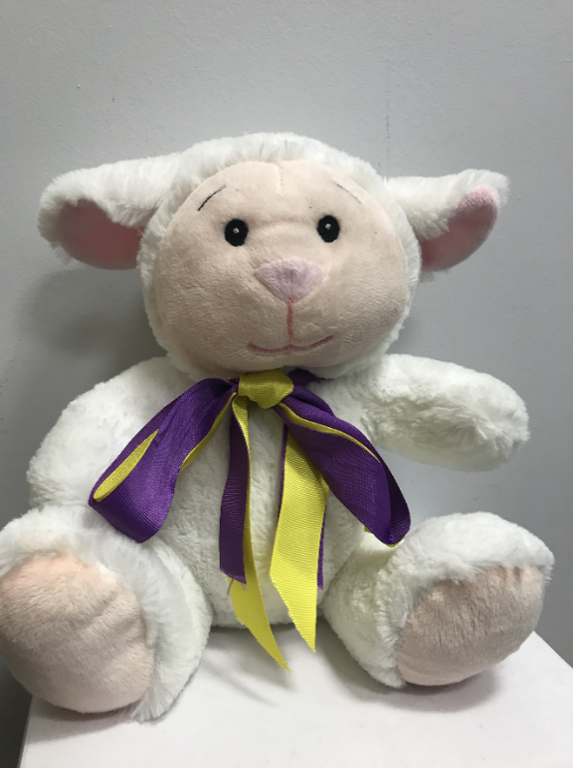

As a Rights Respecting School and Nursery, it is important that our children know their rights from Nursery and that these rights are nutured throughout theur time at St John’s. Each year, all children and pupils will learn more about their rights and will create Rights Respecting Class Charters to ensure that all pupils and Duty Bearers are focused on getting it right for every child.

Our Rights mascot is Sam the Lamb. Whenever we see Sam around the School and Nursery, we know a right is being met. This fun and interactive approach to teaching rights ensures that it is accessible to all children.

General Data Protection Regulations & Data Protection Act 2018

Information on children, parents and guardians is stored on a computer system and may be used for teaching, registration, assessment and other administrative duties. In processing personal information, Inverclyde Council must comply with the General Data Protection Regulation and Data Protection Act 2018.

For further information please refer to
https://www.inverclyde.gov.uk/site-basics/privacy

Important Addresses

Corporate Director: Education, Communities Head of Culture, Communities
& Organisational Development & Educational Resources
Ruth Binks Tony McEwan
Municipal Buildings Education HQ
Clyde Square Wallace Place
Greenock Greenock
PA15 1LX PA15 1JB
Tel: (01475) 712761 Tel: (01475) 712828

Head of Education Community Learning and Development Office Michael Roach Inverclyde Council
Education HQ 32 Nicholson Street
Wallace Place Greenock
Greenock PA15 1UL
PA15 1JB Tel: (01475) 715450
Tel: (01475) 712824

Provost Brennan Councillor MacLeod
Inverclyde Council Inverclyde Council
Municipal Buildings Municipal Buildings
Greenock PA15 1LY Greenock
PA15 1LY PA15 1LY
Tel: (01475) 712727 Tel: (01475) 712727

Inverclyde Councillors Inverclyde Councillors
Councillor McKenzie Councillor Moran
Inverclyde Council Inverclyde Council
Municipal Buildings Municipal Buildings
Greenock Greenock
PA15 1LY PA15 1LY
Tel: (01475) 712727 Tel: (01475) 712727

Although this information is correct at time of presenting, there could be changes affecting any of the matters dealt with in this document:

- before the commencement or during the course of the school year in question.

- in relation to subsequent school years.

Glossary of Terms used in the School Handbook

ASL – Additional Support for Learning

SfL – Support for Learning

CfE – Curriculum for Excellence

GIRFEC – Getting It Right For Every Child

IEP – Individualised Educational Programme

PIPS – Performance Indicators in the Primary School

ICT – Information Communication Technologies

PE – Physical Education

PEF – Pupil Equity Fund

PTA – Parent Teacher Association

EYECO – Early Years Educational & Childcare Officer

EYSA – Early Years Support Assistant

PSA – Pupil Support Assistant

