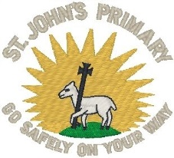 | St John’s Primary & Nursery Class Newsletter  November 2019 | 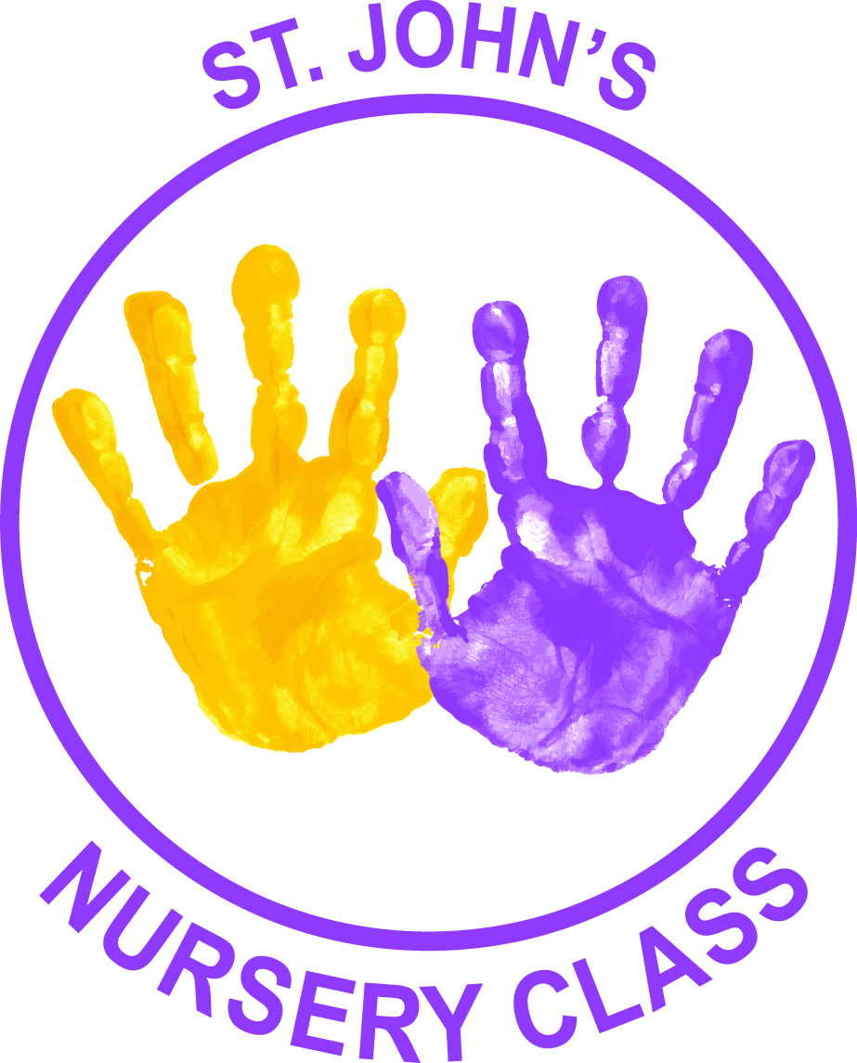

Dear Parents/Carers

The winter is drawing nearer and with that in mind I would like to remind all parents/carers that the Breakfast Club is open to all pupils from 8 am – 8.45 am on a Tuesday, Wednesday and Thursday. Breakfast is provided and active games are available where the pupils can mix together in a safe and friendly environment.

Halloween Pageant
Our Halloween Pageant was a huge success. All pupils were dressed in a variety of weird and wonderful costumes that our panel of judges found extremely difficult to judge. Well done to all pupils and staff for a fantastic event.

Sportshall Athletics
Well done to all the boys and girls who participated in the first heat of the Sportshall Athletics competition. They worked tremendously hard together and were true ambassadors for our school. Well done!

Christmas Fete
The PTA’s Christmas fete will be held on Thursday, 5 December 2019 in the School Hall – 6pm – 8pm. There will be lots of Christmas Joy and plenty of stalls to snap up Christmas bargains. We hope that as many of you can attend as possible to celebrate the work of the PTA in supporting the school – anyone wishing to volunteer to assist the PTA should contact the school office. Many thanks to the PTA members for their continued support and hard work.

There will be a “Come As You Please” on Friday, 29 November 2019 to help support the Christmas fete. Thank you

- Nursery – P2 pupils – Donate chocolate for the Tombola
- P3 – 7 pupils – Donate bottles for the Bottle Stall

Advent Reflections
Reflections will take place in the school every Monday morning during Advent. This provides the pupils with an excellent opportunity to listen to the Word of God and reflect upon their actions.

Sacramental Mass of Enrolment for P4 & P7 Pupils
A Joint Sacramental Enrolment Mass will take place on Sunday, 8 December 2019 at 11am in St John the Baptist Church for the pupils and families of Primary 4 and Primary 7 who will receive the sacraments of Reconciliation, Eucharist and Confirmation. We look forward to seeing you there.

Catholic Education Week Mass – Thursday, 21 November 2019
Catholic Education Week Mass will take place on Thursday, 21 November 2019 in St John the Baptist Church. It is a really uplifting occasion and a great way to celebrate the work of our cluster schools in relation to Catholic Education. I would like to invite all parents/carers and pupils to attend this special occasion.

Reporting to Parents
Parental Interviews took place recently in our school hall. Thank you for the fantastic attendance and the positive comments we received over the course of the evening. As always, if you have any suggestions or comments about how we report to you please let us know.

Targets have been issued for this Term. Each child has 3 Literacy targets, 3 Numeracy targets and 2 Health and Wellbeing targets to focus on for this term.

Traffic – In and Around the School
I would ask that all parents/carers and staff demonstrate respect to our neighbours ensuring safety and consideration when parking around the school. Can I please remind all parents/carers that the car park is for staff use only? Many thanks!

Pupil Council Elections
The Pupil Council Elections took place recently and was a huge success. We now have a newly elected Pupil Council who will work with their classmates and staff to ensure pupils’ voice is heard and they have an impact on decisions that are happening in and around our school and nursery.

TWITTER
If you haven’t already done so please sign up and follow us @StJohnsPG @StJohns_Nursery. By doing so, you will be able to get regular reminders and updates of school and nursery activities first hand.

Christmas Shows
We have had to make a few changes to this year’s Christmas Show to try to enhance your experience of seeing your children perform. This will also help relieve the pressure of storing costumes and props in the school in the lead up to the show. Unfortunately, due to the increasing roll, we can only accommodate 2 tickets per family over a 3 day period. The Shows will commence at 1.30pm and last about 1 hour 15 minutes.

- The Nursery AM and PM classes will both perform the Nativity on a separate day (Extra information to follow)
- P1-3 will perform the Nativity “Born in a Barn” on all 4 dates as listed below
- P4-7 will perform “Christmas Through the Years” on all 4 dates listed below
- 10 December 2019 – School Show Dress rehearsal - Invited Guests from Gibshill Nursery & Marchmount Home.
- 11 December 2019 – School Show 1 – (P2/1, P2, P3 & P6/7)
- 12 December 2019 - School Show 2 – (P1, P6/5 & P7)
- 13 December 2019 - School Show 3 – (P3/4, P4 & P5)

Ticket information will be announced shortly!

Nut/Peanut/Peas/Lentils Allergies
I would ask that pupils do not bring nuts/peanuts or any item containing nuts/peanuts to school as several of our pupils have nut/peanut allergies.

We also have pupils who have allergies to lentils and would ask that you do not give your child lentil soup for their lunch.

Mary Street Gate/Nursery Entrance
The gate at the bottom of Mary Street at the Nursery entrance should be kept closed at all times. I would ask Parents/Carers who are using the gate to make sure that they close the gate behind them. Thank you for your co-operation with this matter.

Attendance & Parental Contacts
We have received further guidance on attendance and timekeeping from the Education Authority. It is important that if your child is absent for any reason that:

- a text is made to the school explaining the absence using this contact number: 07860004806
- and that a letter of explanation is sent to the school upon your child’s return to school.

In our efforts to care for the children it is sometimes necessary to contact parents/carers to collect a child who is unwell. Please ensure that any changes of contacts or numbers are reported to the office staff. It is through speedy contacts that we can reduce the distress to pupils.

P7 Spooky Coffee Morning
This year P7 pupils held a Spooky Coffee Morning to support fundraising for their residential trip – the event was a huge success raising a massive £608. Many thanks to all who contributed to this fantastic event.

Yours sincerely

Mark Coyle

Mark Coyle
HEAD TEACHER

Forthcoming November Activities
Wednesday, 6 November 2019 – Cross Country Event at Parklea
Wednesday, 6 November 2019 – P7 Visit to St Stephen’s
Wednesday, 6 November 2019 – Parent Council Meeting @ 6pm in the school
Saturday, 9 November 2019 – Parent Council Race Night – 6pm in the Church Hall
Friday, 8 November 2019 – P1 visit to Gourock
Monday, 11 November 2019 – P1 visit to Port Glasgow Library
Tuesday, 12 November 2019 – P2/1 visit to Gourock
Wednesday, 13 November 2019 – P7 Visit to St Stephen’s
Friday, 15 November 2019 – P2 visit to Gourock
Friday, 15 November 2019 - Netball Competition
Wednesday, 20 November 2019 – P7 Visit to St Stephen’s
Thursday, 21 November 2019 – Catholic Education Week Mass – 7pm in St John the Baptist Church
Friday, 22 November 2019 – Sportshall Athletics Competition
Wednesday, 27 November 2019 – P7 Visit to St Stephen’s
Friday, 29 November 2019 – Come As You Please in aid of the Christmas Fete

Forthcoming December Activities
Monday, 2 December 2019 – Advent Reflection in the Hall @ 9am
Wednesday, 4 December 2019 – P7 Visit to St Stephen’s
Wednesday, 4 December 2019 – Christmas Lights Switch On
Thursday, 5 December 2019 – Christmas Lunch
Thursday, 5 December 2019 – School Fete 6pm – 8pm
Friday, 6 December 2019 – 1st Friday Mass
Friday, 6 December 2019 – Sportshall Athletics Competition
Sunday, 8 December 2019 – Sacramental Enrolment Mass for P4 & P7 pupils – 11am in St John the Baptist Church
Monday, 9 December 2019 – Advent Reflection in the Hall @ 9am
Tuesday, 10 December 2019 – School Show Dress rehearsal - Invited Guests from Gibshill Nursery & Marchmount
Wednesday, 11 December 2019 – School Show
Thursday, 12 December 2019 - School Show
Friday, 13 December 2019 - School Show
Monday, 16 December 2019 – Advent Reflection in the Hall @ 9am
Monday, 16 December 2018 – Christmas Pupil Activities Day
Tuesday, 17 December 2019 – Nursery Dress Rehearsal
Wednesday, 18 December 2019 – Nursery Show
Friday, 20 December 2019 – Mass and Carol Service in the Church at 9.30am – Parents/Carers welcome
Friday, 20 December 2019 – Close – 2.30

