**Practical Cookery Revision Resources**

*Achieve - School: St Columba’s High School*

**Search for Practical Cookery**

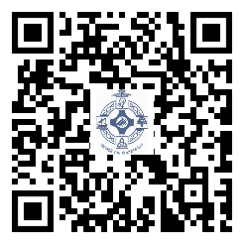

*SQA Past Papers*

*Quizlet (app or online)*

*Search for N5 Practical*

*Cookery*