**Fashion & Textile Technology– Revision Resources**

**HIGHER FASHION & TEXTILE TECHNOLOGY**

**SQA Past Papers**



**N5 FASHION & TEXTILE TECHNOLOGY**

**SQA Past Papers**





Books – some people like to buy a revision books or but these are definitely not necessary to purchase as all pupils have a full set of comprehensive notes and copies of past paper questions provided for every key area. However, if you wish to, this is a useful book:

The Sewing Book Alison Smith MBE

ISBN No: 978-0-2413-1363-3

Pupils all have access to Teams and a variety of School Resources, including Power Point Presentations and notes on exam answering technique are available.

[BlooketBlooket](https://www.blooket.com/)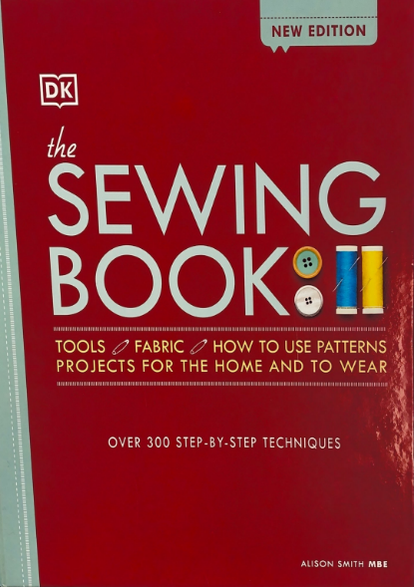



www. Quizizz.com

Online resource.

Search for topic: eg Fabric Properties Garment construction techniques