**Physics Revision Resources**

**JABStem** - Physics N5 Higher

**BBC Bitesize**–

N5 Higher

**SQA Past Papers** -  **Scholar**

*Achieve - School: St Columba’s High School*

**School code: Y7EJyw3B**

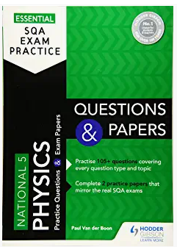**Physics Revision Books:**