**Chemistry Revision Resources**

**Microsoft Teams** - All class resources are posted on the class Team, including PowerPoints, Homework Exercises & Revision Materials. Assessment information is also posted to keep pupils informed.

**JABChem**

(Past Papers with answers and written solutions) N5 Higher

**BBC Bitesize** –

  **Scholar** <https://scholar.hw.ac.uk/>

N5 Higher

****SQA Past Papers**

**YouTube Revision Videos**

[Miss Adams Chemistry - YouTube](https://www.youtube.com/c/MissAdamsChemistry)

**ClickView** - SCHS videos for Chemistry can

be found in our school library

 (pupils sign in with GLOW login)

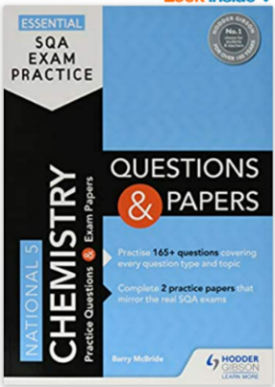Chemistry Revision Books:**