Summary of NPA Photography Level 5 SCQF –Credit Points 24
ENGLISH
LANGUAGES

Nat 5
UNITS

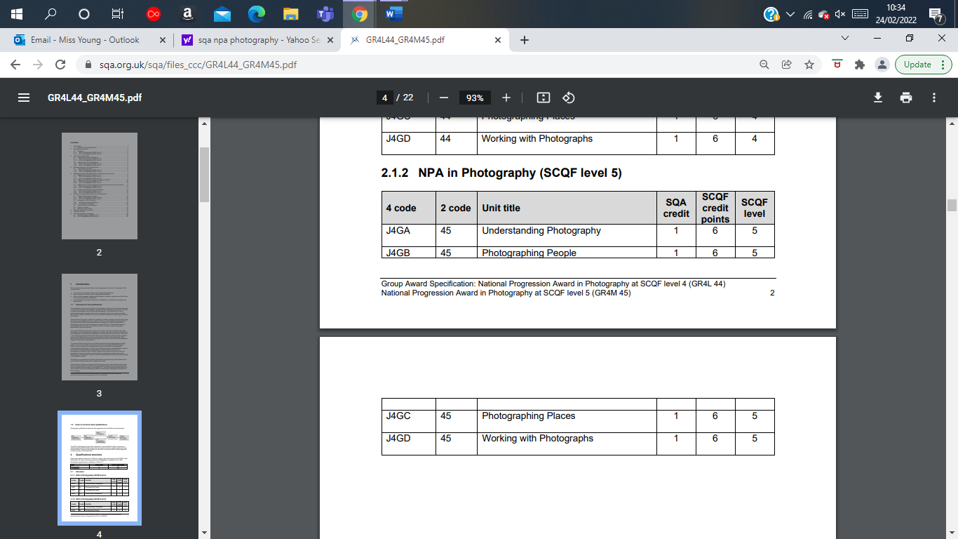
4 Units Included
COURSE ASSESSMENT
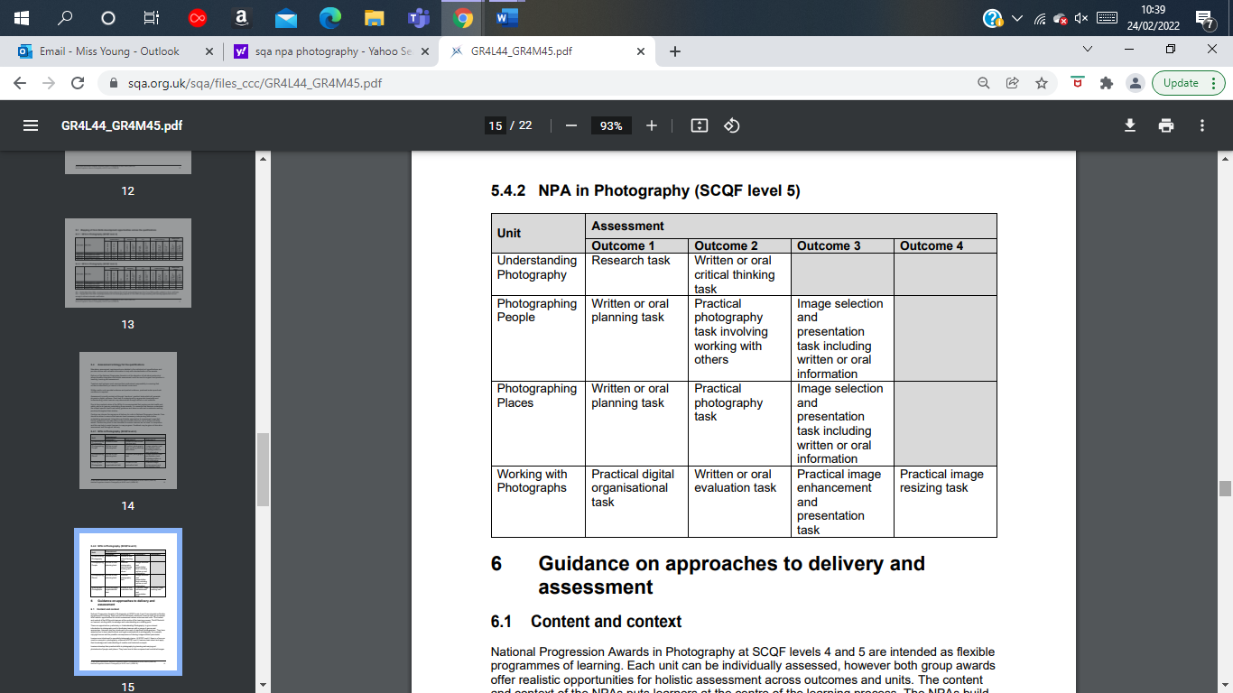

What skills will be developed? And Assessment

- Core Skills - Communication, ICT, Problem Solving, Working with Others. All SCQF
- Assessment is mostly carried out through ‘hands-on’ practical tasks which will generate physical or digital evidence. Each task is underpinned by appropriate knowledge and understanding, which learners may demonstrate through written or oral evidence.

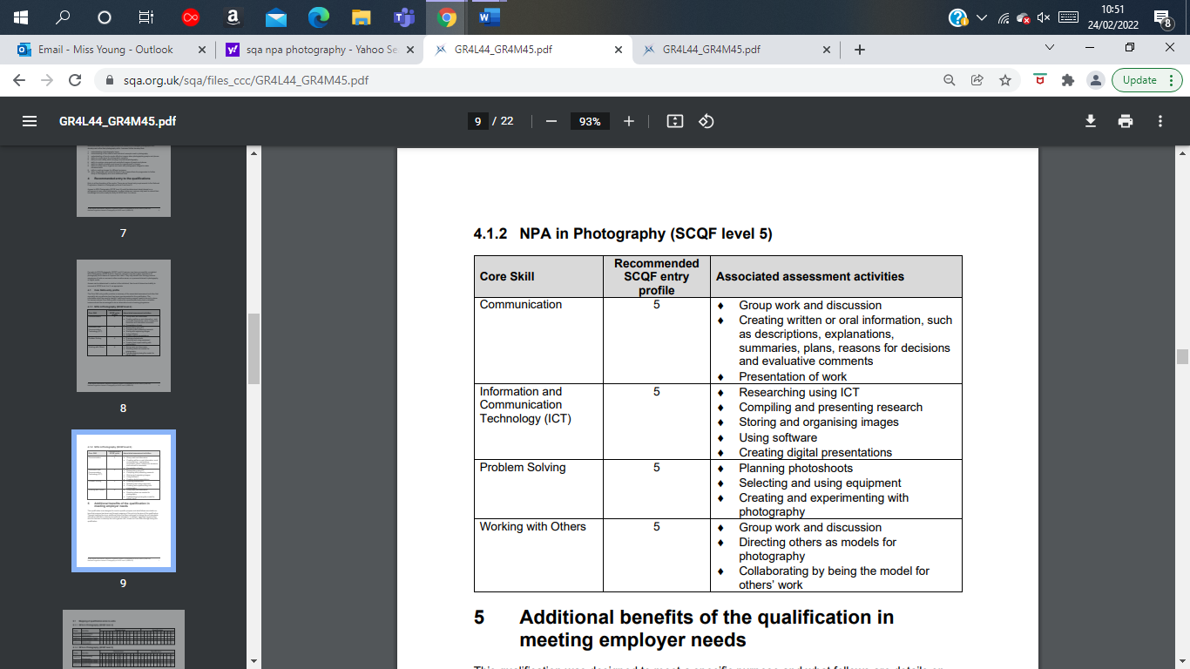

What will be experienced during the course?
- Learners develop their practical skills in photography by planning and carrying out photoshoots of people and places. They learn how to take composed and controlled images.
- At this level, learners develop their understanding of creative and technical concepts used by photographers. Learners research the work of photographers. Inspired by their research images, learners plan and carry out their own photoshoots. They develop their evaluation skills by identifying strengths and areas for development in photographs. They learn about and apply techniques to make enhancements to photographic images.

Home learning

- Completion of work from class/studying for assessments etc.

Careers in Photography and Further Study
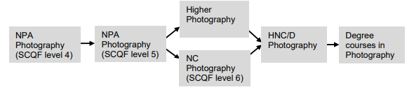
A small selection of Jobs
Photographer | Photojournalist | Freelance Photographer | Photo Editor
Wedding Photographer | Event Photographer | Product Photographer | Fine Art Photographer
Fashion Photographer | Travel Photographer | Advertising Photographer | Videographer
Cameraperson | Graphic Designer | Film Editor | Magazine Art Editor

