Summary of Music Technology National 4
MUSIC
TECHNOLOGY

Nat 4
The aims of the Course are to enable learners to:
- develop basic skills in the use of music technology hardware and software
to capture and manipulate audio
- use music technology creatively in sound production in straightforward contexts
- develop understanding of a range of 20th and 21st century musical styles and genres
- reflect on their own work and that of others

while developing their knowledge of music and their skills in using music technology,
learners can work independently or in collaboration with others. These activities and approaches to learning will help learners to plan and organise, to make decisions and to take some responsibility for managing their own learning and their interactions with others. The practical and experiential nature of the Course gives learners opportunities to show imagination, creativity and technical problem-solving skills as they develop, review and refine their musical ideas and use music technology for specific effects.

Course structure and conditions of award

Course structure
The Course consists of three mandatory Units. Each of the component Units of the Course is designed to provide progression from the corresponding Unit at National 3 and to the corresponding Unit at National 5.

Units are statements of standards for assessment and not programmes of learning and teaching. They can be delivered in a number of ways.

Music Technology Skills (National 4)
In this Unit, learners will develop skills and techniques relating to the use of music technology hardware and software to capture and manipulate audio. Learners will explore a range of uses of this technology through practical activities.

Understanding 20th and 21st Century Music (National 4)
In this Unit, learners will develop knowledge and understanding of 20th and 21st century musical styles and genres, and an understanding of related music technology developments.

Music Technology in Context (National 4)
In this Unit, learners will use music technology skills in a range of contexts such as live performance, radio broadcast, composing and/or sound design for film, TV themes, adverts and computer gaming.

Added Value Unit: Music Technology Assignment (National 4)
This Unit requires the learner to apply and integrate skills, knowledge and understanding from the other Units to plan and carry out a short creative production using music technology.

Conditions of Award
To achieve the National 4 Music Technology Course, learners must pass all of the required Units, including the Added Value Unit. The required Units are shown in the Course outline section.

National 4 Courses are not graded.

Summary of Music Technology National 5
MUSIC
TECHNOLOGY

Nat 5
The purpose of the National 5 Music Technology Course is to enable learners to develop
their knowledge and understanding of music technology, and of Music concepts,
particularly those relevant to 20th and 21st century music, and to engage in the
development of technical and creative skills through practical learning. This Course
will provide opportunities for learners to develop their interest in music technology and
to develop skills and knowledge relevant to the needs of the music industry.
The aims of the Course are to enable learners to:
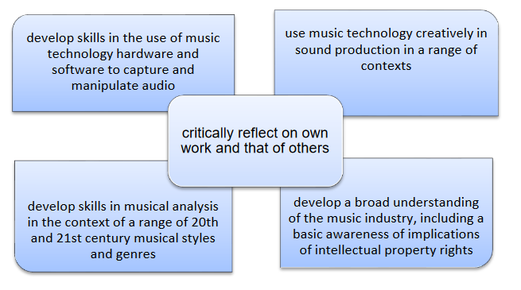

Course structure and conditions of award

Course structure
The Course consists of three mandatory Units. Each of the component Units of the Course is designed to provide progression from the corresponding Unit at National 5 and to the corresponding Unit at Higher.

Units are statements of standards for assessment and not programmes of learning and teaching. They can be delivered in a number of ways.

Music Technology Skills (National 5)
In this Unit, learners will develop skills and techniques relating to the use of music technology hardware and software to capture and manipulate audio. Learners will explore a range of uses of this technology through practical activities.

Understanding 20th and 21st Century Music (National 5)
In this Unit, learners will develop knowledge and understanding of 20th and 21st century musical styles and genres, and an understanding of related music technology developments.

Music Technology in Context (National 5)
In this Unit, learners will use music technology skills in a range of contexts such as live performance, radio broadcast, composing and/or sound design for film, TV themes, adverts and computer gaming.

Course Assessment
The assessment consists of two components
an assignment (70 marks) and a question paper (30 marks).
The assignment will be one piece of work which will demonstrate planning, evaluating and application of
knowledge and skills gained throughout the Course. Learners can choose to develop one of their pieces of work from Unit 3, or to apply their skills in a new context. The production should demonstrate audio capture, manipulation and production of an audiomaster
Learners could evidence their planning, progress and evaluating using screen shots, written text, blog, podcast etc.
Marks will be awarded for each of the three areas : planning, implementing and evaluating.
The question paper will assess learners’ knowledge and understanding of music styles and genres of the 20th and 21st century, musicconcepts and aspects of music technology.
It will consist of questions in response to music excerpts in a range of 20th and 21st century styles
and genres.
A range of question types will be used, assessing understanding of relevant
musicand technological concepts

