St Columba’ High School

Standards and Quality 19/20
Recovery Action plan Autumn 2020/21
Context of the school:

St Columba’s High School is a Catholic school serving the South-west of Greenock along with Gourock and the villages of Inverkip and Wemyss Bay. We occupy a modern school campus overlooking the Firth of Clyde and have a capacity for 686 pupils. The school roll has steadily increased in recent years and in session 2019-2020, the roll was 722 pupils. Around 49% of our pupils live in SIMD 1-3. The school is very successful in securing positive outcomes for pupils’ future destinations including Higher Education, Further Education, training and employment. The number of pupils who leave school to attend university, college or enter employment remains high. Vulnerable young people continue to enjoy excellent support into employment or college through very effective transition programmes and post school support planning.

Highly effective cluster partnerships with St. Andrew’s, St. Joseph’s and St. Ninian’s Primary Schools are a key feature of successful school improvement. Families across the school community are active participants in the life of the school and are well led by the Parent Council.

The St Columba’s High School vision is, ‘Attainment, achievement and positive futures for all’.
St Columba’s is a Catholic school, committed to the Values of the Gospel. Every member of our school community is encouraged to uphold our values which include - Faith; Ambition; Inclusion; and Perseverance. St Columba’s High School is a nurturing and inclusive school committed to high levels of support, participation and achievement for all. We aim to develop as a community of faith and learning, providing the highest quality of education, and offering formation through the promotion of Gospel values, through celebration and worship, and through service to the common good. By regular prayer and worship, we foster the distinctive Catholic ethos of the school.

The school was visited by a local authority review team in March 2018 and the following key points were highlighted:
- In the short period of time the HT has been in post she, ably supported by her senior management team, has shared and established a vision for improvement and has developed leadership at all levels.
- Staff are sensitive and responsive to the wellbeing of each individual young person.
- Staff provide a wide range of opportunities to improve pupil engagement, attainment and develop their skills for learning, life and work.
- Throughout our engagement with pupils they demonstrated their pride in the school and its community.
Further information can be found in our school handbook which is available on our school website at http://st-columbashigh.inverclyde.sch.uk/

Review of progress for session Aug 2019 - March 2020
School priority 1:
NIF Priority  Improvements in attainment, particularly in literacy and numeracy  NIF Driver  Assessment of children's progress  Teacher professionalism | HGIOS?4 QIs  3.2 Raising attainment and achievement  2.3 Learning, teaching and assessment  2.2 Curriculum  Other Drivers  HGIOELC?  RRS  Article 28: (Right to education):
Strategies
- Continue to engage with moderation activities at departmental, cluster and local authority level.
- PT Literacy and PT Numeracy to establish a series of Family Learning Workshops.
- Plan and implement further professional learning activities with a focus on leadership, and learning, teaching and assessment.
- Further develop staff engagement with tracking and monitoring pupil progress via data analysis and learner conversations.
- Implement new self-evaluation for self-improvement policy incorporating: double-banking classroom visits followed by quality professional dialogue.
Progress and Impact
- PT Literacy & PT Numeracy attended cluster and local authority events in October 2019 and November 2019. As a result, staff confidence has increased.
- Timetable of joint planning and lesson delivery now established and cluster staff have agreed on common methodology for learning, teaching and assessment. This approach will enhance the transition process and have a positive impact on pupil progress.
- Literacy/Numeracy workshops launched at P7 Open Evening in October which enhanced our approach to family learning at home.
- Middle and senior leaders engaged in individual coaching sessions with JP Fitzpatrick which explored their style of leadership and impact on others. Subsequently, middle and senior leaders are focused have become increasingly aware of their strengths and agreed priorities for further development. Twelve teaching staff have engaged in the Thrive teaching programme which has focused on pupil engagement and feedback. The teaching staff involved have identified one aspect of pedagogy for improvement which has led to an enhanced approach to learners’ experiences.
- All teaching staff have engaged in analysing data: including standardised assessments, the poverty-related attainment gap, expected progress for all pupils and additional support needs. Consequently, all teaching staff are fully aware of targeted interventions and the role they play in implementing support and challenge to ensure pupils make expected progress.
- SLT Double Banking learning visits completed and, as a result, we have developed a shared understanding of high quality learning and teaching. Pilot Departmental Review with English and maths department has led to a shared understanding of departmental strengths and areas for development which was informed by data analysis, learning visits, pupil voice and staff voice. SLT/PT Link Meetings continue to develop a greater consistency of support and challenge discussions around departmental and whole school improvement priorities.
Next Steps:
- Continue to engage with moderation activities at school, cluster, local and inter-authority levels.
- PT English and PT Maths to plan further opportunities for collaborating with cluster colleagues on approaches to learning, teaching and assessment.
- PT English and PT Maths to establish a calendar of family learning workshops and input to Family Learning Newsletters.
- Plan further professional learning activities with a focus on blended approaches to learning and teaching including digital learning.
- Further develop staff engagement with tracking and monitoring pupil progress via data analysis and learner conversations
- Continue to implement self-evaluation for self-improvement policy incorporating: double-banking classroom visits followed by quality professional dialogue; pupil voice activities leading to appropriate action (HGIOURS); planned opportunities to interrogate data and identify appropriate interventions; and roll-out our pilot approach to departmental reviews.

School priority 2: Closing the attainment gap between the most and least disadvantaged children

NIF Priority  Closing the attainment gap between the most and least disadvantaged children  NIF Driver  School leadership  Teacher professionalism | HGIOS?4 QIs  1.3 Leadership of change  3.1 Ensuring wellbeing, equality and inclusion  3.2 Raising attainment and achievement
Strategies
- Use data, including SNSA, PiPs, TPJs to secure expected progress for all learners, in particular, literacy and numeracy.
- Establish a PEF steering group to identify pupils who are not making expected progress and plan and evaluate appropriate interventions.
- Pupil support team to further develop a systematic approach to tracking and monitoring pupil attendance and punctuality including: daily tasks; attendance letters; attendance forums; and team meetings.
- Planned collegiate activity to focus on ensuring all staff are fully aware of the poverty-related attainment gaps in their own classroom and the appropriate interventions required.
- Continued focus on targeting additional wider achievement opportunities towards our most vulnerable young people.

Progress and Impact
- Data analysis/target-setting meetings for leaners in BGE including targeted cohorts has ensured that almost all learners are making expected progress. PT Numeracy identified correlation between SNSA and TPJs/school based assessment data which will enhance the transition between BGE and Senior Phase.
- PEF Steering Group (parents, staff, pupils) met and the following actions were agreed: explore and set up healthy ‘Breakfast Bar Baskets’; issue uniform/shoe donation reminder; explore bus tickets for transport home after extra-curricular activities.
- Late-coming desk established and procedures are outlined via information leaflet. The intervention has resulted in improved punctuality for some pupils. Guidance Team and Wellbeing Officer initiate text messages, parental phone calls, attendance letters and attendance forum meetings which has resulted in improved attendance for some pupils. Interventions for current non-attenders have been discussed with our Educational Psychologist and follow-up meetings with guidance staff have initiated appropriate actions.
- PT Literacy, PT Numeracy, and Faculty Head of Health and Wellbeing led a collegiate activity with staff outlining some effective interventions and their subsequent impact on outcomes for young people. As a result, staff have become aware of particular intervention strategies and how such approaches should transfer across the curriculum.
- Spreadsheet has been established to track wider achievements across 4 contexts for learning. The following opportunities have been targeted towards some of our most disadvantaged young people: S2 Resilience Group; Family Cook School; Drama Club/Festival Entries; Active schools literacy project; ICT Club; PE clubs; Iona Young Carers Group; Film Club; Nurture groups; CLD Groups.
Next Steps:
- PT English and PT Maths to identify expected progress in literacy and numeracy for all learners.
- Further develop PEF steering group to identify and agree most appropriate interventions and evaluate impact.
- Pupil support team and wellbeing officer to further develop a systematic approach to tracking and monitoring pupil attendance and punctuality including: daily tasks; attendance letters; attendance forums; and team meetings.
- Continued focus on ensuring all staff are fully aware of the poverty-related attainment gaps, particularly those created by the blended learning approach, and are able to identify and implement the interventions required.
- Continued focus on targeting additional wider achievement opportunities towards our most vulnerable young people.
- Increase focus of all departments on Family learning, parental engagement and digital equity.
- Analyse impact of family learning initiatives.
- Further develop our in-house CLPL programme to continue to focus on Excellent Teaching & Learning through an equity lens (including adaptive pedagogies for blended learning).
- Use Insight, TPJ and SNSA data to analyse ‘the gap’ in each individual subject area with subsequent sharing of successful strategies and good practice.

School priority 3: Improvement in children and young people's health and wellbeing.
NIF Priority  Improvement in children and young people's health and wellbeing  NIF Driver  Parental engagement | HGIOS?4 QIs  3.1 Ensuring wellbeing, equality and inclusion  2.5 Family learning  2.7 Partnerships
Strategies
- Chaplaincy team to plan and implement further opportunities for developing our faith including pupil and staff retreats.
- Review and update HWB strategy incorporating PSE curriculum planning and implementation.
- Senior Phase wellbeing sessions to be embedded in Core PE and RE.
- Establish a series of family learning workshops including: mental health; family fitness; financial education; social media/on-line safety.

Progress and Impact
- Staff reflection 1 in Oct 2019: well-attended/received by staff.
- Pupils had several opportunities throughout the year to develop their faith both inside and outside the classroom.
- Senior pupils completing the Caritas Award have engaged in a number of events including volunteering opportunities in the community eg the Inverclyde Foodbank. Fifty S3 pupils have planned and prepared to take part in a pilgrimage to Rome in May 2020, this experience will be offered to pupils in the near future. This pilgrimage offers our young people an enhanced opportunity to deepen their faith in prayerful worship, learn about the history of the church, foster a sense of community with their peers and develop a range of life skills.
- SP core RE lessons: pupils engaged in multiple sessions such as ‘Sound Sleep’ and study skills resulting in them managing their stress and anxiety associated with the Senior Phase (PE department)
- New H&WB strategy launched at November Staff Collegiate with a focus on QI 3.1. As a result the Health and wellbeing improvement team have led a number of initiatives to improve the understanding of H&WB as the responsibility of all. By also taking part in department H&WB evaluations staff have a clearer understanding of their contributions to H&WB.
- S4 pupils engaged in the Inter House Competition where opt-in levels were high with a focus being on healthy body and healthy mind. As a result, we seen an increase in some of our S4 pupils engaging in extra – curricular activities such as the fitness suite after school.
- Mental Health First Aiders – 11 staff and 5 pupils are now trained. MHF Aiders have developed a Mental Health Protocol which will be rolled out next session. Staff confidence increased in recognising and responding to MH concerns.
- The Health and Wellbeing Improvement group set up a number of sub groups including 12 senior pupil Mental Health Ambassadors, Anti-Bullying group, Spreading acts of kindness, Heartstart training for staff (8) and all S1 – S3 pupils with optional sessions for Senior Phase and the Gambling Awareness group (10 pupils and 2 staff). The sub groups have raised awareness of MH priorities and have begun to develop support strategies in line with the H&WB strategic plan.
- Pupil HWB survey – The school engaged in a whole school HWB survey. Particular targets were identified including gambling awareness programmes to reduce the risk to young people as well as tracking H&WB closely. As a result, the key priorities are part of the H&WB strategic plan 2019 - 2022.
- Re-engagement in ‘Hungry for Success’ with support from Home Economics Department. Outcome was very positive and pilot programme set up to track healthier lunches via the Cook School. Links were established with Inverclyde Leisure to support active lifestyles. As a result, the small cohort involved in the programme reported improved cookery skills as well as improving their nutritional knowledge and eating habits at lunchtime.
- Family Workshops - 2 family fitness evenings delivered: multi sports and fitness sessions. Cook school sessions for PEF pupils and their parents - engaged in multiple cooking sessions throughout the year to help support cooking on a budget/promote healthy eating choices. National Chef Gary McLean visited and lead workshops with pupils and parents. Our work was recognised in the Scottish Parliament for our innovative approach to supporting healthier dietary targets for those most vulnerable in our community.
- Staff Wellbeing Sessions –August inset workshops and throughout the session were well attended and included various fitness sessions. With a focus on wellbeing, our May Inset Day enabled staff to engage in a range of virtual sessions including: yoga, gardening, fitness, music, languages and spiritual wellbeing. As a result, staff had the opportunity to come together ahead of returning to school and restore connectivity across the school community. Staff evaluations of the May Inset Day were extremely positive with many articulating an enhanced impact on their wellbeing.

Next Steps:
- Continue to develop the school Faith and Learning calendar in order to plan a formal retreat programme for all year groups.
- Build on the success of previous Rome pilgrimages – plan and engage with pupils during 2021 and provide them with the opportunity to take part.
- New model to be implemented in the delivery of Caritas during session 2020-21, S5 pupils will now become involved in the programme over 2 years.
- Expand HWB programme between RE/PE to deliver sessions which meet the needs of our senior pupils during key points of the session.
- Investigate a robust tracking and monitoring of HWB across the whole school community as part of Responsibility of All.
- Pupil Support Team and Health and Wellbeing Improvement Team to work more collaboratively.
- Explore next steps established from local Authority Schematic Review of QI 3.1
- Build on family workshops delivered by departments to encompass a whole school approach / timetable in order to promote partnership working and supporting healthy lifestyle choices.
- Build on success of Healthier lunch tracking programme with new S1 pupils and the cook school in order to improve the nutritional knowledge and eating habits of our young people.
- Continue to build on the success of Staff wellbeing sessions.
- Re – establish Health and Wellbeing Council of S1 – S6 pupils, supported by staff from the H&WB improvement group.

School priority 4: Improvement in employability skills and sustained positive school leaver destinations for all young people

NIF Priority  Improvement in employability skills and sustained positive school leaver destinations for all young people  NIF Driver  School leadership  Performance information | HGIOS?4 QIs  2.6 Transitions  3.3 Increasing creativity and employability  2.7 Partnerships
Strategies
- Enhance our S6 curriculum offering to include: Financial Education; Higher Leadership; 1 year Foundation Apprenticeship Children & Young People; and Higher Politics.
- To engage with Digital Future Scotland and Inverclyde’s Education Digital Strategy to improve Digital Literacy for learners. Pupil and staff training in the use of My WoW provision and opportunities to share information and successes in FAs via parents’ information evenings and careers fayres.
- Integrate Personal Learning Planning document and support information to: plan, coordinate and evaluate learning experiences of pupils on vocational pathways in S3 – S6.
- Further develop S3 curriculum with a focus on: profiles, employability skills and Citizenship programme.
- Improve and sustain positive school leavers' destinations.
Progress and Impact
- S6 curriculum offering has been extended to include: Financial Education; Higher Leadership; 1 year Foundation Apprenticeship Children & Young People; and Higher Politics. As a result, we are maximising progression and positive outcomes for our senior pupils.
- Digital Literacy Steering Group established. Representatives from departments involved in developing departmental websites / Microsoft Teams and progress is underway to secure Digital Schools Award. Consequently, staff and pupils are becoming increasingly confident in using technology to enhance learning.
- An increased uptake of Senior Phase Learners accessing Vocational Learning Pathways through West College Scotland, including courses on childcare.
- A number of new resources developed and trialled with S3 Citizenship classes including social Issues such as: homelessness, poverty, mental health and racism. Additionally options and tracking inserts were supplemented with BGE profiles. Pupil and staff evaluations have revealed the need for additional input for financial education and lifeskills. Further development required in linking and exemplifying skills development in line with the Careers Education Standard.
- Guidance Team have been working in collaboration with SDS and MCMC to identify pupils at risk of a negative destination to offer combined partnership support. Guidance staff have contacted all pupils at risk. Our school leavers’ destination data has improved for this session.
- Guidance Team and PT STEM/DYW introduced a programme of support (completing on-line application forms, personal statement writing) for senior phase pupils applying for further education. Consequently, our young people developed a greater confidence in their literacy skills and further improved the quality of their application forms.
- Relevant members of Guidance Team and PT STEM/DYW presented to S5-S6 parents and pupils at S5/6 Information Evening to raise awareness about UCAS, REACH, Top Up and Modern Apprenticeships. A representative from Focus West completed 3 days of individual interviews with S5 pupils who expressed an interest in Higher Education. Representatives of UoG REACH/Access to a Career programmes delivered workshops and provided individual support to S5 pupils interested in pursuing a Higher Education undergraduate studies in Medicine, Veterinary Science, Dentistry, Law, Primary Education and Engineering.
- PT STEM/DYW supported individual pupils through application process for Modern Apprenticeships. Subsequently, this support led to a number of young people securing a modern apprenticeship.

Next Steps:
Digital Literacy
- Secure Digital Schools Award
- Improve digital literacy via a blended learning and teaching model

Collection of data
- Establish electronic procedures for updating 16+ careers data in regular intervals throughout the year and add onto maintenance agenda for pupil support team.
Financial Education
- Expand personal finance input for S6 pupils (through Yorkshire Building Society)
- Embed CV writing session with SDS into personal statement masterclass
BGE Employability Skills
- Enhance employability skills in BGE using resources on MyWOW across curricular areas, increasing engagement in My WOW Week.
- Incorporate Barclays Life Skills, including basic budgeting, into citizenship plans.
- Link employability skills in S3 with the Careers Education Standard, supporting pupils to cross reference and exemplify skills development across the curriculum and out-with school.
Application for Further Education Support
- Engage in enhanced programme for S6 with Focus West and an introductory session with S5.
- Establish masterclasses to support college applications

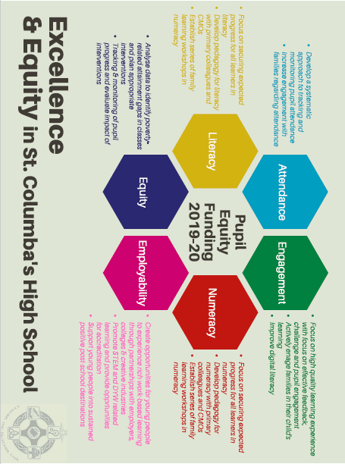
St. Columba’s High School - Pupil Equity Funding Overview 2019-20

PEF Plan 2019-20 Summary:

PEF Team:
PT Literacy, PT Numeracy PT Equity, PT STEM/DYW, Wellbeing Officer, ASN auxiliary Lit/Num
and DHT Excellence & Equity.

Literacy:
PT Literacy has developed and delivered and number of initiatives across the school, with a particular focus on S1-3. These include, the Fresh Start Programme (S1 & S2), identifying pupils who need extra support and its provision, Literacy Leadership programme for S6, Active Schools Literacy Programme, reading challenges/incentives, cluster moderation and primary liaison in literacy. Initial reading age data demonstrates significant progress for some pupils since starting programme in August ‘19:
Pupil | Reading Age in May ’19 (yrs) | Reading Age in Jan ’20 (yrs) | Increase (yrs)
A | 8.4 | 11.1 | 2.7
B | 8.10 | 11.2 | 3.1
C | 8.6 | 9.10 | 0.5

Numeracy:
PT Numeracy has developed and delivered an range of initiatives including, introducing 2nd/3rd level numeracy homework booklets in Maths, Primary Liaison in Numeracy, leading workshop at West Partnership Maths Conference, working closely with primary colleagues due to receiving STEM grant money, developing numeracy working group, numeracy drop in sessions for pupils and numeracy leadership for S6 pupils.

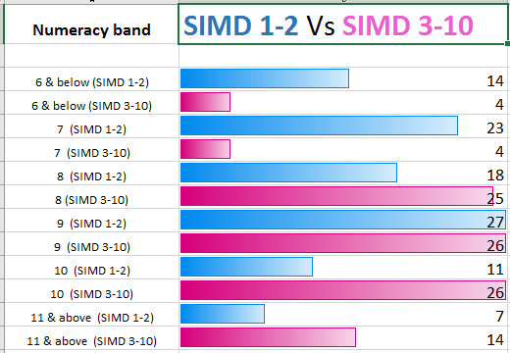
PT Numeracy has been monitoring S1 assessment data and comparing with p7 SNSA data to evaluate robustness.
There has been a strong correlation between the two data sets.
This data was shared with all staff in August 2019 and highlights ‘the gap’ in numeracy. It provides us with a baseline that can be used to measure progress in BGE.

STE(A)M / DYW:
PT STE(A)M /DYW implemented a number of initiatives and led a range of STEAM events/activities – with a specific focus on target groups e.g. SIMD1/2 , FME, Nurture groups
PT STE(A)M/DYW input was also significant across the whole school with specific focus on Work Experience, Careers, Employability, Apprenticeships, Positive Destinations, Enterprise, Parental Engagement.
Equity
A group of S3 pupils were identified as requiring an extra layer of pastoral care and a number of interventions were put in place to help with attendance, late-coming, engagement, behaviour and wellbeing. A breakfast nurture group was established and was well received with a number of improvements evident, particularly around attendance.
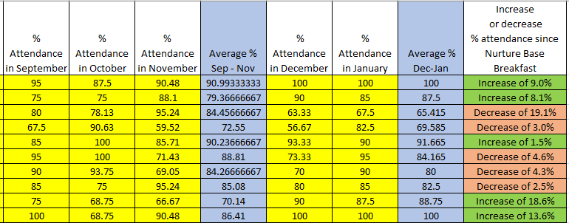

This data shows significant improvements in attendance for half of the target group. Only one pupil showed a significant decrease in attendance but this individual’s attendance is significantly improved since May 2020.
Data Analysis:
Teacher Professional Judgement and SNSA data from P7 was analysed and shared with all staff to help raise awareness of SNSA , ‘the gap’ and to identify interventions at an early stage in S1.
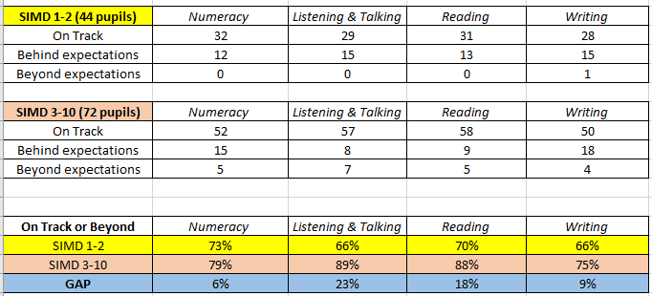
Important to note the greatest ‘gap’ in our S1 is evidenced in Listening & Talking and Reading. The positive ‘gap’ data for Numeracy and Writing could be attributed to improved cluster working and increased moderation focus in these areas.

S3 SNSA & SQA data was also analysed. Candidates who achieved 5+ N5s had achieved the following bands in S3 SNSAs:
Numeracy - The majority of those who achieved 5+ Nat 5 awards at A-C had achieved Band 9 or higher in S3 (only one candidate in the Band 8 category achieved 5+ Nat5s).
Reading - The majority of those who achieved 5+ Nat 5 awards at A-C had achieved Band 8 or higher in S3 (two candidates in the Band 7 or below category achieved 5+ Nat5s).
Writing - The majority of those who achieved 5+ Nat 5 awards at A-C had achieved Band 9 or higher in S3 (only one candidate who had a Band 8 achieved 5+ Nat5s).
Previous S4 performance in N5 Maths and English was also analysed and compared with S3 SNSA data.
The current S4 SNSA data was then used to ensure that every pupil was entered at the highest possible level in English/Maths and to set aspirational targets.
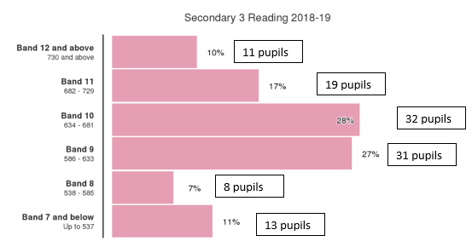
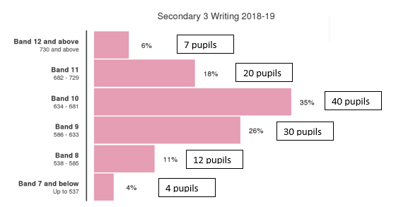

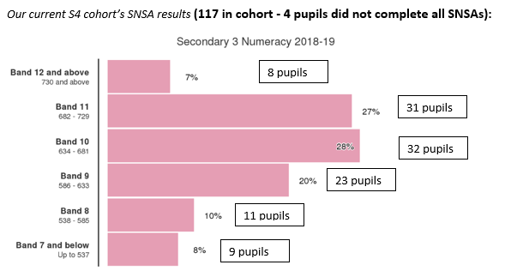
Numeracy:

This data was also shared with teachers in all subjects and presentation levels and attainment in S4 has shown a significant improvement this session. It is important to note that a number of this S4 cohort have had two years of significant PEF interventions in S2 and S3.
Previous S4 SQA attainment summary:

Current S4 presentation summary:
Greatly increased presentation at N5 this session - especially at
3+ and 5+ @N5.
Significant increase in presentation levels of those in SIMD1/2.

Post Prelim analysis shows significant progress particularly at 3+ N5 attainment:
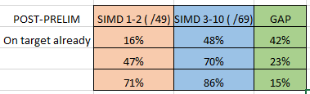

5+@N5
3+@N5
1+@N5

Parental Engagement:
A continued focus on engaging parents in their child’s learning is an ongoing priority. This session our parental engagement developments included: Study skills and Mindset supported study for pupils and parents; Family Cook School; Family fitness sessions; Family learning newsletter and PEF steering group established to share suggestions for use of funding and evidence of impact.

Next Steps:
Sustainability:
Continue to focus on evaluating the evidence of impact and embedding interventions to ensure sustainability.
Our aim is that as the culture continues to evolve in the school, the role of DHT Equity and Excellence will no longer be needed as all staff will have equity as part of their values.
The PEF team themselves are focussed on raising capacity and excellence in all staff, again these roles will eventually be no longer needed.

Parental engagement:
Increase focus of all departments on Family learning and parental engagement.
Analyse impact of family learning initiatives.
Further develop the PEF steering group (Parents, non-PEF staff and pupils) established this session and calendar termly meetings to share impact and interventions.

Relentless focus on Excellence & Equity:
Further develop our in-house CLPL programme to continue to focus on Excellent Teaching & Learning through an equity lens.
Use Insight, TPJ and SNSA data to analyse ‘the gap’ in each individual subject area.
Which departments and which qualifications have most success with pupils from SIMD 1/2?
Why is this? How can these strategies be shared?

Response to Covid-19 Lockdown closure – March 2020 – June 2020

In order to maintain continuity of learning, our remote learning offer platforms included Microsoft Teams and YouTube videos. Teaching staff used these platforms to expose pupils to new learning and to set tasks and assignments which supported learning and engagement. Pupil engagement with this remote learning offer has been variable with a range of factors contributing to this including: access to ICT; confidence in using ICT; and self-motivation. In order to address equity of access, we have been supported by the local authority to provide additional laptops to families where the need is greatest. Furthermore, we have contacted families to ascertain what level of support they require in order to increase pupil engagement. We have received very helpful feedback from families to inform what is working well and what could be further improved.

During the initial stages of lockdown, daily contact was maintained with all staff in an attempt to monitor staff welfare. As a result, staff continued to feel connected with their colleagues and the school community as a whole. Regular contact with all staff has been maintained throughout lockdown and a range of digital platforms have supported regular opportunities for collegiate discussion and connectedness.

Our Pupil Support Team have maintained regular contact with all families in their caseload. Furthermore, we have worked in partnership with Barnardos, Home-School Link worker, Social Work, and CLD to support our most vulnerable families including those in need of child protection. Feedback from families regarding our offer of support has been extremely positive.

A significant number of teaching and non-teaching staff have supported the Moorfoot Hub during lockdown. This enable children of key workers and some of our most vulnerable children access to childcare in a safe and nurturing environment. Feedback from pupils and parents was very positive and there was a recurring theme of appreciation of staff and their commitment to young people in the Hub.

