Hi. D&M - Homework Task – Ergonomics
Questions
- Describe how ergonomics has influenced the design of this kettle. To attract full marks you must include the influence of all three areas of ergonomics in your answer.
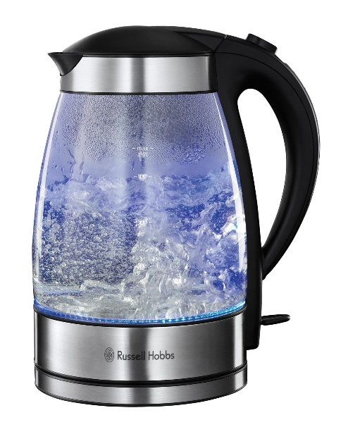
- Identify which percentile would have been considered when designing various aspects of this armchair (e.g. adult female 95th). Use your data booklet to help you.
  - Height of seat cushion from floor (popliteal height)
  - Height of back rest (sitting height)
  - Length of seat cushion (buttock-popliteal length)
  - Length of arm rest (forward reach)
  - Width of back rest (shoulder width)
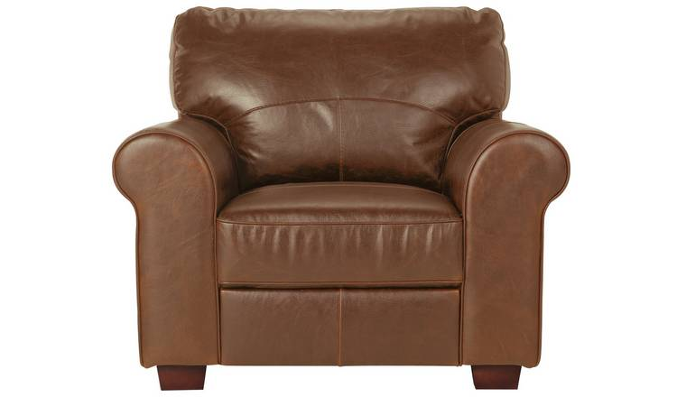
- Describe how physiology has influenced the design of this lawnmower.
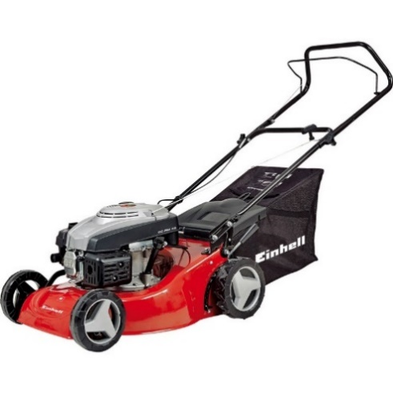
- Describe how psychology has influenced the design of this microwave.
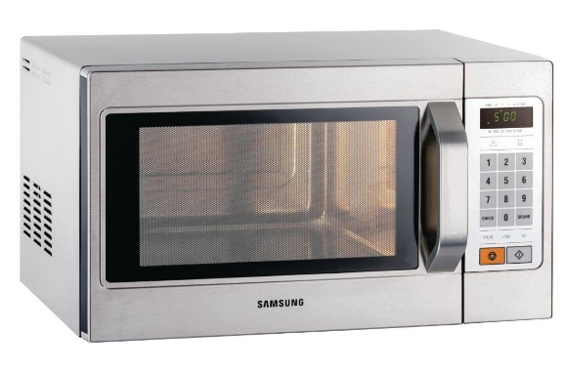
- Apply the seven stages of action for the goal of adjusting the volume on a television. Write this is a list. Stage 1 has been given for you. 1) Adjust the volume on the television.
- Describe how ergonomics has influence the design of this child's highchair. To attract full marks you must include the influence of all three areas of ergonomics in your answer.
