Hi. D&M - Homework Task 1 (Brief Analysis, Research and Specifications)
Questions
- A design brief with lots of specific information regarding materials, manufacturing process and product features can be described as a...
  - open brief.
  - closed brief.
- Explain why the designer may prefer an “open brief” rather than a “closed
brief”.
- Secondary research is research which...
  - ...has been carried out by the designer themselves.
  - ...has been carried out previously by a third party which the designer then refers to.
- Describe why should questionnaires include both open and closed questions?
- Quantitative data is best represented in...
  - ...graphs and charts.
  - ...key quotes from responses.
- Describe the difference between a user trial and a user trip.
- What information can be gained from using test rigs?
- Product comparisons are useful for gaining what kind of information about products? List as many examples as you can.
- Describe the information that would be identified by user trials.
- Outline a product specification for this chair. Some of its features are listed below.
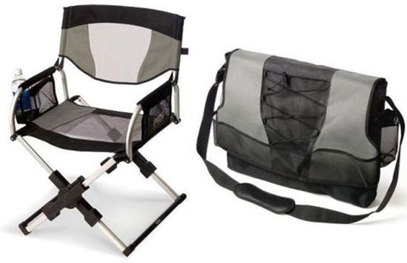

  - Less than 100 mm thick when folded.
  - Comes with telescoping legs and folding backrest.
  - Made from aluminium, plastic and nylon mesh seat.
  - Integrated cup holder and two pockets in the armrests.
  - Retail price £95

