National 5
SQL
Cheat Sheet

To search for and display data:
SELECT field1, field2 …
FROM table1, table2
WHERE condition1
AND condition2…
ORDER BY field1 ASC, field1 DESC;

To add a new complete record:
INSERT INTO table
VALUES ("data", "data", "data", "data");

To add a new, partially complete record:
INSERT INTO table (field1, field2, …)
VALUES ("data for field 1", "data for field 2", …);

To update the data in a record(s):
UPDATE table
SET field1 = "data1", field2 = "data2"
WHERE condition;

To delete records from a table:
DELETE FROM table
WHERE condition1
AND condition2;
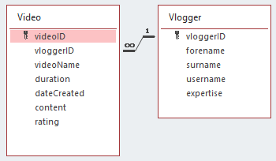
Video table (sample data)
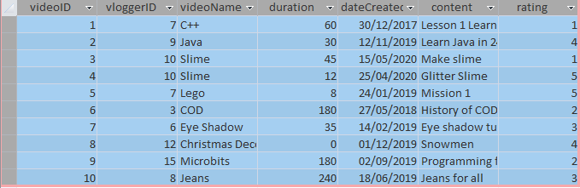
Vlogger table (sample data)
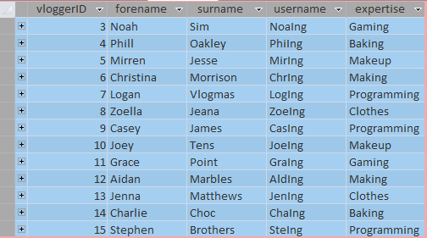

The above database is available from:
https://www.sqa.org.uk/pastpapers/papers/papers/2019/N5_Computing-Science_Assignment-Electronic-Files_2019.zip
SQL questions using the 2019 Assignment vlogger database.
Write SQL statements that could be used to implement the requests below.
- Display the video name and video duration of the video called “Microbits”.
- Remove the vlogger, Jenna Matthews, ID 13 from the database.
- Display the full names of all the Makeup experts.
- Display all the videos (name and date created) with a rating of 1. The data should be displayed from the oldest video to the newest.
- Add the following new vlogger to the database: vloggerID 16, Jenna Atkins, jening, Programming
- Display the forename and surname of the vlogger(s) who have created a Gaming video less than 60 minutes long. The vloggers should be displayed in alphabetical order of surname.
- vlogger 12 created a new video today called Jumpers. The video is 43 minutes long, includes “description of jumper types” and has been given a rating of 4.
Add the new video to the database.
- The database will no longer store the details of vloggers who specialise in Programming videos. Remove all these vloggers from the database.
- The expertise Gaming has been widened to cover other types of game. Change the expertise from “Gaming” to “Games”.
- Display all video IDs and names of every video created on the 25th April 2019 by baking experts.
- Add a new vlogger, Giles Cannon to the database. You’ll need to make up an ID and username for Giles. You don’t know what his expertise is yet.
- A decision has been made to change the rating system so that the maximum rating is 4 instead of 5. Any videos currently rated 5 should be changed to 4.
- Display the vlogger’s name, expertise, video name and duration of any video between 30 and 180 minutes long. The videos should be displayed from the longest video to the shortest.
- Display the complete details of any vlogger who has had at least a rating of 4.
- Noah Sim has requested that all his videos are removed from the database. Implement Noah’s request.
- Display the names of all the videos created by a programming expert, with a rating of 4 that are less than 60 minutes long. The video names should be displayed in alphabetical order.

