N5 Business Management
Management of Marketing
Questions Booklet
Name:
Class:
Teacher:

St Columba’s High School
ICT FACULTY







About This Booklet

This booklet is can be used to set questions as part of class work and homework at the teacher’s judgement to suit the needs of learners in the class. Stage 1 questions are generally less challenging than Stage 2 questions. Pupils should use the command words guide to aid them in their responses.

STAGE 1 QUESTIONS – MARKETING

MARKETING TERMINOLOGY
- Suggest one reason why it is important to be the market leader. (1)
- Define the term ‘Market’ (1)
MARKET SEGMENTATION AND MARKET RESEARCH
- Carla and her brother Fabio decided to go into partnership opening a children’s nursery in Peebles. Before going into business they carried out market research.
Suggest one market segment which Carla and Fabio will target. (1)
- Outline 3 ways small businesses use market research to satisfy customer needs. (3)
- Describe 2 benefits of market segmentation. (2)
- Name and describe the 2 types of market research. (4)
- Sony, Microsoft and Nintendo carry out market research.
Identify and describe 2 methods of field research and 2 methods of desk research. (4)
- Give one advantage and one disadvantage of using field research to get information. (2)

PRODUCT
BRANDING
- Describe the term “brand name”. (1)
- Glenmorangie, the whisky group, has revealed a new brand image.
Suggest 2 possible reasons why Glenmorangie changed their brand image. (2)

PRICE

  - Identify and describe one method of pricing that a business may use. (2)
  - Give 2 reasons why choosing a suitable price is important. (2)
- Jimmy Choo shoes are sold at a premium price.
Describe premium pricing. (1)
PROMOTION
- Identify 3 promotional strategies used by small businesses. (3)
- Suggest 2 ways a company such as BP could make customers more aware of their brand. (2)

TECHNOLOGY IN MARKETING

- The Tobermory Chocolate Company sell their chocolates online through their website.
  - Give 2 advantages of selling chocolates online. (2)
  - Give 2 disadvantages of selling chocolates online. (2)
- Give 2 advantages to the organisation and 2 advantages to the customer of online shopping. (4)

END OF STAGE 1 QUESTIONS

STAGE 2 QUESTIONS – MARKETING

THE ROLE OF MARKETING
- Describe the role of the Marketing Department in an organisation. (4)

MARKETING TERMINOLOGY
- Define the term “market share”. (1)
- Describe the term “market leader”. (1)

MARKET SEGMENTATION AND MARKET RESEARCH

- The Hub, based in Glasgow, is a Social Enterprise. It offers sports, youth and homework clubs, IT classes for the elderly and fitness classes. It also has a sports shop and a cafe which members can use.
Identify 2 market segments that the organisation is targeting. (2)
N5 2015 S1 Q1a (Adapted)

- The Aurora Hotel Collection has a wide range of customers.
Outline 4 methods which the Aurora Hotel Collection could use to segment their customers. (4)
- Outline 3 reasons why organisations use target marketing. (3)

- Give an example of:
  - field research (1)
  - desk research (1)
- Describe how market research can help managers plan decisions in the business. (2)
- Describe 3 benefits of market research. (3)
- Suggest and justify an appropriate method of field (primary) research and desk (secondary) research that a business such as Greggs could use to gather market research. (4)
- Describe 2 advantages and 2 disadvantages of using field research. (4)
- Identify and describe 4 methods of field research that could be used by an organisation. (8)
- Compare desk research and field research. (3)
N5 Spec S2 Q3c
- Identify and describe 2 methods of sampling the Marketing Department could use. (4)

- Discuss the costs and benefits of using desk research (4)
N5 2015 S2 Q6b

PRODUCT
BRANDING
- Describe the advantages of branding to an organisation (4)
N5 Spec S2 Q3b
- Mackie’s is a well-known Scottish company.
Describe 3 advantages to Mackie’s of having a strong brand when diversifying into new markets. (3)
- Outline 3 of the possible drawbacks (costs) of developing a brand name. (3)

- Explain the benefits to a business of having a strong brand. (2)
N5 2015 S1 Q2c
PRICE
- The whisky industry in Scotland is still booming.
Identify 3 other factors an organisation may consider when setting the price of a product. (3)
- Describe pricing methods that an organisation could use other than premium pricing. (4)
- Compare 2 pricing methods an organisation could use. (2)

- Describe factors that The Hydro will consider before setting prices for tickets. (3)
N5 Spec S1 Q2; N5 2014 S1 Q2e

PLACE
- TRAID is a charity that recycles and re-uses Britain’s unwanted clothes and shoes by selling clothes back to the public in one of their charity shops in London or via their website.
Outline 3 reasons for a charity such as TRAID operating in London and online. (3)
- Describe methods that can be used to sell goods directly to customers. (4)
- The Big Issue could use rail to deliver its magazines to its distribution points nationwide.
  - Identify another method of distribution. (1)
  - State the advantages and disadvantages of this method. (4)
N5 2014 S1 Q2d

PROMOTION
- Identify and outline 3 methods of promotion that could be used in business to improve market share. (6)
- Outline 2 methods a (small) organisation might use to market its products, other than using a website. (2)
- Compare 2 of the benefits of using social networking to print media advertising. (2)
- Businesses use promotional activities.
Identify and describe 3 methods of promotion that can be used by an organisation in order to attract customers. (6)

  - Identify 3 methods of advertising that a business could use. (3)
  - For each of the methods you have identified, describe a different advantage and disadvantage. (6)

- Promotion is an element of the marketing mix.
- Describe the other elements of the marketing mix (3)
- Outline the methods of sales promotion which an organisation could use (3)
N5 2015 S2 Q6a
- Read the case study below and answer the questions that follow
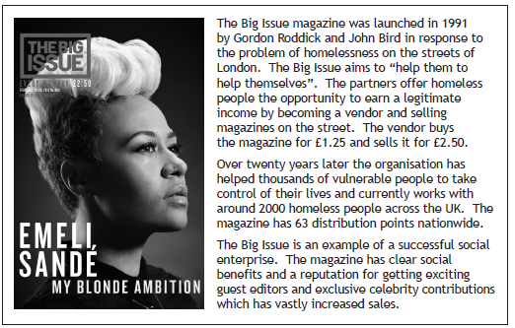

- From the case study, identify the method of promotion that is used by The Big Issue. (1)
- Describe other methods of promotion that could be used by The Big Issue (3)
N5 2014 S1 Q2b

THE MARKETING MIX
- Identify and describe the 4 elements of the marketing mix. (8)
- Suggest how a business such as Greggs could adapt the 4 elements of the marketing mix in order to win customers from its rivals. (4)
- For each element of the marketing mix, describe 2 activities an organisation could undertake to increase sales. (8)
Outline 3 benefits of having different products for different customers. (3)

RESEARCH & DEVELOPMENT
- Describe the term “prototype”. (1)
- Outline 3 of the key stages used by organisations when developing a new product. (3)
- Describe 3 stages involved in bringing a new product to market. (3)

PRODUCT LIFE CYCLE AND EXTENSION STRATEGIES
- Introduction is the first stage in the product life cycle.
Identify the other stages of the product life cycle (3)
N5 Spec S2 Q3a
- Draw and label a diagram of the product life cycle. (3)

- Describe 4 actions that an organisation may take to revitalise sales of a product that is in decline. (4)
- Suggest and justify how altering the “Product” and “Price” elements of the Marketing Mix could extend the Product Life Cycle of a Sony Laptop. (4)

- Suggest methods used by manufacturers to extend the life cycle of a product. (6)
- Describe 4 ways of extending the life of a product. (4)
- Other than new versions of the product, describe and justify 2 ways in which Ford could extend the Product Life Cycle of its cars. (4)
- Read the case study below and answer the questions which follow
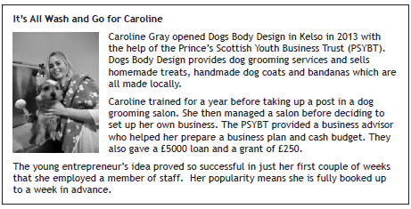
- From the case study, identify the stage of the product life cycle for Caroline’s business (1)
- Describe the stage identified in part (a) (1)
N5 2014 S1 Q1e

ETHICAL MARKETING

- Discuss the importance of ethical marketing in modern business. (2)

TECHNOLOGY IN MARKETING

- Outline ways in which technology can contribute to effective marketing. (3)

END OF STAGE 2 QUESTIONS

