N5 Business Management
Management of Finance
Questions Booklet

St Columba’s High School
ICT FACULTY




Name:
Class:
Teacher:

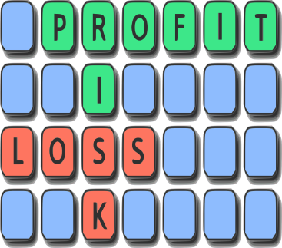


About This Booklet

This booklet is can be used to set questions as part of class work and homework at the teacher’s judgement to suit the needs of learners in the class. Stage 1 questions are generally less challenging than Stage 2 questions. Pupils should be issued with the command words guide to aid them in their responses.

STAGE 1 – MANAGEMENT OF FINANCE

SOURCES OF FINANCE
- Name and describe the main sources of finance for a public sector organisation. (4 Marks)
- Suggest and justify 2 sources of finance an entrepreneur could have used when starting their own business. Use a different justification for each suggestion.
(4 Marks)
- Charan raised capital through friends and family along with a bank loan.
Give one advantage and one disadvantage of using a bank loan. (2 Marks)
- Give one advantage and one disadvantage of having a grant as a source of finance for a business. (2 Marks)
- TRAID is a charity that re-uses and recycles Britain’s unwanted clothes and shoes.
Other than selling remade clothes, describe 2 ways TRAID could raise funds. (2 Marks)

SOURCES OF ASSISTANCE

- Identify and describe 3 sources of advice/support available to small businesses.
(6 marks)

END OF STAGE 1 QUESTIONS
STAGE 2 – MANAGEMENT OF FINANCE

SOURCES OF FINANACE

- Identify and describe2 sources of finance available to a start-up business, other than obtaining finance from the local council. (4 Marks)
- Identify and describe 2 sources of finance that may be available to a partnership. (4 Marks)
- Identify and describe 2 sources of finance available to a private limited company. (4 Marks)
- Other than donations, identify 3 other sources of finance available to a charity that wishes to open up a new shop.(3 Marks)
- Describe 2 benefits to an organisation of using a bank loan as a source of finance. (2 Marks)
- Outline one advantage and one disadvantage of purchasing goods on credit. (2 Marks)
- A business has approached a venture capital organisation as a potential source of finance.
Describe one advantage and one disadvantage of this source of finance. (2 Marks)
- Rizwan and his sister Azia run a family owned restaurant and are considering applying for a bank loan. They could also apply for a grant.
Identify an organisation which might provide a grant. (1 Mark)
- Give a reason why a young entrepreneur might go to YBS (Prince’s Trust Youth Business Scotland) for financial support rather than their bank.
(1 mark)
- Identify 2 areas of support, other than finance, provided by YBS. (2 Marks)
- There are a number of different methods of finance available to businesses.
Distinguish between a loan and a grant. (2 Marks)
- Explain one advantage and one disadvantage of using a bank loan as a source of finance (2 Marks)

- Read the following case study and answer the question below

EMMA CHANG

Emma Chang is 28 years old and has worked for a well-known American Bar Diner as a restaurant manager for four years. She works extremely long and unsociable hours and has now decided to leave the company and put all her skills, expertise and dedication into her own business. She would like to open up her own delicatessen/café. She has some savings put aside for her new venture.

Emma is currently in the process of looking at sites, deciding upon furniture, fittings and decoration for her premises and making decisions about what stock she would like to sell in her deli.

From the case study, identify and justify the source of finance which Emma has decided to use to start her own business (2 Marks)

- Justify the use of the following sources of finance:
- a bank loan
- a grant
- an overdraft
(3 marks)
N5 2015 S2 Q3d

SOURCES OF ASSISTANCE

- Describe the type of advice the following individuals/groups could offer an organisation (a different type of advice must be given for each):
a) Lawyer b) Accountant c) Banks
(3 Marks)

- Other than Youth Business Scotland, suggest and justify another source of advice for young entrepreneurs. (2 Marks)

- Asif recently received assistance from YBS for his business.
(a) Give a reason Asif approached YBS for financial support rather than his bank. (1 Mark)

(b) Identify 2 areas of support, other than finance, provided by YBS. (2 Marks)
N5 Spec S1 Q1a (Adapted)

- Read the case study below and answer the question that follows
Caroline Gray opened Dogs Body Design in Kelso in 2013 with the help of the Prince’s Scottish Youth Business Trust (PSYBT). Dogs Body Design provides dog grooming services and sells homemade treats, handmade dog coats and bandanas which are all made locally.
Caroline trained for a year before taking up a post in a dog grooming salon. She then managed a salon before deciding to set up her own business. The PSYBT provided a business advisor who helped her prepare a business plan and cash budget. They also gave a £5000 loan and a grant of £250.
The young entrepreneur’s idea proved so successful in just her first couple of weeks that she employed a member of staff. Her popularity means she is fully booked up to a week in advance.

From the case study, compare the 2 types of finance provided by the PSYBT. (2 Marks)
N5 2014 S1 Q1b

INCOME STATEMENTS

- Describe the use of an income statement (2)
RS 2014 S2 Q5

- Define the following terms found in a profit statement.
- gross profit
- net profit
(2 marks)
N5 Spec 2013
- Distinguish between the following terms:
- Gross profit and net profit (1)
21.
INCOME STATEMENT
 | £ | £
Sales revenue |  | 200,000
Less: Cost of sales |  | A
Gross profit |  | (100,000)
Less: Expenses
Advertising costs | 20,000
It equipment | 20,000
Interest and bank charges | B
Wages | 55,000 | 100,000
Profit/(Loss) for the year |  | C

 |  | (a) | From the income statement, calculate the figures at points A, B and C. | 3
 |  | (b) | Describe 3 different ways the business could improve its profit/loss figure. | 3
RS 2015 S2 Q3a

CASH FLOW AND CASH BUDGETS
- Define the following terms used in a cash budget (2)
- Opening balance
- Total payments
RS 2015 S2Q3c

- Justify the use of cash budgets for an organisation. (4)
- Describe measures an organisation can take when faced with a negative cash balance in their cash budget. (3)

- Describe the actions that can be taken by an organisation to reduce costs. (3)
N5 2014 S2 Q4b

Cash Budget
 | £ | £ | £
Month | Jan | Feb | Mar
Opening Balance | 1,100.00 | 1,000.00 | 600.00
Receipts
Cash Sales | 700.00 | 600.00 | 500.00
Credit Sales | 600.00 | 400.00 | 400.00
Total Receipts | 1,300.00 | 1,000.00 | 900.00
Expenses
Rent | 500.00 | 500.00 | 700.00
Purchase of Stock | 600.00 | 600.00 | 600.00
Wages | 300.00 | 300.00 | 300.00
Total Expenses | 1,400.00 | 1,400.00 | 1,600.00
Closing Balance | 1,000.00 | 600.00 | -100.00
From the cash budget, identify concerns that the business may have. (2)

BREAK EVEN

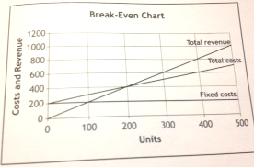
 | (a) | From the break even chart, identify:  - the number of units sold at break-even point  - total revenue at break even point | 2
 | (b) | Calculate the selling price per unit. | 1
 | (c) | Define the term “fixed costs” and give an example of a fixed cost. | 2
N5 Spec 2013

- Define the following financial terms. (3)
• Fixed Costs
• Variable Costs
• Sales Revenue
N5 2014 S2 Q4a
- Distinguish between the following terms:
- Fixed costs and variable costs (1)

- Give 2 examples of variable costs (2)

 | Maddy Taylor is the owner and only employee of a cake-making business called Charm Cakes. She has produced the following break-even chart based on sales of her standard cakes.
 | 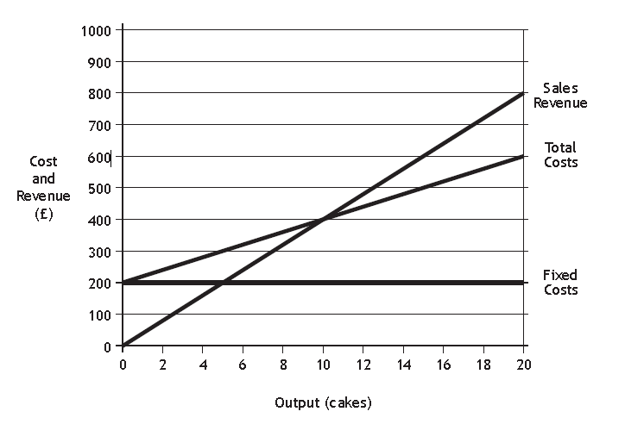
 | (a) | From the break even chart, identify:  • the number of cakes sold at the Break-Even Point;  • Total Costs at Break-Even Point. | 2
 | (b) | From the chart, calculate the Variable Cost per Unit. | 2
 | (c) | Define the following terms.  • Break-Even | 1
N5 2015 S2 Q3
- 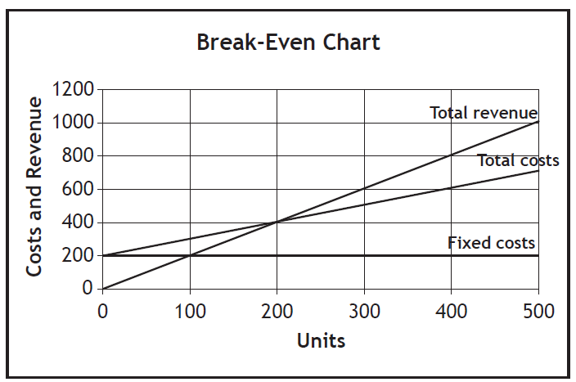
(a) From the break-even chart, identify:
• the number of units sold at break-even point (1)
• total revenue at break-even point. (1)
(b) Calculate the selling price per unit. (1)
(c) Define the term “fixed costs” and give an example of a fixed cost. (2)

N5 Spec S2 Q6

- 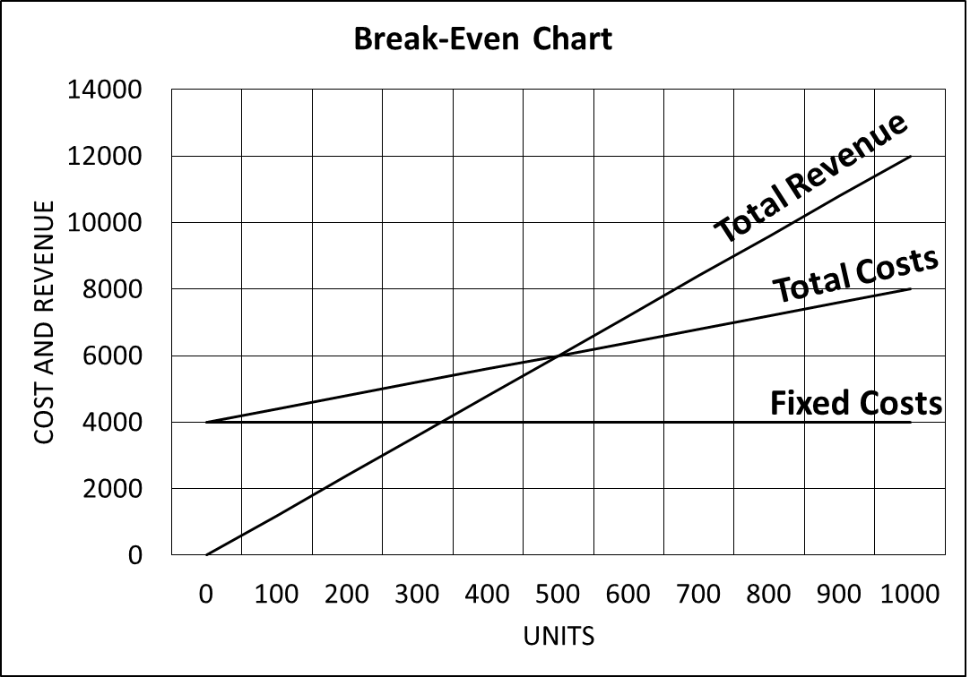
(a) | From the graph shown above, identify:  - the break-even point  - the fixed costs  - the total revenue when 1000 units are sold. | 3
(b) | Identify the possible fixed costs an organisation may have. | 2
RS 2013 S2 Q5

 | Define the following terms used in a Break-Even chart:  - total revenue  - units  - fixed costs. | 3
RS 2013 S2 Q3

TECHNOLOGY IN FINANCE

The finance department of an organisation will use ICT.

- Justify the use of a spreadsheet in the finance department (3)
- Describe the ways that other software can be used in the finance department. (3)
N5 Spec S2 Q6; N5 2014 S2 Q4

END OF STAGE 2 QUESTIONS

