St Andrew’s Primary
Anti-Bullying Policy

ng Policy

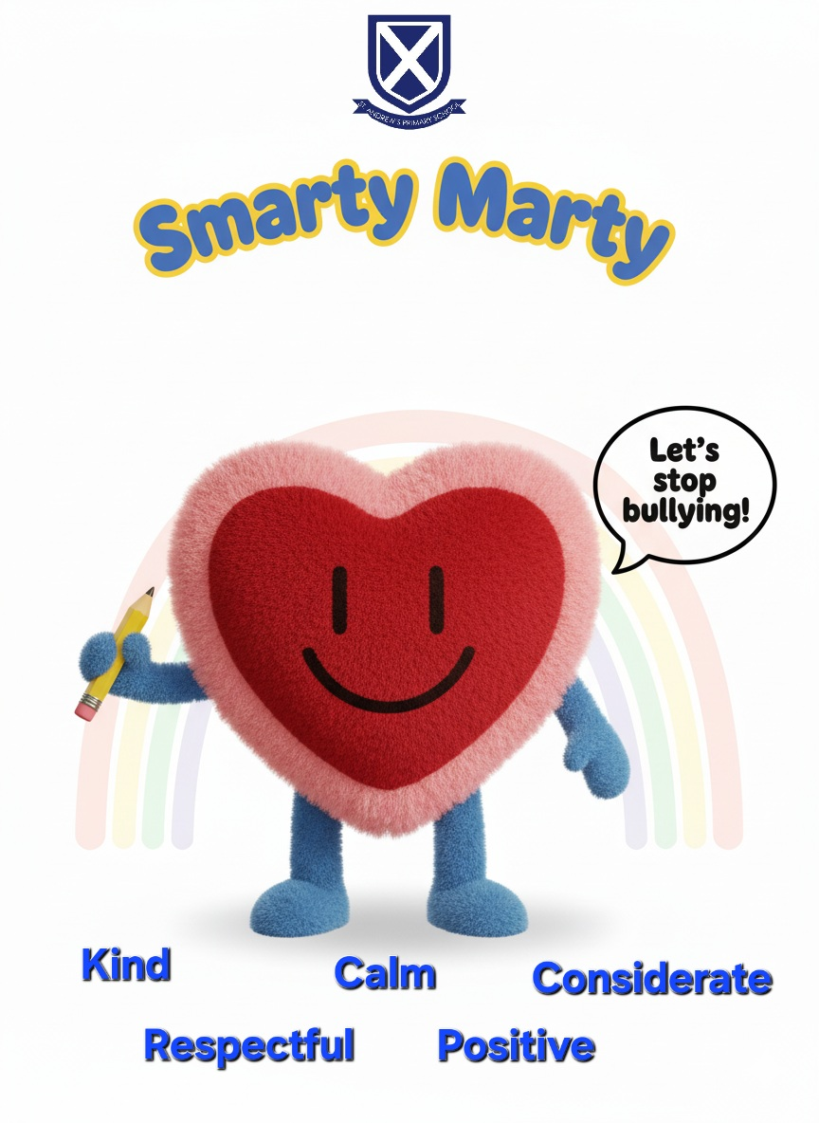

St Andrew’s Primary School

Anti-Bullying Policy

Sections
1. Introduction and scope
2. Our definition of bullying behaviour
3. What bullying is not
4. Legislative and policy framework
5. Aims and principles
6. Equality, inclusion and prejudice-based bullying
7. Prevention and early intervention
8. Roles and responsibilities
9. Reporting, recording and investigating concerns
10. Responding to bullying behaviour
11. Support, follow-up and escalation
12. Monitoring, evaluation and staff learning
13. Related policies and helpful links
14. Appendices

Policy information and version control
Policy Leads | Alan Connick (Head Teacher) / Anton Gallagher (Depute HT/Anti-Bullying Lead)
Version | October 2026
Approved by | TBC
Next formal review | Every three years, or sooner if required.
Consultation | Pupils, parents/carers, staff and relevant partners
1. Introduction and scope
St Andrew’s Primary School is committed to providing a safe, nurturing, inclusive and rights-respecting environment in which every child can learn, participate and thrive. Bullying behaviour is unacceptable and will never be treated as a normal or inevitable part of growing up.
This policy explains how the school prevents bullying, responds to concerns, records and monitors incidents, supports the children involved and works with families and partners. It applies to all pupils during the school day, on school transport, at school events and activities, and to online or out-of-school behaviour where there is an impact on a pupil’s wellbeing, safety, relationships or learning in school.
The policy is based on the Inverclyde Education Service Anti-Bullying Policy (2025) and Scotland’s national approach, Respect for All (2024). Where a concern also raises child protection, safeguarding or potentially criminal issues, the appropriate procedures will take priority and relevant agencies may be contacted.
Our commitment
Children and young people have the right to be safe, heard, respected and included. Reports will be taken seriously, considered fairly and responded to without labelling children.

Our approach reflects the school values:
• Take responsibility
• Act responsibly
• Show kindness
• Respect everyone
• Be honest
• Aspire to be more.
2. Our definition of bullying behaviour
In line with Respect for All (2024), and the definition adopted by Inverclyde Council:
National definition
“Bullying is face-to-face and/or online behaviour which impacts on a person’s sense of physical and emotional safety, their capacity to feel in control of their life and their ability to respond effectively to the situation they are in. The behaviour does not need to be repeated, or intended to cause harm, for it to have an impact. Bullying behaviour can be physical, emotional or verbal and can cause people to feel hurt, threatened, frightened and left out.”

Bullying behaviour may include:
• name-calling, teasing, put-downs or threats, in person or online
• hitting, pushing, tripping or other physical behaviour
• taking, hiding or damaging belongings
• ignoring, excluding or spreading rumours
• abusive messages, images or posts on social media, messaging, gaming platforms or devices
• behaviour that reduces a child’s sense of control, safety or belonging
• targeting someone because of who they are, or who they are perceived to be
• encouraging or involving a wider group, increasing the reach and impact of the behaviour.
Impact is central. Behaviour does not have to be repeated or intended to cause harm before it can be considered bullying. Staff will gather relevant information and use professional judgement in the context of each child and situation.
We use the terms “child experiencing bullying behaviour” and “child whose behaviour has caused harm”. We do not label children as “bullies” or “victims”.
3. What bullying is not
Not every disagreement, friendship difficulty, unkind comment or incident of distressed behaviour is bullying. Children may fall out, disagree or make mistakes as they learn to manage relationships. Such concerns still require an appropriate adult response, but the support and recording may be different.

Conflict
Conflict can occur in equal relationships. Those involved usually have a shared interest in resolving the difficulty and restoring the relationship. Examples may include an argument between friends, an isolated unkind remark, or rough play where all children were participating willingly. Staff will not dismiss these situations and will help children resolve them safely.

Potentially criminal or safeguarding behaviour
Some reported behaviour may be more serious than bullying and may require action under child protection, safeguarding or police procedures. The school will assess immediate risk, follow Inverclyde procedures and contact parents/carers and partner agencies where it is safe and appropriate to do so.
4. Legislative and policy framework
This policy should be read and applied in the context of current national and local requirements, including:
• United Nations Convention on the Rights of the Child (UNCRC), as incorporated into Scots law
• Children and Young People (Scotland) Act 2014 and Getting it right for every child (GIRFEC)
• Equality Act 2010, including the Public Sector Equality Duty
• Education (Additional Support for Learning) (Scotland) Act 2004, as amended
• Scottish Government, Respect for All: The National Approach to Anti-Bullying for Scotland’s Children and Young People (2024)
• Inverclyde Council Education Service Anti-Bullying Policy (2025)
• Inverclyde child protection, safeguarding, equalities, complaints and data-protection procedures.

Children’s rights and GIRFEC
Bullying behaviour can interfere with children’s rights, particularly the right not to be discriminated against, the right to have views heard and taken seriously, the right to protection from harm, the right to education and the right to recovery and support. Relevant UNCRC Articles include 2, 3, 12, 13, 19, 28, 29 and 39.
Our response will consider the child’s wellbeing across the GIRFEC indicators: Safe, Healthy, Achieving, Nurtured, Active, Respected, Responsible and Included (SHANARRI). Wellbeing assessment and planning will be proportionate to need and coordinated with existing plans where appropriate.
5. Aims and principles
The policy aims to:
• prevent bullying through an inclusive, nurturing, relational and whole-school approach
• ensure children know how to report concerns and trust that adults will act
• provide a clear, timely and consistent reporting, investigation and follow-up process
• support the wellbeing and rights of every child involved
• address behaviour, impact and underlying need without labelling or stigmatising children
• work in partnership with parents/carers, Education Services and other agencies
• use incident data and stakeholder feedback to improve practice.
Responses will be child-centred, proportionate, solution-focused and sensitive to age, development, communication and additional support needs. Restorative approaches may be used only where appropriate and safe. A child will not be pressured to meet or reconcile with another child.
6. Equality, inclusion and prejudice-based bullying
St Andrew’s Primary School will have due regard to the need to eliminate discrimination, advance equality of opportunity and foster good relations. We recognise that bullying can be related to actual or perceived identity, difference, association or vulnerability, and that experiences can overlap.
The Equality Act 2010 protected characteristics are age, disability, gender reassignment, marriage and civil partnership, pregnancy and maternity, race, religion or belief, sex and sexual orientation. In a school context, the duties applying to pupils are considered in line with legislation and local authority guidance. We also recognise bullying linked to additional support needs, care experience, poverty, family circumstances, body image, appearance, language or accent.
Prejudice-based incidents will be specifically identified and recorded. They will be addressed even where the behaviour is not assessed as bullying. Patterns will be monitored and used to plan education, supervision and support.

Additional support and communication needs
Some children may communicate distress or disclose concerns differently. Staff will make reasonable adjustments and use accessible approaches such as visuals, communication aids, trusted adults, additional processing time, adapted questions or support from a person who knows the child well. Behaviour associated with disability or additional support needs will be understood in context, while the impact on other children is still addressed.
7. Prevention and early intervention
Prevention is the most effective response. The school will build a culture in which rights, respect, equality, empathy and help-seeking are explicitly taught and consistently modelled.
• Teach respectful relationships, equalities, digital citizenship, emotional literacy and help-seeking through Health and Wellbeing and across the curriculum.
• Use assemblies, class discussion, anti-bullying learning and age-appropriate resources to challenge prejudice and celebrate diversity.
• Maintain appropriate supervision and review locations, times and online contexts where concerns are more likely to arise.
• Use nurturing, relational and restorative approaches to resolve difficulties early and repair harm where appropriate.
• Ensure each child can identify trusted adults and accessible ways to share a concern.
• Involve pupils through the Pupil Council, learner conversations, focus groups, surveys, class discussions and the Smarty Marty anti-bullying mascot and materials.
• Work with parents/carers to promote consistent messages about respectful behaviour, reporting and non-retaliation.
• Provide staff induction and regular professional learning on definitions, equalities, recording, investigation, online behaviour, communication needs and restorative practice.

Pupil voice
Pupils will help shape prevention work and policy review. Pupil voice will be gathered through whole-school surveys, assemblies and groups such as our pupil council. During an investigation, each child will be supported to share their account, views about safety and preferred support. Staff will explain what can happen next, record the child’s views and show how these influenced decisions. Where a requested action cannot be taken, the reason will be explained in an accessible way.
8. Roles and responsibilities

Children and young people will be supported to:
• treat others with kindness and respect in person and online
• tell a trusted adult if they experience, witness or are worried about bullying behaviour
• avoid retaliation and seek adult help
• share their views and participate in agreed support or restorative work where appropriate
• help create an inclusive school community.

Parents and carers are asked to:
• report concerns promptly to the class teacher or school leadership team
• listen calmly, keep relevant information or digital evidence, and reassure their child
• work with the school through the agreed investigation and support process
• encourage help-seeking rather than retaliation
• avoid naming or discussing children or incidents on social media
• use the school and Council complaints processes if concerns remain after investigation and follow-up.

All staff and volunteers will:
• know and apply this policy and the Inverclyde Education Service policy
• respond calmly, take all reports seriously and consider immediate safety
• make an initial factual note and pass concerns promptly to the designated lead
• avoid promising complete confidentiality and share information only where needed
• make reasonable adjustments for communication and additional support needs
• model inclusion and challenge prejudiced language and behaviour
• complete required training and contribute to prevention and monitoring.

Head Teacher and Anti-Bullying Lead will:
• lead or delegate a fair, timely investigation and keep appropriate oversight
• ensure parents/carers are informed, unless doing so could increase risk or conflict with safeguarding advice
• ensure incidents, decisions, prejudice factors, actions and outcomes are recorded accurately in SEEMIS
• coordinate support, follow-up and referrals
• monitor patterns, report appropriately and use findings for improvement
• ensure consultation, staff learning and formal policy review take place.

Inverclyde Education Services and partners
Education Services provides the authority framework, professional learning, advice and monitoring. The school may work with Educational Psychology, health services, Community Learning and Development, social work, Police Scotland or relevant third-sector services where this is necessary and proportionate.
9. Reporting, recording and investigating concerns

How to report
A concern may be raised by a child, parent/carer, member of staff, volunteer, witness or partner. Children can tell any trusted adult, use class or school worry-reporting arrangements, or ask another person to help them report. Parents/carers can contact the school in person, by telephone or by email.
• School telephone: 01475 715806
• School email: office@st-andrews.inverclyde.sch.uk
• Anti-Bullying Lead: Anton Gallagher
• Head Teacher: Alan Connick

Immediate response
The adult receiving the concern will listen without blame, acknowledge the impact, check immediate safety, record the main facts and explain the next step. Urgent risk will be acted on immediately. The concern will be passed to the Head Teacher or Depute Head Teacher/ Anti-Bullying Lead on the same school day, or as soon as practicable.

Recording
All reported bullying concerns and confirmed incidents will be recorded confidentially in the SEEMIS Bullying and Equalities module, in accordance with Inverclyde guidance. Records will distinguish reported information, evidence, professional assessment, action and outcome. They will include any prejudice-based element, online context, additional support or communication needs, parent/carer communication, support provided and planned follow-up. Data will be shared only with those who need it and handled in line with data-protection requirements.

Investigation process
1. Log the concern and assess immediate safety, wellbeing and safeguarding needs.
2. Speak separately and sensitively with the child who reported the concern, the child experiencing the impact, and the child or children whose behaviour may have caused harm.
3. Gather relevant witness accounts and contextual information from staff.
4. Where online behaviour is involved, preserve relevant evidence with support from parents/carers where appropriate.
5. Keep an open mind and avoid requiring children to repeat their account unnecessarily.
6. Consider impact, context, relationship dynamics, the national definition, patterns and any equality or additional support factors.
7. Decide whether the concern is bullying, conflict, a prejudice-based incident, another wellbeing/behaviour concern, or a safeguarding/potentially criminal matter.
8. Record the decision and reasons, agree actions and communicate the outcome as fully as confidentiality allows.

Expected timescales
Immediate / same school day | Listen, assess safety, record initial concern and notify the lead.
Within 1 school day | Investigation begins and parents/carers are normally informed.
Within 5 school days | Investigation is normally concluded and initial actions/outcome communicated.
If more time is needed | Parents/carers and children receive an update, reasons and a revised timescale.
Follow-up | Check-ins normally take place at about 2 weeks, 1 month and 3 months, adjusted to need.
Timescales are expectations rather than rigid limits. Safety, complexity, absence, safeguarding advice or partner-agency involvement may require a different timescale. The school will maintain communication when this happens.
10. Responding to bullying behaviour
Action will be proportionate to the circumstances and individual needs. A single standard consequence is not appropriate for every situation. The response will seek to stop the behaviour, reduce risk, repair harm where possible, restore the child’s sense of safety and help all children learn.

For the child experiencing bullying behaviour
• agree a safety and support plan with the child
• identify trusted adults and preferred check-in arrangements
• consider changes to supervision, routines, seating, groups or transitions
• provide nurture, counselling, wellbeing or partner support where appropriate
• address effects on attendance, participation or learning
• keep the child and parent/carer informed and review whether support is working.

For the child whose behaviour caused harm
• explain clearly the behaviour, its impact and what must change
• explore unmet need, communication, peer dynamics and contextual factors without excusing harm
• set clear expectations, support and proportionate consequences
• teach alternative skills, empathy, emotional regulation and respectful behaviour
• use restorative work only with informed agreement and when safe
• involve parents/carers and relevant support services
• monitor behaviour and recognise sustained positive change.

Restorative approaches
Restorative conversations may help children understand impact, take responsibility and agree how to put things right. They are not a substitute for investigation, safety planning or appropriate consequences. They will not be used to require an apology, force reconciliation or place responsibility on the child who experienced harm.
11. Support, follow-up and escalation

Follow-up
The designated lead will ensure agreed actions are completed and that the views of the children involved are revisited. Follow-up will normally occur at approximately 2 weeks, 1 month and 3 months, or more frequently where risk or need indicates. Records will be updated and support adjusted. A case will not be considered resolved solely because there have been no further reports; staff will check the child’s sense of safety, inclusion and control.

Referral and escalation
For persistent, serious or complex concerns, the school may convene a wellbeing meeting, update a Child’s Plan, seek advice from Education Services, or involve appropriate partners. Child protection procedures will be followed where there is a concern that a child may be at risk of significant harm. Police advice may be sought where behaviour may be criminal.

If a parent or carer remains dissatisfied
Parents/carers should first discuss concerns with the Head Teacher and allow the school to complete its investigation and follow-up. If they remain dissatisfied with how the matter has been handled, they may use the school’s complaints procedure and then Inverclyde Council’s complaints process. Information on the Council process is available at www.inverclyde.gov.uk/complaints. This does not prevent a parent/carer raising an urgent safeguarding concern at any time.
12. Monitoring, evaluation and staff learning
The Senior Leadership Team will monitor implementation rather than considering the policy complete once published. Monitoring will include:
• termly review of SEEMIS records for frequency, location, time, online context, prejudice factors, recurrence and groups disproportionately affected
• checking whether actions and follow-up were completed and effective
• pupil feedback through surveys, focus groups, learner conversations, Pupil Council and safe, accessible feedback methods
• parent/carer and staff feedback through consultation and evaluation
• review of supervision, curriculum and targeted prevention in response to patterns
• appropriate reporting to the Parent Council, Education Services and school improvement processes, using anonymised information.
Findings will inform the School Improvement Plan, Standards and Quality reporting, equalities work and professional learning. All staff will receive induction on this policy. Refresher learning will cover the national definition, prejudice-based bullying, online behaviour, recording, additional support and communication needs, investigation and restorative approaches.
The policy will be formally reviewed every three years, or sooner following significant national or local change, a serious incident, identified pattern or stakeholder feedback. Pupils, parents/carers and staff will be involved in review, and the school will explain the changes made as a result.

Consultation record
• Pupil Council meeting: February 2026
• Parental surveys: December 2025 and April 2026
• Staff surveys: November 2025 and April 2026
• Whole-school Anti-Bullying Mascot Competition: October 2025
• Further consultation and approval: TBC
13. Related policies and helpful links
This policy should be read alongside the school and Council policies and procedures on:
• Child protection and safeguarding
• Positive relationships, behaviour and restorative practice
• Equality and diversity
• Additional support for learning
• Digital learning and online safety
• Attendance and inclusion
• Complaints handling
• Data protection and information management.

Helpful links
• Inverclyde Education Service Anti-Bullying Policy (2025): https://www.inverclyde.gov.uk/assets/attach/20030/2025-04-Anti-bullying-Policy.pdf
• Respect for All (2024): https://www.gov.scot/publications/respect-national-approach-anti-bullying-scotlands-children-young-people/
• RespectMe: https://www.respectme.org.uk/
• Parentzone Scotland: https://education.gov.scot/parentzone/
• Childline: 0800 1111 | https://www.childline.org.uk/
• Police Scotland non-emergency: 101 | https://www.scotland.police.uk/

14. Appendices

Appendix 1: Reporting and response flowchart
1. Concern raised | Child, parent/carer, staff member or witness reports a concern, or staff notice signs.
2. Immediate response | Listen; reassure; check immediate safety; record key facts; do not promise complete confidentiality.
3. Notify and record | Pass to HT/DHT/Anti-Bullying Lead on the same school day; create/update the SEEMIS record.
4. Investigate | Speak separately with those involved; gather witnesses, context and relevant evidence; make communication adjustments.
5. Assess and decide | Apply the Respect for All definition; consider impact, equality, ASN, context, safeguarding and potential criminality.
6. Act and communicate | Agree safety, support, learning and proportionate consequences; inform children and parents/carers as confidentiality allows.
7. Follow up | Check wellbeing and impact at about 2 weeks, 1 month and 3 months; update records and adjust support.
8. Escalate if needed | Use wellbeing/Child’s Planning, partner referrals, Education Services advice, safeguarding or complaints processes as appropriate.

Appendix 2: Child-centred investigation prompts
Use developmentally appropriate language, visuals and communication supports. Avoid leading questions and unnecessary repetition.
• Tell me what happened, in your own way.
• Where and when did it happen? Who was there?
• How has this affected you at school, at home or online?
• What would help you feel safer and more in control now?
• Who are the adults you would like to help you?
• Is there anything that makes it easier or harder for you to tell us?
• What do you think should happen next?
• Is there anything you do not want to happen?
• When and how should we check in with you again?

Appendix 3: Restorative conversation guide
Use only after immediate safety and investigation have been addressed, and only where participation is appropriate and voluntary.
• What happened?
• What were you thinking or feeling at the time?
• Who has been affected, and in what way?
• What have you thought about since?
• What needs to happen to repair the harm?
• What support will help prevent this happening again?
• What will each person do next, and when will we review it?

Appendix 4: Examples of prejudice-based bullying
Examples include name-calling, exclusion, jokes, rumours, imitation, hostile online content, threats or physical behaviour connected to:
• race, ethnicity, nationality, language, colour or culture
• religion or belief
• disability or additional support needs
• sex, sexual orientation or gender reassignment
• care experience or family circumstances
• poverty, clothing or possessions
• body image, appearance or health.
This list is not exhaustive. Any prejudice-based incident will be challenged, supported and recorded appropriately, whether or not it is assessed as bullying.

Appendix 5: Quick record and quality check
☐ Immediate safety and safeguarding considered
☐ Child’s own words, views and desired support recorded
☐ Parents/carers informed or reason recorded
☐ All relevant accounts and evidence considered
☐ Impact, context and relationship dynamics assessed
☐ Prejudice-based factor considered and recorded
☐ ASN, disability and communication adjustments recorded
☐ Decision and rationale recorded
☐ Actions for each child recorded
☐ Review dates and responsible person identified
☐ Outcome and follow-up impact recorded

