
St. Andrew’s Primary School
Standards and Quality 2025 - 26

Context of the Establishment

Our school:
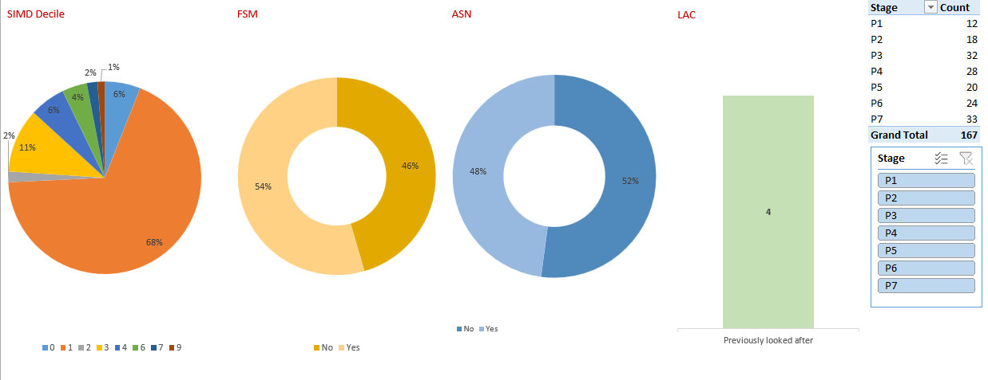

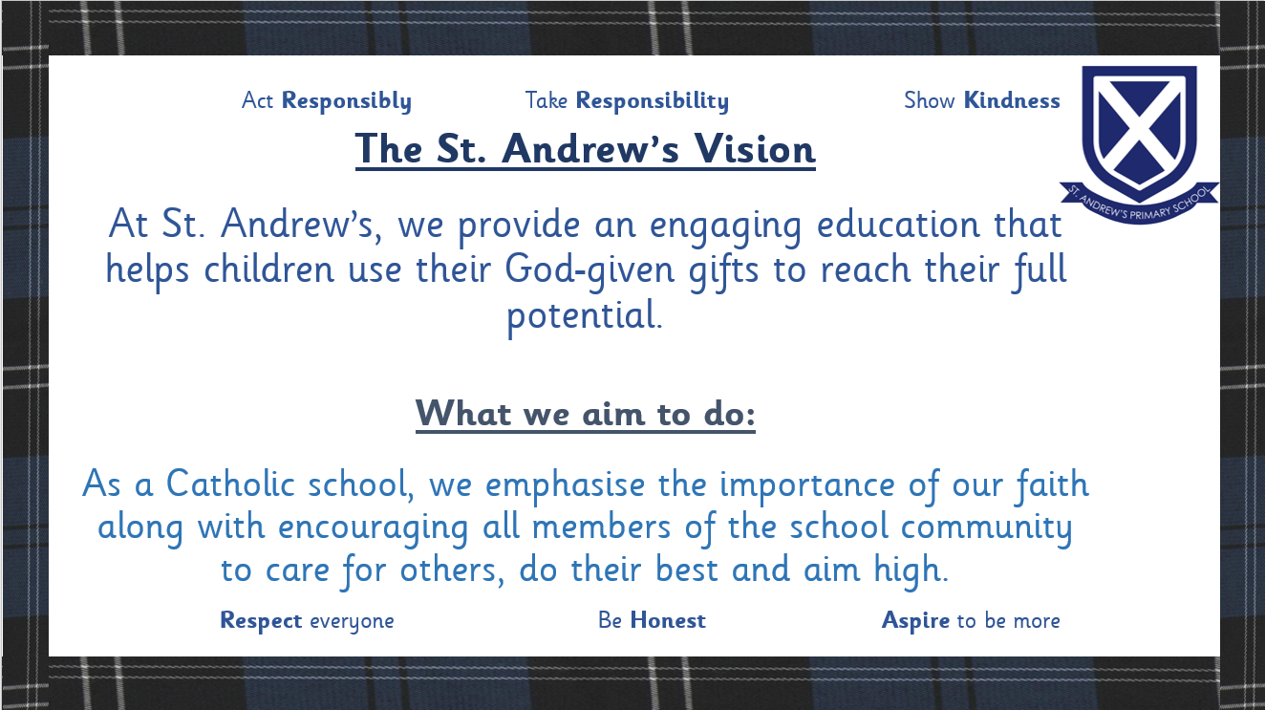

Establishment priority 1

NIF Priority  Closing the attainment gap between the most and least disadvantaged children and young people  Improvements in attainment, particularly in literacy and numeracy  National Improvement Framework Outcomes  4. High achievement and reduced attainment gap for all learners.  5. Skilled teachers and leaders delivering excellent, inclusive education. | HGIOS  2.3 Learning, teaching and assessment  3.2 Raising attainment and achievement  2.5 Family learning  UNCRC  Article 28: (Right to education):  Article 29 (Goals of education):
Outcomes:
- All teaching staff will investigate the revised Numeracy Strategy by the end of September and be able to access this for support as often as required.
- Learning observations will highlight improvements in practice in numeracy and maths as teachers will access and use the materials and resources in the strategy.
- All class teachers will create the Fact, Story, Action for their class using data available alongside recommended strategies for supporting pupils. This will be the basis for discussion in planning and progress meetings with the senior management team. All pupils will have increased focus on strategies for support and improvement.
- Identified pupils who are Behind Expectation or on track but at risk of falling behind will receive targeted intervention support in maths and numeracy from their own class teacher and additional teacher access. This will be short term ‘sprint’ input to ensure progress.
- At least 60% of all parents in the school will have attended and participated in a numeracy-based family learning activity by June 2026 to help further their understanding of current practices and how to help their child.
- All pupils will participate in at least one experience of outdoor learning every week from August ’25 until June ’26 either as part of Reduced Class Contact input or with their class teacher.
- Whole school attendance figure will increase by at least 1% to 92.5% by December 2025 and then to 93% by June 2026.

Progress and impact of outcomes for learners:
(Please ensure you have explicitly indicated how your PEF spend impacted on the outcome)
- All teaching staff accessed and made use of the revised Numeracy Strategy. Staff commented that there has been early impact in their teaching as a result. This will again have allotted time next session for staff to implement aspects in line with their new class.
- Through accessing the strategy, staff have become more aware of resources that are available. Some members of staff have been able to access these additional resources already to support teaching and learning.
- Peer observations of Number Talks took place with staff sharing feedback with colleagues. A summary was created which highlighted teachers encouraging multiple strategies for pupils, the use of higher-order questioning to encourage deeper thinking connected to mathematical concepts.
- Each class created a Fact, Story, Action report which identified pupils who were requiring additional support to become On Track or to stay On Track as well as planning interventions and support for others who are Beyond Expectation or further Behind. Senior managers, class teachers and PEF funded support teachers created a plan to ensure this additional support was offered and received. The plans were monitored and updated at regular intervals throughout the year.
- Sprint plans were created by class teachers and shared with Pupil Support Assistants/relevant members of staff. Plans were put in place and implemented with outcomes reflected in recent tracking.
- Stay and Play events were offered for parents of P1-3 pupils during Maths Week. This was a well-attended event – around 70% of parents attended the events.
- There were plans for parents to attend a numeracy showcase as part of National Numeracy Day – this was unable to go ahead due the ongoing works in the Assembly Hall.
- All classes participated in various blocks of outdoor learning lessons covering numeracy/maths, science and expressive arts. The positive impact of this on learning and teaching were shared during a collegiate session. Feedback from teaching staff was very positive and will be further developed next session. Pupil feedback is also very positive with very high levels of engagement being recorded too.
- Although we have not increased our average attendance figure to the targeted level our overall figure is slightly higher than last session. End of year average is 90.6%
In addition, we have reduced the number of pupils who had attendance under 90% last session. Overall, 56 pupils improved their attendance from this targeted group. 33 of these pupils (38%) of these pupils now have attendance above 90%.

Current levels of attainment and targets for improvement (Numeracy)
Stage | Numeracy
 | August ‘25 | Target | Achieved
Primary 1 | No target set |  | 92%
Primary 2 | 76% | 88% | 83%
Primary 3 | 77% | 83% | 69%
Primary 4 | 96% | 96% | 96%
Primary 5 | 70% | 75% | 75%
Primary 6 | 71% | 75% | 71%
Primary 7 | 77% | 82% | 82%

Overall attainment in Numeracy has increased or stayed in the same in almost all stages. The exception being Primary 3 where not only was the target not achieved but the overall level was lower than the beginning. This is partly due to an increase in the number of pupils at this stage and some children not making expected progress as the expectations increase.
Our challenging targets have been achieved in Primary 4,5 and 7 while consistent progress is evident in Primary 2 and 6.
Our Primary 1 group have a significantly high level of attainment which we will aim to ensure stays at this level.

Pupils currently Beyond Expectation and Targeted improvement (Numeracy)

Stage | Numeracy
 | August ‘25 | Target | Achieved
Primary 1 | No data |  | 4
Primary 2 | 3 | 3 | 4
Primary 3 | 5 | 5 | 6
Primary 4 | 3 | 4 | 5
Primary 5 | 1 | 2 | 2
Primary 6 | 1 | 4 | 2
Primary 7 | 1 | 4 | 7

In Primary 2,3,4 and 7 we exceeded our target for pupils who are Beyond Expectation. In Primary 5 and 6 we increased the number Beyond.

PEF used to support closing the gap: [This may differ from your planned spend. Delete if no PEF spend]
Class Teacher allocation 1.1 FTE £67967.00
Teejay Maths Resource £1536.47
Admin support for Attendance £1500.00

Next steps
- School engagement with Curriculum Improvement Cycle activities and all new documentation, advice etc.
- Continue use of Fact, Story, Action focusing on all pupils. Incorporate elements of ‘Sprint’ planning for targeted interventions which include class teacher, and PSA support and PEF funded support teacher,
- Enhance outdoor learning to create a progressive planner covering all stages. This will include elements of numeracy and maths as well as other curricular areas.
- Engage with documentation regarding the Curriculum Improvement Cycle throughout the year.
- Through staff discussions and ongoing allocation of time ensure the Numeracy strategy remains an essential resource for all staff.
- Develop a consistent school-wide approach to recording and evidencing progress in Number talks.
- Increase opportunities for parental showcases as well as family learning opportunities.
- Continue to implement the school Attendance policy while keeping the various stages of intervention under review.
- Create a clear Learning and Teaching in St. Andrew’s Policy in line with changes in our curriculum offer as well as the ongoing learning from the Improvement Cycle.
- Classes at Second Level will implement an ‘Activ8’ style approach to learning.

Establishment priority 2

NIF Priority  Improvements in attainment, particularly in literacy and numeracy  Closing the attainment gap between the most and least disadvantaged children and young people  National Improvement Framework Outcomes  4. High achievement and reduced attainment gap for all learners.  3. Inclusive curriculum and assessment for a sustainable future.  5. Skilled teachers and leaders delivering excellent, inclusive education. | HGIOS  2.3 Learning, teaching and assessment  3.2 Raising attainment and achievement  2.2 Curriculum  UNCRC  Article 29 (Goals of education):  Article 31 (Leisure, play and culture):
Outcomes:
- All pupils will benefit from the teacher’s access and use of the Literacy Strategy and the St. Andrew’s Teaching of Literacy Handbook to receive a consistent, progressive approach to their learning in Literacy.
- Learning observations will highlight good practice in Literacy, with particular reference to pupil talk as an essential part of all learning.
- All class teachers will create the Fact, Story, Action for their class using data available alongside recommended strategies for supporting pupils. This will be the basis for discussion in planning and progress meetings with the senior management team. All pupils will have increased focus on strategies for support and improvement.
- Identified pupils who are Behind Expectation or on track but at risk of falling behind will receive targeted intervention support in maths and numeracy from their own class teacher and additional teacher access. This will be short term ‘sprint’ input to ensure progress.
- All pupils will participate in progressive, weekly learning activities in French delivered by class teachers.

Progress and impact of outcomes for learners:

- Levels of attainment in Listening and Talking are high throughout the school reflecting our focus on the use of discussion and pupil dialogue as a focus in learning.
In Primary 1 our pupils show good levels of attainment. There is a small number in this cohort including some children who have English as an Additional or second language. They have made good progress but may not have achieved the national level at the moment.
In Primary 2 our overall attainment in reading did increase but did not reach the target set despite the allocation of additional teaching time from our PEF funded staff. Writing not only failed to reach the target but actually reduced. Staff evaluation reflected on the high level of pupils’ needs in this cohort as well as the increased expectations of the first level pathway. – focus for next session (with P4)
Neither Reading nor Writing reached the target set in Primary 3 and reduced over the year. Again, despite additional teacher support at this stage progress did not continue at the previous rate as learner needs had greater impact on their learning.
In Primary 4 – attainment in Reading increased but not to the level of the very ambitious target. It is, however, at an excellent level and highlights the additional teaching support for targeted learners as well as the high-quality teaching and learning in this area. There is a slight dip in writing level which is, in part, due to the increased expectations of First Level Benchmarks and the addition of some other children to the cohort.
Primary 5 shows a continued level of attainment in Reading and Writing. With the significant levels of needs in this group this continued progress has been secured through a great deal of class teacher and additional PEF teacher support.
Our attainment in Primary 6 shows a slight reduction in Reading and Writing. Again, this group have high levels of needs and are also taking some time to adapt to changes in their writing processes such as multiple paragraph planning.
Primary 7 continue to show very good levels of attainment. Although they couldn’t quite reach their targets we were aiming for small, marginal gains. The pupils at this stage are achieving well and should continue to progress in High School.
- Learning observations focusing on literacy/writing took place. Almost all learners experience a well-paced, stimulating learning experience which is supported by our whole-school Teaching of Literacy Handbook. This has led to greater consistency in our teaching approaches with positive impact on learners at all points. Evidence from observations shows pupil talk as being increasingly used as an essential part of learning. Staff feedback highlights questions around some pupils’ understanding and use of dialogic and reciprocal strategies. This is an area which will be a focus for improvement next session.
- The focus and details encompassed in each class Fact, Story, Action showed greater depth from all teachers which resulted in increased support for all pupils. An increased allocation within the Working Time Agreement aided this increase in workload without negative impact on staff. We will further develop this in the next session.
- A large number of pupils experienced additional, targeted support as a result of the needs highlighted in Fact, Story, Action and also our use of the ‘sprint’ approach introduced to class teachers. This implemented short-term, focused support with clear targets for achievement. Staff feedback is positive on this approach which we will further develop next session.
- Across the school we re-introduced learning of French as an at least weekly activity for all classes. We used assembly time to introduce some common Gaelic phrases for all learners. Both of these will be further developed next session.

Current levels of attainment and targets for improvement (Literacy)

Stage | Listening & Talking |  |  | Reading |  |  | Writing
 | August ‘25 | Target | Achieved | August ‘25 | Target | Achieved | August ‘25 | Target | Achieved
Primary 1 | No data |  | 75% | No data |  | 75% | No data |  | 75%
Primary 2 | 70% | 88% | 83% | 70% | 82% | 72% | 70% | 82% | 56%
Primary 3 | 87% | 90% | 91% | 77% | 80% | 66% | 74% | 80% | 59%
Primary 4 | 100% | 100% | 100% | 86% | 96% | 89% | 86% | 96% | 82%
Primary 5 | 80% | 95% | 90% | 65% | 70% | 65% | 60% | 70% | 65%
Primary 6 | 95% | 100% | 87.5% | 67% | 75% | 62.5% | 67% | 71% | 62.5%
Primary 7 | 91% | 94% | 91% | 80% | 88% | 85% | 77% | 85% | 82%

Pupils currently Beyond expectation and targeted improvement (Literacy)

Stage | Listening & Talking |  |  |  | Reading |  |  |  | Writing
No. of pupils | August ‘25 | Target |  | Achieved | August ‘25 | Target |  | Achieved | August ‘25 | Target | Achieved
Primary 1 | No data |  |  | 1 | No data |  |  | 3 | No data |  | 3
Primary 2 | 4 |  | 5 | 4 | 4 |  | 5 | 5 | 4 | 5 | 4
Primary 3 | 7 |  | 8 | 7 | 6 |  | 7 | 8 | 7 | 8 | 4
Primary 4 | 4 |  | 5 | 6 | 4 |  | 5 | 10 | 1 | 3 | 4
Primary 5 | 0 |  | 2 | 0 | 6 |  | 6 | 5 | 2 | 4 | 2
Primary 6 | 0 |  | 2 | 1 | 1 |  | 3 | 1 | 1 | 5 | 1
Primary 7 | 0 |  | 4 | 1 | 0 |  | 4 | 0 | 5 | 8 | 7

PEF used to support closing the gap: [This may differ from your planned spend. Delete if no PEF spend]
Class Teacher allocation 1.1 FTE £67967.00

Next steps
- Our P3 and 4 pupils will be part of the National Improving Writing Program which will begin in September. This will have clear, specific targets for improvement.
- Continue use of Fact, Story, Action focusing on all pupils. Incorporate elements of ‘Sprint’ planning for targeted interventions which include class teacher, and PSA support and PEF funded support teacher,
- Engage with documentation regarding the Curriculum Improvement Cycle throughout the year.
- Primary 1 and 1/2 will participate in the Education Scotland’s Leading Play Pedagogy in Primary One project to develop and consolidate the aspects of understanding and good practice already present.
- Revisit use of reciprocal skills across the school and the progressive development of these for pupils.
- With particular reference to the targeted areas for improvement, create a specific and detailed support and improvement plan to increase attainment in those areas.
- Priority 1 next session will incorporate Literacy and Numeracy.
- Create a clear Learning and Teaching in St. Andrew’s Policy in line with changes in our curriculum offer as well as the ongoing learning from the Improvement Cycle.
- Classes at Second Level will implement an ‘Activ8’ style approach to learning.

Establishment priority 3

NIF Priority  Improvement in children and young people's health and wellbeing  Placing the human rights and needs of every child and young person at the centre of education  National Improvement Framework Outcomes  2. Strong partnerships between schools, services, families, and communities.  6. Positive relationships, behaviour, and attendance in a respectful culture.  1. Empowered and accountable education system supporting lifelong learning. |  | HGIOS  2.1 Safeguarding and child protection  3.1 Ensuring wellbeing, equality and inclusion  1.5 Management of resources to promote equity  UNCRC  Article 3 (Best interests of the child):  Article 19 (Protection from all forms of violence):  Article 28: (Right to education):
Outcomes:
- All pupils will share in a number of activities to develop the creation of pupil-friendly versions of the numerous policies to enable greater understanding for them and greater awareness of their role in following the guidance.
- Pupils with historical attendance below 90% will be part of the creation of their own action plan to support increased attendance, with increased attainment and access to support if required.
- At least 60% of parents will attend a class workshop/session explaining and highlighting pupil learning in connection with emotional literacy.
- All pupils will further develop their emotional literacy with this becoming increasingly embedded in their class curriculum.

PEF used to support closing the gap:
Admin support for Attendance £1500.00

Progress and impact of outcomes for learners:
- All children from P1-7 have been actively engaged in development of Anti-Bullying policy and creation of our Anti-bullying school mascot. Learners are involved in Pupil voice groups and class discussions which shape pupil-friendly versions of policies and have been shared with all children, staff and stakeholders.

Pupils demonstrate increased awareness of policies and their purpose, supported by assemblies and visible pupil roles.

All pupils are increasingly involved in understanding policy, though full co- construction across all policies is still developing.

- Our average attendance figure is around the same as last year – 90.4%. Some pupils and families have shown improvement after implementation of our new policy strategies but a number of individuals and families, despite working with the Family Support Service, have shown no impact.
We have reduced the number of pupils who had attendance under 90% last session. Overall, 56 pupils improved their attendance from this targeted group. 33 of these pupils (38%) of these pupils now have attendance above 90%.
Our new attendance policy has been shared with all stakeholders using pupil-created family explainer and pupil video.

- & 4 All classes have integrated Emotion Works into their writing work to make a whole school Emotion Works book. Each class used Cogsworth our bear mascot as a central character in the stories.

All P1 parents for 25/26 and 26/27 learned of the schools Emotion Works programme and work through Induction Day activities.

Emotional literacy was used as theme for some aspects of our Expressive Arts week and family showcase.

Almost all learners demonstrate improved emotional vocabulary, greater awareness of feelings and relationships, enhanced ability to manage conflict and express needs.

Our statistics show a decrease in bullying/equalities related incidents this year: 18 recorded incidents in 24/25 vs 7 in 25/26 (61.11% decrease)reflecting increased empathy and awareness of others in the school.

I like this school | I work hard in this school | I am good at working with others |  | I like being chosen to do things in school |  | Other pupils look out for me in school / make sure I am feeling ok |  | I have friends in this school |  | I am proud of the work I do in school / my work is good |  | I can wait until it is my turn |  | I can stand up for myself in school |  | Adults look out for me in school / make sure I am feeling ok
8.8 | 8.9 | 8.6 |  | 8.7 |  | 8.7 |  | 9.4 |  | 9.0 |  | 8.9 |  | 8.7 |  | 9.2
People in school can help me if I get upset | Teachers tell me what I am good at |  | I follow the school rules |  | People listen to me in school |  | I feel safe in school |  | I belong to this school / I feel important to this school |  | I will keep trying even if the work is hard |  | I stay calm even if I don't get what I want |  | I would complain if I felt picked on by anyone in school |  | I feel good about myself in school
9.0 | 9.3 |  | 8.9 |  | 8.3 |  | 9.0 |  | 8.9 |  | 9.1 |  | 9.0 |  | 8.6 |  | 9.0

Our school’s current direction is highly effective in promoting emotional literacy. GMWP data tells us:

Pupils feel protected, valued, and supported by adults – this is essential for developing
emotional risk-taking and expression.
Strong Relationships (Adult + Peer). High scores in belonging and friendships indicates
empathy and social emotional learning.
Embedded Resilience & Regulation - Pupils demonstrate strong emotional control. Data suggests consistent behaviour and growth mindset approaches.
Positive Self-Identity - Pupils feel capable and valued, indicating emotional reflection and confidence.

Emotional literacy is effectively embedded and consistently reinforced across the curriculum and school life. This is visible in planning, examples of learning, learning environments and pupil voice.

Next steps
- Continue to develop the inclusive nature of emotional literacy throughout the school through the ongoing implementation of our program while looking at new ways to enhance this.
- As an ongoing element of planning meetings there will be a focus on elements of equalities and emotional literacy as clearly included in planning.
- Staff will reflect on the ‘mirrors and windows’ aspects of their classroom and amend the environment to ensure inclusivity for all learners.
- Increase parental engagement and involvement through a planned programme of class assemblies and learning showcases.
- Plan and hold a second Celebrating Cultures Week.
- Organise and train the new team of Peer Mediators to continue the very positive beginning this programme has had.
- Involve our new Nurture teacher in the use of our GMWP processes and working closely with the Senior Leadership team on this.
- Revisit the language of the Wellbeing Indicators for all pupils. As we can return to whole school and large group assemblies, we will be more able to do this together.
Establishment priority 4

NIF Priority  Placing the human rights and needs of every child and young person at the centre of education  Improvement in skills and sustained, positive school-leaver destinations for all young people  National Improvement Framework Outcomes  1. Empowered and accountable education system supporting lifelong learning.  3. Inclusive curriculum and assessment for a sustainable future.  7. Digital technology enhancing learning and tackling digital inequality. | HGIOS  2.2 Curriculum  2.5 Family learning  1.3 Leadership of change  2.3 Learning, teaching and assessment  UNCRC  Article 42 (Knowledge of rights):  Article 3 (Best interests of the child):
Outcome:
- All pupils will have access to a wider, more structured and progressive curriculum as a result of the adoption of uniform planning procedures adopted, adapted and implemented by all teachers. This will take place throughout the year.

Progress and impact of outcomes for learners:
An initial staff survey highlighted staff eagerness for help and support in their planning for the wider aspects of the curriculum such as French, Outdoor Learning, Science, Expressive Arts which has been followed up by the creation and development of new planning pathways and resources throughout the school.
All teachers benefitted from the reintroduction of the Power Language platform to support the teaching of French. With the current and continued use of this framework pupils will experience progressive learning experiences throughout their school journey.
In assembly we also introduced some common Gaelic phrases for the pupils to practise.
Development of Science and STEM planning as well as Outdoor Learning and Expressive Arts planning formats for implementation from August 2026. We will monitor these planning formats throughout the year in staff meetings, planning discussions, pupil voice activities and learning observations as well as learning walks.
All classes participated in planned blocks of outdoor learning lessons covering numeracy/maths, science and expressive arts. The positive impact of this on learning and teaching were shared during a collegiate session. Feedback from teaching staff was very positive and will be further developed next session. Pupil feedback is also very positive with very high levels of pupil engagement being recorded.
In order to expand our curriculum offer STEM became the focus for weekly RCCT for each class. In this time all pupils experienced STEM through stories as well as learning through our progressive, planned science progression framework which was being modelled and adapted with the pupils as they learned. Our teacher who led this has created a whole school structured plan which will again be implemented next session. We have been approached by other schools to share this more widely too.
As part of this learning all pupils undertook a certified CREST Award challenge, successfully completing these and we became the first (and only) school in Scotland to have done so, developing a wide range of skills while also enjoying a wider curriculum as we set out to do.
Next steps
- We will monitor these planning formats throughout the year in staff meetings, planning discussions, pupil voice activities and learning observations as well as learning walks.
- Develop outdoor learning to create a progressive, staged program. This will involve accessing specific training.
- Engage fully with the materials coming from the Curriculum Improvement Cycle.
- Develop music education throughout the school with the support of the music service as well as song writing, Sonappa digital music and a DJing project.
- Further develop our STEM and science program – as part of RCCT but also with increased input from class teachers.
- Develop our ‘pull to school’ involving targeted skills activities such as coding, the use of AI to support learning, engineering and other suggestions from pupils.

Data

Key Strengths:
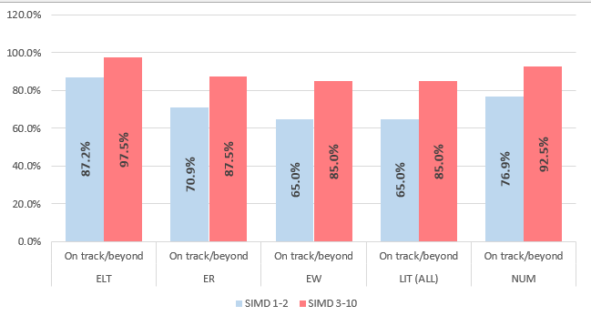

- Graphs above show our gap between SIMD 1 & 2 and 3-10. Although we have a relatively small number of pupils in SIMD 3-10, we are aware that the gap has increased in some areas and we will have specific targets to rectify this next session.
- Our overall levels of attainment remain at reasonable levels- particularly in Listening and Talking and Numeracy.
- In Literacy and Numeracy there are significant increases in the number of children now assessed as Beyond Expectation.
- Our data is shared in greater detail in Priorities 1 and 2.
- At Primary 1, 4 and 7 we show good levels of attainment in all aspects of literacy and numeracy too.
 | L & T | Reading | Writing | Literacy | Numeracy
Attainment @ P1, 4 & 7 | 91.7% | 83.3% | 83.3% | 80.6% | 87.5%
Overall attainment | 87.9% | 74.5% | 72.1% | 70.3% | 78.2%
Difference | -3.8% | -8.8% | -11.2% | -10.3% | -9.3%

Key Priorities:
- Analyse the dip in attainment in Reading and Writing – particularly in the middle stages of the school. All of our Primary 3 and 4 pupils will be involved in the National Improving Writing Programme – along with their teachers and the Head Teacher.
- Use Education Scotland Numeracy self-evaluation document to look in particular at the current Primary 3 levels of attainment as well as utilising NSA early in the next session to identify areas requiring improvement.
- Ensure all Primary 1 pupils undertake a carefully structured phonics programme as well as using the POLAAR resource to identify any challenges as early as possible.
- Our overall attainment figures for the whole school are lower than our Primary 1, 4 and 7 levels. We will aim to ensure these levels are raised by June 2027.
- Create specific targets to raise attainment in all areas with increased focus on SIMD 1+ 2 to close our attainment gap.

National Improvement Framework Quality Indicators
1.3 Leadership of change
Good

Key Strengths:
- Due to the clear understanding of not only our socio-economic context but also our whole school vision and aims all staff have shown clear willingness to enhance the wider opportunities the curriculum offers our learners e.g. drama club, STEM learning, learning in cultural diversity.
- We continue to share and develop our Vision, Values and Aims with the pupils and more widely with the school community.
- Staff are actively involved in planning and implementing change at a strategic whole-school level as well as at their own classroom level.
- The enhanced, detailed collegiate plan created with staff input provided clarity and support for many aspects of improvement.
- Developing use of Fact, Story, Action supports learners’ improvements and progress.
- Significant change in our curriculum ‘offer’ involving science, STEM and outdoor learning in particular.

Key Priorities:
- Ensure there is a detailed collegiate improvement plan/calendar in place early in the new school session with input from all staff.
- As our school are involved in national improvement activities, we will have enhanced leadership opportunities for all staff in developing the curriculum. Primary 1 and 1/2 will participate in the Leading Play Pedagogy programme with Education Scotland, Primary 3/4 and 4 are involved in the National Improving Writing Programme and Primary 5 – 7 will create an in-school working group to develop pupil voice and leadership of their learning in a more active way using successful models from other schools.
- Cluster involvement in Project Based Learning development will involve Head Teacher and at least one class teacher.
- Develop a consistent school-wide approach to recording and evidencing progress in Number talks.
- Further develop Pupil voice opportunities through creating class ‘voice’ groups with clear rationale and plans created for their development.
- Create, open and develop our new ASN provision ensuring transitions remain strong and personalised for our pupils and their families.

2.3 Learning, teaching and assessment
Good

Key Strengths:
- Clear rationale is shared for learners behind expectation or at risk of becoming behind and targeted interventions are planned and implemented.
- Teachers are very able to analyse data to discuss improvement and implement targeted interventions to support learners and inform future planning.
- Staff are imaginative and willing to introduce different and innovative methods to enhance learning in their classroom. Staff reflect that they feel supported by senior leaders to show imagination and experimentation in their teaching.
- Various opportunities are in place providing personalisation and choice in all classes through approaches such as play pedagogy, aspects of an “Activ8” approach, floor books for planning.
- Our approach to providing a wider range of learning in the curriculum has enabled all pupils to achieve a personal CREST Award while developing their skills in STEM activities such as research, resilience, problem solving and recording.
- The development of outdoor learning is a significant step for the school and will be further developed next session. Observation evidence comments positively on pupil motivation and engagement.
- Learning observations highlight that almost all pupils are fully engaged in learning activities and differentiation is evident in all teaching and learning opportunities.
- A range of opportunities are available for all pupils which enable greater independence such as Peer mediators, Play Leaders, Buddies, supporting toothbrushing, leading masses, Pupil Council.

Key Priorities:
- Enhanced tracking and monitoring of targeted interventions incorporating increased use of ‘sprint’ planning for those targeted pupils.
- Continue to discuss and develop learners’ identification and awareness of the agreed language of our meta-skills across the school. Pupils will present at school and parent assemblies.
- Develop pupil and staff digital capabilities through investigating the use of AI to support and extend learning.
- Primary 3 and 4 pupils will participate in the National Improving Writing Programme from August to develop and improve writing attainment at these stages and support teacher skill in analysing data for improvement.
- Further and more regular use of Sprint planning will enhance and support learner improvements in attainment.
- Revisit the use of reciprocal skills across the school to ensure consistency and progression in approach.
- Further increase opportunities for pupil independence through the more structured and planned approach to active learning in Second Level before blending this into First level learning too.

3.1 Ensuring wellbeing, equity and inclusion
Very Good

Key Strengths:
- Our extensive plan for developing various policies and involving our school community has been very successful with the policies created, discussed, shared and pupil-friendly versions also in place.
- Following participation in our core Nurture intervention, all children showed measurable progress in wellbeing, evidenced through increased GMWP scores and successful reintegration into the class routines.
- Improvements were also observed during outdoor play, with children demonstrating more positive interactions, engagement and self-regulation.
- An established program exists for assessing and supporting pupil wellbeing through good use of the GMWP data. This is gathered at two main points in the year but is also used in separate occasions to support specific pupils and look at particular needs.
- All staff have a thorough understanding of the socio-economic make up of our school community and understand their important role in ensuring the best opportunities for our learners.
- Our school Vision, Values and Aims are known and discussed across the school. These are the core of all learning and development.
- Our use of data highlights and provides focus on pupils in various demographic groups and the focus on providing improvement.
- Signs of Safety training has been undertaken, and this approach is being used with some pupils.

Key Priorities:
- Continue to develop the inclusive nature of emotional literacy throughout the school through the ongoing implementation of our program while looking at new ways to enhance this.
- Staff will reflect on the ‘mirrors and windows’ aspects of their classroom and amend the environment to ensure inclusivity for all learners.
- Plan and hold a second Celebrating Cultures Week.
- Organise and train the new team of Peer Mediators to continue the very positive beginning this programme has had.
- Support our new Nurture teacher in her transition into our school.
- Involve our new Nurture teacher in the use of our GMWP processes and working closely with the Senior Leadership team on this.
- Revisit the language of the Wellbeing Indicators for all pupils. As we can return to whole school and large group assemblies, we will be more able to do this together.
- Continue to implement the school Attendance policy while keeping the various stages of intervention under review.

3.2 Raising attainment and achievement/Securing children’s progress
Good

Key Strengths:
- Most age groups show positive progress and increase in attainment in all areas of literacy and numeracy. For those who have not made expected progress, there is still improvement and analysis of any issues.
- Pupil Support assistants work closely with class teachers and the Depute Head to create and implement focused, detailed and well-planned interventions for identified pupils. Feedback is shared for analysis and to inform further improvement.
- Staff planning for improvement is focused on clear targets and discussed regularly to support any adaptations required.
- Assessment data is carefully used by staff to plan for further improvement.

Key Priorities:
- Our P3 and 4 pupils will be part of the National Improving Writing Program which will begin in September. This will have clear, specific targets for improvement.
- Continue use of Fact, Story, Action focusing on all pupils. Incorporate elements of ‘Sprint’ planning for targeted interventions which include class teacher, and PSA support and PEF funded support teacher,
- Reinforce the consistent use of approaches to reading and writing in particular but numeracy too in all stages.
- Increase focus on our attainment gap while ensuring increase in attainment for pupils in SIMD 1 and 2.
- All teaching staff will participate in at least one short term enquiry focused on raising attainment.

Other quality indictors evaluated from 3-year plan
2.2 Curriculum
Good
Key Strengths:
- All pupils have experienced a wider curriculum offer this session including outdoor learning, STEM focused challenges, the reintroduction of another language (French) as well as elements of Gaelic during assembly.
- Planning formats have been developed and introduced for all teachers to support their delivery of the curriculum.
- Collegiate sessions have shared various updates with staff concerning the Curriculum Improvement Cycle and staff are aware that further materials will be published imminently.

Key Priorities:
- Monitor our new planning formats for other areas of the curriculum throughout the year in staff meetings, planning discussions, pupil voice activities and learning observations as well as learning walks.
- Develop outdoor learning to create a progressive, staged program. This will involve accessing specific training.
- Engage fully with the materials coming from the Curriculum Improvement Cycle.
- Develop music education throughout the school with the support of the music service as well as song writing, Sonappa digital music and a DJing project.
- Further develop our STEM and science program – as part of RCCT but also with increased input from class teachers.
- Develop our ‘pull to school’ involving targeted skills activities such as coding, the use of AI to support learning, engineering and other suggestions from pupils.

Key Achievements of the Establishment

- Every pupil in our school has been awarded a CREST Award in recognition for their learning and activities in STEM this session. As a school we are the First, and only, school in Scotland to achieve this outstanding award.

- Our charity – Mini Vinnies- group organised various fundraising activities throughout the year, raising a tremendous amount for Missio.

- Primary 4/5 pupils worked in partnership with Sonappa Music to develop digital music skills. All learners in this class achieved and received the Bronze level Digital Music Maker Award.

- Primary 7 pupils participated in a very successful event with the other denominational schools from Inverclyde as part of the church’s Jubilee Year of Pilgrimage as they celebrated our Prayers in the Park event.

- Despite some gym-hall based delays around 60 pupils prepared, rehearsed and performed a hugely successful school show in the summer term. Special thanks to Inverclyde Academy for their kindness in hosting us.

- Our football and netball teams hade great success in many competitions and friendly games across the session. Our athletics group also participated in various events across the year.

- Our whole-school Cultures week highlighted many areas of learning for pupils including other world religions, expressive arts from other countries, facts and knowledge including famous landmarks and many musical aspects. These were shared with parents in a learning display/showcase.

