

SCHOOL HANDBOOK
2026 – 2027

St. Andrew’s Primary School

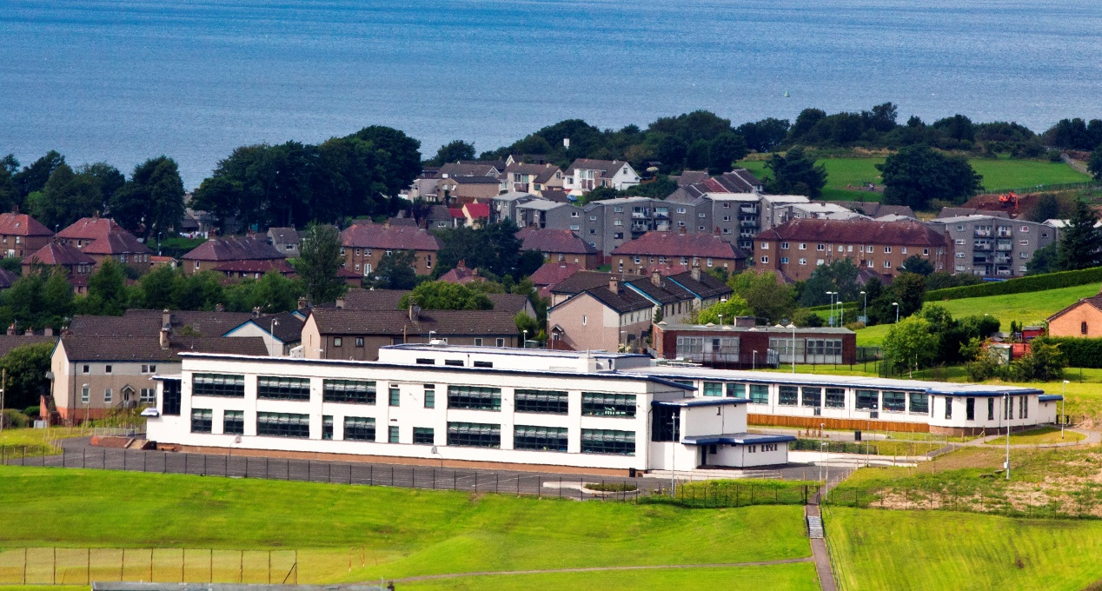

Authority Strategic Statement

Building Inverclyde through excellence, ambition and regeneration.

Goals and Values
Our Core values are: Respect, Honesty, Responsibility and Tolerance.

Our vision for the children and young people of Inverclyde is that they should be ambitious for themselves and be successful learners, confident individuals, responsible citizens and effective contributors.

To achieve our ambition of building Inverclyde through excellence, ambition and regeneration our children must be:

Safe: protected from abuse, neglect and harm by others at home, school and in the community.

Healthy: enjoy the highest attainable standards of physical and mental health, with access to healthy lifestyles.

Achieving: have access to positive learning environments and opportunities to develop their skills, confidence and self-esteem to the fullest potential.

Active: active with opportunities and encouragement to participate in play and recreation including sport.

Respected and responsible: involved in decisions that affect them, have their voices heard and be encouraged to play an active and responsible role in their communities.

Included: have access to high quality services when required and should be assisted to overcome the social, educational, physical, environmental and economic barriers that create inequality.

Nurtured: educated within a supportive setting.
Contents

Essential Information
Welcome 4
School Vision, Values and Aims 5
School Information 6 – 9
Child Protection information 9-10
Registration for School 10 – 12
Transition from Early – Primary 12-13
Equalities at St. Andrew’s 13 – 14
School Term Dates 14 – 15
The Curriculum 15 – 26
Additional Support for Learning 27 – 29
Homework 30
Assessment 30
Home and School Links 31
Parent Partnership 32
Parentzone information 33
Extra-Curricular activities 34
Attending school 34 – 36
School and Community 36
Pupil Voice 36
Positive Relationships 37
Safety in and around school 38
School uniform and Clothing Grant info. 39
School Meals 40
Breakfast Club 41
School transport 41
Medical information 43 – 45
P7 – S1 Transition 45
Complaint procedure 46
Useful addresses 47 - 49

Cover photo by Mr. Albert Burrows who kindly allowed us to use it.

Welcome – from Mr. Alan Connick


I am delighted to welcome you to St. Andrew’s
Primary School. I hope you find our handbook
helpful and useful.
Along with you, as first educators, we aim to provide an active, fun education for your children, which will enable them to use their God-given talents to fulfil their potential in every way.
At the centre of our work is the good and benefit of every St. Andrew’s child. To develop as Responsible Citizens, Successful Learners, Effective Contributors and Confident Individuals we must ensure they are, and feel, Safe, Healthy, Achieving, Nurtured, Active, Respected, Responsible and Included. Every member of the school community is encouraged to #BeLikeStAndrew - caring for others, doing their best and always aiming high.

We welcome you in to the school and I ask that you do not hesitate to call or visit with any query or request.
I look forward to getting to know you and your family as we work together in our St. Andrew’s community.
Alan Connick
Head Teacher

In St. Andrew's our school values aren't just words, they are the things we do and the way we act. We:
​
Take RESPONSIBILITY for our actions and act RESPONSIBLY.​
Show KINDNESS to others.​
RESPECT ourselves and other people – and the world.​
Be HONEST.
ASPIRE to do more and to be more.
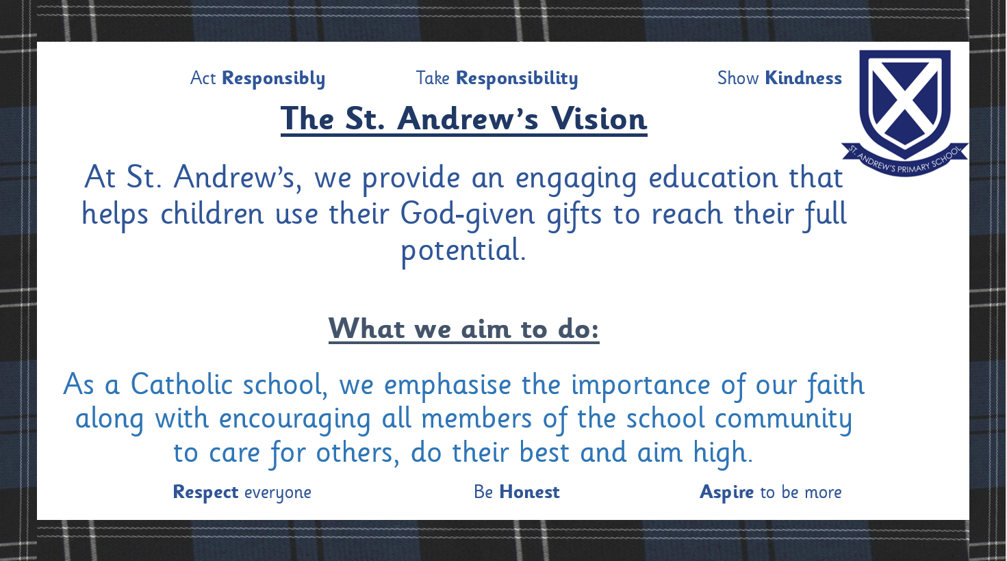

We aim for our pupils to become:

SUCCESSFUL LEARNERS by providing the highest quality learning and teaching to ensure all our children achieve their potential

CONFIDENT INDIVIDUALS by encouraging self-respect, ambition, and a sense of physical, mental and emotional well-being with secure values and beliefs and by valuing and celebrating each child’s attainment and achievement.

RESPONSIBLE CITIZENS by developing and fostering positive attitudes and skills for all pupils enabling them to have respect for themselves and others. We aim for our pupils to know and be proud of Scotland and our culture and to explore the cultures of other countries.

EFFECTIVE CONTRIBUTORS by encouraging an enterprising attitude, resilience, independent learning skills and the ability to work as part of a team.
We aim to get it right for every child and to provide a caring environment in which all children feel safe, healthy, active, respected and responsible, included and nurtured.

Contact Details:

Head Teacher – Mr Alan Connick

Depute Head Teacher – Mr Anton Gallagher

St Andrew’s Primary
Chester Road
Greenock
PA16 0TT
Tele. 01475 715806

School website: https://blogs.glowscotland.org.uk/in/saintandrews/

You can find our school performance information, plans for improvement and all of our school and authority policies here.

Email address: office@st-andrews.inverclyde.sch.uk

St Andrew’s is a Denominational Co-educational Primary School
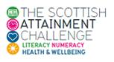
We are proud to be part of the Scottish Government’s Attainment Challenge to increase the life chances and tackle the attainment gap of those less well off in our country.

School Information
Present Roll 165 Agreed Capacity 394

Parents should note that the working capacity of the school might vary dependent upon the number of pupils at each stage and the way in which the classes are organised.
Roll at Each Stage:
Primary 1 12
Primary 2 18
Primary 3 31
Primary 4 27
Primary 5 20
Primary 6 24
Primary 7 33

Class Teachers School Staff List
Primary 1/2 Mrs Thomson
Primary 3/2 Mrs Bonar
Primary 3/4 Miss Staunton
Primary 4/5 Miss Kane
Primary 5/6 Mrs Millar
Primary 6/7 Mrs Gisbey
Primary 7 Miss Fleming
Support for Learning Mrs J Carroll
RCCT Mrs Neeson
Nurture Teacher Mrs McShane
Support Teachers Mrs McCormack and Mrs Steel

Support Staff
Mrs P Watt & Mrs H Gibson – Senior Clerical Assistants
Mrs K Lyne – Clerical Assistant
Miss G Lyne – Clerical Assistant
Mr I McLaren – Pupil Support Assistant
Mrs J McClure – Pupil Support Assistant
Miss K Sorrell – Pupil Support Assistant
Mrs L Loy – Pupil Support Assistant
Mrs K O’Donnell – Pupil Support Assistant
Miss D Baxter – Pupil Support Assistant
Miss A Williams – Pupil Support Assistant
Mrs M Real – Pupil Support Assistant
Miss J Scott – Pupil Support Assistant
Mrs A Michie– Catering Manager
Mr R Dunsmore – Janitor

Daily Timetable
School Opens: 9.00am
Interval: 10.30 – 10.45am
Lunch: 12.15 – 1.00pm
School Closes: 3.00pm

Promoted Staff and Remits

Mr Alan Connick – Head Teacher
Overall responsibility for the running of the school
Management Issues
Pastoral care of all staff and pupils
Parental Communications
Class organisation / Staff allocation
Curriculum support
Resourcing
School budget
Staff Development and support
Pupil Support
School Policies
NSA Co-ordinator
Strategic Equity Fund Implementation representative

Mr Anton Gallagher – Depute Head Teacher
Deputising for HT as required
Pastoral care
Student/NQT Co-ordinator
GIRFEC /Additional Support Needs Co-ordinator
Attendance Monitoring
Parental Engagement
Curriculum Support
Religious Education
Rights Respecting School
Staff Development
Support to colleagues

Child Protection
Inverclyde Council Education Services has Child Protection Guidelines and Procedures which all schools and establishments are required to follow. Education Services work very closely with other agencies namely Police Scotland, HSCP, NHS Greater Glasgow and Clyde and the Children’s Reporter to support children. Common responsibilities of all staff are to protect children from abuse and exploitation, to respond appropriately when abuse is identified, and to ensure whenever possible that all children are able to exercise their right to be raised in a warm, stimulating and safe environment with the support of staff, their families and carers.

PREVENT Duty and Radicalisation

The PREVENT strategy is part of the UK government's overall counter-terrorism strategy, CONTEST. In the context of safeguarding, the aim of PREVENT is to intervene early to safeguard vulnerable children and protect them from being drawn into terrorism or supporting extremism. This is a core part of the school's wider safeguarding duty.
At St. Andrew’s Primary School, we are committed to promoting fundamental values such as democracy, the rule of law, individual liberty and mutual respect of different faiths and beliefs to help build pupils' resilience to radicalisation.

The Designated PREVENT Lead for St. Andrew’s Primary School is:
Alan Connick (Head Teacher)

REGISTRATION FOR P1 SCHOOL SESSION 2026 - 2027
REGISTRATION IS AVAILABLE FROM
5 JANUARY 2026 - 9 JANUARY 2026
Children who reach the age of five years between 1 March 2026 and 28 February 2027 (this will be children who are born between 1 March 2021 - 28 February 2022) are due to start Primary 1 at the beginning of the new school term in August 2026.
Parents should complete the P1 online registration process between 5 - 9 January 2026 regardless if they are considering a deferred year to school for their child. Parents can choose between denominational or non-denominational schools or Gaelic Medium Education.
Gaelic Medium Education is available at Whinhill Primary School for all pupils residing in Inverclyde. Please choose Whinhill (Gaelic) School from the online drop down menu when registering.
There are no denominational primary schools within the areas of Quarriers Village, Kilmacolm, Inverkip and Wemyss Bay. Parents often choose to send their children to the local non-denominational primary school because of the travelling distance to their nearest denominational primary school. In such circumstances the following admission arrangements will apply:
- Only those children who have a certificate of baptism into the Roman Catholic faith when registering for primary 1 will have the choice at primary 7 to seek admission to the denominational school assigned to their address. For more information, please read our Pupil Placement Policy which is available in the documents section.
Once parents have completed the primary 1 registration, they will have the choice to complete a placing request application to a school other than the catchment primary.
A deferred entry application is also available to parents considering deferring their child’s entry to primary 1 in August 2026.
No documents will be required at this stage; however, we may have to contact you, should we require further information.
Parents will be notified by 30 April 2026 confirming their child’s place in school and information regarding induction days will follow from the school after this date.

Placing Request
If you have completed the primary one registration process and did not apply for a placing request at that time, you can still make an application by completing the form linked on this page under the Related Links heading.
All placing request applications must be submitted by 1 February 2026. Applications received after 1 February will not be considered until the placing request process is complete. Applications will be acknowledged within five working days of receipt of each application (excluding school holidays). If you do not receive an acknowledgement, please contact Admissions Section on 01475 712850 (please select option 1) to ensure your form has arrived. Parents will be advised of the outcome of their request no later than 30 April.

Defer Entry
Defer entry applications for the school term starting August 2026 are open until 1 February 2026. To make an application you should have registered your child for primary 1 between 5 -9 January 2026. If you have not registered your child please contact the admissions section on 01475 712850 (please select option 1) before completing the defer entry application form under the. All defer entry applications must be submitted by 1 February 2026

Entry Age
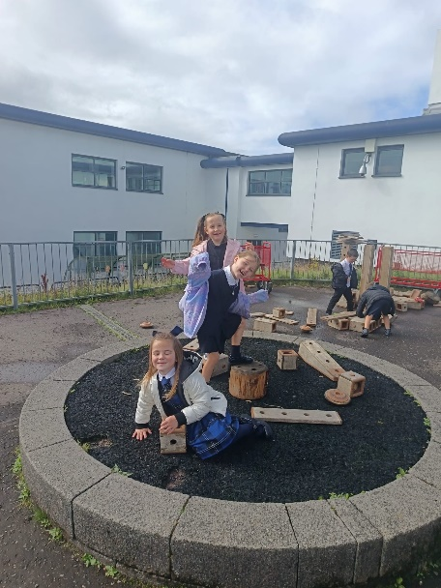
If a child has not reached the age of 5 years by the last day in February they would not be eligible to register at this time. In exceptional circumstances, a formal request in writing for early entry should be submitted to Education Services for consideration.
Transition arrangements
We arrange for pre-school pupils to visit the school in May and June. This gives the children, who will be starting school in August the opportunity to get to know the teachers, visit the classroom etc. So he/she finds it easier to settle down when school begins. It also gives parents a chance to find out what their child will be doing in school and how best they can prepare him/her. Topics such as writing, phonics, reading, counting, the school health programme etc. are also discussed.
We work closely with Larkfield Children’s Centre and Aileymill Nursery to ensure a smooth passage from there to our school.
Staff from St. Andrew’s visit other early years establishments to get to know the pupils who will be starting with us in August.
If required, we arrange extra visits for pupils to the school.
If you think your child would benefit from an extra visit, please contact the school.

Equalities
Inverclyde Education Service is committed to ensuring that no children or members of staff or service users receive less favourable treatment on any ground including age, gender reassignment, pregnancy and maternity, race, disability, sex, sexual orientation, marriage and civil partnership, religion or belief. We have a moral, social and legal obligation to mainstream and put equality at the heart of everything we do. We aim to promote a culture in which equality of opportunity exists for all. We are opposed to all forms of discrimination, direct or indirect, and aim to eliminate all discriminatory practices. We will ensure that, in our schools and other educational establishments, equality permeates the curriculum and underpins all our policies and practices in terms of access to education. We must ensure that all our children achieve their full potential to develop physically, emotionally and academically. Finally, we believe that equality and inclusion should be a given right, where everyone is valued and treated with respect.


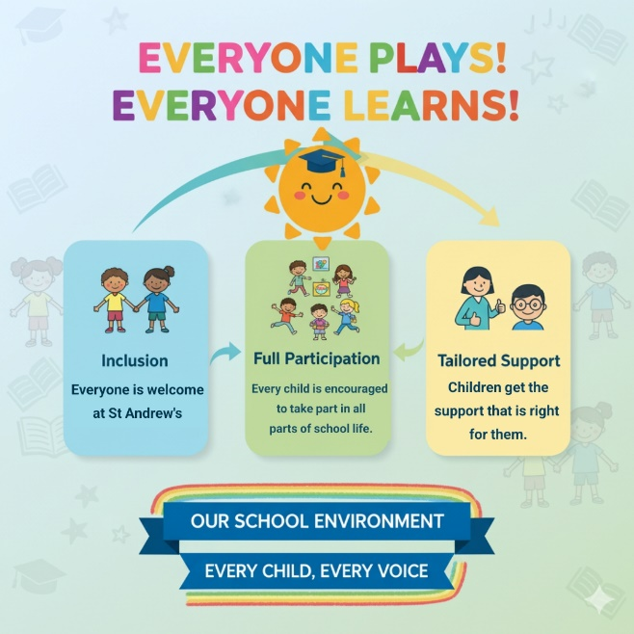


School Holidays 2026/2027
Pupils do not need to attend on In-Service Days
FIRST TERM
In-Service Day Friday 14th August 2026
In-Service Day Monday 17th August 2026
School Open Tuesday 18th August 2025 (First Day for Primary 1s)
Local Holidays Friday 25th September 2026
Monday 28th September 2026
Re-open Tuesday 29th September 2026
Close Friday 9th October 2026
October Week Monday 12th – Friday 16th October 2026
In-Service Day Monday 19th October 2026
Re-open Tuesday 20th October 2026
Christmas Holidays Wednesday 23rd December 2026 – Tuesday 5th January 2027
SECOND TERM
Re-open Wednesday 6th January 2027
Local Holidays Monday 15th and Tuesday 16th February 2027
In-Service Day Wednesday 17th February 2027
Re-open Thursday 18th February 2027
Close Thursday 25th March 2027
Good Friday/Easter Monday Friday 26th March – Monday 29th March 2027
Re-open Tuesday 30th March 2027

THIRD TERM
Spring Break Monday 5th April 2027 – Friday 16th April 2027
Re-open Monday 19th April 2027
May Day Monday 3rd May 2027
In-Service Day Tuesday 4th May 2027
Re-open Wednesday 5th April 2027
Local Holidays Friday 21st May 2027
Monday 24th May 2027
Re-open Tuesday 25th May 2027
Close Wednesday 30th June 2027

Curriculum for Excellence

The curriculum framework for all Scottish educational establishments 3 – 18, called Curriculum for Excellence, offers better educational outcomes for all young people and provides more choices and more chances for those young people who need them.

The aims of Curriculum for Excellence are that every child and young person should:

Know they are valued and will be supported to become a successful learner, an effective contributor, a confident individual and a responsible citizen.

Experience a traditionally broad Scottish curriculum that develops skills for learning, skills for life and skills for work, with a sustained focus on literacy and numeracy that encourages an active, healthy and environmentally sustainable lifestyle and builds an appreciation of Scotland and its place in the world.

The experiences and outcomes under Curriculum for Excellence are written at five levels, with progression to qualifications described under the senior phase.

Early Level – the pre-school years and P1 or later for some

First Level – to the end of P4, but earlier for some

Second Level – to the end of P7, but earlier for some

Third and Fourth – S1 to S3, but earlier for some

Senior Phase – S4 to S6 and college or other means of study

The St. Andrew’s Curriculum

We are always looking for new, innovative ways to enhance pupil learning.

In St. Andrew’s we believe that teachers should see learning through the eyes of the student and students should see themselves as facilitators of their own learning.

Over the past few years, we have carried out various self-evaluation exercises including parental and pupil questionnaires, and Pupil Voice activities concerning our curriculum offer and how we could shape this.

Unfortunately, Inverclyde has higher than national average levels of unemployment and poverty and our catchment area, in particular Larkfield, are higher than the Inverclyde average for these. Due to this, we see the vital importance of providing our pupils with the skills, the tools, for a successful future.
Along with our cluster colleagues, in response to our self-evaluation and national messages, we introduced discussions and focus on the meta-skills being used by the children as an area of priority.
An authority priority has been Equalities with particular focus on Racial Literacy. Unfortunately, our society shows an increasing number of racist incidents, which is why we increased our time to talk about and educate staff and children on the protected characteristics within the Equality Act as well as specific mention on anti-racism.
For a number of years we have been developing Play pedagogy throughout the school, we are part of Play Scotland’s pilot Award programme, and have tried various ways to enhance this at First and Second level. This has led to an increase in project based learning as well as exploratory play but this year we are further developing this through the development of Outdoor Learning as well as our RCCT teacher’s Makerspace.

ORGANISATION OF THE CURRICULUM

The curriculum is organised under eight headings but every effort is made to link areas of the curriculum together to make learning more real and relevant.

The eight areas are: Languages, Mathematics, Health and Wellbeing, Social Studies, Technologies, Expressive Art, Religious and Moral Education and Science.
In the next few pages we have a brief description of each area.
Central to all areas of the curriculum is the methodology used by the teacher and the need to engage our pupils in their learning.

Scotland’s Curriculum is evolving
We are currently in the second year of a ten-year programme to strengthen the curriculum.
This is called the Curriculum Improvement Cycle (CIC)
The refreshed curriculum will start to be formally adopted in schools and settings from August 2028. It is being co-created by teachers, practitioners, partners, and children and young people. We anticipate draft curriculum guidance will be shared in the summer of 2026. It will provide greater clarity, strengthen the connections between knowledge, skills and understanding, and improve coherence from the ages of 3 to 18.
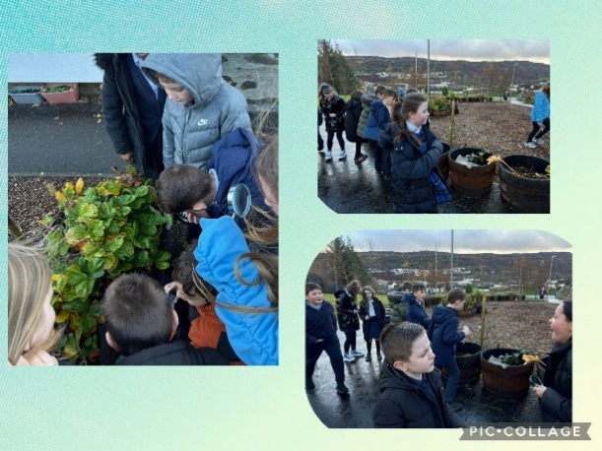
Learning outdoors using our wonderful grounds


Our school is fully embracing play based learning. We collaborate with other schools to develop our play based, nurturing approach to learning.
Studies have proven that play based learning for children from birth to 7 years allows children the best possible start in life, something which Saint Andrew’s has at the heart of our school.
Play is how our children learn best and we are ready to support our children and give them the best possible start in their school journeys.

How will our children be learning?

Our children will have full ownership of their learning and will be fully engaged in creative thinking and problem solving each day. All learning will meet every child’s individual needs and will allow them to progress at their own pace. Children will be engaged in free flow play each day and will choose what learning will take place. Teachers and support staff will then work with your child based on what they have chosen. This will be our teaching time but your child will be leading it. Teachers are trained to spot the perfect ‘teaching moments’ which will create wonder and critical thinking moments for all children. This will leave your children happy and stress free, as all learning will be tailored to their interests and needs.
Please do not panic! Phonics, reading and numeracy will also be done as class lessons alongside play, however children will not be expected to read until term 3.
All children will have their own progress folder, which records the progress your child makes throughout Primary 1. This will include photographs, drawings, stories and any other important evidence of your child’s learning journey.

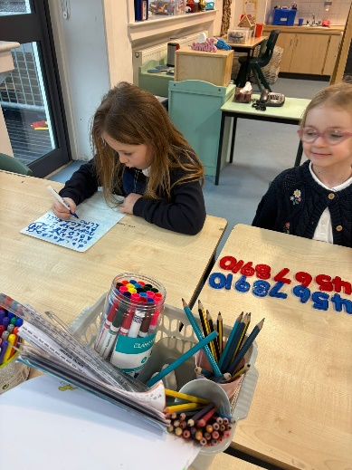
Mathematics and Numeracy

We utilise the Inverclyde Numeracy and Mathematics Pathway to provide a structured learning pathway for all. We also use a variety of excellent resources for the teaching of Mathematics. We encourage an “active” approach to learning in all classes. Mental maths, the use of ‘Number Talks’ and basic number work is fully covered and attention is given to each of the areas of Information Handling; Shape, Position and Movement; number, Money and Measure and Problem Solving.

Language and Literacy
Language is at the core of thinking and at the centre of our learning. Through language our pupils gain much of their knowledge and many of their skills across the curriculum.

The four main components of language are:

Talking & Listening, Reading, Writing
The importance of Spoken English is emphasised in St Andrew’s School. From Primary 1 children are encouraged to develop their skills in talking and to articulate their learning.

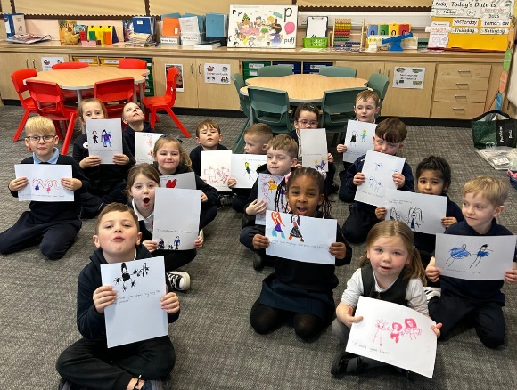
In literacy we use the North Lanarkshire Active Literacy approach to support our children in their initial phonic development. This provides a framework for excellent learning and teaching which extends throughout the school.
A wide range of reading texts is used in all classes. Reading for pleasure, as well as for information, is encouraged throughout the school and we have well-stocked libraries.
The area of written English includes work on the techniques of language (punctuation, grammar, and spelling) which help the children to produce work which can be read and understood by others – work such as factual reports, imaginative stories, etc. We encourage the highest standards in the presentation of written work and foster the pupils’ ability to express themselves in writing. All children have formal handwriting lessons.

We are a Reading School
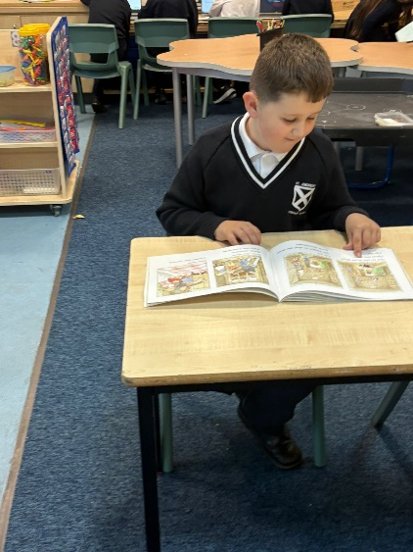
Reading Schools is an accreditation programme for schools that are committed to building a culture of reading for their learners and communities. Research proves that reading for pleasure has positive impacts on learners' attainment across the curriculum, supporting wellbeing, critical thinking, creativity, empathy and resilience. We have achieved Silver Level Reading School Award.



Bookbug
Bookbug is Scotland's universal early years book gifting programme, which supports families to read, sing, and play with their little ones from birth to give them the best start in life. Starting school is an exciting and challenging time for your child and your support at home makes a real difference to their learning. Look out for your Bookbug Primary 1 Family Bag, a free bag of books and activities your child will receive at school in November from Bookbug, to help support their reading, writing and counting skills. You will find films of the books being read aloud and more information about the P1 Bag here.

Read Write Count
Read Write Count with the First Minister is a National gifting programme, aiming to build parents' confidence and encourage families to include easy and fun reading, writing and counting activities in their everyday lives. Every Primary 2 and Primary 3 child in Scotland will receive a free bag with books, educational games and writing materials to be gifted during Book Week Scotland, in November. Resources for schools and extra activities for families to use at home can be found here.

1 + 2 Languages

In line with the Scottish Government initiative titled 1+2 where all Primary age pupils experience a language other than English from Primary 1. We introduce all of our pupils to French – learning words and phrases as well as learning about France. Some of our classes are also being introduced to elements of the Spanish language and learning about Spain.

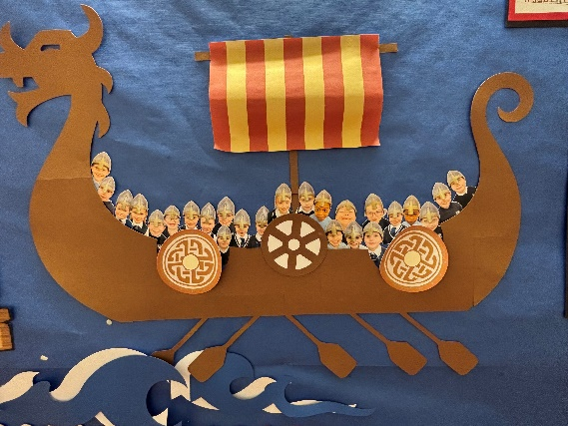
Social Studies
In Social Studies pupils look at societies at different times (history) and in different places (geography). This will, for example, involve them in studying important people and events in the past, investigating transport and communication networks at home and further afield; and in looking at the ways our communities are run.
Visits to places of educational interest are arranged whenever possible to allow the children the opportunity of seeing things at first hand. The experiences are designed to encourage links with other areas of the curriculum so that learners have deeper, more enjoyable and more active experiences.
Science
The science curriculum within Curriculum for Excellence challenges us to ensure that all children must develop a secure understanding of important scientific concepts and that their experience of science in school should kindle a lifelong interest in science.
The science outcomes have been developed into seven areas
- Planet Earth
- Energy in the Environment
- Communication
- Forces and Motion
- Life and Cells
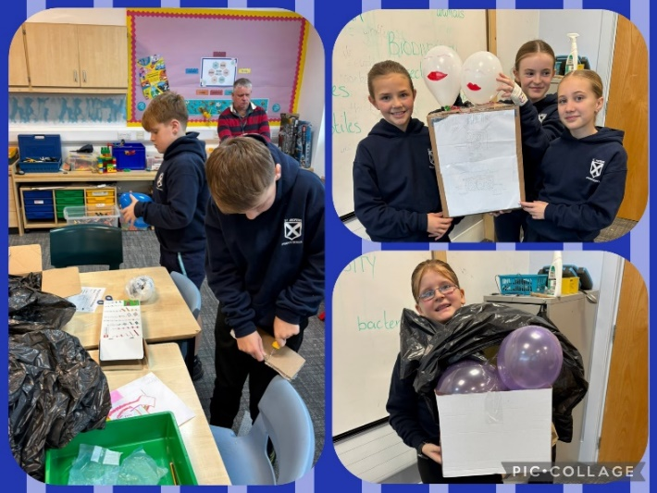
- Materials
- Topical Science

Technologies

As pupils study aspects of Technology, they learn about its impact in the home, in schools, in industry and in the wider community. They should also be given the chance to use their own skills and offer solutions to design problems, using different materials and resources.
Information Technology should involve pupils in, for example, using and learning about audio-visual equipment (such as CD and DVD), computers and a variety of computer ‘applications’. St Andrew’s Primary has excellent ICT resources.

All of our classes experience STEM activities – where Science, Technology, Engineering and Maths are combined to create rounded activities exploring many real-life contexts.

EXPRESSIVE ARTS

Drama
Using movement, mime and language. Communication, creating and presenting drama activities.

Art and Design
Drawing, painting, printing, collage, modelling and sculpture, design and appreciation of art and artists. You will see examples of the children’s work displayed throughout the school.

Music
Exploring sound, using the voice and instruments. Creating and performing and appreciating.
We encourage a love of music and the children enjoy performing at our Christmas Concert, St. Andrew’s Day Hoolie and other events throughout the year. For the past two years, our drama group have prepared and performed an amazing school show in the summer term.
In St Andrew’s Primary School, we have ongoing programmes in each area of Expressive Arts – Art, Music and Drama. Each area has its own body of content which focuses on the skills and techniques to be learned. We encourage all our children to develop their talents and to enjoy all aspects of Expressive Arts. This encourages their creative expression and fosters creative activities, important in times of greater opportunities for leisure. We showcase the talents of our children in various events throughout the year.
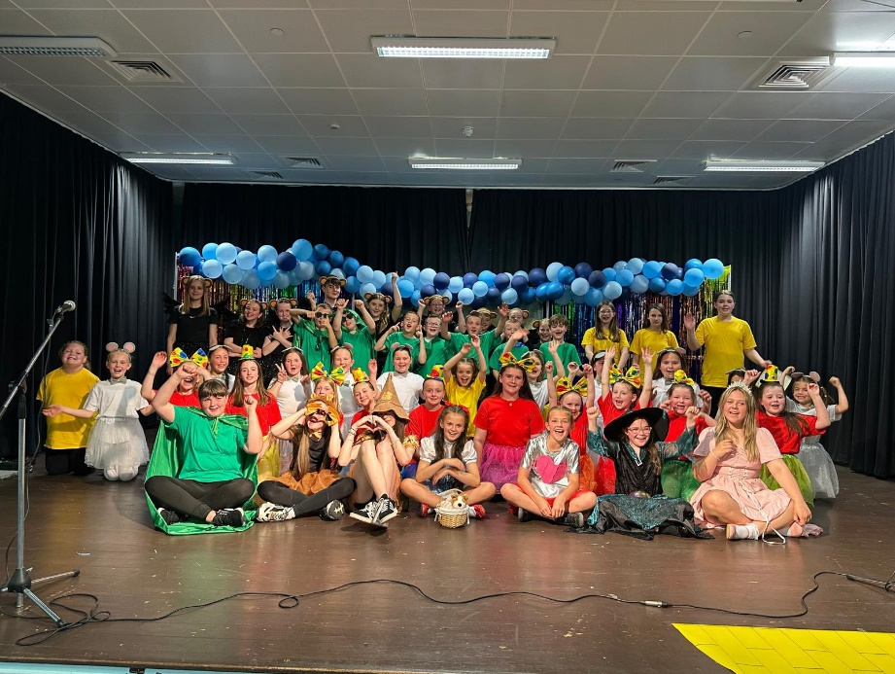

Our amazing Drama Group performed The Wizard of Oz.
A new show coming soon…

Health and Wellbeing

We are a Health Promoting School. Health and Wellbeing Education is an important part of the work of St Andrew’s Primary. It is concerned with all aspects of mental, emotional, social and physical wellbeing now and in the future.

Health and Wellbeing is subdivided into the following areas:
• Mental, emotional, social and physical wellbeing
• Planning for choices and changes
• Physical education, physical activity and sport
• Food and Health
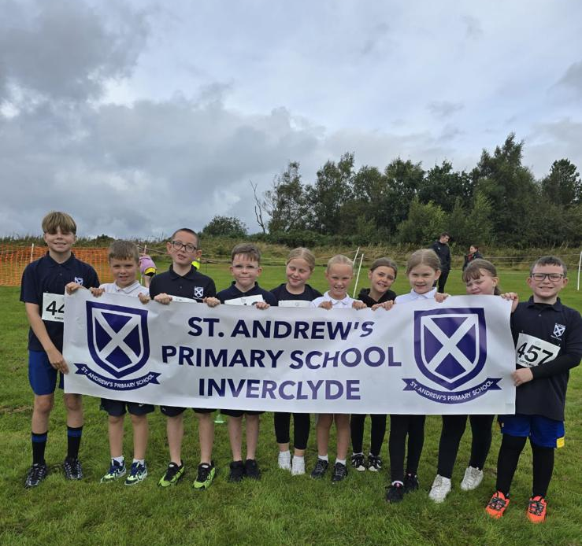
• Substance misuse
• Relationships, sexual health and parenthood.
Pupils are given well planned opportunities to learn about their own health and wellbeing, relationships and health and safety in the environment. We encourage PE and we ensure that pupils have 2 hours quality Physical Education per week.

Parents should note that pupil activities might be restricted because health and safety requirements state that jewellery of any kind must not be worn where pupils are undertaking games or physical activities. This includes jewellery worn as a result of body piercing.

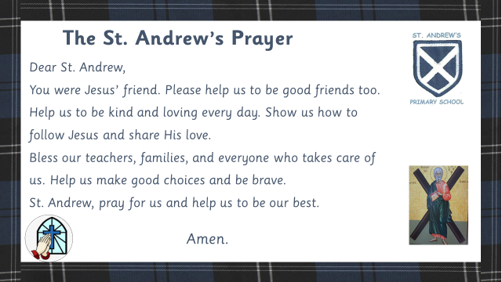
Religious Education

In accordance with your wishes, your child is taught the doctrine, prayers and practices of the Roman Catholic Church. He/she is prepared for the reception of the Sacraments of Reconciliation, Confirmation and Holy Eucharist. With your co-operation, we encourage him/her to become a practising member of the Church and part of the parish community. The school chaplain, Father Danny McLaughlin visits each class on a regular basis.
At daily prayers in class, weekly school assemblies, masses in class, school and St Andrew’s Church, we all come together to worship God and share our faith. Parents are welcome to participate in school/class masses or celebrations and are informed of these by letter. Should any parent wish to withdraw their child from this religious programme, they should contact the Head Teacher and, if necessary, special arrangements will be made.

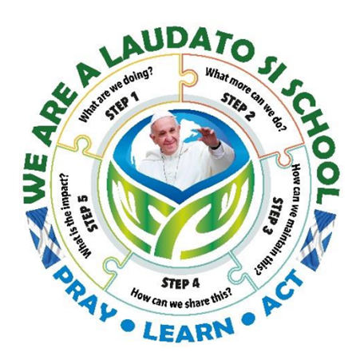
We are a Laudato Si School

The Laudato Si' Schools’ Programme seeks to take the core principles of the Pope’s encyclical letter into schools as a way to promote ecological conversions among our children, encouraging them to learn about the world around them empowering them to take action to care for our common home.

Spiritual, Social, Moral and Cultural Values

Parents from ethnic minority religious communities may request that their children be permitted to be absent from school in order to celebrate recognised religious events. Only written requests detailing the proposed arrangements will be considered. Appropriate requests will be granted on not more than three occasions in any one school session and the pupil noted as an authorised absentee in the register.

Sex and Relationship education is an integral part of a school’s health education programme. It focuses on the physical, emotional, moral and spiritual development of all children. Teachers are central to the delivery of sex education from Primary 1-7 and work in partnership with parents/carers and appropriate health professionals. Parents/carers will be fully informed and consulted on the content and purpose of sex and relationship education in schools, and have the opportunity to raise concerns with school staff. On an occasion where a parent/carer wishes to exercise the right to withdraw his/her child from sex and relationship education they should discuss their concerns and alternative arrangements with school staff (as per Inverclyde Council’s policy “Sexual Health and Relationship Education”.)
Our school follow the Scottish Catholic Education Service programme – ‘God’s Loving Plan’ and all teaching staff are trained in the delivery of this.

Citizenship and Enterprise Education
Both of these areas have a high priority in St Andrew’s School. They develop confidence and self-respect in our pupils. They help pupils to develop their decision making skills. They give them opportunities to work as part of a team and to show respect for differing opinions and other cultures. Most of all they encourage pupils to be creative and enterprising in co-operating with others as part of a team, showing care and respect for others, their opinions and their cultures.
Throughout the school year, every class has many opportunities to take part in Enterprising Activities and as well as being educational, they are always great fun!

Every teacher in St Andrew’s School encourages good citizenship and an enterprising attitude in the classroom and across all areas of school life.

Additional Support for Learning
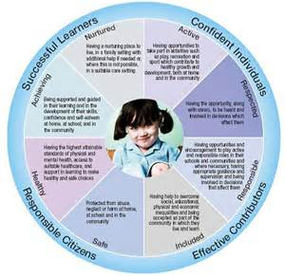
Every teacher has a responsibility to support the learning of all pupils in their class. The type of support offered will vary according to the needs of pupils. This includes consideration given to children who have a disability, children with social, emotional and behavioural difficulties, children with learning difficulties of a specific or general nature, children who are exceptionally able, those who demonstrate underachievement relating to gender issues, children whose learning has been interrupted through absence or illness, bilingual children who have English as an additional language, travelling children and those children whose family circumstances impact on attendance and learning.

If a parent considers that his or her child has additional support needs and wishes to make enquiries about this, they should contact the head teacher.

Children with learning difficulties, for whatever reason e.g. prolonged absence, are given extra help by Mr Gallagher our Learning Support Co-ordinator, Mrs. Carroll our Learning Support Teacher and our support staff. This learning follows closely with that led by the class teacher. This supportive work is extended to suit all levels of work within each classroom.

Multi-sensory programmes of work are developed for children with specific learning difficulties. Parents are kept fully informed of such programmes of work and are invited to school to discuss their child’s progress on a regular basis.

Our Learning Support Facilities are used not only for those children experiencing difficulties, but also to encourage the more able children in their work and continue to present them with challenging resources.
It is the aim of the school to ensure that all pupils reach their full potential in all areas of the school curriculum.
We are very lucky in St Andrew’s to have a Nurture Class where we can further meet the social, emotional and behavioural needs of all our pupils.

The School Psychologist is Ms Daniela Cubeddu. Children may be referred to her for a variety of reasons, but parents are always informed first.

We will always work with parents for the benefit of the child.
If a parent considers that his or her child has additional support needs and wished to make enquiries on this, they should contact the Head Teacher.

Our Depute Head, Mr Gallagher, co-ordinates additional support within St. Andrew’s. He is available to talk to parents if they have any worries. Please feel free to phone for an appointment or drop in to arrange a chat.

St. Andrew’s Primary and Inverclyde Council have a number of policies and procedures which support the implementation of the Education (Additional Support for Learning) (Scotland) Act 2009.
A child or young person’s needs are identified at the earliest possible stage and can be met in a number of ways, for example by adaptations to the curriculum or learning environment, as well as input from the Support for Learning Teacher and on occasion support from visiting specialists. The appropriateness of the support is determined through a process of assessment, planning and monitoring, working jointly with parents and carers, and is regularly reviewed.

Learning outcomes for children and young people with additional support needs are set out in a plan and all educational establishments hold regular review meetings with parents and carers to determine needs and the most appropriate supports. Everyone’s views are equally important in order to consider what is currently working and how to determine next steps.
Children and young person’s needs are identified in a number of ways, and the process of assessment is an on-going, shared process with partnerships with parents and carers at the forefront. On some occasions health service staff or other partner agencies make children known to Education Services. Other additional support needs may be notified to Education Services by parents themselves or identified by one of a range of staff working closely with the child.

Some children and young people will have additional support needs arising from complex or multiple factors which require a high degree of co-ordination of support from both education and other agencies in order that their needs can be met. In these cases, the school will hold a meeting to decide whether the child or young person meets the criteria for a co-ordinated support plan.
The coordinated support plan is a statutory document which ensures regular monitoring and review for those children and young people who have one.

You have the right to ask the education authority to establish whether your child needs a coordinated support plan. Your child can make this request themselves, if they are aged 16 or over. You and your child, if they want to, will attend a meeting with staff at their school. Other professionals from different agencies who may be involved in providing support for your child will also attend. If your child does not want to attend meetings or feels unable to, their views must still be sought and considered.

Inverclyde’s mediation service can be accessed by contacting Michael Roach, Head of Education at the address: -
Education Services
Wallace Place
GREENOCK
PA15 1JB

For further advice, please telephone 01475 712850
Useful information can be found at:

www.enquire.org.uk www.siaa.org.uk www.sclc.org.uk/

Homework

Regular homework is encouraged in St Andrew’s Primary School as a means of reinforcing learning done in school and to involve our parents in their child’s school learning. All pupils are encouraged to read at home – either using their ‘Reading Book’ or a library book. Some pupils may also receive topic based learning, numeracy practice or some other task. Various consultation exercises with our parents have shown that families do not generally support much homework so we follow the wishes of our community. We always welcome your views on this.

Let us know if you would like us to arrange any parent workshops to help you with any area of your child’s school work.

Assessment

Throughout the year, pupils are involved in various assessment activities.
We use formative assessment methods in class, for example, discussing the aims of lessons with the class before the lesson, providing and sharing feedback throughout the activity and recapping on what we have achieved at the end. Teachers assess continuously throughout their time in class sharing feedback with pupils. Pupils can decide how well they think they have done with this as they can self and peer assess.
Parents Evenings are held in October and March. Our reporting procedures keep parents informed of their child’s progress. Pupil Targets are sent home for discussion and teachers will then report on progress a few months later.

Parents are welcome at all times in the school and arrangements can easily be made for parents to discuss their child’s progress at any time during the school year. We really value your input and your partnership in your child’s learning.

Our assessment procedures fulfil three purposes
• To diagnose areas of difficulty
• To provide reliable information on pupil progress
• To provide the basis for communicating to parents areas of strength and concern
We use a variety of published assessment materials to monitor progress in literacy and numeracy. The information from these is used to support pupil learning and to plan additional support if required.

Home and School Links
In St Andrew’s Primary School we work closely with parents and value their input into school life. Parents are kept closely informed of all the activities and happenings in the school by newsletters and the use of email. You may also follow us on X (formally Twitter) (@saintandrewsps).
We have a hard working Parent Partnership and all associated in any way with the school are encouraged to play an active part in school life.

Welcome Afternoons are held in all classes, when parents are invited to come along and meet their child’s teacher, look at the resources being used, the homework to be covered, etc. Parent’s Evenings are held in October and March when parents are invited to come to the school to discuss their child’s work with the class teacher.
Parents are invited into the school regularly for workshops or to celebrate pupils’ learning in topics.
Any parent who wishes to contact the school with any concern or complaint should phone on 01475 715806 to make an appointment to speak to Mr. Connick, Head Teacher or Mr Gallagher, Depute Head, or come in to the school personally.

On such occasions we will attempt to speak to you immediately regarding your concern or complaint.
In such events we will attempt to answer your query as quickly as possible, depending on how quickly the matter can be investigated.

We appreciate your support in this process and will speak to you in person or by phone as soon as possible after the initial meeting.
For more info see:
http://www.inverclyde.gov.uk/education-and-learning/parental-involvement

Parent Partnership

We have a very supportive and busy Parent Partnership group. Please speak to the school for information on meetings and how you can become involved.

Scottish Schools (Parental Involvement) Act 2006 led to the establishment of Parent Councils in primary, secondary and special schools. The Act recognises the vital role that parents play in supporting their children’s learning. It places a duty on authorities to promote the involvement of parents in children’s education and the wider life of the school. It aims to help parents to be: -

▪ Involved with their child’s education and learning

▪ Welcomed as an active participant in the life of the school

▪ Encouraged to express their views on school education
generally

The Parent Council, as a statutory body, has the right to information and advice on matters which affect children’s education.

Parents who are involved on a regular basis in schools require a PVG certificate.

Our Parent Council Chairperson is Mrs Valerie Main.

Parentzone Scotland is a unique website for parents and carers in Scotland, from early years to beyond school. The website provides up-to-date information about learning in Scotland, and practical advice and ideas to support children’s learning at home in literacy, numeracy, health and wellbeing and science. Information is also available on Parentzone Scotland regarding additional support needs, how parents can get involved in their child’s school and education. Parentzone Scotland also has details about schools, including performance data for school leavers from S4-S6 and links to the national, local authority and school level data on the achievement of Curriculum for Excellence levels

ParentPay
We use an online way for parents to pay for school funds, the breakfast club and school trips etc. This makes payments simple and straightforward. This is part of the system we use to order school meals for the pupils too.
Extra-Curricular Activities


In St Andrew’s School we offer a variety of lunch time and after school activities throughout the school year.
We are always looking for new ways to involve our pupils so, if you have an idea for a club, please let us know.
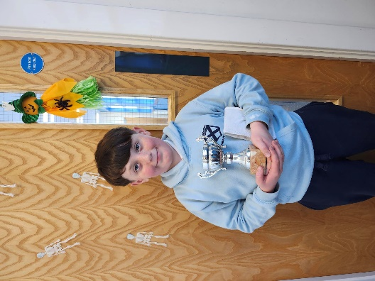
One of our Players of the Week at lunchtime football club.

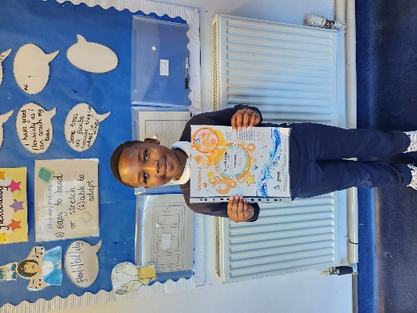

We encourage children to share their successes outside school too

Children Absent from School through ill Health and Attendance at School


Parents should inform the school by telephone or Parent Portal every morning of an absence and provide a reason for the pupil’s absence. The school will contact the pupil’s main contact by text message if we have not been contacted. This contact will be made in the morning and by direct phone call early after the restart after lunch in the case of an afternoon absence.

Young people of school age may be unable to attend school for a wide range of reasons including illness, accidents or long term medical conditions. In general there will be an automatic referral by the school for education out-with school after 15 days of continuous or 20 working days of intermittent absence, within a single session, for verifiable medical reasons.

Other agencies may be contacted if no contact with the pupil’s family can be achieved and if there are continuing or emerging concerns about a pupil’s safety or wellbeing. On return to school parents should provide a note explaining the reasons for absence.
Parents should keep the school informed of any changes of address or home and mobile telephone numbers, both their own and those of the emergency contacts.

Section 30 of the 1980 Education Act lays a duty on every parent of a child of ‘school age’ to ensure that their child attends school regularly. Attendance must be recorded twice a day, morning and afternoon.

Regulation 7 of The Education (School and Placing Information) (Scotland) Amendment, etc. Regulations 1993 requires each child’s absence from school to be recorded in the school register as authorised: i.e. approved by the authority and unauthorised: i.e. unexplained by the parent (truancy) or temporarily excluded from school. The Scottish Government has provided guidance on the management of attendance and absence in Scottish schools in its publication Included, Engaged and Involved- part 1: Attendance in Scottish Schools. Every effort should be made to avoid family holidays during term time as this both disrupts the child’s education and reduces learning time. It has been clarified that family holidays should not be recorded as authorised absence, except in exceptional domestic circumstances, where a family needs time together to recover from distress, or where a parent's employment is of a nature where school-holiday leave cannot be accommodated (e.g. armed services or emergency services). It is for local authorities and schools to judge when these circumstances apply and authorise absence, accordingly.
The categorisation of most term-time holidays as unauthorised absence has been a contentious issue for some families, many of whom are concerned at the higher cost of holidays during school holiday periods. The Scottish Government has no control over the pricing decisions of holiday companies or flight operators. Our main focus is to encourage parents and pupils to recognise the value of learning and the pitfalls of disrupting learning for the pupil, the rest of the class and the teacher.

Clearly where an absence occurs with no explanation from the parent, the absence is unauthorised. Schools investigate unexplained absence, and Education Services has the power to write to, interview or prosecute parents, or to refer pupils to the Children’s Reporter, if necessary.

School and the Community

St Andrew’s Primary School works closely with the local community.

We enjoy a very close working relationship with Aileymill Primary School. Our schools join together in St Andrew’s Church for the celebration of Harvest and Christmas. Our children take part in charity events and local sports activities. We also collect for local charities

Pupil Voice – Pupil Council
Every class is represented on our Pupil Council. They meet regularly with Mr Gallagher and sometimes Mr Connick to discuss different issues. They were part of the wide group who created our school Anti-Bullying Policy.
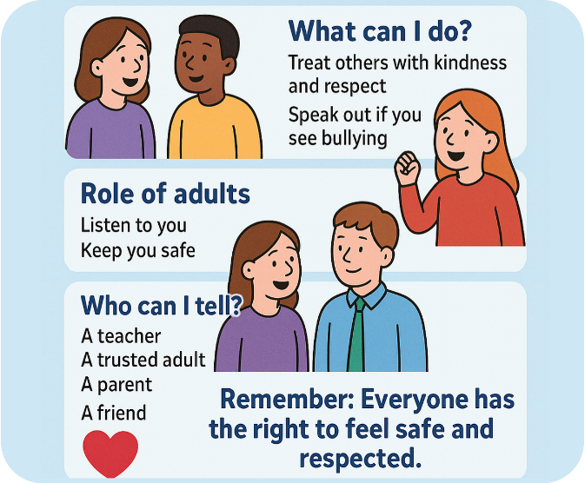


Positive Relationships

We are a Rights Respecting School and this encourages a positive attitude to each other and a school as a whole. We are delighted to have received The United Nations Rights Respecting School award – Level 1.

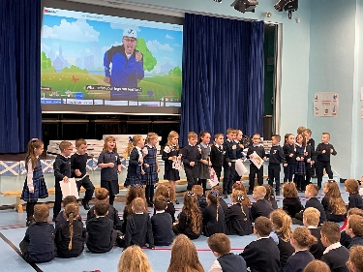
In order that pupils can learn in a calm environment and that learning can continue without interruption and to preserve safety in the playground and corridors, pupils are expected to conform to certain rules of behaviour.

In St Andrew’s Primary School, we consistently try to encourage positive attitudes and we make use of a simple merit scheme, whereby children are rewarded for good behaviour and for special effort in class.
Children are awarded with a Head Teacher’s award sticker for good behaviour, work and manners. Every class nominate a Star Writer and Star Pupil every week. We also have Playground Star Awards.

As you can see, we positively encourage good behaviour and good manners. If any child’s behaviour gives us cause for concern, we will consult with the parents immediately.
We aim to work with our parents to ensure a happy, well-disciplined working atmosphere in St Andrew’s Primary School.

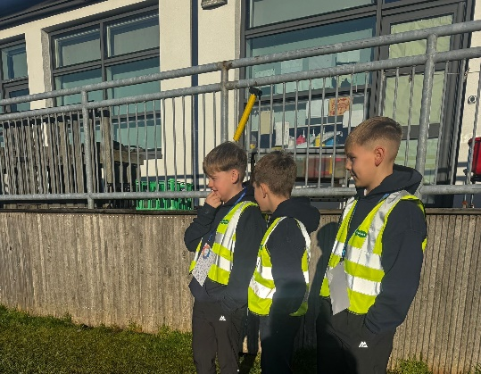
We have Primary 7 pupils who have been trained in Peer Mediation who help to support all other pupils in the school. We are very proud of our ‘Cog Crew’ who voluntarily do this work.

School Security

After the children come in at the 9am bell, all doors are closed. These are security doors and can only be opened from inside and can be opened easily by even the smallest child in an emergency. Anyone entering the building must use the front entrance. This door has a bell system with video and intercom at the right of the door. Please press for entrance. Stand in front of the panel to be seen on the video and to enable the staff member to talk to you through the intercom. All doors apart from the main door are “Pupil Only” doors.

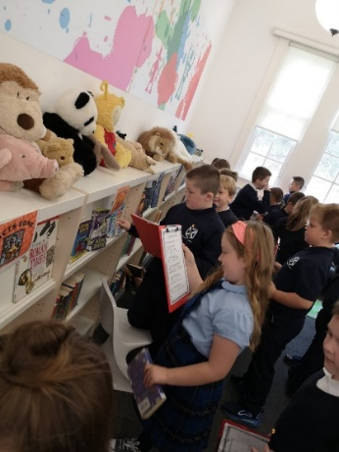
Visitors’ Badges

After ascertaining the identity of the parent/visitor, whether from the video or the intercom, the door lock is released for entry. All visitors must then report to the reception. If collecting children during school hours, school staff will use the PA system for the child or go to collect them from class. If visiting any other area of the school, all visitors must sign in.

Supervision of Playgrounds

An adult presence is provided in playgrounds at break times in terms of the Schools (Safety and Supervision of Pupils) (Scotland) Regulations, 1990.
At Playtime and including lunchtime, the doors into the playground are open to allow children out and in with access to the toilet. All visitors are still required to come in through the front door. Adults should not walk through the playground. There may be exceptions to the rule e.g. class masses, fetes, concerts. At these times the door will be open but managed by a member of staff.
Our aim is to make our school safe, happy and welcoming for everyone. These measures have been drawn up to keep the children, staff and visitors to our school safe. We welcome parents and visitors to our school, but ask that all pay special attention to our security procedures.

Clothing and Uniform

Please put your child’s name on his/her clothing/uniform, lunch bags etc.

Inverclyde Policy on Uniform
Given that there is substantial parental and public approval of uniform, schools in Inverclyde are free to encourage the wearing of school uniform. In encouraging the wearing of uniform account is taken in any proposals to prevent any direct or indirect discrimination on the grounds of race or gender. Any proposals will be the subject of widespread consultation with the parents and pupils. Against this background it should be noted that it is the policy of the Education & Lifelong Learning Committee not to insist on pupils wearing uniform or having specialist items of clothing as a prerequisite of their attending and engaging in all of the activities of the curriculum.
There are forms of dress which are unacceptable in school, such as items of clothing which:
- potentially, encourage faction (such as football colours);
- could cause offence (such as anti-religious symbolism or
political slogans);
- could cause health and safety difficulties, such as loose fitting clothing, or clothing made from flammable material.
- carry advertising, particularly for alcohol or tobacco
- could be used to inflict damage on other pupils or be used by others to do so.

We urge any parent to apply for a Clothing Grant and Free School Meals if they think they may be eligible. Please contact Mr. Connick or Mr. Gallagher if you would like any help with this.

In addition, jewellery such as dangling earrings and large rings could cause health and safety difficulties and are unacceptable to be worn in school.

Our school uniform is:

Navy skirt, pinafore or trousers
White shirt with tie OR School polo shirt
Navy cardigan/jumper or Navy sweat shirt
In summer, blue checked school dresses may be worn
Navy blazer

Your child or children are entitled to free school meals and a clothing grant if you receive one of the following benefits:
•Income Support (IS);
• Income-based Job Seekers Allowance (JSA);
• Any income related element of Employment and Support Allowance (ESA);
• Universal Credit (UC), where your take home pay does not exceed £1,244;
or
• you are seeking asylum and receiving support under part VI of the Immigration and Asylum Act 1999;
or
• you look after a child/children as part of a formal Kinship Care agreement registered by Social Work Services.
• INCOME SUPPORT (IS)
• INCOME BASED EMPLOYMENT AND SUPPORT ALLOWANCE (ESA)
• INCOME RELATED JOB SEEKERS ALLOWANCE (JSA)
• PENSION CREDIT
https://www.inverclyde.gov.uk/education-and-learning/schools/www-dwp-gov-uk

Approval of requests for such grants made by parents in different circumstances is at the discretion of the Corporate Director Education and Social Care.
Information and application forms may be obtained from schools and from Education Services, Wallace Place, Greenock, PA15 1JB.
The council is concerned at the level of claims being received regarding the loss of pupils’ clothing and/or personal belongings. Parents are asked to assist in this area by ensuring that valuable items and unnecessarily expensive items of clothing are not brought to school. Parents should note that the authority does not carry insurance to cover the loss of such items and any claims submitted are likely to be met only where the authority can be shown to have been negligent.

School Meals

A cafeteria system operates. Pupils may have hot meals or picnic snacks. Vegetarian dishes are also available.

All pupils in Primary 1 to 7 are entitled to a free school meal, regardless of personal/family circumstances.

It should be noted that a special diet is available to any child who requires such on medical grounds.

The pupils who bring packed lunches have their meals in the school canteen.

Information and application forms for free school meals may be obtained from schools and Education Services, Wallace Place, Greenock, PA15 1JB. In addition, such children will be entitled to free milk.

Every effort is made to encourage children to choose their food sensibly. The canteen uses a three-weekly Menu rotation system. We send the menu home at the beginning of the year so that your children can discuss the options and choose what they like before coming to school.

We urge any parent to apply for a Clothing Grant and Free School Meals if they think they may be eligible. Please contact Mr. Connick or Mr. Gallagher if you would like any help with this.

Breakfast Club
We have a popular breakfast club in St Andrew’s School every day from 8.00-9am. Breakfast Club staff run the club and the children enjoy cereal, juice and toast followed by games and physical activity in the hall. Attendance at Breakfast Club is free for pupils in receipt of a Free School Meal/clothing grant and cost £1 for others. This is paid through ParentPay.

Transport

The Council has a policy of providing free transport to all primary pupils who live more than one mile from their local school by the recognised shortest walking route. This policy is more generous than the law requires. This means that the provision of transport could be reviewed at any time. Parents who consider they are eligible should obtain an application form from the school or Education Services at 105 Dalrymple Street, Greenock, PA15 1HU. These forms should be completed and returned before the end of February for those pupils beginning school in August to enable the appropriate arrangements to be made.


Applications may be submitted at any time throughout the year but may be subject to delay whilst arrangements are made. The appropriate officer has discretion in special circumstances to grant permission for pupils to travel in transport provided by the authority, where spare places are available and no additional costs are incurred

Pick up Points

Where free transport is provided it may be necessary for pupils to walk a certain distance to the vehicle pick-up point. Walking distance in total including the distance from home to the pick-up point and from the drop-off point to the school in any one direction will not exceed the authority’s limits. It is the parent’s responsibility to ensure that their child arrives at the pick-up point in time. It is also the parent’s responsibility to ensure the child behaves in a safe and acceptable manner while boarding, travelling in and alighting from the vehicle. Misbehaviour could result in a child losing the right to free transport.

Placing Requests

Education Services does not provide transport for those pupils in receipt of a placing request other than in exceptional circumstances. In the case of under-age placing requests if the child is offered a place in his/her catchment area school, transport will be provided in accordance with Council policy stated above.

Medical and Health Care


The children have routine medical examinations at five years of age and some at eleven years of age. A questionnaire and consent form is issued by the School Nurse. Routine hygiene examinations go on each session throughout the school. There are also hearing and eyesight tests.

In the case of minor accidents at school, the child will receive attention from Mrs O’Donnell or Miss Williams our First Aiders. Should a child become ill at school, the parent/carer is notified and asked to accompany the child home. If they are unavailable, the emergency contact (name, address and telephone number is on a child’s confidential record) is notified.

If a child has an accident, arrangements similar to those above are operated. However, if the accident is of a serious nature and immediate hospital attention is required, the Head Teacher or, if necessary, an ambulance will take the child to hospital, at the same time notifying parents either at home or at work of what is happening.
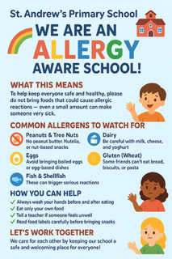

INHALERS

In accordance with the National Asthma Campaign – if your child is Asthmatic please ensure they have a spare inhaler that they can keep in their class.
SCHOOL DENTIST

The school dentist visits the school annually and indicates where treatment is necessary. Parents may choose to send their child to the school dentist or to make their own arrangements.
In St Andrew’s Primary School, we endeavour to promote good health in every way possible. We have a structured programme of health education throughout the school.
Pupils in Primary 1 and 2 are supported to brush their teeth every day after lunch.
If parents wish to send medicine to school with a child, a medication form with details must be completed, signed and handed in to the office. (These are available from the office). Only medicines prescribed by a doctor will be administered.

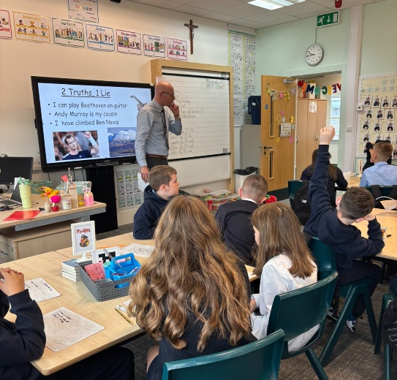

Transfer to Secondary School

St Columba’s High School

Pupils are normally transferred between the ages of 11½ and 12½ years, so that they will have the opportunity to complete at least 4 years of secondary education. Parents will be informed of the arrangements no later than December of the year preceding the date of transfer at the start of the new session.
Excellent liaison with the Head Teacher and staff of St Columba’s High School ensures that the transition to secondary school is as easy as possible for the pupils.
Specific transition meetings occur in January/February for ASN pupils and in May for all Primary 7 pupils.

A successful outcome of the liaison is the induction period when the pupils from Primary 7 spend time in St Columba’s High School in June of each year. They are introduced to the staff, get to know the building, the school rules etc. They follow a secondary timetable, thus receiving an introduction to all subjects.
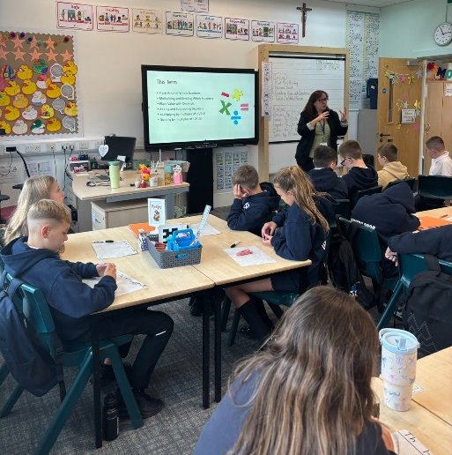
Staff from St Columba’s work with our pupils throughout the year and liaise with our teaching staff.
The Head Teacher of St Columba’s High School also makes arrangements to meet the parents of pupils in the term before they enter the school.

The address of St Columba’s High School is:

St Columba’s High School
Fletcher Avenue
Gourock
Tel. 715250

How Do I Complain?
Positive and open relationships are important and key to us as a school. We are always keen to ensure that parents are aware of how we would prefer to handle situations when things maybe have not gone as any of us would have liked.
Our initial hope is that we can resolve matters swiftly and informally. In the first instance, and where appropriate, we would ask that you contact the school and ask to speak to Mr Connick or Mr Gallagher. Please get in touch with them via the main office on 01475715806 or office@st-andrews.inverclyde.sch.uk
I would hope that we would be able to resolve any concerns or complaints at school / level, however if not, please refer to the council complaints process and contact Education Headquarters at: admin.educationhq@inverclyde.gov.uk : How to make a complaint - Inverclyde Council

Useful Addresses

Corporate Director of Education, Communities & Organisational Development

Ruth Binks
Inverclyde Council
Municipal Buildings
Clyde Square
Greenock
PA15 1LX
Tel. No. – 01475 712761

Head of Education

Michael Roach
Inverclyde Council
Education Services
Wallace Place
Greenock
PA15 1JB
Tel No. – 01475 712824

Provost Drew McKenzie
Inverclyde Council
Municipal Buildings
Greenock

Councillor Jim Clocherty
Convenor of Education and lifelong Learning Committee
Municipal Buildings
Greenock

Councillors – Inverclyde South
John Crowther
Natasha McGuire
Tommy McVey

Tel No – 01475 715450
School Health Department Free Meals & Clothing Grant
Greenock Health Centre Customer Service Centre
Wellington Street Clyde Square
Greenock, PA15 4NH Greenock

Tel: 724477 Tel: 712893

Community Facilities

Community Facilities are available in the school and details of the letting procedures are available from:

Area Community
Letting Officer
Waterfront Leisure Complex

Information in Emergencies
We make every effort to maintain a full educational service, but on some occasions circumstances arise which lead to disruption. Schools may be affected by, for example, severe weather, and temporary interruption of transport, power failures or difficulties of fuel supply. In such cases we shall do all we can to let you know about the details of closure or re-opening. We shall keep you in touch by using letters, notices in local shops and community centres, announcements in local churches and announcements in the press and on local radio.

General Data Protection Regulations and Data Protection Act 2018
Information on children, parents and guardian is stored on a computer system and may be used for teaching, registration, assessment and other administrative duties. In processing personal information, Inverclyde Council must comply with the General Data Protection Regulation and Data Protection Act 2018.
For further information, please refer to https://www.inverclyde.gov.uk/site-basics/privacy or click on the following: Privacy page link
Please note:
Although this information is correct at time of presenting, there could be changes affecting any of the matters dealt with in the document –

(a) before the commencement or during the course of the school year in question.

(b) in relation to subsequent school years.

