

St Andrew’s Primary School Child Protection Policy
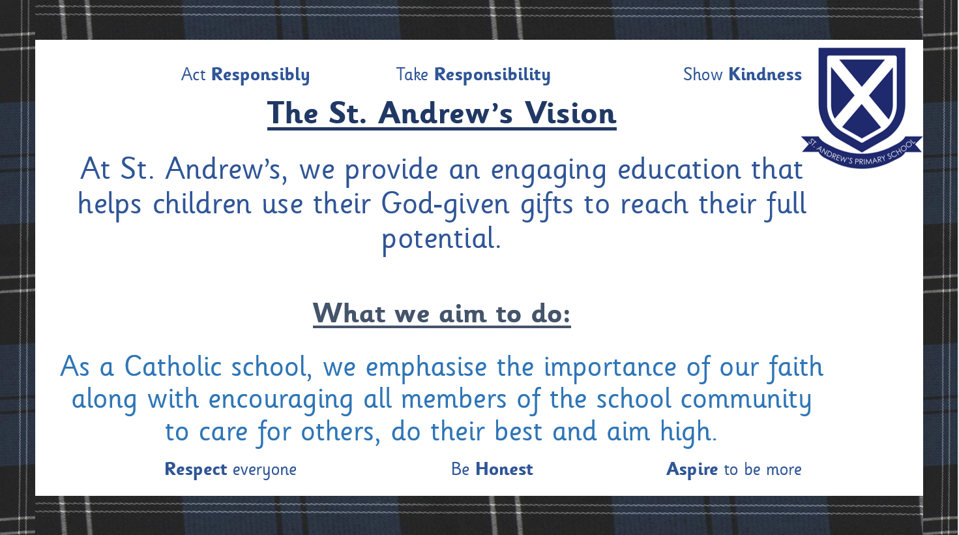

Our Commitment
At St Andrew’s Primary School, every child has the right to feel safe, valued, and respected. We are committed to protecting children from harm, abuse, and neglect, and to promoting their wellbeing in line with Getting It Right for Every Child (GIRFEC) and the United Nations Convention on the Rights of the Child (UNCRC).
This policy is established in accordance with the following key legislation and guidance:
- Education (Scotland) Act 1980
- Children (Scotland) Act 1995
- Getting it Right for Every Child (GIRFEC)
- National Guidance for Child Protection in Scotland 2021 (updated 2023) which can be accessed at:
- national-guidance-child-protection-scotland-2021-updated-2023.pdf
- Inverclyde Council Child Protection Committee (ICPC) policies and procedures
which can be accessed at Child Protection - Inverclyde Council
Our staff work together with families, Social Work, Health, and Police Scotland to make sure all children get the right help at the right time.

Key Principles
We believe that:
- All children have the right to be safe, healthy, active, nurtured, achieving, respected, responsible, and included (SHANARRI).
- Protecting children is everyone’s responsibility — staff, parents, and the wider community all play a part.
- Listening to children and taking their views seriously is at the heart of our approach.
- All concerns will be taken seriously and acted on quickly.

Roles and Responsibilities

Head Teacher – Alan Connick has overall responsibility for child protection within the school and for ensuring that this policy is implemented effectively.

This role includes:
- Ensuring all staff are aware of and adhere to this policy and related procedures.
- Ensuring appropriate training is provided for all staff.
- Liaising with external agencies as necessary.
- Monitoring and reviewing the effectiveness of this policy.

The Child Protection Coordinator (CPC) – Alan Connick
- The designated CPC is responsible for:
- Being the main point of contact for child protection matters.
- Providing advice and support to staff on child protection issues and Responsibilities
- Liaising with the Head Teacher (if not the CPC) and external agencies regarding concerns.
- Maintaining accurate and confidential records of concerns.
- Contributing to the development and review of the child protection policy and procedures.

In the absence of the Head Teacher, the Depute Head Mr Anthony Gallagher will assume the role of CPC.

All adults working in or visiting St. Andrew’s Primary School have a responsibility to:
- Be aware of this Child Protection Policy and related procedures.
- Recognise potential indicators of abuse, neglect, and harm.
- Report any concerns about a child’s safety or wellbeing promptly to the CPC or, in their absence, the Depute Head Teacher.
- Contribute to a safe and supportive environment for all children.
- Participate in relevant child protection training at least annually.
Inverclyde Council Education Services and the Inverclyde Child Protection Committee (ICPC) oversee training, guidance, and policy compliance.

PREVENT Duty and Radicalisation

The PREVENT strategy is part of the UK government's overall counter-terrorism strategy, CONTEST. In the context of safeguarding, the aim of PREVENT is to intervene early to safeguard vulnerable children and protect them from being drawn into terrorism or supporting extremism. This is a core part of the school's wider safeguarding duty.
At St. Andrew’s Primary School, we are committed to promoting fundamental values such as democracy, the rule of law, individual liberty and mutual respect of different faiths and beliefs to help build pupils' resilience to radicalisation.

The Designated PREVENT Lead for St. Andrew’s Primary School is:
Alan Connick (Head Teacher)

Staff must be aware of the signs of radicalisation and extremism, which are treated as a safeguarding concern. Concerns relating to a child's vulnerability to radicalisation must be reported immediately using the established procedures for reporting any other
child protection concern.

The PREVENT Lead will ensure staff are trained to understand the risks of radicalisation and how to apply the Notice, Check, Share procedure when appropriate, in line with Inverclyde Council's policies and procedures regarding the Prevent Multi-Agency Panel (PMAP).

Remember – Notice – Check – Share concerns

Recognising and Responding to Concerns
Staff should be alert to the signs and symptoms of abuse and neglect, which may
include but are not limited to:

- Physical injury that is unexplained, inconsistent with the account given, or inflicted
by someone else.
- Neglect, such as poor hygiene, inadequate clothing, or lack of supervision.
- Emotional distress, such as withdrawal, anxiety, or changes in behaviour.
- Sexual abuse, which may be disclosed by a child or indicated through their behaviour.
- Signs of radicalisation.
Concerns may arise from:
- Something a child says (a disclosure)
- Physical signs or changes in behaviour
- Concerns about parenting or home circumstances
- Information from another person or agency

Reporting a concern
Immediate Action:
If a child discloses information that suggests they are at immediate risk of harm, or if you witness an incident that causes immediate concern for a child’s safety, ensure the child’s immediate safety and seek medical attention/ Police support if required.
If a child is in immediate danger, call 999.
If any member of staff or parent is worried about a child, no matter how small the worry may be: Speak to the Head Teacher Mr Alan Connick (CPC) as soon as possible.
Record the facts on Appendix 3 attached to this document or email all details to Mr Connick – see information below.
If Mr Connick is unavailable, concerns should be reported immediately to the Depute Head Teacher, Mr Gallagher.

Recording Concerns
Using the information required for Appendix 3 a clear, accurate and dated written record of the concern must be made as soon as possible. This should include:

- The child’s name and date of birth. The date and time the concern arose including context about what the child was doing at the time e.g. during Emotional Check- In, whilst playing in the role play area etc.
- A factual account of what was seen, heard, or disclosed using the child’s words.
- Any action taken.
- The name of the person reporting the concern.

This should be shared in person, by phone and followed up with written email.

Mr Connick will record the incident on SEEMiS as a significant event for chronology.

Referral to External Agencies

In line with Inverclyde Council ICPC policies and procedures (Appendix 2), Mr Connick will
determine whether a referral to external agencies such as Social Work Services or
Police Scotland is necessary. Staff should not attempt to investigate concerns themselves.
Local Contacts:
- Request for Assistance (Social Work): 01475 715365
- Out of Hours Social Work: 0300 343 1505
- Police Scotland: 101 (or 999 in emergency)

Confidentiality and Information Sharing
Children have the right to privacy, but safety always comes first.
If we believe a child is at risk, information will be shared with appropriate professionals even without consent.
We always aim to keep parents/carers informed unless doing so would place the child at further risk.
Information sharing guided by the principles outlined in the National Guidance
for Child Protection in Scotland 2021 and Inverclyde Council ICPC policies and procedures.
Records of child protection concerns will be stored securely on SEEMiS in accordance with data protection legislation.

Supporting Children and Families

St. Andrew’s Primary School is committed to providing support to children and families who are affected by child protection issues. This includes providing a safe and supportive
environment for the child, liaising with relevant support services and working in partnership with parents where appropriate and safe to do so.

Secrets should NOT be kept

At any time during discussions with a child (or third party), staff should not agree to keep secret any information which implies that a child might have been subject to abuse or is at risk of future abuse.

It should be explained that the information will be treated with extreme sensitivity and will only be conveyed to those professionals who are in a position to protect and support the child.

In discussion with a child, he or she should be reassured that they will be kept informed of what is happening and will be supported by staff as appropriate. Any information subsequently shared with the child should be appropriate to the child’s age and stage of development and should not breach the confidentiality of any other parties involved.

If a third party is involved, he or she should be informed on a ‘need to know’ basis that
the matter is now being dealt with according to the appropriate procedures. As
confidentiality must not be breached there is no need to specify which procedures. The third party can be supported by staff as appropriate.

Allegations Against Staff
If an allegation of harm or abuse is made against a staff member:
- It will be reported immediately to the Head of Education and Social Work/Police.
- The matter will be handled sensitively, with support for all involved and confidentiality maintained.

A Safe and Supportive Learning Environment
We promote a caring ethos where:
- Children are encouraged to speak openly about worries.
- Relationships are based on trust, respect, and fairness.
- Wellbeing is embedded through the Health and Wellbeing curriculum and positive relationships policy.
- Our school building is kept safe and secure thanks to Mr Richard Dunsmore, our janitor and our office staff – Mrs Lyne, Mrs Gibson, Mrs Watt and Miss Lyne who follow careful, welcoming and friendly sign in procedures for all visitors.

Medication Procedure
Our Office staff and Pupil Support Assistants follow careful procedures when a pupil is given medication during the school day. This is detailed in the authority Medication Policy.

Online Safety
Children learn how to use the internet safely and responsibly.
We work with families to help protect children from cyberbullying, online grooming, and exploitation.
Parents are encouraged to monitor their child’s online activity and seek advice from ThinkUKnow or Childline if concerned.

Staff Training
- All school staff receive annual Child Protection training.
- The Child Protection Co-ordinator receives enhanced training through Inverclyde Council and the ICPC.
- Training covers recognising signs of abuse, responding to disclosures, and following referral procedures.

Partnership Working
We work closely with:
- Parents and carers, to support families and build trust.
- Social Work, Health, and Police Scotland, to safeguard children.
- Other schools and early years settings, to ensure smooth and safe transitions for pupils.

Monitoring and Review
This policy is reviewed annually and updated in line with Inverclyde Council Education Services Child Protection Guidelines (2025) and National Child Protection Guidance (2023).
We also take account of The Promise (2020), the Children and Young People (Scotland) Act 2014, and the Equal Protection from Assault Act 2019.

Useful Contacts
- St Andrew’s Primary School: 01475 715806
- Head Teacher / Child Protection Co-ordinator: [Insert name and email]
- Inverclyde Child Protection Committee: www.inverclyde.gov.uk/childprotection
- Social Work Request for Assistance: 01475 715365
- Police Scotland: 101 or 999 in an emergency
- Childline: 0800 1111

Remember
If you’re worried about a child, don’t wait — share your concern.
It could make all the difference.

Updated: October 2025
Review Date: August 2026

Other Information
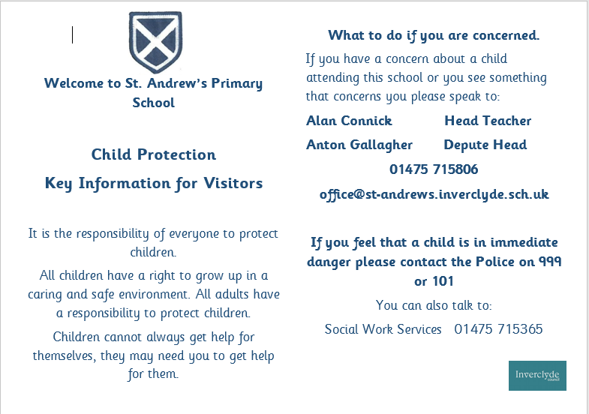
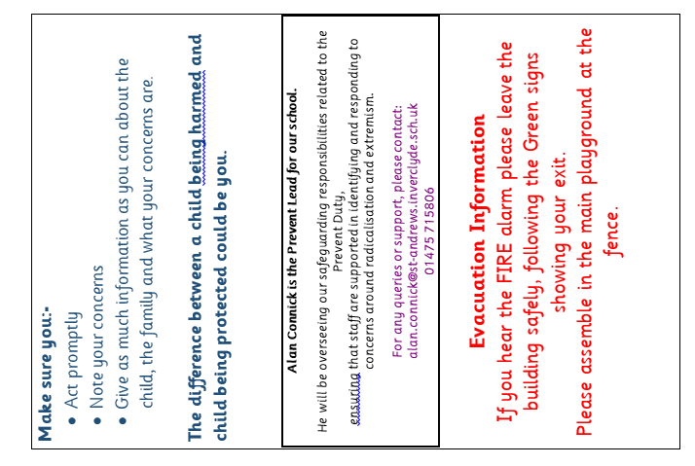

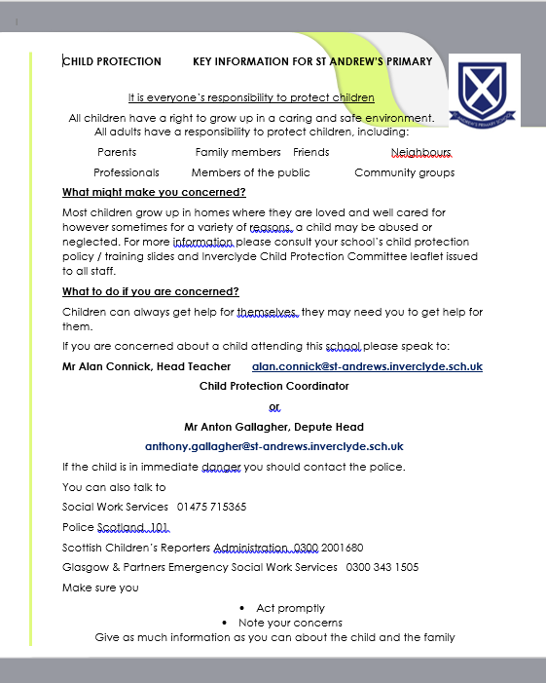

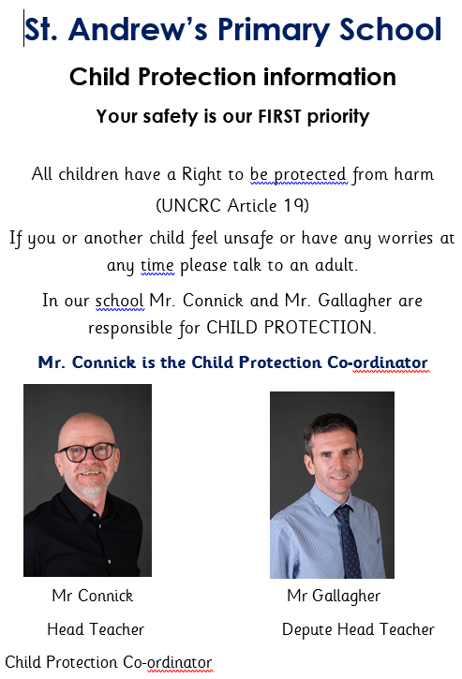
Appendix 2
Grounds for concern: Action for Head of Establishment
For public display in the work place
A member of staff identifies grounds for concern and a record of concern alert is reported to the Head Teacher or Child Protection Co-ordinator on appendix 3.
Within 48 hours
Receive acknowledgement of request for assistance from social work and an IRD should be convened within 48 hours.
Send copy of RFA to Education HQ via HQ Admin@ email address.
If making NO referral to the social work department
Record concern in pastoral notes and in chronology in confidential case file
Consider holding Team around the Child / Family meeting
Plan actions to support the child in collaboration with parents and carers
Arrange a review date and name of reviewer
If making a referral to the social work department
Phone RFA to discuss
Complete and send request for assistance form (appendix 4)
Send outcome of referral to Head of Education
Record the date of child protection referral as a pastoral note (no details of the incident should be included)
Copy should be sent to health visitor.
File a copy of the request for assistance form in the Child Protection file
The Head of Establishment gathers all available information and assesses risk to the child. Using this information and professional judgement, this may include a preliminary discussion with social work about a concern.

Child Protection Record of Concern

Appendix 3 : Report of Concern
When you have a concern about a child or a young person you must report it immediately to the Head Teacher.
Key Information

Day and Date
Head or Manager to whom the concern was reported
Name of child/young person
Establishment
Source of Concern (please tick)

Personal Observation
Reported by child
Reported by another source (complete below)
Please give details of source (phone call/letter/email/conversation)
Please give details of concern. If a disclosure has been made record using the child’s own words. SIGN AND DATE DIRECTLY UNDER STATEMENT.

Print name:
Date and time:
Job Title:

