

**SCHOOL HANDBOOK**

**2025 – 2026**

**St. Andrew’s Primary School**

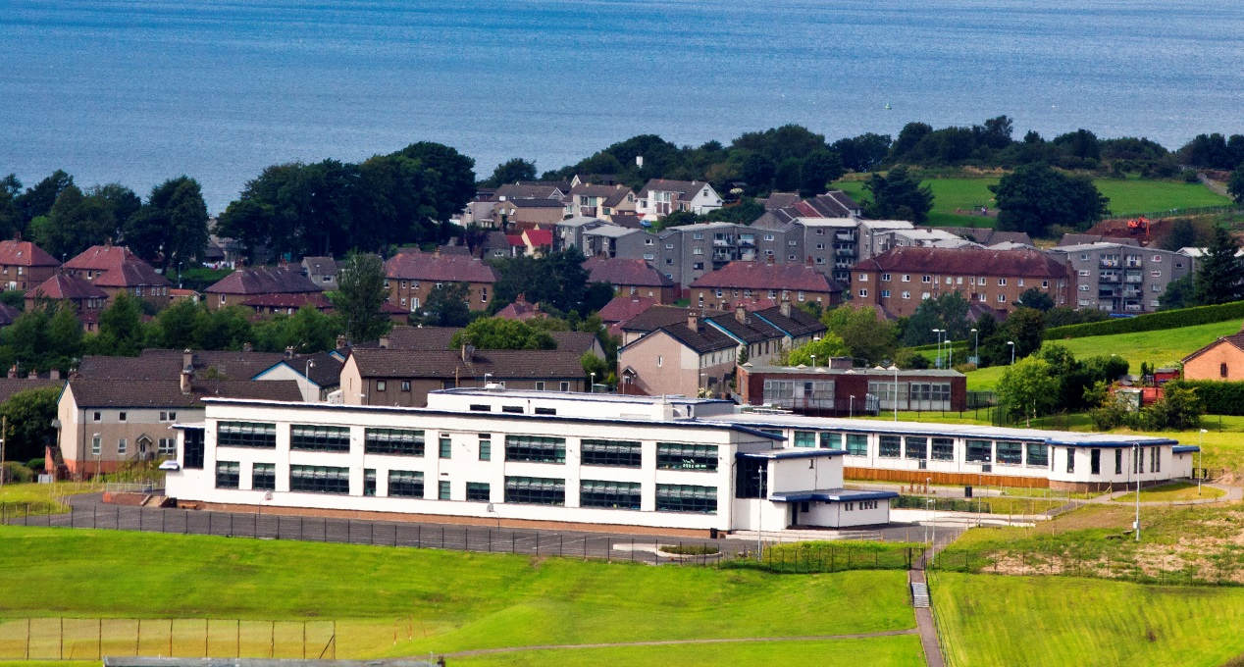

**Authority Strategic Statement**

Building Inverclyde through excellence, ambition and regeneration.

**Goals and Values**

Our Core values are: Respect, Honesty, Responsibility and Tolerance.

Our vision for the children and young people of Inverclyde is that they should be ambitious for themselves and be successful learners, confident individuals, responsible citizens and effective contributors.

To achieve our ambition of building Inverclyde through excellence, ambition and regeneration our children must be:

Safe: protected from abuse, neglect and harm by others at home, school and in the community.

Healthy: enjoy the highest attainable standards of physical and mental health, with access to healthy lifestyles.

Achieving: have access to positive learning environments and opportunities to develop their skills, confidence and self-esteem to the fullest potential.

Active: active with opportunities and encouragement to participate in play and recreation including sport.

Respected and responsible: involved in decisions that affect them, have their voices heard and be encouraged to play an active and responsible role in their communities.

Included: have access to high quality services when required and should be assisted to overcome the social, educational, physical, environmental and economic barriers that create inequality.

Nurtured: educated within a supportive setting.

**Contents**

|  |
| --- |
| **Essential Information**  **Welcome** 4  School Vision, Values and Aims 5 & 6  School Information, Staff List and Remits 6 - 9  Child Protection 10  Enrolment 10 -11  Transition from Early Years 12  Equalities 13  School Term Dates 13 - 14  **The Curriculum 14 – 25**  Additional Support for Learning 26-28  Homework 29  Assessment 29-30  Home and School Links 31  Extra-Curricular Activities 33  Attendance at School 34 - 35  Parent Forum and Parent Council 32 - 33  Community Links 35  Pupil Voice 36  Positive Relationships 36  Playground Supervision and School Security 37 - 38  Clothing and Uniform 38 - 40  School Meals 40  Breakfast Club 41  Transport 41 - 42  Medical and Health Care 42 - 43  Transfer from Primary School to Secondary 44  Complaint Procedure 45  Information in Emergencies 47  Useful Addresses 46 - 47  Local Councillors 46 - 47  Data Protection Regulations 47 - 48 |

*Cover photo by Mr. Albert Burrows who kindly allowed us to use it.*

I am delighted to welcome you to St. Andrew’s

Primary School. I hope you find our handbook

helpful and useful.

Along with you, as first educators, we aim to provide an active, fun education for your children, which will enable them to use their God-given talents to fulfil their potential in every way.

At the centre of our work is the good and benefit of every St. Andrew’s child. To develop as Responsible Citizens, Successful Learners, Effective Contributors and Confident Individuals we must ensure they are, and feel, Safe, Healthy, Achieving, Nurtured, Active, Respected, Responsible and Included. Every member of the school community is encouraged to #BeLikeStAndrew - caring for others, doing their best and always aiming high.

We welcome you in to the school and I ask that you do not hesitate to call or visit with any query or request.

I look forward to getting to know you and your family as we work together in our St. Andrew’s community.

Alan Connick

Head Teacher

In St. Andrew's our school values aren't just words, they are the things we do and the way we act.  ​We:

​

**Take RESPONSIBILITY for our actions and act RESPONSIBLY.​**

**Show KINDNESS to others.​**

**RESPECT ourselves and other people – and the world.​**

**Be HONEST​.**

**ASPIRE to do more and to be more.**

**Our Vision:**

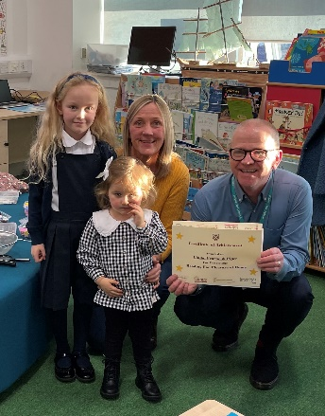Working together we aim to ensure an active, fun education which enables learners to use their God-given talents to fulfil their potential in every way. At the centre of our work is the good and benefit of every St. Andrew’s child. To develop as Responsible Citizens, Successful Learners, Effective Contributors and Confident Individuals we must ensure they are, and feel, Safe, Healthy, Achieving, Nurtured, Active, Respected, Responsible and Included.

**Our aims:**

Working within ‘Curriculum for Excellence’ we strive to provide the highest quality learning and teaching. We try to ensure that all our children attain and achieve their full potential and acquire the full range of skills and abilities relevant to growing, living and working in the modern world.

We aim for our pupils to become:

**SUCCESSFUL LEARNERS** by providing the highest quality learning and teaching to ensure all our children achieve their potential

**CONFIDENT INDIVIDUALS** by encouraging self-respect, ambition, and a sense of physical, mental and emotional well-being with secure values and beliefs and by valuing and celebrating each child’s attainment and achievement.

**RESPONSIBLE CITIZENS** by developing and fostering positive attitudes and skills for all pupils enabling them to have respect for themselves and others. We aim for our pupils to know and be proud of Scotland and our culture and to explore the cultures of other countries.

**EFFECTIVE CONTRIBUTORS** by encouraging an enterprising attitude, resilience, independent learning skills and the ability to work as part of a team.

We aim to get it right for every child and to provide a caring environment in which all children feel safe, healthy, active, respected and responsible, included and nurtured.

**Contact Details:**

**Head Teacher – Mr Alan Connick**

**Depute Head Teacher – Mr Anton Gallagher**

**St Andrew’s Primary**

**Chester Road**

**Greenock**

**PA16 0TT**

**Tele. 01475 715806**

School website: https://blogs.glowscotland.org.uk/in/saintandrews/

Email address: [office@st-andrews.inverclyde.sch.uk](mailto:office@st-andrews.inverclyde.sch.uk)

St Andrew’s is a Denominational Co-educational Primary School

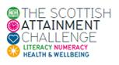

We are proud to be part of the Scottish Government’s Attainment Challenge to increase the life chances and tackle the attainment gap of those less well off in our country.

**School Information**

Present Roll 182 Agreed Capacity 394

Parents should note that the working capacity of the school may vary dependent upon the number of pupils at each stage and the way in which the classes are organised.

Roll at Each Stage:

Primary 1 17

Primary 2 29

Primary 3 26

Primary 4 20

Primary 5 25

Primary 6 35

Primary 7 30

**Class Teachers School Staff List**

Primary 1 Mrs Thomson

Primary 2 Miss Boyle

Primary 2/3 Miss Docherty

Primary 3/4 Mrs Millar

Primary 4/5 Mrs Gisbey

Primary 5/6 Mr Reynolds

Primary 6/7 Miss Fleming

Primary 7 Miss Mazzoni

Support for Learning Mrs J Carroll

RCCT Mrs Steel

Nurture Teacher Mrs McShane

Recovery Teacher Miss McPherson

**Support Staff**

Mrs P Watt & Mrs H Gibson – Senior Clerical Assistants

Mrs K Lyne – Clerical Assistant

Miss G Lyne – Clerical Assistant

Mr I McLaren – Pupil Support Assistant

Mrs J McClure – Pupil Support Assistant

Miss N Provan – Pupil Support Assistant

Miss K Sorrell – Pupil Support Assistant

Mrs L Loy – Pupil Support Assistant

Mrs K O’Donnell – Pupil Support Assistant

Miss D Baxter – Pupil Support Assistant

Miss A Williams – Pupil Support Assistant

Miss J Scott – Pupil Support Assistant

Miss N McClure – Pupil Support Assistant

Mrs M Real – Pupil Support Assistant

Mrs H Gibson – Pupil Support Assistant

Mrs A Michie– Catering Manager

Mr R Dunsmore – Janitor

**Daily Timetable**

School Opens: 9.00am

Interval: 10.30 – 10.45am

Lunch: 12.15 – 1.00pm

School Closes: 3.00pm

**Promoted Staff and Remits**

**Mr Alan Connick – Head Teacher**

Overall responsibility for the running of the school

Management Issues

Pastoral care of all staff and pupils

Parental Communications

Class organisation / Staff allocation

Curriculum support

Resourcing

School budget

Staff Development and support

Pupil Support

School Policies

NSA Co-ordinator

Strategic Equity Fund Implementation representative

**Mr Anton Gallagher – Depute Head Teacher**

Deputising for HT as required

Pastoral care

Student/NQT Co-ordinator

GIRFEC /Additional Support Needs Co-ordinator

Attendance Monitoring

Parental Engagement

Curriculum Support

Religious Education

Rights Respecting School

Staff Development

Support to colleagues

**Mrs Karen Bonar – Principal Teacher (PEF funded)**

Improve attainment in Reading and Reading engagement at all levels.

**Child Protection**

**Inverclyde Council Education Services has Child Protection Guidelines and Procedures which all schools and establishments are required to follow. Education Services work very closely with other agencies namely Police Scotland, HSCP, NHS Greater Glasgow and Clyde and the Children’s Reporter to support children. Common responsibilities of all staff are to protect children from abuse and exploitation, to respond appropriately when abuse is identified, and to ensure whenever possible that all children are able to exercise their right to be raised in a warm, stimulating and safe environment with the support of staff, their families and carers.**

**REGISTRATION FOR P1 SCHOOL SESSION 2025 - 2026**

**REGISTRATION IS AVAILABLE FROM 6 JANUARY 2025 - 10 JANUARY 2025**

Children who reach the age of five years between 1 March 2025 and 28 February 2026 (this will be children who are born between the 1 March 2020 - 28 February 2021) are due to start primary 1 at the beginning of the new school term in August 2025.

Parents should complete the P1 online registration process between 6 - 10 January 2025 regardless if they are considering a deferred year to school for their child.  Parents can choose between denominational or non-denominational schools or Gaelic Medium Education. Gaelic Medium Education is available at Whinhill Primary School for all pupils residing in Inverclyde**.** Please choose Whinhill (Gaelic) School from the online drop down menu when registering.

There are no denominational primary schools within the areas of Quarriers Village, Kilmacolm, Inverkip and Wemyss Bay. Parents often choose to send their children to the local non-denominational primary school because of the travelling distance to their nearest denominational primary school. In such circumstances the following admission arrangements will apply:

* Only those children who have a certificate of baptism into the Roman Catholic faith when registering for primary 1 will have the choice at primary 7 to seek admission to the denominational school assigned to their address.  For more information, please read our Pupil Placement Policy which is available in the documents section.

Once parents have completed the primary 1 registration, they will have the choice to complete a placing request application to a school other than the catchment primary.

A deferred entry application is also available to parents considering deferring their child’s entry to primary 1 in August 2025.

No documents will be required at this stage; however, we may have to contact you, should we require further information.

Parents will be notified by 30 April 2025 confirming their child’s place in school and information regarding induction days will follow from the school after this date.

Placing Request

If you have completed the primary 1 registration process and did not apply for a placing request at that time, you can still make an application by completing the form linked on this page under the Related Links heading.

**All placing request applications must be submitted by 1 February 2025.** Applications received after 1 February will not be considered until the placing request process is complete. Applications will be acknowledged within five working days of receipt of each application (excluding school holidays). If you do not receive an acknowledgement, please contact Admissions Section on 01475 712850 (please select option 1) to ensure your form has arrived. Parents will be advised of the outcome of their request no later than 30 April.

**Defer Entry**

Defer entry applications for the school term starting August 2025 are open until 1 February 2025. To make an application you should have registered your child for primary 1 between 6 -10 January 2025. If you have not registered your child please contact the admissions section on 01475 712850 (please select option 1) before completing the defer entry application form under the Related Links heading.

**All defer entry applications must be submitted by 1 February 2025**

**Entry Age**

If a child has not reached the age of 5 years by the last day in February they would not be eligible to register at this time. In exceptional circumstances, a formal request in writing for early entry should be submitted to Education Services for consideration.

**Transition arrangements**

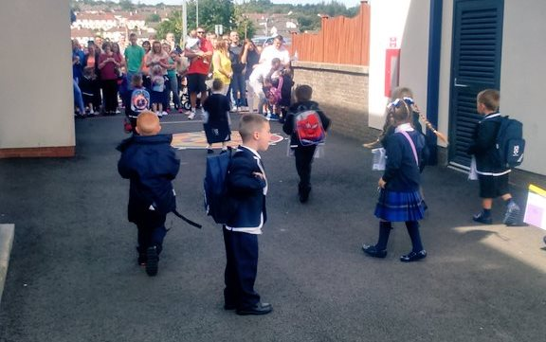We arrange for pre-school pupils to visit the school in May and June. This gives the children, who will be starting school in August the opportunity to get to know the teachers, visit the classroom etc. So he/she finds it easier to settle down when school begins. It also gives parents a chance to find out what their child will be doing in school and how best they can prepare him/her. Topics such as writing, phonics, reading, counting, the school health programme etc. are also discussed.

We work closely with Larkfield Children’s Centre and Aileymill Nursery to ensure a smooth passage from there to our school.

Staff from St. Andrew’s visit other early years establishments to get to know the pupils who will be starting with us in August.

If required, we arrange extra visits for pupils to the school.

If you think your child would benefit from an extra visit, please contact the school.

**Equalities**

**Inverclyde Education Service is committed to ensuring that no children or members of staff or service users receive less favourable treatment on any ground including age, gender reassignment, pregnancy and maternity, race, disability, sex, sexual orientation, marriage and civil partnership, religion or belief. We have a moral, social and legal obligation to mainstream and put equality at the heart of everything we do. We aim to promote a culture in which equality of opportunity exists for all. We are opposed to all forms of discrimination, direct or indirect, and aim to eliminate all discriminatory practices. We will ensure that, in our schools and other educational establishments, equality permeates the curriculum and underpins all our policies and practices in terms of access to education. We must ensure that all our children achieve their full potential to develop physically, emotionally and academically. Finally, we believe that equality and inclusion should be a given right, where everyone is valued and treated with respect.**

**School Holidays 2025/2026**

**Pupils do not need to attend on In-Service Days**

**FIRST TERM**

In-Service Day Friday 15th August 2025

In-Service Day Monday 18th August 2025

**School Open Tuesday 19th August 2025 (First Day for Primary 1s)**

Local Holidays Friday 26th September 2025

Monday 29th September 2025

**Re-open** **Tuesday 30th September 2025**

Close Friday 10th October 2025

October Week Monday 13th – Friday 17th October 2025

In-Service Day Monday 20th October 2025

**Re-open** **Tuesday 21st October 2025**

Christmas Holidays Monday 22nd December 2025 – Friday 2nd January 2026

**SECOND TERM**

**Re-open Monday 5th January 2026**

Local Holidays Monday 16th and Tuesday 17th February 2026

In-Service Day Wednesday 18th February 2026

**Re-open Thursday 19th February 2026**

Close Thursday 2nd April 2026

**THIRD TERM**

Spring Break Friday 3rd April 2026 – Friday 17th April 2026

**Re-open Monday 20th April 2026**

May Day Monday 4th May 2026

In-Service Day Tuesday 5th May 2026

**Re-open Wednesday 6th April 2026**

Local Holidays Friday 22nd May 2026

Monday 25th May 2026

**Re-open Tuesday 26th May 2026**

Close Tuesday 30th June 2026

**Curriculum for Excellence**

The curriculum framework for all Scottish educational establishments 3 – 18, called Curriculum for Excellence, offers better educational outcomes for all young people and provides more choices and more chances for those young people who need them.

The aims of Curriculum for Excellence are that every child and young person should:

Know they are valued and will be supported to become a successful learner, an effective contributor, a confident individual and a responsible citizen.

Experience a traditionally broad Scottish curriculum that develops skills for learning, skills for life and skills for work, with a sustained focus on literacy and numeracy that encourages an active, healthy and environmentally sustainable lifestyle and builds an appreciation of Scotland and its place in the world.

The experiences and outcomes under Curriculum for Excellence are written at five levels, with progression to qualifications described under the senior phase.

Early Level – the pre-school years and P1 or later for some

First Level – to the end of P4, but earlier for some

Second Level – to the end of P7, but earlier for some

Third and Fourth – S1 to S3, but earlier for some

Senior Phase – S4 to S6 and college or other means of study

**ORGANISATION OF THE CURRICULUM**

The curriculum is organised under eight headings but every effort is made to link areas of the curriculum together to make learning more real and relevant.

The eight areas are: Languages, Mathematics, Health and Wellbeing, Social Studies, Technologies, Expressive Art, Religious and Moral Education and Science.

In the next few pages we have a brief description of each area.

Central to all areas of the curriculum is the methodology used by the teacher and the need to engage our pupils in their learning.

We are always looking for new, innovative ways to enhance pupil learning. A particular area of interest is Digital Literacy.

In St. Andrew’s we believe that teachers should see learning through the eyes of the student and students should see themselves as facilitators of their own learning. In order to achieve this, we devised an aspirational goal for visible learning in our school

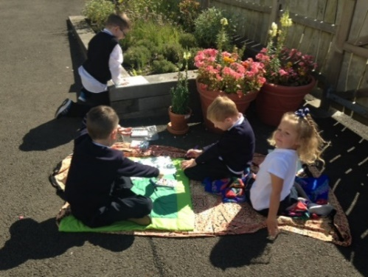

Learning outdoors using our wonderful grounds

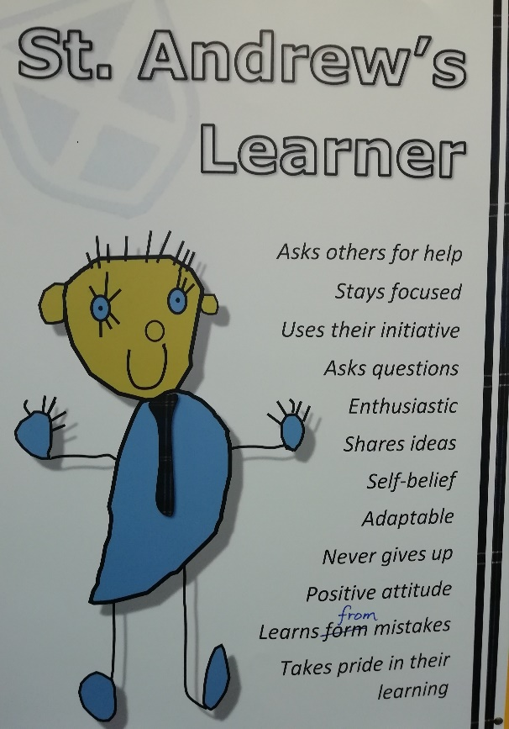

“*All pupils in St. Andrew’s will be able to describe what a good learner is and how they are one. Pupils will describe effective thinking habits and thinking strategies that they use to help them learn. Pupils will seek and receive effective feedback from teachers and peers which supports progress in their learning. Pupils will know where they are, where they are going and next steps in Maths and Language. Pupils will be assessment capable learners. Teachers will be inspired, passionate and impactful.”*



Our school is fully embracing play based learning in Primary 1. We will be collaborating with other schools to pilot a play based, nurturing approach.

Studies have proven that play based learning for children from birth to 7 years allows children the best possible start in life, something which Saint Andrew’s has at the heart of our school.

Play is how our children learn best and we are ready to support our children and give them the best possible start in their school journeys.

**How will our children be learning?**

Our children will have full ownership of their learning and will be fully engaged in creative thinking and problem solving each day. All learning will meet every child’s individual needs and will allow them to progress at their own pace. Children will be engaged in free flow play each day and will choose what learning will take place. Teachers and support staff will then work with your child based on what they have chosen. This will be our teaching time but your child will be leading it. Teachers are trained to spot the perfect ‘teaching moments’ which will create wonder and critical thinking moments for all children. This will leave your children happy and stress free, as all learning will be tailored to their interests and needs.

Please do not panic! Phonics, reading and numeracy will also be done as class lessons alongside play, however children will not be expected to read until term 3.

All children will have their own progress folder, which records the progress your child makes throughout Primary 1. This will include photographs, drawings, stories and any other important evidence of your child’s learning journey.

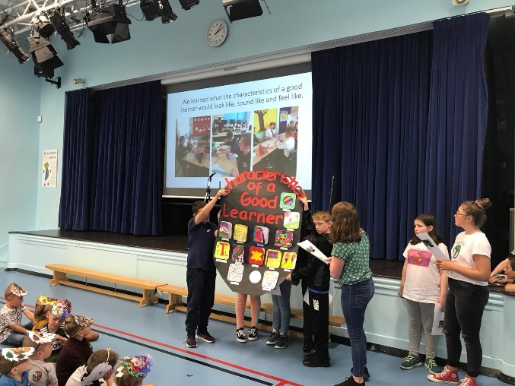**Mathematics and Numeracy**

We utilise the Inverclyde Numeracy and Mathematics Pathway to provide a structured learning pathway for all. We also use a variety of excellent resources for the teaching of Mathematics. We encourage an “active” approach to learning in all classes. Mental maths, the use of ‘Number Talks’ and basic number work is fully covered and attention is given to each of the areas of Information Handling; Shape, Position and Movement; number, Money and Measure and Problem Solving.

**Language and Literacy**

Language is at the core of thinking and at the centre of our learning. Through language our pupils gain much of their knowledge and many of their skills across the curriculum.

The four main components of language are:

**Talking & Listening, Reading, Writing**

The importance of Spoken English is emphasised in St Andrew’s School. From Primary 1 children are encouraged to develop their skills in talking and to articulate their learning.

In literacy we use the North Lanarkshire Active Literacy approach to support our children in their initial phonic development. This provides a framework for excellent learning and teaching which extends throughout the school.

A wide range of reading texts is used in all classes. Reading for pleasure, as well as for information, is encouraged throughout the school and we have well-stocked libraries.

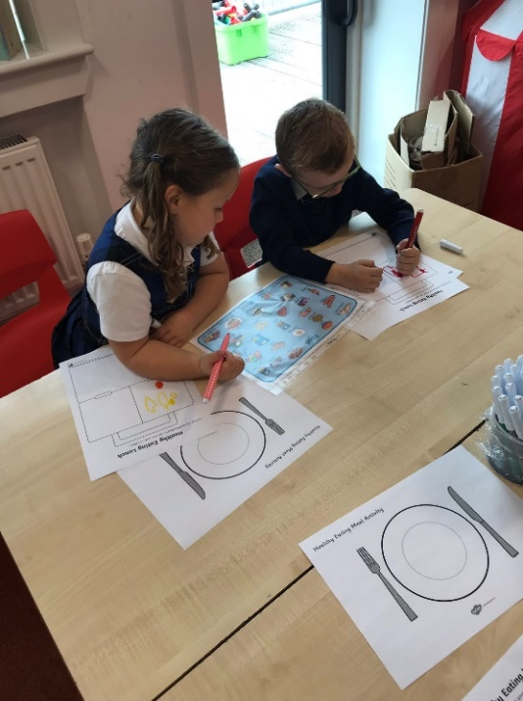The area of written English includes work on the techniques of language (punctuation, grammar, and spelling) which help the children to produce work which can be read and understood by others – work such as factual reports, imaginative stories, etc. We encourage the highest standards in the presentation of written work and foster the pupils’ ability to express themselves in writing. All children have formal handwriting lessons.

**We are a Reading School**

Reading Schools is an accreditation programme for schools that are committed to building a culture of reading for their learners and communities. Research proves that reading for pleasure has positive impacts on learners' attainment across the curriculum, supporting wellbeing, critical thinking, creativity, empathy and resilience.  We are a Core Level Reading School.  We are currently working towards a Silver Level Reading School Award.



**READ, WRITE, COUNT**

The Read, Write, Count programme aims to support parental engagement in literacy and numeracy. Gift bags are distributed annually to all P2 and P3 pupils in Scotland by Scottish Book Trust. The gift bags contain literacy and numeracy materials to support children’s learning, as well as advice and support to parents.

Studies show a direct link between a strong family learning environment and progress in reading, writing and counting. In addition to the activity booklet included in the bag Scottish Book Trust offers a range of hints, tips and advice to help parents engage in their child’s learning on the [website](https://www.scottishbooktrust.com/reading-and-stories/read-write-countoffers).

**BOOKBUG**

[Bookbug](https://www.scottishbooktrust.com/bookbug) is Scotland’s universal early years book gifting programme and aims to inspire a love of stories, songs and rhymes from birth. Bookbug gives every child in Scotland four free bags of books as babies, toddlers, three and five year olds. The bags contain books and other resources for sharing songs and rhymes that are suited to their age. Gaelic Bookbug Bags are also available.

The **Bookbug Explorer Bag** is gifted to all 3 year olds at their childcare setting. It includes three lovely books, an activity book, pencils, and postcards to encourage mark making.

Every year, The Bookbug Picture Book Prize celebrates the best new Scottish picture books, and the winner of the prize is chosen by children across Scotland. All Primary 1 pupils receive the three shortlisted books in the **Bookbug P1 Family Bag**, given out in November during Book Week Scotland, and can vote for their favourite in school or at home with their families.

Check out the [website](https://www.scottishbooktrust.com/bookbug) for booklists, book sharing videos, activity

ideas and much more.

**1 + 2 Languages**

In line with the Scottish Government initiative titled 1+2 where all Primary age pupils experience a language other than English from Primary 1. We introduce all of our pupils to French – learning words and phrases as well as learning about France. Some of our classes are also being introduced to elements of the Spanish language and learning about Spain.

**Social Studies**

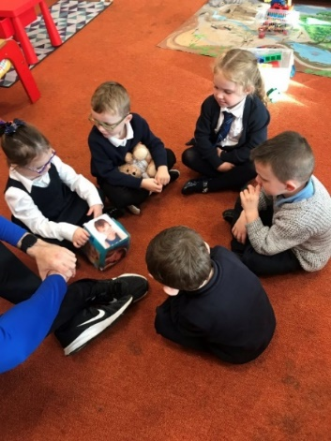In Social Studies pupils look at societies at different times (history) and in different places (geography). This will, for example, involve them in studying important people and events in the past, investigating transport and communication networks at home and further afield; and in looking at the ways our communities are run.

Visits to places of educational interest are arranged whenever possible to allow the children the opportunity of seeing things at first hand. The experiences are designed to encourage links with other areas of the curriculum so that learners have deeper, more enjoyable and more active experiences.

**Science**

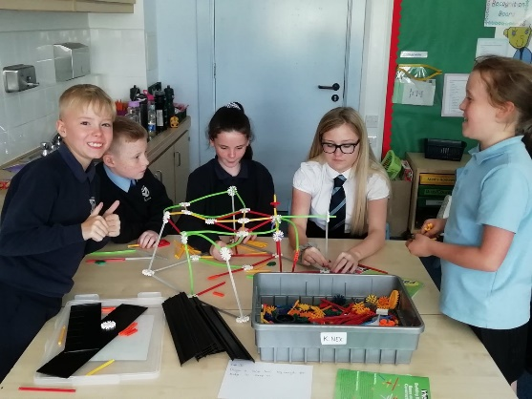

The science curriculum within Curriculum for Excellence challenges us to ensure that all children must develop a secure understanding of important scientific concepts and that their experience of science in school should kindle a lifelong interest in science.

The science outcomes have been developed into seven areas

* Planet Earth
* Energy in the Environment
* Communication
* Forces and Motion
* Life and Cells
* Materials
* Topical Science

**TECHNOLOGIES**

As pupils study aspects of Technology, they learn about its impact in the home, in schools, in industry and in the wider community. They should also be given the chance to use their own skills and offer solutions to design problems, using different materials and resources.

Information Technology should involve pupils in, for example, using and learning about audio-visual equipment (such as CD and DVD), computers and a variety of computer ‘applications’. St Andrew’s Primary has excellent ICT resources.

All of our classes experience **STEM** activities – where Science, Technology, Engineering and Maths are combined to create rounded activities exploring many real-life contexts.

**EXPRESSIVE ARTS**

**Drama**

Using movement, mime and language. Communication, creating and presenting drama activities.

**Art and Design**

Drawing, painting, printing, collage, modelling and sculpture, design and appreciation of art and artists. You will see examples of the children’s work displayed throughout the school.

**Music**

Exploring sound, using the voice and instruments. Creating and performing and appreciating.

We encourage a love of music and the children enjoy performing at our Christmas Concert, St. Andrew’s Day Hoolie and other events throughout the year.

In St Andrew’s Primary School, we have ongoing programmes in each area of Expressive Arts – Art, Music and Drama. Each area has its own body of content which focuses on the skills and techniques to be learned. We encourage all our children to develop their talents and to enjoy all aspects of Expressive Arts. This encourages their creative expression and fosters creative activities, important in times of greater opportunities for leisure. We showcase the talents of our children in various events throughout the year.



**Health and Wellbeing**

We are a Health Promoting School. 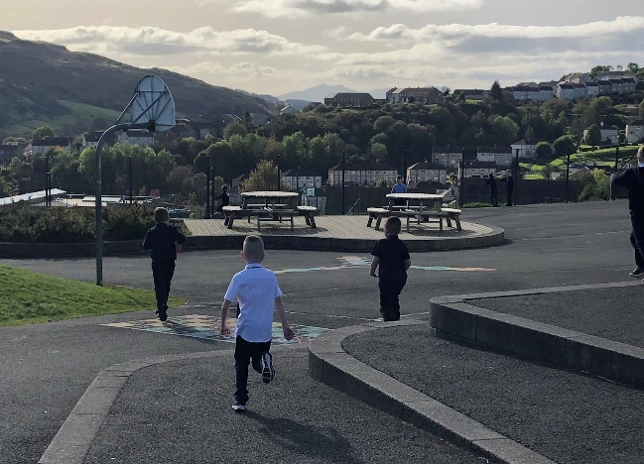Health and Wellbeing Education is an important part of the work of St Andrew’s Primary. It is concerned with all aspects of mental, emotional, social and physical wellbeing now and in the future.

Health and Wellbeing is subdivided into the following areas:

• Mental, emotional, social and physical wellbeing

• Planning for choices and changes

• Physical education, physical activity and sport

• Food and Health

• Substance misuse

• Relationships, sexual health and parenthood.

Pupils are given well planned opportunities to learn about their own health and wellbeing, relationships and health and safety in the environment. We encourage PE and we ensure that pupils have 2 hours quality Physical Education per week.

Every class participates in the ‘Daily Mile’ where pupils walk or run one mile every day.

Parents should note that pupil activities may be restricted because health and safety requirements state that jewellery of any kind must not be worn where pupils are undertaking games or physical activities. This includes jewellery worn as a result of body piercing.

**Religious Education**

In accordance with your wishes, your child is taught the doctrine, prayers and practices of the Roman Catholic Church. He/she is prepared for the reception of the Sacraments of Reconciliation, Confirmation and Holy Eucharist. With your co-operation, we encourage him/her to become a practising member of the Church and part of the parish community. The school chaplain, Father Danny McLaughlin visits each class on a regular basis.

At daily prayers in class, weekly school assemblies, masses in class, school and St Andrew’s Church, we all come together to worship God and share our faith. Parents are welcome to participate in school/class masses or celebrations and are informed of these by letter. Should any parent wish to withdraw their child from this religious programme, they should contact the Head Teacher and, if necessary, special arrangements will be made.

**We are a Laudato Si School**

The Laudato Si' Schools’ Programme seeks to take the core principles of the Pope’s encyclical letter into schools as a way to promote ecological conversions among our children, encouraging them to learn about the world around them empowering them to take action to care for our common home.

**Spiritual, Social, Moral and Cultural Values**

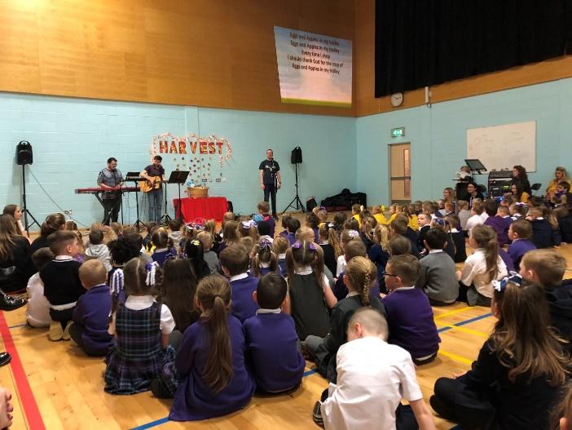Parents from ethnic minority religious communities may request that their children be permitted to be absent from school in order to celebrate recognised religious events. Only written requests detailing the proposed arrangements will be considered. Appropriate requests will be granted on not more than three occasions in any one school session and the pupil noted as an authorised absentee in the register.

Sex and Relationship education is an integral part of a school’s health education programme. It focuses on the physical, emotional, moral and spiritual development of all children. Teachers are central to the delivery of sex education from Primary 1-7 and work in partnership with parents/carers and appropriate health professionals. Parents/carers will be fully informed and consulted on the content and purpose of sex and relationship education in schools, and have the opportunity to raise concerns with school staff. On an occasion where a parent/carer wishes to exercise the right to withdraw his/her child from sex and relationship education they should discuss their concerns and alternative arrangements with school staff (as per Inverclyde Council’s policy “Sexual Health and Relationship Education”.)

Our school follow the Scottish Catholic Education Service programme – ‘God’s Loving Plan’ and all teaching staff are trained in the delivery of this.

**Citizenship and Enterprise Education**

Both of these areas have a high priority in St Andrew’s School. They develop confidence and self-respect in our pupils. They help pupils to develop their decision making skills. They give them opportunities to work as part of a team and to show respect for differing opinions and other cultures. Most of all they encourage pupils to be creative and enterprising in co-operating with others as part of a team, showing care and respect for others, their opinions and their cultures.

Throughout the school year, every class has many opportunities to take part in Enterprising Activities and as well as being educational, they are always great fun!

Every teacher in St Andrew’s School encourages good citizenship and an enterprising attitude in the classroom and across all areas of school life.



**Additional Support for Learning**

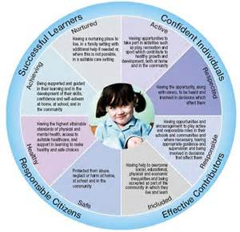Every teacher has a responsibility to support the learning of all pupils in their class. The type of support offered will vary according to the needs of pupils. This includes consideration given to children who have a disability, children with social, emotional and behavioural difficulties, children with learning difficulties of a specific or general nature, children who are exceptionally able, those who demonstrate underachievement relating to gender issues, children whose learning has been interrupted through absence or illness, bilingual children who have English as an additional language, travelling children and those children whose family circumstances impact on attendance and learning.

If a parent considers that his or her child has additional support needs and wishes to make enquiries about this, they should contact the head teacher.

Children with learning difficulties, for whatever reason e.g. prolonged absence, are given extra help by Mr Gallagher our Learning Support Co-ordinator, Mrs. Carroll our Learning Support Teacher and our support staff. This learning follows closely with that led by the class teacher. This supportive work is extended to suit all levels of work within each classroom.

Multi-sensory programmes of work are developed for children with specific learning difficulties. Parents are kept fully informed of such programmes of work and are invited to school to discuss their child’s progress on a regular basis.

Our Learning Support Facilities are used not only for those children experiencing difficulties, but also to encourage the more able children in their work and continue to present them with challenging resources.

It is the aim of the school to ensure that all pupils reach their full potential in all areas of the school curriculum.

We are very lucky in St Andrew’s to have a Nurture Class where we can further meet the social, emotional and behavioural needs of all our pupils.

The School Psychologist is Ms Andrea Montgomery. Children may be referred to her for a variety of reasons, but parents are always informed first.

We will always work with parents for the benefit of the child.

If a parent considers that his or her child has additional support needs and wished to make enquiries on this, they should contact the Head Teacher.

**Our Depute Head, Mr Gallagher, co-ordinates additional support within St. Andrew’s. He is available to talk to parents if they have any worries. Please feel free to phone for an appointment or drop in to arrange a chat.**

St. Andrew’s Primary and Inverclyde Council have a number of policies and procedures which support the implementation of the Education (Additional Support for Learning) (Scotland) Act 2009.

A child or young person’s needs are identified at the earliest possible stage and can be met in a number of ways, for example by adaptations to the curriculum or learning environment, as well as input from the Support for Learning Teacher and on occasion support from visiting specialists. The appropriateness of the support is determined through a process of assessment, planning and monitoring, working jointly with parents and carers, and is regularly reviewed.

Learning outcomes for children and young people with additional support needs are set out in a plan and all educational establishments hold regular review meetings with parents and carers to determine needs and the most appropriate supports. Everyone’s views are equally important in order to consider what is currently working and how to determine next steps.

Children and young person’s needs are identified in a number of ways, and the process of assessment is an on-going, shared process with partnerships with parents and carers at the forefront. On some occasions health service staff or other partner agencies make children known to Education Services. Other additional support needs may be notified to Education Services by parents themselves or identified by one of a range of staff working closely with the child.

Some children and young people will have additional support needs arising from complex or multiple factors which require a high degree of co-ordination of support from both education and other agencies in order that their needs can be met. In these cases, the school will hold a meeting to decide whether the child or young person meets the criteria for a co-ordinated support plan.

The coordinated support plan is a statutory document which ensures regular monitoring and review for those children and young people who have one.

You have the right to ask the education authority to establish whether your child needs a coordinated support plan. Your child can make this request themselves, if they are aged 16 or over. You and your child, if they want to, will attend a meeting with staff at their school. Other professionals from different agencies who may be involved in providing support for your child will also attend. If your child does not want to attend meetings or feels unable to, their views must still be sought and considered.

Inverclyde’s mediation service can be accessed by contacting Michael Roach, Head of Education at the address: -

For further advice, please telephone 01475 712850

Or write to;

[www.enquire.org.uk](http://www.enquire.org.uk)

**Education Services** [www.siaa.org.uk](http://www.siaa.org.uk)

**Wallace Place** [www.sclc.org.uk/](http://www.sclc.org.uk/)

**GREENOCK**

**PA15 1JB**

**Homework**

Regular homework is encouraged in St Andrew’s Primary School as a means of reinforcing learning done in school and to involve our parents in their child’s school learning. Teachers will inform parents of the Homework Plan for the year at the Welcome Morning/Afternoon in August/September. A variety of homework will be given. This will generally be assigned on four evenings per week. This work should not take more than 30 minutes each evening. We always welcome your views on this.

**Let us know if you would like us to arrange any parent workshops to help you with any area of your child’s school work.**

Some reasons for Homework:

Homework strengthens the liaison between home and school.

Homework keeps parents informed of progress.

Homework encourages parents to help and motivate their children.

[](http://www.bing.com/images/search?q=home-work&view=detailv2&&id=E41991EB28A6E4E50649E7915E4459D68B6D1762&selectedIndex=85&ccid=r+8fupwJ&simid=608031803591950684&thid=OIP.Mafef1fba9c0965ae18d71a8b71bc12aao0)Homework is useful in reinforcing work done in school (particularly when a new skill is being taught and additional practice is required).

Homework encourages initiative (e.g. Topic Work).

Homework enables the parent to be seen as joint educator of the child.

Homework is valuable.

**Assessment**

National Guidelines on Assessment have been issued to all schools. As part of the development plan, assessment procedures in the school are being revised in the light of these guidelines.

For up to date information click <http://www.educationscotland.gov.uk/learningandteaching/assessment/index.asp>

We use formative assessment methods in class, for example, discussing the aims of lessons with the class before the lesson, providing and sharing feedback throughout the activity and recapping on what we have achieved at the end. Teachers assess continuously throughout their time in class sharing feedback with pupils. Pupils can decide how well they think they have done with this as they can self and peer assess.

Parents Evenings are held in October and March. We have recently changed our reporting procedures to keep parents more informed of their child’s progress. Pupil Targets are sent home for discussion and teachers will then report on progress a few months later.

Parents are welcome at all times in the school and arrangements can easily be made for parents to discuss their child’s progress at any time during the school year. We really value your input and your partnership in your child’s learning.

Our assessment procedures fulfil three purposes

• To diagnose areas of difficulty

• To provide reliable information on pupil progress

• To provide the basis for communicating to parents areas of strength and concern

We use a variety of published assessment materials to monitor progress in literacy and numeracy. The information from these is used to support pupil learning and to plan additional support if required.

**Home and School Links**

In St Andrew’s Primary School we work closely with parents and value their input into school life. Parents are kept closely informed of all the activities and happenings in the school by newsletters and the use of email. You may also follow us on Twitter (@saintandrewsps) and download our school app.

We have a hard working Parent Partnership and all associated in any way with the school are encouraged to play an active part in school life.

Welcome Afternoons are held in all classes, when parents are invited to come along and meet their child’s teacher, look at the resources being used, the homework to be covered, etc. Parent’s Evenings are held in October and March when parents are invited to come to the school to discuss their child’s work with the class teacher.

Parents are invited into the school regularly for workshops or to celebrate pupils’ learning in topics.

**Any parent who wishes to contact the school with any concern or complaint should phone on 01475 715806 to make an appointment to speak to Mr. Connick, Head Teacher or come in to the school personally.**

**On such occasions we will attempt to speak to you immediately regarding your concern or complaint.**

In such events we will attempt to answer your query as quickly as possible, depending on how quickly the matter can be investigated.

We appreciate your support in this process and will speak to you in person or by phone as soon as possible after the initial meeting.

For more info see:

<http://www.inverclyde.gov.uk/education-and-learning/parental-involvement>

**Parent Partnership**

**We have a very supportive and busy Parent Partnership group. Please speak to the school for information on meetings and how you can become involved.**

Scottish Schools (Parental Involvement) Act 2006 led to the establishment of Parent Councils in primary, secondary and special schools. The Act recognises the vital role that parents play in supporting their children’s learning. It places a duty on authorities to promote the involvement of parents in children’s education and the wider life of the school. It aims to help parents to be: -

▪ Involved with their child’s education and learning

▪ Welcomed as an active participant in the life of the school

▪ Encouraged to express their views on school education

generally

The Parent Council, as a statutory body, has the right to information and advice on matters which affect children’s education.

Parents who are involved on a regular basis in schools require a PVG certificate.

Our Parent Council Chairperson is Mrs Claire Regan



**ParentPay**

We use an online way for parents to pay for school funds, the breakfast club and school trips etc. This makes payments simple and straightforward. This is part of the system we use to order school meals for the pupils too.

**Extra-Curricular Activities**

****In St Andrew’s School we offer a variety of lunch time and after school activities throughout the school year.

We are always looking for new ways to involve our pupils so, if you have an idea for a club, please let us know.

**Children Absent from School through ill Health and Attendance at School**

**Parents should inform the school by telephone or Parent Portal every morning of an absence and provide a reason for the pupil’s absence. The school will contact the pupil’s main contact by text message if we have not been contacted. This contact will be made in the morning and by direct phone call early after the restart after lunch in the case of an afternoon absence.**

Young people of school age may be unable to attend school for a wide range of reasons including illness, accidents or long term medical conditions. In general there will be an automatic referral by the school for education out-with school after 15 days of continuous or 20 working days of intermittent absence, within a single session, for verifiable medical reasons.

Other agencies may be contacted if no contact with the pupil’s family can be achieved and if there are continuing or emerging concerns about a pupil’s safety or wellbeing. On return to school parents should provide a note explaining the reasons for absence.

**Parents should keep the school informed of any changes of address or home and mobile telephone numbers, both their own and those of the emergency contacts.**

Section 30 of the 1980 Education Act lays a duty on every parent of a child of ‘school age’ to ensure that their child attends school regularly. Attendance must be recorded twice a day, morning and afternoon.

Regulation 7 of The Education (School and Placing Information) (Scotland) Amendment, etc. Regulations 1993 requires each child’s absence from school to be recorded in the school register as authorised: i.e. approved by the authority and unauthorised: i.e. unexplained by the parent (truancy) or temporarily excluded from school. The Scottish Government has provided guidance on the management of attendance and absence in Scottish schools in its publication Included, Engaged and Involved- part 1: Attendance in Scottish Schools. Every effort should be made to avoid family holidays during term time as this both disrupts the child’s education and reduces learning time. It has been clarified that family holidays should not be recorded as authorised absence, except in exceptional domestic circumstances, where a family needs time together to recover from distress, or where a parent's employment is of a nature where school-holiday leave cannot be accommodated (e.g. armed services or emergency services). It is for local authorities and schools to judge when these circumstances apply and authorise absence, accordingly.

The categorisation of most term-time holidays as unauthorised absence has been a contentious issue for some families, many of whom are concerned at the higher cost of holidays during school holiday periods. The Scottish Government has no control over the pricing decisions of holiday companies or flight operators. Our main focus is to encourage parents and pupils to recognise the value of learning and the pitfalls of disrupting learning for the pupil, the rest of the class and the teacher.

Clearly where an absence occurs with no explanation from the parent, the absence is unauthorised. Schools investigate unexplained absence, and Education Services has the power to write to, interview or prosecute parents, or to refer pupils to the Children’s Reporter, if necessary.

**School and the Community**

St Andrew’s Primary School works closely with the local community.

We enjoy a very close working relationship with Aileymill Primary School. Our schools join together in St Andrew’s Church for the celebration of Harvest and Christmas. Our children take part in charity events and local sports activities. We also collect for local charities

**Pupil Voice - House Teams**

In St. Andrew’s every pupil is allocated to a House group – “. like in Hogwarts” as our pupils say. These are named after Scottish lochs – Katrine, Thom, Awe, Lomond, Ness and Fyne.

Pupils earn points for their House team by displaying excellence within our core values of Honesty, Respect, Responsibility, Kindness and Aspiration and by always trying in their learning.

**Positive Relationships**

We are a Rights Respecting School and this encourages a positive attitude to each other and a school as a whole. We are delighted to have received The United Nations Rights Respecting School award – Level 1.

In order that pupils can learn in a calm environment and that learning can continue without interruption and to preserve safety in the playground and corridors, pupils are expected to conform to certain rules of behaviour.

In St Andrew’s Primary School, we consistently try to encourage positive attitudes and we make use of a simple merit scheme, whereby children are rewarded for good behaviour and for special effort in class.

Children are awarded with a Head Teacher’s award sticker for good behaviour, work and manners.

Each staff member has a ‘Good News’ Book where pupils are noted for a wide number of reasons which are mentioned at our assemblies.

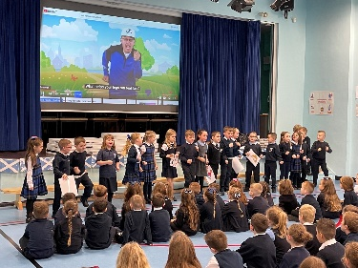As you can see we positively encourage good behaviour and good manners. If any child’s behaviour gives us cause for concern, we will consult with the parents immediately.

We aim to work with our parents to ensure a happy, well-disciplined working atmosphere in St Andrew’s Primary School.

**School Security**

After the children come in at the 9am bell, all doors are closed. These are security doors and can only be opened from inside and can be opened easily by even the smallest child in an emergency. Anyone entering the building must use the front entrance. This door has a bell system with video and intercom at the right of the door. Please press for entrance. Stand in front of the panel to be seen on the video and to enable the staff member to talk to you through the intercom. All doors apart from the main door are “Pupil Only” doors.

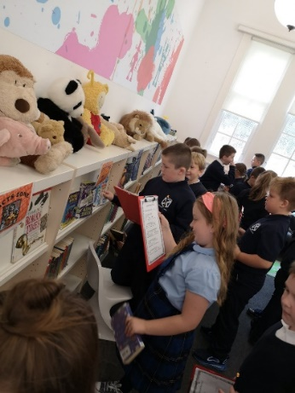**Visitors’ Badges**

After ascertaining the identity of the parent/visitor, whether from the video or the intercom, the door lock is released for entry. All visitors must then report to the reception. If collecting children during school hours, school staff will use the PA system for the child or go to collect them from class. If visiting any other area of the school, all visitors must sign in.

**Supervision of Playgrounds**

An adult presence is provided in playgrounds at break times in terms of the Schools (Safety and Supervision of Pupils) (Scotland) Regulations, 1990.

At Playtime and including lunchtime, the doors into the playground are open to allow children out and in with access to the toilet. All visitors are still required to come in through the front door. Adults should not walk through the playground. There may be exceptions to the rule e.g. class masses, fetes, concerts. At these times the door will be open but managed by a member of staff.

Our aim is to make our school safe, happy and welcoming for everyone. These measures have been drawn up to keep the children, staff and visitors to our school safe. We welcome parents and visitors to our school, but ask that all pay special attention to our security procedures.

**Clothing and Uniform**

**Please put your child’s name on his/her clothing/uniform, lunch bags etc**

**Inverclyde Policy on Uniform**

Given that there is substantial parental and public approval of uniform, schools in Inverclyde are free to encourage the wearing of school uniform. In encouraging the wearing of uniform account is taken in any proposals to prevent any direct or indirect discrimination on the grounds of race or gender. Any proposals will be the subject of widespread consultation with the parents and pupils. Against this background it should be noted that it is the policy of the Education & Lifelong Learning Committee not to insist on pupils wearing uniform or having specialist items of clothing as a prerequisite of their attending and engaging in all of the activities of the curriculum.

There are forms of dress which are unacceptable in school, such as items of clothing which:

* potentially, encourage faction (such as football colours);
* could cause offence (such as anti-religious symbolism or

political slogans);

* could cause health and safety difficulties, such as loose fitting
* clothing, or clothing made from flammable material.
* carry advertising, particularly for alcohol or tobacco
* could be used to inflict damage on other pupils or be used by others to do so.

**We urge any parent to apply for a Clothing Grant and Free School Meals if they think they may be eligible. Please contact Mr. Connick or Mr. Gallagher if you would like any help with this.**

In addition, jewellery such as dangling earrings and large rings could cause health and safety difficulties and are unacceptable to be worn in school.

Our school uniform is:

**Navy** skirt, pinafore or trousers

**White** shirt with tie OR School polo shirt

**Navy** cardigan/jumper or Navy sweat shirt

In summer, **blue checked** school dresses may be worn

**Navy** blazer

**Your child or children are entitled to free school meals and a clothing grant if you receive one of the following benefits:**

**•Income Support (IS);**

**• Income-based Job Seekers Allowance (JSA);**

**• Employment and Support Allowance (Income Related) (ESA);**

**• Child Tax Credit, but not Working Tax Credit and where income is less than £19,995 (in 2024/245) as assessed by HMRC;**

**• Parent or Carer is in receipt of Working Tax Credit and/or Child Tax Credit with Annual Gross Earnings of no more than £15,051;**

**• Universal Credit, where your take home pay does not exceed £1,199, as shown on your monthly Universal Credit statement;**

**• An Asylum Seeker, receiving support under Part VI of the Immigration and Asylum Seekers Act 1999.**

[**http://www.inverclyde.gov.uk/education-and-learning/schools/clothing-grant-and-free-school-meals**](http://www.inverclyde.gov.uk/education-and-learning/schools/clothing-grant-and-free-school-meals)

Approval of requests for such grants made by parents in different circumstances is at the discretion of the Corporate Director Education and Social Care.

Information and application forms may be obtained from schools and from Education Services, Wallace Place, Greenock, PA15 1JB.

The council is concerned at the level of claims being received regarding the loss of pupils’ clothing and/or personal belongings. Parents are asked to assist in this area by ensuring that valuable items and unnecessarily expensive items of clothing are not brought to school. Parents should note that the authority does not carry insurance to cover the loss of such items and any claims submitted are likely to be met only where the authority can be shown to have been negligent.

**School Meals**

A cafeteria system operates. Pupils may have hot meals or picnic snacks. Vegetarian dishes are also available.

**All pupils in Primary 1 to 7 are entitled to a free school meal, regardless of personal/family circumstances.**



It should be noted that a special diet is available to any child who requires such on medical grounds.

The pupils who bring packed lunches have their meals in the school canteen.

Information and application forms for free school meals may be obtained from schools and Education Services, Wallace Place, Greenock, PA15 1JB. In addition, such children will be entitled to free milk.

Every effort is made to encourage children to choose their food sensibly. The canteen uses a three-weekly Menu rotation system. We send the menu home at the beginning of the year so that your children can discuss the options and choose what they like before coming to school.

**We urge any parent to apply for a Clothing Grant and Free School Meals if they think they may be eligible. Please contact Mr. Connick or Mr. Gallagher if you would like any help with this.**

**Breakfast Club**

**We have a popular breakfast club in St Andrew’s School every day from 8.00-9am. Breakfast Club staff run the club and the children enjoy cereal, juice and toast followed by games and physical activity in the hall. Attendance at Breakfast Club is free for pupils in receipt of a Free School Meal/clothing grant and cost £1 for others. This is paid through ParentPay.**

**Transport**

The Council has a policy of providing free transport to all primary pupils who live more than one mile from their local school by the recognised shortest walking route. This policy is more generous than the law requires. This means that the provision of transport could be reviewed at any time. Parents who consider they are eligible should obtain an application form from the school or Education Services at 105 Dalrymple Street, Greenock, PA15 1HU. These forms should be completed and returned before the end of February for those pupils beginning school in August to enable the appropriate arrangements to be made.

Applications may be submitted at any time throughout the year but may be subject to delay whilst arrangements are made. The appropriate officer has discretion in special circumstances to grant permission for pupils to travel in transport provided by the authority, where spare places are available and no additional costs are incurred

**Pick up Points**

Where free transport is provided it may be necessary for pupils to walk a certain distance to the vehicle pick-up point. Walking distance in total including the distance from home to the pick-up point and from the drop-off point to the school in any one direction will not exceed the authority’s limits. It is the parent’s responsibility to ensure that their child arrives at the pick-up point in time. It is also the parent’s responsibility to ensure the child behaves in a safe and acceptable manner while boarding, travelling in and alighting from the vehicle. Misbehaviour could result in a child losing the right to free transport.

**Placing Requests**

Education Services does not provide transport for those pupils in receipt of a placing request other than in exceptional circumstances. In the case of under-age placing requests if the child is offered a place in his/her catchment area school, transport will be provided in accordance with Council policy stated above.

**Medical and Health Care**

****The children have routine medical examinations at five years of age and some at eleven years of age. A questionnaire and consent form is issued by the School Nurse. Routine hygiene examinations go on each session throughout the school. There are also hearing and eyesight tests.

In the case of minor accidents at school, the child will receive attention from Mrs O’Donnell our First Aider. Should a child become ill at school, the parent/carer is notified and asked to accompany the child home. If they are unavailable, the emergency contact (name, address and telephone number is on a child’s confidential record) is notified.

If a child has an accident, arrangements similar to those above are operated. However, if the accident is of a serious nature and immediate hospital attention is required, the Head Teacher or, if necessary, an ambulance will take the child to hospital, at the same time notifying parents either at home or at work of what is happening.



**ALLERGIES/NUT FREE ZONE**

As some of our pupils are allergic to nuts and nut products and could suffer an anaphylactic reaction if exposed to them we ask that children **do not bring nuts/nut products to school – THIS INCLUDES NUTELLA.**

**INHALERS**

In accordance with the National Asthma Campaign – if your child is Asthmatic please ensure they have a spare inhaler that they can keep in their class.

**SCHOOL DENTIST**

The school dentist visits the school annually and indicates where treatment is necessary. Parents may choose to send their child to the school dentist or to make their own arrangements.

In St Andrew’s Primary School, we endeavour to promote good health in every way possible. We have a structured programme of health education throughout the school.

Pupils in Primary 1 and 2 are supported to brush their teeth every day after lunch.

**If parents wish to send medicine to school with a child, a medication form with details must be completed, signed and handed in to the office. (These are available from the office). Only medicines prescribed by a doctor will be administered.**

**Transfer to Secondary School**

**St Columba’s High School**

Pupils are normally transferred between the ages of 11½ and 12½ years, so that they will have the opportunity to complete at least 4 years of secondary education. Parents will be informed of the arrangements no later than December of the year preceding the date of transfer at the start of the new session.

Excellent liaison with the Head Teacher and staff of St Columba’s High School ensures that the transition to secondary school is as easy as possible for the pupils.

Specific transition meetings occur in January/February for ASN pupils and in May for all Primary 7 pupils.

A successful outcome of the liaison is the induction period when the pupils from Primary 7 spend time in St Columba’s High School in June of each year. They are introduced to the staff, get to know the building, the school rules etc. They follow a secondary timetable, thus receiving an introduction to all subjects.

Staff from St Columba’s work with our pupils throughout the year and liaise with our teaching staff.

The Head Teacher of St Columba’s High School also makes arrangements to meet the parents of pupils in the term before they enter the school.

The address of St Columba’s High School is:

St Columba’s High School

Fletcher Avenue

Gourock

Tel. 715250

**How Do I Complain?**

If you have a complaint, please speak to Mr Connick at the school. He will do his best to help you but if you would like to record the complaint officially both he and Mr Gallagher will help you to do this.

It is easier for us to resolve complaints if you make them quickly and directly to the school, so please talk to either Mr Connick or Mr Gallagher as soon as possible. Then they can try to resolve any problems on the spot.

If you are not satisfied you should contact our Education Officer Elaine McLoughlin on 01475 717171

**Useful Addresses**

**Corporate Director of Education, Communities & Organisational Development**

Ruth Binks

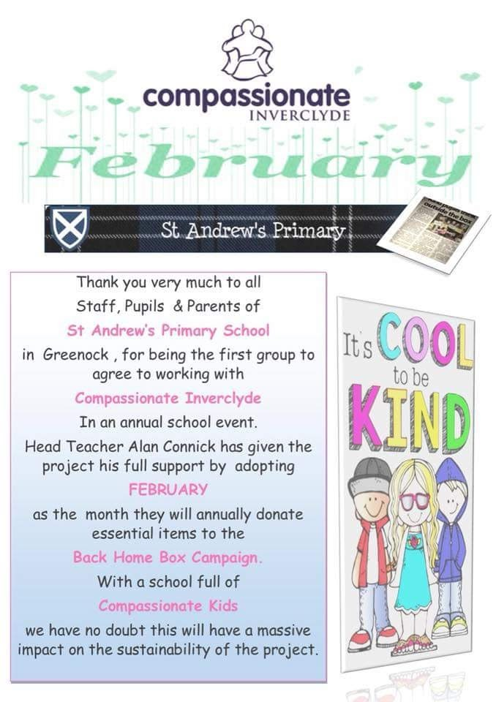Inverclyde Council

Municipal Buildings

Clyde Square

Greenock

PA15 1LX

Tel. No. – 01475 712761

**Head of Education**

Michael Roach

Inverclyde Council

Education Services

Wallace Place

Greenock

PA15 1JB

Tel No. – 01475 712824

**Provost Drew McKenzie**

Inverclyde Council

Municipal Buildings

Greenock

**Councillor Jim Clocherty**

Convenor of Education and lifelong Leaning Committee

Municipal Buildings

Greenock

Councillors – Inverclyde South

John Crowther

Natasha McGuire

Tommy McVey

Tel No – 01475 715450

School Health Department Free Meals & Clothing Grant

Greenock Health Centre Customer Service Centre

Wellington Street Clyde Square

Greenock, PA15 4NH Greenock

Tel: 724477 Tel: 712893

**Community Facilities**

Community Facilities are available in the school and details of the letting procedures are available from:

Area Community

Letting Officer

Waterfront Leisure Complex

**Information in Emergencies**

We make every effort to maintain a full educational service, but on some occasions circumstances arise which lead to disruption. Schools may be affected by, for example, severe weather, and temporary interruption of transport, power failures or difficulties of fuel supply. In such cases we shall do all we can to let you know about the details of closure or re-opening. We shall keep you in touch by using letters, notices in local shops and community centres, announcements in local churches and announcements in the press and on local radio.

**General Data Protection Regulations and Data Protection Act 2018**

**Information on children, parents and guardian is stored on a computer system and may be used for teaching, registration, assessment and other administrative duties. In processing personal information, Inverclyde Council must comply with the General Data Protection Regulation and Data Protection Act 2018.**

**For further information please refer to** [**https://www.inverclyde.gov.uk/site-basics/privacy**](https://www.inverclyde.gov.uk/site-basics/privacy) **or click on the following:** [Privacy page link](https://www.inverclyde.gov.uk/site-basics/privacy)

Please note:

Although this information is correct at time of presenting, there could be changes affecting any of the matters dealt with in the document –

(a) before the commencement or during the course of the school year in question.

(b) in relation to subsequent school years.

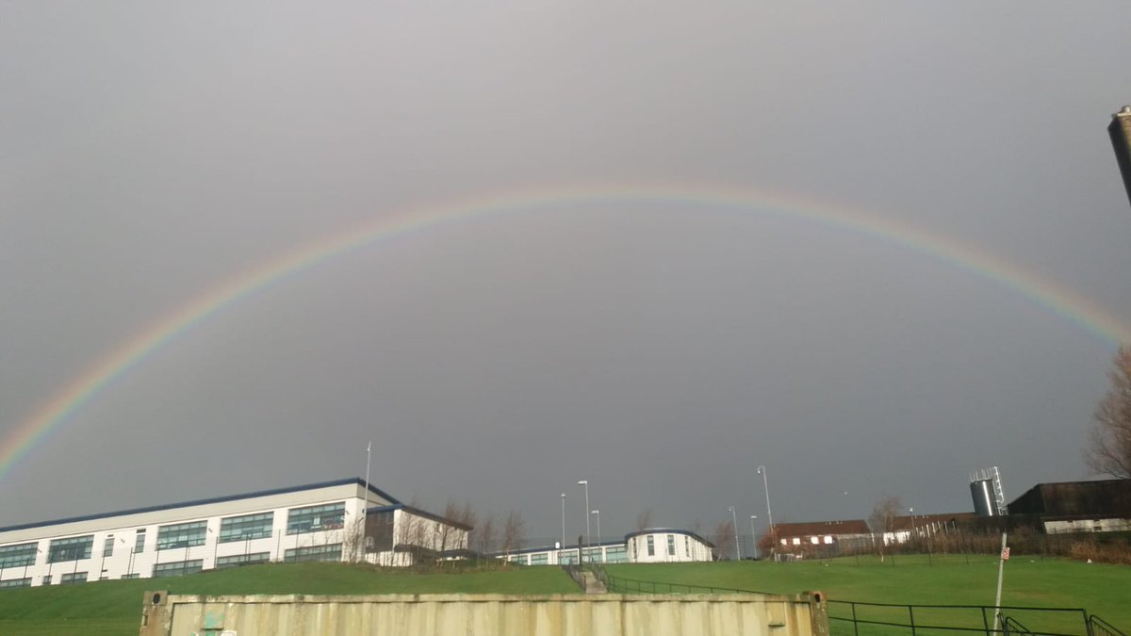

Thanks to Kairen Rodgers for kindly allowing use of this photo.