

Rainbow Family Centre Sept/Oct 2025 Newsletter
Hi everyone,
We can’t believe its September already !!
First of all we would like to welcome any new children and families to Rainbow Family Centre. We are excited to get to know you all!
In this terms newsletter, you will find a variety of information that will help you build an understanding of what will be happening at Rainbow Family Centre.
We hope you find this Newsletter informative. If you have any questions please do not hesitate to speak to a member of staff who will be more than happy to help.



Rainbow Family Centre

Let’s begin with some wonderful pictures of the children playing and learning over that last year.
Within our 0-2 playroom we recognise and support each child to develop their communication and language, confidence, creativity and curiosity skills. Children learn by the way others interact with them and staff are attuned to their individual needs. Children need spaces where they can relax, feel safe, happy and content and within the 0-2 room we ensure our playroom has the right balance of stimulating and calming indoor and outdoor environments. Babies are continuously learning and within the playroom staff establish positive, loving and nurturing relationships which supports the children's all round wellbeing
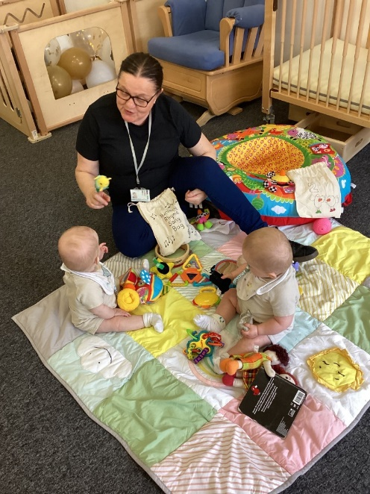
0-2 Room
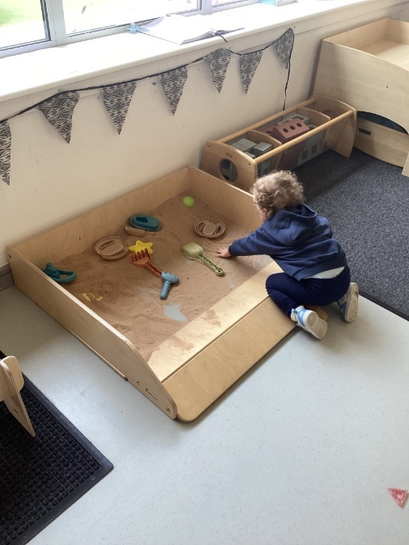
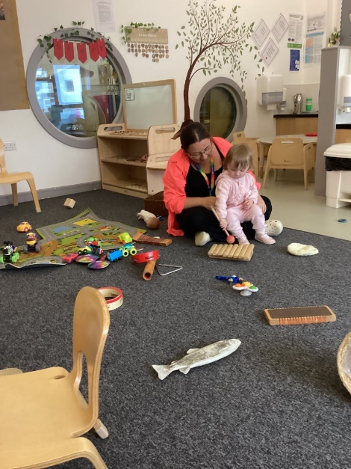

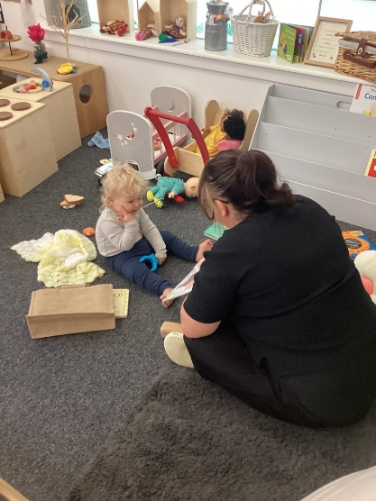

2-3 Room
The 2-3 playroom setting offers many opportunities for children to develop their own individual interests and curiosities .The staff within the playroom are skilled in ensuring the right balance between child-initiated play , adult initiated or adult directed experiences . Staff understand the need to step back and observe the children's play in order to extend their learning. Our indoor and outdoor environments provide opportunities for children to develop their independence, physical, imaginative and creative skills. Children have access to outdoor play everyday and in all weathers. This supports the child's all round wellbeing and development. When children are toddlers they need spaces in which they can have fun and within our playroom we offer spaces that promotes interesting opportunities for children to develop their learning in literacy and numeracy and encourages and values play.
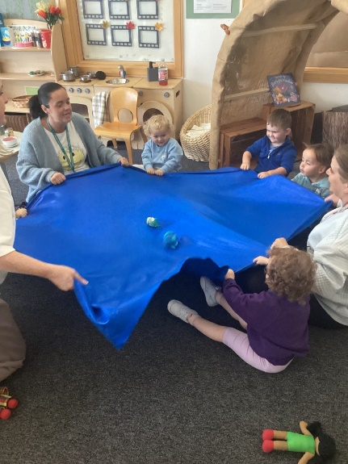
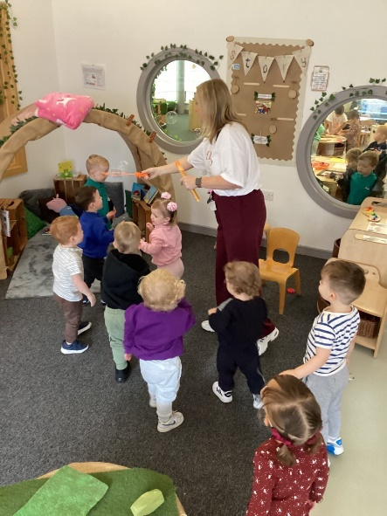
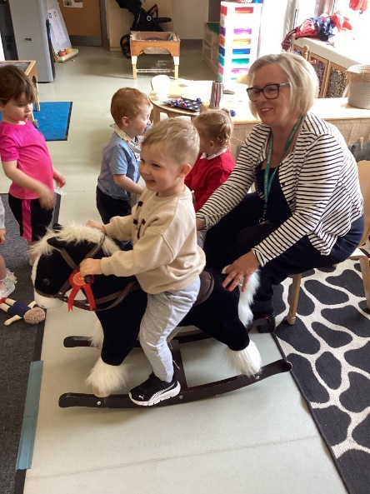

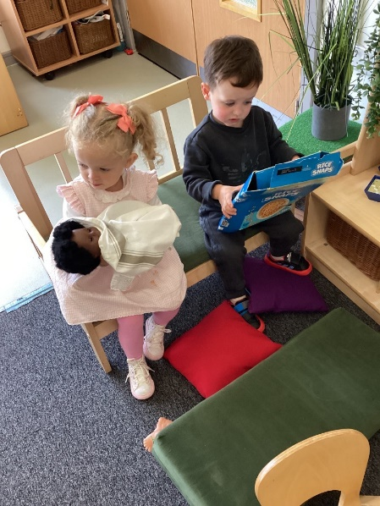
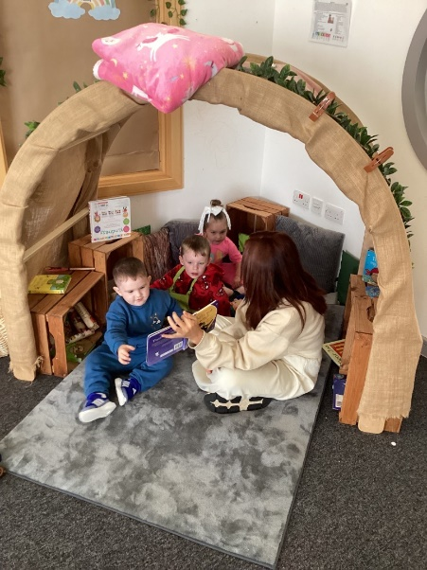
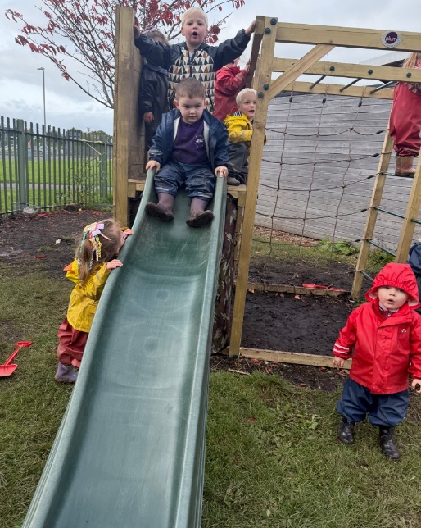

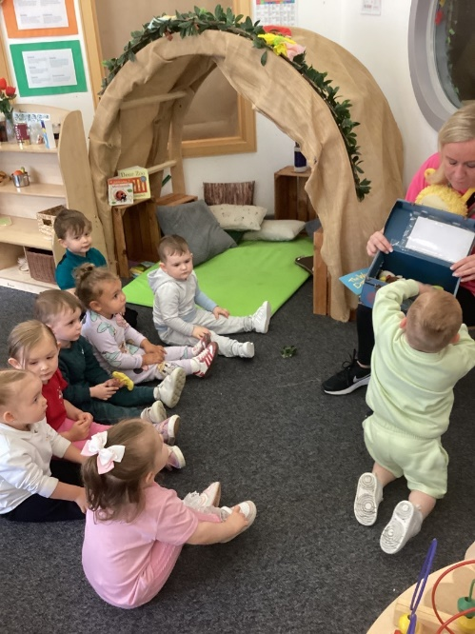
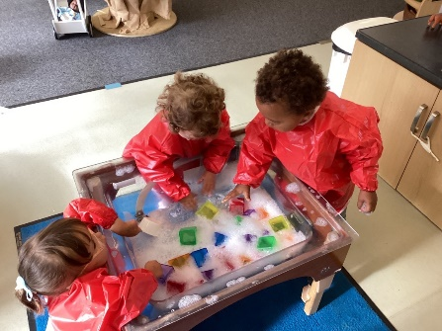
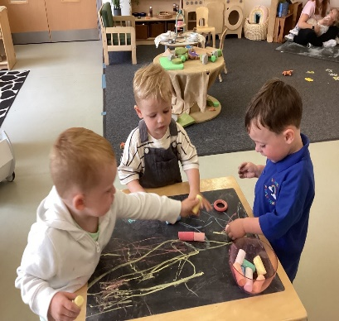

3-5 Room
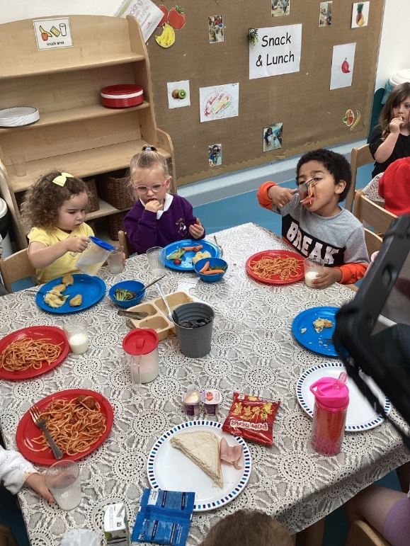
Within our 3-5 playrooms we provide children with the interactions, experiences and spaces they need to grow and develop at a pace that is right for them. The children receive a warm and nurturing approach from all staff that ensures their wellbeing is at the centre of everything we do. The children have access to a wide range of learning experiences suited to their development needs. As you will see from the pictures below, we focus on providing children with open ended resources that the children can interact with depending on their stage of development. The children have access to outdoor play daily, they are able to be outdoors at a time of their choosing during free play. Relationships are also very important to us, children are supported sensitively by staff as we help them to build relationships with other children and to develop an understanding of their world. Garden Room
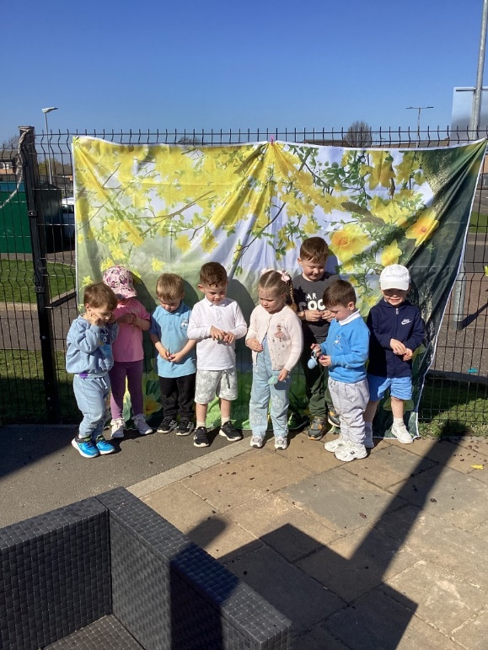

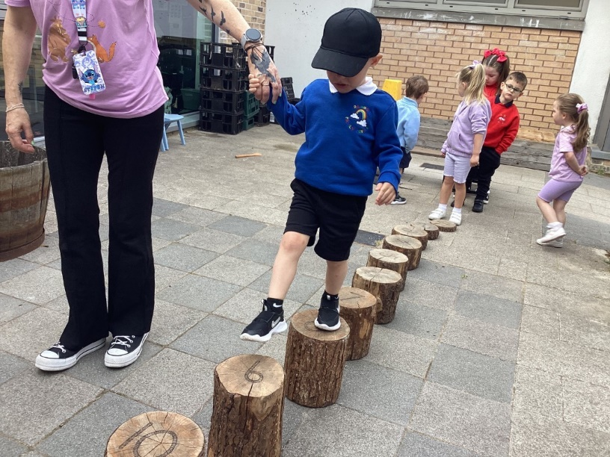
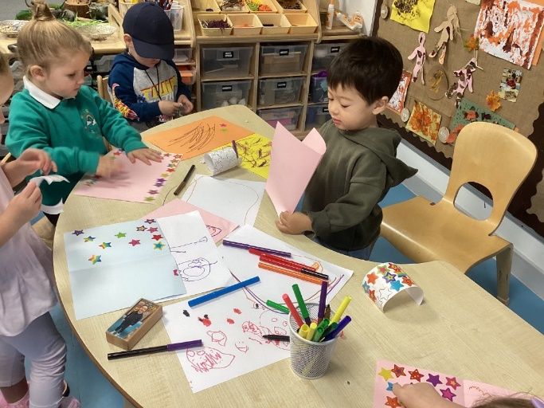

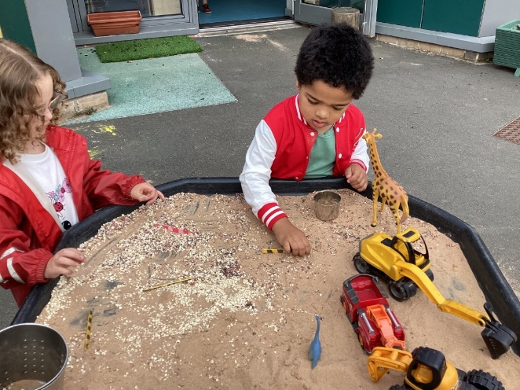
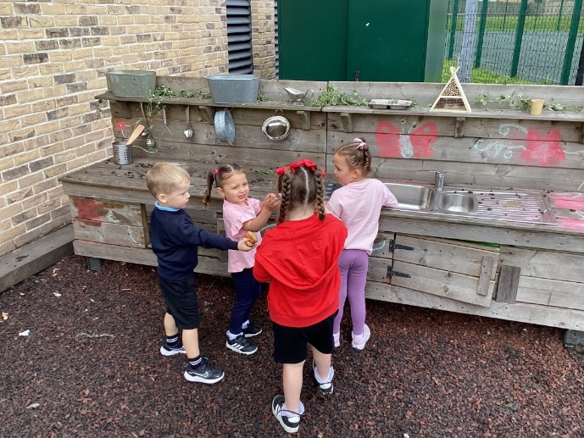

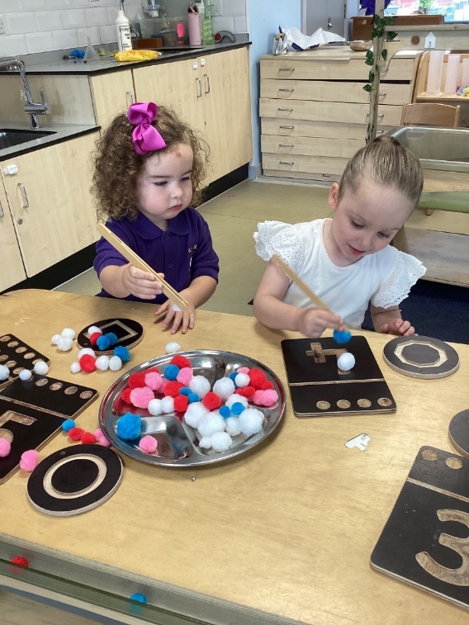
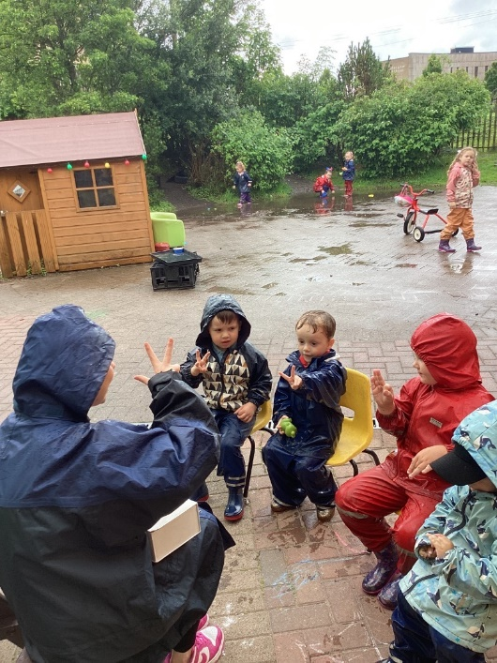

Rainbow Room
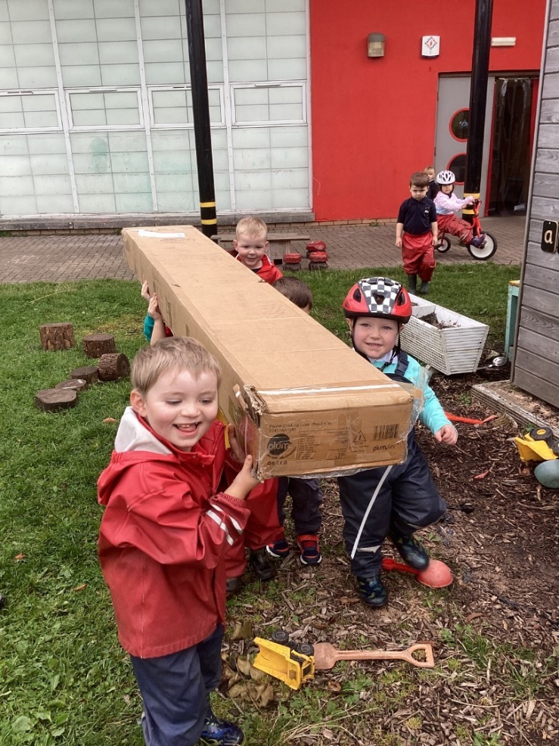
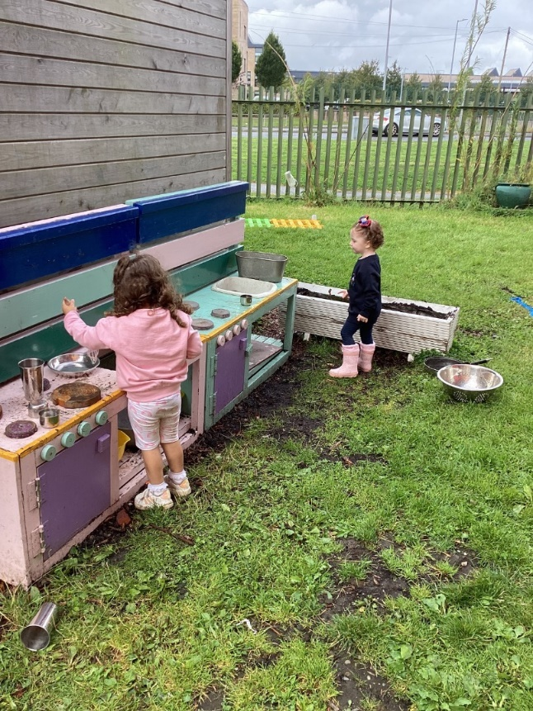

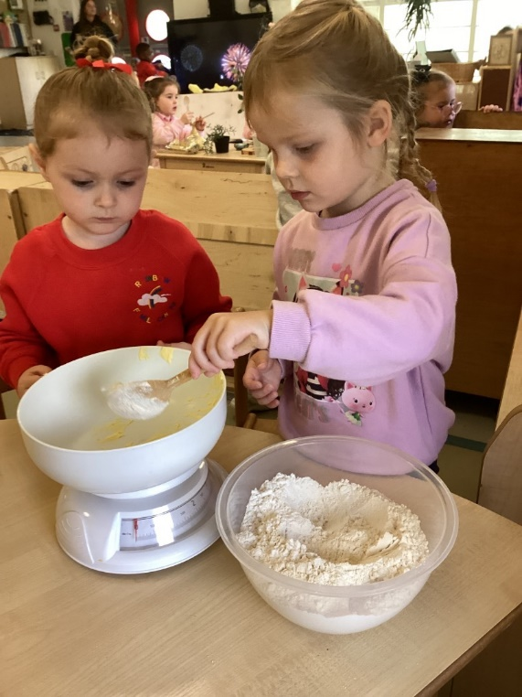
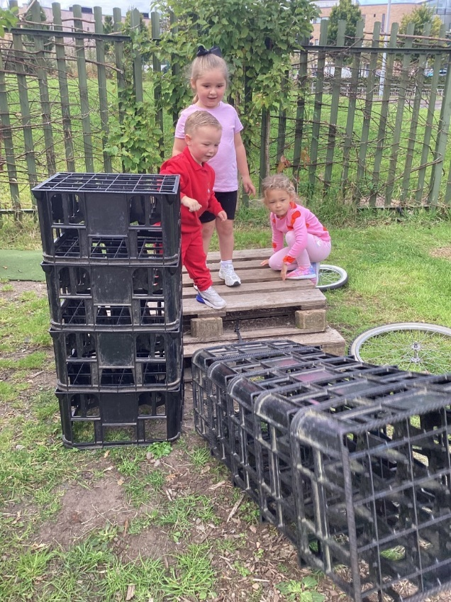

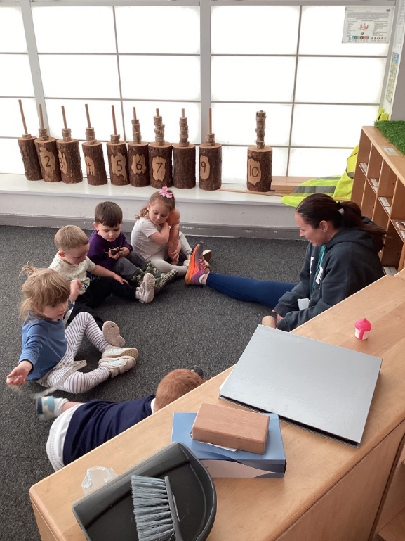
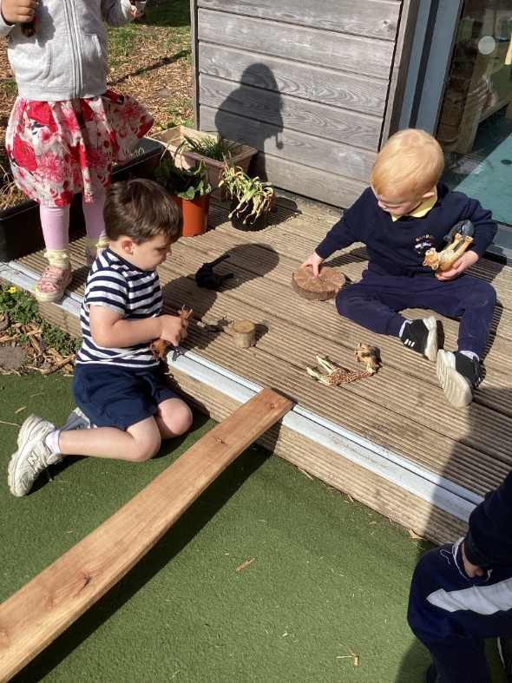

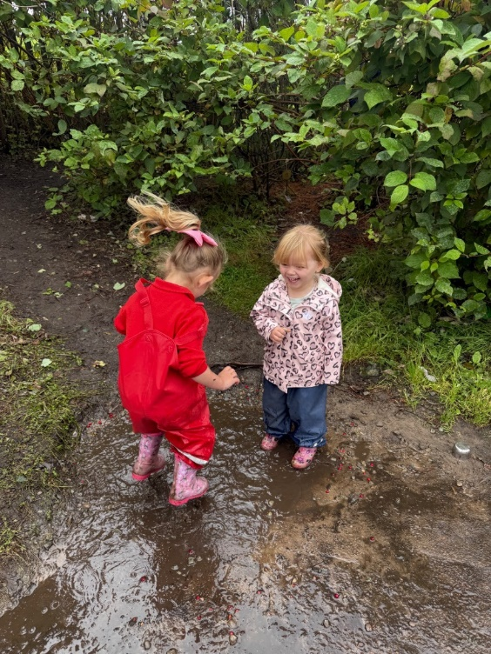
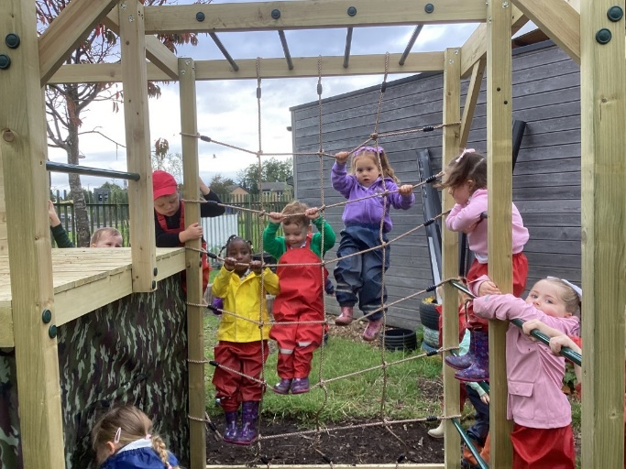

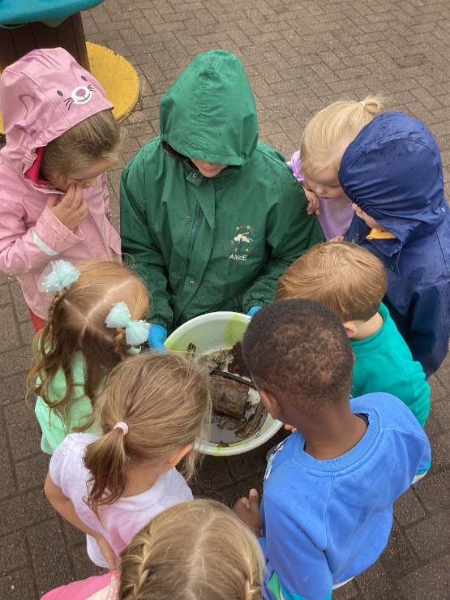

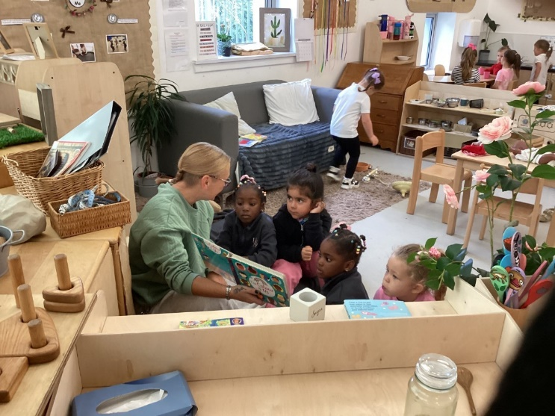


Important Dates

September

Friday 26th September – The nursery will be closed for Model 1 Children that attend nursery 9am-3pm Mon – Fri
Monday 29th September - The nursery will be closed for Model 1 Children that attend nursery 9am-3pm Mon - Fri
October
Thurs 1st Oct – Stay and play session Rainbow Room 10.00am – 11.30am
Thurs 1st Oct – Stay and play session Garden room 1.30pm-3.00pm
Thurs 2nd Oct – Stay and play session 0.2 room & 2-3 rooms 10.30am – 11.30am & 1.00pm – 2.00pm
Monday 13th Oct – Friday 17th Oct - The nursery will be closed for Model 1 Children that attend nursery 9am-3pm Mon – Fri
Monday 20th Oct – The nursery will be closed to ALL child for an in-service day
Wednesday 29th Oct - 3-5 Room Halloween Parties (Baby & 2-3 rooms TBC)

December
W/C 1st December - There will be Parent days / Evenings and parties taken place with individual dates to be confirmed nearer the time.
W/C 8th December – Christmas stay and plays craft days. Separate room dates will be confirmed.
Wednesday 17th December – Christmas party day
Monday 22nd December – 2nd January – The nursery will be closed to all children for the Christmas Holidays.
All Children will return to Nursery on the 5th January 2026.

Keep In Touch


Please join our Facebook Page Group – Rainbow Family Centre Port Glasgow (Please note there are a few questions to be answered before you are accepted into the group)
Contact Number for Reception 01475 715724
Email Address – office@rainbowfamily.inverclyde.sch.uk
Building address – Oronsay Avenue, Port Glasgow, PA14 6DY

Positive Respectful Relationships

Everyone within Rainbow works hard to provide the best quality of early learning and Childcare and try our upmost to keep you updated on your child's day however, unfortunately at certain times of the day this can be tricky to navigate. If you are happy with our centre please tell others, if you are unhappy please come and speak to us.

Dear Parents,
Positive and open relationships are important and key to us as Rainbow Family Centre .We are always keen to ensure that parents are aware of how we would prefer to handle situations when things maybe haven’t gone as any of us would have liked. Our initial hope is that we can resolve matters swiftly and informally. In the first instance, and where appropriate, we would ask that you contact the member of staff concerned. However, there may be occasions when the matter needs to be drawn to the attention of our SMT team. Please get in touch with them via the main office on 01475 715724 or alternatively email Office@rainbowfamily.inverclyde.sch.uk Thereafter, if a resolution is not reached then the matter can be raised with the Head of centre via the contact details above.
Ultimately, if you remain dissatisfied, please get in touch with me directly via the main office. I would hope that we would be able to resolve any concerns or complaints at Rainbow, however if not, please refer to the council complaints process and contact
Education Headquarters at: admin.educationhq@inverclyde.gov.uk :

How to make a complaint - Inverclyde Council

Our new planning process

All children within the nursery have 3 targets set that focuses around children's individual learning. These targets are discussed with the parent and reviewed every 12 weeks. At six weeks the staff will meet with the Senior Management team to review children's individual targets. Your child's Learning Journal will have observation which are linked to their targets and stories which capture other aspects of their learning.



We are actively looking at ways for you to become involved in the life of the nursery and we are looking for parents to be part of our Fund committee and our Fundraising group. If you are interested please let a staff member know. If there are any other suggestions to become involved please let us know.

Lunch At the Nursery

All children attending nursery are entitled to a free school meal.
However we know that some children prefer a packed lunch from home.
Please can we ask that you provide a healthy packed lunch for your child and remember that we are an ALLERGY AWARE nursery. Can you please be mindful of the food within the packed lunch and avoid adding the foods below that can cause allergic reactions. Please check in the ingredients on the food packaging as some foods may contain small amounts of the below that may cause the same effect.

Nuts
Lentils
Sesame Seeds
Pea’s
White Fish

If your child is going to arrive later than 9.30am in the mornings could you please phone the nursery before 9.30 am to choose their lunch.

Stay and Play Sessions
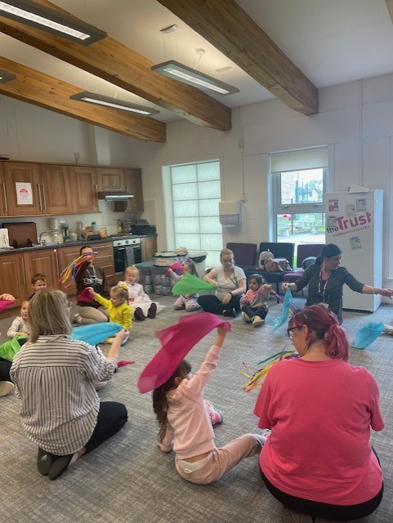

We will be arranging stay and play sessions this year and will invite parents to come in and spend some time with their child. This will be ongoing throughout the year and we welcome any suggestions to what you would like to be involved in whether it is with your child or on your own. Please note these sessions will only continue if we have parental participation.

Improvement groups

At the beginning of every year we review our Improvement Plan that supports continual improvements within the nursery. In both Foyers you will see our Improvement Plans for this year and our Standards and Qualities 2024/2025 and you will find these on our Website also. If you would like a copy of these please speak to our Senior Management Team.

Visions and Values
Thanks to everyone who responded to our questionnaire. This has helped to share our aims, visions and values for the future. These will be proudly displayed in both nursery foyers. Below is our updated vision & values.
- We aim to provide a safe, nurturing and stimulating environment where every child can grow, learn and thrive at their own pace.
- Respect – We foster a culture of mutual respect, celebrating diversity and individuality.
- Child centred learning – we celebrate the uniqueness of every child, encouraging curiosity and creativity.
- Nurturing – we ensure a secure and supportive environment for children to feel safe and valued.
- Inclusive – We embrace diversity and ensuring every child and family feels welcome and respected.
- Partnership – we work closely with our families, local support initiatives and professionals outside agencies to best support our children’s development.
- Play based exploration – we encourage learning through play, to foster independence, feed their curiosity and enhance their love of discovery.

Our outdoor areas

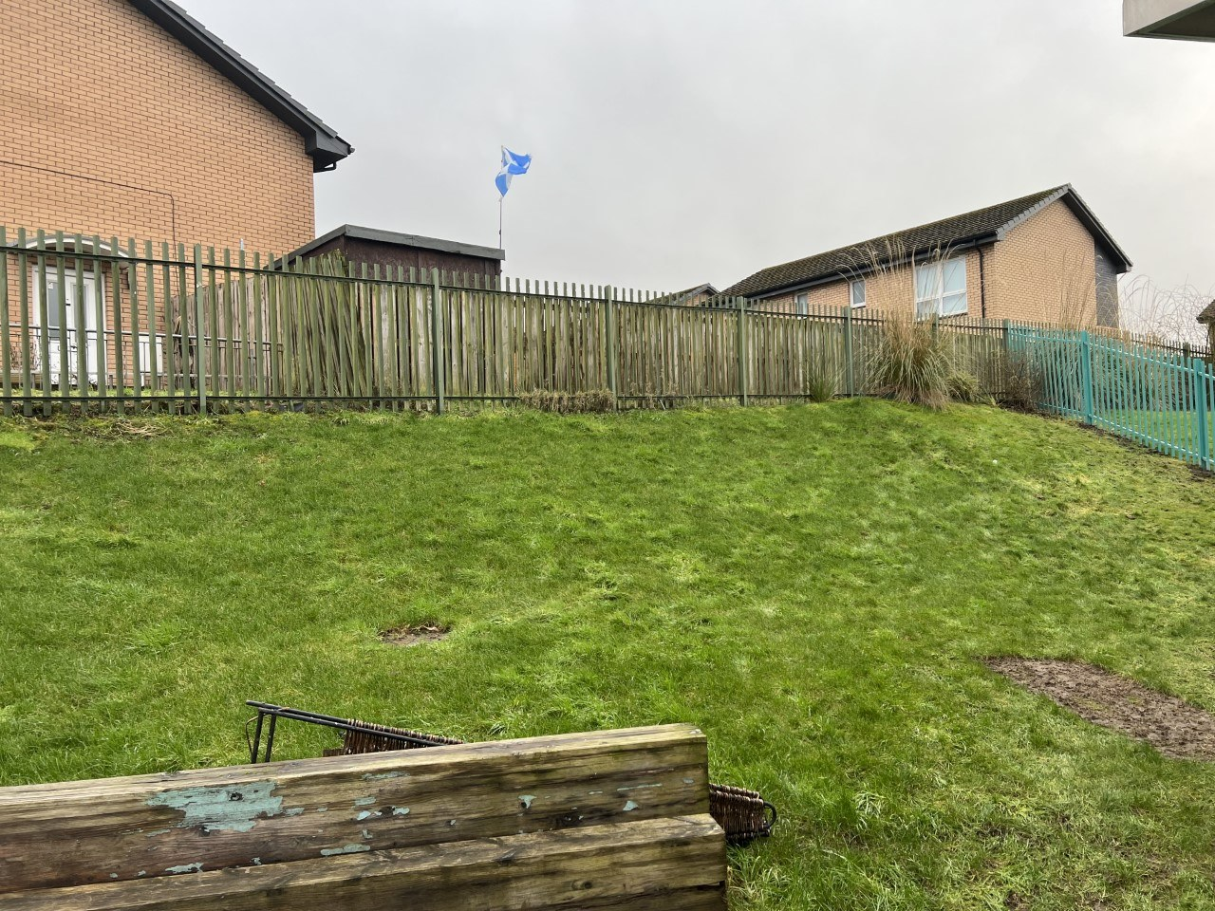

The staff within the playrooms have worked really hard in providing rich outdoor learning experiences for the children. We would love to involve you in these projects and are looking for your help. If you have any gardening skills, manual labour skills and would like to help us please speak to a member of staff.
We are looking for a bit of help to encourage children curiosity if you have any of the following items can you please bring them in.
Old pots and or pans, Jar, lids, Keys, kitchen utensils, Plant pots, Gardening tools, boxes and Curtain rings.

Parental involvement
Throughout the year we will have a variety of opportunities for you to be part of the nursery life. Questionnaires will be sent out shortly asking for your opinions and ideas relating to how we could improve our nursery, how you found the enrolment procedure and what parent sessions would you like to support your child's learning. There will also be sessions offering advice and support and we would love to hear from you.
We have two new televisions installed within the foyers and information regarding the nursery will be found on these. There will also be pictures showing children within the playrooms engaging in both indoor and outdoor play If you do not want your child's pictures on these please let a member of staff know.
Within both foyers there is Parents wellbeing walls and information walls guiding you to agencies you may require. We also have various leaflets on child's learning that may be interest to you.




Keeping Children Safe

SIMOA is the campaign launched by Care Inspectorate in 2021 and the aim is to raise awareness of how and why a child could leave a childcare setting without a responsible adult. We have devised a leaflet that gives you information on the ways in which Rainbow Family Centre reduces the risk. These can be found in our foyers .If you would like one please ask the staff within the playrooms

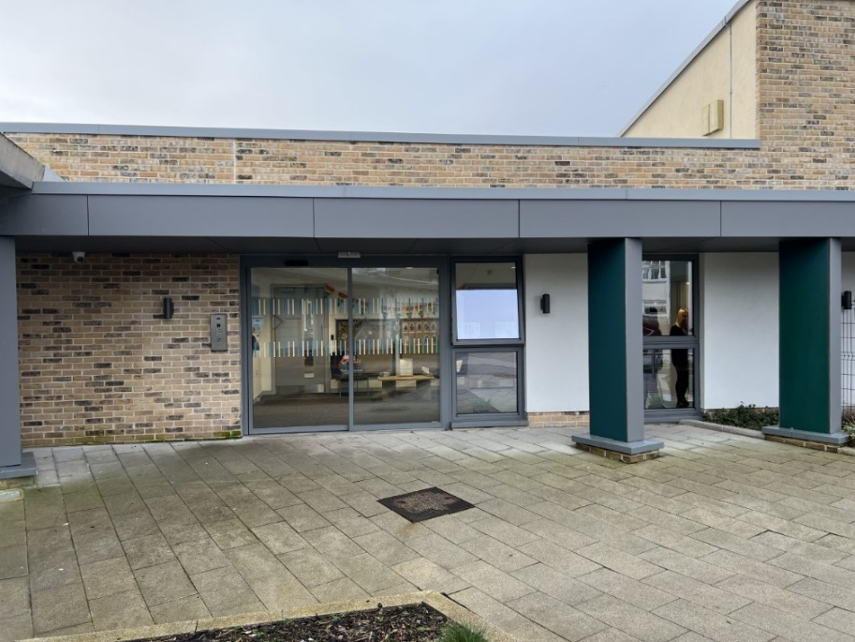
Nursery Sessions

Just to let you know that the children who stay after 15.30 will be rotating weekly between the Garden room and Rainbow room.
This gives children the opportunity to come together and also provides time for staff to engage in Professional Development.
If you are unsure when your child's session begins and ends, please ask a member of staff who will be happy to advise.


It is lovely to see that our families are regularly engaging with the online Learning Journals and using this to see what your child has been doing at nursery. We also love to read your observations of things that your child has been doing at home and in the community. It is also a great way for you to share any achievements that your child has experienced. If you need any support accessing your child's learning journal please speak to a member of staff who will be happy to help.
Learning Journals Login Page:
https://rainbowfc.yourlearningjournals.co.uk/Login.aspx

Thrive Under 5
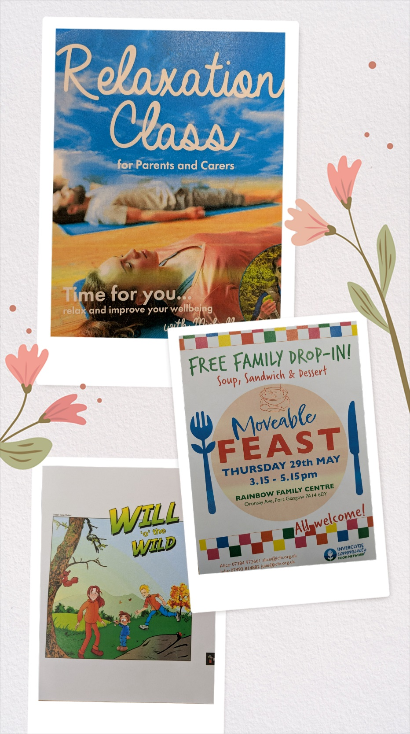
Rainbow Family Centre is happy to be part of the Thrive Under 5 project. This exciting initiative is a whole system approach to provide families with resources and information to support their all-round wellbeing. Through this we are able to offer access to the following:
- Flat pack meals (every week for 12 weeks) TBC
- Food Pantry access
- Free monthly £20 voucher for Tesco or ALDI( once a month for 12 weeks))
- Free cooking sessions and support with Income maximisation. TBC
If you are interested in any of the above please contact the nursery and ask for Carrie, Chris, Jacqueline or Jakki.

Clothing
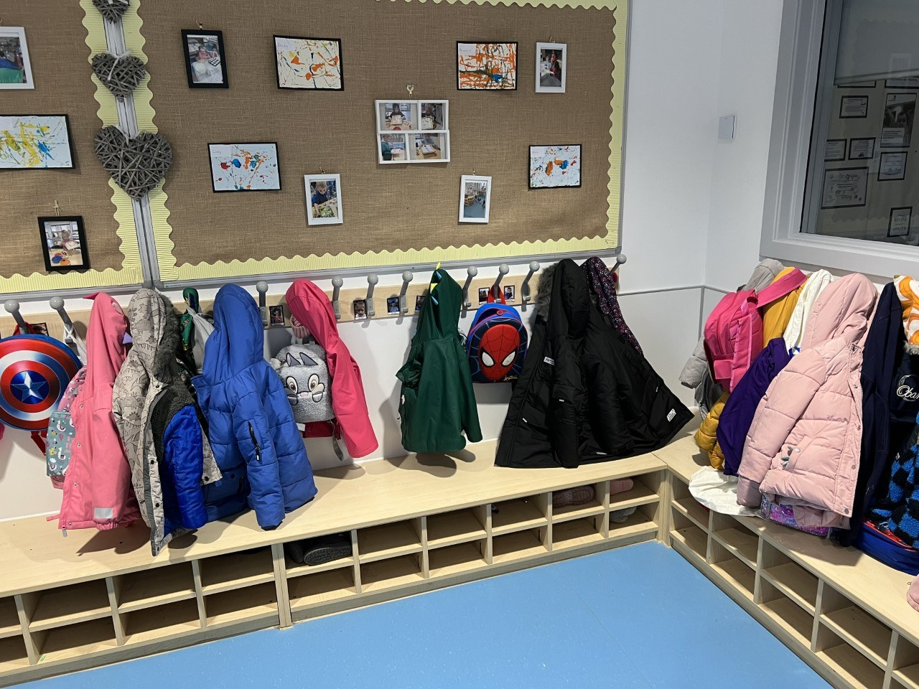

Nursery Life
As you know the weather in Port Glasgow is unpredictable and we can have all four seasons in one hour never mind one day. Can you please ensure your child is dressed for all weather conditions.
We would really appreciate if you could provide a change of clothes for your child in a bag clearly labelled which you can leave on your child's peg.
Could we ask all parents to ensure your children wear suitable outdoor shoes and clothing. We understand that Crocs are very comfortable however they are impractical and have caused children to slip and fall both indoors and out. Thank you for your understanding on this subject.

Sickness


If you child is going to be off nursery for any reason, please phone the nursery and let us know on 01475 715724.
May we ask that if your child is unwell they should stay at home as this will help their recovery and limit the spread of infection to other children and staff within the nursery.

Voluntary Contributions



A big thank you to everyone who pays £1.00 per week donation to the nursery funds.
We really appreciate your weekly contributions which help pay for little extras for the children for special events.
These donations are voluntary and should be no more than £1.00 per family per week.

Car Park


Can we please remind you not to park in the disabled parking bays at drop off/pickup times unless you are eligible to do so. Can you please display your blue badge.
The safety of our children is very important please be mindful of your speed when driving in and out of the car park.
We would appreciate if you could take your child's hand walking to and from the nursery building and use the pavements. This helps children to understand road safety.
- It is now illegal to park on pavements and dropped pavements in Scotland. Please ensure your car is parked in the parking bays within the car park and not at the corners.


Rainbow Staff News
Please welcome our new members early years education childcare officers.


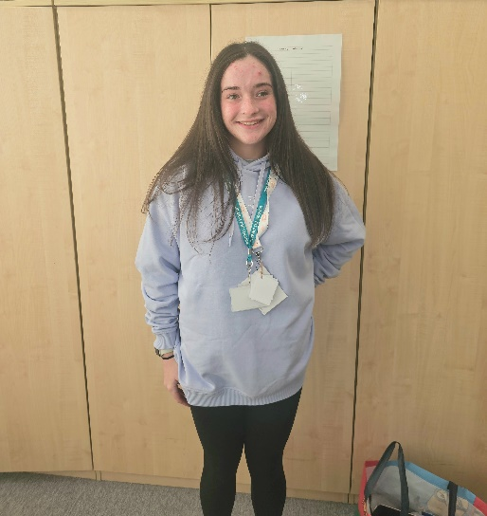
Leah Gisbey (Eyeco) 0-2 / 2-3 Room’s Jessica MacCreath (Eyeco) Garden Room

Please find below the staff you will see around the nursery this term.
Senior Management Team



Carrie-Head of Centre Chris - Depute Jacqueline- Depute



Jakki – Senior EYECO Linda Senior EYECO
0-2 room





Ann-EYECO Sam -EYECO Karli – EYECO Gemma - EYESA

2-3 room





Jessie – EYECO Susan – EYECO Chloe – EYECO Julie - EYECO
Rainbow Room





Simone – Group Red Purple Group – Alex-EYECO Blue Group – Nadine-EYECO
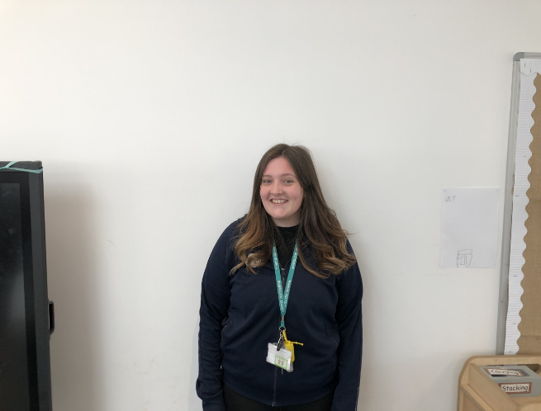


Green Group – Kim-EYECO Pink Group – Terrey EYECO Yellow GroupJemma - EYECO

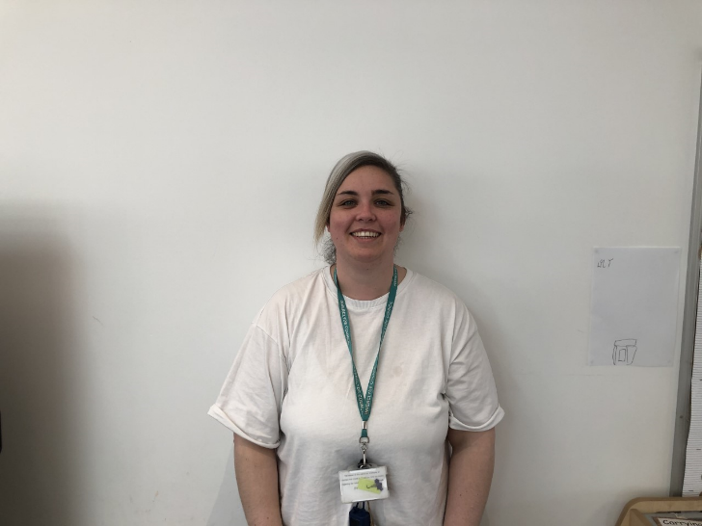
White Group – Beth-EYECO Orange Group – Lesley-EYECO Yellow Michelle - EYECO


Arlene – EYESA
Garden Room





Sarah-Jayne Poppy - EYECO Kellyann – Bluebell Eyeco Lyndsay – Tulip Group EYECO


 Tulip

Lily Group-Megan-EYECO John – Buttercup Group EYECO Elaine – Rose EYECO



Clover Group-Lauren-EYECO Ursula - Sunflowers EYECO Jo – Thistle Group – EYECO






Maria Scullian Rose Group – EYECO Jen – Primrose Group EYECO Jessica – Primrose Group EYECO

Emma – EYSA Stacey McWaters - EYSA

Other staff members you may see around the nursery


Gillian – Equity & Excellence Lead






Norah – Catering Rebecca – Catering Lyndsey – Catering Kayleigh



Rhys – Janitor Heather - Admin Mark – Admin Karen – Cleaning Operative
Picture to Follow
Mairi – Cleaning Operative



October 2025
Model 1 children only
- Schools close at the end of the school day on Friday, 10 October 2025
- Monday, 13 October 2025 to Friday, 17 October 2025 (October week)
- Monday, 20 October 2024 (Return date for Teachers & In-service day)
- Tuesday, 21 October 2024 (Return date for pupils)
December 2025
All children and staff
- The last day will be Friday, 19 December 2025
- Monday, 22 December 2025 to Friday, 2 January 2025 (Christmas & New Year)
- All Children Return to Nursery on 05th January 2026

Attendance Policy
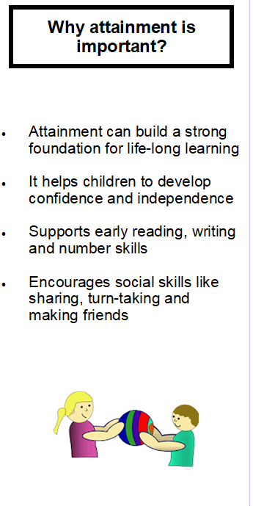
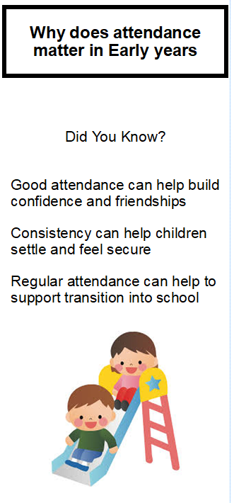
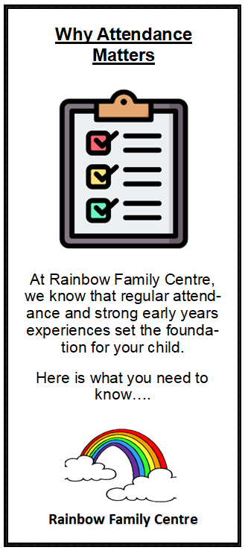

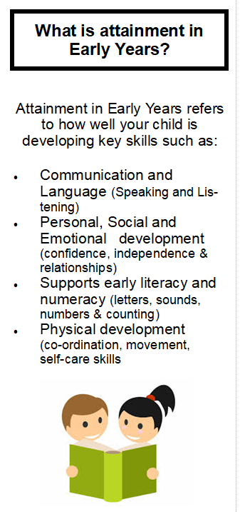
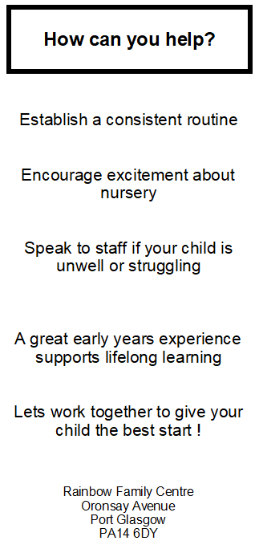



Rainbow Family Centre

If you are concerned about a child who attends Rainbow family Centre our
Child Protection Co-Ordinator and STILT LEAD:

Carrie Murphy – Head of centre

If Carrie is not available the depute co-ordinators are


Jacqueline Coombes – Depute Head or Chris Orr-Depute Head



Thanks for taking the time to read this newsletter, hopefully this provides you will lots of interesting information. Please get in touch if you have any questions or queries. We would also like to hear from you if you have any ideas you would like to share in relation to our nursery.

