|  |  |  |  |  |  |
| --- | --- | --- | --- | --- | --- |
| National 5  Mathematics | Pupil Name: | | | | |
| Teachers Name: | | | | |
| Homework Booklet 3 Part 1  All units | | | | | |
| Progress Table (if correct then ***√*** if more work is required then **x**) | | | | | |
|  | Homework 21 | Homework 22 | Homework 23 | Homework 24 | Notes |
| Algebraic Fractions | 7’,8’ | 6, 6’,7’ |  | 8 |  |
| Angles |  | 5 |  |  |  |
| Arc Length/Area of Sectors |  | 3 | 8’ | 3’ |  |
| Changing the Subject | 6’ | 5’ | 2 | 2 |  |
| Circle Geometry | 7 | 8’ | 11’ | 3 |  |
| Compound Percentages | 1’ | 2’ | 7’ | 1’ |  |
| Expand brackets and simplify | 2 | 1’ | 3 | 1 |  |
| Factorising/Completing the Sq. | 3’ | 1 |  |  |  |
| Fractions |  |  | 1 |  |  |
| Functions |  |  | 9’ |  |  |
| Indices |  |  |  | 7 |  |
| Pythagoras |  |  | 6’ |  |  |
| Quadratic Graphs | 6 | 8 | 9 | 4 |  |
| Quadratic Theory | 5’ | 3’ | 2’,13’ | 5 |  |
| Reverse Percentages |  |  | 4’ | 4’ |  |
| Scientific Notation |  |  | 1’ |  |  |
| Significant Figures | 2 | 4’ | 1’ |  |  |
| Similarity |  |  |  | 5 |  |
| Simultaneous Equations | 4’ | 4 | 4 | 6 |  |
| Solving an Equation/Inequation |  |  | 3 |  |  |
| Straight Line | 1 | 2 | 5 | 6 |  |
| Surds | 3 |  |  | 3 |  |
| Trigonometry Graphs/Equations | 5, 9’ | 7, 9, 9’ | 12’ | 7 |  |
| Vectors | 8 | 3 | 3 | 4 |  |
| Volume | 2 | 4’ | 3’ | 2’ |  |
| Score | **/67** | **/59** | **/77** | **/60** |  |
| Percentage | **%** | **%** | **%** | **%** |  |
| LATE |  |  |  |  |  |

You will need a QR Reader and your SCHOLAR username and password to access materials.

SCN: Password:

|  |  |  |
| --- | --- | --- |
| Fractions | Expand Brackets and Simplify | Changing the subject |
| Reverse Percentages | Compound Percentages | Percentage Appreciation |
| Volume | Significant Figures | Scientific Notation |
| Arc Length / Area of Sectors | Angles | Factorising/Completing the square |
| Surds/Indices | Quadratics | Solving equation/Inequation |
| Simultaneous equations | Pythagoras | Trig Graphs/Equations |
| Straight Line | Algebraic Fractions | Similarity |

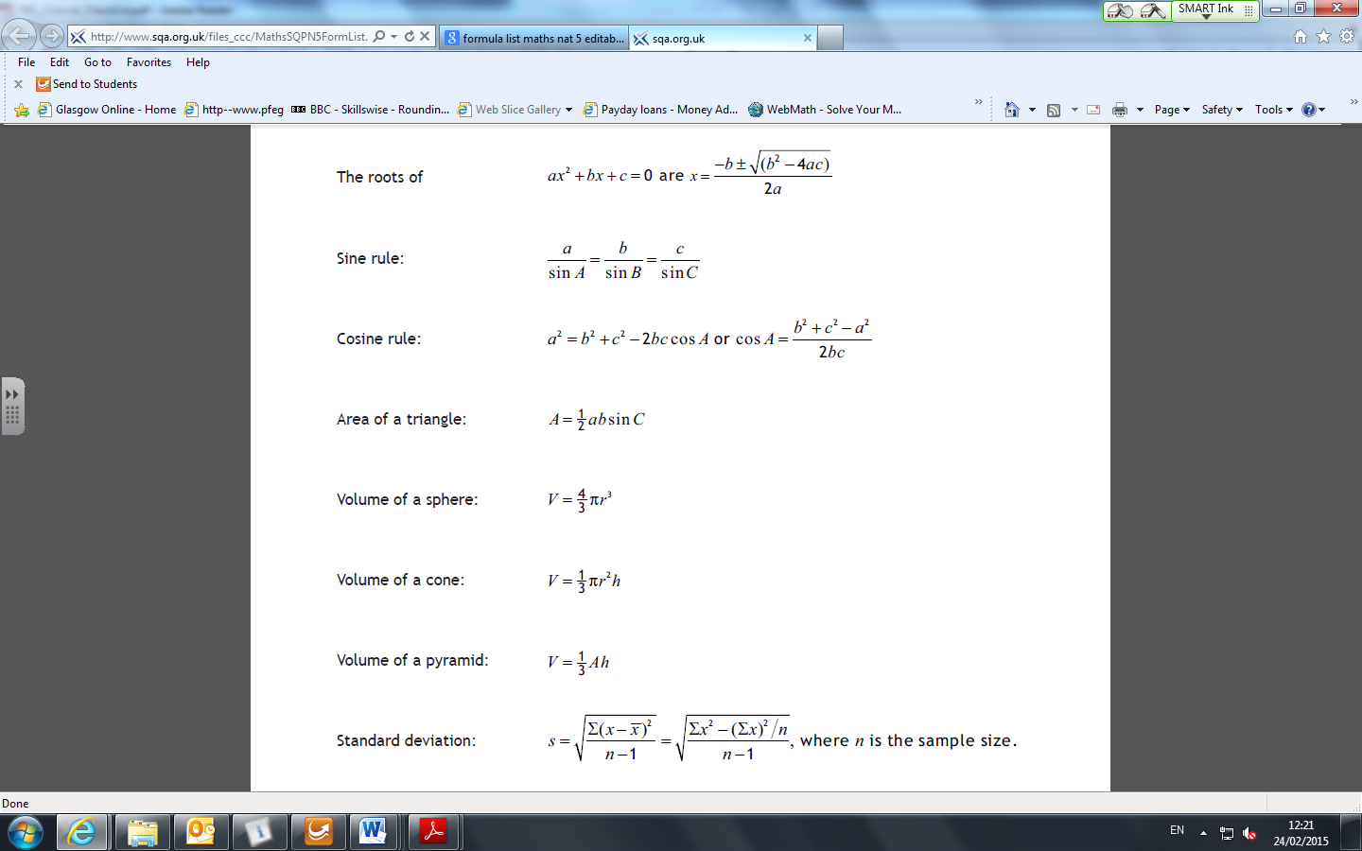**Formula Sheet**

**Homework 21**

67

**Non Calculator**

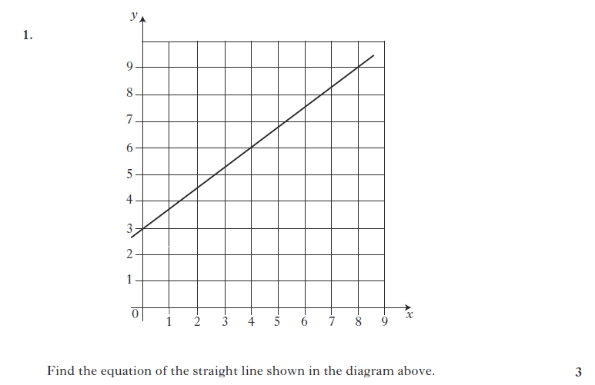

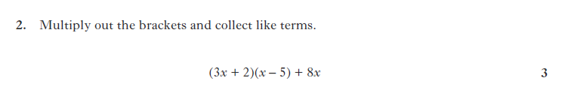



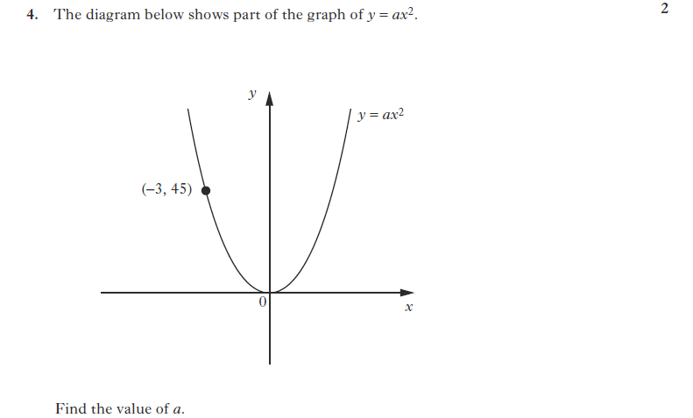

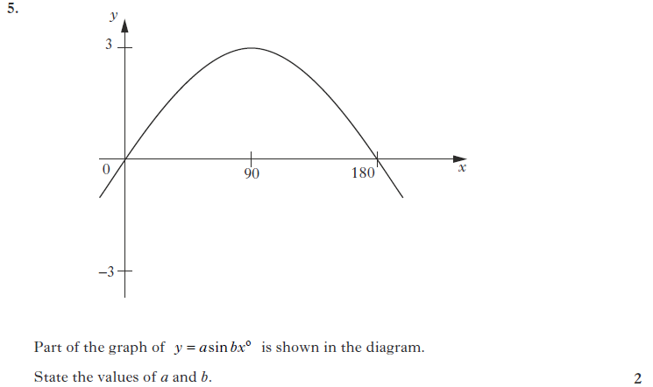

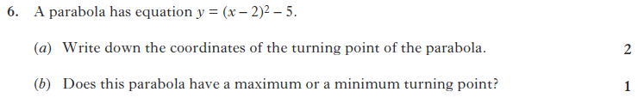

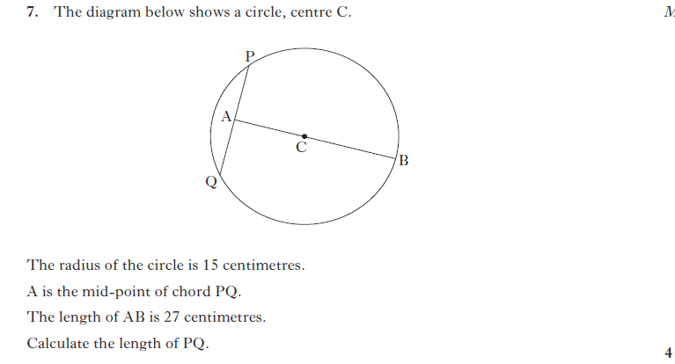

8.

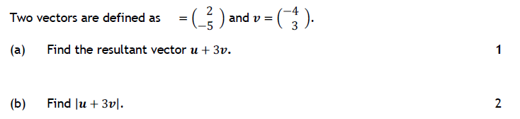

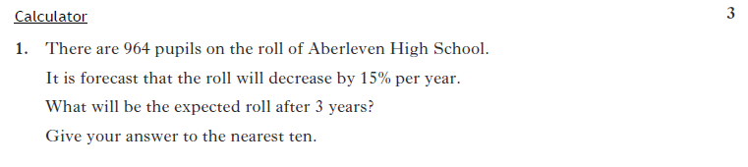

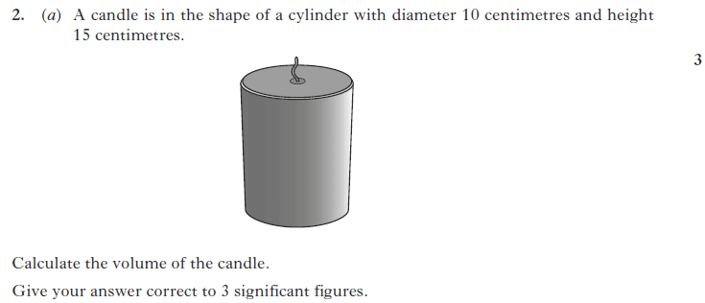

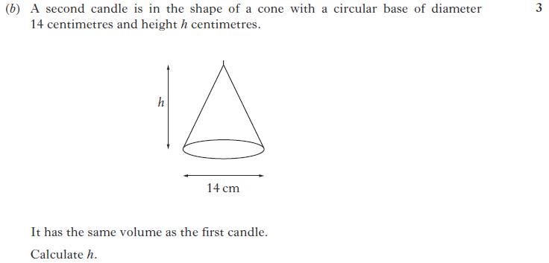

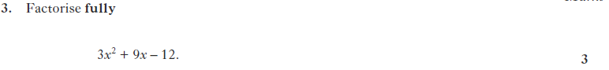

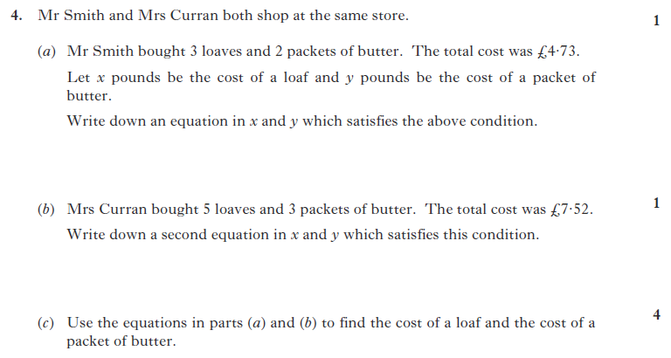

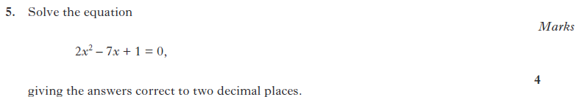

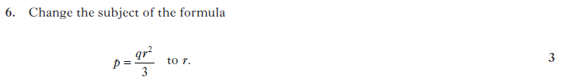

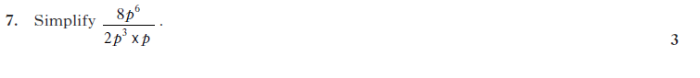

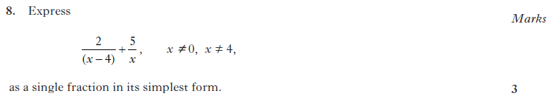

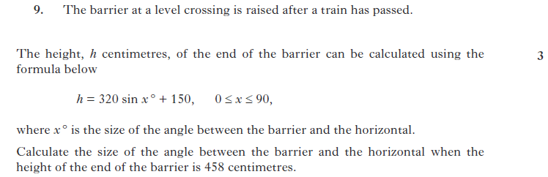

**Homework 22**

59

**Return by :**

**Non Calculator**





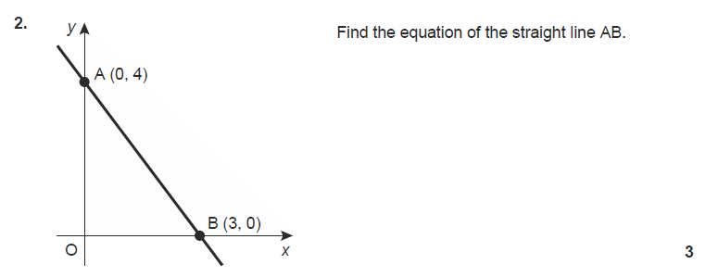

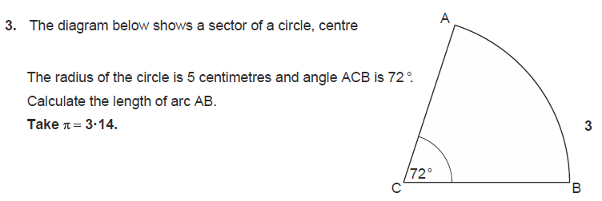

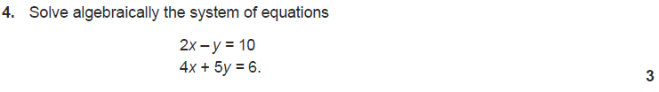

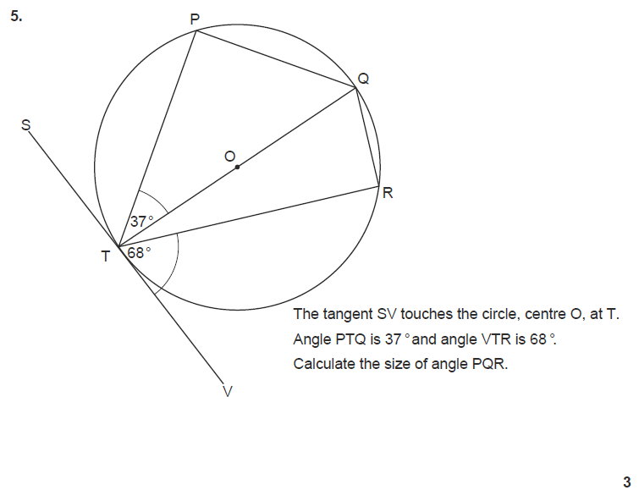





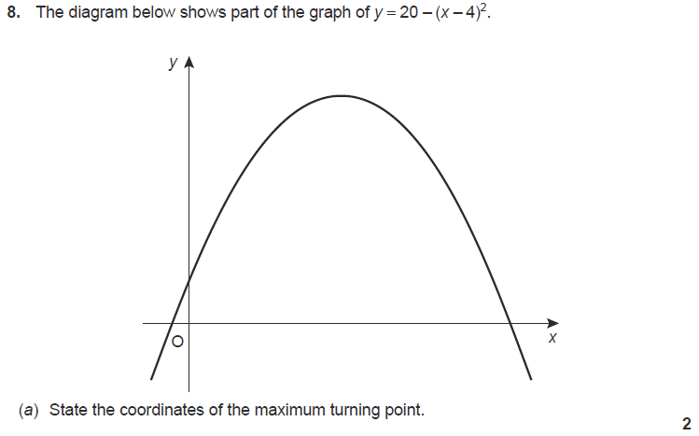



10. 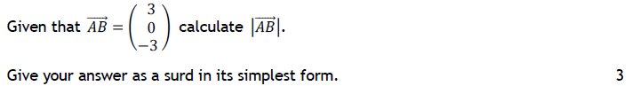

**Calculator**

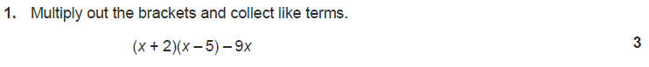

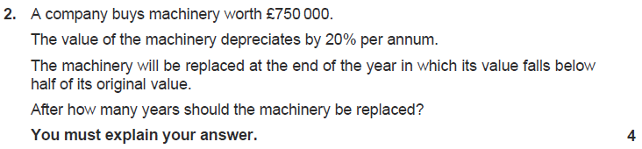

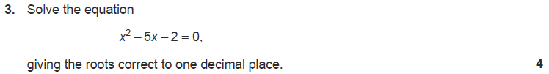

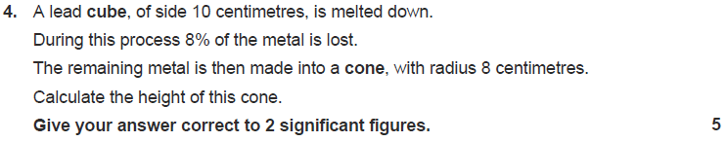

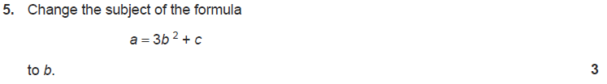



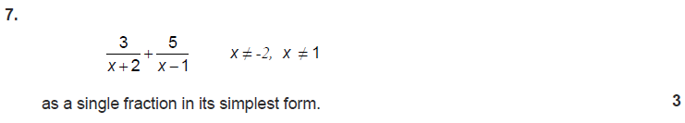

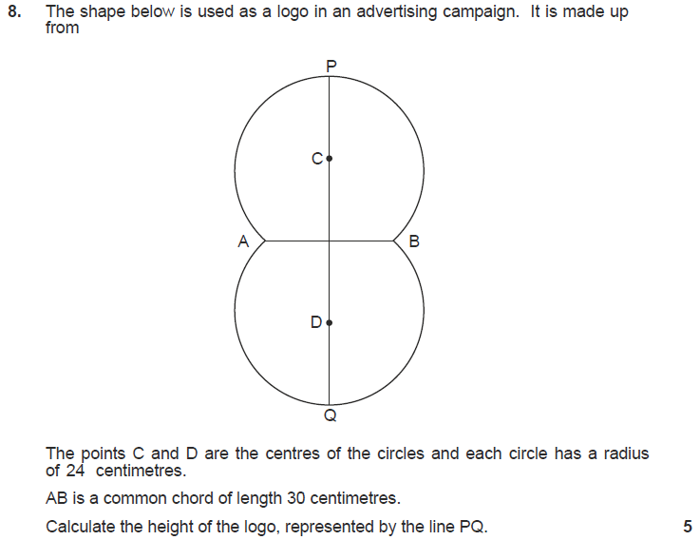

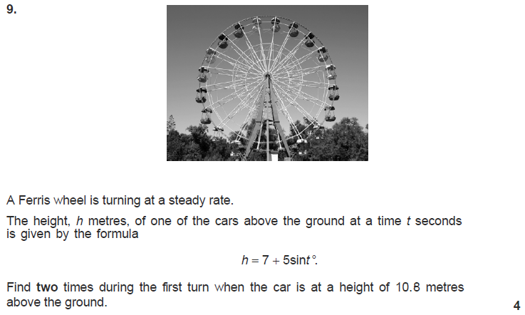

**Homework 23**

77

**Non Calculator**





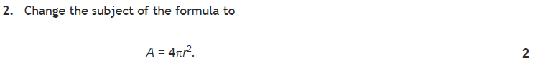



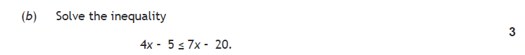

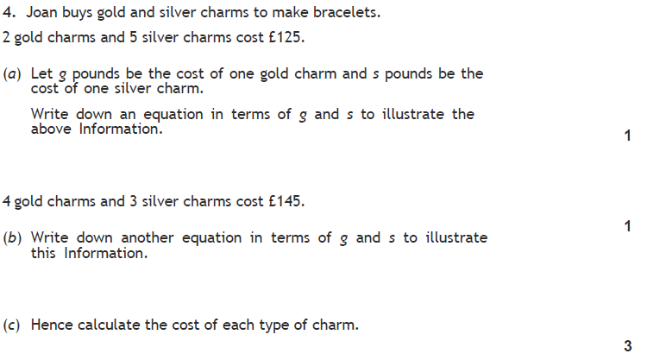

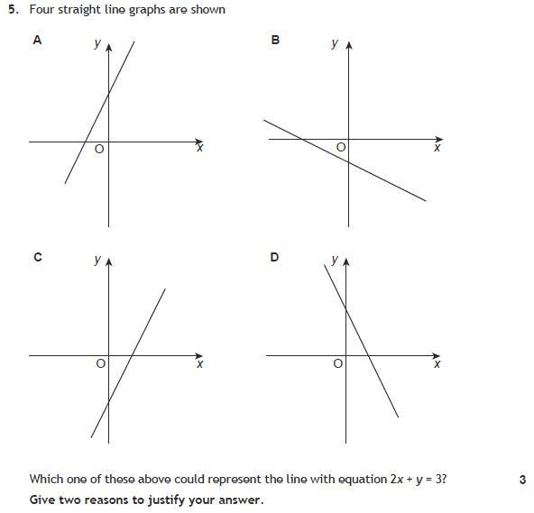 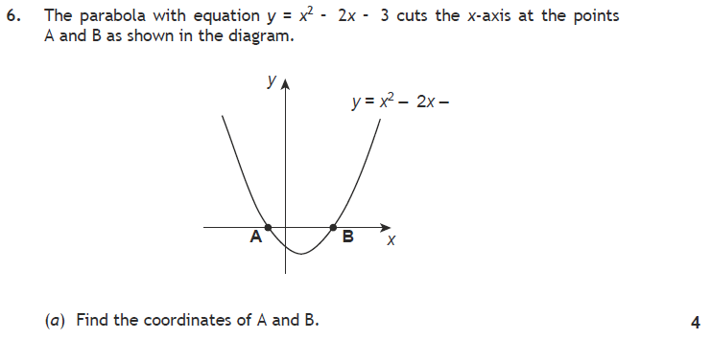 

7. 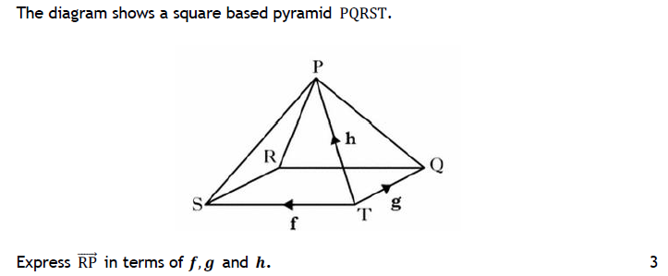

**Calculator**

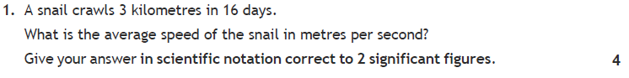

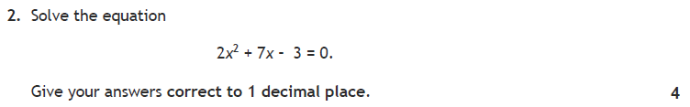

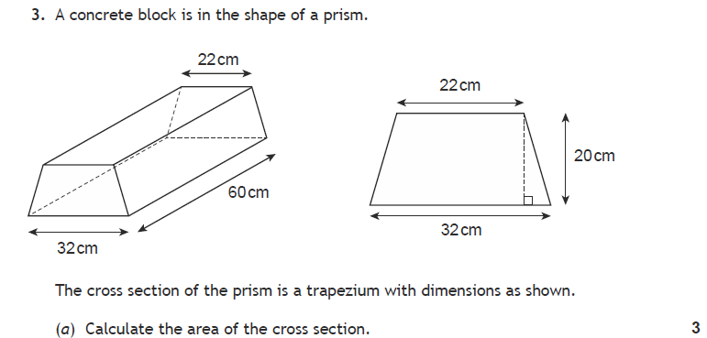



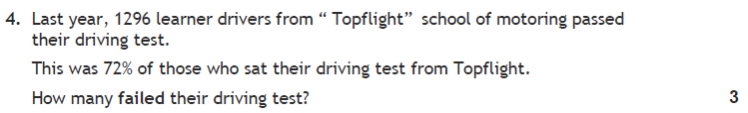

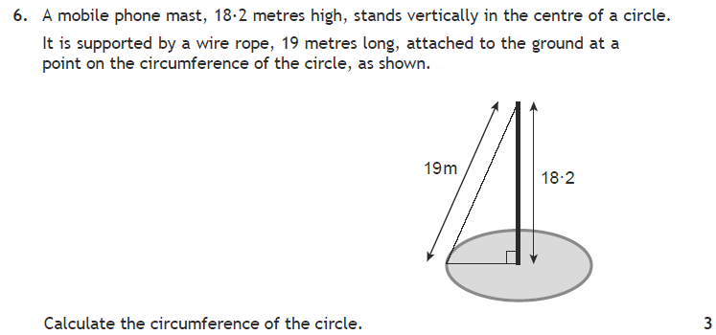

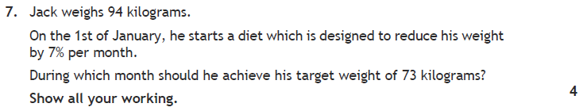

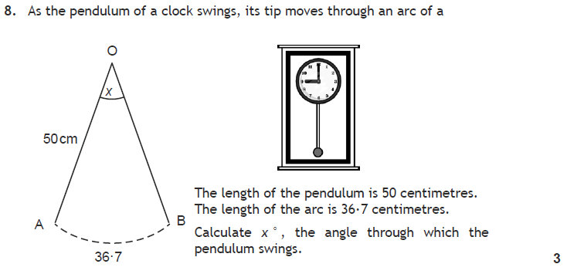

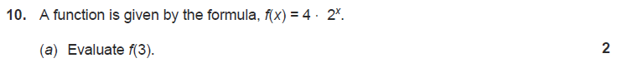



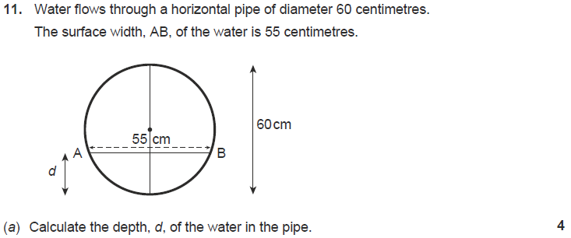



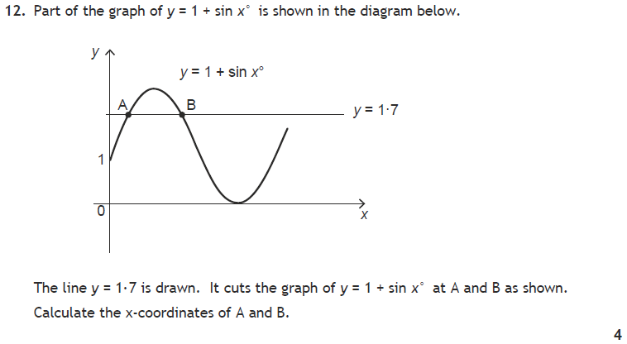

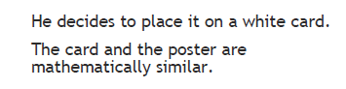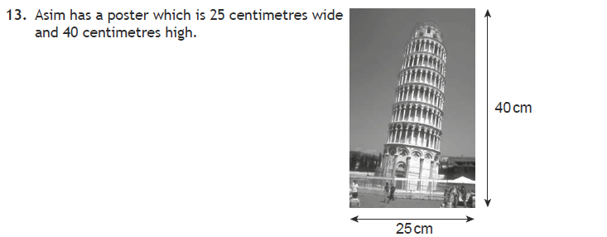

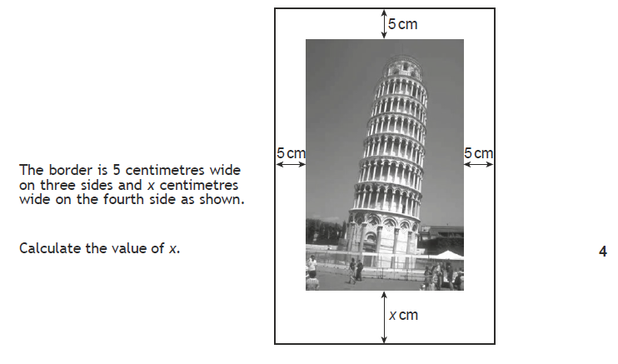

**Homework 24**

60

**Return by :**

**Non Calculator**



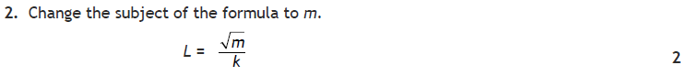

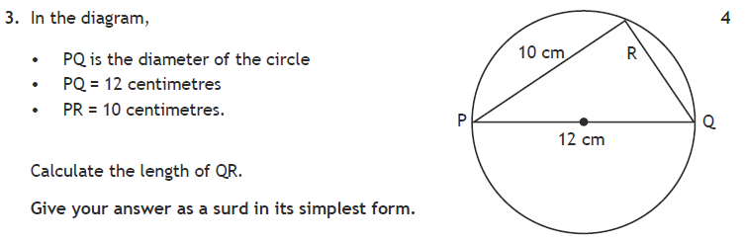

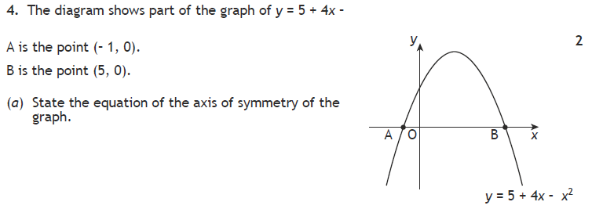 

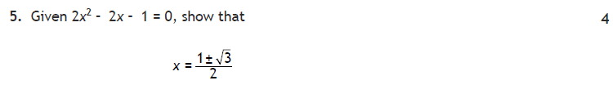

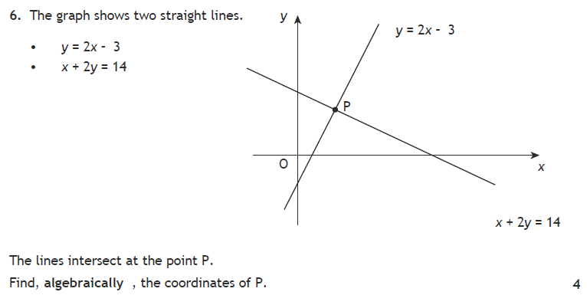

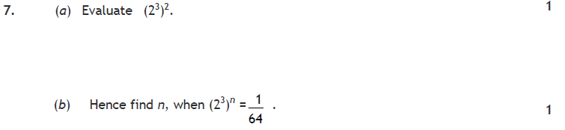

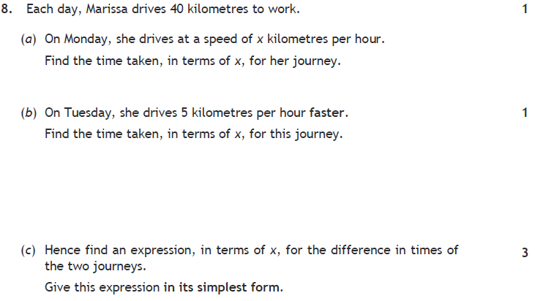

9.

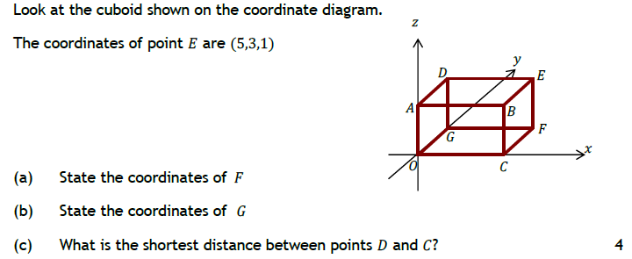

**Calculator**

