|  |  |  |  |  |  |  |  |  |  |  |
| --- | --- | --- | --- | --- | --- | --- | --- | --- | --- | --- |
| National 5  Mathematics | | Pupil Name: | | | | | | | | |
| Teachers Name: | | | | | | | | |
| Homework Booklet 3 Part 2  All units | | | | | | | | | | |
| Progress Table (if correct then ***√*** if more work is required then **x**) | | | | | | | | | | |
|  | Homework 25 | | Homework 26 | Homework 27 | Homework 28 | Homework 29 |  |  |  |  |
| Algebraic Fractions |  | |  |  |  |  |  |  |  |  |
| Angles |  | |  |  |  |  |  |  |  |  |
| Arc Length/Area of Sectors |  | |  |  |  |  |  |  |  |  |
| Changing the Subject |  | |  |  |  |  |  |  |  |  |
| Circle Geometry |  | |  |  |  |  |  |  |  |  |
| Compound Percentages |  | |  |  |  |  |  |  |  |  |
| Expand brackets and simplify |  | |  |  |  |  |  |  |  |  |
| Factorising/Completing the Sq. |  | |  |  |  |  |  |  |  |  |
| Fractions |  | |  |  |  |  |  |  |  |  |
| Functions |  | |  |  |  |  |  |  |  |  |
| Indices |  | |  |  |  |  |  |  |  |  |
| Pythagoras |  | |  |  |  |  |  |  |  |  |
| Quadratic Graphs |  | |  |  |  |  |  |  |  |  |
| Quadratic Theory |  | |  |  |  |  |  |  |  |  |
| Reverse Percentages |  | |  |  |  |  |  |  |  |  |
| Scientific Notation |  | |  |  |  |  |  |  |  |  |
| Significant Figures |  | |  |  |  |  |  |  |  |  |
| Similarity |  | |  |  |  |  |  |  |  |  |
| Simultaneous Equations |  | |  |  |  |  |  |  |  |  |
| Solving an Equation/Inequation |  | |  |  |  |  |  |  |  |  |
| Straight Line |  | |  |  |  |  |  |  |  |  |
| Surds |  | |  |  |  |  |  |  |  |  |
| Trigonometry Graphs/Equations |  | |  |  |  |  |  |  |  |  |
| Volume |  | |  |  |  |  |  |  |  |  |
| Score | **/23** | | **/23** | **/21** | **/45** | **/49** |  |  |  |  |
| Percentage | **%** | | **%** | **%** | **%** | **%** |  |  |  |  |
| LATE |  | |  |  |  |  |  |  |  |  |

You will need a QR Reader and your SCHOLAR username and password to access materials.

SCN: Password:

|  |  |  |
| --- | --- | --- |
| Fractions | Expand Brackets and Simplify | Changing the subject |
| Reverse Percentages | Compound Percentages | Percentage Appreciation |
| Volume | Significant Figures | Scientific Notation |
| Arc Length / Area of Sectors | Angles | Factorising/Completing the square |
| Surds/Indices | Quadratics | Solving equation/Inequation |
| Simultaneous equations | Pythagoras | Trig Graphs/Equations |
| Straight Line | Algebraic Fractions | Similarity |

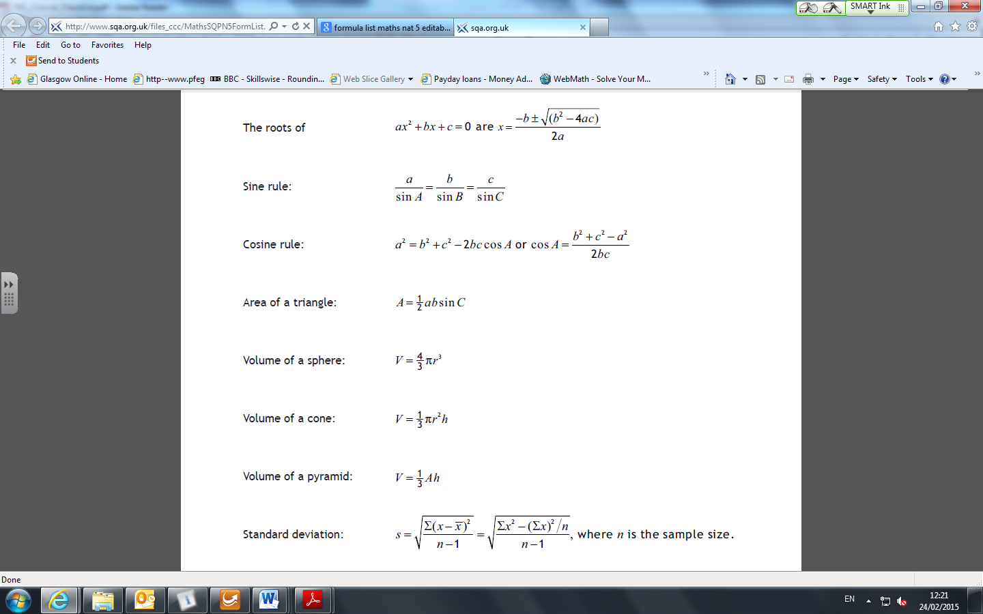**Formula Sheet**

**Homework 25**

23

**Return by :**

**Calculator**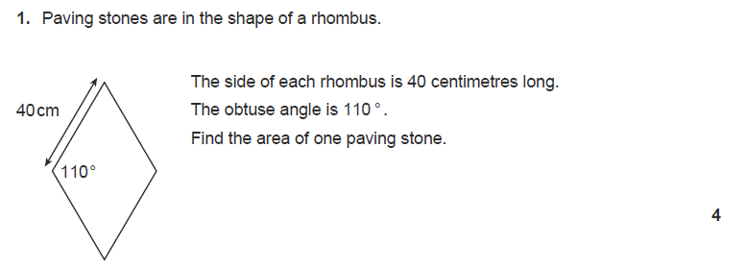

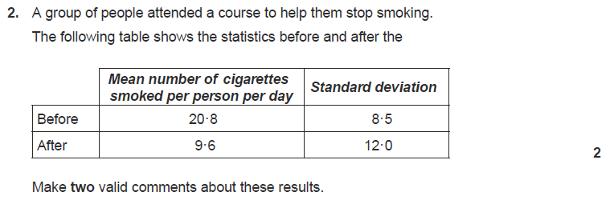

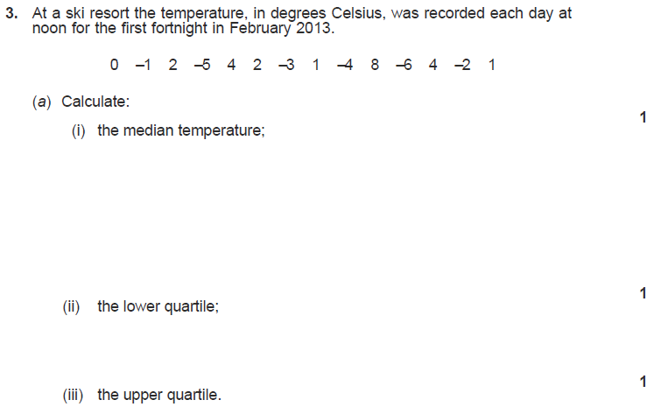

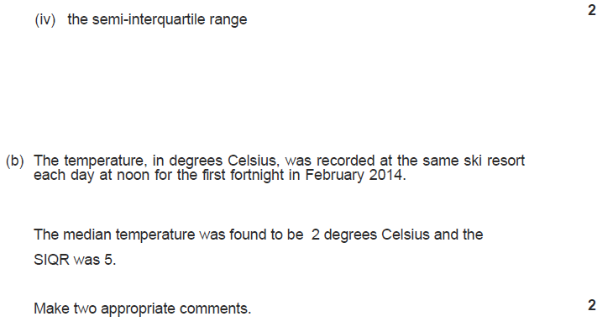

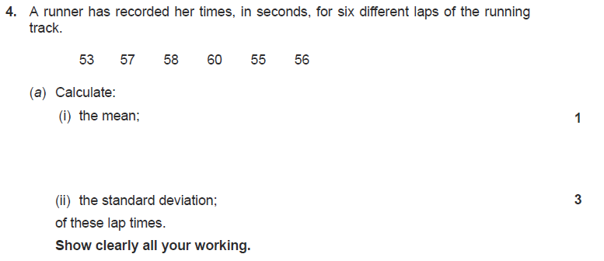

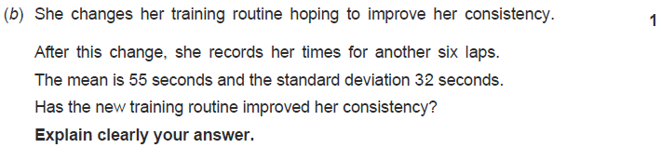

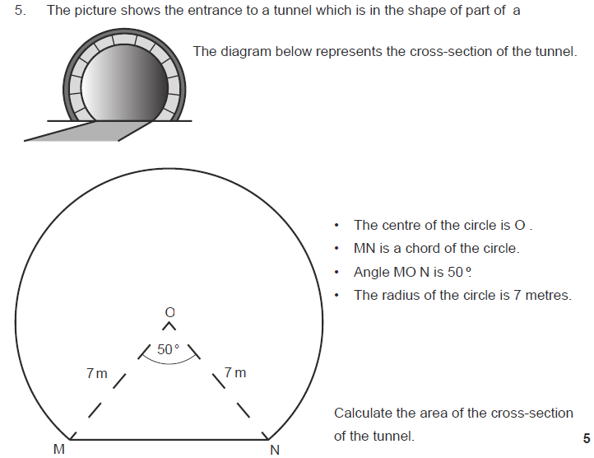

**Homework 26**

23

**Return by :**



**Calculator**

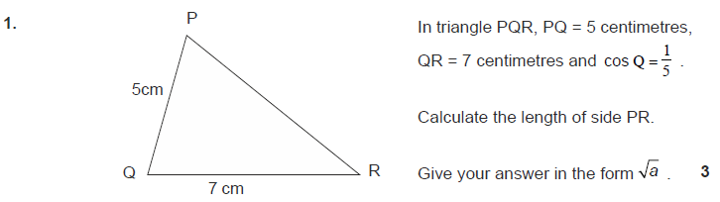

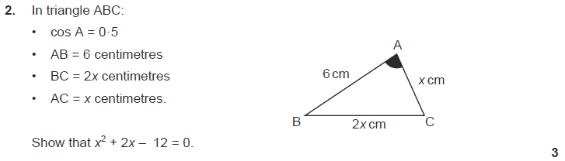

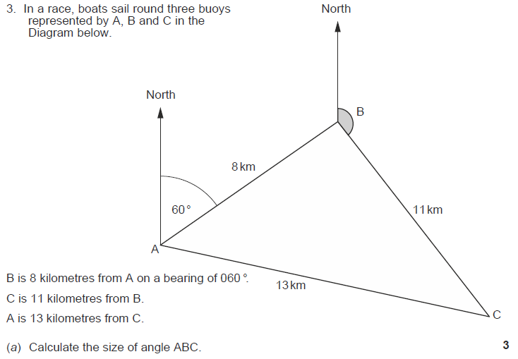



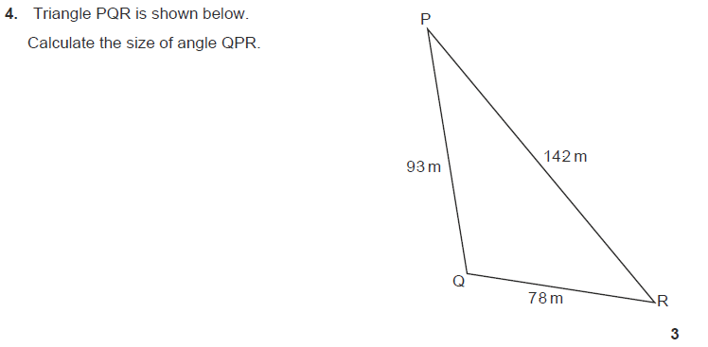

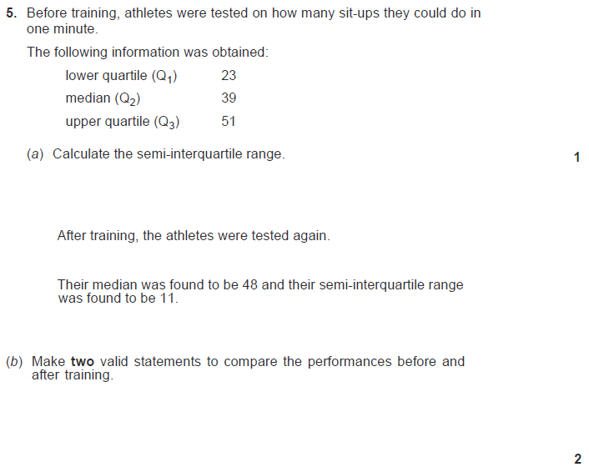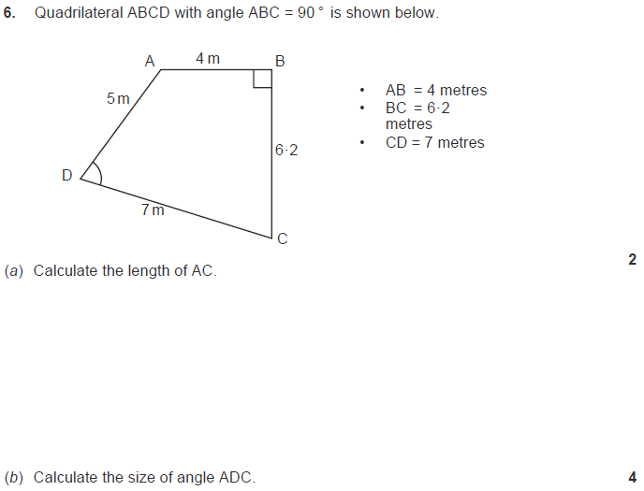

**Homework 27**

21

**Return by :**

**Calculator**



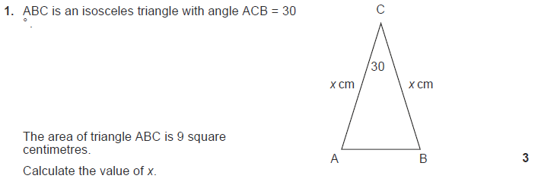

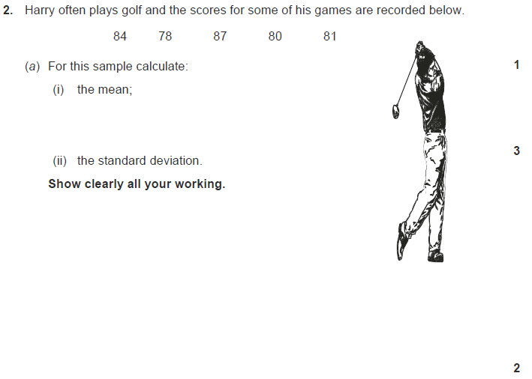

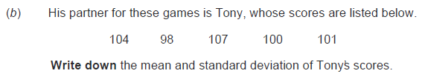

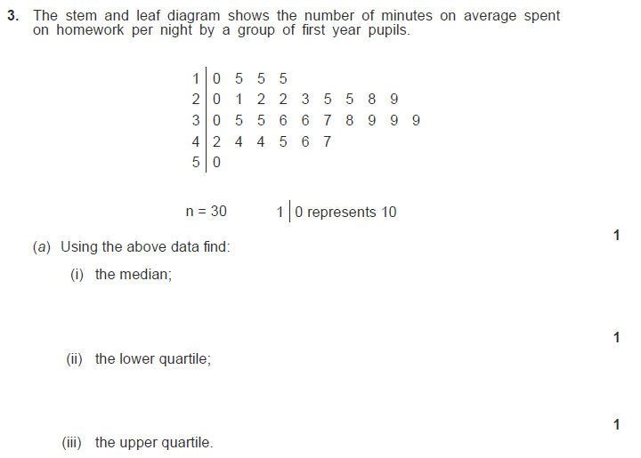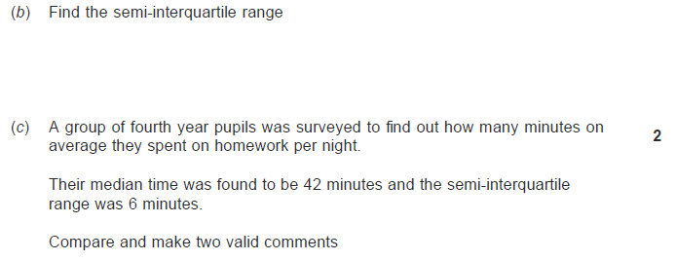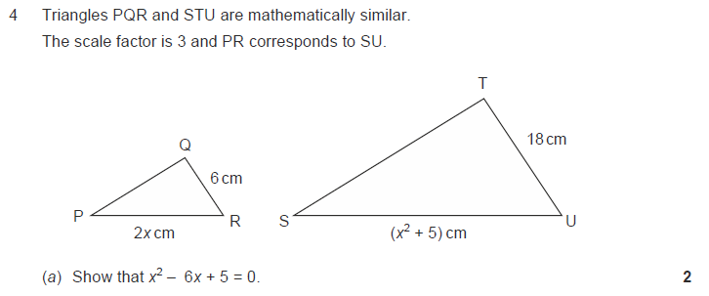

**Homework 28**

45

**Return by :**

**Non Calculator**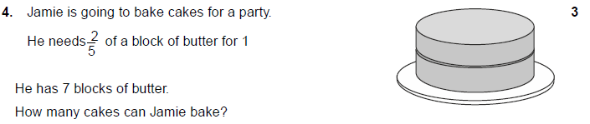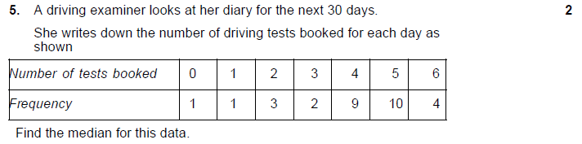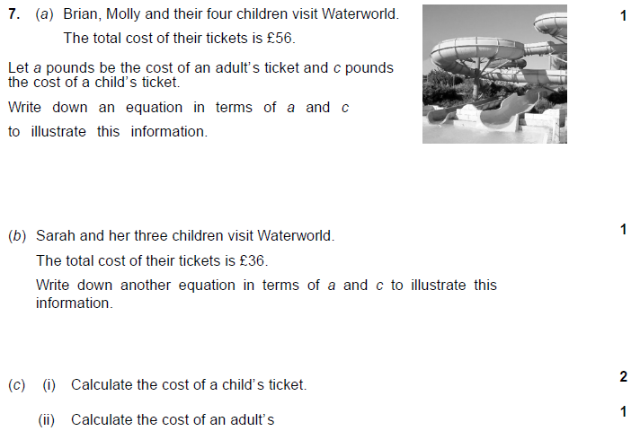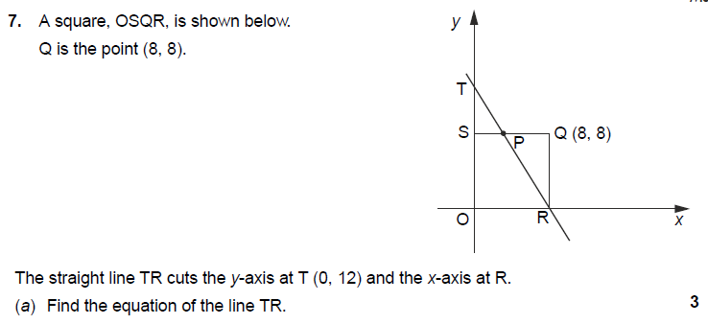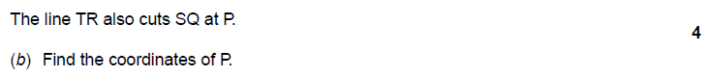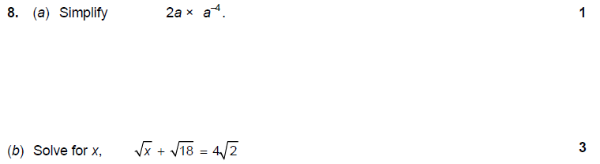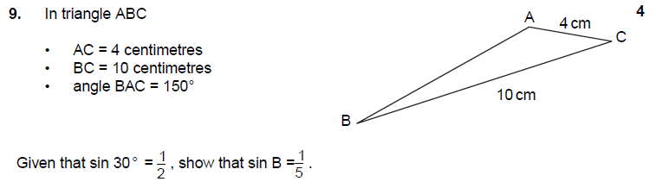

**Calculator**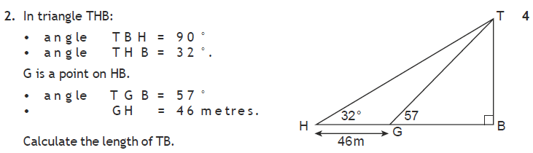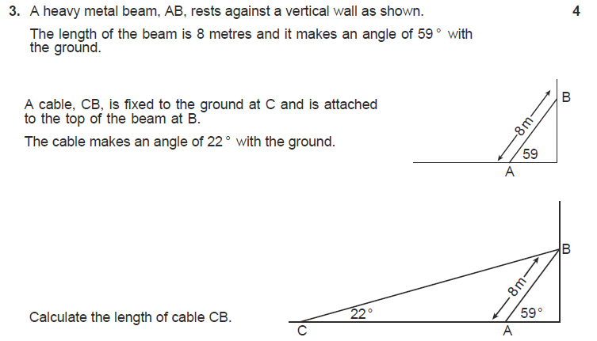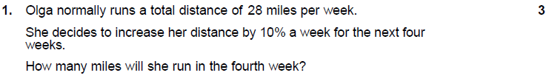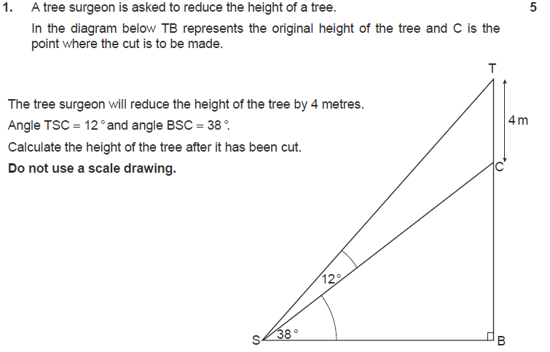

**Homework 29**

49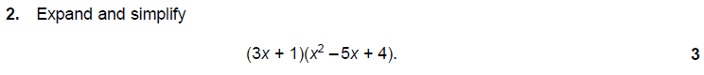

**Return by :Calculator**

