**Port Glasgow High School**

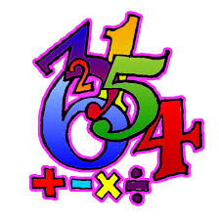

**Numeracy Booklet**



**Introduction**

**What is the purpose of the booklet?**

This booklet has been produced to give guidance to pupils and parents on how certain common Numeracy topics are taught in the mathematics classroom and throughout the school. Staff from all departments have been consulted during its production and will be issued with a copy of the booklet. It is hoped that using a consistent approach across all subjects will make it easier for pupils to progress.

**How can it be used?**

This booklet should be used in class and at home for completing homework. Simply look up the relevant page for a step by step guide and useful examples.

The booklet includes Numeracy skills useful in subjects other than Mathematics, such as Home Economics, Technical, Science, and Geography amongst others.

For help with mathematics topics, pupils should refer to their mathematics textbook or ask their teacher for help.

**Why do some topics include more than one method?**

In some cases (e.g. percentages), the method used will be dependent on the level of difficulty of the question, and whether or not a calculator is permitted.

For all calculations, pupils should be encouraged to develop a variety of strategies so that they can select the most appropriate method in any given situation. Pupils gain full credit for all valid working shown.

**Table of Contents**

|  |  |
| --- | --- |
| **Topic** | **Page Number** |
| Basic Numeracy Skills | 4 |
| Estimation - Rounding | 5 |
| Estimation - Calculations | 6 |
| Measurement – in Technical  Addition | 7  9 |
| Addition | 11 |
| Subtraction | 12 |
| Multiplication | 13 |
| Division | 14 |
| Order of Calculations (BODMAS) | 15 |
| Time | 16 |
| Fractions | 18 |
| Percentages | 20 |
| Ratio | 24 |
| Proportion | 26 |
| Information Handling - Tables | 27 |
| Information Handling - Bar Graphs | 28 |
| Information Handling - Line Graphs | 29 |
| Information Handling - Scatter Graphs | 30 |
| Information Handling - Pie Charts | 31 |
| Information Handling - Averages | 32 |
| Graphs in Science | 33 |
| Variables in Science | 34 |
| Significant Figures | 35 |
| Scientific Notation | 36 |
| Computing Science | 37 |
| Numeracy Dictionary | 39 |

**Basic Numeracy Skills**

At Port Glasgow High School we expect pupils to demonstrate, acquire and regularly revise some of the more basic number skills such as their times tables and simple addition or subtraction.

All pupils should know their times tables from 1 to 12, however it is well worth encouraging extra practice in the six, seven, eight and nine times tables.

|  |  |  |  |  |  |  |  |  |  |  |  |  |
| --- | --- | --- | --- | --- | --- | --- | --- | --- | --- | --- | --- | --- |
| **x** | **1** | **2** | **3** | **4** | **5** | **6** | **7** | **8** | **9** | **10** | **11** | **12** |
| **1** | 1 | 2 | 3 | 4 | 5 | 6 | 7 | 8 | 9 | 10 | 11 | 12 |
| **2** | 2 | 4 | 6 | 8 | 10 | 12 | 14 | 16 | 18 | 20 | 22 | 24 |
| **3** | 3 | 6 | 9 | 12 | 15 | 18 | 21 | 24 | 27 | 30 | 33 | 36 |
| **4** | 4 | 8 | 12 | 16 | 20 | 24 | 28 | 32 | 36 | 40 | 44 | 48 |
| **5** | 5 | 10 | 15 | 20 | 25 | 30 | 35 | 40 | 45 | 50 | 55 | 60 |
| **6** | 6 | 12 | 18 | 24 | 30 | 36 | 42 | 48 | 54 | 60 | 66 | 72 |
| **7** | 7 | 14 | 21 | 28 | 35 | 42 | 49 | 56 | 63 | 70 | 77 | 84 |
| **8** | 8 | 16 | 24 | 32 | 40 | 48 | 56 | 64 | 72 | 80 | 88 | 96 |
| **9** | 9 | 18 | 27 | 36 | 45 | 54 | 63 | 72 | 81 | 90 | 99 | 108 |
| **10** | 10 | 20 | 30 | 40 | 50 | 60 | 70 | 80 | 90 | 100 | 110 | 120 |
| **11** | 11 | 22 | 33 | 44 | 55 | 66 | 77 | 88 | 99 | 110 | 121 | 132 |
| **12** | 12 | 24 | 36 | 48 | 60 | 72 | 84 | 96 | 108 | 120 | 132 | 144 |

At primary school pupils will be taught about the importance of place value. This can be a difficult concept and should be reinforced at home.

**26∙57 means**

**2 tens, 6 units, 5 tenths and 7 hundredths**

**or**

**20, 6, 0.5 and 0.07**

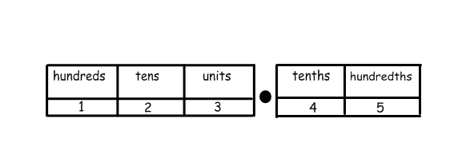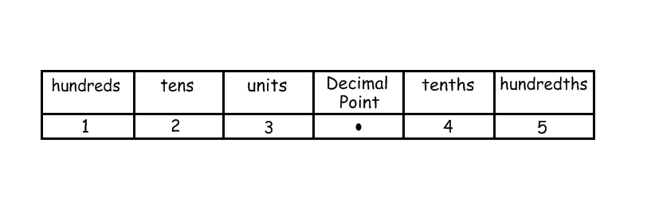**Estimation - Rounding**

Numbers can be rounded to give an approximation

67**3**4 rounded to the nearest 10 is 6730

6**7**34 rounded to the nearest 100 is 6700

**6**734 rounded to the nearest 1000 is 7000



In general, to round a number, we must first identify the place value to which we want to round. We must then look at the next digit to the right (the “check digit”) - if it is 5 or more round up.

**Example 1** Round 3 527 to the nearest thousand

3 is the digit in the thousands column - the check digit (in the

hundreds column) is a 5, so round up.

3527

= 4 000 to the nearest thousand

**Example 2** Round 1∙2439 to 2 decimal places

The second number after the decimal point is a 4 - the check digit

(the third number after the decimal point) is a 3, so round down.

1∙2439

= 1∙24 to 2 decimal places

**Estimation - Calculations**

When rounding numbers 0 – 4 rounds down

5 – 9 rounds up

So 46**2**5 rounded to the nearest 10 is 46**3**0



**Example 1**

Tickets for a concert were sold over 4 days. The number of tickets sold each day was recorded in the table below. How many tickets were sold in total?

|  |  |  |  |
| --- | --- | --- | --- |
| Monday | Tuesday | Wednesday | Thursday |
| 486 | 205 | 197 | 321 |

Estimate = 500 + 200 + 200 + 300 = 1200 tickets

Calculate: 486 + 205 + 197 + 321 = 1209 tickets using any valid strategy.

**Example 2**

A bar of chocolate weighs 42g. There are 48 bars of chocolate in a box. What is the total weight of chocolate in the box?

**Estimate** = 50 x 40 = 2000g

Calculate the actual weight:

2016g

We can use numbers which have been rounded to give us an approximate answer to a calculation. This allows us to check that our answer is sensible.

[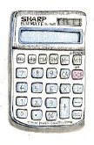](http://images.google.com/imgres?imgurl=http://tr.toonpool.com/user/1270/files/calcolator_160615.jpg&imgrefurl=http://tr.toonpool.com/cartoons/calculator_16061&usg=__Q4CqDScjn9vStxIoJE7DpPBuGMA=&h=500&w=328&sz=42&hl=en&start=7&tbnid=EbOLGstsw0WTgM:&tbnh=130&tbnw=85&prev=/images?q%3Dcartoon%2Bcalculator%26gbv%3D2%26hl%3Den)

48

X

42

=

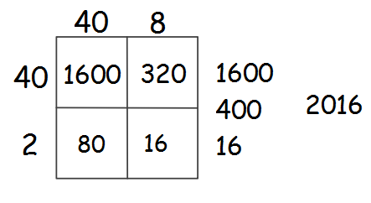

**Measurement**

At secondary school, pupils will work with a number of different units of measurement relating to lengths, weights, volumes etc.

In the Technical department, measurements are generally in millimetres (mm).

There are 10 mm in 1 cm, often rulers

are marked in cm with small divisions

showing the millimetres.

It is useful to be able to approximate sizes of familiar objects in mm.

**Some examples**

desk – 1200 mm wide person – 1700 mm tall

computer keyboard – 450 mm wide house – 8000 mm tall

In engineering and construction objects are still measured in mm

even when they are very large, for example the height of a house.

Pupils should be able to identify a suitable unit for measuring objects given their relative lengths, i.e.

Index finger millimetres

Desk centimetres

Football pitch metres

Glasgow to Edinburgh Kilometres

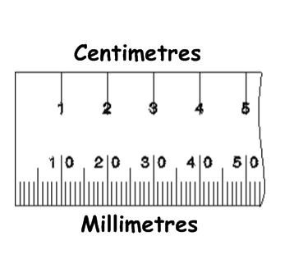

**Measurement**

In Home Economics and science, pupils will work with a wide range of measurements when dealing with quantities of food or liquids.

Measuring jugs allow liquids to be poured

in millilitres (ml) or litres.

Kilograms and grams are used

to measure cooking ingredients.

In Mathematics pupils also look at converting between all of these different units. Here are some useful conversions to note;

**Length** **Volume**

10 millimetres = 1 centimetre 1cm3 = 1ml

100 centimetres = 1 metre 1000 millilitres = 1 litre

1000 metres = 1 kilometre

**Mass**

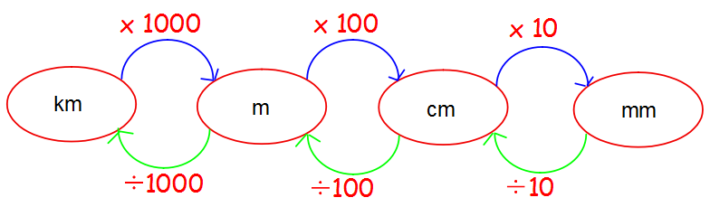

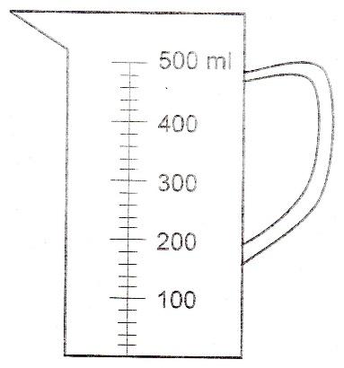

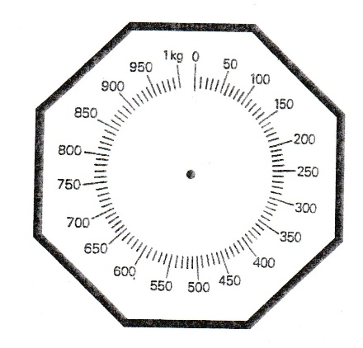

1000 grams = 1 Kilogram

1000 kilograms = 1 Tonne

**Measurement in Technical**

In Technical, pupils have to measure and mark out accurately, when producing models or drawings. The unit of measurement we use is millimetres (mm).

A millimetre is one tenth of a centimetre. In technical pupils sometime have to convert between centimetre and millimetres.

Here are some useful conversions to note.

* 10 millimetres = 1 centimetres
* 100 millimetres = 10 centimetres
* 1000 millimetres = 100 centimetres

**Examples**

Convert the following sizes into millimetres.

0.5 centimetres = 0.5 x 10 = 5 mm

0.9 centimetres = 0.9 x 10 = 9 mm

1.5 centimetres = 1.5 x 10 = 15 mm

20 centimetres = 20 x 10 = 200 mm

0.6 metre = 0.6 x 100 = 60 cm = 60 x 10 = 600 mm

[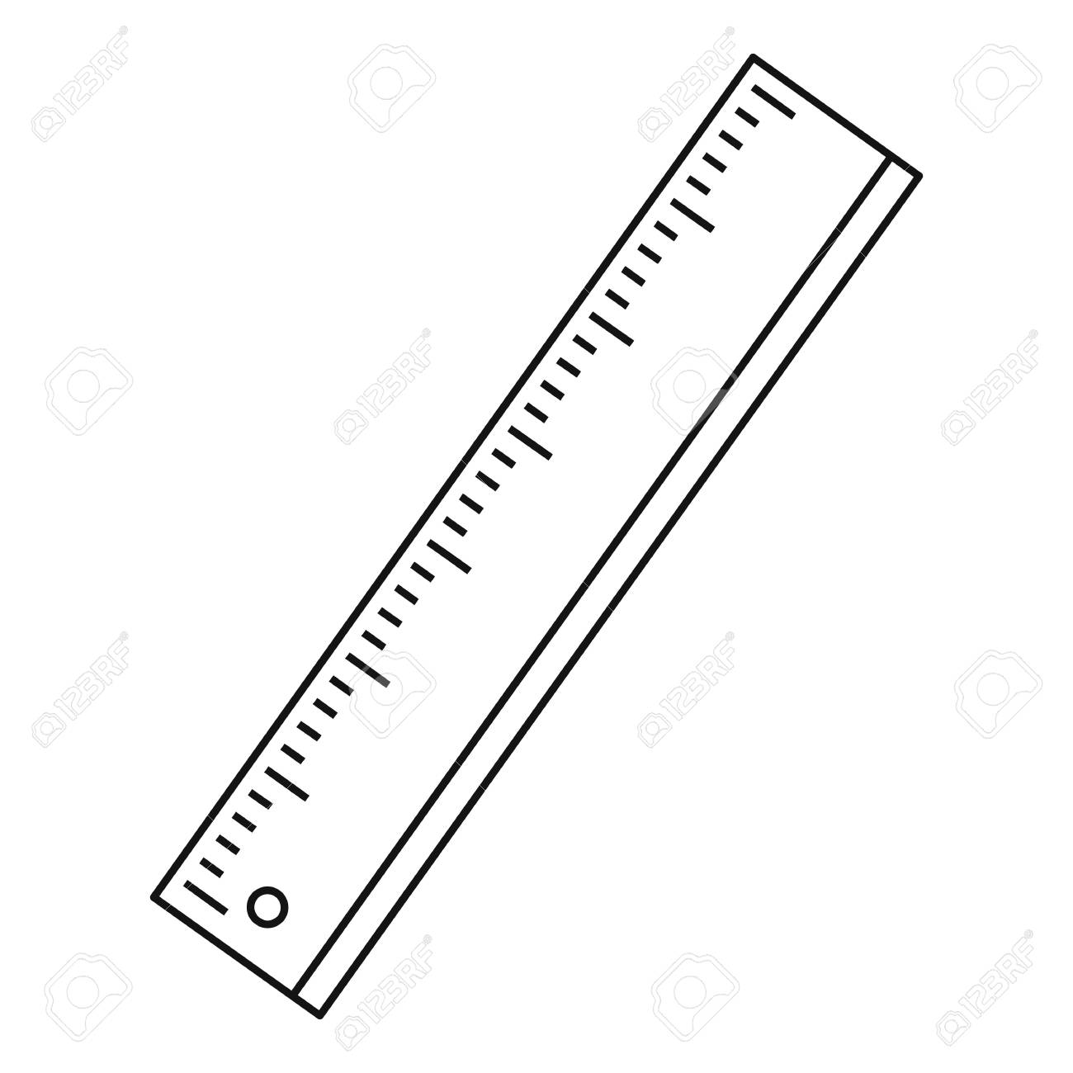](https://www.google.co.uk/url?sa=i&rct=j&q=&esrc=s&source=images&cd=&cad=rja&uact=8&ved=2ahUKEwjQpfzSnOvhAhXCUhUIHffNDcMQjRx6BAgBEAU&url=https://www.123rf.com/photo_72535390_stock-vector-ruler-icon-outline-illustration-of-ruler-vector-icon-for-web.html&psig=AOvVaw30odx_C4QwfcrgnbcrTAlD&ust=1556280986608254)

**Dimension in Technical**

A Dimension is a measurable extent of a particular kind, such as length, breadth, depth, or height. Shown below is the dimension of a cube.

[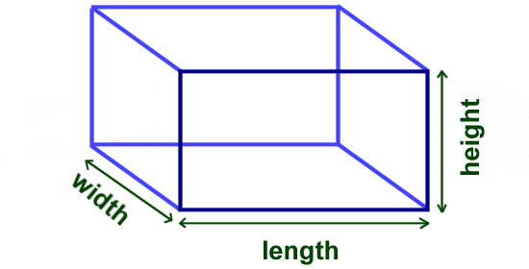](https://www.google.co.uk/url?sa=i&rct=j&q=&esrc=s&source=images&cd=&cad=rja&uact=8&ved=2ahUKEwiLjcbXm-vhAhW2SxUIHZY3APwQjRx6BAgBEAU&url=https://www.ducksters.com/kidsmath/finding_the_volume_of_a_cube_or_box.php&psig=AOvVaw3KvFAIzqQ6ATQfxYZUoCwK&ust=1556280737823428)

**Dimensions of a circle**

* The circumference of a circle is the line all the way round which makes the circle.
* The centre (**+**) is the middle of the circle
* The radius (**R**) is the distance from the centre to any part of the circumference

The diameter (shown by this symbol) [](https://www.google.co.uk/url?sa=i&rct=j&q=&esrc=s&source=images&cd=&ved=2ahUKEwiksLunnuvhAhXfVRUIHQ9qCHUQjRx6BAgBEAU&url=https://www.wisc-online.com/assetrepository/viewasset?id%3D3625&psig=AOvVaw2Xxx4JiK_DhkCthza1s2KJ&ust=1556281443107005) is a line drawn from one side of the circumference to the other side through the centre.

* The diameter is always twice the size of the radius
* In Maths we use *d* for diameter and *r* for radius

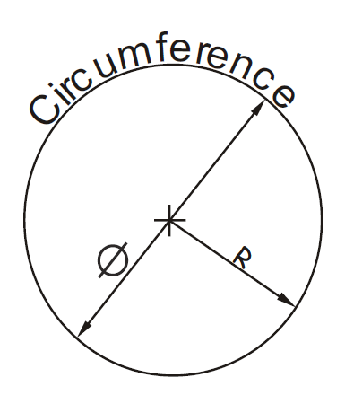

**(depth)**

**Addition**

**breadth**

**(width)**

**Addition**

**Strategies**



**Example** Calculate 54 + 27

**Method 1** Add tens, then add units, then add together

50 + 20 = 70 4 + 7 = 11 70 + 11 = 81

**Method 2** Split up the number to be added into tens and units

and add separately.

54 + 20 = 74 74 + 7 = 81 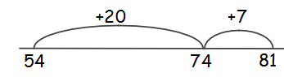

**Method 3** Round up to nearest 10, then subtract

54 + 30 = 84 but 30 is 3 too many therefore subtract 3

84 - 3 = 81

**Written Method**

When adding numbers, ensure that the numbers are lined up according to place value.

Start at right hand side, write down units, and carry tens.

**Example** Add 3032 and 589

There are a number of useful mental strategies for addition. Some examples are given below.

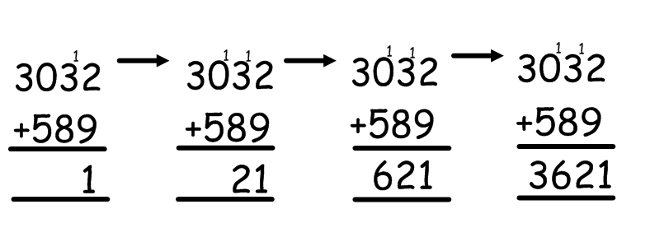**Subtraction**

2 + 9 = 11

3+8+1=12

0+5+1=6

3 + 0 = 3



**Strategies**

**Example** Calculate 93 - 56

**Method 1** Count on

Count on from 56 until you reach 93. This can be done in several ways

e.g.

4 30 3 = 37

56 60 70 80 90 93

**Method 2** Break up the number being subtracted

e.g. subtract 50, then subtract 6 93 - 50 = 43

43 - 6 = 37

6 50

37 43 93

**Written Method**

**Example 1** 4590 – 386 **Example 2** Subtract 197 from 2000

We use decomposition as a written method for subtraction (see below). Alternative methods may be used for subtraction calculations.

**Multiplication**

**1 9 9 1**

2 0 0 0

- 1 9 7

1 8 0 3

Start

8 1

4590

- 386

4204



|  |  |  |  |  |  |  |  |  |  |  |  |  |
| --- | --- | --- | --- | --- | --- | --- | --- | --- | --- | --- | --- | --- |
| **x** | **1** | **2** | **3** | **4** | **5** | **6** | **7** | **8** | **9** | **10** | **11** | **12** |
| **1** | 1 | 2 | 3 | 4 | 5 | 6 | 7 | 8 | 9 | 10 | 11 | 12 |
| **2** | 2 | 4 | 6 | 8 | 10 | 12 | 14 | 16 | 18 | 20 | 22 | 24 |
| **3** | 3 | 6 | 9 | 12 | 15 | 18 | 21 | 24 | 27 | 30 | 33 | 36 |
| **4** | 4 | 8 | 12 | 16 | 20 | 24 | 28 | 32 | 36 | 40 | 44 | 48 |
| **5** | 5 | 10 | 15 | 20 | 25 | 30 | 35 | 40 | 45 | 50 | 55 | 60 |
| **6** | 6 | 12 | 18 | 24 | 30 | 36 | 42 | 48 | 54 | 60 | 66 | 72 |
| **7** | 7 | 14 | 21 | 28 | 35 | 42 | 49 | 56 | 63 | 70 | 77 | 84 |
| **8** | 8 | 16 | 24 | 32 | 40 | 48 | 56 | 64 | 72 | 80 | 88 | 96 |
| **9** | 9 | 18 | 27 | 36 | 45 | 54 | 63 | 72 | 81 | 90 | 99 | 108 |
| **10** | 10 | 20 | 30 | 40 | 50 | 60 | 70 | 80 | 90 | 100 | 110 | 120 |
| **11** | 11 | 22 | 33 | 44 | 55 | 66 | 77 | 88 | 99 | 110 | 121 | 132 |
| **12** | 12 | 24 | 36 | 48 | 60 | 72 | 84 | 96 | 108 | 120 | 132 | 144 |

**Strategies**

**Example** Find 39 x 6

**Method 1**

**Method 2**

**Method 3**

It is essential that pupils know all of the multiplication tables from 1 to 12. These are shown in the tables square below.

**Division**

240 - 6

= 234

40 is 1 too many so take away 1x6

40 x 6

=240

180 + 54

= 234

9 x 6

= 54

30 x 6

= 180

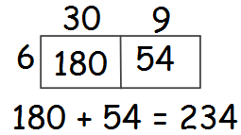



**Example 1** There are 192 pupils in first year, shared equally

between 8 classes. How many pupils are in each class?

0 2 4

8 1 1932

There are 24 pupils in each class.

**Example 2** Divide 4**∙**74 by 3

1 **∙**  5 8

3 4 **∙**1 724

**Example 3** A jug contains 2**∙**2 litres of juice. The juice is poured evenly into 8 glasses, how much juice is in each glass?

0 **∙** 2 7 5

8 2 **∙**226040

Each glass contains

0**∙**275 litres

Pupils should be able to divide by a single digit or by a multiple of 10 or 100 without a calculator.

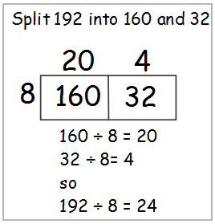v**Order of Calculation (BODMAS)**

Method 1

Algorithm

20 + 4 = 24 VIPs

8 160 + 32 x2 = 16

x4 = 32

x 10 = 80

x20 =160

Method 4

Partitioning

24

24

24

24

24

24

24

24

192 pupils

96

96

Method 3

Bar Modelling

Method 2

Grid/Box method

**When dividing a decimal number by a whole number, the decimal points must stay in line.**

**If you have a remainder at the end of a calculation, add a zero onto the end of the decimal and continue with the calculation.**



The **BODMAS** rule tells us which operations should be done first. **BODMAS** represents:

Scientific calculators use this rule, some basic calculators may not, so take care in their use.

**Example 1** 15 – 12 ÷ 6 BODMAS tells us to divide first

= 15 – 2

= 13

**Example 2** (9 + 5) x 6 BODMAS tells us to work out the

= 14 x 6 brackets first

= 84

**Example 3** 18 + 6 ÷ (5 - 2)Brackets first

= 18 + 6 ÷ 3 then divide

= 18 + 2 now add

= 20

Calculations which have more than one operation need to be done in a particular order. The order can be remembered by using the mnemonic **BODMAS**

**Time**

**(B)rackets**

**(O)f**

**(D)ivision**

**(M)ultiplication**

**(A)ddition**

**(S)ubraction**



**12-hour clock**

Time can be displayed on a clock face, or digital clock.

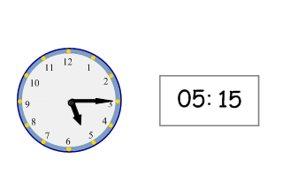

When writing times in 12 hour clock, we need to add a.m. or p.m. after the time.

a.m. is used for times between midnight and noon (morning)

p.m. is used for times between noon and midnight (afternoon / evening).

**24-hour clock**



Time may be expressed in 12 or 24 hour form.

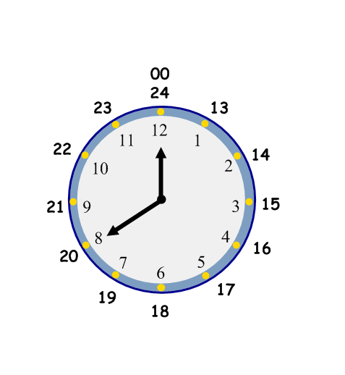**Time**

**Examples**

12 hr 24hr

7.00 am 07:00 hours

10.35 am 10:35 hours

Noon 12:00 hours

9.45 pm 21:45 hours

Midnight 00:00 hours

In 24 hour clock notation, the hours are written as 4 digit numbers between 01:00 and 00:00.

Midnight is expressed as 00:00.

After 12 noon, the hours are 13:00, 14:00, 15:00… etc.

These clocks both show fifteen minutes past five, or quarter past five.



**Time Facts**

In 1 year, there are: 365 days (366 in a leap year)

52 weeks

12 months

There are 10 years in a decade, 100 years in a century and 1000 years in a millennium.

The number of days in each month can be remembered using the rhyme:

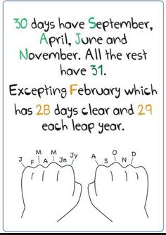

**Distance, Speed and Time**.

For any given journey, the distance travelled depends on the speed and the time taken. If speed is constant, then the following formulae apply:

Distance = Speed x Time or D = S x T

Speed =  or S = 

Time =  or T = 

Pupils who study Physics will be expected to refer to an objects speed as its velocity (v) and the distance travelled as displacement (s).

It is essential to know the number of months, weeks and days in a year, and the number of days in each month.

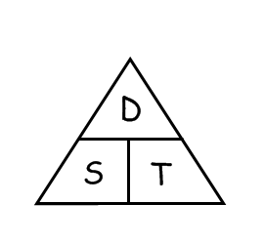 **Fractions**

The months that fall on your knuckles have 31 days and the months that fall in the spaces have 30 (except for February which has 28)

Addition, subtraction, multiplication and division of fractions are studied in Mathematics.

However, the examples below may be helpful in all subjects.



**Understanding Fractions**

**Example**

A necklace is made from black and white beads.



What fraction of the beads are black?

There are 3 black beads out of a total of 7, so  of the beads are black.

**Equivalent Fractions**

**Example**

What fraction of the flag is shaded?

|  |  |  |  |
| --- | --- | --- | --- |
|  |  |  |  |
|  |  |  |  |
|  |  |  |  |

6 out of 12 squares are shaded. So of the flag is shaded.

It could also be said that the flag is shaded.

 and  are **equivalent fractions**.

**Fractions**

|  |  |  |  |
| --- | --- | --- | --- |
|  |  |  |  |
|  |  |  |  |
|  |  |  |  |

**Simplifying Fractions**



**Example 1**

(a) ÷5 (b) ÷8

 =   = 

÷5 ÷8

This can be done repeatedly until the numerator and denominator are the smallest possible numbers - the fraction is then said to be in its **simplest form**.

**Example 2** Simplify   =  =  =  (simplest form)

**Calculating Fractions of a Quantity**



**Example 1** Find  of £150

 of £150 = £150 ÷ 5 = £30

**Example 2** Find  of 48

 of 48 = 48 ÷ 4 = 12

so  of 48 = 3 x 12 = 36

The top of a fraction is called the **numerator**, the bottom is called the **denominator**.

To simplify a fraction, divide the **numerator (the top)** and **denominator** **(the bottom)** of the fraction by the same number.

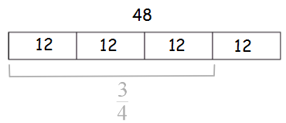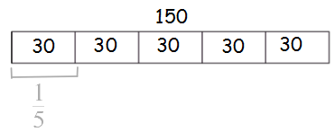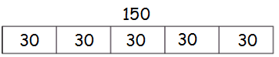**Percentages**

Divide by the bottom, multiply by the top.

To find the fraction of a quantity, divide the quantity by the denominator (the bottom).

To find  divide by 2, to find  divide by 3, to find  divide by 7 etc.



25% means =

25% is therefore equivalent to which is 0.25

**Common Percentages**

Some percentages are used very frequently. It is useful to know these as fractions and decimals.

|  |  |  |
| --- | --- | --- |
| Percentage | Fraction | Decimal |
| 1% |  | 0.01 |
| 5% | $$\frac{1}{20}$$ | 0.05 |
| 10% |  | 0.1 |
| 20% |  | 0.2 |
| 25% |  | 0.25 |
| 30% |  | 0.3 |
| 331/3% |  | 0.333… |
| 40% |  | 0.4 |
| 50% |  | 0.5 |
| 60% |  | 0.6 |
| 662/3% |  | 0.666… |
| 70% | $$\frac{7}{10}$$ | 0.7 |
| 75% |  | 0.75 |
| 80% | $$\frac{4}{5}$$ | 0.8 |
| 90% | $$\frac{9}{10}$$ | 0.9 |
| 100% | $$\frac{100}{100}$$ | 1.0 |

Percentage effectively means a fraction of a hundred.

A percentage can be converted to an equivalent fraction or a decimal.

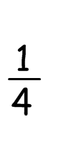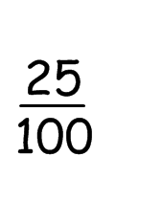**Percentages**



**Non-Calculator Methods**

**Method 1 Using Equivalent Fractions**

**Example** Find 25% of £640

25% of £640 =  of £640 = £640 ÷ 4 = £160

**Method 2 Using 1%**

In this method, first find 1% of the quantity (by dividing by 100), then multiply to give the required value.

**Example** Find 9% of 200g

1% of 200g =  of 200g = 200g ÷ 100 = 2g

so 9% of 200g = 9 x 2g = 18g

**Method 3 Using 10%**

This method is similar to the one above. First find 10% (by dividing by 10), then multiply to give the required

value.

**Example** Find 70% of £35

10% of £35 =  of £35 = £35 ÷ 10 = £3.50

so 70% of £35 = 7 x 10% of £35 = 7 x £3.50 = £24.50

There are many ways to calculate percentages of a quantity. Some of the common ways are shown below.

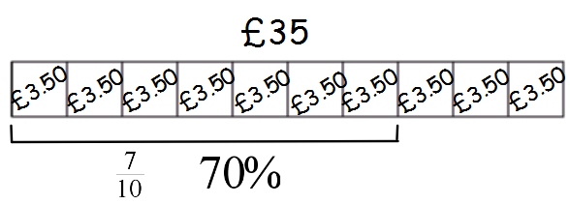**Percentages**

**Calculator Method**

To find the percentage of a quantity using a calculator, change the percentage to a decimal, then multiply.

**Example 1** Find 23% of £15 000

23% = 0.23 so 23% of £15 000 = 0.23 x £15 000 = £3 450



**Example 2** House prices increased by 19% over a one year period.

What is the new value of a house which was valued at

£236 000 at the start of the year?

19% = 0.19 so Increase = 0.19 x £236 000

= £44 840

Value at end of year = original value + increase

= £236 000 + £44 840

= £280 840

The new value of the house is £280 840

**Alternative strategy (quick):**

100% + 19% = 119% = 1.19

Therefore new value = 236 000 x 1.19 = £280 840

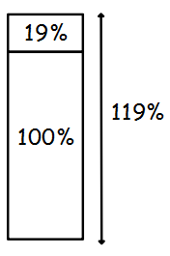**Percentages**

We do not use the % button on calculators. The methods taught in the mathematics department are all based on converting percentages to decimals.

**Finding the percentage**



**Example 1** There are 30 pupils in Class 3A. 18 are girls.

What percentage of Class 3A are girls?

 = 18 ÷ 30 = 0.6 = 60%

60% of 3A are girls

Which also means that 40% of 3A are boys!

**Example 2** James scored 36 out of 44 his biology test.

What is his percentage mark?

Score =  = 36 ÷ 44 = 0.81818…

= 81.818..% = 82% (rounded)

**Example 3** In class 1M, 14 pupils had brown hair, 6 pupils had blonde

hair, 3 had black hair and 2 had red hair. What

percentage of the pupils were blonde?

Total number of pupils = 14 + 6 + 3 + 2 = 25

6 out of 25 were blonde, so,

 = 6 ÷ 25 = 0.24 = 24%

24% were blonde.

To find a percentage of a total, first make a fraction, then convert to a decimal by dividing the top by the bottom. This can then be expressed as a percentage.

**Ratio**



**Writing Ratios**

**Example 1**

j0112668

**Example 2**

 The ratio of red : blue : green is 5 : 7 : 8

**Simplifying Ratios**

Ratios can be simplified in much the same way as fractions.

**Example 1**

A shade of paint can be made by mixing 10 tins of green paint with 6 tins of yellow. The ratio of green to yellow can be written as 10 : 6

It can also be written as 5 : 3, as it is possible to split up the tins into 2 groups, each containing 5 tins of green and 3 tins of yellow.





When quantities are to be mixed together, the ratio, or proportion of each quantity is often given. The ratio can be used to calculate the amount of each quantity, or to share a total into parts.

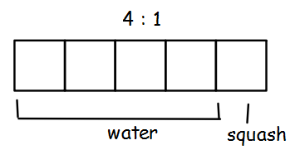**Ratio**

To make a fruit drink, 4 parts water is mixed with 1 part of squash.

The ratio of water to squash

is 4 : 1 (said “4 to 1”)

The ratio of squash to water is 1 : 4.

To simplify a ratio, divide each figure in the ratio by the same number.

**G G G G G Y Y Y**

In a bag of balloons, there are 5 red, 7 blue and 8 green balloons.

**Order is important when writing ratios.**

Green: Yellow

10 : 6

5 : 3

**G G G G G Y Y Y**

**Simplifying Ratios (continued)**

**Example 2**

Simplify each ratio:

(a) 4:6 (b) 24:36 (c) 6:3:12

(a) 4:6 (b) 24:36 (c) 6:3:12

= 2:3 = 2:3 = 2:1:4

**Example 3**

Concrete is made by mixing 20 kg of sand with 4 kg cement. Write

the ratio of sand : cement in its simplest form

Sand : Cement = 20 : 4

= 5 : 1

**Using ratios**

**Example 1**

The ratio of fruit to nuts in a chocolate bar is 3 : 2. If a bar contains 15g of fruit, what weight of nuts will it contain?

|  |  |
| --- | --- |
| Fruit | Nuts |
| 3 | 2 |
| x5 | x5 |
| 15 | **10** |

So the chocolate bar will contain 10g of nuts.

**Example 2**

Ronnie and Debbie play the lottery. If they win they share the money in a ratio of 3:2. How much will each receive if they win £5800?

3:2 = 3 + 2 = 5 parts

1 part = 5800 ÷ 5 = 1160

Ronnie = 3 x £1160 = £3480 Debbie = 2 x £1160 = £2320

Divide each figure by 3

Divide each figure by 12

Divide each figure by 2

**Proportion**

Debbie £2320

Ronnie £3480

**£5800**

£1160

£1160

£1160

£1160

£1160



It is often useful to make a table when solving problems involving proportion.

**Example 1**

A car factory produces 1500 cars in 30 days. How many cars would they produce in 90 days?

|  |  |
| --- | --- |
| Days | Cars |
| 30 | 1500 |
| x3 | x3 |
| 90 | **4500** |

The factory would produce 4500 cars in 90 days.

**Example 2**

5 adult tickets for the cinema cost £27.50.

How much would 8 tickets cost?

|  |  |
| --- | --- |
| Tickets | Cost |
| 5 | £27.50 |
| 1 | £5.50 |
| 8 | £44.00 |

The cost of 8 tickets is £44

Two quantities are said to be in direct proportion if when one doubles the other doubles.

We can use proportion to solve problems.

**Information Handling - Tables**

Working:

£5.50 £5.50

5 £27.50 4x 8

£44.00

Find the cost of 1 ticket



**Example 1** The table below shows the average maximum

temperatures (in degrees Celsius) in Barcelona over

a 12 month period.

|  |  |  |  |  |  |  |  |  |  |  |  |  |
| --- | --- | --- | --- | --- | --- | --- | --- | --- | --- | --- | --- | --- |
| Month | J | F | M | A | M | J | J | A | S | O | N | D |
| Barcelona | 13 | 14 | 15 | 17 | 20 | **24** | 27 | 27 | 25 | 21 | 16 | 14 |

The average temperature in June in Barcelona is 24°C

**Frequency Tables** are used to present information.

**Example 2** Shoe sizes for a class of pupils in S1

9 8 7 8 9 8 8 6 6 10

5 8 9 7 10 8 5 7 6 9

9 8 7 5 10

|  |  |  |
| --- | --- | --- |
| Size | Tally | Frequency |
| 5 | ||| | 3 |
| 6 | ||| | 3 |
| 7 | |||| | 4 |
| 8 | |||| || | 7 |
| 9 | |||| | 5 |
| 10 | ||| | 3 |

Each mark is recorded in the table by a tally mark.

Tally marks are grouped in 5’s to make them easier

to read and count.

It is sometimes useful to display information in graphs, charts or tables.

**Information Handling - Bar Graphs**



**Example 1** The graph below shows urban populations as discussed in Modern Studies lessons.

**Example 2** School Enrolment Percentages

Bar graphs are often used to display data.

The horizontal axis should show the categories, and the vertical axis the frequency.

All graphs should have a title, and each axis

should be labelled.

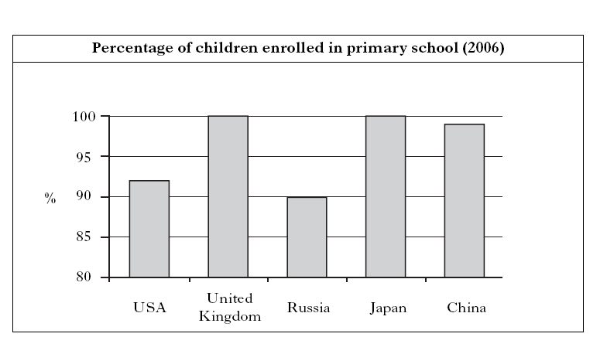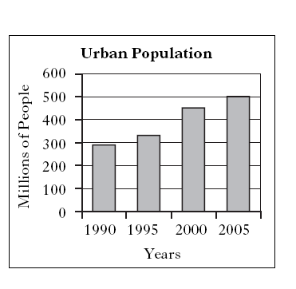**Information Handling - Line Graphs**



**Example 1**

**Example 2** The graph below shows the temperature every day at park on a particular day in Rome.

Although there was a small drop in

temperature on Thursday the general

trend is a rise in temperature over the week!

Line graphs consist of a series of points which are plotted, then joined by a line. All graphs should have a title, and each axis must be labelled. The trend of a graph is a general description of it.

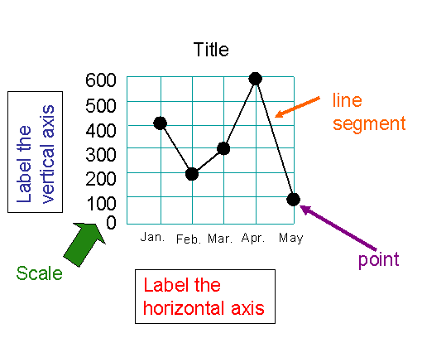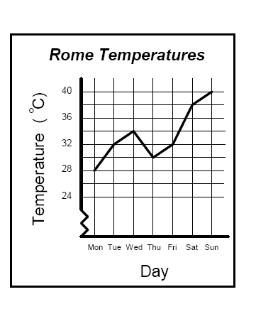**Information Handling - Scatter Graphs**



**Example** The scatter graph below shows the heights and weights of ten members of a local

Darts team.

The graph illustrates that Eric is 90 kg in weight and 150 cm tall.

Note that in some graphs, it is a requirement that the axes start from zero.

A scatter graph is used to display the relationship between two variables.

A pattern may appear on the graph.

This is called a **correlation**.

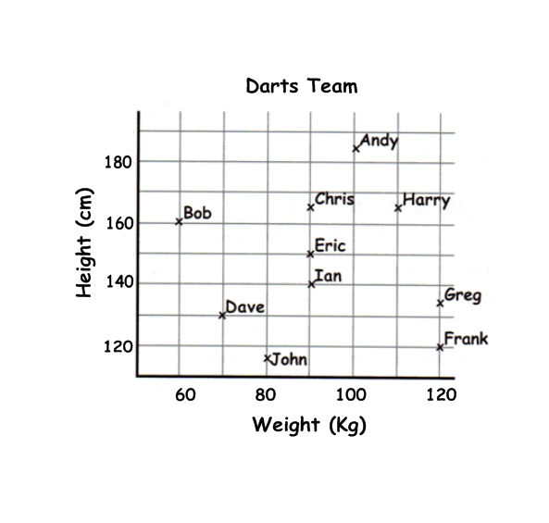**Information Handling - Pie Charts**



**Example**

In a survey 300 people were asked to indicate which one of five sports they liked the best. The results were displayed in a pie chart which can be used to work out how many people chose each sport.

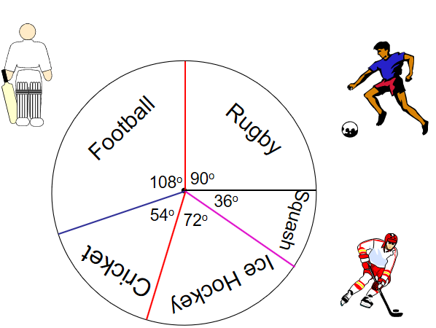

$$Rugby= \frac{90}{360} X 300=75 people$$

$$Football= \frac{108}{360} X 300=90 people$$

$$Cricket= \frac{54}{360} X 300 =45 people$$

$$Ice Hockey= \frac{72}{360} X 300=60 people$$

$$Squash= \frac{36}{360} X 300=30 people$$

A pie chart can be used to display information. Each sector (slice) of the chart represents a different category. The size of each category can be worked out as a fraction of the total by measuring angles.

**Information Handling - Averages & Spread of Data**



**Mean**

The mean is found by adding all the data together and dividing by the number of values.

**Median**

The median is the middle value when all the data is written in numerical order (if there are two middle values, the median is half-way between these values).

**Mode**

The mode is the value that occurs most often.

**Range**

The range of a set of data is a measure of **spread**.

Range = Highest value – Lowest value

**Example**  Class 1A4 scored the following marks for their homework assignment. Find the mean, median, mode and range of the results.

7, 9, 7, 5, 6, 7, 10, 9, 8, 4, 8, 5, 7, 10

Mean = 

=  Mean = 7.3to 1 decimal place

Ordered values: 4, 5, 5, 6, 7, 7, 7, 7, 8, 8, 9, 9, 10, 10

Median = 7

7 is the most frequent mark, so Mode = 7

Range = 10 – 4 = 6

Range = 10 – 4 = 6

To provide information about a set of data, the average value may be given.

There are 3 ways of finding the average value – the mean, the median and the mode.

**Graphs in Science**

In Science, we use special graph paper to create bar charts and line graphs. It is important that we use an appropriate scale to represent that data we have collated.

Here is some data on washing detergent and we want to know which makes the best bubbles?

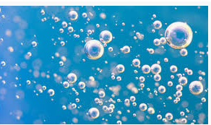 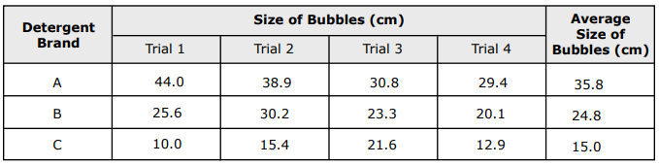

**Step 1**: Label your x-axis (detergent) and y-axis (size of bubbles)

**Step 2**: Find the highest variable = 35.8cm.

**Step 3**: Determine the scale of the graph

Highest value = 40cm = 0.44 per box – round this to 0.5 per box

No. of boxes 90 boxes

Number of bars on x-axis will be 3: evenly spaced and the same width

**Step 4**: Determine & draw

the height of the bars

**Step 5**: Label your bar chart

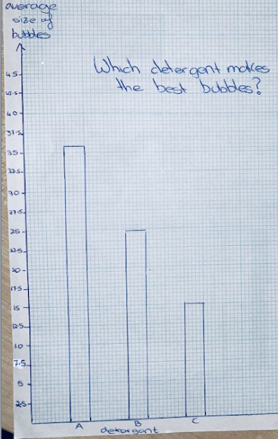

**Variables in Science**

In Science, ‘**variable’** is a word used for a quantity or condition that can change.

**Independent Variable**

An independent variable is a variable that you can control. It is the variable that you can change during the experiment.

For example, in an experiment investigating the effect of light intensity on the rate of photosynthesis, you can control the light intensity. You might increase light intensity by moving the lightbulb closer to the plant or you might decrease light intensity by moving the bulb further away from the plant.

**Dependent Variable**

A dependent variable is the variable that you observe and measure. You want to observe what happens to the dependent variable as you change the independent variable.

For example, if you are investigating the effect of light intensity on the rate of photosynthesis, the number of oxygen bubbles produced by the plant will be the dependent variable.

This experiment can be visualised below:

10 cm

5 cm

**Significant Figures**

The significant figures of a number are the digits that have a meaning or contribute to the value of the number.

There are three rules which tell you which digits in a number **ARE** significant:

1. All non-zero digits
2. Any zeros between significant digits
3. The final zeros at the end of a decimal point

The rules above are shown in the diagram below:

The digits that are **NOT** significant are:

1. The final zeros to the left of a decimal point
2. The first zeros to the right of a decimal point

The rules above are shown in the diagram below:

**Examples** of how many significant figures there are in a number are shown below:

1. 7600 – 2 significant figures
2. 0.07801 – 4 significant figures
3. 10.0063 – 6 significant figures
4. 10.006300 – 8 significant figures
5. 7000 – 1 significant figure
6. 7000.00 – 6 significant figures

**Scientific Notation**

2) The first zeros to the right of a decimal point

**7,600 0.07801**

1) The final zeros at the left of a decimal point

3) The final zeros at the end of a decimal point

2) Any zeros between significant digits

1) All non-zero digits

**90006.0304000**

Scientific notation is a way of writing down a very large or very small number more easily.

The method used for writing very large numbers in scientific notation is shown below:

1. Start by putting a decimal point after the first digit
2. To find out what power of 10 to use, count the number of places from the decimal point to the end of the number
3. Erase the zeros and write the number x 10 to the power

**Example**

Writing 7126000000000 in scientific notation is shown below:

For very small numbers, count back to the original decimal point and write the power of 10 as a negative.

The number above, written in scientific notation, would be:

**7.126 x 10-8**

**0.00000007126**

3) Erase the zeros and write the number x 10 to the power

**7.126 x 1012**

1) Place a decimal point after the first digit

**7.1260000000000**

2) Count the number of places from the decimal point to the end of the number. This will tell you what power of 10 to use. In this case there are 12 numbers after the decimal point

**Numeracy in Computing Science**

The following are examples of formulae in Admin & IT

Spreadsheets use a range of formulae to carry out

Arithmetic calculations.

Some symbols used here are:

* = Multiply / = Divide + = Add - = Subtract

Other calculations used can be:

SUM = add values in a range of cells in the spreadsheet

AVERAGE ROUNDUP ROUNDDOWN

* Example formula using multiplication.

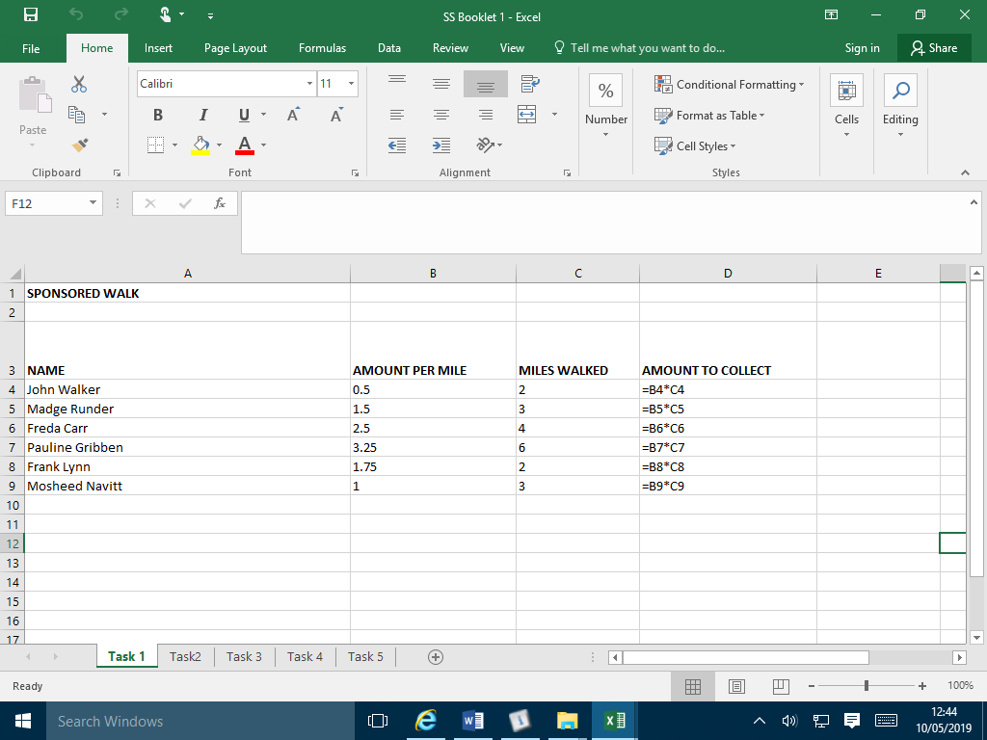

* Further example of different type of multiplication where pupils often have difficulty:

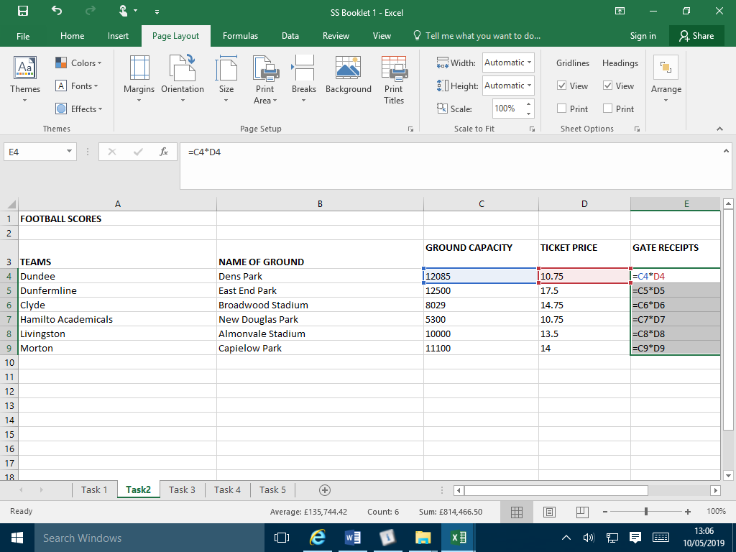

The spreadsheet can display the results – as you can see here.

John Walker made £1

Madge Runder made £4.50

The spreadsheet can display the formula – here you can see column C is multiplied by column D.

**Numeracy in Computing Science**

* PUPILS ASKED TO FIND THE NEW STAFF PRICE FROM DISCOUNT:

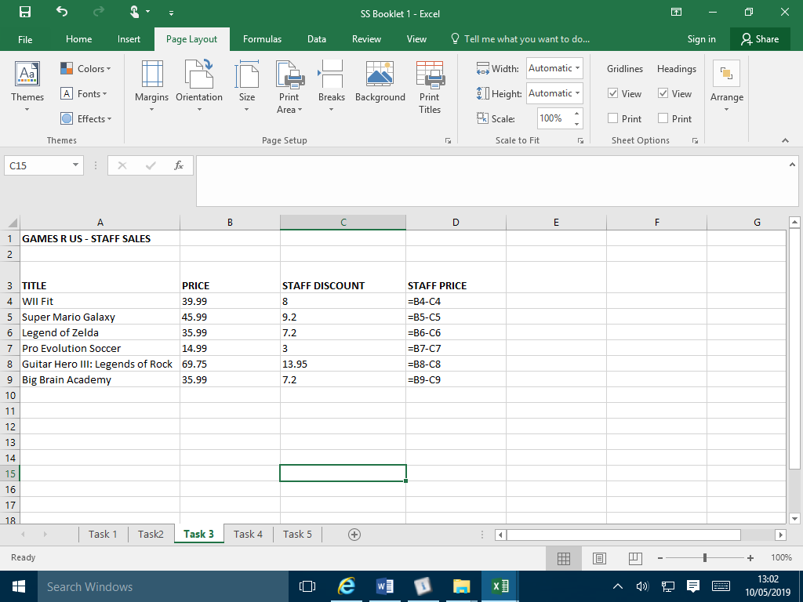

* PUPILS ASKED TO FIND THE SUM, MAXIMUM, MINIMUM AND AVERAGE

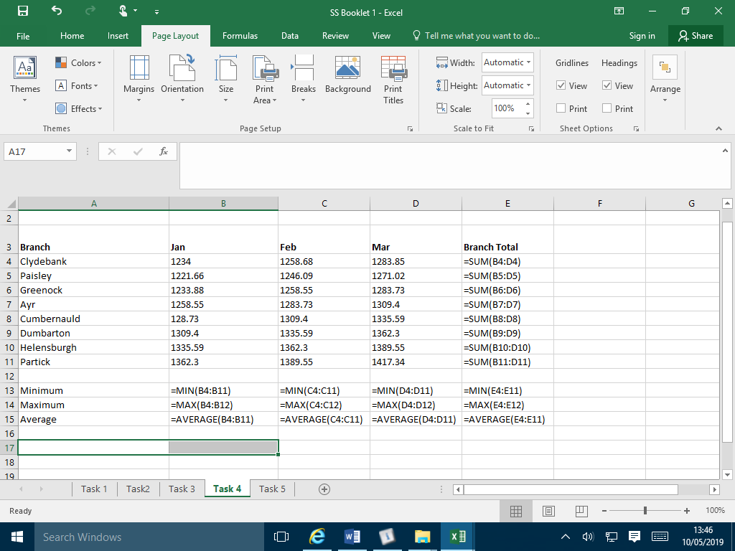

In computing the average is always the mean (sum of the values divided by the number of values)

As you can see, Column C is subtracted from Column B to get the answer in column D

Sum can be used as a quick way of adding rows and columns.

**Numeracy Dictionary (Key words)**

|  |  |
| --- | --- |
| Add; Addition (+) | To combine 2 or more numbers to get one number (called the sum or the total) Example: 12+76 = 88 |
| a.m. | Meaning ante meridiem. Any time in the morning (between midnight and 12 noon). |
| Approximate | Nearly correct but not exact, often obtained by rounding to nearest 10, 100 or decimal place. |
| Average | A number used to describe data such as the mean, the mode or the median. See definitions below |
| Calculate | Find the answer to a problem.  It doesn’t mean that you must use a calculator. |
| Circumference | The perimeter of a circle. |
| Coefficient | A number or letter multiplying an algebraic term. |
| Data | A collection of information  (may include facts, numbers or measurements). |
| Denominator | The bottom part in a fraction  (the number of parts into which the whole is split). |
| Difference (-) | The amount between two numbers (subtraction).  Example: The difference between 50 and 36 is 14 |
| Division (÷) | Sharing a number into equal parts.  24 ÷ 6 = 4 |
| Double | Multiply by 2. |
| Equals (=) | Makes or has the same amount as. |
| Equivalent fractions | Fractions which have the same value.  Example  and  are equivalent fractions |
| Estimate | To make an approximate or rough answer, often by rounding. |
| Evaluate | To work out the answer. |
| Even | A number that is divisible by 2 (without remainder).  Even numbers end with 0, 2, 4, 6 or 8. |
| Factor | A number which divides exactly into another number, leaving no remainder. The factors of 15 are 1, 3, 5, 15. |
| Frequency | How often something happens. In a set of data, the number of times a number or category occurs. |
| Greater than (>) | Is bigger or more than.  Example: 10 is greater than 6.  10 > 6 |
| Least | The lowest number in a group (minimum). |
| Less than (<) | Is smaller or lower than.  Example: 15 is less than 21 written as 15 < 21. |
| Maximum | The largest or highest number in a group. |
| Mean | The arithmetic average of a set of numbers (see p30) |
| Median | Another type of average - the middle number of an ordered set of data (see p30) |
| Minimum | The smallest or lowest number in a group. |
| Minus (-) | To subtract. |
| Mode | Another type of average – the most frequent number or category (see p30) |
| Most | The largest or highest number in a group (maximum). |
| Multiple | A number which can be divided by a particular number, leaving no remainder. Example Some of the multiples of 4 are 8, 16, 48, 72 |
| Multiply (x) | To combine an amount a particular number of times.  Example 6 x 4 = 24 |
| Negative Number | A number less than zero. Shown by a minus sign.  Example -5 is a negative number. |
| Numerator | The top part in a fraction. |
| Odd Number | A number which is not divisible exactly by 2.  Odd numbers end in 1 ,3 ,5 ,7 or 9. |
| Operations | The four basic operations are addition, subtraction, multiplication and division. |
| Order of operations | The order in which operations should be done. BODMAS (see p13) |
| Place value | The value of a digit dependent on its place in the number.  Example: In the number 1573.4, the 5 has a place value of 500. |
| p.m. | Meaning post meridiem. Any time in the afternoon or evening (between 12 noon and midnight). |
| Prime Number | A number that has exactly 2 factors (can only be divided by itself and 1). Note that 1 is not a prime number as it only has 1 factor. |
| Product | The answer when two numbers are multiplied together.  Example: The product of 5 and 4 is 20. |
| Remainder | The amount left over when dividing a number. |
| Share | To divide into equal groups. |
| Sum | The total of a group of numbers (found by adding). |
| Total | The final amount when a group of numbers are added. |
| **Technical** | |
| Diameter | A straight line passing from side to side through the centre of a circle |
| Dimension | A measurable extent of a particular kind, such as length, breadth, depth, or height |
| Millimetre (mm) | One tenth of a centimetre. Used in joinery to measure lengths. For example the length of a standard washing machine is 600mm (60cm) |
| Radius | A straight line from the centre to the circumference of a circle |
| **Science** | |
| Dependent Variable | A dependent variable is a variable whose value depends upon the independent variable. It is the variable that is measured in an experiment or mathematic equation. |
| Independent Variable | This variable is changed by the scientist |
| Percentage | An amount expressed as a number out of 100 |
| Prefix | A prefix is a letter or a series of letters attached to the beginning of a word. For example, adding the letters ‘bi’ to some words means two of that thing. For example, bilayer. |
| Proportion | Where a quantity changes in a fixed relation to another. |
| Range | A range is the complete group that is included between two points on a scale of measurement. For example, The [product](https://dictionary.cambridge.org/dictionary/english/product) is [aimed](https://dictionary.cambridge.org/dictionary/english/aim) at [young](https://dictionary.cambridge.org/dictionary/english/young) [people](https://dictionary.cambridge.org/dictionary/english/people) in the 18–25 [age](https://dictionary.cambridge.org/dictionary/english/age) range.  In Maths the range is highest value subtract lowest value. |
| Ratio | Ratiois a relationship between two or more groups or amounts.  Example: The ratio of boys to girls was 3:2 |
| Rounding | The process of replacing a number by another number of approximately the same value but having fewer digits. For example, 28.99 would be rounded up to 29. |
| Significant Figures | A Significant Figure shows accuracy. All nonzero digits of a number and the zeros that are included between them or that are final zeros of a decimal are significant.  Example: 0.203 (3Sig Figs) 45 600 (3Sig Figs if rounded) |
| Scientific Notation | A way of writing down very large or very small numbers easily.  Example: 103 = 1000 |
| Unit | Units are standards for measurement of physical quantities that need clear definitions to be useful. For example, the metre is a unit of length that represents a definite predetermined length. |
| Variable | A factor, trait or condition that can exist in differing amounts. |
| **Computing Science** | |
| Abstraction | Seeing a problem and its solution at many levels of detail and generalising the information that is necessary.  Abstraction allows us to represent an idea or a process in general terms (e.g. variables) so that we can use them to solve other problems that are similar in nature. |
| Algorithm | The ability to develop a step by step strategy for solving a problem.  Algorithm design is often based on the decomposition of a problem and the identification of a patter that helps to solve the problem. |
| Decomposition | Breaking down a task so that we can clearly explain a process to another person or to a computer. Decomposing a problem frequently leads to patter recognition and generalisation/abstraction and thus the ability to design an algorithm. |
| Generalisation | Realising that a solution to one problem may be used to solve a whole range of related problems. |
| Variables | A variable is useful for a programmer to store data (such as a number) in the computer in an area where it can be found quickly. A variable is a space in the computer’s memory where we can hold data used by our program (like a container that can store different values) |