Port Glasgow High

Homework
S1

Silver/Gold

Port Glasgow High School
S1 Homework 1 (Silver/Gold)
No Calculator, Show working

- Write as a number: Thirty thousand, two
hundred and nine.

- Write in words: 561 301

- 14061 + 35991

- 87012 – 36763

- 43 x 500

- 5 + 4 x 3

- 18 – 3 x 5

- 80 ÷ (5 x 8)

- 43 x 137

- 990 ÷ 22

Port Glasgow High School
S1 Homework 2 (Silver/Gold)
No Calculator, Show working

- 12780 ÷ 60

- 23 x 300

- What number is 3 10th up from 4.8

- 15.97 + 21.08

- 8 x 3.79

- 4² x 3 ÷ (30 – 6)

- Write in Scientific Notation: 45300

- Write in Scientific Notation: 0.000784

- 40 x 6.89

- 0.4 x 6.89

Port Glasgow High School
S1 Homework 3 (Silver/Gold)
No Calculator, Show working

- 353600 ÷ 800

- 148.23 – 97.64

- Find 4% of 3400

- Find 45% of 660

- Convert 70% into a fraction in its simplest form

- 47 x 218

- 56 ÷ 0.7

- Increase £240 by 30%

- Decrease £1400 by 25%

- Write 17 out of 25 as a percentage

Port Glasgow High School
S1 Homework 4 (Silver/Gold)
No Calculator, Show working

- What number is 6 100th down from 5.42

- Find 15% of 80

- 5 – 8

- (-2) + 6

- (-9) – 9

- Write in number form 4.5 x 10³

- I bought a calculator for £8 and sold it for £6. What is the percentage loss?

- 8 x (-3)

- (-10)²

- (-42) ÷ (-7)

Port Glasgow High School
S1 Homework 5 (Silver/Gold)
No Calculator, Show working

- What is the place value of the 3 in 54.73

- 4 – (-2)

- Simplify 2x + 3y – x + 2y

- Expand 4(2x – 3)

- Expand and simplify 6(x + 2) – 2x

- 5² + 4 x 2

- (-2) x (-3) x (-4)

- Expand (x + 2) (x – 3)

- Expand (x – 4) (x – 5)

- Expand and simplify (x + 1) (x + 7) – x²

Port Glasgow High School
S1 Homework 6 (Silver/Gold)
No Calculator, Show working

- Find 7% of 2800

- X = 2, y = -3. Find the value of y² + 2x

- X = -4, y = -1. Find the value of 2x – y

- Solve 3x + 4 = 19

- Solve 7x – 2 = 47

- Increase £350 by 20%

- Solve 5x + 2 = 3x + 12

- Solve 7x – 3 = 9x – 21

- Solve 2(x + 4) = 3x + 1

- Solve 7(x – 2) = 2(x + 13)

Port Glasgow High School
S1 Homework 7 (Silver/Gold)
No Calculator, Show working
- 300 x 461

- 711.5 ÷ 5

- Convert 4233mm into metres.

- Calculate the area:
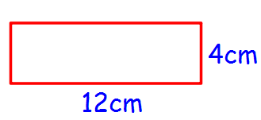
- Calculate the perimeter for Q4.

- 36 – 4 x 9

- Write 532000 in Scientific Notation

- Calculate the volume:
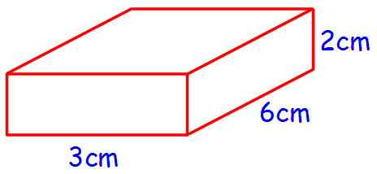
- Calculate the capacity in ml for Q8.

- Calculate the capacity in litres for Q8.
Port Glasgow High School
S1 Homework 8 (Silver/Gold)
No Calculator, Show working

- Find 23% of 5300

- (-7) x 3

- Solve 6x + 3 = 45

- Plot the points A(4,7), B(6,5), C(4,1) and D(2,5)

- Join up A to B, B to C, C to D and D to A from Q4. Name the shape.

- Increase 3500 by 40%

- (-2)³ x (5 + 2) – 6

- 3(2x – 4) = 4(x + 1)

- Plot the points A(-4,1), B(-2,1) and C (-3,5). Join the coordinates to make a triangle.

- Reflect the triangle in the x-axis and y-axis, so there is a triangle in each quadrant from Q9.

