Port Glasgow High

Homework
S1

Bronze/Silver

Port Glasgow High School
S1 Homework 1 (Bronze/Silver)
No Calculator, Show working

- Write as a number: Five hundred and forty seven

- Write in words: 4521

- 120 + 190

- 655 – 438

- 7 x 8

- Write as a number: Thirty thousand, two
hundred and nine.

- Write in words: 561 301

- 14061 + 35991

- 87012 – 36763

- 43 x 500

Port Glasgow High School
S1 Homework 2 (Bronze/Silver)
No Calculator, Show working

- 49 ÷ 7

- 8 x 6

- How many 10p pieces should I get for £2.80

- Round 3.452 to the nearest whole number

- £5.67 + £2.78

- 12780 ÷ 60

- 23 x 300

- What number is 3 10th up from 4.8

- 15.97 + 21.08

- 8 x 3.79

Port Glasgow High School
S1 Homework 3 (Bronze/Silver)
No Calculator, Show working

- 81 ÷ 9

- £4.76 – £3.89

- Find 10% of 560

- Find 20% of 340

- Find 25% of 280

- 353600 ÷ 800

- 148.23 – 97.64

- Find 4% of 3400

- Find 45% of 660

- Convert 70% into a fraction in its simplest form

Port Glasgow High School
S1 Homework 4 (Bronze/Silver)
No Calculator, Show working

- Write the place value of the “4”: 35.34

- Find 70% of 160

- What temperature is 5 degrees down from 4ºC

- What temperature is 8 degrees up from -6ºC

- What temperature is 2 down from -3ºC

- What number is 6 100th down from 5.42

- Find 15% of 80

- 5 – 8

- (-2) + 6

- (-9) – 9

Port Glasgow High School
S1 Homework 5 (Bronze/Silver)
No Calculator, Show working

- Round 45.611 to the nearest whole number

- What temperature is 5 degrees up from -7ºC

- Simplify 4x + 3x

- 12x – 3x

- 50x ÷ 10

- What is the place value of the 3 in 54.73

- 4 – (-2)

- Simplify 2x + 3y – x + 2y

- Expand 4(2x – 3)

- Expand and simplify 6(x + 2) – 2x

Port Glasgow High School
S1 Homework 6 (Bronze/Silver)
No Calculator, Show working

- 40% of 160

- X=2, y= 3 calculate 2x + 4y

- X=2, y= 3 calculate 3y – x

- X=2, y= 3 calculate xy

- X=2, y= 3 calculate y²

- Find 7% of 2800

- X = 2, y = -3. Find the value of y² + 2x

- X = -4, y = -1. Find the value of 2x – y

- Solve 3x + 4 = 19

- Solve 7x – 2 = 47

Port Glasgow High School
S1 Homework 7 (Bronze/Silver)
No Calculator, Show working

- 156 + 235

- £3.33 – £2.29

- Convert 50mm into centimetres.

- Convert 14m into centimetres.

- Convert 12km into metres.

- 300 x 461

- 711.5 ÷ 5

- Convert 4233mm into metres.

- Calculate the area:
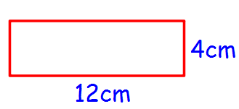
- Calculate the perimeter for Q9.

Port Glasgow High School
S1 Homework 8 (Bronze/Silver)
No Calculator, Show working
- Find 30% of 240

- What temperature is 5 degrees below -2⁰C

- X = 4, Y = 3 calculate 3xy
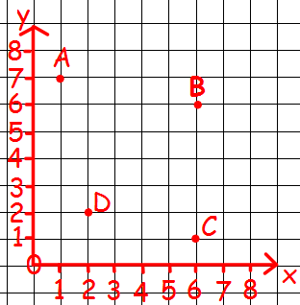
- Write down the coordinates of A,B,C & D

- Which two points have the same x-value.

- Find 23% of 5300

- (-7) x 3

- Solve 6x + 3 = 45

- Plot the points A(4,7), B(6,5), C(4,1) and D(2,5)

- Join up A to B, B to C, C to D and D to A from Q9. Name the shape.

