Port Glasgow High School



Homework

S2

Port Glasgow High School

S2 Homework 1

**Show working**

1. Round the following to 2 decimal places :- 0.4565
2. Convert to a decimal:

a) 4% b) 3×6%



1. A large truck carries 21 containers.

In each container there are 96 boxes.

In each box there are 48 packets of sweets.

Each packet has 9 sweets.

Estimate, to the nearest ten, how many sweets there are in the truck.

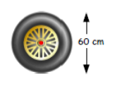

1. This tyre has a diameter of 60cm Calculate
2. Its circumference b) Its area
3. a) Draw a coordinate grid and plot the following points:

A(2 , -6) B(4 , -2) C(2, 2)

b) What is the *y*-coordinate of B?

c) ABCD is a rhombus.

Plot D on your grid and write down its coordinates.

1. Remove the brackets:- 5(x + 3)

Port Glasgow High School

S2 Homework 2

**Show working**

1. Find:-
2. 92 b. 33 c. 24



1. Find the lowest common multiple of 3, 5 and 6.
2. Find the highest common factor of 12 and 48.
3. Find the following and give your answer correct to 2 decimal places:- $\sqrt{1876}$
4. a) Plot the following six points on a co-ordinate grid

J(2,3), K(-1,5), L(-4,3), M(-4,-1), N(2,-1) and O(-1, -3)

1. Name the shape formed when the six points are joined in order.
2. Solve the following equations:-
3. 2x + 4 = 16 b) 9y – 3 = 4y + 5

Port Glasgow High School

S2 Homework 3

**Non-Calculator, Show working**

1. Simplify the following fractions:

a) 4/14 b) 10/15 c) 24/32

1. A rectangle has length $4\frac{2}{3}$ cm and breadth $2\frac{1}{4}$ cm. Calculate the area of the rectangle.

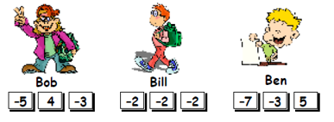

1. In a special card game, each

set of three cards is added

together and the smallest total wins.

1. Who wins the game shown?
2. By how much did the winner beat the third place?
3. Factorise:- 5y + 45
4. a) Explain why the number 13 is a prime number
5. Explain why the number 9 is not a prime number
6. Explain why the number 1 is not a prime number

Port Glasgow High School

S2 Homework 4

**Show working**

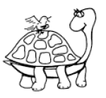

1. a) A tortoise walks at 2 metres per minute.

How long will it take to walk 9 metres?

1. Addison can sprint at 4 metres per second.

How far will he travel in 10 and a half seconds?

c) A bus journey, 60km long, takes one and a half hours.

How fast is the bus travelling?

1. Find the value of each expression below when a = 2, b = 3 and c = 4

a) a + b – c b) 2a + 4b – 3c c) (c – a)2 – 2b

1. Calculate how long it is from:-



1. 3:25 pm to 8:10 pm b) 10:40 am to 11:30 pm
2. Find the highest common factor of 100 and 225
3. Solve the following equation :- 5x + 3 = 3x + 5

Port Glasgow High School

S2 Homework 5



**Show working**

1. Allan wanted to change £75 into euros. If the exchange rate was £1 = 1.13 euros. How many euros did he receive?
2. Jamie buys 3 books costing £12.99, £8 and £7.99. He hands over two £20 notes. How much change will he receive?
3. Five sandwiches and three cups of coffee cost £12.35.

If the sandwiches cost £1.75 each. How much was each cup of coffee?

1. Find:-

a) $\frac{2}{5}+\frac{1}{5}$ b) $\frac{4}{5}+\frac{2}{3}$ c) $5\frac{1}{3}-2\frac{3}{4}$

1. For each of the following questions, write the correct calculation and work out the answer.
2. Heidi is travelling from Earth to the moon which is a distance of 238 855miles.

MC900055668[1]

She has so far travelled 178 469 miles.

How far does she still have to go?

b) Andy drives 540 miles and uses 20 litres of petrol.



How many miles did he travel for each litre?

1. Round the following to 2 decimal places.
2. 24×8539 b) 17×3761579

Port Glasgow High School

S2 Homework 6

**Show working**

1. Name the angle marked below and state what type of angle they are.

a) b)

**A**

**D**

**H**

**B**

**Y**

**D**

2. Copy the diagram below and fill in the missing angles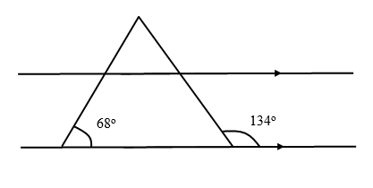

3. Calculate the length of the side marked *x* in each of these right angled triangles to 2 decimal places:

**a**) **b**)

***x***

13 cm

5 cm

***x***

10 cm

3 cm

4. Multiply these brackets

**a**. (*x* + 4)(*x* + 7) **b**. (*s* + 12)(*s* - 2)

5. Find:-

a. b.

6. Last week my bank balance was (-£60).

I cleared my overdraft and then paid my mobile phone bill of

£35.

After I put some money into my account my balance read £20.

How much had I put into my account in total since my (-£60)

balance?

Port Glasgow High School

S2 Homework 7

**Show working**

**1.** James thinks that shape A has been reduced by a scale factor of

$\frac{1}{2}$ to get shape B. Is he correct?

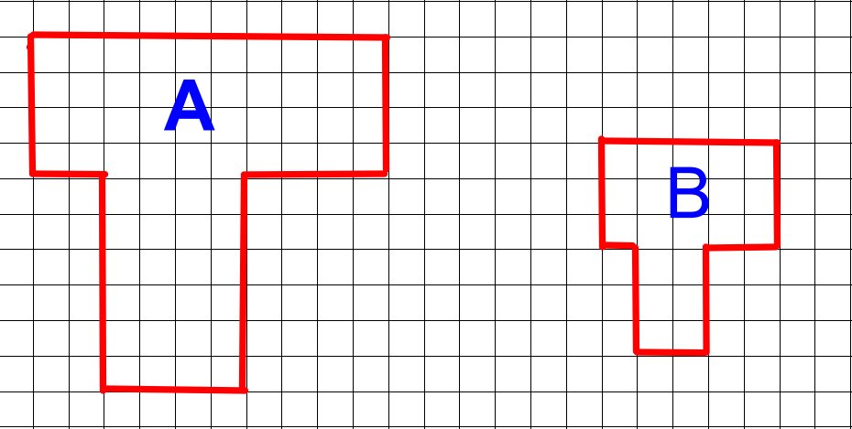

2. Jenny is standing 25 metres away from the bottom

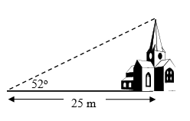

of a church tower. She looks up at the top at an angle

of elevation of 52o.

Calculate the height of the tower.

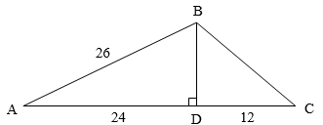

3. Consider the framework opposite.

(a) Calculate the length of BD.

(b) Hence calculate the length of BC.

(c) Calculate the area of triangle ABC.

4. A car leaves Dumfries at 1.25pm and reaches Edinburgh at

2.53pm.

(a) How long did the journey take?

(b) If the distance travelled was 84 miles,

calculate the average speed of the car correct to the nearest

mile per hour.

5. Solve these equations:

a) 2t + 1 = 11 b) 3a – 1 = 14

1. If a = (-2) and b = 6 find the value of:- a2 – 2b

Port Glasgow High School

S2 Homework 8

**Show working**

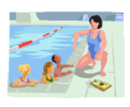

1. At the swimming pool the ratio of boys to girls is 4:5.
2. How many boys if there were 45 girls?
3. How many girls if there were 48 boys?
4. If there were a total of 81 children, how many girls were there?
5. Round the following to 1 decimal place.

a) 5×72 b) 12×49 4586

1. Calculate the size of the other angles in each of these shapes.

28o

a) b)

540

4. A car park has charges as shown.

a) How much does Paul pay for parking his car

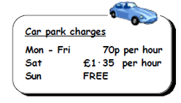

for 3 hours shopping on a Saturday?

b) How much does Emma pay for parking her car

every weekday from 9am to 5pm?

c) Alex parks on a Friday for 4 hours,

Saturday for 5 hours and a Sunday for 2 hours.

How much does Alex pay in total?

Port Glasgow High School

S2 Homework 9

**Show working**

1. List all of the square numbers between 0 and 100.
2. A rectangular table seats 6 people, two tables seat 10, three tables seat……



1. Copy and complete the table

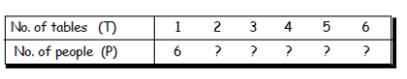

1. Write a formula for finding the amount of people who can be seated when you know the amount of tables. ( P = …. X T + ….)
2. Use the formula to find how many people can sit around 11 tables.

3. Debbie and her sister Ashley are both dress designers.

Debbie is paid monthly and earns £1280.50 per month.

Ashley is paid weekly and gets £295.25 per week.

a) Calculate Debbie’s annual pay

b) Calculate Ashley’s annual pay.

c) Who’s annual pay is greater, and by how much?

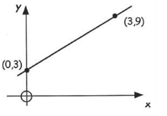

4. a) Write down the coordinates of the point

where this line cuts the y-axis.

b) Calculate the gradient of the line.

c) Now write down its equation.

Port Glasgow High School

S2 Homework 10

**Show working**

**1.** The line graph shows the sales of Toni’s ice-cream one week in July.

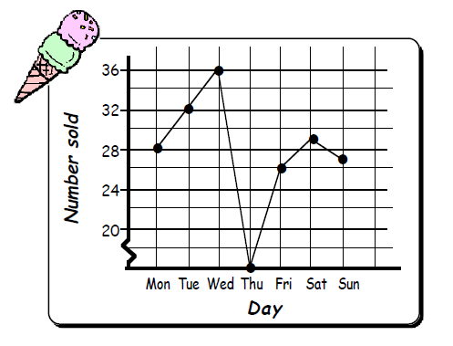

a) How may ice-creams did Tony sell

on Friday.

b) Tony was ill one day and could not drive his van to work.

What day was Tony ill?

c) What day do you think was the hottest day? Explain.

d) What were the total number of ice-creams sold that week?

e) What was the mean number of ice-creams sold over the seven days?

1. Multiply out the brackets and simplify:-
2. 2(f + 3) + 3(f + 1) b) 4(3p - 4) – 3(4p – 5)
3. Find the volume of the following, giving your answer correct to 2 decimal places:-

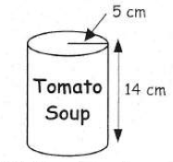

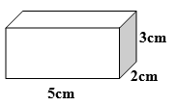

1. Solve the following:- 3x + 5 < 23

Port Glasgow High School

S2 Homework 11

**Show working**

1. Find the mean, median, mode and range of the following:-

10, 14, 15, 15, 16, 19, 22, 23, 27, 27, 30

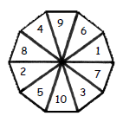

1. A spinner numbered 1 to 10 is spun. Find:-
2. P(even) b) P(less than 7)
3. Calculate the area of the following shapes:-

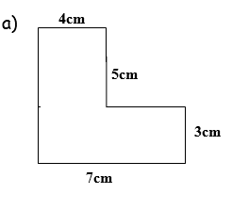

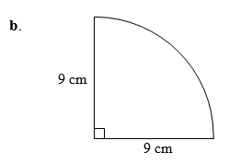

1. Jamie is going to bake cakes for a party.

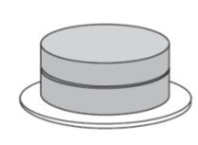

He needs $\frac{2}{5}$ of a block of butter for 1 cake.

He has 7 blocks of butter.

How many cakes can Jamie Bake?

1. This year Ben paid £260 for his car insurance.

This is an increase of 30% on last year’s payment.

How much did Ben pay last year?

1. There are 720 pupils in Dunrod High School;

The ratio of boys to girls in the school is 5:4.

How many girls are in the school?

1. Evaluate:- a) 2.4 + 5.46 ÷ 60 b) 40% of £11.50 - £1.81