Port Glasgow High

Homework
S2

Bronze/Silver

Port Glasgow High School
S2 Homework 1 (Bronze/Silver)
No Calculator, Show working

- Write down the first 4 multiples of 8

- What is the lowest common multiple of 3 & 4?

- 180 + 130

- 925 – 431

- 11 x 8

- Write down the factors of 12

- What is the highest common factor of 6 and 10?

- (-6) x 3

- Find 20% of 580

- (a) 2⁴ (b) 6² - 3³

Port Glasgow High School
S2 Homework 2 (Bronze/Silver)
No Calculator, Show working

- 56 ÷ 7

- 8²

- How many 10p pieces should I get for £6.80

- What is the lowest common multiple of 6 & 8?

- List all of the prime numbers between 10 & 20

- 3180 ÷ 60

- $\frac{1}{4} + \frac{1}{4}$

- What is the highest common factor of 20 & 24?

- $\frac{1}{3}$ of £39.30

- Solve 2x + 1 = 25

Port Glasgow High School
S2 Homework 3 (Bronze/Silver)
No Calculator, Show working

- 72 ÷ 9

- $\frac{2}{5}$ of 125g

- Find 10% of 240

The picture shows a mixture of snacks made up of burgers and hotdogs. Use this to answer the following questions:
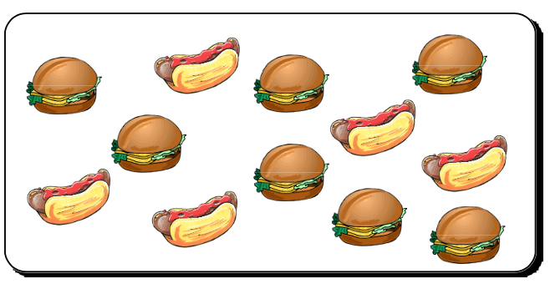
- What fraction of the snacks are burgers?

- Can you simplify this fraction?

- What fraction of the snacks are hot dogs?

- 7² - 2³

- Find 5% of 6600

- 12 x 11

- Convert 80% into a fraction in its simplest form

Port Glasgow High School
S2 Homework 4 (Bronze/Silver)
No Calculator, Show working

- What is the lowest common multiple of 6 & 12?

- Find 70% of 240

- What temperature is 8 degrees down from 2ºC

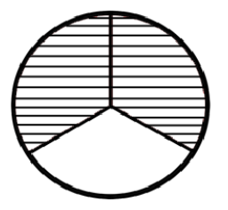
- $\frac{4}{9}$ of £81

- What fraction is shaded?

- Simplify the fraction $\frac{15}{20}$

- $\frac{2}{3} + \frac{1}{6}$

- (-5) – 8

- Write $\frac{4}{10}$ as a percentage and decimal

- Write down two fractions equivalent to $\frac{2}{5}$

Port Glasgow High School
S2 Homework 5 (Bronze/Silver)
No Calculator, Show working

- Write $\frac{1}{5}$ as a percentage and decimal

- Calculate $\frac{3}{8}$ of £328

- Simplify 6x + 5x

- 8 x 7
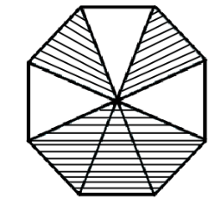
- 23 x 40

- What is the fraction that is shaded?

- $\frac{3}{4} - \frac{5}{8}$

- Write 5.45pm in 24 hour clock time

- 11²

- What is the time difference between 0730 to
1115?

Port Glasgow High School
S2 Homework 6 (Bronze/Silver)
No Calculator, Show working

- 40% of 180

- 12² - 10²

- Write 1320 in 12 hour clock format

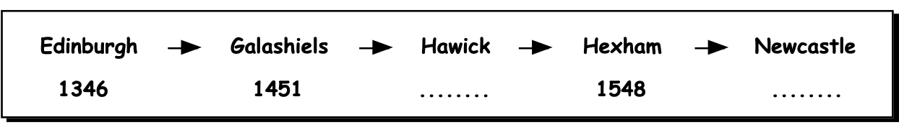
Here is a bus timetable from Edinburgh to Newcastle:

- What time did the bus leave Edinburgh?
Answer in 12 hour clock format

- How many minutes before 3pm did the bus
reach Galashiels?

- The bus passed through Hawick 20 minutes
after Galashiels, what time was this?

- Newcastle is half an hour away from Hexham,
what time does it arrive in Newcastle?

- How long is the journey from Edinburgh to
Newcastle?

- 2 x 3 + 4

- 345 - 199

Port Glasgow High School
S2 Homework 7 (Bronze/Silver)
No Calculator, Show working

- 296 + 738

- £10 – £3.49

- Write 1732 in 12 hour clock format

- What is the time difference between 1020 to
1410?

- Jack bought a guitar for £160 and sold it one year
later for £85. What was the loss he made?

- 300 x 491

- $\frac{3}{5} - \frac{2}{10}$

- Mary buys sweets costing £8.46. What change will
she receive from £20 note?

- How many degrees are between North and West?
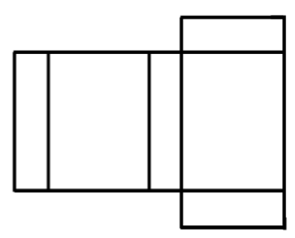
- What 3D shape would this net make?

Port Glasgow High School
S2 Homework 8 (Bronze/Silver)
No Calculator, Show working
- Find 30% of £450

- What temperature is 5 degrees below -2⁰C

- What change would I get from £10 if I spent £1.55?

- I face North West. I turn 90° clockwise. What
direction am I now facing?

- Simplify 3y + 12y

- 233 + 129

- (-7) x 3

- Find $\frac{2}{7}$ of £63

- Make a scale drawing of the wall using 1cm = 3m
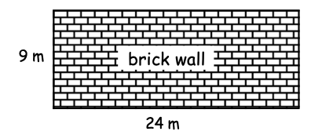

- On a map two aeroplanes are 4.5cm apart.
The scale on the map is 1cm = 20km.
Find the real distance between the areophane’s.

