|  |  |  |  |  |  |  |  |  |  |  |  |
| --- | --- | --- | --- | --- | --- | --- | --- | --- | --- | --- | --- |
| National 5  Mathematics | | Pupil Name: | | | | | | | | | |
| Teachers Name: | | | | | | | | | |
| Homework Booklet 2  Expressions and Formulae & Relationships | | | | | | | | | | | | |
| Progress Table (if correct then ***√*** if more work is required then **x**) | | | | | | | | | | | | |
|  | Homework 11 | | Homework 12 | Homework 13 | Homework 14 | Homework 15 | Homework 16 | Homework 17 | Homework 18 | Homework 19 | Homework 20 | |
| Fractions | 1 | | 1 | 1 | 1 | 1 | 1 | 1 | 1 | 1 | 1 | |
| Expand brackets and simplify | 2 | |  | 2 |  |  | 2 |  |  |  | 2 | |
| Changing the Subject |  | |  |  | 2 | 2 |  |  |  | 14 |  | |
| Reverse Percentages | 3 | | 3 | 3 | 3 | 3 | 3 | 3 | 3 | 3 | 3 | |
| Percentage Depreciation | 8 | | 8 | 8 |  |  |  |  |  |  | 13 | |
| Percentage Appreciation |  | | 8 |  | 8 |  | 9 |  | 7 |  |  | |
| Volume |  | | 10 | 10 |  |  |  |  | 10 |  |  | |
| Significant Figures |  | | 10 | 10 |  |  | 9 |  |  |  |  | |
| Scientific Notation |  | | 11 | 11 | 10 | 9 |  | 10 |  |  | 12 | |
| Arc Length/Area of Sectors | 10 | |  |  | 11 | 10 | 12 | 11 |  | 11 |  | |
| Angles |  | |  |  |  |  |  |  |  | 13 |  | |
| Factorising/Completing the Sq. | 4 | | 2 5 | 4 6 | 4 | 4 | 4 11 | 4 | 4 5 | 4 6 | 4 6 | |
| Surds | 6 | | 6 | 5 | 5 | 5 6 |  | 7 8 | 6 | 7 | 5 | |
| Indices | 7 | |  |  | 6 |  | 8 |  |  | 8 | 8 | |
| Solving an Equation/Inequation | 5 | |  |  |  |  | 3 |  |  | 2 |  | |
| Simultaneous Equations |  | |  |  |  |  | 7 | 2 | 2 | 10 | 7 | |
| Pythagoras |  | | 4 |  |  |  |  | 6 |  | 12 | 14 | |
| Trigonometry | 10 | |  |  |  | 10 | 12 |  |  |  |  | |
| Straight Line | 9 | | 9 | 9 | 9 | 8 | 10 | 9 |  | 9 | 11 | |
| Algebraic Fractions |  | | 7 | 7 |  |  | 5 | 5 | 9 |  | 10 | |
| Similarity |  | |  |  | 7 | 7 |  |  | 8 |  |  | |
| Functions |  | |  |  |  |  |  | 12 |  | 8 | 9 | |
| Score | **/34** | | **/30** | **/30** | **/30** | **/32** | **/36** | **/30** | **/28** | **/42** | **/40** | |
| Percentage | **%** | | **%** | **%** | **%** | **%** | **%** | **%** | **%** | **%** | **%** | |
| LATE |  | |  |  |  |  |  |  |  |  |  | |
| Teacher Comment |  | |  |  |  |  |  |  |  |  |  | |

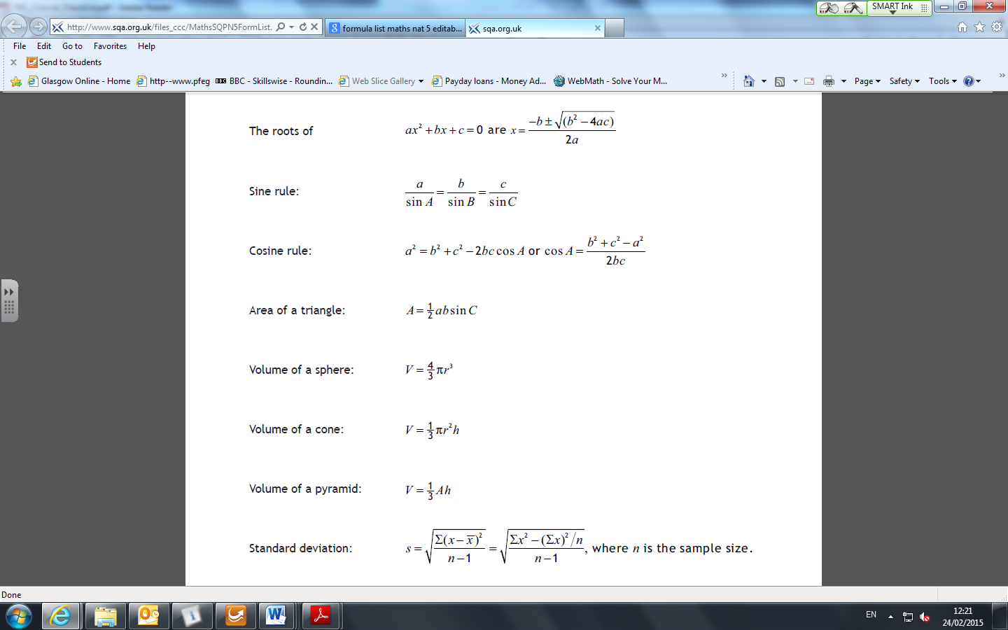**Formula Sheet**

**Homework 11**

34

**Return by :**

$$\frac{\frac{1}{4}-\frac{1}{6}}{\frac{2}{9}}$$

**Non Calculator**

3

3

1. Evaluate 2. Expand and collect like terms (4x – 2)(2x + 3) + (x – 1)2

1. A sport action camera is on sale at 12.5 % less than its recommended retail price. If it is on sale for £84.35,

what is its recommended retail price?

3

4. Factorise fully

2

1

2

1. 10h + 12h2 (b) 8 - 8u2 (c) d2 - 3d - 10

5. Solve 3x + 2(x - 1) + 5 = 4x 6. Rationalise the denominator:

2

2

7. Simplify, leaving your answers with positive indices

1. $\frac{\text{4a x 3}{\text{a}}^{\text{-5}}}{\text{6}{\text{a}}^{\text{-2}}}$ (b) $\frac{(\text{3x})^{2}}{\text{12}{\text{x}}^{5}}$

2

2

**Calculator**

1. A farmer buys a new tractor for £42 000. The tractor depreciates at a rate of 10% in each of its first 2 years

and then at a rate of 8% in each successive year.

3

How long will it take for the tractor to be worth less than £28 000?

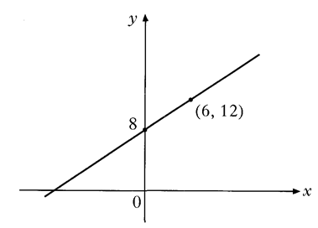9. Find the equation of the straight line below.

3

10. The diagram below shows an ornamental garden. The garden is in the

3

 shape of a rectangle with a sector of a circle added at one end.

The length of the garden is 35 metres and its breadth is 20 metres.

1. Calculate OB the radius of the sector.

3

1. Find the perimeter of the garden.

**Homework 12**

30

**Return by :**

**Non Calculator**

2

2



1. Evaluate 2. Factorise fully 2x2 + 9x - 5

3

3. From age 7 to age 17, Billy’s height increased by 50%.

If Billy was 195 cm aged 17, how tall was Billy aged 7?

4. Calculate the height of the triangle. Express your answer as a surd in its simplest form.

3

5. Express x2 – 6x – 81 in the form (x-p)2 + q 6. Rationalise the denominator

2

2

3

7. Express the following as a fraction in its simplest form

$$\frac{x}{x^{2}-9} ÷ \frac{2}{x-3}, x≠3, -3$$

**Calculator**

1. In 1999, the city of Venice was visited by 16 million tourists. From 2000 to 2002 (3 years), the number of tourists

fell at a rate of 3.5% per annum, and then from 2003 to 2005 (3 years), the number of tourists rose at a rate of 6.8%

per annum. Calculate the number of tourists who visited Venice in 2005.

3

1. The cost of a journey with Fred’s Taxis depends on the distance travelled. The graph below shows the cost, P pounds of the journey with Fred’s Taxis against the distance travelled, d miles.

3

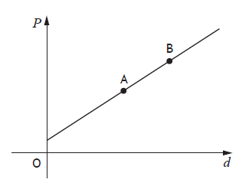

Point A represents a journey of 6 miles which costs £10.

Point B represents a journey of 12 miles which costs £20.

Find the equation of the line in terms of P and d.

10. A buoy is in the shape of a hemisphere with

5

70 cm

105 cm

a cone on top, as shown opposite.

Calculate the volume of this buoy.

**Give your answer correct to three significant figures**

C:\Users\fm4617c\AppData\Local\Microsoft\Windows\Temporary Internet Files\Content.IE5\7Q6DXZNK\5602735294_7cb9565a14_z[1].jpg

C:\Users\fm4617c\AppData\Local\Microsoft\Windows\Temporary Internet Files\Content.IE5\7Q6DXZNK\5602735294_7cb9565a14_z[1].jpg

1. A test tube contains 3 x 104 cubic millimetres of water. If each cubic millimetre of water contains 1.75 x 103

2

bacteria, how many bacteria are in the test tube?

**Give your answer in Scientific Notation.**

**Homework 13**

30

**Return by :**

**Non Calculator**

3

2



1. Evaluate 2. Expand and collect like terms

(x2 – 5x – 2)(2x – 3)

3

3. The cost of Data Storage Disks has fallen 70% over the last eight years.

If a Data Storage Disk costs £27 today, how much did it cost eight years ago?

4. Factorise fully

1. 5p2 - 35p b. 3c2 - 27d2

1

2

5. Calculate the area of the triangle. Express your answer a surd in its simplest form.

3

6. Express x2 + 12x – 15 in the form (x-p)2 + q 7. Express $\frac{4}{b^{2} } - \frac{3}{b}, b ≠0$

2

2

As a fraction in its simplest form.

**Calculator**

4

8. David builds a snowman. It is 1.8 metres high. When the Sun comes out the snowman begins to melt and

after an hour the snowman is 1.53 metres high.

so01380_so01380_

1.8 m 1.53m

1.53 m

If the snowman continues to melt at the same percentage rate find its height after another 3 hours.

9. Calculate the gradient of the line passing through the pair of points shown

1



10. The diagram shows a cylinder with a cone cut from it.

5

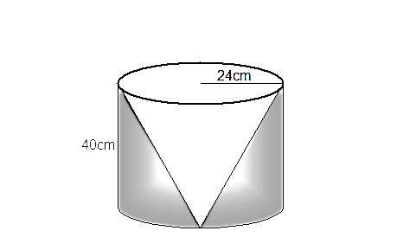

The cone and the cylinder both have radius 24 centimetres and height 40 centimetres.

Calculate the volume of the solid once the cone has been removed.

**Give your answer correct to three significant figures**

1. A biologist is carrying out a study into coral on the Great Barrier Reef of Australia. He estimates 1 cubic metre of

2

coral contains 5.66 x 105 individual’s animals. How many individual animals would there be in 10 000 cubic metres of coral?

**Give your answer in Scientific Notation.**

**Homework 14**

30

**Return by :**

**Non Calculator**

2

3

1. Evaluate 2. Change the subject of the formula to x.

3

3. Mandy’s car fell in value by 30% between 2014 and 2015. If it is valued at £9 800 in 2015,

what was its value in 2014?

4. (a) Factorise x2 – 6x (b) Hence simplify

3

1

5. Simplify 6. Simplify, leaving your answers with positive indices

3

2

C:\Users\fm4617c\AppData\Local\Microsoft\Windows\Temporary Internet Files\Content.IE5\7Q6DXZNK\5602735294_7cb9565a14_z[1].jpgC:\Users\fm4617c\AppData\Local\Microsoft\Windows\Temporary Internet Files\Content.IE5\7Q6DXZNK\5602735294_7cb9565a14_z[1].jpg

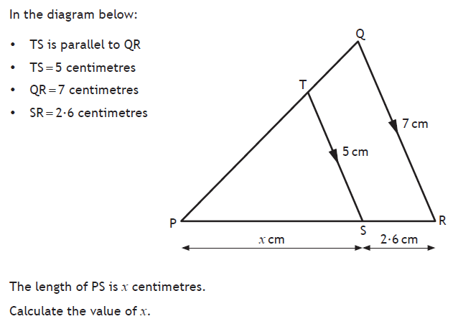

7.

3

**Calculator**

8. In 2004 the cost of the average holiday in Spain was £420. By 2006 this had risen to £483.

4

If the cost of a holiday to Spain continues to increase at this rate find the expected cost in 2010.

1

9. Calculate the gradient of the line passing through the pair of points shown



10. A new airport terminal has been open for 200 days. In total 2.66 x 107 passengers have passed through the

2

terminal. Calculate the average number of passengers passing through the terminal each day.

**Give your answer in Scientific Notation.**

11.

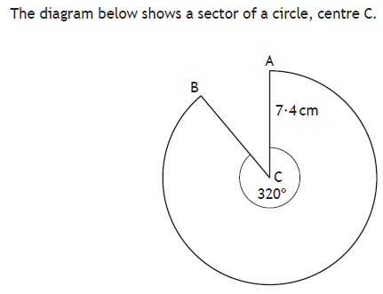

8.3cm

3

The radius of the circle is 8.3cm.

Calculate the length of the major arc AB.

**Homework 15**

32

**Return by :**

**Non Calculator**

3

3

1. Evaluate 2. Change the subject of the formula to b

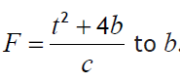

3

3. Between December 2011 and May 2012, the average used car price of a Jaguar S-type fell by 35%.

If a Jaguar S-type was priced at £11 700 in May 2012, what would its expected price have been in

December 2011?

1. (a) Factorise x2 – 16 (b) Hence simplify

3

1

C:\Users\fm4617c\AppData\Local\Microsoft\Windows\Temporary Internet Files\Content.IE5\7Q6DXZNK\5602735294_7cb9565a14_z[1].jpg

5. A square is shown below. Calculate the length of side x, giving your answer as a surd in its simplest form.

3

x



6. Simplify

2

$\sqrt{6}\left(3\sqrt{\text{10}}\text{ - 2}\sqrt{6}\right)$

**Calculator**

3

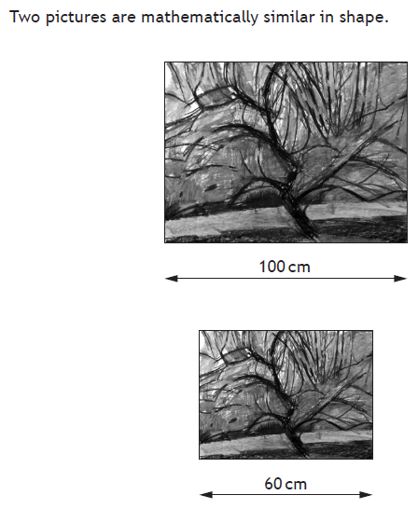7.

The cost of each picture is proportional to its area.

The large picture costs £45.99.

Find the cost of the small picture.

8. Find the equation of the line passing through the pair of points shown

3

9. In one orbit of the Sun the planet Mercury travels approximately

2

3.48 x 108 kilometres. This orbit takes 88 days.

Calculate the speed of Mercury, in kilometres per **hour,**

as it travels round the Sun.

**Give your answer in** **Scientific Notation.**

10. The diagram opposite shows a rose garden.

6

The garden is in the shape of a circle, centre O, with a straight edge.

O

A wall is to be built round the outside of the garden.

Find the length of the wall

**Homework 16**

36

**Return by :**

**Non Calculator**

2

3

1. Evaluate 2. Expand and collect like terms

(4x – 1)(3x2 – x)

2

1. The number of Ebola cases detected per week in Liberia fell by 95% between September 2014 and

January 2015.

If the number of cases detected in January were 10 per week, how many cases per week were detected

in the previous September?

4. (a) Factorise 2m2 – 4m (b) Hence simplify

1

3

5. Express as a single fraction in its simplest form

2

6. Solve, algebraically, the inequation

3



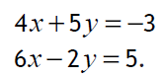7. Solve algebraically the system of equations 8. Simplify, leaving your answers with positive indices

2

3

C:\Users\fm4617c\AppData\Local\Microsoft\Windows\Temporary Internet Files\Content.IE5\7Q6DXZNK\5602735294_7cb9565a14_z[1].jpg

C:\Users\fm4617c\AppData\Local\Microsoft\Windows\Temporary Internet Files\Content.IE5\7Q6DXZNK\5602735294_7cb9565a14_z[1].jpgC:\Users\fm4617c\AppData\Local\Microsoft\Windows\Temporary Internet Files\Content.IE5\7Q6DXZNK\5602735294_7cb9565a14_z[1].jpg

**Calculator**

9. A geologist measures stalactites in a cave. The longest measured is 235 centimetres long.

4

If the stalactite grows at a rate of 4.5% every 10 years, how long will it be in 50 years time?

**Give your answer correct to 2 significant figures**

3

10. Find the equation of the line passing through the pair of points shown

11. Express x2 - 8x – 15 in the form (x + a)2 + b

2

1. A worktop is in the shape of a rectangle with identical sectors of a circle, centre O, at each end.

6

The width of the table top is 155 centimetres and its length is 2 metres.

**0**

Calculate the perimeter of the worktop

**Homework 17**

30

**Non Calculator**

3

3

1. Evaluate 2. Solve the system of equations algebraically

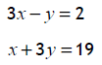

3. A plant increases in height by 60% over three years and is now 128 cm high.

2

What was its height three years ago?

4. Factorise fully

2

2

(a) 5x2 - 80y2 (b) 5m2 - 6m + 1

5. Express as a single fraction in its simplest form

2

6. Is the triangle below right angled?

3

7. Simplify 8. Express with a rational denominator in its simplest form

1

2

$\sqrt{\text{28}}-\sqrt{\text{1000}} +\text{ 3}\sqrt{\text{63}}$ $\frac{2}{\sqrt{5}}$

**Calculator**

9. Find the equation of the line passing through the pair of points shown

3

10. A comet travels a distance of 5.33 x 108 kilometres in one year.

2

Calculate the speed of the comet in kilometres per hour.

**Give your answer in Scientific Notation.**



11.The path traced by a golfer’s club when he hits the ball is an arc of a circle.

2

If the golf club is 95 centimetres long, calculate the distance travelled when the golfer swings his club.

pe00485_

12. The function g is defined by f(g) = 3g - 2. Find the value of:

1

2

(i) f(-5) (ii) What value of g satisfies f(g) = 19

**Homework 18**

28

**Return by :**

**Non Calculator**

3

3

1. Evaluate 2. Solve, the system of equations algebraically

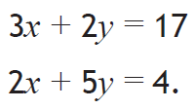

3

3. John faces a 20% increase in his rent after a recent rent review by his landlord.

If he is now expected to pay £552 per calendar month, what was his rent before the increase?

4. Factorise fully

1

(a) x2 – y2 (b) 3x2 - 2x - 21

2

5. Express x2 + 6x + 1 in the form (x + a)2 + b

2

6. Evaluate

2

**Calculator**

3

7. It is estimated a swarm of locusts contains 750 000 individuals.

If the swarm increases in size at a rate of 20% every week, calculate the number of individuals in the

swarm in 6 weeks time.

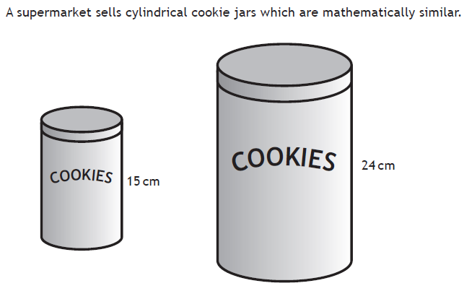8.

3

The volume of the larger jar is 3072cm3. Find the volume of the smaller jar.

9. Express as a single fraction in its simplest form

2



4

10. The cube and the cuboid below have the same volume.

Calculate the height of the cuboid

**Homework 19**

42

**Return by :**

**Non Calculator**

$$\frac{\frac{3}{4}}{(1\frac{1}{2})^{2}}$$

3

3

1. Evaluate 2. Solve 5 – (1 – 2f) ≤ 4(2f + 1)

3. Imran successfully bids for a car at auction. An ‘auction tax’ of 12% is added to his bid price.

2

He pays £2800 in total. Calculate his bid price.

1. Express x2 + 10x - 1 in the form a(x + b)2 + c

2

1. Simplify

2

6. Factorise n2 – 25 (b) Hence simplify

3

1

7. Evaluate

2

8. f(x) =

2

3

1. Express f(3) with a rational denominator. (b) Given f(x) = 4, find x.

****9. Find the equation of the line below

3

**Calculator**

1. 6 pencils and 4 rubbers cost £1.08. 4 pencils and 3 rubbers cost 75 pence.

6

**Find the cost of 5 pencils and 5 rubbers.**

11. In the diagram the area of the sector is 75.4cm2.

3

Calculate the size of the angle at the centre of the sector.

3

12. The diagram shows a cut-off circle with a horizontal base.

OA is a radius of the circle. Calculate h.

1. The line AB is a tangent to the circle shown.

C

A

B

O

D

65°

1

O is the centre of the circle.

Angle DCA is 65°

Calculate the size of angle DOC.

1. Change the subject of the formula $V= \frac{4}{3}{πr}^{3}$ to r

3

**Homework 20**

40

**Return by :**

**Non Calculator**



3

3

1. Evaluate 2. Expand and collect like terms

3. Andy and Rafael achieve first and second place respectively in a tennis tournament. Andy receives a

3

cash prize of £42 000. Andy’s cash prize is 40% **more** than Rafael’s. How much does Rafael receive?

2

1

4. Factorise fully 5. Express with a rational denominator in its simplest form

49 – x2

1. Express x2 + 14x - 3 in the form (x + b)2 + c

2

2

7. Solve

8. (a) Evaluate 8-2 (b) Simplify, leaving your answers with positive indices

2

2

9. A function is defined by

2

1

* 1. Find the value of $f(3)$ (b) Given $f(a) = 21$, find the value of a.

10. Express as a single fraction in its simplest form

2

3

11. Find the equation of the line below

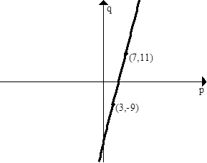

**Calculator**

12. There are 6.02 x 1023 particles in one mole of carbon. How many particles are there in 700 moles of carbon.

2

**Give your answer** in **Scientific Notation.**

13. A van rental company purchases vans costing £22 000 each.

4

The value of a van depreciates by 30% in its first year and then by 15% in each successive year.

A van is replaced at the end of the year in which its value falls below half its original price.

After how many years will the company replace a van?

1. Mr. and Mrs. Alba take their 3 children to see the film Black Knight. The tickets cost a different amount

for adults and children. Altogether they pay £25.50 for their tickets.

6

1. Using **x** to represent an adult ticket and **y** to represent a child ticket,

write down an equation involving x and y.

(b) Mr. McMahon and his son also go to see the Black Knight. They pay £10.50 for their tickets.

Write down another equation involving x and y.

(c) Mr. and Mrs. Chicklis take their 5 children to see the same film.

What will the total cost be for their tickets?