|  |  |  |  |  |  |  |  |  |  |  |  |
| --- | --- | --- | --- | --- | --- | --- | --- | --- | --- | --- | --- |
| National 5  Mathematics | | Pupil Name: | | | | | | | | | |
| Teachers Name: | | | | | | | | | |
| Homework Booklet 1  Expressions and Formulae | | | | | | | | | | | |
| Progress Table (if correct then ***√*** if more work is required then **x**) | | | | | | | | | | | |
|  | Homework 1 | | Homework 2 | Homework 3 | Homework 4 | Homework 5 | Homework 6 | Homework 7 | Homework 8 | Homework 9 | Homework 10 |
| Fractions | 1 | | 1 | 1 | 1 | 1 | 1 | 1 | 1 | 1 | 1 |
| Expand brackets and simplify | 2 | | 2 | 2 | 2 | 2 | 2 | 2 | 2 | 2 | 2 |
| Reverse Percentages | 3 | | 3 | 3 | 3 | 3 | 3 | 3 | 3 | 3 | 3 |
| Percentage Depreciation |  | |  |  |  | 7 | 7 |  |  | 9 | 9 |
| Percentage Appreciation | 4 | | 5 | 4 |  |  | 7 | 7 | 8 |  |  |
| Volume | 5 | | 4 6 | 5 | 4 | 6 | 8 | 9 | 10 | 11 |  |
| Significant Figures | 4 | | 4 6 | 4 | 4 | 6 | 7 | 7 | 10 |  | 9 |
| Rounding | 5 | | 5 |  |  |  |  | 9 |  | 9 |  |
| Arc Length |  | |  |  |  | 5 |  | 8 | 9 | 10 |  |
| Area of Sectors |  | |  |  | 5 |  | 6 |  |  |  | 10 |
| Factorising |  | |  |  |  | 4 | 4 | 4 | 4 | 4 | 4 |
| Surds |  | |  |  |  |  | 5 | 5 | 5 | 5 | 5 |
| Indices |  | |  |  |  |  |  |  |  | 8 | 8 |
| Re-arranging a formula |  | |  | 5 | 5 |  | 8 | 9 | 9 | 10 |  |
| Solving an Equation |  | |  |  |  |  |  | 6 | 6 | 7 | 7 |
| Pythagoras |  | |  |  |  |  |  |  |  |  | 11 |
| Show that… |  | |  |  |  |  |  |  |  |  | 12 |
| Rationalise Denominator/Numerator |  | |  |  |  |  |  |  | 7 | 6 | 6 |
| Score | **/21** | | **/18** | **/16** | **/19** | **/21** | **/31** | **/32** | **/38** | **/37** | **/41** |
| Percentage | **%** | | **%** | **%** | **%** | **%** | **%** | **%** | **%** | **%** | **%** |
| LATE |  | |  |  |  |  |  |  |  |  |  |
| Teacher Comment |  | |  |  |  |  |  |  |  |  |  |

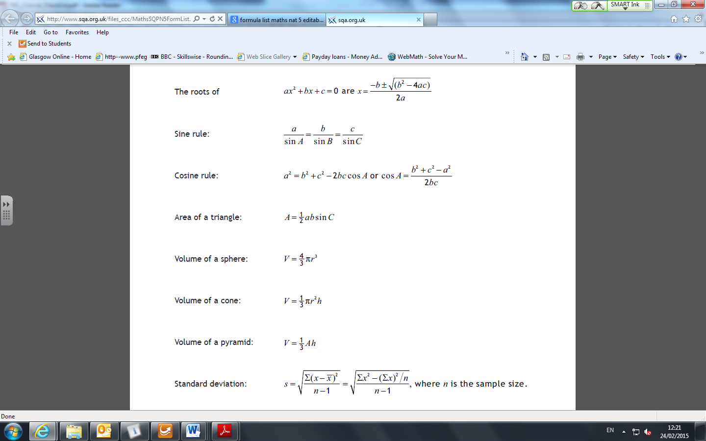**Formula Sheet**

*Unit 1*

Expressions and Formulae

**National 5 – Formulae List – Units 1 & 2**

**(Formulae you will NOT be given in the exam)**

***Circle and related formulae***

* Circumference of a circle: ***C =* π*d***
* Length of an arc: ***Arc Length* = $\frac{angle at centre}{{360}^{°}}×πd$**
* Area of a circle: ***A* = π*r*²**
* Area of a sector: ***Area of Sector* = $\frac{angle at centre}{{360}^{°}}×πr^{2}$**
* Volume of a cylinder: ***Volume =* π*r*²h**

***Pythagoras***

Theorem of Pythagoras:

***c b c*² = *a*² + *b*²**

|  | **Rules of surds/indices** |
| --- | --- |
| 1 | **Equation: sqrt a  times sqrt a  = a** |
| 2 | **Equation: sqrt {ab}  = sqrt a  times sqrt b** |
| 3 | **Equation: sqrt {frac{a}{b}} = frac{{sqrt a }}{{sqrt b }}** |
| 4 | **Equation: {a^m} times {a^n} = {a^{m + n}}** |
| 5 | **Equation: {a^m} div {a^n} = {a^{m - n}}** |
| 6 | **Equation: {a^0} = 1** |
| 7 | **Equation: {({a^m})^n} = {a^{m times n}}** |
| 8 | **Equation: {a^{ - n}} = frac{1}{{{a^n}}}** |
| 9 | **Equation: {a^{frac{1}{n}}} = sqrt[n]{a}** |
| 10 | **Equation: {a^{frac{m}{n}}} = {(sqrt[n]{a})^m}** |

***a***

***Percentages***

Percentage Increase / Decrease = $\frac{difference}{original value}×100$

***Equation of a Straight Line***

Gradient formula: $m= \frac{y_{2}-y_{1}}{x_{2}-x_{1}}$

Equation of a straight line: $y=mx+c$ OR *y−b = m(x−a)*

**Homework 1**

21

**Return by :**

**Non Calculator**

2

2

1. Evaluate
2. $4\frac{2}{5}-1\frac{1}{2}$ (b) $1\frac{1}{6}×\frac{3}{7}$
3. Expand and collect like terms

2

2

2

1. (*p* – 1)(*p* + 6) (b) (3*w* – 2) 2 (c) (5*x* + 3*y*)(3*x* – *y*)

3

1. The population of a Scottish village has dropped by 45%.

If the population is now 440, what was the population originally?

**Calculator**

3

1. The population of Liberia was 3.75 million in the year 2007.

If the population is growing at a steady rate of 4.5% per annum, what would the population be in 2015?

**Give your answer correct to three significant figures**

5

1. The cross-section of the shape shown consists of a rectangle and a triangle.

Calculate its volume.

16 cm

22 cm

14.5 cm

10 cm

**Give your answer correct to the nearest hundred**

**Homework 2**

**Return by**

18

**Non Calculator**

2

2

1. Evaluate 2. Expand and collect like terms

$\frac{2}{3}÷1\frac{1}{5}$ (5*t* – 3)(2*t* – 4)

3

3. The cost of a holiday increased by 8% from 2001 to 2002.

If it cost £540 for the holiday in 2002, what was the cost in 2001?

3

4**.** The cone has diameter of 20 cm and height 30 cm.

**C:\Users\ks2704a\AppData\Local\Microsoft\Windows\Temporary Internet Files\Content.IE5\7YN7FRF9\MC900048284[1].wmf**

Calculate its volume.

30 cm

**Use π = 3.14**

**Give your answer correct to two significant figures.**

20 cm

**Calculator**

3

1. Amanda is a secondary school teacher. She earns £32 500 per annum.

Her union agree a 3-year pay deal which will see her get an annual rise of 2.6%.

How much will Amanda earn in 3 years’ time?

**Give your answer** **correct to the nearest hundred pounds.**

5

0.6 cm

2.4 cm

1. A pharmaceutical pill is shown below in the shape of a cylinder with

hemispherical ends.

The radius of each hemisphere is 0.6 cm and the cylindrical height is 2.4 cm.

Calculate the volume of the pill.

**Give your answer correct to 3 significant figures.**

**Homework 3**

16

**Return by**

**Non Calculator**

3

2

1. Evaluate 2. Expand and collect like terms

(2*x* + 3)(*x*2 - 3*x* – 1)

3

1. The average cost of a computer has fallen in price by 45% since 1999.

If the average cost is now £660, find the average cost in 1999.

**Calculator**

1. The area of the Sahara desert is approximately 3 500 000 square miles. If the Sahara desert is increasing in size at a rate of 4% per annum, calculate its size in 5 years’ time.

3

**Give your answer correct to 3 significant figures.**



1. A concrete block has a cross-section in the shape of a square with sides of 38 cm, with identical quarter

circles removed from each corner shown below.

5

38 cm

30 cm

38 cm

If the volume of this prism is 27 875 cm3, calculate the depth, d, of the block.

**Homework 4**

19

**Return by**

**Non Calculator**

4

2

1. Evaluate 2. Expand and collect like terms

${\frac{3}{7}\left(\frac{1}{2}+\frac{3}{5}\right) }^{}$ 5*x* – (3*x* – 3)(*x* – 2)

3

3. Laura’s wages have increased by 6%. She now earns £19 080.

Find her wage before the increase.

**Calculator**

5

1. A farmyard barn is designed in the shape of a cuboid with a semi-cylindrical roof.

Calculate the volume of the barn.

**Give your answer correct to two significant figures.**

5

1. The diagram below shows the emblem for a sports club. The emblem

consists of 3 identical sectors of a circle, each of radius 16 millimetres.

The sectors have a combined area of 335 square millimetres.

Calculate the size of angle at the centre of each sector.

**Homework 5**

21

**Return by**

**Non Calculator**

2

3

1. Evaluate 2. Expand and collect like terms

(2*p* – 4)(*p*2 + 2*p* + 4)

3. The roll of a school has fallen by 15% since the year 2001.

3

The school roll is now 1,190. What was the roll in 2001?

4. Factorise fully

1

1

1

1. *c*2 + 8*c* (b) *x*2 - 9 (c) *x*2 - 4*x* + 4

**Calculator**

1. The curved part on an anchor is in the shape of an arc of a circle which has radius 1.2 metres.

The angle at the centre is 85o

in00204_

2

Calculate the length of this arc.

5

1. Calculate the volume of the shape below. The cross-section consists of 2 identical

80 cm

75 cm

34 cm

34 cm

semicircles and a rectangle.

Give your answer correct to **two significant figures.**

1. A water tank contains 650 litres of water. A hole in the tank means that water is leaking from the tank at a rate of 3.65% every 10 minutes. How much water will be left in the tank after an hour?

3

**Homework 6**

31

**Return by**

**Non Calculator**

3

3

1. Evaluate 2. Expand and collect like terms

(*u* + 3*w*)2 – 5*w*2

3. The cost of a season ticket for Hillside Town FC is £273 for a child.

3

If this represents 65% of the cost of an adult ticket, find the cost of an adult season ticket.

4. Factorise fully

1

1

1

(a) (b) 25*y*2 – 16 (c) *x*2 – *x* – 6

5. Simplify

3

1

1

(a) $\sqrt{98}$ (b) $\sqrt{128}$ (c) $5\sqrt{27}$ + $4\sqrt{12}$

**Calculator**

1. The radar beam sent out by an aeroplane reaches a distance of 120 kilometres and covers an angle of 150°.

2

tn00234_ Calculate the area covered by the beam.

1. In 2004, a house was valued at £85 000 and its contents were valued at £32 000.

The value of the house appreciates at a rate of 12% each year.

The value of the contents depreciates at a rate of 4% each year.

3

3

1. What will be the value of the house in the year 2010?

3

3

1. What will be the value of the contents in the year 2010?
2. What will be the **total** value of the house **and** its contents in the year 2010?

1

3

**Give your answer correct to two significant figures.**

5

1. The diagram below shows 3 metal pipes with a total volume of 470 485 mm3.

 Each pipe is identical with a circular cross-section.

Calculate the length of each pipe.

**Homework 7**

32

**Return by**

**Non Calculator**

2

4

1. Evaluate 2. Expand and collect like terms

(2*a* + *c*)2 + (*a* – *c*)2

1. The total annual cost of sending a child to a private school has increased by an average of 460% over the last 25 years.

3

If the total average annual cost today is £16 800, what was the cost 25 years ago?

4. Factorise fully

2

1

1

(b) 1 – (c) 2*x*2 + *x* – 21

5. Simplify

2

2

2

(a) (b) (c)

6. Solve

2

1

(a) 7*n* + 5 = 3*n* + 1 (b) 6(*s* - 1) = 2(2*s* + 10)

**Calculator**

3

7. According to the Institute for Fiscal Studies (2014), the ‘squeezed upper middle class’ have

seen earnings rise, on average, by 1.21% p.a. from 1989 to 2014.

If somebody in this category was earning £110,000 in 1989, what would they be earning, on

average, in 2014?

**Give your answer correct to two significant figures**.

1. A windscreen wiper is 45 centimetres long. In one sweep it turns through an angle of 115°.

2

115°

45 cm

Calculate the distance it covers in one sweep.

5

9. The cross-section of the prism below is a rectangle and a semi-circle.

Given the volume of this prism is 1,740 cm3, calculate d **correct to the nearest whole number.**

**Homework 8**

38

**Return by**

**Non Calculator**

3

2

1. Evaluate 2. Expand and collect like terms

(3*a* – 4) (*a*2 – 3*a* – 5)

3

3. A cereal box is on special offer with 40% extra free.

If the special offer box contains 840 grams of cereal, how much cereal is there in the standard box?

4. Factorise fully

2

1

1

1. 4*d* + 6*d*2 (b) 4*p*2 - 36 (c) 2*x*2 - 5*x* - 3

5. Simplify

2

2

2



6. Solve

2

(a) (b)

2

7. Rationalise the denominator.

Give your answer in simplest form.

(a) 

2

2

**Calculator**

4

8. The diagram below shows the height of the same cactus plant a year apart.

na01627_na01627_

Height 1.6 m Height 2 m

Year 1 Year 2

If the cactus continues to grow at the same percentage rate, calculate its height in Year 6.



1. A pendulum is 45 centimetres long. When the pendulum swings it travels along the arc of a circle and covers a distance of 27.5 centimetres.

3

Calculate the size of the angle through which the pendulum travels.

5 

1.  A storage barn is in the shape of a cylinder with a hemisphere on top.

Calculate the volume of the storage barn.

**Give your answer correct to 3 significant figures.**

**Homework 9**

37



**Return by**

**Non Calculator**

3

3

1. Evaluate 2. Expand and collect like terms

(3*m*2 – 2*m* + 2)(2*m* – 5)

3. Asif received a pay increase of 2% and his salary is now £14 280. What was his salary before the increase?

3

4. Factorise fully

1

1

2

1. 10*n*2 + 15*n* (b) 5*x*2 - 5 (c) *d*2 + 2*d* - 35

5. Simplify 6. Rationalise the denominator. Give your answer in  simplest form

2

2

7. (a) A function is defined as $f\left(x\right)=4x+1$. (b) A function is defined as $g\left(x\right)=4x^{3}-1$.

2

2

Given that *f*(*a*) = 21, calculate *a*. Given that *g*(*b*) = 31, calculate b.

8. Simplify.

(a) $\frac{{24n}^{9}}{{2n^{3} ×4n}^{-1}}$ (b) $\frac{x^{13} × x^{-5}}{x^{2}}$

2

3

**Calculator**

3

1. Hillside secondary school had a roll of 1,400 in 2001.

If the roll falls at a rate of 4% per annum, calculate the roll of the school in 2006.

**Give your answer correct to the nearest ten.**

3

10. A fan is in the shape of an arc of a circle with radius 35 centimetres.

The length of the arc is 48 centimetres.



*x*o

Calculate the size of the angle *x*o.

1. A waste paper bin is in the shape of a large cone with a smaller cone removed.

5

The large cone has radius of 14 centimetres and height 22 centimetres.

The small cone has radius of 8 centimetres.

 Calculate the volume of the bin.

**Homework 10**

41



**Return by**

**Non Calculator**

3

2

1. Evaluate 2. Expand and collect like terms

(3*x* – 5*y*)2 – 25*y*2

3

3. An antique collector sold a piece of art for 32% more than his purchase price.

If he sold it for £462, what was his purchase price?

4. Factorise fully

1

1

2

1. 8*n* + 12*n*2 (b) 3*n*2 – 75 (c) *w*2 – 2*w* – 63

5. Simplify 6. Rationalise the denominator.

Give your answer in simplest form.

 

3

2

7. Solve

(a) 4(2*g* – 5) – 3*g* = 5 + 2(*g* – 1) (b) $\frac{3x}{4}+1=2x$

2

1

1. Simplify.
2. $6a^{-3}×\frac{7a^{6}}{3}$ (b) $\frac{(2p)^{2}}{8p^{2}}$

2

2

**Calculator**

3

1. The number of flamingos in one lake in Africa is estimated at 45 000.

Due to changes in habitat, the number of flamingos is falling at a rate of 8% per annum.

Calculate the number of flamingos there will be in 6 years’ time.

**Give your answer correct to 2 significant figures.**

5

1.  In the diagram below AC and BD are arcs of circles with centres at O.

The radius, OA, is 10 centimetres and the radius, OB, is 16 centimetres.

Calculate the shaded area.

4

1.  Show that the triangle opposite is right-angled at B.



1. . The perimeter of the shape opposite is 38 metres.

2

1. Show that AB = 34 – 8x
2. Hence show that the area of the shape is

3

A = 80x – 16x2.