National 4  Mathematics |  | Pupil Name:
 |  | Teachers Name:
Homework Booklet
Expressions and Formulae 1
Progress Table (if correct then √ if more work is required then x)
 | Homework 1 |  | Homework 2 | Homework 3 | Homework 4 | Homework 5 | Homework 6 | Homework 7 | Homework 8 | Homework 9 | Homework 10
Non Calc % of a Quantity | 1 |  | 1 | 1 | 1 | 1 | 1 | 1 | 1 | 1 | 1
Non Calc Fract of a Quantity | 2 |  | 2 | 2 | 2 | 2 | 2 | 2 | 2 | 2 | 2
Non Calc Decimal Add/Subt. | 3 |  | 3 | 3 | 3 | 3 | 3 | 3 | 3 | 3 | 3
Expanding Brackets | 4,5 |  | 4,5 | 4,5 | 4,5
Factorising | 6 |  | 6 | 6 | 6
Simplifying Expressions |  |  |  |  |  | 4 | 4 | 4 | 4
Formulae & Substitution |  |  |  |  |  | 5,6 | 5,6 | 5,6 | 5/6
Number Patterns |  |  |  |  |  |  |  |  |  | 5 | 5
Gradient |  |  |  |  |  |  |  |  |  | 6 | 6
Area & Circ of Circle |  |  |  |  |  |  |  |  |  | 4 | 4
Area of Quads
Surface Area of Prism
Volume of Prism
Rotational Symm.
Freq Tables (class intervals)
Mean & Range
Pie Charts
Probability
Score | /25 |  | /25 | /25 | /25 | /27 | /27 | /27 | /27 | /29 | /29
Percentage | % |  | % | % | % | % | % | % | % | % | %
LATE
Teacher Comment

Formula Sheet (Formulae you WILL be given in the exam)
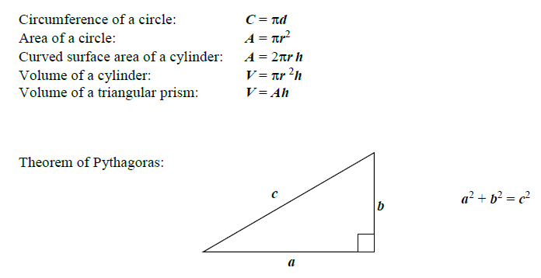
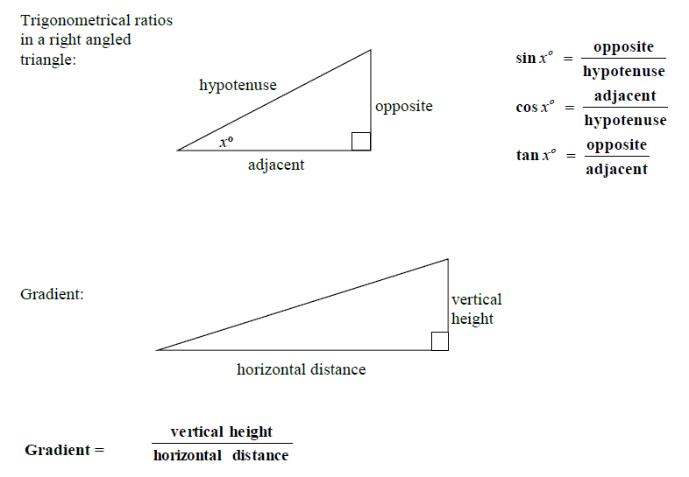
Formula List
(Formulae you will NOT be given but may need in the exam)

Area
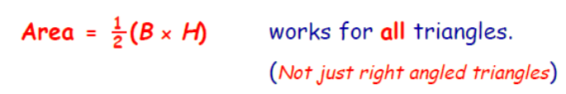
Statistics
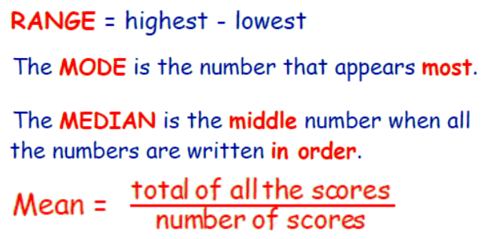
Speed , Distance , Time
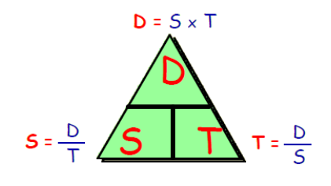
Homework 1
Return by :
Non Calculator
1. To book a holiday, 30% of the total cost must be paid at the time of booking.
How much must be paid to book a holiday costing a total of £850?
(3)

2. A cinema has 640 seats.
On Saturday, the cinema was 4/5 full.
How many people were in the cinema on Saturday? (3)

3. To make orange paint, a painter mixes 3∙65 litres of yellow paint with 1∙8 litres of red paint.

The painter uses 4∙2 litres of this orange paint.
How much paint is not used? (3)

4. Expand the brackets:

a) 2(3x - 3) b) 4(5y + 2) c) 6(2c - 1) d) 5(4a - 5) (4)

5. Expand the brackets and simplify:

- 3(y + 2) – 5 b) 7+ 3(a - 2) c) 7(n - 1) + 2n (6)

6. Factorise:

- 3a + 12 b) 5y - 15 c) 81 - 45n (6)

Homework 2
Return by :
Non Calculator
1. To book a holiday, 70% of the total cost must be paid at the time of booking.
How much must be paid to book a holiday costing a total of £650?
(3)

2. A cinema has 350 seats.
On Saturday, the cinema was 3/7 full.

How many people were in the cinema on Saturday? (3)

3. To make orange paint, a painter mixes 3∙45 litres of yellow paint with 1∙9 litres of red paint.

The painter uses 3∙2 litres of this orange paint.
How much paint is not used? (3)

4. Expand the brackets:

a) 5(3x - 4) b) 7(5y + 2) c) 6(2c - 1) d) 5(4a - 5) (4)

5. Expand the brackets and simplify:

- 3(y + 2) – 5 b) 7 + 4(a - 2) c) 7(n - 2) + 4n (6)

6. Factorise:

- 3a + 18 b) 5y - 40 c) 12 - 45n (6)

Homework 3
Return by :
Non Calculator
1. To book a holiday, 40% of the total cost must be paid at the time of booking.
How much must be paid to book a holiday costing a total of £390?
(3)

2. A cinema has 468 seats.
On Saturday, the cinema was 4/9 full.

How many people were in the cinema on Saturday? (3)

3. To make orange paint, a painter mixes 8∙35 litres of yellow paint with 2∙9 litres of red paint.

The painter uses 5∙2 litres of this orange paint.
How much paint is not used? (3)

4. Expand the brackets:

a) 4(7x - 5) b) 3(5e + 7) c) 6(4c - 3) d) 7(3a - 1) (4)

5. Expand the brackets and simplify:

- 8(y + 2) – 5y b) 9 + 4(a - 3) c) 4(n - 3) + 6n (6)

6. Factorise:

- 7a + 35 b) 3y - 36 c) 20 + 48n (6)

Homework 4
Return by :
Non Calculator
1. To book a holiday, 15% of the total cost must be paid at the time of booking.
How much must be paid to book a holiday costing a total of £460?
(3)

2. A cinema has 248 seats.
On Saturday, the cinema was 5/8 full.

How many people were in the cinema on Saturday? (3)

3. To make orange paint, a painter mixes 4∙45 litres of yellow paint with 1∙7 litres of red paint.

The painter uses 3∙8 litres of this orange paint.
How much paint is not used? (3)

4. Expand the brackets:

a) 7(2x - 5) b) 3(5y + 8) c) 4(3c - 5) d) 6(3a - 7) (4)

5. Expand the brackets and simplify:

- 3(y + 3) – 15 b) 9 + 3(a - 5) c) 6(n - 2) + 5n (6)

6. Factorise:

- 6a + 30 b) 7y - 42 c) 30 - 54n (6)

Homework 5
Return by :
Non Calculator

1. To book a holiday, 15% of the total cost must be paid at the time of booking.
How much must be paid to book a holiday costing a total of £940?
(3)

2. A cinema has 248 seats.
On Saturday, the cinema was 3/4 full.

How many people were in the cinema on Saturday? (3)

3. To make orange paint, a painter mixes 5.98 litres of yellow paint with 2.6 litres of red paint.

The painter uses 4.2 litres of this orange paint.
How much paint is not used? (3)

4) Simplify a) 8x + 3y – 4x – y b) 3a + c + 2c + a + a + c

c) 8g + 2h – 7g – h + 3g + 4h d) 4x + 4y + 4 – 3x – 3y + 3

(4)

5) a) When x = 5 and y = 3, find the value of 6x – 2y.

b) When a = 2 and b = 3, find the value of 3a + b

c) When e = 4 and f = 3 and g = 2, find the value of ef + g.

(6)

6) a) The sum, S of the angles in a polygon with n sides is given by the formula
S = 180(n - 2).

Find S when: i) n = 7 ii) n = 12

(4)

b) A magician charges £25 for every show he performs, plus an extra £10 per hour spent on stage. The formula for calculating his charge is C = 10t + 25, where C is the charge in pounds and t is the length of the show in hours. How much does he charge for a show lasting the following durations:

i) 3 hours ii) 5.5 hours

(4)

Homework 6
Return by :
Non Calculator

1. To book a holiday, 35% of the total cost must be paid at the time of booking.
How much must be paid to book a holiday costing a total of £260?
(3)

2. A cinema has 256 seats.
On Saturday, the cinema was 5/8 full.

How many spare seats were available in the cinema on Saturday? (3)

3. To make purple paint, a painter mixes 5∙45 litres of red paint with 1∙7 litres of blue paint.

The painter spills 3∙9 litres of this purple paint.
How much paint is left? (3)

4) Simplify a) 8x - 3y – 4x – y b) 3a + c - 2c + a + a + c

c) 8g + 2h – 7g – h - 3g + 4h d) 4x + 4y - 4 – 3x – 3y + 3

(4)

5) a) When x = 5 and y = 3, find the value of 6x + 2y.

b) When a = 2 and b = 3, find the value of 3a - b

c) When e = 4 and f = 3 and g = 2, find the value of ef - g.

(6)

6) a) The sum, S of the angles in a polygon with n sides is given by the formula
S = 180(n - 2).

Find S when: i) n = 9 ii) n = 22

(4)

b) A magician charges £15 for every show he performs, plus an extra £8 per hour spent on stage. The formula for calculating his charge is C = 8t + 15, where C is the charge in pounds and t is the length of the show in hours. How much does he charge for a show lasting the following durations:

i) 3 hours ii) 5.5 hours

(4)

Homework 7
Return by :
Non Calculator

1. To book a holiday, 35% of the total cost must be paid at the time of booking.
How much must be paid to book a holiday costing a total of £420?
(3)

2. A cinema has 217 seats.
On Saturday, the cinema was 5/7 full.

How many spare seats were available in the cinema on Saturday? (3)

3. To make purple paint, a painter mixes 7∙45 litres of red paint with 2∙7 litres of blue paint.

The painter spills 4∙8 litres of this purple paint.
How much paint is left? (3)

4) Simplify a) 8x - 3y – x – 3y b) 4a + c - 2c + a + a + 3c

c) 9g + 2h – 7g – 7h - 3g + h d) 5x + 4y + 4 – 3x – 3y - 9

(4)

5) a) When x = 5 and y = 3, find the value of 7x + 5y.

b) When a = 2 and b = 3, find the value of 4a - 5b

c) When e = 4 and f = 3 and g = 2, find the value of ef + 3g.

(6)

6) a) The sum, S of the angles in a polygon with n sides is given by the formula
S = 180(n - 2).

Find S when: i) n = 14 ii) n = 32

(4)

b) A magician charges £15 for every show he performs, plus an extra £8 per hour spent on stage. The formula for calculating his charge is C = 8t + 15, where C is the charge in pounds and t is the length of the show in hours. How much does he charge for a show lasting the following durations:

i) 5 hours ii) 3.5 hours

(4)

Homework 8
Return by :
Non Calculator

1. To book a flight, 15% of the total cost must be paid at the time of booking.
How much must be paid to book a flight costing a total of £280?
(3)

2. A cinema has 224 seats.
On Tuesday, the cinema was 3/7 full.

How many spare seats were available in the cinema on Tuesday? (3)

3. To make purple paint, a painter mixes 2∙35 litres of red paint with 3∙9 litres of blue paint.

The painter spills 4∙7 litres of this purple paint.
How much paint is left? (3)

4) Simplify a) 7x - 3y – 9x + 8y b) -a + c - 7c + a + a - 3c

c) 9g - 2h – 7g – 7h - 3g + h d) 5x + 7y + 4 – 3x – 8y - 9

(4)

5) a) When x = 4 and y = 5, find the value of 7x + 5y.

b) When a = 3 and b = 4, find the value of 4a - 5b

c) When e = 5 and f = 4 and g = 3, find the value of ef - 7g.

(6)

6) a) The sum, S of the angles in a polygon with n sides is given by the formula
S = 180(n - 2).

Find S when: i) n = 7 ii) n = 102

(4)

b) A plumber charges £30 for every call-out he attends, plus an extra £25 per hour spent on the repair. The formula for calculating his charge is C = 25t + 30, where C is the charge in pounds and t is the length of time he spent in hours. How much does he charge for a repair lasting the following durations:

i) 9 hours ii) 3.5 hours

(4)

Homework 9
Return by :
Non Calculator

1. To book a flight, 35% of the total cost must be paid at the time of booking.
How much must be paid to book a flight costing a total of £180?
(3)

2. A cinema has 225 seats.
On Tuesday, the cinema was 3/5 full.

How many spare seats were available in the cinema on Tuesday? (3)

3. To make purple paint, a painter mixes 2∙85 litres of red paint with 3∙3 litres of blue paint.

The painter spills 4∙8 litres of this purple paint.
How much paint is left? (3)

Calculator
4. This diagram shows the base of a cup.
The base of the cup is a circle with diameter of 9cm (6)
9cm Calculate… (a) the circumference and (b) the area of the base.

5.
N | 1 | 2 | 3 | 4 |  | 8
T | 4 | 6 | 8

a) Complete the table above. (2)
b) Write down a formula for finding T if you know N. (2)

c) Use your formula in b) to find T if N = 16. (2)

d) Find N if T = 64. (3)

6. Which of these ramps is the steepest? (Justify your answer by calculation)
a) V = 7m, H = 12m b) V = 8cm, H = 14cm (5)
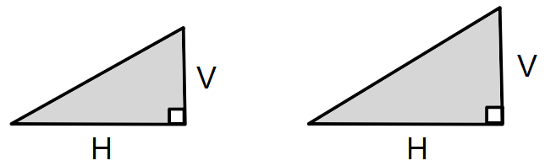
Homework 10
Return by :
Non Calculator

1. To book a flight, 85% of the total cost must be paid at the time of booking.
How much must be paid to book a flight costing a total of £280?
(3)

2. A cinema has 176 seats.
On Tuesday, the cinema was 5/8 full.

How many spare seats were available in the cinema on Tuesday? (3)

3. To make purple paint, a painter mixes 7∙85 litres of red paint with 3∙4 litres of blue paint.

The painter spills 3∙9 litres of this purple paint.
How much paint is left? (3)

Calculator
4. This diagram shows the base of a cup.
The base of the cup is a circle with diameter of 7cm (6)
7cm Calculate… (a) the circumference and (b) the area of the base.

5.
N | 1 | 2 | 3 | 4 |  | 8
T | 7 | 10 | 13

a) Complete the table above. (2)
b) Write down a formula for finding T if you know N. (2)

c) Use your formula in b) to find T if N = 12. (2)

d) Find N if T = 64. (3)

6. Which of these ramps is the steepest? (Justify your answer by calculation)
a) V = 8m, H = 13m b) V = 9cm, H = 15cm (5)
National 4  Mathematics |  | Pupil Name:
 |  | Teachers Name:
Homework Booklet 2
Expressions and Formulae
Progress Table (if correct then √ if more work is required then x)
 | Homework 1 |  | Homework 2 | Homework 3 | Homework 4 | Homework 5 | Homework 6 | Homework 7 | Homework 8 | Homework 9 | Homework 10
Non Calc % of a Quantity | 1 |  | 1 | 1 | 1 | 1 | 1 | 1 | 1 | 1 | 1
Non Calc Fract of a Quantity | 2 |  | 2 | 2 | 2 | 2 | 2 | 2 | 2 | 2 | 2
Non Calc Decimal Add/Subt. | 3 |  | 3 | 3 | 3 | 3 | 3 | 3 | 3 | 3 | 3
Expanding Brackets
Factorising
Simplifying Expressions
Formulae & Substitution
Number Patterns
Gradient
Area & Circ of Circle
Area of Quads | 4 |  | 4 | 4 | 4
Surface Area of Prism | 5b |  | 5b | 5b | 5b
Volume of Prism | 5a |  | 5a | 5a | 5a
Rotational Symm. |  |  |  |  |  | 4 | 4 | 4
Freq Tables (class intervals) |  |  |  |  |  | 5 | 5 | 5
Mean & Range |  |  |  |  |  |  |  |  | 4 | 4 | 4
Pie Charts |  |  |  |  |  |  |  |  | 5 | 5 | 5
Probability |  |  |  |  |  |  |  |  | 6 | 6 | 6
Score | /20 |  | /20 | /20 | /20 | /15 | /15 | /15 | /18 | /18 | /18
Percentage | % |  | % | % | % | % | % | % | % | % | %
LATE
Teacher Comment

Formula Sheet (Formulae you WILL be given in the exam)
Formula List
(Formulae you will NOT be given but may need in the exam)

Area
Statistics
Speed , Distance , Time
Homework 1
Return by :
Non Calculator
1. To book a holiday, 35% of the total cost must be paid at the time of booking.
How much must be paid to book a holiday costing a total of £640?
(3)

2. A football stadium has 24 000 seats.
On Saturday, the stadium was 3/5 full.
How many people were in the stadium on Saturday? (3)

3. To make orange paint, a painter mixes 4∙65 litres of yellow paint with 2∙08 litres of red paint.

The painter spills 5∙2 litres of this orange paint.
How much paint is left over? (3)

4. Calculate the area of the following:
a)
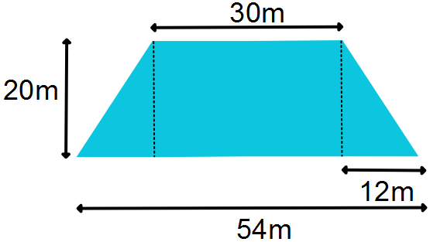 (3)
b)
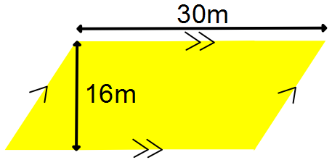 (2)

5. For the container below with L = 12cm, B = 6cm, H = 5cm, calculate the…

a) Volume b) Surface Area (6)

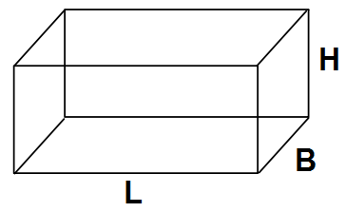
Homework 2
Return by :
Non Calculator
1. To book a holiday, 45% of the total cost must be paid at the time of booking.
How much must be paid to book a holiday costing a total of £320?
(3)

2. A football stadium has 21 000 seats.
On Saturday, the stadium was 3/7 full.
How many people were in the stadium on Saturday? (3)

3. To make orange paint, a painter mixes 4∙65 litres of yellow paint with 3∙17 litres of red paint.

The painter spills 5∙09 litres of this orange paint.
How much paint is left over? (3)

4. Calculate the area of the following:
a)
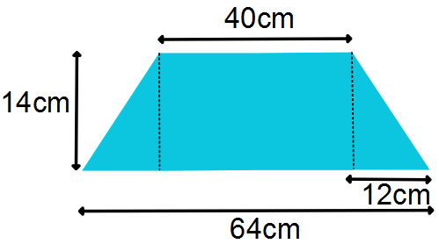 (3)
b)
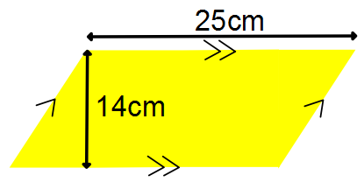 (2)

5. For the container below with L = 10m, B = 7m, H = 5m, calculate the…

a) Volume b) Surface Area (6)

Homework 3
Return by :
Non Calculator
1. To book a holiday, 35% of the total cost must be paid at the time of booking.
How much must be paid to book a holiday costing a total of £940?
(3)

2. A football stadium has 18 000 seats.
On Saturday, the stadium was 3/4 full.
How many people were in the stadium on Saturday? (3)

3. To make orange paint, a painter mixes 4∙35 litres of yellow paint with 8∙38 litres of red paint.

The painter spills 5∙9 litres of this orange paint.
How much paint is left over? (3)

4. Calculate the area of the following:
a)
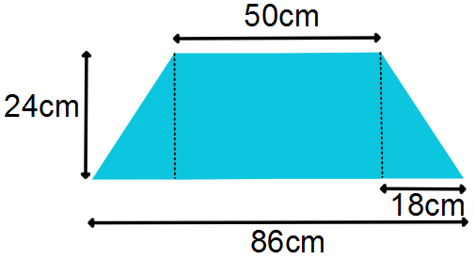
(3)
b)
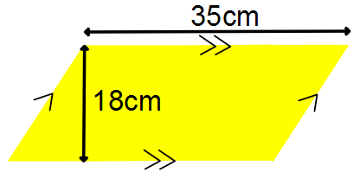
(2)

5. For the container below with L = 13cm, B = 5cm, H = 7cm, calculate the…

a) Volume b) Surface Area (6)

Homework 4
Return by :
Non Calculator
1. To book a holiday, 35% of the total cost must be paid at the time of booking.
How much must be paid to book a holiday costing a total of £640?
(3)

2. A football stadium has 24 000 seats.
On Saturday, the stadium was 3/5 full.
How many people were in the stadium on Saturday? (3)

3. To make orange paint, a painter mixes 4∙65 litres of yellow paint with 2∙08 litres of red paint.

The painter spills 5∙2 litres of this orange paint.
How much paint is left over? (3)

4. Calculate the area of the following:
a)
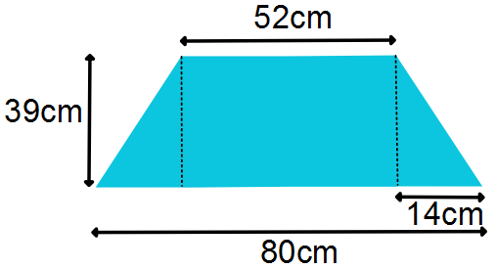
(3)
b)
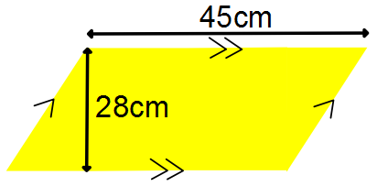
(2)

5. For the container below with L = 20m, B = 9.5m, H = 6m, calculate the…

a) Volume b) Surface Area (6)

Homework 5
Return by :
Non Calculator
1. To book a holiday, 45% of the total cost must be paid at the time of booking.
How much must be paid to book a holiday costing a total of £340?
(3)

2. A football stadium has 24 000 seats.
On Saturday, the stadium was 3/8 empty.
How many people were in the stadium on Saturday? (3)

3. To make orange paint, a painter mixes 7∙65 litres of yellow paint with 2∙38 litres of red paint.

The painter spills 5∙2 litres of this orange paint.
How much paint is left over? (3)

4. Complete this diagram so that it has rotational symmetry of order 4, about O.
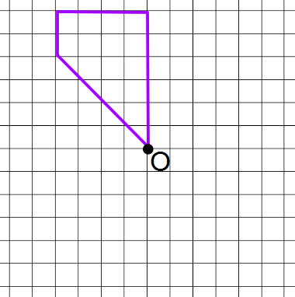
(3)

5. The number of visitors to a local cinema was recorded each day for two weeks.
The results are shown below.

138 | 164 | 158 | 142 | 161 | 169 | 170
149 | 155 | 162 | 168 | 159 | 163 | 178

Complete the frequency table for these results.
Score | Tally | Frequency
130 – 139
 |  | Total =
(3)

Homework 6
Return by :
Non Calculator
1. To book a holiday, 65% of the total cost must be paid at the time of booking.
How much must be paid to book a holiday costing a total of £240?
(3)

2. A football stadium has 24 000 seats.
On Saturday, the stadium was 3/5 empty.
How many people were in the stadium on Saturday? (3)

3. To make orange paint, a painter mixes 6∙65 litres of yellow paint with 3∙38 litres of red paint.

The painter spills 4∙2 litres of this orange paint.
How much paint is left over? (3)

4. Complete this diagram so that it has rotational symmetry of order 4, about O.
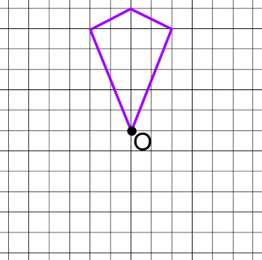
(3)

5. The number of visitors to a local museum was recorded each day for two weeks.
The results are shown below.

148 | 174 | 168 | 142 | 161 | 169 | 180
149 | 165 | 172 | 178 | 169 | 173 | 178

Complete the frequency table for these results.
Score | Tally | Frequency
140 – 149
 |  | Total =
(3)
Homework 7
Return by :
Non Calculator
1. To book a holiday, 45% of the total cost must be paid at the time of booking.
How much must be paid to book a holiday costing a total of £680?
(3)

2. A football stadium has 28 000 seats.
On Saturday, the stadium was 4/7 empty.
How many people were in the stadium on Saturday? (3)

3. To make orange paint, a painter mixes 7∙65 litres of yellow paint with 3∙18 litres of red paint.

The painter spills 5∙9 litres of this orange paint.
How much paint is left over? (3)

4. Complete this diagram so that it has rotational symmetry of order 4, about O.
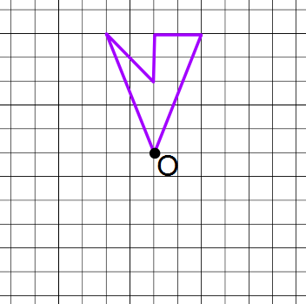

(3)
5. The number of visitors to a local church was recorded each day for two weeks.
The results are shown below.

248 | 274 | 268 | 242 | 261 | 269 | 280
249 | 265 | 272 | 278 | 271 | 273 | 258

Complete the frequency table for these results.
Score | Tally | Frequency
240 – 249
 |  | Total =
(3)
Homework 8
Return by :
Non Calculator
1. To book a holiday, 45% of the total cost must be paid at the time of booking.
How much must be paid to book a holiday costing a total of £470?
(3)

2. A football stadium has 18 000 seats.
On Sunday, the stadium was 4/9 empty.
How many people were in the stadium on Sunday? (3)

3. To make orange paint, a painter mixes 2∙65 litres of yellow paint with 7∙28 litres of red paint.

The painter spills 4∙98 litres of this orange paint.
How much paint is left over? (3)

4. Eight people were timed running 5 kilometres.
The time, in minutes, each person took was recorded and the results are shown below.
16 | 14 | 29 | 26
25 | 23 | 25 | 18

a) Calculate the mean time taken. Show all working. (2)

b) Calculate the range. (1)

Each person then followed a training programme for 7 weeks.
At the end of the training programme they were timed running 5 kilometres again.
After training:
- the mean was 18 minutes, and

- the range was 19

c) Write one comment comparing the results before training with
the results after training. (1)

5. Eighty pupils were asked how they travelled to school.
The table below shows the results.
Complete the blanks in the table to find the angles required for each travel method in the pie chart. (Do not draw the pie chart)
Travel method | No of pupils | Angle at the centre
Cycle | 20
Walk | 50
Car | 10
(3)

6. A spinner has 5 edges as shown in the diagram.
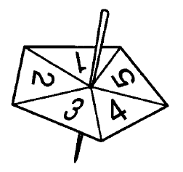
When it is spun it comes to rest on one edge.

What is the probability that it comes to rest on a number greater than 2? (2)

Homework 9
Return by :
Non Calculator
1. To book a holiday, 85% of the total cost must be paid at the time of booking.
How much must be paid to book a holiday costing a total of £380?
(3)

2. A new theatre has 1800 seats.
On Sunday, the theatre was 2/9 empty.
How many people were in the theatre on Sunday? (3)

3. To make purple paint, a painter mixes 3∙65 litres of blue paint with 7∙38 litres of red paint.

The painter spills 4∙78 litres of this purple paint.
How much paint is left over? (3)

4. Eight people were timed running 8 kilometres.
The time, in minutes, each person took was recorded and the results are shown below.
22 | 19 | 36 | 32
31 | 29 | 31 | 24

a) Calculate the mean time taken. Show all working. (2)

b) Calculate the range. (1)

Each person then followed a training programme for 4 weeks.
At the end of the training programme they were timed running 8 kilometres again.
After training:
- the mean was 24 minutes, and

- the range was 19

c) Write one comment comparing the results before training with
the results after training. (1)

5. Forty painters were asked their favourite primary colour.
The table below shows the results.
Complete the blanks in the table to find the angles required for each primary colour in the pie chart. (Do not draw the pie chart)
Colour | No of painters | Angle at the centre
Blue | 5
Red | 25
Green | 10
(3)

6. A spinner has 5 edges as shown in the diagram.
When it is spun it comes to rest on one edge.

What is the probability that it comes to rest on a prime number? (2)

Homework 10
Return by :
Non Calculator
1. To book a cruise, 15% of the total cost must be paid at the time of booking.
How much must be paid to book a cruise costing a total of £1380?
(3)

2. A new theatre has 1640 seats.
On Sunday, the theatre was 3/8 empty.
How many people were in the theatre on Sunday? (3)

3. To make purple paint, a painter mixes 2∙67 litres of blue paint with 5∙39 litres of red paint.

The painter spills 4∙68 litres of this purple paint.
How much paint is left over? (3)

4. Eight people were timed walking 8 kilometres.
The time, in minutes, each person took was recorded and the results are shown below.
44 | 38 | 72 | 64
62 | 58 | 62 | 48

a) Calculate the mean time taken. Show all working. (2)

b) Calculate the range. (1)

Each person then followed a power-walk training programme for 4 weeks.
At the end of the training programme they were timed walking 8 kilometres again.
After training:
- the mean was 44 minutes, and

- the range was 36

c) Write one comment comparing the results before training with
the results after training. (1)

5. Ninety fashion designers were asked their favourite primary colour.
The table below shows the results.
Complete the blanks in the table to find the angles required for each primary colour in the pie chart. (Do not draw the pie chart)
Colour | No of designers | Angle at the centre
Blue | 5
Red | 60
Green | 25
(3)

6. A letter is selected at random from the word TRIGONOMETRY.
What is the probability that the letter is a vowel? (2)

