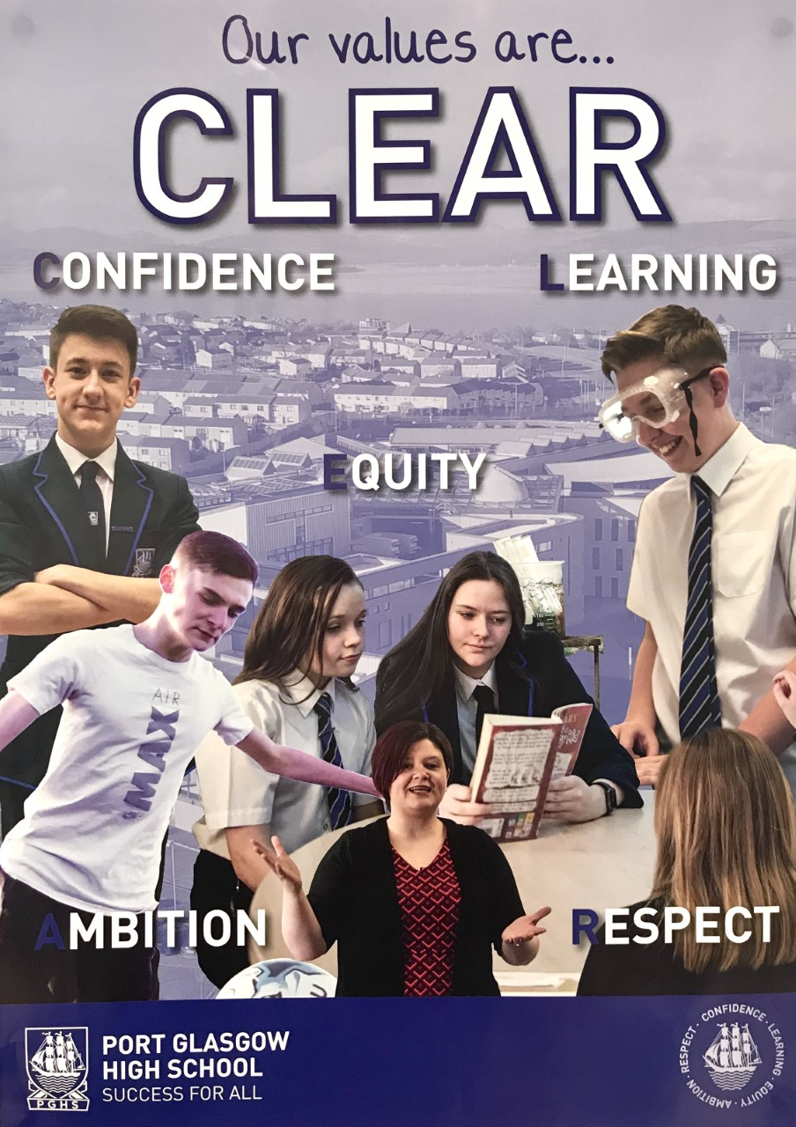

Port Glasgow High School
Handbook
Handbook – 2021-22

Welcome to Port Glasgow High School
Dear Parent/ Carer,
I am delighted to welcome you and your child to Port Glasgow High School.
This handbook contains important information about our school and the opportunities that we offer our students. It provides an insight into the life of Port Glasgow High School, its aims and achievements along with the practical details you need as a parent/ carer.
We are a welcoming school with high expectations for all of our young people. Our school values of confidence, learning, equity, ambition and respect underpin all that we do as we support our young people in their academic, social and personal achievements.
We are a school community where parents, pupils and staff work together to ensure all our young people achieve their full potential. We are extremely proud of the achievements of our young people both in and out of the classroom. Along with academic success we value the development of skills for learning, life and work. As such our young people leave school equipped with a range of qualifications, skills and confidence which allows them to move on to the next phase in their life, whether that be the world of work or continuing in education.
We believe in working in partnership with our parents to ensure the success of all our young people as they journey through Port Glasgow High School. We encourage parents to take an active interest, not just in their own child, but also in the life of the school as a whole. We believe in working in partnership with our parents and our community to the benefit of our pupils.
We look forward to welcoming you and your child as members of our school community and hope that this will be the start of strong positive partnership.

Mrs G. Carroll
Head Teacher

Port Glasgow High School
Handbook
Contents

Page 4 School Contact Information
Page 5-6 Key Staff Directory
Page 7-8 Communication with the school
Page 9-10 The Ethos of the School
Page 11 Learning in Port Glasgow High School
Page 12 School Uniform
Page 13-14 Good Learning means Good Behaviour
Page 15-16 Supporting Learners
Page 17-19 Learning at Home and Wider Learning
Page 20-24 Curriculum in Port Glasgow High School
Page 25 Assessing Progress in Learning
Page 26 Transition: Primary to Secondary
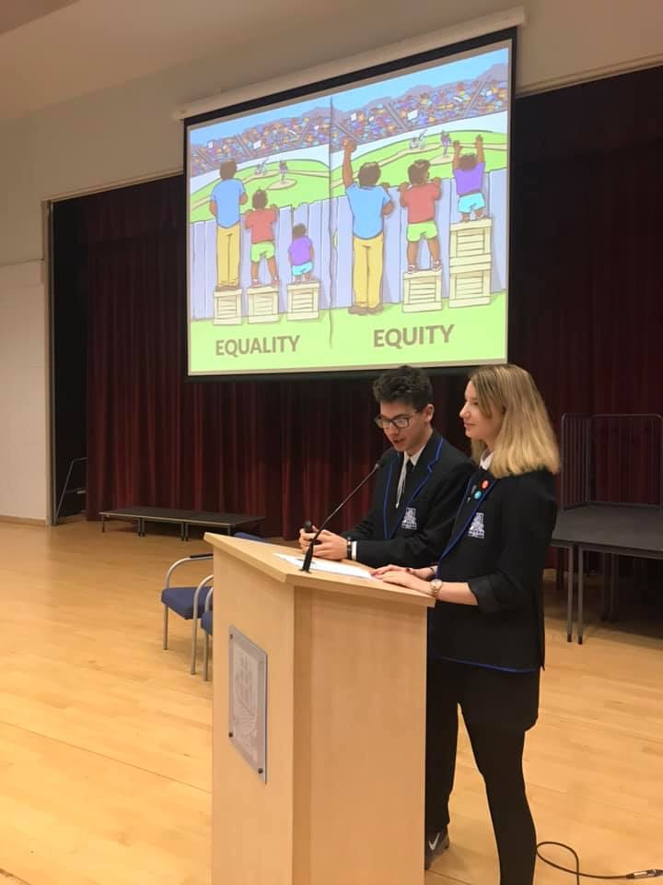
Page 27 Parent Partnership
Page 28 Community Partnership
Page 29 Appendices

Port Glasgow High School
Handbook
School Information
Port Glasgow High School is a non-denominational, co-education secondary school serving Port Glasgow, Kilmacolm and Quarrier’s Village. It provides education for young people from S1 – S6.
Contact Details
Address: Port Glasgow High School
Port Glasgow Community Campus
Kilmacolm Road
Port Glasgow
PA14 6PP
Tele No.: 01475 715200
Fax No.: 01475 715201
Email: INPortGlasgow@glowscotland.onmicrosoft.com
School Website: http://portglasgow.inverclyde.sch.uk
Twitter: @PortGlasgowHS
Facebook – ‘like’ us at: www.facebook.com/PortGlasgowHigh

School Roll
The current school roll (December 2020) is as follows:
S1 – 93
S2 – 92
S3 – 94
S4 – 79
S5 – 84
S6 – 59
Total – 501
Port Glasgow High School
Handbook
Key Staff Directory
Senior Leadership Team (SLT)

Head Teacher Depute Head Teacher Depute Head Teacher Acting Depute Head Teacher
Mrs G. Carroll Mrs F. Craig Ms S. Welsh Mrs N. Lyons

Everything we do as a school is determined by its impact on the educational experiences of our pupils. All the members of the SLT are responsible for teaching and learning within the school and for the creation of a positive learning environment.
Individual members of the SLT also have special responsibilities, some of which are detailed below:
Mrs G. Carroll (Head Teacher)
Mrs Carroll is the head of the school and is responsible for all aspects of school organisation and policy. She has a special responsibility for the development of the school and for implementing the educational policies for Inverclyde Council. Mrs Carroll is also responsible for the development of universal and targeted support for pupils and leadership of the Principal Teachers of Support (Guidance and Support for Learning).
Mrs. F. Craig (Depute Head Teacher)
Mrs Craig’s responsibilities include; Head of S1-3, Curriculum for Excellence (Broad General Education), Partnership with Associated Primaries, Transition P7-S1, Transition to Senior Phase, Recognition of Achievement, Responsibility of All Areas (Literacy, Numeracy & Health and Wellbeing), Staff Professional Review & Development.
Ms. S. Welsh (Depute Head Teacher)
Ms. Welsh’s responsibilities include; Head of S4-6, Curriculum for Excellence (Senior Phase), Transition from school, Developing the Young Workforce, 16+ Learning Choices, College & Employer Partnerships.
All of the SLT liaise closely with a number of subject departments. They also take joint responsibility for the general promotion of a positive school ethos and maintenance of high standards of behaviour and conduct across the school.

Port Glasgow High School
Handbook
Key Staff Directory
Pupil Support Team
On enrolment to Port Glasgow High School each pupil is assigned to one of three houses (which have been named after shipyards in the town). Each house is then looked after by a Principal Teachers of Guidance. Pupils will remain with the same PT Guidance throughout their school career.
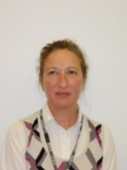

Mrs. K. Brown Mrs. L. Fitzharris Mrs. L. Greenlees Ms J. Byrne
Ferguson House Kingston House Glen House
Miss G. Kirkpatrick Mr C. Hart
Acting PT Guidance Acting PT Guidance
(Ferguson) (Kingston/ Glen)

The Principal Teachers of Guidance are the first points of contact for parents. They are responsible for attendance, records, reports and providing references. They work in partnership with the Support for Learning Staff, teaching colleagues and external partners to coordinate any support for pupils as needs arise.
As part of the Pupil Support Team, working alongside Guidance Teachers are:
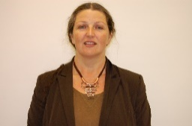

Mrs K Wilson Mr S Cummings
PT Support for Learning Home Link Worker

Communication
Two-way communication between the home and school is important to ensure that each young person gets the best out of their time in Port Glasgow High School. Contact details for the school are given on page 4.
The most common reasons for you contacting the school are:
Reporting Absence or Sickness
If your child is absent from school, please contact the School Office by telephone as early as possible after 08:30. After the morning registration period, parents are informed by text message if their child is absent from school and we have not been informed. On return from absence we ask that a note explaining the reason for the absence is given to the Registration Teacher. If we do not receive a reason for absence within one week the absence will be recorded as unauthorised.
Asking a question or raising a concern
The Guidance Staff take a close personal interest in all the pupils in their care and are a natural first point of contact between the school and the home. They are always extremely willing to discuss any matter with parent/carers. To contact your child’s Principal Teacher of Guidance, telephone the School Office or send a message to the school e-mail address. Guidance PTs are also subject teachers with heavy timetables, so they may not be available when you call, they will get back to you as soon as possible. Parents wishing to visit the school should make a prior appointment if at all possible.
The most common reasons for the school contacting home are:
Reporting Progress
Each pupil receives a number of reports throughout each session.
S1/2: Four Tracking Reports. These give a rating for effort, behaviour and homework. Furthermore, they provide a Curriculum for Excellence Attainment Level. Information to explain this information is provided with the report.
S3: Four Tracking Reports. These give a rating for effort, behaviour and homework. Furthermore, they provide a Curriculum for Excellence Attainment Level. Information to explain this information is provided with the report. In addition, a full detailed written report is provided at the end of January in advance of the S3>4 options process.
S4-6: Two Tracking Reports early in the session to provide an on-going indication of progress towards National Qualifications. An additional written report in February to provide an update a few weeks after Parents’ Evening.

Raising a concern
Staff regularly monitor the progress of every pupil and judge if appropriate progress is being made. If there is a concern about any issues such as attendance, home learning, preparation for assessments, parents will be informed through an intervention letter. This will be a formal notification of the concern which will have been discussed with the young person and we will ask for your support in rectifying the concern.
Principal Teachers of Guidance may also contact you by telephone if there are a number of concerns about your child’s progress.
Emergency Contact
If your child becomes ill or is injured at school and is unable to continue to stay in school we will contact you via emergency contact number that you provided us with. We will usually ask that your child be collected from school especially if medical advice is required. In more serious cases we may call an ambulance at the same time as we contact you.
Making a complaint
If your contact relates to a complaint, you should contact your child’s Principal Teacher of Guidance. The guidance staff will attempt to resolve this in the first instance, in line with First Line Response within the council’s complaints procedure. If the complaint remains unresolved it will be passed to the Head Teacher for further action.
Other Information
A lot of information about the school, its procedures and successes can be found on the school’s social media pages and website.
http://port Glasgow.inverclyde.sch.uk
Twitter - @PortGlasgowHS Facebook – www.facebook.com/PortGlasgowHigh
Details of other events and reminders about school holidays etc. will be sent out by email, or letter delivered by your child. We also use the Parent Call system (text call) to send out last minute reminders.
Emergency Contact
Occasionally we need to close the school due to bad weather or other emergency. Any decision to do so is taken in conjunction with the education department and will be communicated on the Inverclyde Council website and by announcements on local radio. We will also post messages on our twitter and Facebook page. If we need to send pupils home early you will be contacted by text message to your mobile phone. Where possible, a letter will be sent home with your child explaining the reason for the emergency closure.
School Term Dates (2021-22):
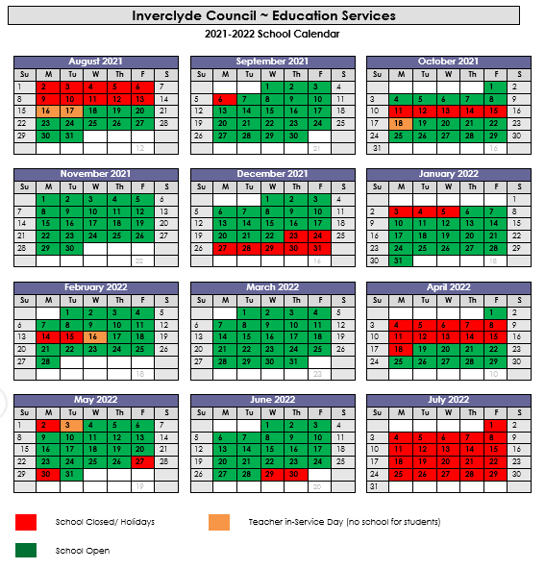

Port Glasgow High School
Handbook

Port Glasgow High School Values and Aims
Success for All
Our values are CLEAR
Our values are a clear concise summary of what we value in Port Glasgow High School. They are consistent with the four capacitates being developed within the Curriculum for Excellence; to create successful learners, confident individuals, responsible citizens and effective contributors.
- Confidence
- Learning
- Equity
- Ambition
- Respect
Aims
Build respect and confidence by promoting ambition, achievement and life-long learning.
- We aim to provide experiences which build self-esteem and self-belief
- We aim to ensure high quality learning experiences and promote positive attitudes to lifelong learning
- We aim to ensure all members of the school community receive the help they need to reach their potential
- We aim to celebrate achievements and develop a desire to contribute to society
- We aim to develop relationships where every individual is respected and valued

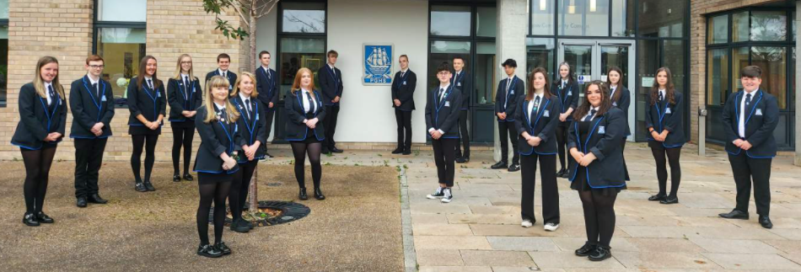

Port Glasgow High School
Handbook

Pupil Leadership
One of the major strengths of Port Glasgow High School is the attitude and ethos amongst our pupils. Our pupils are proud of their school and they have a major role in leading improvement in the school. There are a variety of ways pupils have a leadership role within the school, these include:

Senior Pupil Leadership Team (SPLT)
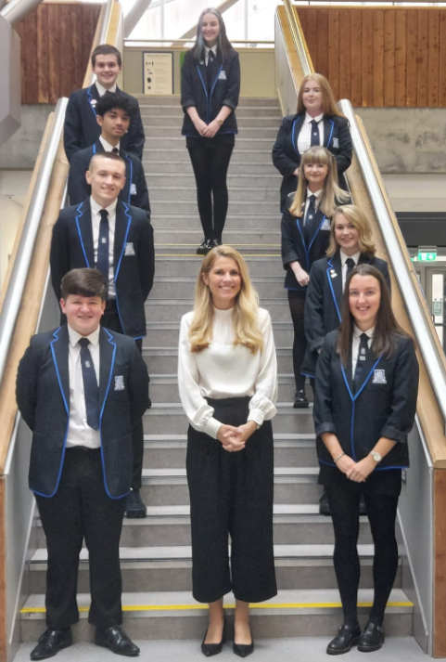
This is chaired by our Head Boy/Girl and is comprised of our Head Pupils and House Captains. The SPLT co-ordinates a variety of activities.
House councils
There is a House Council for each of our three Houses. These meetings are chaired by our House Captains and each Registration class has elected a representative to ensure their voice is heard.
School Council
This our main pupil decision making body. It is chaired by our Head Pupils and meets once per term. It debates and votes on key school issues.

What do our pupils think of Port Glasgow High School?

At first high school seems like a daunting thought – there’s a lot of new subjects, a huge new building and lots of new people to meet. However, in my opinion it is these things that make high school so exciting, especially here at Port Glasgow High School. Six years ago (hard to believe) I was twelve years old and starting first year in high school, I still look back at how many amazing memories I made just within my first few weeks at Port Glasgow High. The amazing teachers made sure that we were all comfortable and made every lesson new and exciting, I loved coming to school every day and made lots of friend throughout the years – no day was the same. Now I am approaching eighteen in my sixth year of school and my enthusiasm and attitude is still the same. Our school prides itself on listening to pupil voices in order to make our school a place where pupils want to be, which is why there is such a positive ethos and atmosphere throughout our school community. Port Glasgow High School has provided me with a fantastic education, I have worked hard alongside my teachers to secure good grades and in September I will start my journalism degree at university. Without the encouragement and positivity from my teachers I would not be where I am today. I am forever grateful for the special memories that Port Glasgow High has given me that I will treasure for the rest of my life.
Kirsten Irvine – Former Head Girl

Port Glasgow High School
Handbook

Learning
We aim to develop each young person to be the best learner that they can be. Good learners have the skills and knowledge to learn in any situation and apply their learning in new and unfamiliar places.

Good learners develop 5 key characteristics or attributes. We call these our 5Rs
.Reasoning: Making careful decisions
.Reflective: Learning from experience
.Resilient: Sticking at it especially when thinks are difficult
.Responsible: Looking after yourself and others
.Resourceful: Knowing what to do and where to go when you get stuck

The School Day
Being a learner means taking every opportunity to learn.
Attending well and being on time for class is very important. The teaching week is split into 32 periods of 50 minutes each. Each day begins with registration, which lasts for 10 minutes. Registration classes are made up from pupils S1 to S6, thus allowing the senior pupils to act as buddies and role models for junior pupils.
Period Mon & Tue Wed, Thu, Fri
Registration 08:50 – 09:00 08:50 – 09:00
Period 1 09:00 - 09.50 09:00 – 09:50
Period 2 09:50 - 10:40 09:50 - 10:40
Interval 10:40 – 10:55 10:40 – 10:55
Period 3 10:55 – 11:45 10:55 – 11:55
Period 4 11:45 – 12:35 11:45 – 12:35
Lunch 12:35 – 13:15 12:35 – 13:15
Period 5 13:15 – 14:05 13:15 – 13:15
Period 6 14:05 - 14.55 14:05 – 14:55
Period 7 14:55 – 15:45 No period 7
Port Glasgow High School
Handbook

School Uniform
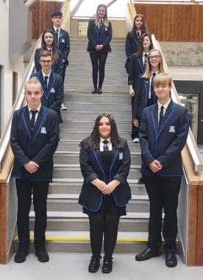
At Port Glasgow High School, our pupils wear school uniform. We believe it looks smart, helps eliminate social differences and promotes school spirit. The uniform is:
. White shirt or blouse with school tie (1-3 Junior Tie / S4-6 Senior tie)
. School blazer (optional for S1-4, expected for S5/6)
. Specially designed Port Glasgow High School polo shirt
. Specially designed Port Glasgow High School sweat shirt
. Black / grey trouser or skirt

There are forms of dress which are unacceptable in school, such as items of clothing which:
. Potentially encourage factions (such as football colours)
. Could cause offence (such as anti-religious symbolism or political slogans)
. Could Cause health and safety difficulties, such as loose fitting clothing made of flammable
Material (for example track suits in practical classes), dangling earrings and other body piercings
. Carry advertising, particularly for alcohol or tobacco, and could be used to inflict damage on other pupils or be used by others to do so
In addition jewellery such as dangling earrings and large rings could cause health and safety difficulties and are unacceptable to be worn in school. Casual clothing and denims are not permitted as part of normal school uniform. Outdoor clothing such as jackets, hoodies, non-uniform jumpers, scarves etc. are expected to be removed in class. We are happy that all our pupils wear appropriate clothes to school. We are very grateful for the support we receive from parents in this matter.

Physical Education
To gain the maximum benefit and be as hygienic as possible, it is important to bring a change of clothing for PE activities. The following items are recommended as a PE kit:
. PGHS School Sports Top
.Navy shorts
.Training shoes or sandshoes
.Change of socks.
It is useful to bring the kit in a carrier bag inside the school bag.
Port Glasgow High School
Handbook

Good Learning Means Good Behaviour

Our approach to promoting positive behaviour is simple:
. We have a clear Code of Conduct (see Appendix)
. We praise and reward good behaviour
. We manage inappropriate behaviour so that it will stop quickly and will not affect top quality learning
and teaching

Rewarding Good Behaviour
As a school, we believe firmly that praise is a vital part of working with our young people. We should not take good behaviour and conduct for granted – we actively praise youngsters for work that is “well done”.
We also give pupils the following recognition rewards:
- Pupils are issued with “positive referrals” when they perform a notable piece of work. These take the form of simple notes which detail the reason for the referrals. These are completed by class teachers, signed by the Head Teacher and given home.

- During the session, class teachers nominate up to five pupils at any one time for “Merit Awards” which are awarded on the basis of our Learner Attributes (5Rs). We hope that all our youngsters will work towards receiving awards which will be a way of the school publicly endorsing their good behaviour, effort and attitude towards learning

- Class Merits: these can be given directly by class teachers and are totalled up on a regular basis with a variety of rewards throughout the session. Rewards include certificates, positive texts home, Tea with the HT, trips and reward vouchers.

Port Glasgow High School
Handbook

Award Ceremonies

As a school, we regularly recognise pupils who have made good progress and effort in their learning. The major events in the school year are;

Merit Awards (all years)

Each term teachers are asked to nominate pupils from their classes who have demonstrated the attributes of a good learner. Pupils are then presented with a certificate from the Head Teacher at the Merit Award Ceremony.

Distinction Award Ceremony for S1, S2 and S3

Every subject is asked to nominate pupils who deserve awards for best class achiever and making most progress. Each teacher can choose one pupil in each category from each class taught. Awards are presented in the Assembly Hall in June each year.

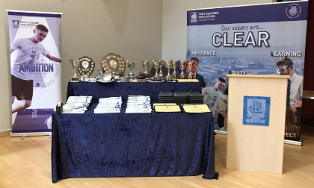
School Prize giving
This major event in the life of the school is held every year in September. The school celebrates the work of the year with musical items and a distinguished speaker (who has a connection with the school).
Pupils in S4, S5 and S6 are presented with prizes for their work in various subjects, and awards are made to the sports champions and pupils who have brought distinction to themselves, the school and the community.

Managing Inappropriate Behaviour
We all want the school to function effectively as a purposeful, orderly place in which effective learning and teaching are allowed to flourish. Any deviation from the code of conduct will be dealt with in a way which keeps disruption to learning and teaching to a minimum.
We firmly believe that discipline is most effective when it takes place within a strong and close partnership between the school and the home.
The following is a list of sanctions (becoming more serious as they “move up”) which are used by the school.

Stage 1: “Official Warning” by the class teacher

Stage 2: “Isolation within the class” –e.g. moving seat

Stage 3: Ten minutes of detention at the next lunch break (this takes place at the beginning so there is still plenty time for lunch)

Stage 4: “Behaviour Report” – a written note saying clearly what the offence has been and asking for parental signature as an acknowledgement that it has been seen. If a child regularly receives these, the parent may be asked to come to the school to speak to a senior member of staff.

Stage 5: For either a serious offence or a build up through the previous stages, a child will be sent straight to a senior member of staff and the parent will be contacted.

Port Glasgow High School
Handbook

Supporting Learners
Supporting young people in their learning involves a range of people – parents and carers, teachers, support staff, college staff, psychological services, Skills Development Scotland, volunteers and workers from voluntary organisations and local authority youth work provision. It is important that we work in partnership to “get it right for every child”.
Young people are entitled to personal support to enable them to:
- Review their learning and plan for next steps
- Gain access to learning activities which will meet their needs
- Plan for opportunities for personal achievement
- Prepare for changes and choices and be supported through change and choices
In Port Glasgow High School every young person is allocated a dedicated Principal Teacher of Guidance:
- To know and to be known to every young person and to be concerned with the overall wellbeing of each child as an individual
- To assist young people to gain the maximum benefit from all aspects of school life
- To provide the necessary curricular and careers advice so that young people can make appropriate choices.
For the majority of pupils, the Principal Teacher of Guidance will offer the Named Person service. This is a single point of contact for any help and support needed and the co-ordinator of any in-school support requested. For a small number of pupils, the Named Person may be the Principal Teacher of Support for Learning (Mrs Wilson).
Guidance Structure
Each pupil is assigned to one of three houses: Glen, Ferguson and Kingston
The promoted members of staff provide support to pupils. They are also responsible for attendance records, reports and providing references. The guidance staff prepare the social, health and careers programme for all pupils from S1 to S6. Career guidance is also given by our visiting career adviser.
Close liaison is maintained with members of partner agencies such as health professionals, careers advisers, social workers and the psychological service to ensure that specialist advice is readily available as and when required. The school works closely with other members of the Education Service at Inverclyde Council, and shares information relating to pupils with our school Educational Psychologist.
Registration and House Groups
Within each house, pupils are assigned to house groups and it is to these groups that pupils go to register every morning. They are placed in groups with pupils of all stages from S1 to S6 and we ensure that families are kept together to provide a close link to enable the house tutor (register teacher) to get to know pupils and families well.
All parents are individually notified through the associated primary in June as to their child’s class, house and guidance teacher.
Extended Support Team (EST)
From time to time, pupils require additional support and Principal Teachers of Guidance/Support for Learning may require advice on next steps to meet learners’ needs. An Extended Support Team, chaired by the Head Teacher and attended by Educational Psychologist, meets on a weekly basis to discuss these referrals. Once per month, a multi-agency EST operates which includes colleagues from the police, NHS, CLD, and Social work. If your child is to be referred for multi-agency support, your consent will be sought first.

Port Glasgow High School
Handbook

Support for Learning
All children and young people need support to help them learn. The main sources of support in schools are the staff who, through their normal practice, are able to meet a diverse range of needs. With good quality teaching and learning and an appropriate curriculum most young people are able to make appropriate progress in their learning without the need for additional support.
The definition of additional support is a wide one and it is not possible to provide an exhaustive list of all possible forms of additional support.
Support for learning is an integral part of our aim to meet the needs of all pupils within Port Glasgow High School. The process begins while pupils are still in P7. We make an early identification of the needs of young people, including those who may have an additional support need, either of a general nature or in a specific field (eg reading or spelling). Within P7 there are likely to be a number of pupils who, for a variety of reasons, will have Individual Education Plans. If a parent considers that his or her child has additional support needs they should contact their child’s PT Guidance.
Support is provided in the following ways:
Differentiated Teaching Strategies
While learners in S1-3 follow programmes planned around the same experiences and outcomes, this does not mean that they all complete exactly the same work irrespective of their needs. Account is taken of individual needs and previous achievements. Different groupings, different resources and a range of learning strategies are used flexibly, allowing pupils to progress at their own pace and to succeed in their learning. This applies for all young people, stretching the most able as well as supporting those who are having difficulty.
In-Class Support
This is a valuable way of enhancing the support offered to all pupils. The Support for Learning Team work cooperatively within classes across the whole school, both to provide individual support as needed and to help the whole class.
Support for Learning Department
To further enhance the support we can give to pupils who have missed lessons because of extensive absence and to pupils who find it difficult to cope in whole class teaching groups, Port Glasgow High School has a well-resourced Support for Learning department. This area is well staffed and is equipped with a range of resources to support pupils learning.
Workshops On occasions, pupils needing concentrated support are extracted from class for a short time and given help. This may be from the learning support team or from visiting specialists.
Senior Support
S6 students provide help and support to individual pupils in S1 and S2. Senior students help many youngsters in:
- Giving one-to-one support in areas of difficulty;
- Helping teachers with practical work (e.g. experiments in Science)
- Supporting pupils who may have some difficulty in settling into secondary by being a supportive peer.

Port Glasgow High School
Handbook

Learning at Home
Learning at home plays a fundamental role in developing good learners. It is one of the ways in which the school and parents can have an active partnership. All parents and pupils are provided with access to Show My Homework which will help in planning and completing home learning activities. Parents are asked to ensure they log in and check this application frequently.
Home learning activities will usually consist of the following:
- Completing work started in class
- Home exercises, essays, translations
- Learning vocabulary (either French or some aspect of language- eg specialised words in Science)
- Revising work done in class
- Reading or research e.g. for projects
Success in examinations grow out of the habit of regular study. The reading and revising of a book or notes or practising vocabulary “out loud” becomes increasingly more important as pupils progress from S1 to S4 and beyond. Many pupils “think” and tell their parents that because they have not been given written exercises to do that they have “no homework”. This is not the case! They can always undertake additional reading, make study cards or undertake additional online fact finding.
It is difficult to set a time for home learning activities. What takes one pupil 15 minutes may take another an hour.
In general terms, pupils in S1 & S2 should spend at least one hour on home learning each week night.
In S3 and S4, on average one hour per week for each subject is appropriate. This would be increased to two hours per week in S5 and S6.
After School Activities
A supported study scheme is currently available for pupils in the senior school. The purpose of study support is to provide:
- Tutorial help in subject areas in which students are experiencing difficulty
- Guidance on good study habits
- A place to study away from the TV and noisy brothers and sisters!
- Opportunities for taking part in sport, music and art.
After school supported study sessions for S4-6 take place for one hour during the week and run in blocks. We also run a Saturday School programme for S4-6 pupils. This takes place in blocks and runs from 9.30am-12noon and is very well attended.

Port Glasgow High School
Handbook

Additional Learning Opportunities
There are a number of opportunities for learners to participate in activities out with classes. These range from taking part in schemes to raise money for charity to a wide range of sports, clubs, and pursuits. Some of the activities meet during the lunch break while others take place after school. Some require parental consent and some have special conditions. Some of our activities are detailed below:
Sport
The staff of the PE Department run a range of sport activities at lunchtimes and after school. Our S5 and S6 sports leaders also play an active part in running these activities.
The range of sports includes: dance; dodgeball; gymnastics; insanity; boxercise; table tennis; football; running and athletics.
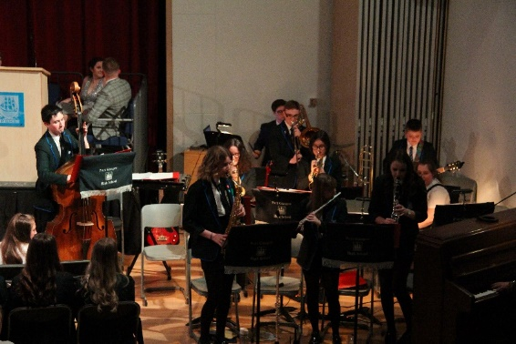
Music The music department offers a huge variety of extra-curricular activities throughout the year including wind band, junior and senior choirs, string group, recorder group, rock bands, soul bands, samba band, chanter group, instrumental ensembles and junior orchestra (including primary pupils).
These groups play at various venues throughout the year including primary schools, community centres, nursing homes and local churches.
The department runs various events throughout the year including talent shows and concerts. Pupils also compete successfully at the Inverclyde Festival and the Rotary Club Young Musician of the Year where we have gained seven first places in the last ten years.
The school is also well represented in Inverclyde Schools Choir, concert bands and string orchestras. Pupils have also played with the West of Scotland Schools Wind Band and Orchestra and performed in the Royal Scottish Academy of Music and Drama and in the Edinburgh International Festival. Pupils regularly achieve success in a wide range of external exams. We are lucky enough to have our own Recording Studio and hence can offer a variety of activities to support pupil skills in recording and performing.
The specific activities vary from session to session, but the summary below gives an indication of the type of activities often offered:
Chess Club
This club runs at lunchtime one day a week and is open to all pupils. In-house competitions are organised when numbers permit- including against staff.
Computing
Pupils come along to the relaxed atmosphere in the department to expand their practical abilities or take part in games tournaments over the course of the year.
Science Club
Senior pupils run a lunchtime club for those with a special interest in Science and Technologies

Port Glasgow High School
Handbook

Graphics Club
This club runs at lunchtime once a week and is open to all pupils. Pupils use software and manual graphics to produce brochures and leaflets.
Rights Respecting School Group
This group of students and staff are responsible for leading the school in their pathway to achieve Rights Respecting School Award. They carry out audits, surveys and deliver workshops to other pupils.
Eco-System Group
S1 and S2 pupils take part in enterprising activities including working towards Eco – school awards.
Charities
In recent years pupils have raised funds for several charities including Nguludi Secondary School (Malawi partner school), Ardgowan Hospice, Children in Need, Breast Cancer Awareness, Teenage Cancer Trust, Rotary Shoebox Appeal, Poppy Scotland, and RNLI.
Drama Clubs
There are after school Drama Clubs run by both our Drama department, and local youth workers. The School Drama Club performs at Assemblies as well as Finlaystone Estate, Inverclyde Schools Burns Supper, Inverclyde Holocaust Memorial Event.
School Show
Our previous shows include Legally Blonde, Calamity Jane, Disco Inferno and Addams Family. These involve a large number of pupils and staff taking part in all aspects of the production which was highly successful and thoroughly enjoyed by everyone.
The Campus Learning Resource Centre
On our shared campus we are very fortunate to have a superbly equipped library. It is very much a ‘hub’ of school life. The library is the ideal place for all information resources and for acquiring the study skills necessary for success in school and beyond:
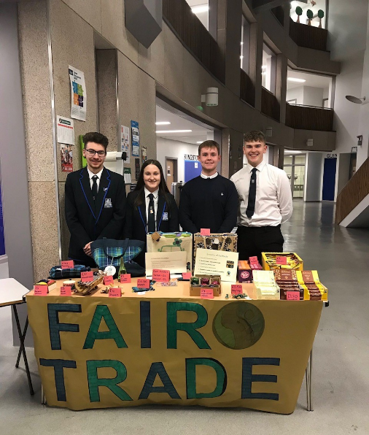
- There is a wide range of books which are continually updated by our librarian;
- The books on display at any one time are used to highlight and compliment work done in the class (e.g. if pupils are completing a science project, then relevant books are prominently displayed, themes including popular authors, festivals etc.);
- The library has a suite of networked PCs which allow access by pupils to vast quantities of knowledge (text, sounds, pictures, videos). They are able to learn in a most interesting and enjoyable way;
- Attached to the library, which contains information on a whole range of possible careers – prospectuses, videos, on line databases;
- Many classes are timetabled to utilise our Learning Resource Centre
- Comprehensive ‘information literacy skills’ induction for first years.

Port Glasgow High School
Handbook

Curriculum for Excellence
The aims of Curriculum for Excellence are that every child and young person should:
- Know they are valued and will be supported to become a successful learner, and effective contributor, a confident individual and a responsible citizen;
- Experience a traditionally broad Scottish curriculum that develops skills for learning, skills for life and skills for work, with a sustained focus on literacy and numeracy that encourages an active, healthy and environmentally sustainable lifestyle.
The experiences and outcomes under Curriculum for Excellence are written at five levels, with progression to qualifications described under the senior phase.
Level | Experiences and outcomes for most children or young people:
Early | In pre-school and in P1
First | By end of P4, but earlier for some
Second | By end of P7, but earlier for some
Third | In S1 – S3, but earlier for some  Fourth level broadly equates to SCQF level 4
Fourth
Senior | In S4 – S6 (leading to National Qualifications)

Courses in S1 – S3
Courses in years S1 – S3 will enable learners to progress through the experiences and outcome of Curriculum for Excellence. By the end of S3 every learner should demonstrate the outcomes in all Curriculum Areas at level 3 and most will have achieved those at level 4.
Curriculum Area | Subject(s) through which Experiences and Outcomes are learned
Mathematics and Numeracy | Mathematics and across other subjects
Language and Literacy | English, French and across other subjects
Social Subjects | Geography, History, Modern Studies
Sciences | Science, Biology, Chemistry, Physics
Technologies | Design and Technology, Computing, Home Economics
Expressive Arts | Drama, Music, Art & Design, Physical Education
Health and Wellbeing | Home Economics, Physical Education, Personal and Social Education
Religious and Moral Education | Religious Education, Personal and Social Education

Port Glasgow High School
Handbook

Skills for Learning, Life and Work
(Including Literacy, numeracy and health & well-being)
The skills and learner attributes which young people develop provide them with a sound basis for their development as lifelong learners in their adult, social and working lives, enabling them to reach their full potential. All young people are entitled to opportunities to develop skills for learning, life and work.
The skills include literacy, numeracy and associated thinking skills: skills for health and wellbeing, including personal learning planning, career management skills, working with others, leadership and physical co-ordination and movement skills: and skills for enterprise and employability.
Literacy
Literacy skills are developed through learning about language in English and French. In addition, literacy skills are developed in every other curricular area through talking, listening, discussing, presenting, reading and writing. We aim to provide young people with consistent experiences in each curriculum area.
Numeracy
Numeracy skills are developed through learning in Mathematics. In addition, numeracy skills are utilised in every other curricular area. We aim to provide young people with consistent experiences in each curriculum area through the use of shared strategies devised by our Mathematics Department.

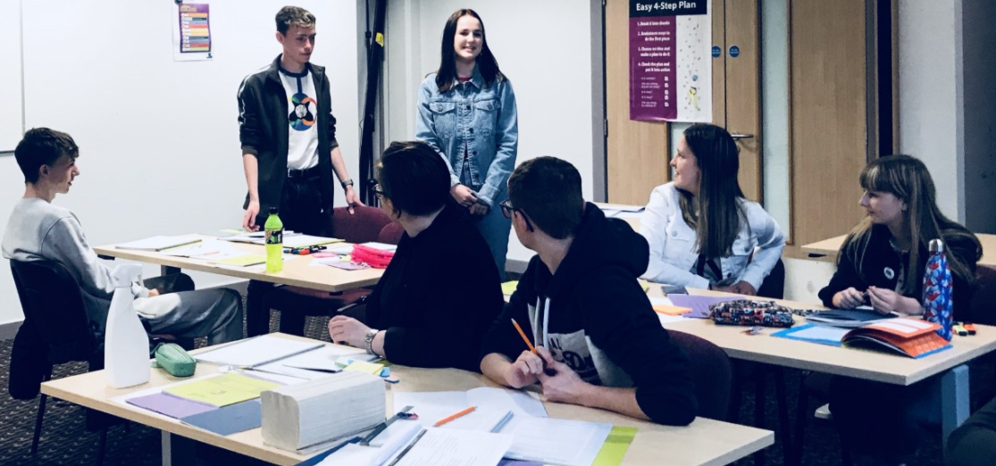
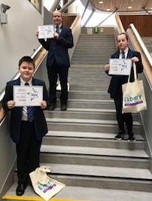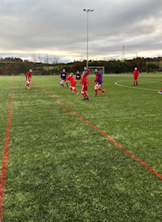

Port Glasgow High School
Handbook

Personal Learning Planning and Career Management
By talking about planning their own learning young people will develop the skills to:
- identify, discuss and reflect on their own evidence of learning
- use appropriate language for self-evaluation
- take responsibility for managing their own learning
- help to plan their own next steps in learning and set their own learning goals
- make informed choices and decisions about their future learning
As young people move into the secondary school they build these skills in personal planning to develop self-awareness and the confidence to gather and organise educational and occupational information, enabling them to better manage future learning and work pathways. Career management skills are developed through the personal and social education programme with support from an adviser from Skills Development Scotland.
Working with others
Skills in working with others and leadership may include planning and carrying out projects in small groups, sharing tasks and responsibilities, and being ready and willing to learn from and with others as well as on their own. Young people will learn to:
- recognise when they will do best by working with others, and when they need to work on their own
- have the courage of their convictions, knowing when and how to assert their own views
- act as a good team learner, knowing how to draw from the strengths of the group and also how to help build those strengths
- put themselves in other people’s shoes, to hear them accurately and enrich their own learning perspectives
- be open to other people’s smart ways of thinking and learning, picking up values and habits that develop their own learning
- agree and take responsibility for their contribution to group tasks, seeking and providing information
- evaluate the effectiveness of their own contribution to group tasks and activities
Health and Wellbeing
“Learning in health and wellbeing ensures that young people develop the knowledge and understanding, skills, capabilities and attributes necessary for mental, emotional, social and physical wellbeing now and in the future.”

Port Glasgow High School
Handbook

Broad General Education in S3
In S1 – S3 young people study subjects which give them a Broad General Education. They learn in subjects across eight curriculum areas in which experiences and outcomes are set out at Curriculum for Excellence Levels 3 and 4 in S3, young people will have the opportunity for some choice in the subjects they study to allow greater depth of learning in preparation for more specialisation in the Senior Phase.
A summary of the subjects undertaken/available throughout the Broad General Education is provided below:
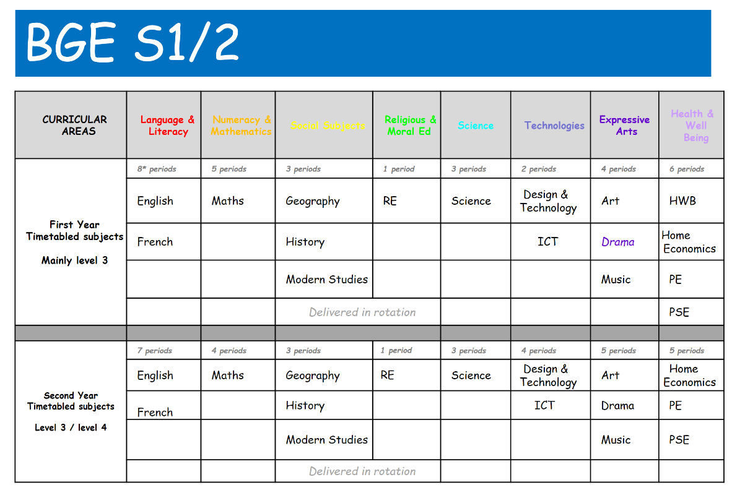

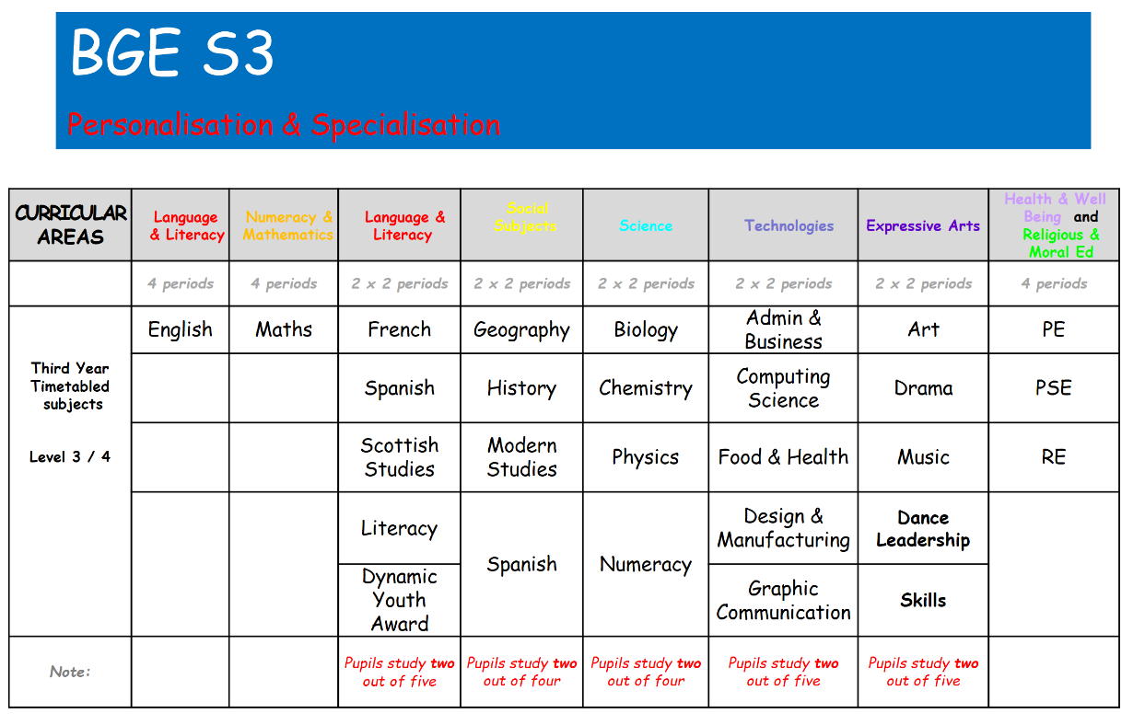

Senior Phase S4 – 6
All young people in Port Glasgow High School will be presented for Scottish Qualifications Authority (SQA) new National Qualifications at appropriate levels by the end of S5 (or earlier if leaving school or completing studies in that course). These qualifications are awarded at different course levels:
Higher same as previous Higher
National 5 equivalent to Intermediate 2 and Credit Standard Grade
National 4 equivalent to Intermediate 1 and General Standard Grade
National 3 equivalent to Foundation Standard Grade and Access 3
Pupils will generally be able to take different levels in different subjects.
Progress in learning will be regularly assessed. Young people will progress to the next level of the available course when they are ready.

S6
Achieved by end of S4
S5

Advanced Higher
Higher
National 5
National 5
National 4

Higher

National 3
National 5
National 4

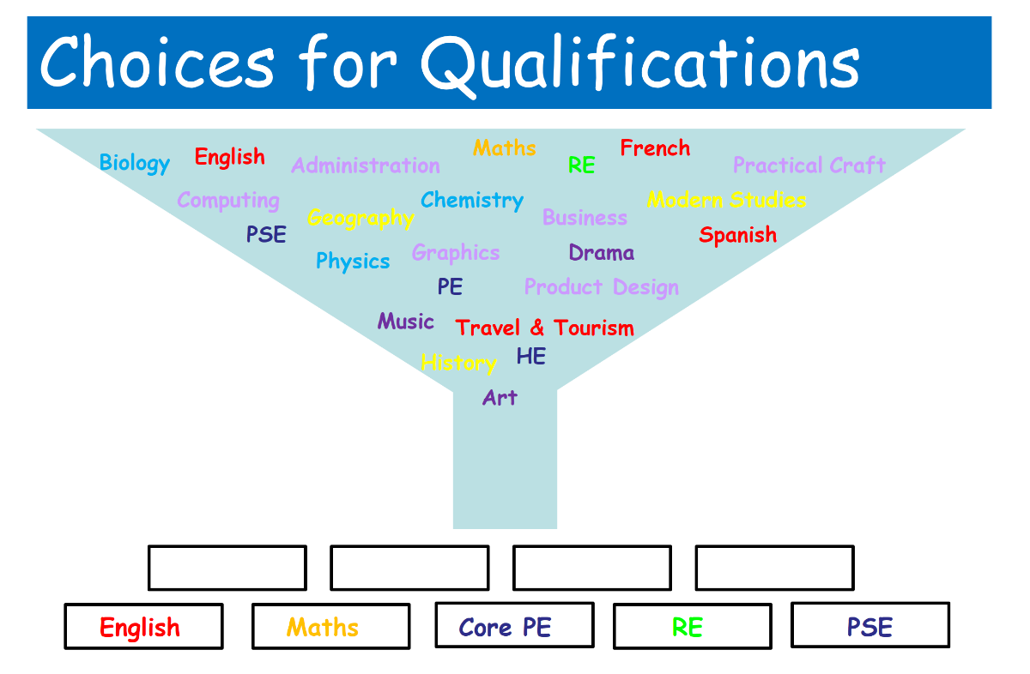

Port Glasgow High School
Handbook

Assessing Progress in Learning
Assessment is an integral part of learning within Port Glasgow High School. It is not only a matter of ‘tests’ or ‘exams’, although these are important. Assessment is for learning strategies are routinely used.
In Broad general Education (S1 – 3), learners are assessed in the normal course of their classwork to analyse progress towards attaining their targets. Learners also assess themselves and each other for the same purpose. Assessment takes many forms e.g. speaking, writing, making, doing, presenting, project work and practical tasks. There are no formal examinations, rather assessments are made and recorded at times suitable to departments and progress is judged at specific times during the year.
In the Senior Phase (S4 – 6), continuous assessment is supplemented by formal examinations, at some levels, and practical tests/investigations. Much of the work of National qualification courses is internally assessed by the school itself and forms part of the final award.
In addition to Unit Assessments for National Qualifications, Preliminary Examinations take place in National 5 and Higher courses. These give all pupils the chance to practice sitting a formal examination which matches the ‘real thing’ closely and it also gives them a formal diet of examinations which mirror the sort of timescales faced in May and June.
Reports to Parents/Parents’ Meetings
The results of assessments and the personal knowledge that a teacher gains about his/her learners is used to build up a profile from which the report sheets are completed.
Reports are issued to parents on a regular basis. Each year group receives a number of reports per year as summarised earlier.
Parents’ Meetings
One Parents’ meeting for each year group is held throughout the session to provide an opportunity for parents to come and discuss their child’s progress with his/her class teachers. At these meetings, a pupil’s strengths and next steps in learning, behaviour and effort can be fully discussed. Dates for these meetings are available at the start of each session on the school website and they are included in the Parent Pack which is emailed out.
Parents are welcome to call at the school at any reasonable time to discuss their child’s progress. An appointment with the appropriate Principal Teacher of Guidance should be made prior to the visit.
In addition, a ‘Help Your Child to Pass’ evening is held for parents of pupils in the Senior Phase (S4-6) and a Learning Showcase is held for parents of pupils in S1-2.
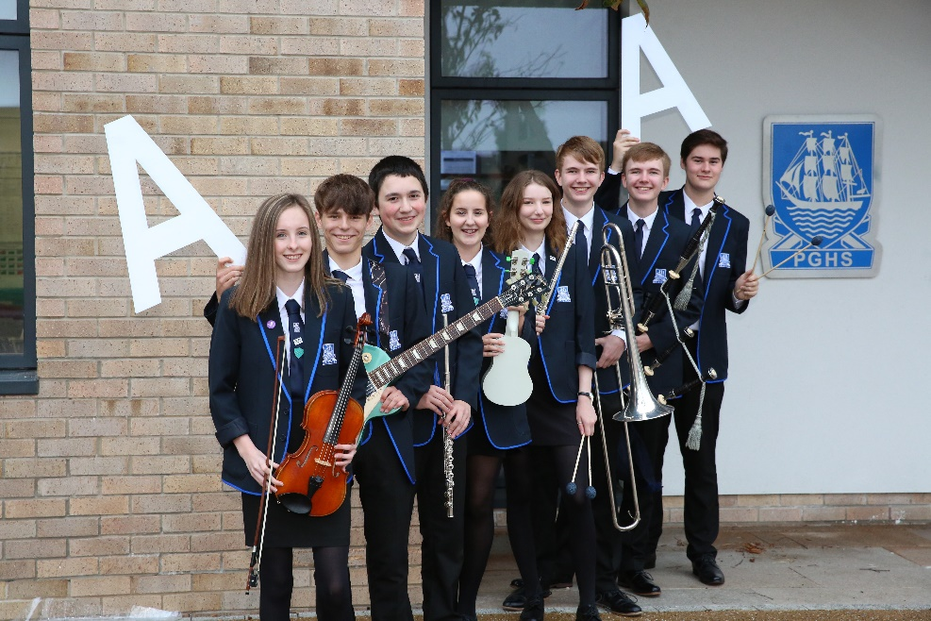

Port Glasgow High School
Handbook

Our Associated Primary Schools
While each school in Inverclyde is managed by its own Head Teacher and Senior Staff, this school is part of a cluster of schools working together to secure improvements and developments in agreed areas of priority. This cluster of schools involves Port Glasgow High School, and its associated Primary Schools and Early Years Establishments. (Craigmarloch School is also part of our Learning Cluster).
Kilmacolm Primary School Newark Primary School
Churchill Road Bridgend Avenue
Kilmacolm Port Glasgow
PA13 4LH PA14 5SU
Tel: 01475 715812 Tel: 01475 715600
Head Teacher: Mrs S McCredie Head Teacher: Mrs L McGugan

Primary – Secondary Transition
We wish to make the transition to secondary as smooth and enjoyable as possible.
Particular points of note are:
- There are regular meetings between our staff and Primary staff to ensure that there are good curriculum links for pupils.
- Our English, Mathematics, Science, French and PE courses are integrated with our primaries as part of the Curriculum for Excellence. This means that, for instance, a pupil leaves P7 in Mathematics and picks up at the exact level in S1, undertaking a course that meets his/her needs. Development continues within the other curriculum areas.
- P6 and P7 pupils visit the school periodically throughout the year to make use of specialised facilities, and some secondary subject specialists visit Primary classes to work with pupils and staff. We have managed to expand on this provision over the past few years for P7 pupils.
- Our Support for Learning and Guidance staff make regular visits to the primaries to find out the needs of individual pupils and see various activities and displays.
- A Learning Showcase is arranged during the autumn for parents and children to tour the buildings, meet staff and pupils and see various activities and displays.
- Primary 7 pupils visit the school in June for two formal induction days. The pupils follow a normal secondary timetable, meet new classmates, use their social areas and get to know their teachers (especially their guidance teacher). Information Evening for parents also takes place at this time.
- Young people with specific support needs have additional opportunities to visit the school. Parents are involved in meetings to ensure that needs can be met through an individual learning plan.

Port Glasgow High School
Handbook
Partnership with Parents
It is well known that young people achieve best in their learning when they are actively supported by their parents and other adults. Although we want them to become confident, independent learners they all need help to achieve this. As a parent you can be involved by:
- Staying informed about what is happening in the school (website, letters, newsletters)
- Talking to your child about what they are learning (ask them about their learning journal)
- Encourage them in their Home Learning (help them organise their time and space)
- Contact your child’s Principal Teacher of Guidance if you have a question or concern
- Attend Parents’ Meetings to speak to school staff
Further information on the school’s and Inverclyde Council’s Parent Partnership Strategies can be found on the school website.
Parent Forum and Parent Council
Every Parent is a member of the Parent Forum, and eligible to be involved in the life of the school.
Scottish Schools (Parental Involvement) Act 2006 led to the establishment of Parent Councils in primary, secondary and special schools. The act recognises the vital role that parents play in supporting their children’s learning. It places a duty on authorities to promote the involvement of parents in children’s education and the wider life of the school. It aims to help parents to be :-
- Involved with their child’s education and learning
- Welcomed as an active participant in the life of the school
- Encouraged to express their views on school education generally

The school is fortunate to have an active Parent Council made of volunteers who want to be actively involved in representing Parent views and supporting the school. Any member of the Parent Forum can become a member of the council. The Parent Council Office Bearers are:
Chair: Mrs M Williams (Acting Chair)
Clerk to the Council Vacant
Treasurer Vacant
The parent council meets approximately every 6 weeks. The Head Teacher attends to advise the Council. Minutes from meetings are available from request. Meeting dates are advertised on the school Facebook and Twitter Page. An invitation to the AGM is sent out to every parent with the Parent Pack at the start of each school session.
The Parent Council, as a statuary body, has the right to information and advice on matters which affect children’s education. Information about the Parent Council, including its constitution is available on the school website or from the school.

Port Glasgow High School
Handbook
Community Partnerships
There is an African saying that “it takes a whole village to bring up a child”, this is true in our culture too. The school works closely with a range of community partners to provide increased learning opportunities and support for our young people. The school may share information with the Community Wardens to assist in promoting the wellbeing of pupils in the community. If you prefer the school not to share information with the warden’s service, please contact the Head Teacher. The school also contributes to a number of local organisations. Some of our partners are:
Community learning and Development, Active Schools Team, our Sports Leaders support all local Primary Schools, the Beacon Arts Guild, Finlaystone Estate, Inverclyde Music Service, Princess Diana Trust, BBC Education, Thick Skin Theatre Company, Rusty Boat Theatre Company, Lomondview Academy, Eco-schools, the Royal Horticultural Society, Greenock Burns Club, the Inverclyde Festival, Inverclyde Student Forum, UNICEF (Rights Respecting School Award), National Violence Reduction Unit (Mentors in Violence Prevention MVP), The Outward Bound Trust, Inverclyde Youth for Christ, St Stephen’s High School, Craigmarloch School, Greenock Morton Community Trust, Scottish Football Association, Action for Aspergers.
Spiritual, Social, Moral and Cultural Values
Religious education and religious observance play a key role in developing spiritual, social, moral and cultural values.
Religious Education
All pupils in S1 to S4 receive one period of Religious Education every week. The programme encourages pupils to:
- Recognise religion as an important expression of human experience
- Reflect on and respond to the values and beliefs of religious traditions within our community and beyond
- Be aware of the practical consequences of religious commitment
- Evaluate, and thereby confirm, deepen or come to their own understanding of the meaning, value and purpose of life
Through Religious Education, pupils will be assisted to develop positive attitudes and to consider, and where appropriate explore, generally accepted values.
Religious Observance
By Religious Observance we mean:
‘community acts which aim to promote the spiritual development of all members of the school community and express and celebrate the shared values of the school community.’
The aims of religious observance are defined as:
‘to promote the spiritual development of all members of the school community, to express and celebrate the shared values of the school community.’
There are regular whole school / House Assemblies and parts of these are conducted by our school Chaplaincy Team which includes representatives from a range of churches;
Jen Paton (Inverclyde Youth for Christ) Rev Ian Stewart (Church of the Nazarene) Pastor Andy Lunn (Mount Zion)
In addition the school is supported by a Chaplaincy Team. Parents have a right to withdraw their child from religious education and / or religious assemblies. We have hope that after reading our policy (see appendix) you will see that this aspect of school life will be beneficial to your child, however you are welcome to contact the Head Teacher to discuss any request to withdraw from the religious education / religious observance.

Port Glasgow High School
Handbook

Appendices to the School Handbook

Contents

School Attainment Results
Pupil Code of Conduct
Religious Observance Policy
Inverclyde Council Policies:
School Uniform
Travel to School
School Meals
Additional Support for Learning
Child Protection and Equalities
Useful Contact details
Data Protection & GDPR

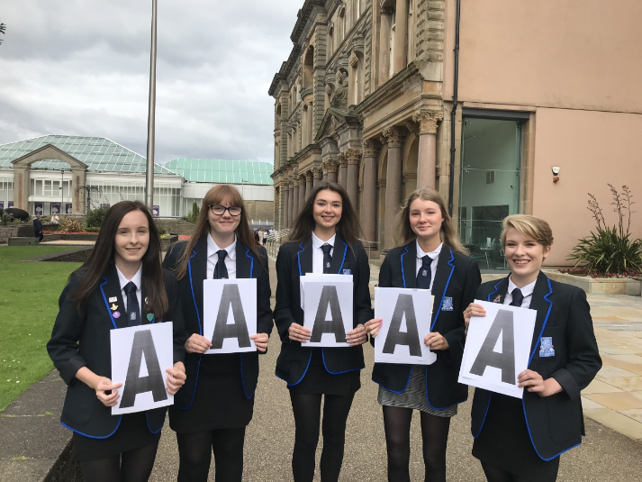
Port Glasgow High School
Handbook

Summary of PGHS Senior Phase Attainment Results & Achievement

SQA Results – 2020
Percentage of S4 pupils attaining 5 National 5s:
2017- 30%, 2018 - 42%, 2019 - 45%, 2020 - 45%
Percentage of S5 pupils achieving 5 Highers:
2017- 4%, 2018- 9%, 2019- 17%, 2020 - 17%
Percentage of S5 pupils achieving 3 Highers:
2017-20%, 2018 - 24%, 2019 - 38%, 2020 - 35%
Percentage of S6 achieving at least 3 Highers:
2017 - 34%, 2018 - 28%, 2019 - 37%, 2020 - 47%
Key Achievements – Session 2019/20
We are very proud of the improvements we have made in relation to our Senior Phase Attainment. In addition to this, we now outperform our comparator schools in relation to Positive Destinations, we have also increased the % of learners going direct to University. A number of our young people have achieved notable success in wider achievements such as Duke of Edinburgh, Young Enterprise and a variety of extra curricular and sporting activities.
A full summary of progress made on school improvement is available in our Standards and Quality Report which is published on the school website each year.

Port Glasgow High School
Handbook
School Information
Port Glasgow High School
Pupil code of Conduct
START OF LESSONS
- Arrive at class on time
- Remove outdoor clothing
- Be prepared to begin work
- Bring necessary equipment
- Take out Learning Journal
DURING LESSONS
- Take responsibility for your own learning
- Follow class teacher’s instructions
- Respect each other
- MP3/4 players should be switched off and out of sight (this includes headphones)
END OF LESSONS
- Reflect on your learning and update your Learning Journal
- Pack up when instructed and wait until dismissed by your teacher
- Make your way to your next class quickly and safely following any one way systems that are in place
WHOLE SCHOOL RULES
- Walk on the left
- Mobile phones should be switched off and out of sight within the school building
- Food and drink should be consumed in the social areas and canteen only
- Litter must be placed in the bins provided
- Hats and hoods must be removed within the school building
- Pupils have access to the social areas and canteen only during interval and lunchtime No pupil should be on the upper floors unless visiting a teacher
- Fire Exists are to be used in emergencies only

Port Glasgow High School

Religious Observance Policy

What is Religious Observance?

“Community acts which aim to promote the spiritual development of all members of the school’s
Community and express and celebrate the shared values of the school community”

This is how Religious Observance is described in the Scottish Government’s advice to schools (Circular 14/2005 and updated February 2011)

We recognise that there is a spiritual element to being human, because we all have the capacity to experience things like: awe, wonder, mystery, a sense of care for others and the environment. We also recognise that it is important to grow in this way as well as physically, mentally and emotionally. In the school, we contribute to this growth by providing our young people, and the adults who support them, with opportunities and time to reflect on what it means to be a human being living in the school community. We call this our Time for Reflection.

Why Time for Reflection?

We recognise that Time for Reflection is an important part of helping grow a better understanding of the things we value in our school; Confidence, Learning, Equity, Ambition, Respect and as a result help our young people become Successful Learners, Confident Individuals, Responsible Citizens and Effective Contributors.

When will we take Time for Reflection?

The Scottish Government advises that there should be at least six occasions during a school session in addition to the celebration of traditional festivals at Christmas and Easter. Our House Group Assemblies and Merit Award Ceremonies will continue to be used as opportunities for reflection.

What is involved in Time for Reflection?

We will still take the opportunity to hold Assemblies, sometimes for the Whole School community and at other times for Year Groups or House Groups. However, we will also give opportunities for young people to participate in smaller groups to explore ideas in more depth through discussion and active learning. A programme of events will be drawn up each session.

During Time for Reflection events young people will be presented with a range of things to consider. These could be from the natural world, from life stories, they may be questions of what is right and wrong. They may come from the past, the present, or from fictional stories but they will always challenge how we think, what we do and how we relate to people.

Who will lead Time for Reflection?

A team has been set up consisting of teachers, support staff and senior pupils who will plan the events. They will be supported and advised by the school’s Chaplaincy Team (describe earlier).

The activities will be led by different people depending on what is planned. Senior Staff, Class Teachers, Young People and Visiting Speakers will all be involved at different times and in different ways.

Is Time Reflection for Everyone?

In recognising that Time for Reflection is an important part of growing as people with well-developed values and beliefs, we believe that everyone in our school community should be involved.

We recognise that in a non-denominational school we have people from a variety of religious backgrounds and with no religious background. We think that Time for Reflection will be suited to everyone irrespective of their background, because it is about developing our capacities as spiritual beings.

The Scottish Government gives the right to parents to withdraw their child from Religious Observance (Education (Scotland) Act 1980). Parents wishing to exercise this right are asked to contact the Head Teacher.

How is Time for Reflection different from RE (Religious and Moral Education)?

Curriculum for Excellence recognises Religious and Moral Education as one of the 8 Curriculum Areas
which make up the entitlement to a broad general education for every learner. These paragraphs from the Curriculum for Excellence advice paper on Religious and Moral Education explain why:

“Scotland is a nation whose people hold a wide range of beliefs from the many branches of the Christian faith represented throughout the land to the world’s other major religions and to beliefs which lie outwith religious traditions. Such diversity enriches the Scottish nation and serves as an inspiring and thought-provoking background for our children and young people to develop their own beliefs and values.”

“Children and young people must become aware that beliefs and values are fundamental to families and to the fabric of society in communities, local and global. There is an intrinsic value in learning about religion as well as learning from religion, as children and young people develop their understanding of diversity in our society and their own roles in it. The skills of reflection and critical thinking and an enhanced understanding of the beliefs and values of others are all crucial in assisting this process”

How will we know young people are benefitting from Time for Reflection?

We constantly evaluate what we do as a school to identify what we do well and what needs further development. Time for Reflection and its impact on developing young people will be an ongoing area focussed attention.

Inverclyde Council: School Uniform

Given that there is substantial parental and public approval of uniform, schools in Inverclyde are free to encourage the wearing of school uniform. In encouraging the wearing of uniform, account must be taken in any proposals to prevent any direct or indirect discrimination on the grounds of race or gender. Any proposals will be the subject of widespread consultation with parents and pupils. Against this background it should be noted that it is the policy of the Education and Life Long Learning Committee not to insist on pupils wearing uniform or having specialist items of clothing as a prerequisite to their attending and engaging in all of the activities of the curriculum. Under no circumstances will pupils be deprived of any educational benefit as a result of not wearing uniform and, in particular, pupils will not be denied access to examinations as a result of not wearing school uniform.

There are forms of dress which are unacceptable in school, such as forms of clothing which:

- Potentially encourage factions (such as football colours)
- Could cause offence (such as anti-religious symbolism or political slogans)
- Could cause health and safety difficulties, such as loose fitting clothing or clothing made of flammable material (for example track suits in practical classes), dangling earrings and other body piercings.
- Carry advertising, particularly for alcohol or tobacco, and could be used to inflict damage on other pupils or be used by others to do so.

The council is concerned at the level of claims being received regarding the loss of children’s clothing and/or personal belongings. Parents are asked to assist in this area by ensuring that valuable items and unnecessarily expensive items of clothing are brought to this establishment. Parents should note that the authority does not carry insurance to cover the loss of such items and any claims submitted are likely to be met only where the authority can be shown to be negligent.

Parents should note that the activities the children may become involved in may be restricted because health and safety requirements state that jewellery of any kind must not be worn where children are undertaking physical activities. This includes jewellery worn as a result of body piercing.

NOTE – Help with clothing

Parents of children receiving one or the following benefits will normally be entitled to monetary grants for footwear and clothing for their children:

- Income Support
- Income-based Job Seeker’s Allowance
- Child Tax Credit, but not Working Tax Credit, and where income is less that £15860 (as assessed by the Inland Revenue)
- An asylum seeker receiving support under Part VI of the Immigration and Asylum Act 1999
- Any income related element of Employment and Support Allowance
- Parent or carer is in receipt of Working Tax Credit with an income below the threshold for receipt of maximum Working Tax Credit (see attached leaflet on clothing grant and free school meals)

Inverclyde Council: Travel to School

The council has a policy of providing free transport to secondary pupils living more than two miles from their local school by the recognised shortest walking route. This policy is more generous than the law requires. This means that the provision of transport could be reviewed at any time. Parents who consider that they are eligible should obtain an application form from the school or education office. These forms should be completed and returned before the end of February, for those pupils beginning school in August, to enable the appropriate arrangements to be made.

Applications may be submitted at any time throughout the year, but may be subject to delay whilst arrangements are made. The appropriate officer has permission, in certain circumstances, to grant permission for pupils to travel in transport provided by the authority, where places are available and no additional costs are incurred.

Where free transport is provided it may be necessary for pupils to walk a certain distance to the vehicle pick up point. Walking distance in total, including the distance from home to the pick up point and from the drop off point to the school in any one direction, will not exceed the authority’s limits (see above paragraph).

Pick Up Times for Port Glasgow High School

It is the parents’ responsibility to ensure that their child arrives at the pick up point in time. It is also the parents’ responsibility to ensure their child behaves in a safe and responsible manner whilst boarding, travelling and alighting from the vehicle. Misbehaviour could result in a child losing the right to free transport.

The main boarding points and times for pupils are as follows, it is advisable to plan for a window of 5 mins on either side:

Gibshill – Leven Road – 8.24am
Port Glasgow – Bogston Station – 8.29
Glen Avenue – 8.43am
Kilmacolm etc - Quarrier’s Village – 8.20am
Kilmacolm Cross – 8.32am

After school, all buses assemble in the bus bay and to ensure the safety of pupils, janirots are on duty each day. The school has no direct control over transport arrangement. The school would, however, wish to be kept informed of any difficulties.

Education Services does not provide transport for pupils in receipt of a placing request other than exceptional circumstances.

Senior pupils who travel to any other school out-with the town as part of their agreed courses will have transport provided free of charge to take them to the other establishment and return to Port Glasgow High School.

School Meals

Parents of children receiving one or the following benefits will normally be entitled to monetary grants for footwear and clothing for their children:

- Income Support
- Income-based Job Seeker’s Allowance
- Child Tax Credit, but not Working Tax Credit, and where income is less that £15860 (as assessed by the Inland Revenue)
- An asylum seeker receiving support under Part VI of the Immigration and Asylum Act 1999
- Any income related element of Employment and Support Allowance
- Parent or carer is in receipt of Working Tax Credit with an income below the threshold for receipt of maximum Working Tax Credit (see attached leaflet on clothing grant and free school meals)

Please visit our website for a copy of the most recent leaflet outlining arrangement to apply for Free School Meals and clothing grant.

In Home Economics, pupils prepare a variety of food. If your child is unable to eat certain foods for medical principled or religious reasons please contact the Principal Teacher of Home Economics (Mrs Cameron) in order that appropriate adjustments can be made.

READ, WRITE, COUNT

The Read, Write, Count programme aims to support parental engagement in literacy and numeracy. Gift bags are distributed annually to all P2 and P3 pupils in Scotland by Scottish Book Trust. The gift bags contain essential literacy and numeracy materials to support children’s learning, as well as advice and support to parents.

Studies show a direct link between a strong family learning environment and progress in reading, writing and counting. In addition to the parent guide included in the gift bags, the Parent Club website (https://www.parentclub.scot/) offers a range of hints, tips and advice to help parents engage in their child’s learning.

FIRST MINISTER’S READING CHALLENGE

The First Minister’s Reading Challenge is an inclusive, exciting programme for all children – fostering a love of reading for pleasure. Research shows that reading for pleasure is crucially important for children’s development.

The Challenge is open to all local authority and independent primary and secondary schools across Scotland, as well as, libraries and community groups. You can find out more information on the Challenge and also how schools can register to take part here: https://www.readingchallenge.scot/

A reading app called Bookzilla, aimed at S1-S3

Inverclyde Council: Additional Support for Learning
The Education (Additional Support for Learning) (Scotland) Act 2009 sets out the provision which each local authority must make for young people with additional support needs:
A child or young person’s needs are identified at the earliest possible stage and can be met in a number of ways, for example by adaptions to the curriculum or learning environment, as well as input from the Support for Learning Teacher and on occasion support from visiting specialists. The appropriateness of the support is determined through a process of assessment, planning and monitoring, working jointly with parents and carers and is regularly reviewed.
Learning outcomes for children and young people with additional support needs are set in a plan and all educational establishment hold regular review meeting with parent and carers to determine needs and the most appropriate supports. Everyone’s views are equally important in order to consider what is currently working and how to determine next steps
Children and young person’s needs are identified in a number of ways, and the process of assessment is an ongoing, shared process with partnerships with parents and carers at the forefront. On some occasions health service staff or other partner agencies make children known to Educational Services. Other additional support needs may be notified to Educational Services by parents themselves or identified by one of a range of staff working closely with the child.
Some children and young people will have additional support needs arising from complex or multiple factors which require a high degree of co-ordination of support from both education and other agencies in order that their needs can be met. In these cases, the school will hold a meeting to decide whether the child or young person meets the criteria for a co-ordinated support plan.
The coordinated support plan is a statutory document which ensures regular monitoring and review for those children and young people who have one.
You have the right to ask the education authority to establish whether your child needs a coordinated support plan. Your child can make this request themselves, if they are aged 16 or over. You and your child, if they want to, will attend a meeting with staff at their school. Other professionals from different agencies who may be involved in providing support for your child will also attend. If your child does not want to attend meetings or feels unable to, their views must still be sought and considered.
Inverclyde’s mediation service can be accessed by contacting Tony McEwan, Head of Culture, Communities &Educational Resources at the address below:
Education Services, Wallace Place, Greenock, PA15 1JB
Further information, advice support to parents of the children and young people with Additional Support Needs is available from the following organisations:
Children in Scotland: Working for children and Their Families, trading as “Enquire – the Scottish advice and information service for additional support for learning”, a charitable body registered in Scotland under registration number SC003527 www.enquire.org.uk
Scottish Independent Advocacy Alliance, a charitable body registered in Scotland under registration number SC033576 www.siaa.org.uk
Scottish Child Law Centre, a charitable body registered in Scotland under registration number SCO12741 www.sclc.org.uk/

Inverclyde Council: Child Protection

Inverclyde Council Education Services has Child Protection Guidelines and Procedures which all schools and establishments are required to follow. Education Services work very closely with other agencies namely Strathclyde Police, Social Work Services, NHS Greater Glasgow and Clyde and the Children’s Reporter to support children. Common responsibilities of all staff are to protect children from abuse and exploitation, to respond appropriately when abuse is identified, and to ensure whenever possible that all children are able to exercise their right to be raised in a warm, stimulating and safe environment with the support of staff, their families and carers.
If you have a concern regarding the safety of a child, please contact the Head Teacher.

Inverclyde Council: Equality Statement
‘Inverclyde Education Service is committed to ensuring that no children or members of staff or service users receive less favourable treatment on any ground including gender, race, disability, age, sexual orientation, religion or belief. We have a moral, social and legal obligation to mainstream and put equality at the heart of everything we do. We aim to promote a culture in which equality of opportunity exists for all. We are opposed to all forms of discrimination, direct or indirect, and aim to eliminate all discriminatory practices. We will ensure that, in our schools and other educational establishments, equality permeates the curriculum and underpins all our policies and practices in terms of access to education. We must ensure that all our children achieve their full potential to develop physically, emotionally and academically. Finally, we believe that equality and inclusion should be a given right, where everyone is valued and treated with respect.’

Port Glasgow High School

Additional Information: Useful Websites
Curriculum Advice and National Qualifications
Curriculum for Excellence http://www.educationscotland.gov.uk/parentzone/ce
National Qualifications http://www.sqa.org.uk/sqa/41292.html
Useful Addresses and Telephone Numbers
Corporate Director of Education and Communities
Ruth Binks
Inverclyde Council
Municipal Buildings
Clyde Square
Greenock
PA15 1LY
Tel (01475) 712761
Inverclyde Council Local Councillors
Ward 1: Cllrs C Curley, S McCabe, D Wilson
Ward 2: Cllrs J MacLeod, D MacKenzie; R Moran
Convener of the Education and Communities Committee:
Cllr. Jim Clocherty
All can be contacted at:
Inverclyde Council SDS Careers Office
18-20 Laird St Municipal Buildings
Greenock Clyde Square
PA15 1LB Greenock
Tel (01475) 721271 PA15 1LY
Tel (01475) 717171
Community Learning and Development
Community Learning and Development
1 Aberfoyle Road
Greenock, PA15 3DE
Tel (01475) 715450
Port Glasgow High School

General Data Protection Regulation and Data Protection Act 2018
Information on children and parents is stored on a computer system and may be used for teaching, registration, assessment and other administrative duties. In processing personal information, Inverclyde Council must comply with the General Data Protection Regulation and Data Protection Act 2018.
For further information, please refer to:
http://www.inverclyde.gov.uk/site-basics/privacy

Important Note
Although this information is correct at the time of publication, there could be changes affecting any of the matters dealt with in the document:
- Before the commencement or during the course of the school year in question
- In relation to subsequent school years

