Week 1 | Monday | Tuesday | Wednesday |  | Thursday | Friday
Option 1  (Red)  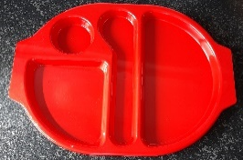 | Pork sausages  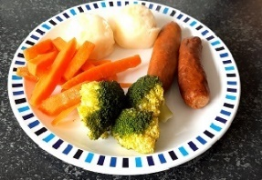 | BBQ Chicken burger  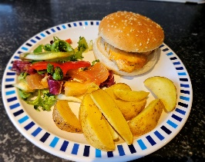 | Mince Pie  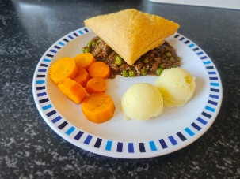 |  | Chicken curry with rice  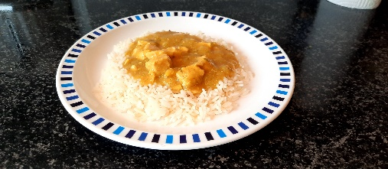 | Fish and Chips  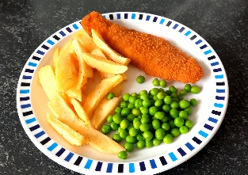
Option 2  (Blue)  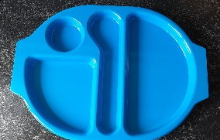 | Salmon bites  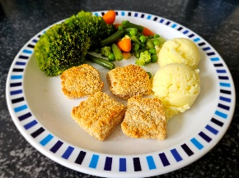 | Homemade cheese and tomato pizza(v)  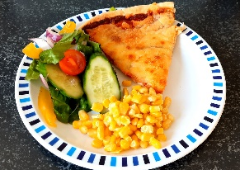 | Quorn Burrito wrap(v)  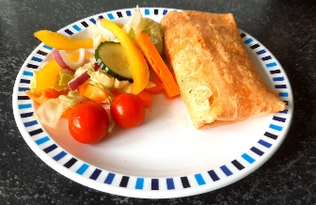 |  | Tomato and basil pasta(v)  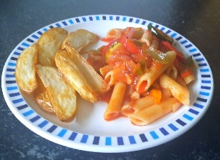 | Cheese Panini(v)  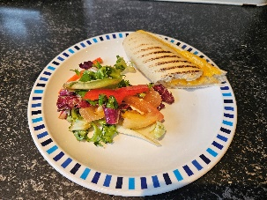
Option 3  (Yellow)   | Cheese Sandwich (v)  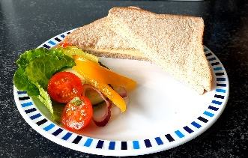 | Chicken Wrap  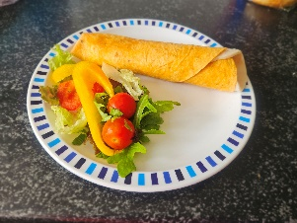 | Cheese Roll  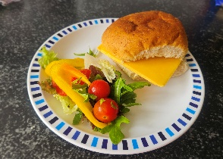 |  | Chicken Sandwich  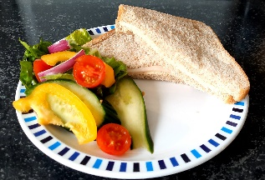
Option 4  (Green)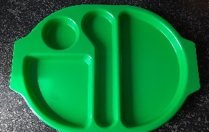 | Baked Potato with Cheese (v)  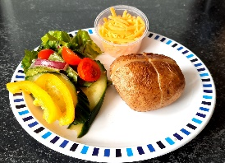 |  |  | Baked Potato with Tuna Mayo  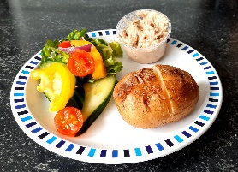
*Pictures are for illustrative purposes only, appearance may differ between schools, and vegetables/salad offered will vary.

Week 2 | Monday | Tuesday | Wednesday |  | Thursday | Friday
Option 1  (Red)  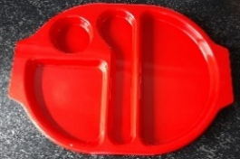 | Chicken burger  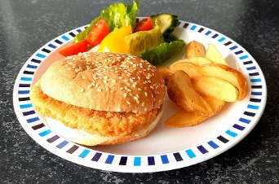 | Chicken Meatballs with pasta  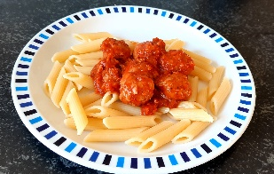 | Steak pie with mash potato  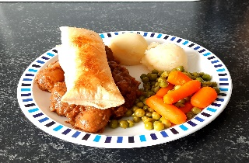 |  | Chicken Curry with rice | Fish and Chips
Option 2  (Blue) | Macaroni Cheese(v)  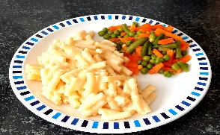 | Quorn dipper with mash potato (v)  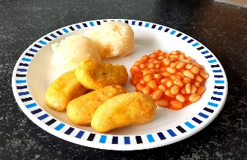 | Quorn Cajun Pasta(v)  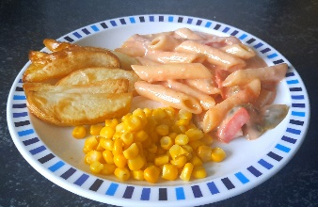 |  | Homemade cheese and tomato pizza(v) | Cheese Panini(v)
Option 3  (Yellow) | Cheese Sandwich (v) | Chicken Wrap | Cheese Roll |  | Chicken Sandwich
Option 4  (Green) | Baked Potato with Cheese(v) |  |  | Baked Potato with Tuna Mayo
*Pictures are for illustrative purposes only, appearance may differ between schools, and vegetables/salad offered will vary.

Week 3 | Monday | Tuesday | Wednesday |  | Thursday | Friday
Option 1  (Red) | Chicken Meatballs with pasta | Roast Turkey  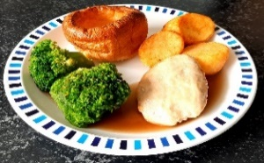 | Pasta Bolognaise  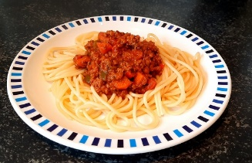 |  | Beef burger with wedges  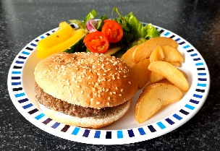 | Vegan sausage roll with chips(v)  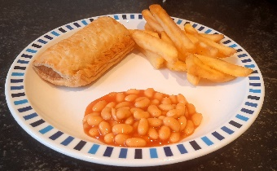
Option 2  (Blue) | Quorn Burrito wrap(v) | Quorn dippers with mash(v) | Homemade cheese and tomato pizza(v) |  | Macaroni Cheese(v)  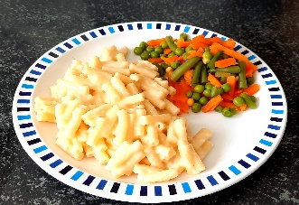 | Cheese Panini(v)
Option 3  (Yellow) | Cheese Sandwich (v)  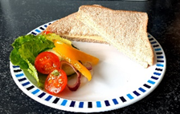 | Chicken Wrap | Cheese Roll(v) |  | Chicken Sandwich
Option 4  (Green) | Baked Potato with Cheese(v)  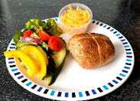 |  |  | Baked Potato with Tuna Mayo(v)  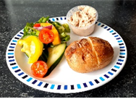
*Pictures are for illustrative purposes only, appearance may differ between schools, and vegetables/salad offered will vary.

