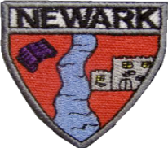
Darcy Lacey Lyle Blake Charlotte Emily Callie-Rose Keigan Lia
Oyinkansola Alexander Ella Remi Kyle Kiahn Daisy John

P2b Newsletter
Connor Arron Robbie Ben Jace Zoey Samuel Jacob
Ciara

Primary 3A Newsletter November 2022

Social Subjects
Our topic this term is Under the Sea. Our focus for this topic will be pollution and the children will learn ways to help reduce pollution in seas and oceans.
Literacy: We will continue to use our Active Literacy strategies to help us Say, make/break, blend, read and write a range of words with our new sounds.
This term P3a will be focussing on Instructional writing. The children will be learning to sequence the steps in the correct order, use bossy verbs and time connectives to make their instructions clear.
In reading, the children will continue to develop their confidence in blending and word attack skills to improve their fluency and expression when reading aloud.

Other Curricular Areas 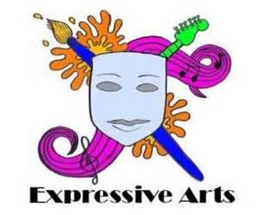

Science: This term we are learning about floating and sinking. We will link this to our topic Under the Sea. RME: This term we will be focusing on Judaism and will be learning the story of David. We will also be looking at the Christmas story.
Expressive Arts- We will experiment with percussion instruments this term.


Numeracy:
P3 will be learning to identify o’clock, half past, quarter past and quarter to times on analogue and digital clocks.
P3 will be learning to add and subtract with tens and ones using different methods. We will also continue with identifying and sequencing numbers to 1000.
P3 will be learning about symmetry and will describe why shapes, pictures and patterns are symmetrical.

How you can help at home…
Spelling homework will be issued on a Monday. Children should complete one spelling activity per night.
The children have also been issued with a Bug Club reading book to practise at home. Please ensure books are returned to class.
Spelling homework should be handed in on Friday.

Health & Wellbeing:
This term our focus will be Road Safety. The children will learn how to keep safe when travelling and explain how to follow the Green Cross Code to cross the road safely.
Our PE days are Tuesdays and Thursdays. In PE this term we will be focussing on team games and gymnastics. Children can wear relaxed uniform on these days. Please ensure that all jewellery is removed before school on gym days.

We would appreciate if you could take the time to fill out the following surveys.
https://nn.typeform.com/to/erHp5QvJ
http://www.nationalnumeracy.org.uk/challenge/newark

P3 Stay and Play date this term is Friday 11th November. We look forward to seeing you in our class at 2pm until home time.

If you have any questions, please do not hesitate to get in touch. You can also keep up with our learning by following our Twitter page @NewarkP3_A. Many Thanks Mrs Stewart & Mrs McLennan.

