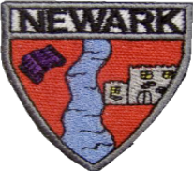
Tylan Josh Fraser Aarya Jay Paul Rayah Abbigail Jace Mason Olivia Callum Ella Mia Logan Mikolaj

Tylan Josh Fraser Aarya Jay Paul Rayah Abbigail Jace Mason Olivia Callum Ella Mia Logan Mikolaj
P2b Newsletter
Ben Ollie Amelia Andrew Ruari Helena Arjun Leia David

Primary 3/2 Newsletter November 2022

Social Subjects
Our topic this term is The Owl Who is Afraid of the Dark and Nocturnal Animals. This has been planned by the children through our floorbook. Our science based topic will also look habitats, food chains, dark and light.
Literacy: Both stages will continue to use our Active Literacy strategies to help us Say, make/break, blend, read and write a range of words with our new sounds. P2 will be focusing on using capital letters, full stops and connectives in our writing. We will also be further developing our letter formation. P3 will be focusing on developing their VCOP – Vocabulary, Connectives, Openers and Punctuation. In reading, the children will continue to develop their confidence in blending and word attack skills to improve their fluency and expression when reading aloud. P3 will further develop their comprehension skills.

Other Curricular Areas 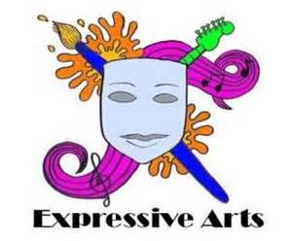

Science: This term as well as topical science, we will be learning about electricity. RME: This term we will be focusing on Judaism and will be learning the story of David. We will also be looking at the Christmas story. Art: We will be investigating colour through colour wheels, tone and texture. We will also be studying Van Gough’s Starry, Starry Night painting. Technology: This term we will be creating paper models.


Numeracy: P2 will be developing their number bonds within 20 using subtraction and addition. They will be learning to skip count in 2s, 5s and 10s. P3 will be learning to add and subtract with tens and ones using different methods. We will also continue with identifying and sequencing numbers to 1000. Both stages will be developing their knowledge of symmetry. P2 will be learning to tell the time on a clock at o’clock and half past. P3 will be learning o’clock, half past, quarter past and quarter to times.

How you can help at home…
It is important that we learn our sounds and spelling words at home. We will send a range of fun activities you can try at home to help your child practice their sound for the week. Our reading will be on Bug club. We would be most grateful if you could please label all uniforms with a biro pen to allow us to return them to the rightful owner.

Health & Wellbeing: During check-in, we will continue to develop our listen and talking skills by sharing our feelings and listening to others. We will continue to build our emotional vocabulary as we learn how to name more feelings. This term our focus will be Road Safety. The children will learn how to keep safe when travelling and explain how to follow the Green Cross Code to cross the road safely. Our PE days are Mondays and Wednesdays. In PE this term we will be focussing on team games and ball skills. Children can wear relaxed uniform on these days. Please ensure that all jewellery is removed before school on gym days.

We would appreciate if you could take the time to fill out the following surveys. https://nn.typeform.com/to/erHp5QvJ http://www.nationalnumeracy.org.uk/challenge/newark
If you have any questions, please do not hesitate to get in touch. You can also keep up with our learning by following our Twitter page @MrsLow98. Miss Hill is in class on Fridays and can be followed on Twitter @_miss_hill__ Many Thanks Mrs Low.

