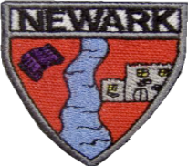
Tylan Josh Fraser Aarya Jay Paul Rayah Abbigail Jace Mason Olivia Callum Ella Mia Logan Mikolaj

Tylan Josh Fraser Aarya Jay Paul Rayah Abbigail Jace Mason Olivia Callum Ella Mia Logan Mikolaj
P2b Newsletter
Ben Ollie Amelia Andrew Ruari Helena Arjun Leia David

Primary 3/2 Newsletter September 2022

Social Subjects
Our topic this term is Scotland. This has been planned by the children through our floorbook.
Literacy: We will continue to use our Active Literacy strategies to help us Say, make/break, blend, read and write a range of words with our new sounds. We are currently consolidating our previous sounds before we move onto a new sound. There will be a focus on using capital letters and full stops in our writing for P2. P3 will be focusing on VCOP – vocabulary, connectives, openers and punctuation. We will be using BugClub to help develop pupil’s comprehension skills and fluency when reading aloud. The reciprocal reading skill we will be focusing on this term will be prediction.

Other Curricular Areas 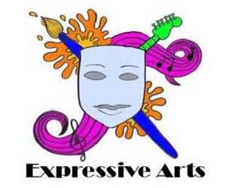

Science: We are learning about the Human Body and the effect that food has on it. We will learn about the main organs and bones in the body. RME: This term we will learning about Christianity and Harvest. Art – We will be experimenting and exploring colour patterns, tone & texture.
The children will be learning through play to enhance their learning and develop their ideas through our floorbook planning.


Numeracy: P2 will be developing their number bonds within 10 and P3 will be up to 20. We will use concrete, pictorial and abstract (CPA) methods. P2 be counting to 100 in 1s and 10s and will identify which numbers come before or after a given number within 30. P3 will be investigating decade numbers and sequencing numbers within 1000. We will also be investigating patterns and 2D shape. We will be learning the properties and names of 2D shapes and name some 3D shapes. P3 will learn properties of 3D shapes and create 2D tiled pictures.

To develop knowledge of numerals and numeral sequences in the range 0-100.

How you can help at home…
It is important that we learn our spelling words at home. We will send a range of fun activities you can try at home to help your child practice their sound for the week. Our reading will be on Bug Club online. A homework grid will be posted on TEAMS as well.
Passwords and logins for these will be sent out shortly.
Health & Wellbeing: During check-in we will continue to develop our listen and talking skills by sharing our feelings and listening to others. We will continue to build our emotional vocabulary as we learn how to name more feelings. We are also going to be learning about the importance of a healthy diet and the effect it has on the body. Our PE days are Wednesday in the hall and Friday in the MUGGA. In PE we will be looking at working as a team and showing good sportsmanship. Children can wear relaxed uniform on these days. Please ensure that all jewellery is removed before school on gym days.

It has been lovely to get to know all the children in P3/2. They have all settled well into their new stages and I can’t wait to have lots of fun learning together. Miss Hill who will be working in our class on a Friday. We would be most grateful if you could please label all uniforms with a biro pen to allow us to return them to the rightful owner.

If you have any questions, please do not hesitate to get in touch. You can also keep up with our learning by following our Twitter page @MrsLow98. Many Thanks Mrs Low.

