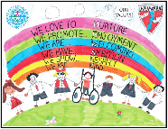
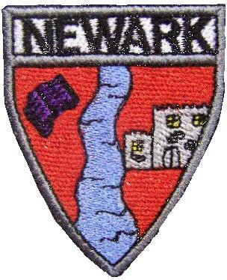





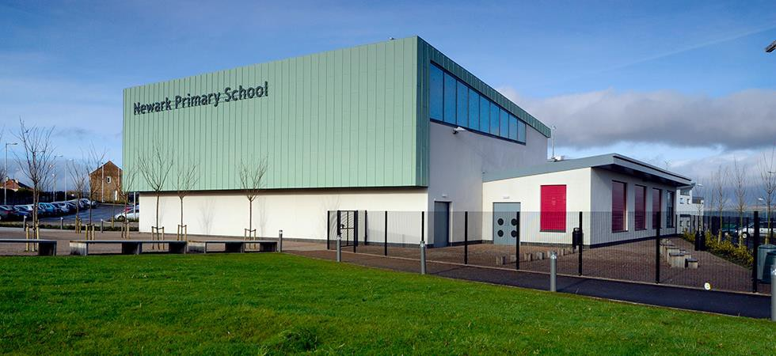

Newark Primary School

School Handbook 2023-2024

School Values: Nurture; Enjoyment; Welcoming; Ambition; Respect; Kindness
Index
- Introduction and welcome from the Head Teacher and pupils
- School Information, Structure and Contact details
- School Team Information
- Our Vision, Values and Aims
- Absence / sickness, school hours
- How do we communicate with parents and share the work of the school?
- Parental Involvement
- Role of the Parent Action Group
- Enrolment and Placing Requests.
- School Holiday Calendar.
- School Ethos.
- Positive Relationships.
- Pupil Voice
- Child Protection in Inverclyde and Equalities in Inverclyde
- The Curriculum and Home Learning
- Assessment and Reporting
- Transitions
- Support for Pupils
- School Improvement
- Practical Information including Transport and Meals
- Newark Primary School Uniform
- Useful Addresses
- Data Protection Act and Glossary



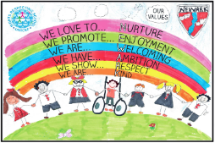

Dear Parents and Carers,

Welcome to Newark Primary School, where we hope your child’s learning journey with us will be a happy one. This means every child feels safe, respected and responsible; included and nurtured and is healthy, active and achieving.
This handbook is designed to be a helpful reference tool which will give you important information, as well as an idea of what goes on in our school, and the kind of things your child will be able to take part in. We hope to involve all our children in as wide a variety of experiences as possible, to fully develop their potential.
Staff are always pleased to help should you have any concerns or problems. All research indicates that children who are most successful at school are those whose parents are involved in their child’s school and learning. We therefore look forward to a positive and active partnership with you in the coming years.

Kind regards,
Mrs Lauren O’Hagan
Head Teacher

Welcome to our school from the Pupil Action Groups!
We look specifically at how to improve our school. All our groups meet regularly and we feedback to everyone at Assembly about our progress. Through the year, pupils meet with Mrs O’Hagan for Tuesday talk. We talk about the skills we’ve learned, and we are asked how we feel about classes, playground and any issues we have. We have members all classes from Primary 1 up to Primary 7.
At Newark we are nurturing by making sure that we are all safe and that there is no fighting in the playground. We are kind to each other and make sure we listen to what other people are saying. The Nurture group are making sure that everyone has at least one friend in the playground and that everyone is having fun. Our first job was to pass on the Newark smile to everyone we walk past. Did you know that a smile is contagious? That means that you can catch it!

The Well-being Action Group will continue to focus on helping pupils in Newark to make healthier snack choices. We have been successful in securing a fund which will help us to buy cooking equipment and the Well-being Action Group will be learning vital food prep skills and sharing their learning with their peers.

“In the pupil action group we get to know what changes are being made in the school. We get to have an opinion and share our thoughts and ideas. Last time we met we helped make a friendlier version of our school improvement plan. We are really excited that we achieved the Gold Rights Respecting Level for the second time”

GIRFEC Action group
“We discuss what strategies help us and could help the other children with things in literacy that they find difficult. We want to get resources together that could help, and we want to make some mnemonics to help with tricky words to spell”

School Information
Newark Primary School
Bridgend Avenue
Port Glasgow PA14 5SU
Telephone No: 01475 715600
Email: INNewark@glowscotland.onmicrosoft.com
Web Address: https://blogs.glowscotland.org.uk/in/newarkprimaryschool2/
Twitter: @NewarkPrimary
Parent Council: newarkprimarypag@gmail.com

COVID-19 Update

All information regarding COVID guidelines, procedures and protocols will be sent by letter through email or Twitter. Some of the COVID protocols currently include staggered entry and exits to school. COVID cases are monitored daily and parents will be informed if/ when changes are made.

Normal School Hours

School Day Hours: 08:50am to 14:50pm
Morning Interval: 10:40am to 10:55am
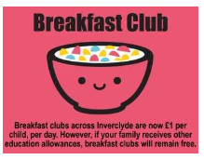
Lunch Break From: 12:05pm to 12:50pm

A Breakfast Club is provided five mornings a week from 07:45am – 08:40am, after which pupils join their friends in the playground. Please contact the school office (715600) for an application form if you wish to use this facility. There is a charge of £1 per child per day; however, if you receive other education allowances, this will remain free.

Inclement Weather
When the weather is bad, ie, torrential rain, snow or high winds, children are invited into the school from 8.35am. Children should enter through the main entrance. They line up in the Assembly Hall or the Gym Hall depending on the floor that their class is allocated. There will be staff to supervise the children and direct them accordingly.
During break time and lunch times, staff supervise the children, either in the playground or the classes. During wet days, P7 monitors also help within the classes.


Parking
There is no parking or drop off facilities for parents and cares within the school grounds. We ask all parents and carers to respect this in order to ensure everyone’s safety. Blue Badge holders may use the car park if they are dropping off or collecting a child with a disability or an adult who is collecting a child in P1-P3. All other adults should use the park and stride facilities at Newark Care Home. Our JRSO officers in partnership with St Michael’s Primary and Newark Nursery have launched our Safe Driver Charter, which almost all parents have already signed up to.

School Structure

Stages of education Primary 1 – 7, (no Gaelic provision)

Denominational status: Non-denominational

Newark has accommodation for 566 pupils in 18 classrooms; 8 classes in the South Wing and 10 in the North Wing, joined by a link administration corridor. We also have a large library/computer suite or ‘Cybrary’; a General Purpose Room; Tutorial Room; Meeting room; Nurture Room, 1 large gymnasium/assembly hall which can be separated into 2 gymnasiums and additional dining and kitchen facilities. All our facilities are designed to be used by people with disabilities. We also have 3 separate playground areas and an outdoor multi-use games area, which we share with St Michael’s Primary, next door.

Complaints Procedure

If something goes wrong or if you are dissatisfied with something we have done, or have not done, please tell us and we will do our best to put things right. Some things are easier to sort than others and it may be a longer term approach that is required but if you make us aware of problems while they are still small we can deal with them more effectively. If we cannot resolve matters in the way you want, we will explain why it is not possible to do as you suggest.

As a staff and school we thrive on positive relationships. Three of our school values are Nurture, Respect and Kindness. We hope parents reflect this on social media. Remember, social media is public, can’t be taken back and may have a harmful effect on others’ relationships and feelings.

Further information can be obtained from the Council website.

www.inverclyde.gov.uk/council-and-government/complaint.

School Team Information

Head Teacher: Mrs Lauren O’Hagan

Depute Head Teacher: Mrs Lisa McGroarty

Acting Depute Head: Mrs Gillian Chalmers (funded through PEF)

Principal Teachers: Mr Joe Blyth and Miss Sarah Neilson

Class structure
There are currently 423 pupils enrolled at Newark Primary School. We have 17 classes, made up as follows:
Teaching Staff |  | Support Staff
P1a | Mrs Lauren Heron | Mrs Carol Fleming- Pupil Support  Mrs Elaine McShefferty- Pupil Support  Miss Leeann O’Hagan - Pupil Support  Mrs Sandra Dunn- Pupil Support  Mrs Marie Kane- Pupil Support  Mrs Linda McLachlan- Pupil Support  Mrs Elspeth Pollock- Pupil Support  Mrs Helen Dalgleish- Pupil Support  Mrs Annette Gray- Pupil Support  Ms Sharon Glancy- Pupil Support  Mrs Clare Doherty- Pupil Support  Mrs Gillian Deegan- Pupil Support  Mrs Carrie Dunn- Pupil Support  Mr Isaac Dunning- Pupil Support  Mrs Tracy Muir- Pupil Support Funded through PEF  Miss Megan McGuiness- Pupil Support Funded through PE  Ms Claire Nicholas- Pupil Support Funded through PEF
P1b | Miss Hannah Hall
P2a | Mrs Kate McLaughlan
P2b | Miss Hannah Dundas
P3/2 | Mrs Karin Low
P3a | Mrs Kirsty Brown
P3b | Mrs Claire McLennan & Mrs
P4a | Miss Hannah Flood
P4b | Mrs Jackie Gilbride
P4c | Miss Kim Holden
P5a | Ms. Katie D’Souza
P5b | Mr Daire Coyle
P6a | Miss Hannah Adams
P6b | Mr Gary Watt & Mrs Jennifer MacPhee
P7a | Miss Nicole Munro
P7b | Mrs Grant Anderson
P7c | Miss Sarah Neilson/  Mr Joe Blyth
Nurture | Mrs June-Anne McKnight
Support for Learning | Mrs June Dukes (0.5 FTE)

Recovery Teachers / Non Class Contact Time (NCCT) Teachers
Mrs Laura Jackson (P4 extended team)
Miss Sophie Hill (Early Years team P1 & P2)
Miss Jenna Doyle (P3)
Miss Lesley-Ann Docherty (P7 extended team)
Mr Stephen McGachy (P5 extended Team)
Mrs Jennifer MacPhee (P6 extended Team)
Office Staff: Miss Rosie Barron (Snr Clerical Assistant); Mrs Nadine McEwan & Ms. Louise Fabiani
Janitor: Mr Paul Fulton
Catering Manager: Ms Kim Guthrie

Our Vision, Values and Aims

At Newark Primary School, we work together with mutual respect to achieve everyone’s full potential. We will achieve this through positive, nurturing relationships and by providing the best learning and teaching experiences in a safe, motivational environment.

These are our values.

Nurture Enjoyment Welcoming Ambition Respect Kindness

Our aims are built around these values:

Nurture

Pupils will feel safe, happy and valued within a secure and supportive, respectful environment.

Staff will feel supported, valued and respected as professionals and plan to ensure all children will be safe, healthy, achieving, nurtured, active, respected, and responsible and included.

Parents/Carers will feel comfortable and confident in all aspects of their communication with the school, with positive relationships central to our ethos.

Enjoyment

Pupils will be actively engaged and enthusiastic about their learning through experiencing the curriculum delivered in a fun and meaningful way within a happy, secure, stimulating environment.

Staff will work collaboratively with enthusiasm and commitment to deliver well planned, high quality, stimulating and imaginative learning experiences.

Parents/Carers will be active partners, enthusiastic and committed to working with their child, to enjoy their learning experiences and assisting us to recognise and celebrate their child’s achievements out with school.

Welcoming

Pupils will behave in a polite or friendly way to a guest or new arrival.

Staff will ensure that all children feel valued and part of the whole school community and will be hospitable.

Parents/Carers will be welcomed by all members of staff, their opinions will be valued and appreciated.

Ambition

Pupils will know what they need to do to improve and challenge themselves, to achieve their potential through commitment, teamwork and demonstrating leadership.

Staff by demonstrating a commitment to self-evaluation, continuing professional development, leadership and teamwork, will provide a motivating and stimulating learning environment, delivering the curriculum with enthusiasm and creativity, to engage and meet the needs of all pupils.

Parents / Carers will encourage and motivate their children to be the best they can be through support and involvement in their learning, both in school and in wider activities, reflecting their interests and talents.

Respect

Pupils will be supported to develop positive relationships and show respect towards each other, staff, the wider school community and the environment.

Staff will model positive relationships and mutual respect within the whole school community and provide learning opportunities to develop positive relationships and promote respect for the environment.

Parents / Carers will support the school ethos of mutual respect by encouraging children to be respectful to other children, adults, themselves and their community, and develop positive relationships at home, school and in the community.

Kindness

Pupils will show kindness to others’ ethical characteristics, have a pleasant disposition, and concern and consideration for others.

Staff will promote kindness by being gentle, caring and helpful.

Parents/Carers will support the school by being considerate in their actions within the school and wider community.

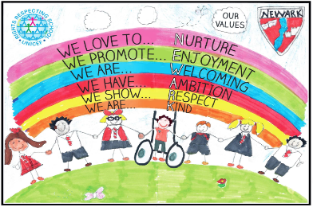

Absence or Sickness

If your child is absent from school, please phone in by 09:15am.

Parents should inform the school by telephone on the first morning of an absence and provide a reason for the pupil’s absence. This information should be updated daily. When your child returns to school, the Authority requires a written note or reply to the attendance text to allow the absence to be recorded as authorised.

Please make every effort to avoid holidays in term time as this can severely affect the continuity of your child’s education.

Attendance Policy


We monitor attendance every 6 weeks and are keen to keep pupil absence to a minimum. Where non-attendance is a factor affecting a child’s learning, support will be initiated through the Council’s Attendance Policy.

Parents will be contacted when their child’s attendance falls below 90% within 6 weeks. A maximising attendance meeting will take place if there is no sustained improvement in attendance. After this step, the next stage is to have a multi-agency planning meeting with senior management, parents and potentially health representative if appropriate. Please feel free to contact us if there are problems we could help with.

We expect pupils to arrive on time, i.e. be in the playground just before the bell and would appreciate your support in ensuring your child arrives on time and ready for school.

Support and Office staff deal with minor injuries, but it is of great importance that you can be contacted in case of an emergency, e.g. illness of, or accident to your child during school hours. If your phone number changes during the school term, please let the Office know and we will update your emergency contact.

If your child has any medical issues or requirements, please inform the Head Teacher.

There is a code of practice for the administration of medicines to pupils, and any parent whose child requires medication should contact the school office to fill out necessary forms, and hand over medication with a pharmacy label in your child’s name, before it can be administered.
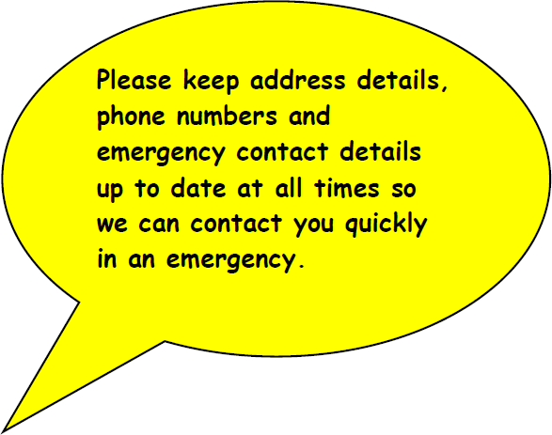

How Do We Communicate with Parents and Share the Work of the School?

We do this in a whole range of ways. Sometimes it’s about giving you information and sometimes it’s about letting you see learning in action or hearing more about the curriculum.

Parent Action Group (PAG) Twitter @PAGNewark & Facebook page

School website https://blogs.glowscotland.org.uk/in/newarkprimaryschool2/

Groupcall email- please keep us informed if you change your email address

Parent Portal

Monthly Newsletters

Class termly newsletters

Parent information events

Curriculum events, e.g.: Science & Engineering events/Literacy Showcase

Class assemblies showcasing learning

First Friday of the Month assemblies

Homework diaries

Text messages if your child is absent from school and you haven’t contacted us

Email: INNewark@glowscotland.onmicrosoft.com

Review meeting/Transition meetings/Team around the Child meetings

Parent Meetings twice annually

Meet the Teacher Event

Reports

Learning in Action Events – working in the classroom with your child

Parent Groups/ Parent Drop In

P1 enrolment information, induction days & Wakelet

Participation in community events

Text messages/group call & radio announcements in the event of a school closure, or reminders of special events

Twitter @NewarkPrimary

Be in The Know!!
Remember to check your email regularly and sign up for Parent Portal

Parental Involvement

Opportunities to become involved:

The ways we share the work of the school as noted above, provide many opportunities for parents/carers to become involved in the life of the school and your child’s learning. Your child’s learning is a partnership between home and school where parents and carers can contribute in many ways.

Supporting learning at home through homework activities is very important. We have changed how we approach homework from when many parents were at school. We hope it is less repetitive and involves more pupil choice and the opportunity for parents to get involved too. Remember if you have any problems at all with homework, please contact us, and we will be pleased to help! There is further information regarding homework later in this handbook.

Many of the children benefit from attending a range of lunchtime clubs and after school clubs which extends their learning, as well as the vast number of clubs parents take them to in the evenings and weekends.

Lunchtime clubs include Choir; Gymnastics; Girls’ Football; Multi Skills, Music/Guitar and after school clubs can include Athletics; Football; Netball; Basketball; Tennis, Cross Country, School Show, etc. There are also alternative lunch clubs which your children can be nominated for and change termly.

How do we seek and take account of parental views?

We have a range of ways in which we seek your views:
- Participation in review meetings
- Parental opinions through variety of ways e.g. MS Forms, Twitter polls, graffiti boards etc.
- Transition times (meetings with nursery staff and secondary school staff)
- Parent comments slips on reports etc.
- Written evaluations following events
- Questionnaires
- Audits
- Surveys
- Parent Council suggestion box at reception
- Question slips on newsletters
- Straw polls at Parents’ Evenings
- Authority Reviews
- School Inspections
- PEF/ School Improvement views annually
We take your views seriously, and your comments and evaluations feed into our ongoing school improvement.

Other ways to become involved:
- Membership of Parent Council and its sub groups, e.g.: Fundraising, Communication
- Parent representatives on Pupil Committees
- Attending Learning in Action events
- Attending parent information/curriculum events
- Attending assemblies, services, sports days, school shows, nativities, music concerts
- Attending parent events during themed weeks
- Sharing of expertise in classes
- Helping at events, e.g. Discos, Summer Fair
- Shared Learning homework
- Stay & Play

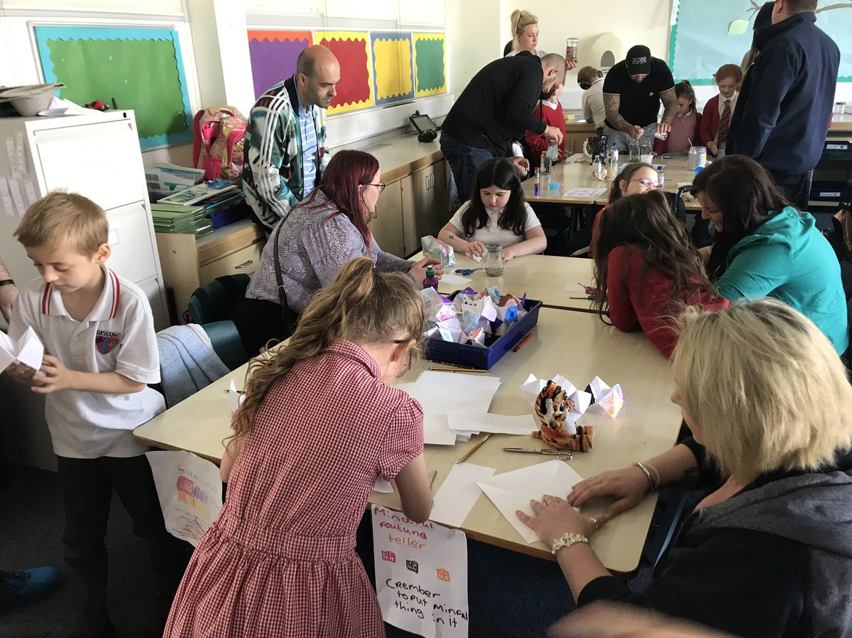

Parents have regular opportunities to join us working in classrooms with their children and finding out what a Curriculum for Excellence is all about!

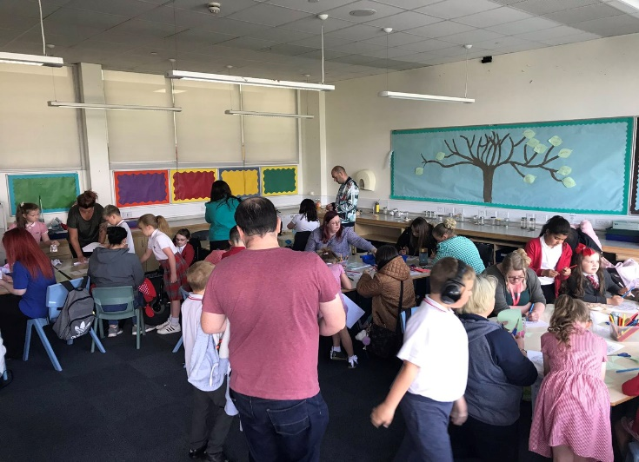

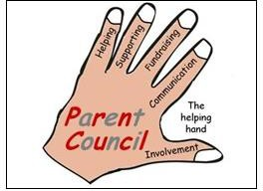
Role of the Parent Action Group

Parents/Carers play a very important role in the life and work of Newark Primary. We ask for and receive great support from parents, from ensuring that homework is completed regularly, and attending Parents’ Evenings to coming along to support children in their class assemblies and the myriad of additional events in which our children are involved. Our Parent Action Group organise Discos for the children, and fund-raising events.

Newark Primary Parent Action Group (PAG)

All Parents are members of the Parent Forum. Scottish Schools (Parental Involvement) Act 2006 led to the establishment of Parent Councils in primary, secondary and special schools. The Act recognises the vital role that parents play in supporting their children’s learning. It places a duty on authorities to promote the involvement of parents in children’s education and the wider life of the school, it aims to help parents to be:

Involved with their child’s education and learning

Welcomed as an active participant in the life of the school

Encouraged to express their views on school education generally

The Parent Council, as a statutory body, has the right to information and advice on matters which affect children’s education. Newark Primary Parent Action Group meets in the school, normally the first Wednesday evening in the month at 6:30pm.

The PAG are kept involved in many different aspects of school education, activities and related topics. Below are the main reasons why we have a council at Newark Primary, and what we try to achieve:

Parents are important and make a real difference to children’s learning. When parents are involved, children and young people do better and achieve more.

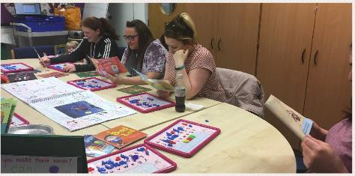
To work together with everyone involved in the school life, parents, learners, teachers, school staff and the wider community – to support the school.

To make sure that all parents have a say in their children’s education and able to express their views and wishes.

To build links and involve parents with the wider learning community – nurseries and pre-school groups, other schools and services.

To listen to what parents want the PAG to do and report back to the Parent Forum on your activities and how they can get involved.

The PAG and its members, with support from other parents, also organise several fundraising events throughout the school term. Monies raised from these events go directly to fund school pupil’s events, from school discos to Christmas pantomimes, and can also help fund, for example, book bags and trophies for pupil competitions. The PAG also support our ethos of having free educational day trips for every child, ensuring there is equality and equity for all.

The PAG are always keen to attract new members, therefore if you would like further information or would like to become a member, then you can contact the council at this email address, newarkprimarypag@gmail.com. Our PAG Chairperson is Heather Lenno. You can also contact the school office on innewark@glowscotland.onmicrosoft.com

Enrolment

Inverclyde Council has changed the way in which children register for primary school. This process will now be undertaken by completing an online application form which can be found on the Inverclyde Council website at http://www.inverclyde.gov.uk/p1-registration

It’s vitally important that parents follow the online registration process to register their child for a Primary 1 place in an Inverclyde school. Children who reach the age of five years between 1 March 2023 and 28 February 2024 are due to start Primary 1 at the beginning of the new school term in August 2023. Parents are asked to register their child in their chosen denominational or non-denominational catchment primary school, from Monday 9th January 2023 - Friday 13th January 2023.

Once parents have completed the Primary 1 registration, they will have the choice to complete a placing request application to a school other than the catchment primary (This includes Primary 1 Gaelic Medium education at Whinhill Primary School).

A deferred entry application is also available to parents considering deferring their child’s entry to Primary 1 in August 2023. No documents will be required at this stage; however, we may have to contact you, should we require further information.

Parents will be notified by 30 April 2023 confirming their child’s place in school and information regarding induction days will follow from the school after this date. Parents who do not have internet access to apply online, are asked to contact their child’s current Early Years Establishment for assistance.

Anyone wishing to enrol their children at Newark Primary school should telephone the school on 01475 715600 for an appointment with the Head Teacher, Mrs Lauren O’Hagan.

We have an extensive transition programme in place that includes all nursery children who will come to Newark. This includes coming to assemblies, PE lessons, class visits, playground visits as well as Mrs O’Hagan and P1 staff visiting the nurseries and getting to know the children.

In May/June the children will come in to meet with P1 teachers and fellow pupils. At the same time, we hold informal meetings with parents to answer all your questions, give advice on how best to prepare your child for school and to talk about what you can expect your child to be doing in P1.

Pupils normally transfer to secondary school between the ages of 11½ and 12½ years, so that they will have the opportunity to complete at least 4 years of secondary education. Parents will be informed of arrangements no later than December of the year preceding the date of transfer at the start of the new session.

The name and address of the school to which pupils from Newark Primary School would transfer to are Port Glasgow High School, Port Glasgow Community Campus, Kilmacolm Road, Port Glasgow, PA14 6PP. The telephone number of the school is 01475 715200.

Placing Requests

Education Services does not provide transport for those pupils in receipt of a placing request, other than in exceptional circumstances. In the case of under-age placing requests, if the child is offered a place in his/her catchment area school, transport will be provided in accordance with Council Policy.

Transitions
Information is shared and passed on to receiving teachers as pupils move through the school to allow smooth transitions from stage to stage. Wherever possible children will have the opportunity to meet their new teacher and visit their new classroom and playground before the summer. Mrs O’Hagan (Head Teacher) ensures that all additional support needs and medical information is passed on.

Children who attend Newark Primary School transition to Port Glasgow High School. In partnership with the High School staff, parents and pupils, we ensure that transitions are successful by sharing relevant information and having visits for 2 days built into our calendar. As information is shared between establishments from P6, parents will be asked to consent to allow a smooth transition to High School and indeed from Nursery to P1.

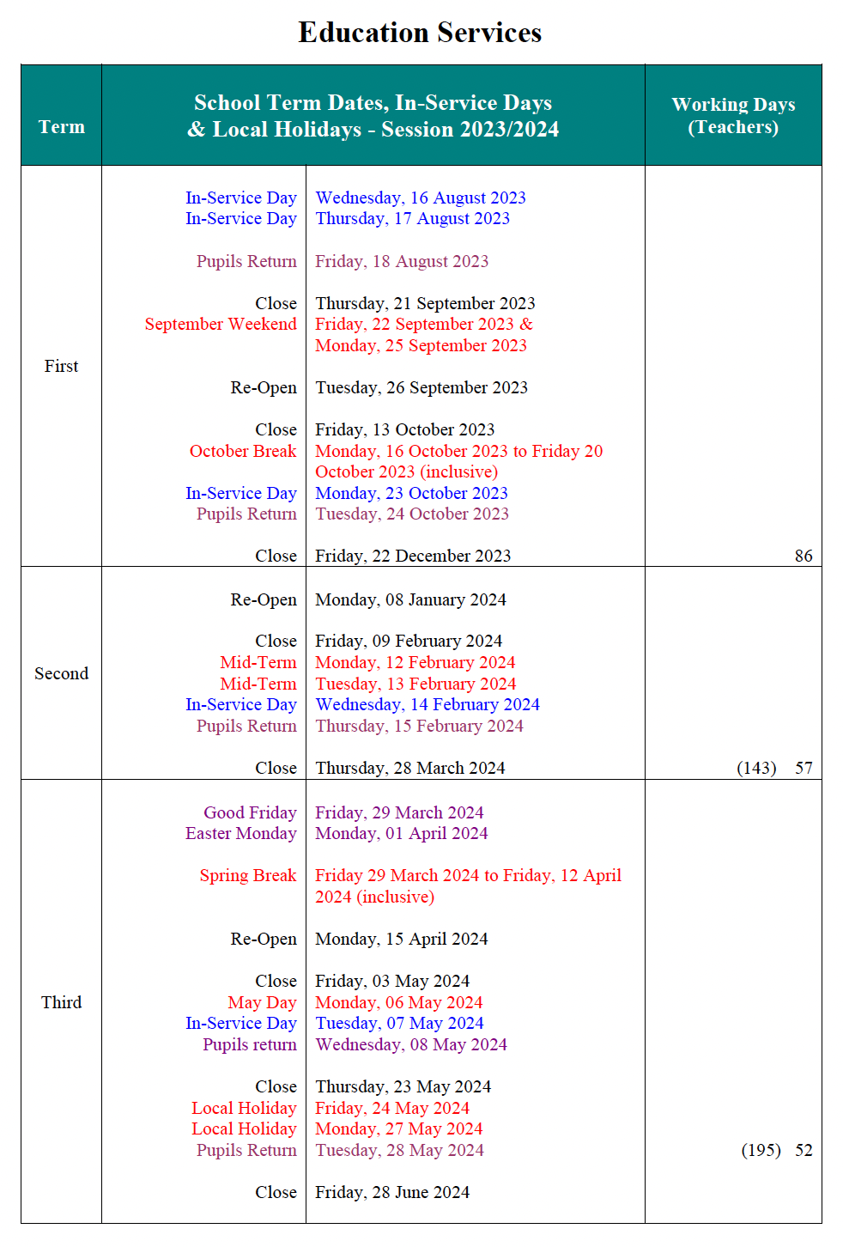

School Ethos

Our school is a Gold Award Rights Respecting School. This means we promote children’s rights as detailed in the United Nations Convention on the Rights of the Child (UNCRC). Newark Nursery and Port Glasgow High School are also Rights Respecting Schools. The children have a steadily growing knowledge of articles contained in the UNCRC and they understand that children do not have to do anything to get their rights however, being responsible with your rights and the rights of others makes you a respectful and responsible citizen. Class Charters are devised each year with the teacher outlining the rights involved with learning in the classroom, and the roles for both children and adults.

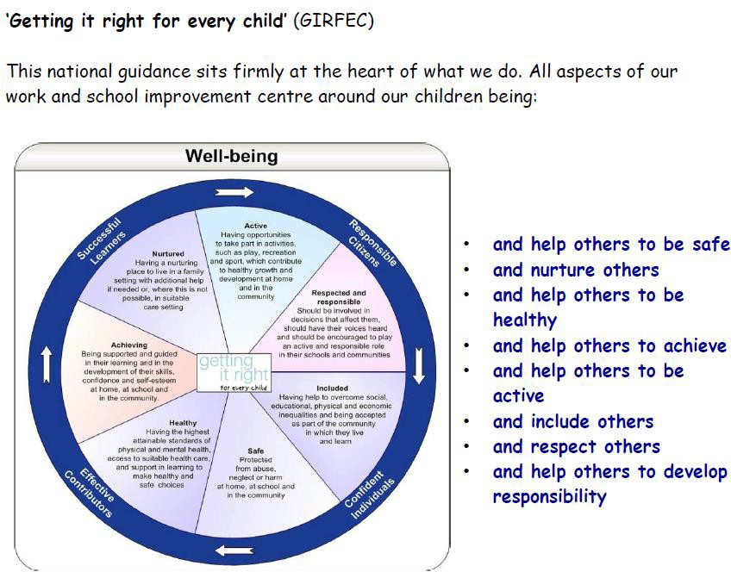
Getting It Right for Every Child’ (GIRFEC)
- Safe
- Healthy
- Achieving
- Nurturing
- Active
- Respectful
- Responsible
- Included

Our work in developing positive relationships through restorative practices has been steadily developed over the last few years. Where children make mistakes in their behaviour they are supported to recognise and put right the harm they have caused. We have undertaken joint training delivered by our Educational Psychologist with our Newark Nursery colleagues. The Inverclyde Positive Relationships Policy has become school policy and is available on our website.

Where problems with behaviour arise, the class teachers will try a variety of strategies to support pupils. If problems persist, we will work with parents to find solutions. Serious incidents of violence, verbal abuse or persistent disruption in the classroom will result in a behaviour alert sheet being sent home, which should be signed and returned to school next day. We will work with the child to help them recognise and repair the harm they have caused.

Repeated alert sheets will trigger Senior Management Team involvement. Solution Focussed Meetings involving parents, school staff and sometimes outside agencies, can be used to identify issues, things that are going well, what needs to happen if things were to have improved over the forthcoming weeks, and an action plan detailing responsibilities and timescales. Everyone’s voice is equal and respected as we work together to identify and agree actions. Behaviour assessment sheets are used to identify triggers, and pupil target sheets can be very helpful.

If the concerns persist, the school’s Education Psychologist may become involved, or an Individual Support Plan will be drawn up with all involved, including parents. Progress will be reviewed on a regular basis. We make full use of external support agencies to maximise support. If any parent has concerns regarding their child’s behaviour, they should contact the Head Teacher.

A Meet the Teacher event early in September allows parents to put a face to the name that their wee one has been speaking about! It also gives you the opportunity to find out about the homework process, as well as chat about any concerns you may have.

Parents’ Night in October will give you a chance to meet your child’s class teacher and discuss their successes and any areas for development. This year, after consultation with staff, parents and pupils, we now report 2 times per year. This will include the levels at which children have achieved. At any time during the session however, parents are welcome to arrange an interview either with the class teacher, or the head teacher by phoning or calling in at the office.


We regularly celebrate children’s achievements in a variety of ways within the classroom.

We have ‘Star Pupil’ certificates presented in Assembly, chosen by either the class teacher, or by their classmates. These are normally given to children who have been demonstrating our school values.

Children also bring in awards/badges/medals/cups that they receive at clubs to show in Assembly.

We have a Star Café to further celebrate our star pupil’s success. This happens on a Thursday from 9.30-10am. The Star Pupil can celebrate with a member of their family on the following Thursday, but don’t worry if you can’t make it, you can come any week that suits your family.
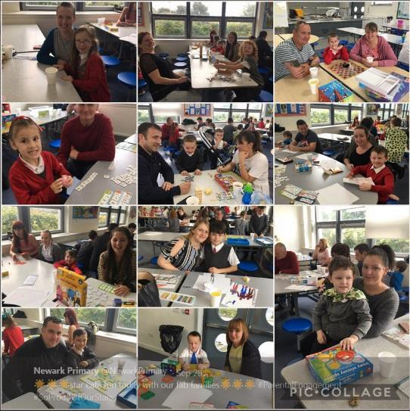
Please let us know of achievements out of school that can also be recognised and celebrated in school and shared at our weekly assemblies.

We have a close relationship with St Michael’s Primary School. Sometimes the children get to work together on topics they are doing and every year we hold a joint P7 Carol Service to which parents are invited. We share our MUGA pitch and both use this to enhance PE lessons. St Michael’s Primary also share in our commitment to being ‘Rights Respecting Schools’.

The cluster head teachers of the Port Glasgow schools meet regularly to ensure smooth transitions and a shared vision.

We work in partnership with a variety of local businesses, churches, charities, and take part in a range of local events, i.e.:

- Open Door events
- Clyde Muirshiel
- Local care homes (Christmas singing and intergenerational projects)
- Inverclyde Music Festival
- Port Glasgow High School Sports ambassadors
- Work experience opportunities
- West of Scotland College
- Inverclyde Foodbank
- Scouts and other uniformed organisations
- Local sports clubs
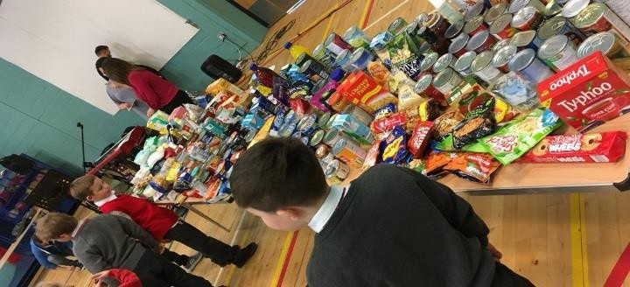
- Fairtrade events and awareness raising
- Various local charities like Jayden’s Rainbow and Ardgowan Hospice

Pupil Voice

We believe strongly in, and listen to, ‘Pupil Voice’. We have a number of pupil committees, or action groups, with representatives from P1 – 7, where children give their opinions and take on leadership roles to support the work of the school, i.e.:
- Pupil Leadership Team
- Eco Warriors
- Rights Respecting School Action Group
- GIRFEC Action Group- with ASD, Dyslexia and ADHD subgroups
- Fairtrade Champions
- Anti-Racism Action Group
- Digital Champions
- Play Champions
- Health Action Group

Child Protection in Inverclyde


Inverclyde Council Education Services has Child Protection Guidelines and Procedures which all schools are required to follow. Education Services work very closely with other agencies, namely Police Scotland; Social Work Services; NHS Greater Glasgow and Clyde and the Children’s Reporter, to support children. Common responsibilities of all staff are to protect children from abuse and exploitation, to respond appropriately when abuse is identified, and to ensure whenever possible that all children are able to exercise their right to be raised in a warm, stimulating and safe environment, with the support of staff, their families and carers. All Newark Primary school staff have child protection training updated at least once a year.

The Equality Statement for Inverclyde Establishments:

Inverclyde Education Service is committed to ensuring that no children or members of staff or service users receive less favourable treatment on any ground, including gender, race, disability, age, sexual orientation, religion and put equality at the heart of everything we do. We aim to promote a culture in which equality exists for all. We are opposed to all forms of discrimination, direct or indirect and aim to eliminate all discriminatory practices. We will ensure that, in our school and other educational establishments, equality permeates the curriculum, and underpins all our policies and practices in terms of access to education. We must ensure that all our children achieve their full potential to develop physically, emotionally and academically. Finally, we believe that equality and inclusion should be given a right, where everyone is valued and treated with respect.

Here at Newark we pride ourselves in being a Level Two Rights Respecting School. As a school we embrace the principle that young people have rights as laid out in the Children’s charter for Young People.

Every class has their own class charter, linked to the Articles of the Children’s Charter, and detailing how the children and staff can show respect for the rights.

.
Examples of this include Article 31
The right to relax and play. This is embedded in our Promoting Positive Behaviour and Relations policy.

The Rights underpin our school values and Children are reminded of them throughout all aspects of their learning.

One of our Pupil Voice Groups is dedicated to Children’s Rights.


The Curriculum


Curriculum for Excellence is intended to help children and young people gain the knowledge, skills and attributes needed for life in the 21st century, including skills for learning, life and work.
“Es and Os”

Sounds like a new type of
noughts and crosses

Purpose

Its purpose is often summed up as helping children and young people to become:
- Successful learners
- Confident individuals
- Responsible citizens
- Effective contributors.
These are referred to as the four capacities.

What is the curriculum and what does it include?

Curriculum for Excellence is designed to achieve a transformation in education in Scotland by providing a coherent, more flexible and enriched curriculum from 3 to 18. The term curriculum is understood to mean everything that is planned for children and young people throughout their education, not just what happens in the classroom.
Curriculum for Excellence includes four contexts for learning:
- Curriculum areas and subjects
- Interdisciplinary learning
- Ethos and life of the school
- Opportunities for personal achievement.

Curriculum areas

There are eight curriculum areas:
- Expressive arts
- Health and wellbeing
- Languages (including English, Gaidhlig, Gaelic learners and modern languages)
- Mathematics
- Religious and moral education
- Sciences
- Social studies
- Technologies

Literacy, numeracy and health and wellbeing are recognised as being particularly important – these areas are seen as being the ‘responsibility of all’ staff.

Principles of curriculum design

There are seven broad principles that teachers should take into consideration when planning children’s learning:
- Challenge and enjoyment
- Breadth
- Progression
- Depth
- Personalisation and choice
- Coherence
- Relevance.

Central to these areas of the curriculum is the methodology used by the teacher and the need to engage our pupils in their learning.
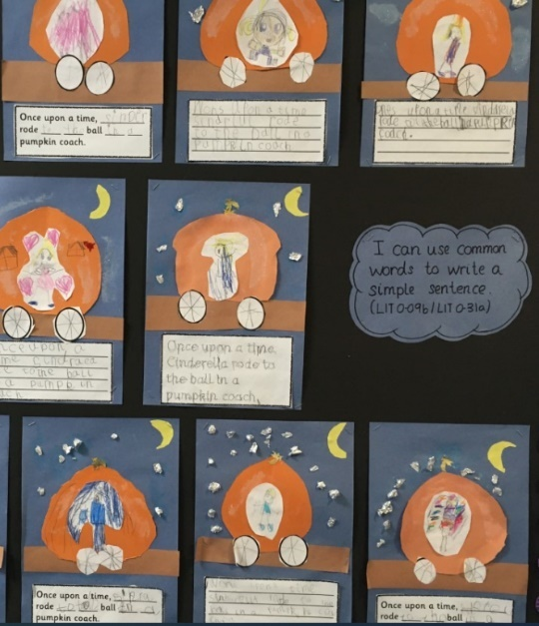
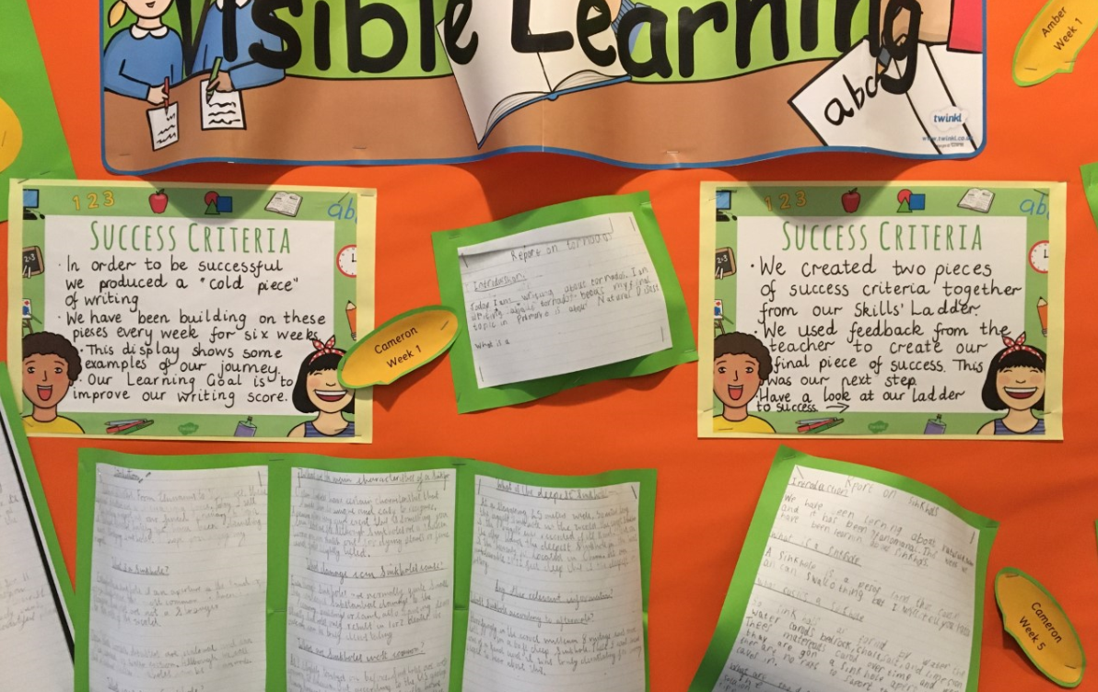


Languages and Literacy
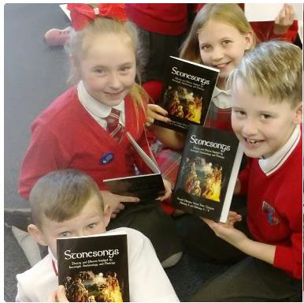
- Language is at the core of thinking, and at the centre of our learning. Through language our pupils gain much of their knowledge and many of their skills across the curriculum.
- The four main components of language are: Listening; Talking; Reading and Writing.
The importance of spoken English is emphasised at Newark.

From Primary 1 children are encouraged to develop their skills in talking, and to articulate their learning.
At the early stages of reading we are using the North Lanarkshire programme of Active Literacy.
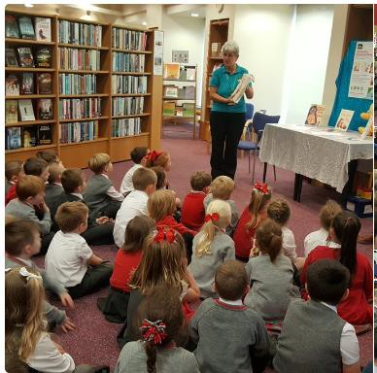
A wide range of reading texts is used in all classes.

Reading for pleasure as well as for information is encouraged throughout the school, and we have a well-stocked library. We encourage the use of our local library and regularly visit it with our classes.

At the early stages of writing we build on drawing and scribbling sentences and introduce punctuation, vocabulary and sentence construction as the children progress. We encourage children to develop a legible, fast, cursive style of handwriting.

As part of the Scottish Government’s 1+2 Languages Programme, French is taught throughout the school. Teachers use many approaches including active learning, games, songs, role play and interactive whiteboard software to create relevant, coherent, enjoyable and successful learning experiences. The third language, Spanish, has been introduced this session.

Mathematics and Numeracy
Mathematics provides more than opportunities to calculate, it enables information to be handled and communicated, and problems solved. Mathematics is used in all aspects of everyday life, allowing us to make sense of the world around us. All children are encouraged to be able to explain their learning and build strong sense of numbers.
Furthermore, children need to be confident and competent in their numeracy skills to be able to function responsibly in everyday life and contribute effectively to society. Mental Maths is a feature at all stages of the school and you may hear your children referring to number talks to aid quick recall of number facts.
The mathematics outcomes in a Curriculum for Excellence are outlined within the following organisers.

Number, Money Measure
- Basic number processes
- Measure
- Patterns and Relationships
Shape, Position & Movement
- Properties of 2D and 3D objects
- Angle, symmetry and Transformation
Information Handling
- Data Analysis
- Ideas of chance and Uncertainty

Health and Wellbeing
Health and Wellbeing Education is an important part of the work of Newark Primary. It is concerned with all aspects of mental, emotional, social and physical wellbeing now and in the future.
Health and Wellbeing is subdivided into the following areas:
- Mental, emotional, social & physical wellbeing.
- Planning for choices and changes
- Physical education, physical activity and sport
- Food and Health
- Substance misuse
- Relationships, sexual health and parenthood.
Pupils are given well planned opportunities to learn about their own health and wellbeing, relationships and health and safety in the environment. We encourage PE and with our two halls ensure that pupils have 2 hours quality Physical Education per week. When our halls are not available, we have Cyber Coach in classrooms, and we run a daily mile regularly.

We request that snacks sent for play time should be healthy and only unflavoured water is permitted. Parents should note that pupil activities may be restricted because health and safety requirements state that jewellery, of any kind, MUST NOT be worn where pupils are undertaking games or physical activities. This includes jewellery worn as a result of body piercing.

Sexual Health and Relationships Education
Sexual Health and Relationship education is an integral part of a school’s health education programme. It focuses on the physical, emotional, moral and spiritual development of all children. Teachers are central to the delivery of sex education from Primary 1 – 7 and work in partnership with parents/carers and appropriate health professionals.

Parents/carers should be fully informed and consulted on the content and purpose of sex and relationship education in schools and have the opportunity to raise concerns with school staff. If the occasion arises where a parent/carer wishes to exercise the right to withdraw his/her child from sex and relationship education, they should discuss their concerns, and alternative arrangements with school staff (as per Inverclyde Council’s Policy “Sexual Health & Relationship Education”).

Social Studies
In Social Studies, pupils look at societies at two different times (history) in different places (geography), and also people in society (modern studies). This will, for example, involve them in studying important people and events in the past, investigating transport and communication networks at home and further afield, and in looking at the ways our communities are run.

Visits to places of educational interest are arranged, whenever possible to allow the children the opportunity of seeing things at first hand. The experiences are designed to encourage links with other areas of the curriculum, so that learners have deeper, more enjoyable and more active experiences.
Technologies
As pupils study aspects of Technology, they learn about its impact in the home, in schools, in industry, and in the wider community. They should also be given the chance to use their own skills and offer solutions to design problems, using different materials and resources.
Information Technology should involve pupils in, for example, using and learning about audio-visual equipment digital cameras, digital microscopes, computers and a variety of computer ‘applications”. Newark Primary has excellent ICT resources.

Expressive Arts – Art, Dance, Drama and Music.
Each of the above subjects has its own body of content to be studied and a range of skills and techniques to be learned. All produce some emotional response and encourage creative expression, all of which are important in the education of every child. These subjects help to stimulate awareness of senses and the acquiring of attitudes and power of discrimination.
The social aspects of recreation activities are especially important in times of greater opportunity for leisure. They touch directly and indirectly on each individual’s health and well-being.
At Newark Primary, all children are encouraged to take part in all areas of the Expressive Arts.

Religious and Moral Education
Religious and Moral Education helps children and young people to explore the world’s major religions and views which are independent of religious belief, and to be challenged by these different beliefs and values.
The curriculum for Excellence outlines areas to be studied namely Christianity, Other World Religions, Beliefs, Values and Issues and Practices and Traditions are explored in both Christianity and other world religions. Newark enjoys close links with St Michaels Primary, sharing worship at key times throughout the year.

Religious Observance
Christmas, Easter and Closing Festivals are held where parents are encouraged to join the school in their worship. We have a weekly P1-7 Assembly.
Children play a very important part in school assemblies, taking part in instrument playing, reading, narrating, dance etc.
Rev. William Boyle is our school chaplain and has an input to the assemblies monthly.
It is normal practice for parents who wish to withdraw their child from religious observance to make suitable arrangements with the Head Teacher.

“Parents from ethnic minority religious communities” may request that their children be permitted to be absent from school in order to celebrate recognised religious events. Only written requests detailing the proposed arrangements will be considered. Appropriate requests will be granted on not more than three occasions in any one school session and the pupil noted as an authorised absentee in the register.

Science
The new science curriculum within Curriculum for Excellence challenges us to ensure that all children will develop a secure understanding of important scientific concepts and that their experience of science in school should kindle a lifelong interest in science.
The science outcomes have been developed into seven areas:
- Planet Earth
- Energy in the Environment
- Communication
- Forces and Motion
- Life and Cells
- Materials
- Topical Science

Home Learning
Home Learning activities are designed to involve parents, carers and families in their children’s learning and to give them a clearer understanding of what is happening in the classroom. It is varied in nature, providing opportunities for challenge, personalisation and choice and the practice of basic skills including Reading, Spelling and Maths. Home learning is issued on Mondays and discussed on Fridays. While it is appreciated that parent/carers may not be able to participate in all the activities, their encouragement is crucial if the children are to gain maximum impact from the tasks set. Support is offered through our Home Learning Club after school on a Monday.

Family Support
Through funding from the Scottish Attainment Challenge, we have access to a Family Support Worker (FSW), affiliated to Barnardo’s. This service is on hand to offer a wealth of support and help you work through your concerns in a supportive and non-judgemental way. FSW is always available on a Friday morning from 9-10.30am for a cup of tea and a chat at parent drop in and can also be contacted at any other time through the school.

PARENTZONE SCOTLAND
Parentzone Scotland is a unique website for parents and carers in Scotland, from early years to beyond school. The website provides up-to-date information about learning in Scotland, and practical advice and ideas to support children’s learning at home in literacy, numeracy, health and wellbeing and science. Information is also available on Parentzone Scotland regarding additional support needs, how parents can get involved in their child’s school and education.
Parentzone Scotland also has details about schools, including performance data for school leavers from S4-S6 and links to the national, local authority and school level data on the achievement of Curriculum for Excellence levels.

READ, WRITE, COUNT
The Read, Write, Count programme aims to support parental engagement in literacy and numeracy. Gift bags are distributed annually to all P2 and P3 pupils in Scotland by Scottish Book Trust. The gift bags contain literacy and numeracy materials to support children’s learning, as well as advice and support to parents.
Studies show a direct link between a strong family learning environment and progress in reading, writing and counting. In addition to the activity booklet included in the bag Scottish Book Trust offers a range of hints, tips and advice to help parents engage in their child’s learning on the website.
First Ministers Reading Challenge and Reading Schools
The First Minister’s Reading Challenge and Reading Schools programmes provides a range of options and support on how to build a love of reading and/or develop a reading culture in your setting. These programmes are brought to you by Scottish Book Trust. Both programmes are flexible to your setting and open to every stage of your reading journey. They have been proven to improve attainment in children and provide professional development opportunities. Whatever stage you are on your reading journey these programmes can support you to get to the next level.
Bookbug
Bookbug is Scotland’s universal early years book gifting programme and aims to inspire a love of stories, songs and rhymes from birth. Bookbug gives every child in Scotland four free bags of books as babies, toddlers, three and five year olds. The bags contain books and other resources for sharing songs and rhymes that are suited to their age. Gaelic Bookbug Bags are also available.
The Bookbug Explorer Bag is gifted to all 3 year olds at their childcare setting. It includes three lovely books, an activity book, pencils, and postcards to encourage mark making.
Every year, The Bookbug Picture Book Prize celebrates the best new Scottish picture books, and the winner of the prize is chosen by children across Scotland. All Primary 1 pupils receive the three shortlisted books in the Bookbug P1 Family Bag, given out in November during Book Week Scotland, and can vote for their favourite in school or at home with their families.
Check out the website for booklists, book sharing videos, activity ideas and much more.

Assessment
Assessments are made constantly by the teacher to ascertain the progress your child has made, to diagnose his/her difficulties, and discover his/her capabilities, so that the teacher may plan a programme for his/her needs.
The principles of formative assessment will be followed; this means that clear aims, success criteria and learning intentions of the lesson is shared and feedback given to pupils. Pupils will also be involved in target setting assessment. Teachers use ‘tests’ or check-ups to confirm learning for example of spellings or at the end of a block of teaching in maths. At the end of a topic there are a variety of ways teachers will assess learning e.g. end of topic quizzes, group presentations, production of posters showing key learning points etc. Our Learning Support Teacher will use standardised tests when there are concerns regarding progress in reading or spelling.

Children may also participate in Scottish National Standardised Assessments (SNSA) for children in P1, P4 and P7. The results from this computer programme can help us to recognise individual, group and class progress.

Senior Management Team meets each term with the teachers at each stage to review the planning for each class and to track progress of groups and concerns regarding individuals’ progress. This may then lead to a decision that enhanced or in some cases more targeted support is required which is how we monitor and meet additional support needs.

Reporting
We report verbally to parents twice per year. There are two Parents’ Evenings usually in October and March/ April when you will be invited to discuss your child’s progress and view their work during an appointment with his/her teacher/s. In October we concentrate on how your child has settled into their new class and it is an opportunity for you to raise any concerns as well as giving you a brief update on literacy and maths.

Our written reports focus on Literacy, Numeracy and Health and Wellbeing. The report details both strengths and what your child needs to work on next. At any time during the session, however, parents are welcome to arrange an interview either with the class or the Head Teacher by phoning or calling in at the office.

P7 e-portfolios have been developed in consultation with Port Glasgow High School Cluster which will be passed on to both parents and their high school and allows the children to record their most recent and best achievements.

Support for Pupils

Getting It Right for Every Child underpins everything that we do at Newark. Your child’s wellbeing is considered in terms of Safe, Healthy, Achieving, Nurtured, Active, Respected, Responsible and Included.

A child or young person’s needs are identified at the earliest possible stage and can be met in number of ways, for example by adaptions to the curriculum or learning environment, as well as input from the Support for Learning Teacher and on occasion support from visiting specialists. The appropriateness of the support in determined through a process of assessment, planning and monitoring, working jointly with parents and carers, and is regularly reviewed. When a teacher or parent is concerned about any aspect of their child’s progress, a Wellbeing Assessment may be undertaken.

Learning outcomes for children and young people with additional support needs are set out in a plan and all educational establishments hold regular review meetings with parents and carers to determine the needs and most appropriate supports. Everyone’s views are equally important in order to consider what is currently working and how to determine next steps. The class teacher will be supporting the learning of all pupils within the class. Some needs are quite short term, and some are more challenging and long term. The class teacher is the person who will know your child best and is the best person to raise any concerns initially.

We have some additional staffing which allows us to provide blocks of extra small group support in language and maths if necessary. We also have Mrs Dukes our Learning Support Teacher who mainly concentrates on supporting children with reading difficulties.

Mrs McKnight leads our Nurture Room, the Butterfly Room, which also provides small group support for pupils having difficulties with relationships. They also provides an opportunity for informal tea/coffee and ‘chat’ to support parents in a range of ways.

Mr Stuart Cummings is based at Port Glasgow High School and is our home link worker, again he will support pupils and parents in a very flexible way but particularly with P6/7 pupils who need a little more help at the transition time between primary and secondary. We have a fabulous building which provides access for disabled pupils and is designed to support those with hearing and visual difficulties.

Our educational psychologist visits the school and will provide additional assessment, support and advice. We also have excellent relationships with a range of other agencies on which we routinely call on for further support e.g. occupational health, speech therapists, specialised nurses, social work, visually impaired and hearing-impaired support.

If a parent considers that his or her child has additional support needs and wishes to make further enquiries about this, they should contact Mrs McGroarty, Depute Head Teacher and Additional Support Needs Leader by calling in at the office to arrange an appointment (01475 715600)

Our practice is informed by the Education (Additional Support for Learning) (Scotland) Act 2009. These procedures have been strengthened through the Children and Young People Act (2014).

A child or young person’s needs are identified at the earliest possible stage and can be met in several ways, for example by adaptions to the curriculum or learning environment, as well as input from the Support for Learning Teacher and an occasion support from visiting specialist. The appropriateness of the support is determined through a process of assessment, planning and monitoring, working jointly with parents and carers, and is regularly reviewed.

Learning outcomes for children and young people with additional support needs are set out in a plan and all educational establishments hold regular review meetings with parents and carers to determine needs and the most appropriate supports. Everyone’s views are equally important in order to consider what is currently working and how to determine next steps.

Children and young person’s needs are identified in a number of ways, and process of assessment is an ongoing, shared process in partnership with parents and carers at the forefront. On some occasions, health service staff or other partner agencies make children known to Educations Services. Other additional support needs may be notified to Education Services by parents themselves or identified by one of a range of staff working closely with the child.

Some children and young people will have additional support needs arising from complex or multiple factors which require a high degree of co-ordination of support from both education and other agencies in order that their needs can be met. In these cases, the school will hold a meeting to decide whether the child or young person meets the criteria for a co-ordinated support plan. The Co-ordinated support plan is a statutory document which ensures regular monitoring and review for those children and young people who have one.

You have the right to ask the education authority to establish whether your child needs a co-ordinated support plan. Your child can make this request themselves if they are aged 16 or over. You and your child, if they want to, will attend a meeting with staff at their school. Other professionals from different agencies who may be involved in providing support for your child will also attend. If your child does not want to attend meetings or feels unable to, their views must still be sought and considered.

Inverclyde’s mediation service can be accessed by contacting Michael Roach, Head of Education, at the address below.

For further advice, please telephone
01475-712824 or write to;
Education Headquarters
Wallace Place
Greenock
PA15 1JB
School Improvement

As part of ongoing school improvement our Strategic Improvement Plan provides the structure for us to review all aspects of a Curriculum for Excellence enabling us to manage changes effectively and fully evaluate the impact on learners. All stakeholders are consulted regarding our priorities for school improvement in a variety of ways on an ongoing basis. We ask key questions such as:

- Where are we now?
- Where do we want to be?
- How will we get there and how will we know?
- Who will lead?
- What are our priorities for year one (in detail) and outline priorities for years two and three?

Our Standards and Quality Report published in October of each year gives details on the previous year’s main achievements.

Our latest Strategic Improvement Plan and Quality Reports are available on our website.

Paper copies are available on request from the school office.

Visit our website to view both documents: https://blogs.glowscotland.org.uk/in/newarkprimaryschool2/

Practical Information
Transport
The Council has a policy of providing free transport to all primary pupils who live more than one mile from their local school by the recognised shortest walking route. This policy is more generous that the law requires. This means that the provision of transport could be reviewed at any time. Parents who consider they are eligible should obtain an application form from the school or Education Services at Wallace Place, Greenock, PA15 1JB. These forms should be completed and returned before the end of February for those pupils beginning school in August to enable the appropriate arrangements to be made.


Applications may be submitted at any time throughout the year but may be subject to delay whilst arrangements are made. The appropriate officer has discretion in special circumstances to grant permission for pupils to travel in transport provided by the authority, where spare places are available, and no additional costs are incurred.

Where free transport is provided it may be necessary for pupil to walk a certain distance to the vehicle pick-up point. Walking distance in total including the distance from home to the pick-up point and from the drop-off point to the school in any one direction, will not exceed the authority’s limits (see above paragraph). It is the parent’s responsibility to ensure their child arrives at the pick-up point in time. It is also the parent’s responsibility to ensure the child behaves in a safe and acceptable manner while boarding, travelling in and alighting from the vehicle. Misbehaviour could result in a child losing the right to free transport.

Bus stops currently are: Lansbury Street, Birkmyre Avenue, Glen Avenue, Kingston Dock at Lithgow Way and Springhill Road.

For any further information please contact Education Services.

Meals

The Scottish Government has stipulated that all pupils from P1-5 will be entitled to receive a free school meal if they so choose; however, it is still important for parents in receipt of certain benefits to apply for clothing and free school benefits. Please ask a member of staff if you would like support completing these forms.

Information and application forms for free school meals P6-7 may be obtained from schools and Education Services, Wallace Place, Greenock PA15 1JB or www.inverclyde.gov.uk (01475-712890). In addition, such children will be entitled to free milk.



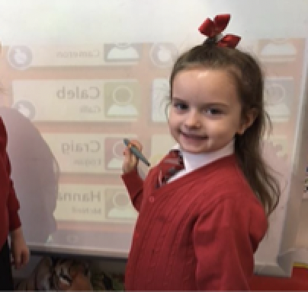
Ordering our lunch on the interactive whiteboard- everyone gets what they ordered!

The menus are compiled with Scottish Diet Action Plans as a Priority and the menu is changed daily.

There is a set cost of £2.25 Children can choose soup and a main course or main course and pudding. A drink, salad and fruit are included in this cost. All meals must be paid for in advance.
From August 2019, all primary schools within Inverclyde will be cashless and will use ParentPay. This is a system for parents to pay for school meals and trips online using a debit or credit card. Parents can also use PayPoint, available at most local shops. This allows you to make cash payments which will feed through to the school’s ParentPay system within 48 hours. www.parentpay.com offers advice for parents; however, if you need help, pop into the school office and we will support you!

If you require a special diet, please notify the Head Teacher who will advise you regarding the necessary arrangements.

We are a Health Promoting Establishment and therefore ask parents to support this by providing healthy snacks/ packed lunches (preferably no sweets or fizzy drinks).

As some of our pupils are allergic to peanuts and peanut products and could suffer an anaphylactic reaction if exposed to them, we ask that children do not bring products containing nuts/nut products to school.
Clothing & Uniform
There are forms of dress which are unacceptable in school, such as items of clothing which:
- Potentially, encourage faction (such as football colours)
- Could cause offence (such as anti-religious symbolism or political slogans)
- Could cause health and safety difficulties such as loose-fitting clothing, dangling earrings or clothing made from flammable material for example shell suits in practical classes.
- Could cause damage to flooring
- Carry advertising, particularly for alcohol or tobacco
- Could be used to inflict damage on other pupils or be used to do so.

The Council is concerned at the level of claims being received regarding the loss of children’s clothing and/or personal belongings. Parents are asked to assist in this area by ensuring that valuable items and unnecessarily expensive items of clothing are not brought to the establishment. Parents should note that the Authority does not carry insurance to cover the loss of such items and any claims submitted are likely to be met only where the Authority can be shown to have been negligent.

Parents should note that the activities the children may become involved in may be restricted because health and safety requirements state that jewellery of any kind must not be worn where the children are undertaking physical activities. This includes jewellery worn as a result of body piercings. There has been a rise in body-piercing, particularly navel piercing and we would vehemently advise against this since it means missing PE for 6 months until the piercing can be removed.

Information and application forms for Clothing Grants may be obtained from schools and from Education Services, Wallace Place, Greenock, PA15 1JB or www.inverclyde.gov.uk (01475-712890).

PLEASE MAKE SURE THAT ALL ITEMS OF CLOTHING ARE CLEARLY MARKED WITH YOUR CHILDS NAME- THANK YOU!

Newark Primary School Uniform

At Newark we have a very smart uniform which we encourage all our children to wear. It consists of:

- White shirt with Newark tie
- White polo shirt, with/without red stripe collar, with/without school logo
- Red sweatshirt with/without school logo or grey pullover with/without red stripe and logo
- Grey skirts or trousers, tartan pinafore/skirt
- Grey blazer or grey, red or black waterproof fleece jacket with/without school logo

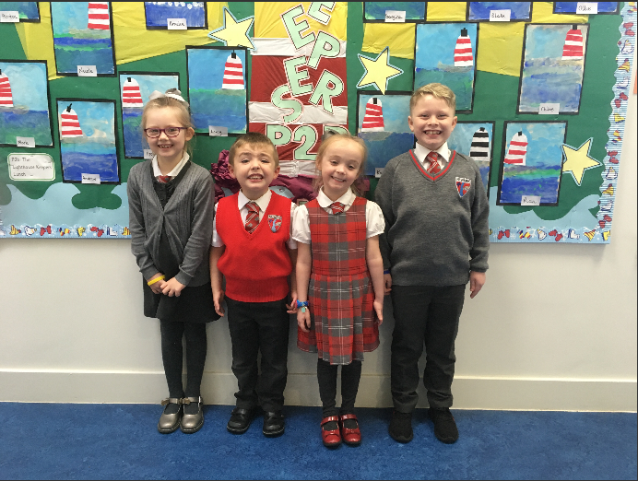

Our main suppliers are:

Baru  7b Moss Street  Paisley  PA1 1BG  0141 848 5755  www.kitmykids.co.uk | Smiths  36 West Blackhall Street  Greenock  PA15 1UU  01475 888555  schooluniformscotland.com

Useful Addresses

Education Services  Wallace Place  GREENOCK  PA15 1JB  (01475 712850) | Inverclyde Council Offices  Municipal Buildings  Clyde Square  GREENOCK  PA15 1LX  (01475 717171)
Inverclyde Booking Office  Gamble Halls  Shore Street  Gourock  PA19  (01475 – 213131) | Community Learning and Development Inverclyde Council  1 Aberfoyle Road  Greenock  PA15 3DE  (01475 715450)
Barnardo’s  9 Terrace Road  GREENOCK  PA15 1DJ  Phone: 01475 728493 | Councillors Curly, Wilson & McCabe  Inverclyde Council  Municipal Buildings  GREENOCK  PA15 1LX  01475 712020
Port Glasgow High School  Kilmacolm Road  PORT GLASGOW  PA14 6PP  01475 715200 | Mr Duncan McNeil MSP  Constituency Office  Union Street  GREENOCK  01475 791820

We are pleased to have the support of our local councillors who regularly attend Parent Action Group meetings and support events within the school. They can be contacted at the council offices at noted above:

Corporate Director of Education, Communities and Organisational development is Ms Ruth Binks;
Head of Service (Education) is Michael Roach;
Quality Improvement Officer at Education Services for Newark Primary is Mr Adam Stephenson

Data Protection

General Data Protection Regulations and Data Protection Act 2018

Information on children, parents and guardian is stored on a computer system and may be used for teaching, registration, assessment and other administrative duties. In processing personal information, Inverclyde Council must comply with the General Data Protection Regulation and Data Protection Act 2018.

For further information please refer to https://www.inverclyde.gov.uk/site-basics/privacy

Although this information is correct at the time of presenting, there could be changes affecting any of the matters dealt with in the document -

- Before the commencement or during course of the school year in question
- In relation to subsequent years.

Glossary

ISP Individual Support Plan

Curriculum The structured pattern of learning carried out in school

RCCT Teachers reduced class contact time

FTE Full time equivalent, eg. 1.0 = full time, 0.5 = half a week

PEF Pupil Equity Fund

Useful Websites

www.inverclyde.gov.uk Inverclyde Council website
www.hmie.gov.uk School and Local Authority Inspection Reports
www.parentszonescotland.gov.uk Lots of information to support parents
www.parentpay.com Website for paying for school meals, trips, etc
www.inverclyde.gov.uk/education-and-learning/schools/clothing-grant-and-free-school-meals

