

School Handbook 2025-2026

Contents

- HT Welcome
- Introduction and School Information
- Senior Leadership Team
- Staff Directory
- The School Day and Placing Requests
- School Dates and Holiday Information
- School Attendance and Absence Reporting
- Communicating With Parents & Complaints Procedure
- EMA and Emergencies
- Clothing
- Medical Information
- Parental Engagement
- School Ethos
- Equality, Child Protection, Health & Safety and GDPR Statements
- Lomond View Models Of Support
- NEST Enhanced Nurture Service
- Corporate Parent Team
- Inverclyde Communciation Outreach Service
- Curriculum
- Assessment and Reporting
- Transitions
- Additional Support Needs
- Pupil Support
- Positive Relationships
- Inverclyde Educational Psychology Service
- School Policies
- School Improvement
- Useful Addresses and Local Councillors

HT Welcome

I am delighted to welcome you to Lomond View Academy’s handbook. My name is Susan McClement and I am the Virtual School Headteacher for Inverclyde, with responsibility for Lomond View Academy. .
Whether you are a pupil, parent, or interested party I am hopeful you will find the handbook useful and will find the information you are looking for, however, please always feel free to contact the school directly if you have anything you wish to discuss. We are always pleased to have visitors to our school.
At Lomond View Academy we continue to make significant changes to the delivery model we are using to support a range of pupils from across Inverclyde. These changes have widened the number of young people attending the school, providing them with appropriate learning experiences to support them to successfully return to their mainstream school, or in some cases to a positive destination post-school.
Part of this change has been the creation of an enhanced nurture provision ( NEST) to support a small number of primary aged pupils, as well as extending our support to include a model for those who have been unable to attend school for a significant period with a focus on re-engagement with their base school ( EBSA & Interupted Learner).
We have other services now linked to Lomond View including the Inverclyde Communication Outreach Service (ICOS), the Corporate Parent Team, Inverclyde Family Support Service and Education Support Workers specifically supporting care experienced children and young people.
Our young people are thriving in these environments and we are developing strong partnerships that will assist with broadening the experiences offered. We have passionate and committed staff who have created a nurturing environment where we invest in positive relationships, develop self-esteem, and confidence, and provide a personalised education.
The very nature of our support recognises that young people can be here for a range of timescales. Whether it is for a few weeks or two years, we must work together to allow our pupils to access a full and individualised curriculum. We look forward to working with all our families in building an environment where we can celebrate the achievement of your child.

Susan McClement, Headteacher

Introduction and School Information
Lomond View Academy is a non-denominational SEBN/ASN school, catering to both boys and girls. We look after the needs of children and young people throughout the Inverclyde area who find the mainstream environment challenging. We also have the Corporate Parenting Team located within our building, the family support service, education support workers and partner with ICOS, located in Inverclyde Academy.

Parents or carers can't file a placing request as our intake comes directly from the Authority Screening Group in partnership with mainstream secondaries and families.

Lomond View is committed to continuous improvement. As such we always welcome any suggestions you may have. Or should there be any complaints, please do not hesitate to get in touch with any member of the Senior Leadership Team.

The full postal address of the school is –
Lomond View Academy
Ingleston Street
Greenock
PA15 4UQ
Tel : 01475 714414
E-mail : Jade.Fyfe@lomondview.inverclyde.sch.uk / Office@lomondview.inverclyde.sch.uk

Information can also be found on our website –
https://blogs.glowscotland.org.uk/in/lomondviewacademy/

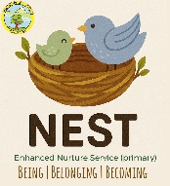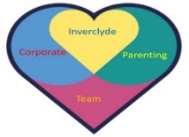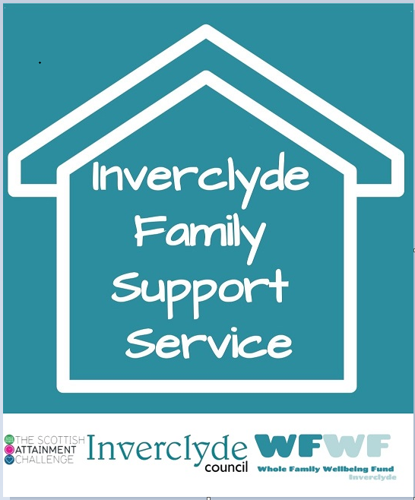

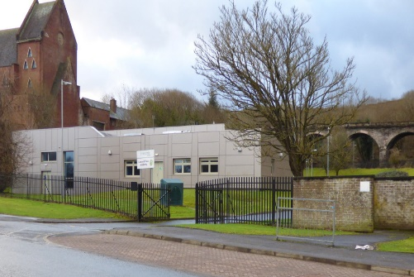

Senior Leadership Team
The senior leadership team is composed of the Head Teacher, One Depute Headteacher and two principal teachers for Lomond View. There are also teo principal teachers for the services.
Members of this team are:
Susan Chambers (HT)
Responsibilities include:
School Finances/Staffing/Safeguarding and Child Protection/School Improvement

Jane Murray (DHT)
Responsibilities Include:
Curriculum Planning/ SQA Coordinator/ Tracking and Monitoring/ Partnership Working/ Employability


Kerry McQuillan (PT)
Responsibilities Include:
Pastoral Care/ Pupil wellbeing /equity and inclusion /ASN Coordinator/ Transitions



Jane Aitken (PT)

Responsibilities Include:
Leadership and management of NEST staff and the service/Training and Outreach support.
Roslyn Friel (PT)

Responsibilities Include:
Overview of Care Experienced Learners/Leading CPT teachers/Delivering Promise Training/Welfare Fund Coordinator
Jan Spence (PT)
Responsibilities Include:
Leadership and management of ICOS Staff and service/Training for staff and parents

Staff Directory
Management Team
Head Teacher | Susan McClement
Deputy Head Teacher | Jane Murray
Principal Teacher Lomond View | Kerry McQuillan
Principal Teacher Corporate Parenting | Roslyn Friel
Principal Teacher NEST | Jane Aitken
Principal Teacher ICOS | Jan Spence
Teaching Staff
Lomond View Teacher | Iain Brown
Lomond View Teacher | Heather Gibson
Lomond View Teacher | Chelsea McDonald
Lomond View Teacher | Jenna Gillespie
Lomond View/ Horizon Teacher | Liz Docherty
Lomond View/ Horizon Teacher | Douglas Clark
Horizon Teacher | Jordan Cronin
Corporate Parenting Teacher | Linda Morris
Corporate Parenting Teacher | Kevin Rodger
Corporate Parenting Teacher | Jacqueline Murdoch
Corporate Parenting Teacher | Ailie Whitelaw
Enhanced Nurture Teacher ( NEST) | Hannah Spencer
Enhanced Nurture Teacher ( NEST) | Juliette Duffy
Enhanced Nurture Teacher ( NEST) | Emma Boyd
ICOS Teacher | Vivienne Doak
ICOS Teacher | Catherine McNamara
ICOS Teacher | Jennifer Sheridan
ICOS Teacher | Sarah Kakooza
Support Staff
Senior EYECO (ICOS) | Julianna Cockburn
Senior EYECO (ICOS) | Kathy Stewart
EYECO (ICOS) | Leah Gisbey
EYECO (ICOS) | Dierdre Boyd
EYECO (ICOS) | Jan Donnachie
Outreach Worker (NEST) | Suzi Gallagher
Pupil Support Assistant ( LVA) | John Chapman
Pupil Support Assistant ( LVA ) | Amanda Harkins
Pupil Support Assistant ( LVA ) | Eilis McDowell
Pupil Support Assistant ( NEST) | Nichola Collins
Pupil Support Assistant ( NEST) | Michele Thomson
Pupil Support Assistant ( NEST) | Shelayne McFerren
Pupil Support Assistant ( NEST) | Chantelle Clarke
Education Support Worker (Virtual School) | Ainsley Brennan
Education Support Worker (Virtual School) | Dawn Bozzelli
Education Support Worker (Virtual School) | Stephen Divers
Family Support Worker (Family Service) | Gaynor Wylie
Janitor | John Pearson
DYW Coordinator (LVA) | Nicola Christie
SDS Link (LVA) | Kirsty Caldwell
Active Schools Coordinator | Gary Forbes

The School Day
Lomond View operates a different timetable than the rest of the secondary schools in Inverclyde. The end of the school day is 3:00pm.

All Young People attend on a part-time basis. Please note Horizon times are different and will be communicated directly with our families. NEST pupils will also follow separate timings and can be here for a full or half day.

At the end of a young person’s day, they will be taken by taxi if they are attending their base school, if they are returning home they will be encouraged to travel independently, if it is safe to do so, on the bus using their Young Scot Card

All pupils will be brought to school in a taxi to support good attendance at school. It is important that pupils are ready and waiting for their taxi as these cannot be sent out again due to costs incurred.

School Meals
Catering is provided each day for the young people. They have access to toast and cereal in the morning, followed by toasties, soup, and fruit at lunchtime. The primary pupils get access to school lunches and will make their choice for the day each morning.

Placing Requests
Lomond View Academy does not accept placing requests. Please contact your child’s mainstream school or Varri Steel (Education Officer, Inclusion) at Varri.steel@inverclyde.gov.uk

For families, out with Inverclyde who will move into the area and who think their child may need our provision, please contact Varri Steel at the above email address. She will advise on the process for applications for out of Authority pupils. Alternatively, please contact Educational Psychology at psychological.service@inverclyde.gov.uk.

School Dates and Holiday Information
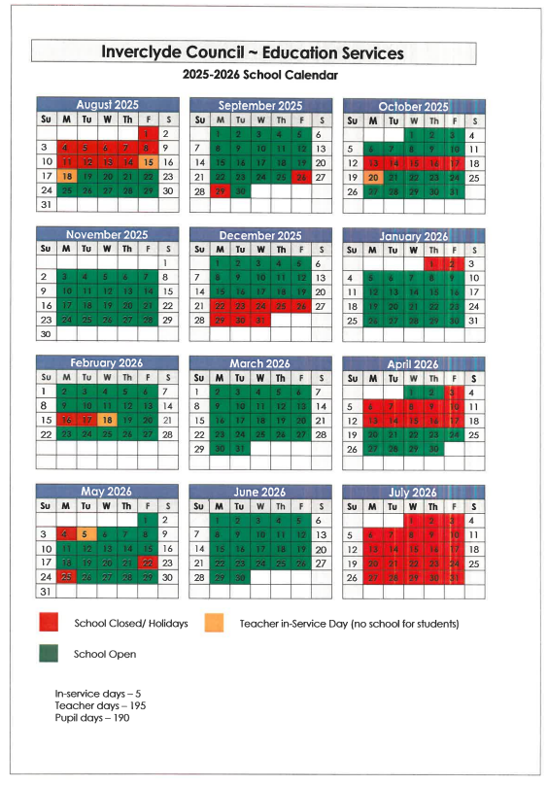

School Attendance and Absence Reporting

What you need to do:
Contact the office on the first day of absence:
- Phone 01475 714414 or text Kerry/Jane to give a reason for your child’s absence and how long you expect them to be absent.
- Keep in touch with us and inform us of how your child is doing and if you need support to get your child back to school.

What Lomond View Academy needs to do if we don’t hear from you!
- Firstly, we will call our main contact for the Young Person. We may also send a text.
- If no response is received we will try again.
- If there is no reply then we will contact your emergency numbers.
- If we are still unclear as to the whereabouts of your child then other agencies may be contacted (social work or police liaison) who may wish to make a home visit to check all is well and your child is safe.

If you know your child will be absent (appointment for example) please contact the school in advance. You can do this by calling the office on: 01475 714414 and, should the time off fit the criteria, the absence will be recorded as “authorised”. This is particularly important if your child receives EMA as unauthorised absences may result in EMA being withdrawn for a week. You can also call your child’s key worker (Maggie Heron or Kim Fowler) who will inform the school.

For unplanned sickness and emergencies, parents are urged to cancel the taxis when they become aware their child will not attend school. There is an enormous yearly cost to the school and this would greatly assist us. Please call Inverclyde Taxis on ( 01475 634563).

Attendance Matters – Some Interesting Facts
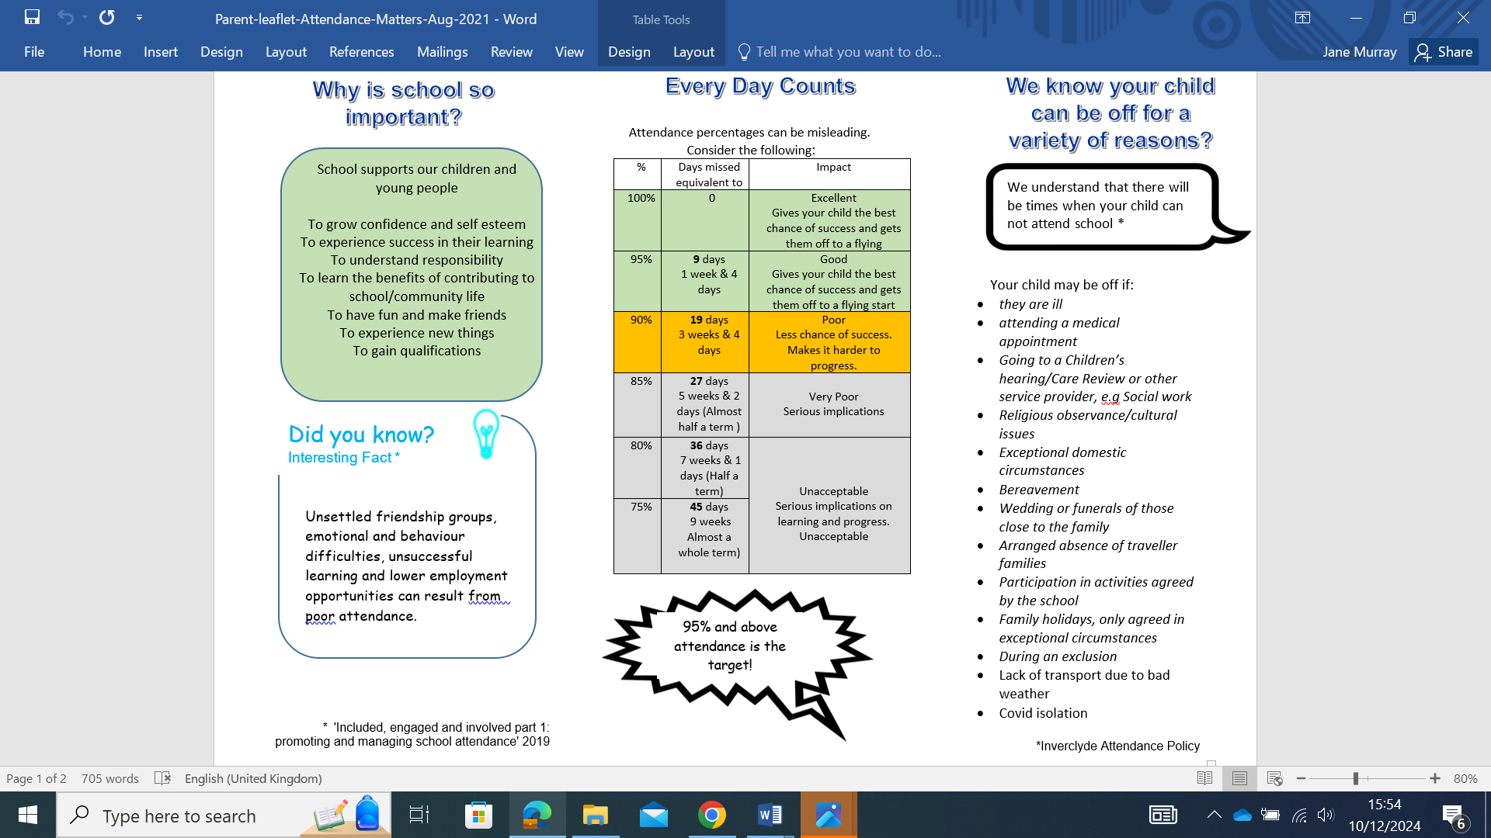

Communication with Parents
We communicate regularly with parents/carers and we aim to keep them updated on progress. Parents/Carers can contact the school via phone, email, or through their young person’s Key Worker.

We attend TAC meetings and liaise with Parents/Carers and base schools to ensure the supports we have in place are appropriate and successful.

If anyone has a concern or issue about a young person we would encourage them to contact the school at their first opportunity.

We are also active on X (Twitter) @Lomond_view

Complaints
Positive and open relationships are important and key to us as a Lomond View Academy. We are always keen to ensure that parents are aware of how we would prefer to handle situations when things maybe haven’t gone as any of us would have liked.

Our initial hope is that we can resolve matters swiftly and informally. In the first instance, and where appropriate, we would ask that you contact the member of staff concerned. However, there may be occasions when the matter needs to be drawn to the attention of Jane Aitken (PT), Iain Brown (PT), Jan Spence (PT) or Roslyn Friel (PT). Please get in touch with them via the main office on 01475 714414 or Office@lomondview.inverclyde.sch.uk

Thereafter, if a resolution is not reached then the matter can be raised with the DHT, Jane Murray via the contact details above.

Ultimately, if you remain dissatisfied, please get in touch with Susan McClement (HT) directly via the main office.

If your complaint is not resolved at school level, please refer to the council complaints process and contact Education Headquarters at: admin.educationhq@inverclyde.gov.uk

How to make a complaint - Inverclyde Council

Education Maintenance Allowance
The Education Maintenance Allowance (EMA) is a grant provided by the government to encourage students to stay on at school beyond their statutory leaving date. It is available to S5 and S6 students if:
• they have completed Fourth Year at school
• they have reached the legal date at which they could have left school, and have opted to return
• they started a Fifth Year course of study in the school session following their statutory leaving date
The grant is a means-tested allowance, based on parental income, but paid directly to the student. The award is up to £30 a week. The payment of allowances, and the payment of the bonus, is dependent upon students maintaining 100% attendance, adhering to the school’s code of conduct and making good progress in their studies

Emergencies
Information in Emergencies We make every effort to maintain a full educational service, but on some occasions circumstances arise which lead to disruption. Schools may be affected by, for example, severe weather, temporary interruption of transport, power failures or difficulties of fuel supply. In such cases we shall do all we can to let you know about the details of closure or reopening. We shall keep you in touch by using letters, text messages, Twitter, Website, notices in local shops and community centres, announcements in local churches and announcements in the press and on local radio.
Staff at Lomond View will, most likely call you so, please be aware that any calls ending 712045 will likely be from the school or Council. Each young person and their family will have the work mobile number of their allocated key worker (Kim Fowler or Maggie Heron) and can contact them re any emergency situations. Parents are encouraged to ensure that emergency contact details are up-to-date.

Clothing
At Lomond View Academy we do not have a school uniform. However young people should attend school wearing acceptable clothing and in line with the below guidance.
There are forms of dress which are unacceptable in school, such as items of clothing which:
- potentially encourage faction (such as football colours);
- could cause offence (such as anti-religious symbolism or political slogans);
- could cause health and safety difficulties, such as loose fitting clothing, dangling earrings or clothing made from flammable material, for example, shell suits in practical classes;
- could cause damage to flooring;
- carry advertising, particularly for alcohol or tobacco; and
- could be used to inflict damage on other pupils or be used by other to do so.
- In addition jewellery such as dangling earrings and large rings could cause health and safety difficulties and are unacceptable to be worn in school.
The council is concerned at the level of claims being received regarding the loss of pupils’ clothing and/or personal belongings. Parents are asked to assist in this area by ensuring that valuable items and unnecessarily expensive items of clothing are not brought to school. Parents should note that the authority does not carry insurance to cover the loss of such items and any claims submitted are likely to be met only where the authority can be shown to have been negligent.
Clothing Grant & Free School Meals
For August 2025, all children in P1-P7 automatically receive a free school meal. However, if you wish to be considered for the clothing grant, or your child is or will be in S1 – S6, you must submit an application form.
Parents of children receiving one of the following benefits will normally be entitled to monetary grants for footwear and clothing for their children –
- Income Support (IS);
- Income-based Job Seekers Allowance (JSA);
- Employment and Support Allowance (Income Related) (ESA) ;
- Child Tax Credit, but not Working Tax Credit and where income is less than £16,105 (in 2019/20) as assessed by HMRC;
- Parent or Carer is in receipt of Working Tax Credit and/or Child Tax Credit with Annual Gross Earnings of no more than £11,288;
- Universal Credit, where your take home pay does not exceed £915, as shown on your monthly Universal Credit statement;
- An Asylum Seeker, receiving support under Part VI of the Immigration and Asylum Seekers Act 1999.
Pupils are eligible for a Clothing Grant in their own right if they are aged 16 – 18 and fall into any of the above categories. Information and application forms for footwear and clothing grants may be obtained from schools and Customer Service Centre, Municipal Buildings, Clyde Square, Greenock PA15 1LY.

Medical Information
MEDICAL EXAMINATION

The routine medical examination of children is undertaken at the ages of 10/11 years and 13/14 years by staff if the Inverclyde Health Board and parents may refer their child at other times to the Clinical Medical Officer for examination or advice.
BCG vaccinations are given in S2. Tetanus and polio vaccinations are given in S3 along with their routine medical examination.
Parents are given prior notice of these examinations and are welcome to attend.

ILLNESS DURING THE SCHOOL DAY

Please note that the school does not have the services of a qualified nurse although some teaching and auxiliary staff have been trained in first aid. It must be emphasised, therefore, that this service is for emergencies only and should you child show symptoms of illness or sustain cuts or bruises out with school he/she should be referred to his/her own doctor.

MEDICAL/EMERGENCY CONTACT FORM

Parents will be provided with a form on which they will be required to state any medical condition or physical disability affecting their child which might influence their education attainment. This also forewarns the school of medical provision or facilities which must be made available. Should parents wish to discuss health matters of a more confidential nature then it is recommended that an appointment be made with the appropriate member of the management team or youth services worker.

Parental Engagement
In Lomond View we recognise that parents play an extremely important role in the education of their children. We believe that for the school to be successful we have to be committed to working in a genuine partnership with all parents. This partnership is fostered in a number of ways –
- Parents are involved regularly in meetings to discuss their child’s welfare and attainment.
- Great emphasis is placed on getting to know the parents as well as the young people, especially during key times like transitions. We have a weekly parents group in order to get to know them and to foster a positive working relationship with all our parents and carers.
- We provide parents with advice and support on how they can support their child’s education
- We keep parents regularly informed of what is going on in the school
Parents are encouraged to keep in close contact with the school to maintain and strengthen this partnership.
For further information please see: https://blogs.glowscotland.org.uk/in/schswebsite/parental-engagement/
PARENTZONE SCOTLAND
Parentzone Scotland is a unique website for parents and carers in Scotland, from early years to beyond school. The website provides up-to-date information about learning in Scotland, and practical advice and ideas to support children’s learning at home in literacy, numeracy, health and wellbeing and science. Information is also available on Parentzone Scotland regarding additional support needs, how parents can get involved in their child’s school and education.
Parentzone Scotland also has details about schools, including performance data for school leavers from S4-S6 and links to the national, local authority and school level data on the achievement of Curriculum for Excellence levels.

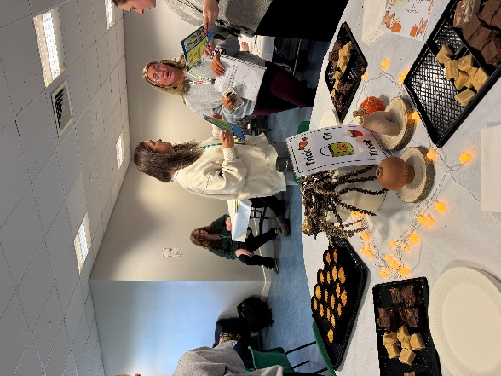

School Ethos
NEST is built on three overarching principles:
Being
Children are accepted for who they are and where they are developmentally, emotionally, and socially.
Belonging
Children are valued members of both NEST and their base school and are consistently “kept in mind” by everyone involved in their care.
Becoming
By meeting each learner where they are, we plan responsively and intentionally to support growth, build skills, and promote readiness for successful engagement in their mainstream environment.
LVA
Our vision is simple and powerful: to thrive and explore your full potential. This belief shapes every aspect of our school community and guides our commitment to providing an environment where each learner is supported to grow, discover and achieve.
Our values express the character of our school. Ambition drives us to set high expectations and inspire learners to pursue excellence in all areas of their development. Resilience strengthens our community, encouraging learners to persevere, adapt and learn from challenges. Belonging ensures that every individual feels welcomed, valued and connected, forming the foundation for meaningful learning and personal growth.
These values guide our aims. We nurture positive relationships that promote respect, trust and wellbeing. We work to develop self-esteem and confidence so that each learner feels capable and empowered. We build strong partnerships with our families and wider communities, recognising that education flourishes when we work together. We provide a personalised education that recognises individual strengths, needs and aspirations, enabling every learner to make progress and experience success.
Together, our vision, values and aims shape an ethos focused on growth, inclusion and opportunity. They reflect our belief in every learner’s potential and our dedication to helping them thrive
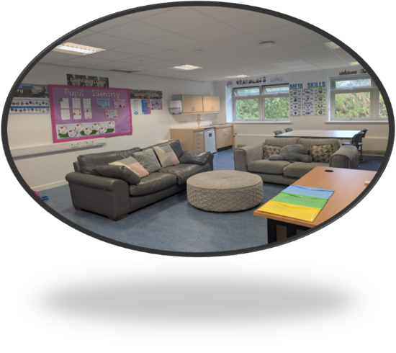
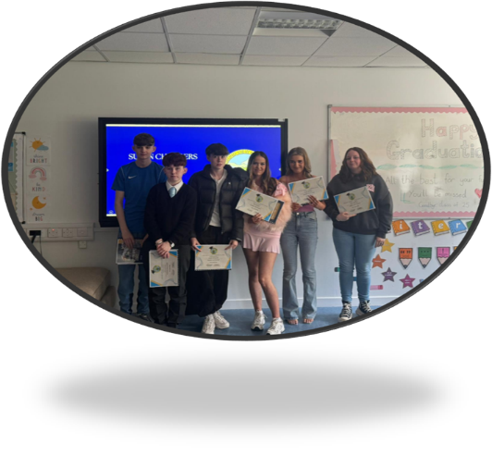
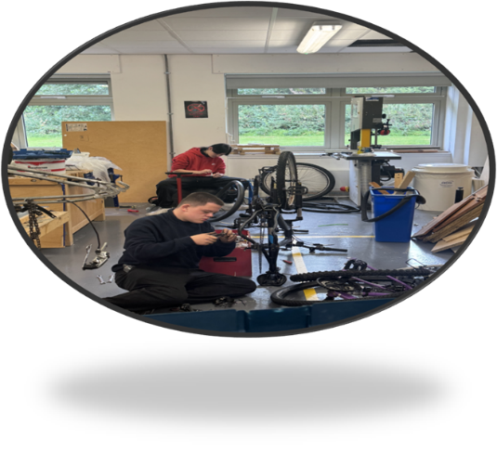

The Equality Statement for Inverclyde Establishments
‘Inverclyde Education Service is committed to ensuring that no children or members of staff or service users receive less favourable treatment on any ground including age, gender reassignment, pregnancy and maternity, race, disability, sex, sexual orientation, marriage and civil partnership, religion, or belief. We have a moral, social, and legal obligation to mainstream and put equality at the heart of everything we do. We aim to promote a culture in which equality of opportunity exists for all. We are opposed to all forms of discrimination, direct or indirect, and aim to eliminate all discriminatory practices. We will ensure that, in our schools and other educational establishments, equality permeates the curriculum and underpins all our policies and practices in terms of access to education. We must ensure that all our children achieve their full potential to develop physically, emotionally, and academically. Finally, we believe that equality and inclusion should be a given right, where everyone is valued and treated with respect.’

Child Protection
Inverclyde Council Education Services has Child Protection Guidelines and Procedures which all schools and establishments are required to follow. Education Services work very closely with other agencies namely Strathclyde Police, Social Work Services, NHS Greater Glasgow and Clyde, and the Children’s Reporter to support children. Common responsibilities of all staff are to protect children from abuse and exploitation, to respond appropriately when abuse is identified, and to ensure whenever possible that all children are able to exercise their right to be raised in a warm, stimulating, and safe environment with the support of staff, their families and carers.

General Data Protection Regulations and Data Protection Act 2018
Information on children, parents and guardian is stored on a computer system and may be used for teaching, registration, assessment and other administrative duties. In processing personal information, Inverclyde Council must comply with the General Data Protection Regulation and Data Protection Act 2018.
For further information please refer to https://www.inverclyde.gov.uk/site-basics/privacy or click on the following: Privacy page link

Health and Safety Statement
At Lomond View Academy, the health, safety, and welfare of our students, staff, and visitors are of paramount importance. We are committed to creating and maintaining a safe and healthy environment that supports the physical and mental well-being of all individuals within our school community.

Models Of Support

Models of Support

NEST Primary Enhanced Nurture Provision
NEST is Inverclyde’s enhanced nurture provision for primary-aged children who have experienced attachment disruption, trauma, or adversity and who require specialised, short-term, targeted interventions to support their social, emotional, and developmental needs. Our work is grounded in attachment theory, play pedagogy, relational practice, and a trauma-informed understanding of behaviour.
Marjorie Boxall described a nurture approach as:
“The emphasis is on emotional growth, focusing on offering broad-based experiences in an environment that promotes security, routines, clear boundaries and carefully planned, repetitive learning opportunities. The aim of the nurture group is to create the world of earliest childhood, build in the basic and essential learning experiences normally gained in the first three years of life and enable learners and young people to fully meet their potential in mainstream schools.”
NEST is based within Lomond View Academy, where we operate three dedicated home rooms designed to meet the developmental stages and learning needs of our children. We offer a shared placement model, allowing learners to engage in intensive, relationship-based nurture provision while maintaining connection with their mainstream school community.
We work in close partnership with the learner’s base school, parents/carers, and partner agencies to ensure a coordinated and holistic approach to support.
Purpose of a NEST Placement
The purpose of a NEST placement is to support each learner to reach a place of emotional safety, readiness, regulation, and relational confidence so they can begin to engage with learning again in ways that are developmentally appropriate.
In NEST, we work to understand what helps the child thrive- the conditions, routines, relationships, accommodations and adjustments that enable safety, connection, and engagement. We also support learners to develop alternative ways of processing their world, challenge unhelpful core beliefs, build healthier internal narratives, and practise new ways of relating, coping, and responding.
Equally, we support the base school to understand these needs and to prepare their environment, expectations, relationships, and classroom culture so the learner can be successful on return.
A child transitioning from NEST may be calmer, safer, and more connected, but they may still require:
• bespoke approaches,
• adapted expectations,
• predictable, attuned relational support,
• developmentally appropriate provision, and
• ongoing nurture-informed practice.
NEST does not “fix” children. Instead, we equip them with new tools, new understandings, and new ways of being, while working with schools to sustain these conditions so progress can continue.

NEST Outreach
Our Outreach service focuses on early intervention, capacity building, and supporting schools to implement developmentally informed, inclusive approaches. Outreach may include:
• Advice, guidance, and modelling of relational and nurturing practices
• Support with creating or adapting classroom environments
• Coaching staff in understanding developmental needs and trauma-informed strategies
• Collaborative planning with schools, families, and partner agencies
• Signposting to appropriate supports
• Ongoing support before, during, and after NEST placements to ensure consistency and sustainability
Outreach ensures that progress made within NEST is understood, shared, and embedded across the learner’s journey.
Our Core Tenets
NEST is built on three overarching principles:
Being
Children are accepted for who they are and where they are developmentally, emotionally, and socially.
Belonging
Children are valued members of both NEST and their base school and are consistently “kept in mind” by everyone involved in their care.
Becoming
By meeting each learner where they are, we plan responsively and intentionally to support growth, build skills, and promote readiness for successful engagement in their mainstream environment.

Contact
For further information about NEST Enhanced Nurture Provision, please contact:
Jane Aitken Principal Teacher, Enhanced Nurture
Email: jane.aitken@lomondview.inverclyde.sch.uk

NEST | A Safe Space to Spread Your Wings

Corporate Parent Team
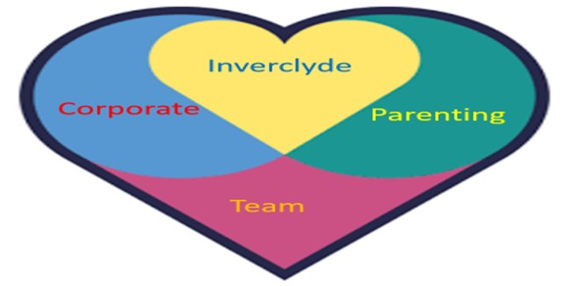
Our experienced team of teachers provide support to the care experienced young people in our authority. Our support is specific to the needs of the young person and we work with their base school to set SMART outcomes each term. Support can be

1) one:one in school
2) in a small group in school
3) in our base at Lomond View Academy
4) at a place that meets the needs of the young person – a community centre, library or in their home

Our aims are to:
- Improve attainment specifically in literacy and numeracy
- Improve attendance
- Reduce exclusions
- Support transitions
- Work with senior phase pupils to ensure they attain the maximum SQA qualifications possible

Establishing positive relationships is at the core of what we do and our team are committed to ensuring the best outcomes possible for our care experienced children.

Pupil Profile

The corporate parenting teacher support is open to referrals for all care experienced young people whether currently or previously subject to compulsory measures. Support can be for pupils across all stages from P1 to S6.

A referral may be appropriate for a pupil who is not reaching their full potential and would benefit from the one:one support and the flexibility that the corporate parenting team can provide. There may be concerns in terms of their attendance, engagement or attainment that current supports are not managing to address as effectively as everyone would like.

Referral Process

Our support is established via the ASG. An initial discussion should take place with Roslyn Friel, Principal Teacher, prior to the paperwork being submitted. Contact details are roslyn.friel@inverclyde.gov.uk or (71)2994. This will facilitate a discussion around whether the CPT would be an appropriate support for a young person

Impact/Joint Working

The corporate parenting teachers are part of the team around the child and work closely with base schools and our colleagues in HSCP and Health to improve the outcomes of the care experienced young people in Inverclyde.

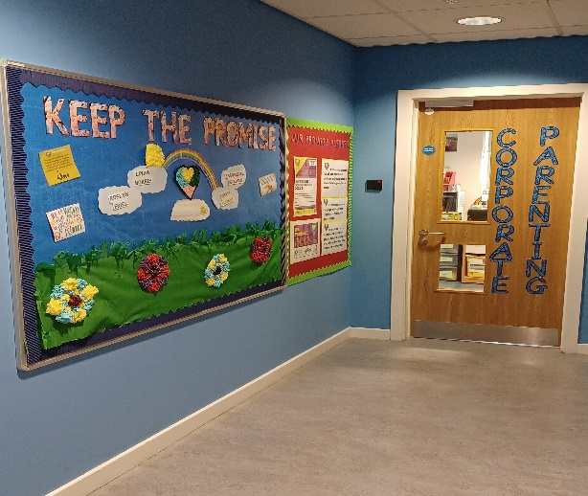

I wouldn’t have got my English and Maths or back to school if it wasn’t for my CPT Teacher”
“I feel my CPT teacher listens to my views and understand me”

my views and

“The CPT Teacher has gone out of her way to ensure both myself & my child were understood & supported both with their education & wellbeing”

“The CPT teacher has helped my child thrive and achieve”

my views and

Curriculum
Curriculum For Excellence
The school has developed its curriculum in line with the Scottish Government’s Curriculum for Excellence initiative. The aims of Curriculum for Excellence are that every child and young person should –
- Know they are valued and will be supported to become a successful learner, an effective contributor, a confident individual and a responsible citizen.

- Experience a traditionally broad Scottish curriculum that develops skills for learning, skills for life and skills for work, with a sustained focus on literacy and numeracy, that encourages an active, healthy and environmentally sustainable lifestyle and builds an appreciation of Scotland and its place in the world.

BGE (The Broad General Education)

Pupils in the BGE follow a Broad General Education that provides the opportunity for all learners to undertake experiences and outcomes up to level 4. At Lomond View, we compliment the curriculum on offer within Base Schools to enhance Learning for our Young People.
During their time at Lomond View, BGE pupils can expect to experience Learning within the following areas:

- Literacy
- Numeracy
IDL (Inter Disciplinary Learning) Including:
- Cookery
- Woodwork
- Wider Acheivement
- Outdoor Learning
- Science
- Social Subjects
- YPI
- Project Based Learning

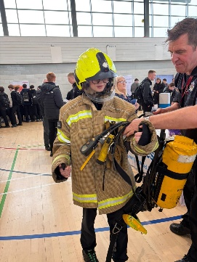
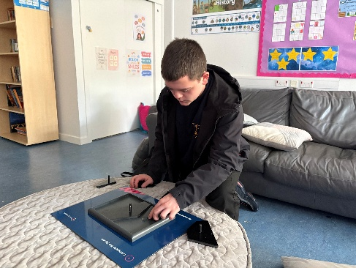
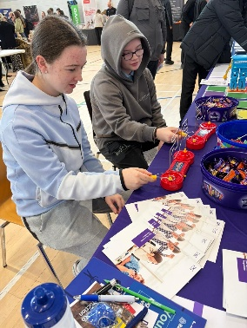

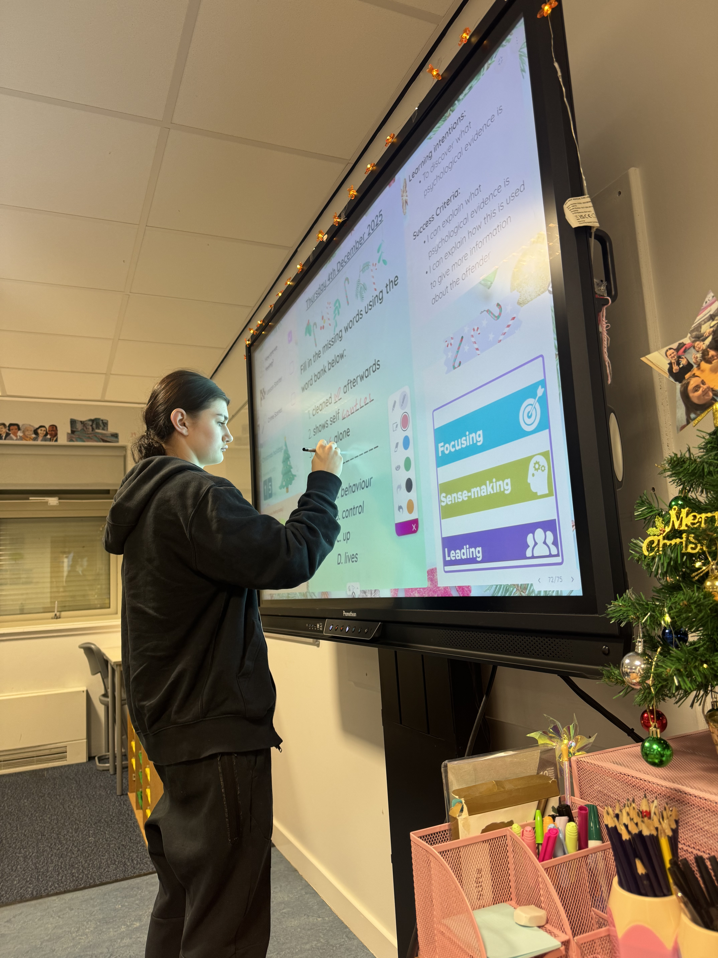

Curriculum

Senior Phase

At the beginning of S4 Young People enter their Senior Phase of secondary education. The purpose of S4 at LVA is to assist Young People to achieve qualifications that will allow them to move on to a positive destination or back to their Base School for S5.

Our S4 model delivers a variety of SQA Qualifications full course awards, alongside National Progression Awards, and Wider achievement awards. Young people also have an opportunity to attend college for vocational courses one afternoon per week, as well as completing the YES (Your Employability Skills) programme with outreach staff from West College Scotland.

Young People in S4 follow an individualised curriculum, which will complement the qualifications they are undertaking at their Base School.

In S4 pupils can study:


  - Employability
- NPA Tenancy
- Practical Cookery
- NPA Horticulture
- Work Experience
- Sports Coaching
- Prince’s Trust Award
- Personal Finance
- Modern Languages for Life and Work
- NPA Criminology
- Customer Service
- History
- Modern Studies

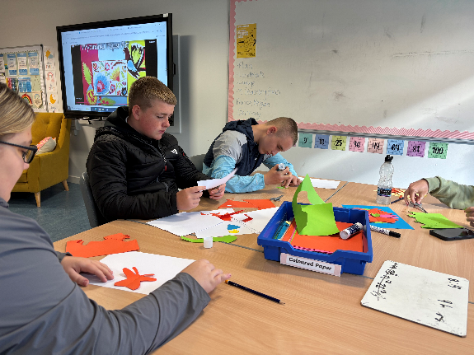
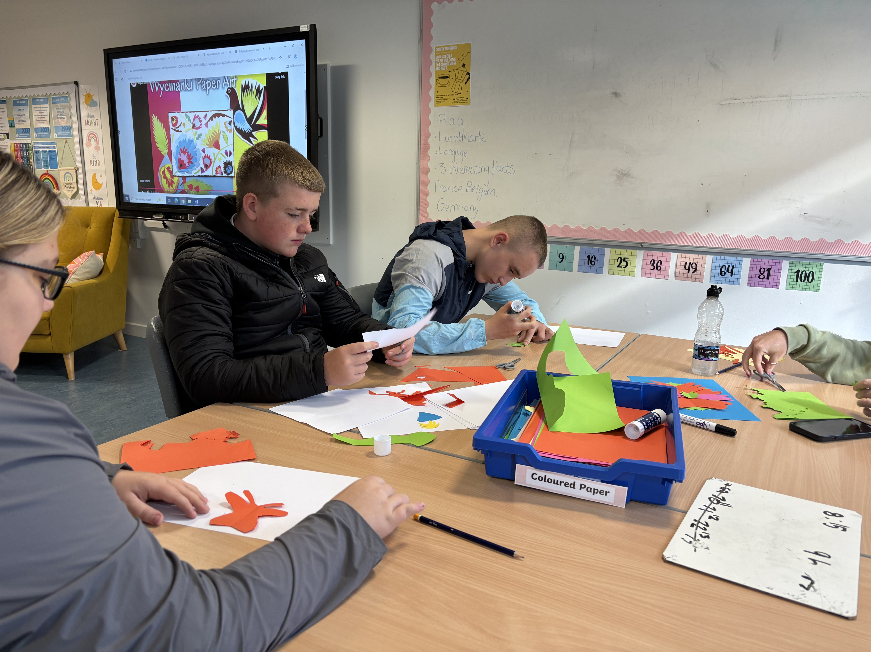
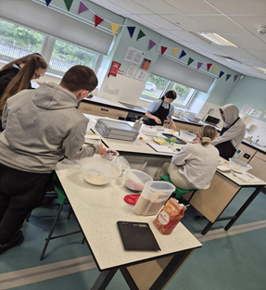

Assessment and Reporting
We pride ourselves on having strong communication with home. As part of this process, S4 pupils receive a formal monthly Tracking and Monitoring Report. The report will show young people’s progress, attendance and engagement with their work at Lomond View. Young People will be given the opportunity to set academic targets during their monthly Learner Conversation with the DHT. Targets and a comment from the DHT will be shared with parents and Base Schools as part of the Tracking and Monitoring report.

BGE pupils will receive at least one formal report per term and will have regular phone calls from staff highlighting areas of strength and next steps. .

All of our young people’s Wellbeing is regularly monitored using the Glasgow Motivation & Wellbeing Profile and Boxall Profile. Each young person has a Wellbeing Profile, which includes strategies to support them. These profiles are shared with LVA staff and Base Schools. Young people meet with the PT termly to set achievable wellbeing targets.

We have strong partnerships with our Base Schools and we encourage the sharing of information at regular intervals between schools.

Transitions

Moving to Lomond View

All referrals to Lomond View are made by mainstream schools in Inverclyde via the ASG. There is no opportunity for parents to seek a placing request into Lomond View. A referring school will follow the process below:

- Initial Inquiry: In the first instance please contact Lomond View Academy directly for an initial conversation with Jane Murray (DHT).
Jane.Murray@lomondview.inverclyde.sch.uk
- ASG Referral: Please submit a detailed referral to the ASG.
- Placement Decision: The Inverclyde Authority Screening Group, in consultation with the child, family, school, LVA staff, and partner agencies, makes placement decisions. These decisions are reviewed regularly.
- Assessment: A contextualized Assessment will be undertaken by a member of Lomond View staff at the Base School.
- Attendance: Young People would usually attend Lomond View for around 50% of their education but some may have a more bespoke schedule based on their needs.

A transition to Lomond View is entirely bespoke and dependent on the needs of the individual. If a place is offered to a Young Person Lomond View will contact the Base School to arrange a TAC meeting.

After this stage, we begin planning for the young person engaging with Lomond View. This differs from young person to young person depending on their needs and wellbeing. Typically, this will involve initial visits to meet staff before gradually building up time and visits until we have reached the desired amount. There is not a set time limit on this happening; we always strive to keep the young person at the centre of any transition.

We hold regular Team Around the Child Meetings to review progress and decide on actions to ensure a successful time in Lomond View.

Transition out of Lomond View

Lomond View Academy placements are intended to be short to medium term interventions. Those attending our BGE model are expected to transition back to their Base School by the end of the session or before and S4 pupils are either supported into a positive destination or will return to their Base School for S5 (this includes Christmas Leavers).
Young People leaving school are given intensive input and guidance from our Developing the Young Workforce Coordinator Nicola Christie. This support is to help ensure that the positive destination is sustained long term. This support varies depending on the needs and wants of the young person.




Transitions

Post School

From S4 onwards all young people begin to pursue different options. At Lomond View we seek to support young people after S4 with a blend of school and college learning or work placement; some will plan to move on to university, college, training programme or to get a job.

Our Developing the Young Workforce coordinator Nicola Christie is in school on Mondays and Thursdays. She works on a 1-1 basis with our young people to find supportive work experience placements. She also assists them with college course applications and is on hand to link directly with our college partners regarding the individual needs of our young people.

In Lomond View, our young are supported in finding the best option for them. Extensive support from the pupil support team and partnership working with Skills Development Scotland, Careers Coaches, More Choices More Chances Team ensures that our young people receive the guidance required.

Skills Development Scotland bring together the knowledge and expertise of what were the Careers Service, Adult Guidance Networks, the Education Business Partnership and Lifelong Learning Partnerships. The services previously offered by these agencies have now been brought together in an integrated way. In Lomond View young people and their parents can access 1-1 time with the Careers Adviser through their weekly slots in school or by visiting their local Careers Centre. Kirsty Caldwell is the Careers Adviser/Work Coach and is in the school every Thursday All pupils are given basic information about careers and interviews are organized for individual pupils.

Kirsty works in partnership with other relevant agencies such as Social Work, Health Service, More Choices, More Chances (MCMC), etc. in order that all pupils can be given the best possible advice about the opportunities open to them.

More information can be obtained from the Skills Development Scotland website - www.skillsdevelopmentscotland.co.uk/

The More Choices, More Chances team support the school in ensuring that those young people at risk of missing out on a positive destination when they leave school are fully supported in finding an appropriate placement. Michelle Scott works very closely with Lomond View staff to support the needs of our senior phase pupils as they leave school. Maureen is invited to most reviews for S4 pupils and above.

Young people at Lomond View will have post school support from our youth support team for up to one year after leaving to assist with achieving a positive and sustained destination.

Additional Support Needs
At Lomond View Academy we are committed to providing a nurturing and inclusive learning environment for all students, with a diverse range of needs. Our dedicated staff recognise the unique challenges that our students may face and are committed to providing the necessary support to help them thrive academically, emotionally, and socially.

Our relationships, strategies and approaches are all underpinned by Trauma Informed Practice.

Each pupil has an individual pupil profile developed collaboratively with parents, teachers from both Lomond View and mainstream schools, and other relevant professionals. This plan will outline specific strategies and interventions tailored to meet the unique needs of each pupil. The pupil profile is regularly reviewed and updated to ensure its effectiveness and relevance.

Our staff undergo training to better understand and address the specific challenges that pupils may experience. This training equips teachers and support staff with the skills to create a positive and supportive learning environment. Our staff members are committed to fostering positive relationships with students and providing the emotional support they require.

Lomond View Academy employs Promoting Positive Behaviour (PPB) strategies to reinforce positive behaviour and discourage negative behaviours. This process includes understanding the function of a young person’s behaviour, providing immediate support to reduce stress and risk, and planning strategies to help the young person to gain the same response in a more positive and socially appropriate way. We recognise the value of crisis communication and active listening and understand the importance of de-escalation intervention strategies to promote safety, preserve relationships and facilitate communication.

In partnership with external bodies such as West College Scotland, Inverclyde Leisure, Finlaystone, Action for Children, Barnardos, Young Carers, Community Learning and Development and Active Schools, Lomond View Academy offers opportunities for young people to explore learning in different environments and develop their interests. These experiences and targeted strategies are designed to increase opportunities for attainment and promote emotional well-being, excellent relationships and positive behaviour.

At Lomond View Academy, we recognise the importance of developing the employability skills of our young people. Developing the Young Workforce (DYW) is a Scottish Government initiative aimed at better preparing young people for the world of work. The initiative emphasises collaboration between schools, businesses, and other partners to create opportunities for young people to develop the skills and experiences needed for employment.

Nicola Christie is our DYW coordinator In LVA and she plays a crucial role in implementing and overseeing the DYW initiative. Nicola has the responsibility of building and maintaining relationships with local businesses and employers to create work-related learning opportunities for pupils, collaborating with teachers and educational staff to integrate employability skills into the school curriculum, organising work placements and work-based learning experiences for pupils and planning and organising events, workshops, and presentations that connect pupils with employers and industry professionals.

Open communication between school staff and parents/guardians is crucial for the success of our pupils. Regular meetings, progress reports, and updates on the student's well-being are provided to keep parents/guardians informed and involved in their young person’s education and support.

Through these comprehensive strategies, Lomond View Academy is dedicated to creating a safe, supportive, and enriching learning environment for all students, with their individual needs in mind.

You will find useful information from the Education (Additional Support for Learning) (Scotland) Act 2009, and the processes for Inverclyde below:
(a) the authority’s policy in relation to provision for additional support needs
A child or young person’s needs are identified at the earliest possible stage and can be met in a number of ways, for example by adaptations to the curriculum or learning environment, as well as input from the Support for Learning Teacher and on occasion support from visiting specialists. The appropriateness of the support is determined through a process of assessment, planning and monitoring, working jointly with parents and carers, and is regularly reviewed.
(b) the arrangements made by the authority in making appropriate arrangement for keeping under consideration the additional support needs of each such child and young person and the particular additional support needs of the children and young persons so identified.
Learning outcomes for children and young people with additional support needs are set out in a plan and all educational establishments hold regular review meetings with parents and carers to determine needs and the most appropriate supports. Everyone’s views are equally important in order to consider what is currently working and how to determine next steps
c) the other opportunities available under this Act for the identification of children and young persons who -
a) have additional support needs,
Children and young person’s needs are identified in a number of ways, and the process of assessment is an ongoing, shared process with partnerships with parents and carers at the forefront. On some occasions health service staff or other partner agencies make children known to Education Services. Other additional support needs may be notified to Education Services by parents themselves or identified by one of a range of staff working closely with the child.
b) require, or would require, a co-ordinated support plan,
Some children and young people will have additional support needs arising from complex or multiple factors which require a high degree of co-ordination of support from both education and other agencies in order that their needs can be met. In these cases, the school will hold a meeting to decide whether the child or young person meets the criteria for a co-ordinated support plan.
The coordinated support plan is a statutory document which ensures regular monitoring and review for those children and young people who have one.
c) the role of parents, children and young persons in the arrangements referred to in paragraph (b).
You have the right to ask the education authority to establish whether your child needs a coordinated support plan. Your child can make this request themselves, if they are aged 16 or over.

You and your child, if they want to, will attend a meeting with staff at their school. Other professionals from different agencies who may be involved in providing support for your child will
also attend. If your child does not want to attend meetings or feels unable to, their views must still be sought and considered.

d) the mediation services provided:
Inverclyde’s mediation service can be accessed by contacting Michael Roach, Head of Education at the address below.
e) the officer or officers of the authority from whom parents of children having additional support needs, and young persons having such needs, can obtain advice and further information about provision for such needs.
For further advice please telephone 01475 712850 or write to:
Education Services
Wallace Place
GREENOCK PA15 1JB

Support Organisations
For further advice, information or support you can contact the organisations below:
Children in Scotland: Working for Children and Their Families, trading as “Enquire – the Scottish advice and information service for additional support for learning”, a charitable body registered in Scotland under registration number SC003527. www.enquire.org.uk
Scottish Independent Advocacy Alliance, a charitable body registered in Scotland under registration number SC033576. www.siaa.org.uk

Scottish Child Law Centre, a charitable body registered in Scotland under registration number SCO12741. www.sclc.org.uk/

Pupil Support
As part of the schools’ GIRFEC agenda, the aim of the Pupil Support staff is to provide a point of personal contact and support for pupils throughout their school career by monitoring their academic, personal, social and vocational development. Where necessary, the pupils’ educational environment is adapted to allow them maximum opportunity to fulfil their potential. The objectives of the staff are -

- To offer emotional support to students, providing a safe space for them to express their feelings and concerns.
- To develop strategies and interventions to address behavioural issues, working closely with students, parents, and other staff members to implement effective plans.

- To provide staff of the school and partner agencies with a known point of referral.
- To facilitate programs and activities aimed at improving social skills, fostering positive relationships, and promoting inclusivity within the school community.
- To create individual support plans tailored to each student's specific needs, collaborating with various professionals such as psychologists, social workers, CAMHS, Barnardo's and Action for Children.
- To work collaboratively with teachers, administrators, and external agencies to ensure there is a holistic approach to supporting students' overall well-being and academic progress.
- To act as an advocate for students, liaising between home and school to ensure a cohesive support system for their educational and emotional needs.
- To regularly monitor students' progress, assess the effectiveness of interventions, and make adjustments to support plans as needed.

- To establish a Careers programme in conjunction with Skills Development Scotland.

Pupil Support staff, along with subject teachers, provide important support for pupils at transition times. This will help to ensure that pupils are following the appropriate courses considering the pupil’s capacity and career aspirations. Kerry McQuillan is our Principal teacher who oversees pupil support and will be happy to discuss any aspect of a child’s education with parents/guardians.

Positive Relationships
At Lomond View Academy, we recognise the significance of positive relationships in creating a supportive and nurturing environment for our students. We aim to cultivate an atmosphere where every individual feels respected, valued, and understood. Our school is founded on the principles of ambition, belonging, and resilience. We encourage students, staff, and families to embrace these values in their interactions, understanding that each person's uniqueness enriches our community.
We prioritise emotional well-being by providing a safe space for students to express themselves. Trained staff members offer guidance, active listening, and appropriate interventions to support emotional needs. We facilitate structured activities and group projects to encourage positive peer interactions. These initiatives aim to build empathy, teamwork, and communication skills among students. Our school promotes healthy conflict resolution strategies. We teach students how to manage conflicts constructively, emphasising empathy, active listening, and finding mutually agreeable solutions. Recognising and celebrating positive behaviours is essential. Our staff employs various methods, such as praise, reward systems, and acknowledgment ceremonies, to reinforce positive behaviour. Collaboration with families is integral. We encourage open communication and involvement in school activities, fostering a supportive network that extends beyond the classroom.
Our dedicated staff undergo continuous training in relationship-building techniques, conflict resolution, trauma-informed practice, and fostering a positive school culture. This ensures they are equipped to address the diverse needs of our students effectively. We seek to actively engage with the wider community, inviting guest speakers, organising community projects, and participating in events that promote understanding and acceptance of diverse perspectives. At Lomond View Academy, the cultivation of positive relationships is fundamental to our school. We believe that by nurturing an environment where respect, empathy, and inclusivity thrive, we empower our students to flourish academically, socially, and emotionally.

Inverclyde Educational Psychology Service
Inverclyde Educational Psychology Service aims to improve the wellbeing and education of children and young people through the application of psychology in practice. We do this by:
- providing training and coaching to educational staff with the goal of optimising the inclusion of all children and young people.
- using the latest research evidence in psychology to advise and consult with others. This helps to assess and plan for children and young people with Additional Support Needs.
- working with others to seek solutions that build on the existing strengths of children and families.
- ensuring that children and young people’s views are heard and included in any planning.
There are many more roles of the Educational Psychologist, you may find these on our website https://www.inverclyde.gov.uk/education-and-learning/inverclyde-educational-psychologyservice.
School Policies
Please visit the website to read the whole school/Inverclyde policies Inverclyde Virtual School/Lomond View Academy/NEST Primary Nurture/Corporate Parenting/ICOS on the following:
Child Protection
Anti Bullying
Promoting Positive Behaviour
Attendance
Health & Safety
Allergy Aware
Learning & Teaching

School Improvement
Standards and Quality Report
On an annual basis, we publish our Standards and Quality report. Copies from previous years are available on the school website. The Standards and Quality report will be used to highlight progress in key areas of school improvement.
The main achievements of our school over the last 12 months can be seen in the Standards and Quality Report on the school website.
Planning For Improvement
Our priorities for improvement are detailed in our School Improvement Plan . Any parent or carer seeking a copy of the Standards and Quality Report or Improvement Plan can contact the school office or check out our website.

Useful Addresses
Head of Education / Quality Improvement Officers
Wallace Place
Greenock PA15 1JB
01475 712850

Community Learning & Development
1 Aberfoyle Road
Greenock
PA15 3DE
01475 714250

Skills Development Scotland
112 West Blackhall Street
Greenock
PA151XR
01475 745903

Local Councillors
Councillor Christopher Curley
Councillor Stephen McCabe
Councillor David Wilson

Although this information is correct at time of presenting, there could be changes affecting any of the matters dealt with in the document –
(a) before the commencement or during the course of the school year in question.
(b) in relation to subsequent years

