Education – Improvement Planning Document – 2025-26

Establishment Name: Virtual School and Lomond View Academy

CONTENTS

- Establishment Vision, Values and Aims

- 3 Year overview of priorities – based on the National Improvement Framework

- Action Plan for session 2025-26

Head of Establishment | Susan Chambers | Date | 30/05/2025

Quality Improvement Officer |  | Date

Our Vision, Values and Aims

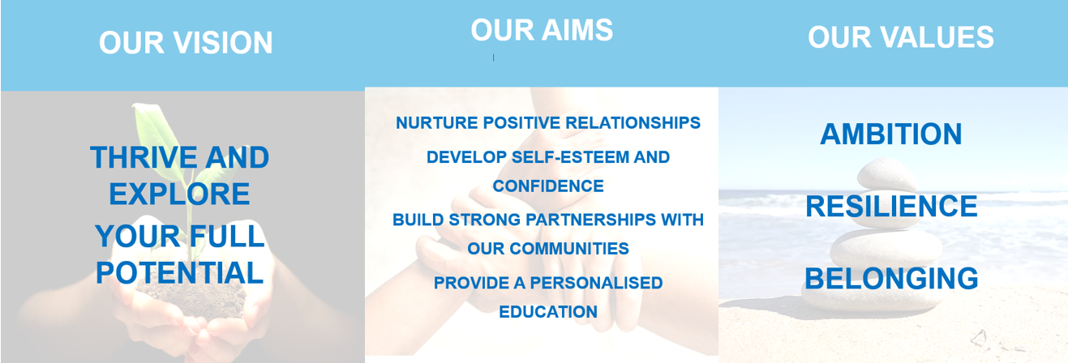

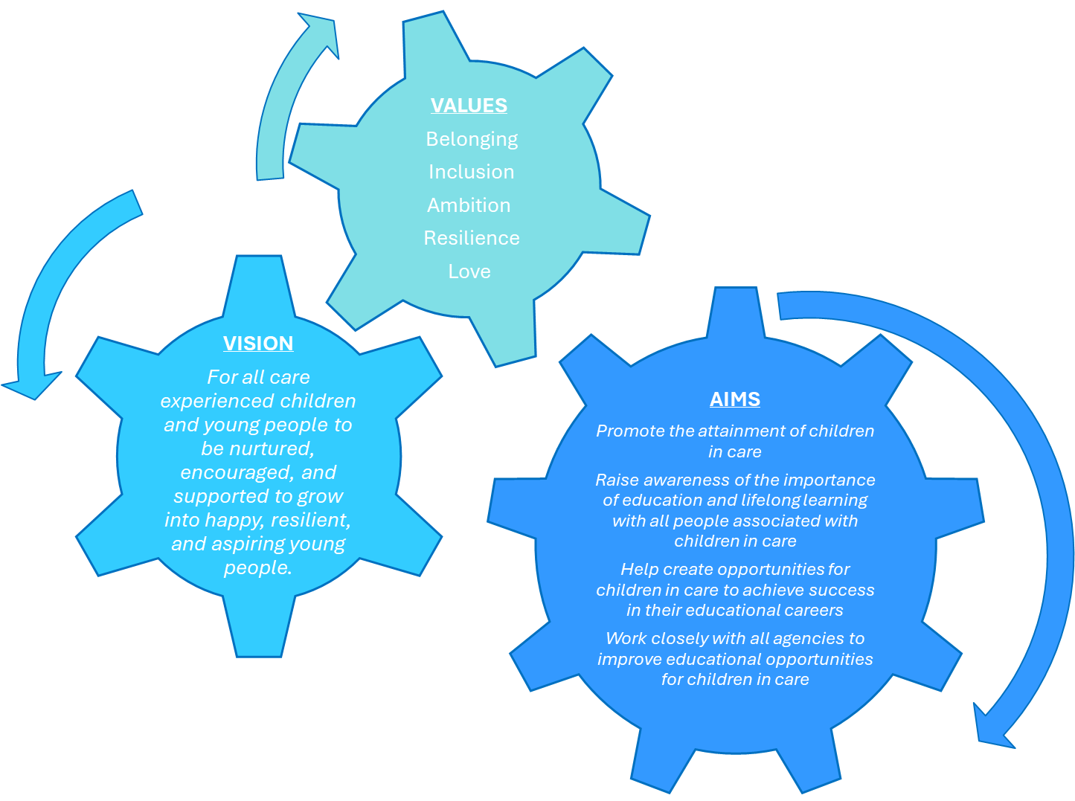

3 Year Overview of Establishment Priorities
The improvement priorities for our establishment are noted on the following page. They have been expressed in the context of the National Improvement Framework
Our Improvement Priorities extend in a rolling programme over three years. Each priority has been coded accordingly:

Session 2025-2026
Session 2026-2027
Session 2027-2028

Virtual School/Lomond View Provision outcomes and tasks are highlighted in differing colours.

Overview of rolling three year plan

National Priorities | Session 2025-2026 | Session 2026-2027 | Session 2027-2028
Placing the human rights and needs of every child and young person at the centre of education | Reduce CECYP exclusions  Rights Respecting Schools Progress  Continue to build provision to be responsive to needs across the authority to support right to education
Improvement in children and young people’s health and wellbeing | Increase CECYP Attendance  Implement family support model  Implement wellbeing services for CECYP  Development of relevant policies
Closing the attainment gap between the most and least disadvantaged children and young people | Increase percentage of level 5 passes for care experienced learners  Improve outdoor learning opportunities  Continue to develop attainment interventions across the service specific to SIMD 1/2/CECYP
Improvement in skills and sustained, positive school-leaver destinations for all young people | Improvement in post school positive destinations figures CECYP  Improvement in post school figures from LVA/transition support across service  Improvement in Meta Skills
Improvement in achievement, particularly in literacy and numeracy | Increase the number CECYP reaching on track for literacy/numeracy  Increase the number of BGE/primary pupils achieving progress within level.

Stakeholder’s views
How were stakeholders views collected?
Stakeholders were consulted throughout the school year to ensure that all perspectives were considered. This was completed through gaining feedback at meetings, through surveys, and focus groups involving teachers, parents, pupils, and partners to gather input on progress. Feedback from stakeholders helped shape our priorities for the next improvement plan.

Plan: Session 2025-26
Priority 1
Closing the attainment gap between the most and least disadvantaged children and young people
Improvements in attainment, particularly in literacy and numeracy
National Improvement Framework Outcomes
4. High achievement and reduced attainment gap for all learners.
5. Skilled teachers and leaders delivering excellent, inclusive education.
3. Inclusive curriculum and assessment for a sustainable future.
Education - achieving excellence and equity: National Improvement Framework 2025
How Good is Our School/Quality Improvement Framework ELC  3.2 Raising attainment and achievement  3.2 Curriculum  2.3 Learning, teaching and assessment  1.1 Self-evaluation for self-improvement  3.3 Increasing creativity and employability  2.4 Personalised support | UNCRC  Article 3 (Best interests of the child):  Article 29 (Goals of education):
Rationale for change based self-evaluation including data and stakeholder views
Although the stretch aim has not been met for achieving the percentage of care experienced learners achieving level 5 study before leaving school, there has been an increased focus on the development of level 5 opportunities across the secondary schools. Last year, 45% achieved level 5 study. Those who did not achieve level 5 before they left school, left out of 4th year which limited their opportunities to increase their pathway options. All primary and secondary virtual school meetings have had an attainment focus this year. Schools have prepared data in advance and this has contributed to a deeper discussion on progress and impact of interventions. Although the attainment gap broadly remains within this cohort, schools can confidently discuss progress being made within levels and are tracking this. For senior phase, schools are adopting flexible, bespoke offers for their care experienced learners including the use of Lomond View, individualised support and appropriate pathways/planning. The Lomond View model supported five care experienced young people to achieve five or more qualifications. This was a 100% success rate. We have been tracking the use of the corporate parent team this year in contributing to the improvement of literacy and numeracy. The support required from the corporate parent team was as follows: Term 2 Literacy 37%, Numeracy 29%, Literacy & Numeracy 29%, Health & Wellbeing/Other Subject 5%. Term 3 Literacy 37%, Numeracy 29%, Literacy & Numeracy 29%, Health & Wellbeing/Other Subject 5%. We continue to develop the tracking of CPT intervention through termly monitoring.
S4 pupils have been entered for between 5 and 9 qualifications or awards. 87.5% have been entered for 6 or more. Young People are completing a minimum of 3 and a maximum of 6 full course awards and 75% are on track to achieve 4 +. 100% of young people have achieved an Employability award. These achievements mean that 100% of our S4 pupils are moving onto a positive destination or into a PLP arrangement with their base school. 100% of Horizon pupils in S4 – S6 have achieved at least one qualification in Maths or English. 60% have achieved qualifications in Maths and English. BGE learners are supported to make improvements in Literacy and Numeracy. This has proven difficult to assess due to a lack of information on levels from base schools. This is something that will be prioritised for transitions next year. The class teacher is able to evidence levels and these are now shared with base schools to contribute to BGE tracking and reporting.
Expected outcomes for learners
Who? By how much? By when? What?
- By December we will have a curriculum rationale for each model and relevant services within Lomond View, leading to an improved offer to access higher attainment levels.
- By August the Learning and Teaching policy, supported by CLPL for all staff within the service, will be implemented which will contribute to engagement and attainment levels.
- To map out the support across the service in supporting literacy and numeracy.
- By June 100% of NEST and LVA pupils will have experienced an outdoor learning opportunity leading to a wider achievement qualification
- By June there will be an improvement in attainment and engagement of 80% of learners engaged with the service.
- By October there will be tracking and monitoring systems across the full service to support the measurement of impact on attainment.
- By June there will be a 5% increase in the number of care experienced learners achieving a level 5 qualification by the end of S5 in line with the stretch aim.

Tasks to achieve priority | Timescale | RAG | Those involved/responsible – including partners | Resources and staff development
Develop a curriculum rationale for the primary and secondary provision, including the services where appropriate. | July 2026 |  | All LVA Staff | Staff training on curriculum rationale/PBL training
Launch the learning and teaching policy across the provision and ensure quality assurance is taking place throughout the year. | August 2025 & ongoing |  | J Murray  All LVA Staff | Continuous CLPL on learning and teaching throughout 25/26
Investigate and support the implementation of the SCQF Ambassadors programme within the secondary provision of LVA | April 2026 |  | S Chambers  J Murray | Staff/Pupil Training
The allocated teachers for outdoor learning will create and deliver experience that can be accredited. | May 2026 |  | I Brown  H Gibson  H Spencer | Staff Training
Engagement Tracker will be developed across the service to ensure engagement is being tracked. Learning & Teaching will be developed to directly impact engagement. | May 2026 |  | J Murray  All Staff | Staff Training
Implement tracking systems for the wider services that will measure the impact of the intervention on attainment and engagement. | October 2025 |  | All PT’s  Staff across services | Training with C McLaren
Continue to work with all secondary establishments on securing level 5 study at the earliest point for all care experienced learners. | June 2026 |  | S Chambers  Senior Phase DHTs | Time for meetings

Measure of Impact: What we will see and where?
How will we measure this? What does “better” look like? How will we recognise better when we see it?
- More young people will be offered and will attain level 5 study by the end of S5
- For those leaving from S4, opportunities will be provided where appropriate to achieve a level 5 award.
- Tracking will show an increase in attainment for those at Lomond View through accessing a broader curriculum.
- Through data analysis we will see improvements in targeted care experienced children and young people’s attainment and achievement on a termly basis.
- All services will have a cleat system to measure impact that will provide data to reflect on impact of interventions. This will allow for the most appropriate and targeted work to be taking place with those who need it most, and where there is a proven positive impact.
- Learners will experience high quality learning and teaching, where there is a consistent approach to their daily experiences. This will be evaluated through pupil and staff voice and through observations.
- Curriculum rationale will provide support to staff on what and why we are delivering our courses, this will include PBL approach for BGE and will reflect the work of the wider services to clearly set out our approach across the service.

Priority 2
Improvement in children and young people's health and wellbeing
Choose an item.
National Improvement Framework Outcomes
6. Positive relationships, behaviour, and attendance in a respectful culture.
2. Strong partnerships between schools, services, families, and communities.
Choose an item.
Education - achieving excellence and equity: National Improvement Framework 2025
How Good is Our School/Quality Improvement Framework ELC  3.1 Ensuring wellbeing, equality and inclusion  2.7 Partnerships  1.5 Management of resources to promote equity  2.4 Personalised support  1.1 Self-evaluation for self-improvement  1.3 Leadership of change | UNCRC  Article 12 (Respect for the views of the child):  Article 2 (Non-discrimination):
Rationale for change based self-evaluation including data and stakeholder views
There have been 22 exclusions of care experienced learners this year. Two in primary schools involving children with significant multi agency support and 20 in secondary. One secondary school was responsible for 13 of these. Unfortunately, this is an increase from last year. There was a secondary exclusion working group established to identify the common causes for care experienced learners being excluded, to share good practice and to identify any gaps that could be supported through the virtual school. The system of contacting the virtual school HT has been effective on almost all occasions. The average attendance for those living at home is 78.6%. This is a 6% increase from last year’s average figure. For those previously care experience the average attendance is 89.3%, a 3% increase from last year and for those living away from home it is 91.7%, which is another 2% increase on the average figure. The wellbeing service being supported through the care experience fund has unfortunately not begun, we are hopeful this can be recruited for next year. There have been delays in establishing the correct level of support required for this service and a delay in support from health colleagues. NEST staff have deepened their understanding and consistency in trauma-informed and neuro affirming approaches. All staff have undertaken professional learning in Nurture, attachment, trauma and brain development, The Boxall Profile and its application in planning and Play pedagogy, child-led learning, and responsive planning. A library of 50+ NEST Practice Guides was developed to underpin consistent practice in areas such as co-regulation, demand reduction, equalising behaviour, PACE, masking, and emotionally based school avoidance. These are now widely used across NEST to support reflective dialogue, coaching, and daily decision-making. Several families noted improved relationships and regulation at home, reflecting strong alignment between NEST support and children’s lived experiences outside of school, whilst also noting that there had also been an improvement in how their child was being supported in their base school too. Audit tools and observation frameworks were developed this year and trialled across the setting, helping embed shared language around quality interactions, space design, and relational attunement. These will be embedded fully next session.
In LVA all staff (100%) have received CIRCLE training and are reconfiguring classrooms to ensure they are circle inclusive. All staff (100%) have begun Trauma training with most achieving module 2. The school was awarded the Bronze RRS award in January 2025. Young People are involved in the RRS process and have chosen 5 rights to focus on to achieve silver. All staff undertook Play Pedagogy training in October 2024 and play is an informal feature of learning at Lomond View. Young People experience play to help with regulation and engagement. Parent and Pupil councils have not been implemented; however, the school has strengthened family engagement through family coffee mornings. There was a Christmas coffee morning and a careers coffee morning both of which were well attended by LVA and Horizon families. We also held an evening event for EBSA pupils and families, which was well attended. Families fed back positively about these events and we will build on these next year.

Expected outcomes for learners
Who? By how much? By when? What?
- By June 2026 all relevant policies will have been consulted on and will be in place across the wider service including PPB, Attendance, Equalities, Anti Bullying and Transitions.
- By June 2026 there will be a reduction in the number of exclusions across the authority for care experienced learners by five instances.
- By June 2026 there will be a 2% increase in the attendance of care experienced learners
- 100% of Inverclyde schools with have achieved the Promise Award by June 2026
- By June 2026 a minimum of 50 families will have been supported through the new multi-agency service for Family Support to reduce the number of RFA’s to social work
- By June 2026 at least 10 children or young people will have been supported by the new mental health support for care experienced children and young people.

Tasks to achieve priority | Timescale | RAG | Those involved/responsible – including partners | Resources and staff development
Write an Equalities Policy for the provision and wider services. | December 2025 |  | Lead by PT’s  All Staff | Training from Educational Psychology
Develop an attendance policy that reflects the virtual school, our provision and wider services in line with the authority policy | October 2025 |  | HT/DHT/All PT’s  Staff/Pupils | Support from Attendance Lead
Ensure through the Horizon and ILS models that all young people under 20% attendance have a clear single agency plan. | September 2025 |  | J Murray  Teaching Staff | Staff Training for writing plans
Review and update the PPB policy to reflect the change within the provision and wider services. | March 2026 |  | I Brown/K McQuillan  Staff/Pupils | Time  Resources
Ensure senior staff within the provision complete Signs of Safety Training during the school year | June 2026 |  | DHT/All PT’s | Signs of Safety Training offer
Implement an anti-bullying policy across the provision and wider services. | January 2026 |  | I Brown/All PT’s  Staff/Pupils | Training from Educational Psychology
Revise and develop a transition policy and plan for all transitions across the wider service. | April 2026 |  | J Murray/All PT’s  Base Schools | Time
Continue to work with the exclusion working group and DHT’s to reduce the exclusions of care experienced young people. | June 2026 |  | S Chambers  Working Group | Working Group Time
To implement the new family support worker multi agency approach and review the impact of this service of families. | August 2025  Ongoing |  | S Chambers/L McFadden/Y Coyle  M Coyle | Guidance/Set up ASG  Rationale for service  Training for all staff
Ensure the wellbeing service is established for care experienced learners and evaluate the impact of this on young people and the fund applications. | November 2025 |  | S Chambers  CECYP Group | Health colleagues support  Support with structure of offer
Work with new attendance lead to establish a new approach to improving attendance for care experienced children and young people. | September 2025 |  | S Chambers  F Walker | Training  Development of new strategy

Measure of Impact: What we will see and where?
How will we measure this? What does “better” look like? How will we recognise better when we see it?
- There will be an increase in young people accessing mental health support who are care experienced. This will be tracked through the attainment fund and impact measured through data collected by mental health staff. There will be clear and equitable process in and out of the service.
- There will be a reduction in the exclusions of care experienced young people, being tracked through monthly monitoring. Young people will be better supported to remain in school and alternatives will be explored. The working group will support with researching alternatives.
- Individual schools will demonstrate an improved approach to offering exclusion alternatives and this will be fed back into the working group.
- Families and children/young people impacted by barriers to accessing education successfully will be targeted by the new family support offer. This will lead to an increase in attendance and engagement for these families and will be monitored throughout.
- There will be an increase in appropriate signposting for post support services where required.
- The attendance of care experienced learners will continue to rise into the next academic year.
- There will be an increase in the engagement and attendance of those targeted through the ILS/Horizon programmes and clear plans within the provision will be offered to allow for progress.
- The range of new policies will contribute to an improving school ethos and consistent approaches among staff and pupils. This will be monitored through pupil voice and feedback. Pupils will report feeling safe and happy at school.
- Transitions in and out of the provision, between services, and in and out of each service will be monitored carefully and will be set out clearly in guidance. This will increase the success of each service/provision in supporting the child or young person within their base school.

Priority 3
Improvement in skills and sustained, positive school-leaver destinations for all young people
Choose an item
National Improvement Framework Outcomes
1. Empowered and accountable education system supporting lifelong learning.
2. Strong partnerships between schools, services, families, and communities.
5. Skilled teachers and leaders delivering excellent, inclusive education.
Education - achieving excellence and equity: National Improvement Framework 2025
How Good is Our School/Quality Improvement Framework ELC  1.4 Leadership and management of staff/practitioners  2.5 Family learning  2.6 Transitions  3.3 Increasing creativity and employability  2.7 Partnerships  2.2 Curriculum | UNCRC  Article 29 (Goals of education):  Article 3 (Best interests of the child):
Rationale for change based self-evaluation including data and stakeholder views
In September the initial positive destination figure for care experienced leavers 92.7%, meaning we did not meet our target of 94%. The follow up figure is 76.7%, which is an increase of 7.5% on last years figure of 69.2%. Although this did not meet our 10% target is a more positive picture. However, it remains significantly lower than the non care experienced peers. Currently the education support workers have supported 83% of their caseload into positive destinations. This has been predominantly college places, some activity agreements and a small number in Street League. They are developing a strong partnership with SDS and are working more closely together. The caseloads for the education support workers are fluid, however there still remains a number of young people who are referred at the point of leaving school. The current caseloads reflect 45% of senior phase pupils. This is something that we will continue to highlight with schools to ensure referrals are made in an effective timeframe. In LVA 100% of young people in S4 have gained an Employability Award. All S4 Young People have been to at least one careers fayre. 50% of S4 completed the Tesco My World of Work Tour. Parents were invited to a careers coffee morning with a focus on destinations and subject choice. 63% of S4 pupils have successfully completed a work experience placement and have gained a level 4 award. Although the target was 70% the remaining Young People could not participate in Work Experience due to their specific needs. 100% of pupils have been offered equal access to targeted post school opportunities. All young people have had regular meetings with our DYW coordinator to explore post school destinations. 100% of S4 pupils have a plan in place for next session. 100% of school leavers have a positive destination in place. 66% of leavers have an unconditional college offer and 33% have a conditional college offer. 100% of CEYP learners who can leave school have secured a positive destination.

Expected outcomes for learners
Who? By how much? By when? What?
- Increase and improve partnerships across the service to support delivery of attainment and wider achievement by introducing two new partners to support the attainment offer.
- To ensure 100% of young people participate in the employability and work experience offer within the provision
- To increase the use of meta skills within the provision to ensure all children and young people gain experience of developing at least two skills.
- Education support workers will have a minimum 80% case load that reflects young people who are still in education before they move into sustained positive destinations.
- To improve the follow up destination figure by 10% for care experienced learners.

Tasks to achieve priority | Timescale | RAG | Those involved/responsible – including partners | Resources and staff development
Develop a post school transition document for the service to reflect each transition point supported by the service. | April 2026 |  | S Chambers/J Murray  All PT’s/Staff | Time  Planning Meetings  Transition Resources
Connect with the local community to find two new partners to enhance our offer | October 2025 |  | I Brown | Develop curriculum offer to reflect partnerships
Work closely with DYW to prioritise the planning and preparation for work experience opportunities. | May 2026 |  | J Murray  N Christie | Time/Planning  Support with delivering work experience module
Through the learning and teaching policy strategy reflect on how to imbed meta skills into the learning experiences across the full service. | April 2026 |  | J Murray/I Brown/J Aitken  All Staff | Meta Skills Training  Observations
To re-establish the education support service with the schools to be clear on referral timescales | August 2025 |  | S Chambers | Further staff input to schools
Education support workers to be trained in how to support low confidence/anxiety in young people. | December 2025 |  | Education Support Workers | Appropriate training offer
Develop a system to engage with staff and young people in the children’s houses, to ensure all those of post school age are fully supported into a sustained destination. | July 2025 |  | Education Support Workers  Childrens House Managers | Staff Meetings
To investigate how to strengthen the partnerships with SDS/College/Employers specifically around supporting care experienced learners to directly impact the follow up figure for positive destinations. | March 2026 |  | S Chambers  G Brown  College/SDS Staff | Time  Meetings/Training

Measure of Impact: What we will see and where?
How will we measure this? What does “better” look like? How will we recognise better when we see it?
- There will be more young people being supported into appropriate destinations. Leading to successful post school experiences. They will have appropriate transition support and will leave school into a destination they can sustain. For those who require it they will be supported by the education support workers. We will monitor this through case load numbers, and impact of successful post school destinations on young people.
- Education support workers will be able to evidence impact of intervention by contributing to the sustained destinations of the young people they are working with. We will see evidence of this in an increase in the follow up figure for care experienced learners.
- Education Support Workers will evidence they are supporting young people at the correct time to build relationships with young people before they leave school. This will be evident through the data on when referrals are received and actioned.
- Education Support Workers will be supporting their caseloads with reducing anxiety and building confidence. We will recognise and increase in those sustaining destinations.
- Children and Young People will be experiencing meta skills at appropriate points in particular within the BGE/NEST offer. We will measure the impact of these through observations and assessments.
- All transitions supported by any part of the wider service will be planned in advance and there will be evidence of transition supporting children and young people successfully between the services/provision.

