Lomond View Academy
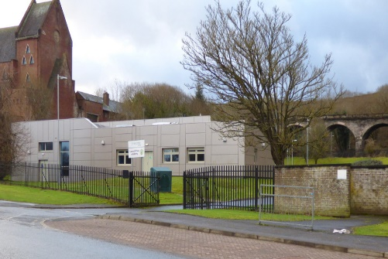
School Handbook 2023/24

Contents

- Head Teacher Welcome
- Equality, Child Protection, Complaints and GDPR Statements
- Vision, Values and Aims
- Introduction and School Information
- Senior Leadership Team
- Staff Directory
- The School Day and Placing Requests
- School Dates and Holiday Information
- School Attendance and Absence Reporting
- EMA and Emergencies
- Clothing
- Medical Information
- Communicating With Parents
- Models Of Support
- Thrive Enhanced Nurture Service
- Curriculum
- Assessment and Reporting
- Transitions
- Additional Support Needs
- Pupil Support
- Inverclyde Educational Psychology Service
- Positive Relationships
- School Improvement
- Useful Addresses and Local Councillors

HT Welcome

I am delighted to welcome you to Lomond View Academy’s handbook. My name is Susan Chambers and I am the Virtual School Headteacher for Inverclyde, with responsibility for Lomond View Academy within that remit.
Whether you are a pupil, parent, or interested party I am hopeful you will find the handbook useful and will find the information you are looking for, however, please always feel free to contact the school directly if you have anything you wish to discuss. We are always pleased to have visitors to our school.
At Lomond View Academy we have made some significant changes to the delivery model we are using to support a range of pupils from across Inverclyde. These changes will widen the number of young people attending the school to provide them with appropriate learning experiences to support them to successfully return to their mainstream school, or in some cases to a positive destination post-school.
Part of this change has been the creation of an enhanced nurture provision, based in St Michael’s Primary this year to support a small number of primary aged pupils four mornings a week, as well as extending our support to include a model for those who have been unable to attend school for a significant period with a focus on re-engagement with their base school.
Our young people are thriving in these environments and we are developing strong partnerships that will assist with broadening the experiences offered. We have passionate and committed staff who have created a nurturing environment where we invest in positive relationships, develop self-esteem, and confidence, and provide a personalised education.
The very nature of our support recognises that young people can be here for a range of timescales. Whether it is for a few weeks or two years, we must work together to allow our pupils to access a full and individualised curriculum. We look forward to working with all our families in building an environment where we can celebrate the achievement of your child.

Susan Chambers, Headteacher

The Equality Statement for Inverclyde Establishments
‘Inverclyde Education Service is committed to ensuring that no children or members of staff or service users receive less favourable treatment on any ground including age, gender reassignment, pregnancy and maternity, race, disability, sex, sexual orientation, marriage and civil partnership, religion, or belief. We have a moral, social, and legal obligation to mainstream and put equality at the heart of everything we do. We aim to promote a culture in which equality of opportunity exists for all. We are opposed to all forms of discrimination, direct or indirect, and aim to eliminate all discriminatory practices. We will ensure that, in our schools and other educational establishments, equality permeates the curriculum and underpins all our policies and practices in terms of access to education. We must ensure that all our children achieve their full potential to develop physically, emotionally, and academically. Finally, we believe that equality and inclusion should be a given right, where everyone is valued and treated with respect.’

Child Protection
Inverclyde Council Education Services has Child Protection Guidelines and Procedures which all schools and establishments are required to follow. Education Services work very closely with other agencies namely Strathclyde Police, Social Work Services, NHS Greater Glasgow and Clyde, and the Children’s Reporter to support children. Common responsibilities of all staff are to protect children from abuse and exploitation, to respond appropriately when abuse is identified, and to ensure whenever possible that all children are able to exercise their right to be raised in a warm, stimulating, and safe environment with the support of staff, their families and carers.

Complaints
Any comments or complaints should be addressed directly to the school office where they will be dealt with by a member of the school leadership team. If parents seek a further response then they should contact Education Services, Wallace Place, Greenock PA15 1JB

General Data Protection Regulations and Data Protection Act 2018
Information on children, parents and guardians is stored on a computer system and may be used for teaching, registration, assessment and other administrative duties. In processing personal information, Inverclyde Council must comply with the General Data Protection Regulation and Data Protection Act 2018.
For further information please refer to https://www.inverclyde.gov.uk/site-basics/privacy or click on the following: Privacy page link

Introduction and School Information
Lomond View Academy is a five year non-denominational ASN school, catering to both boys and girls. We look after the needs of young people throughout the Inverclyde area who find the mainstream environment challenging. We also have a primary enhanced nurture provision located in St Michael’s Primary School as well as the corporate parent team located within our building.

Parents or carers can't file a placing request as our intake comes directly from the Authority Screening Group in partnership with mainstream secondaries and families.

Lomond View is committed to continuous improvement. As such we always welcome any suggestions you may have. Or should there be any complaints, please do not hesitate to get in touch with any member of the Senior Leadership Team.

The full postal address of the school is –
Lomond View Academy
Ingleston Street
Greenock
PA15 4UQ
Tel : 01475 714414
E-mail : INLomondView@glowscotland.onmicrosoft.com / inasmwilson@glow.sch.uk

The current school role is detailed below:

S2: 7
S3: 6
S4: 13
S5: 1
Information can also be found on our website –
https://blogs.glowscotland.org.uk/in/lomondviewacademy/

Senior Leadership Team
The senior leadership team is composed of the Head Teacher, One Depute Headteacher and one Principal Teacher.
Members of this team are:

Susan Chambers (HT)
Responsibilities include:
School Finances
Staffing
Safeguarding and Child Protection
School Improvement

Michael Dyer (DHT)

Responsibilities Include:
Curriculum Planning
SQA Coordinator
Tracking and Monitoring
Partnership Working
Employability

Kerry McQuillan (PT)
Responsibilities Include:
Pastoral Care
Pupil wellbeing, equity and inclusion
ASN Coordinator
Transitions



Staff Directory

Management Team
Head Teacher | Susan Chambers
Deputy Head Teacher | Michael Dyer
Principal Teacher Lomond View | Kerry McQuillan
Principal Teacher Corporate Parenting | Roslyn Friel
Principal Teacher Thrive | Jane Aitken
Teaching Staff
Lomond View Teacher | Iain Brown
Lomond View Teacher | Kwasi Addo
Lomond View Teacher | Ross Kennedy
Lomond View Teacher | Stuart Naylor
Lomond View Teacher (EBSA Model) | Liz Docherty
Corporate Parent Teacher | Linda Morris
Corporate Parent Teacher | Kevin Rodgers
Corporate Parent Teacher | Jacqueline Murdoch
Enhanced Nurture Teacher ( Thrive) | Louise Campbell
Support Staff
Pupil Support Assistant (LVA) | Ross McLaughlin
Pupil Support Assistant ( LVA) | Chantelle Clarke
Pupil Support Assistant ( LVA /Thrive) | Amanda Harkins
Pupil Support Assistant ( LVA /Thrive)
Other Staff
Youth Support Worker (LVA) | Maggie Heron
Youth Support Worker (LVA) | Kim Fowler
DYW Coordinator (LVA) | Nicola Christie
CLD Youth Worker (LVA) | Colleen McCrindle
Active Schools Coordinator (LVA) | Gary Forbes
Admin Support (LVA) | Sharon Wilson
Janitor (LVA) | John Pearson
Cleaner (LVA) | Christine

The School Day
Lomond View operates a different timetable than the rest of the secondary schools in Inverclyde. The end of the school day is 15:00 and we operate 7 periods every day.

No young people attend here on a full-time basis and some could be in for parts of a day.

Breakfast: 0900-0915

P1: 0915-0945

P2: 0945-1030

P3: 1045- 1130

P4:1130-1215

P5: 1245-1330

P6: 1330-1415

P7: 1415-1500

At the end of a young person’s day, they will be taken by taxi if they are attending their base school, if they are returning home they will be encouraged to travel independently, if it is safe to do so, on the bus as every young person has been supported to get a bus pass.

All pupils will be brought to school in a taxi to support good attendance at school. It is important that pupils are ready and waiting for their taxi as these cannot be sent out again due to costs incurred.

School Meals
Catering is provided each day for the young people. They have access to toast and cereal in the morning, followed by toasties, paninis, soup, and fruit at lunchtime.

Placing Requests
Lomond View Academy does not accept placing requests. Please contact your child’s mainstream school or Varri Steel (Education Officer, Inclusion) at Varri.steel@inverclyde.gov.uk

For families, out with Inverclyde who will move into the area and who think their child may need our provision, please contact Varri Steel at the above email address. She will advise on the process for applications for out of Authority pupils. Alternatively, please contact Educational Psychology at psychological.service@inverclyde.gov.uk.

School Dates and Holiday Information

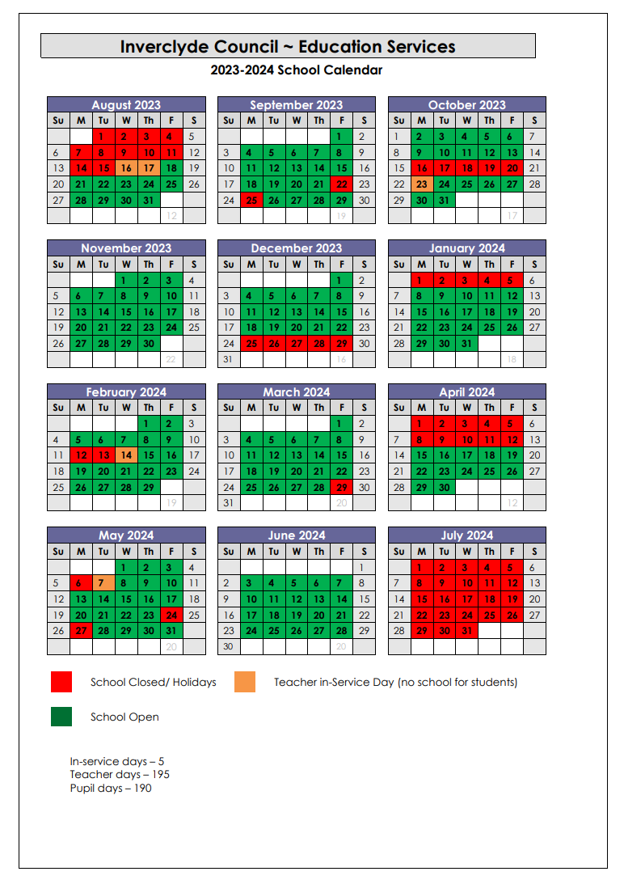

School Attendance and Absence Reporting
Parents should inform the school by telephone on the first morning of an absence and provide a reason for the pupil’s absence. The school will contact the pupil’s family and thereafter other emergency contacts if no explanation is given for the pupil’s absence. This contact will be made before 10am on the first morning of an absence by text or telephone and early after the restart after lunch in the case of an afternoon absence.

Other agencies may be contact if no contact with the pupil’s family can be achieved and if there are continuing or emerging concerns about a pupil’s safety or wellbeing. Parents should keep the school informed of any changes of address or telephone numbers, both their own and those of the emergency contacts.

Section 30 of the 1980 Education Act lays a duty on every parent of a child of ‘school age’ to ensure that their child attends school regularly. Attendance must be recorded at least twice a day, morning and afternoon. The school now records attendance on a period-by-period basis.

The Scottish Government has provided guidance on the management of attendance and absence in Scottish schools in its publication ‘Included, Engaged and Involved – Part 1: Attendance in Scottish Schools’. Every effort should be made to avoid family holidays during term time as this both disrupts the child’s education and reduces learning time. It has been clarified that family holidays should not be recorded as authorised absence, except in exceptional domestic circumstances, where a family needs time together to recover from distress, or where a parent’s employment is of a nature where school holiday leave cannot be accommodated (e.g. armed services or emergency services). It is for local authorities and school to judge when these circumstances apply and authorise absence accordingly.

The categorisation of most term-time holidays as unauthorised has been a contentious issue for some families, many of whom are concerned at the higher cost of holidays during school holiday periods. The Scottish Government has no control over the pricing decisions of holiday companies or flight operators. Our main focus is to encourage parents and pupils to recognise the value of learning and the pitfalls of disrupting learning for the pupil, the rest of the class and the teacher. Clearly where an absence occurs with no explanation from the parent, the absence is unauthorised. Schools investigate unexplained absence, and Education Services has the power to write to, interview or prosecute parents, or to refer pupils to the Children’s Reporter if necessary.

If you know your child will be absent (appointment for example) please contact the school in advance. You can do this by calling the office on: 714414 and, should the time off fit the criteria, the absence will be recorded as “authorised”. This is particularly important if your child receives EMA as unauthorised absences may result in EMA being withdrawn for a week. You can also call your child’s key worker (Maggie Heron or Kim Fowler) who will inform the school.

For unplanned sickness and emergencies, parents are urged to cancel the taxis when they become aware their child will not attend school. There is an enormous yearly cost to the school and this would greatly assist us. Please call Inverclyde Taxis on (634563)

Education Maintenance Allowance
The Education Maintenance Allowance (EMA) is a grant provided by the government to encourage students to stay on at school beyond their statutory leaving date. It is available to S5 and S6 students if:
• they have completed Fourth Year at school
• they have reached the legal date at which they could have left school, and have opted to return
• they started a Fifth Year course of study in the school session following their statutory leaving date
The grant is a means-tested allowance, based on parental income, but paid directly to the student. The award is up to £30 a week. The payment of allowances, and the payment of the bonus, is dependent upon students maintaining 100% attendance, adhering to the school’s code of conduct and making good progress in their studies

Emergencies
Information in Emergencies We make every effort to maintain a full educational service, but on some occasions circumstances arise which lead to disruption. Schools may be affected by, for example, severe weather, temporary interruption of transport, power failures or difficulties of fuel supply. In such cases we shall do all we can to let you know about the details of closure or reopening. We shall keep you in touch by using letters, text messages, Twitter, Website, notices in local shops and community centres, announcements in local churches and announcements in the press and on local radio.
Staff at Lomond View will, most likely call you so, please be aware that any calls ending 712045 will likely be from the school or Council. Each young person and their family will have the work mobile number of their allocated key worker (Kim Fowler or Maggie Heron) and can contact them re any emergency situations. Parents are encouraged to ensure that emergency contact details are up-to-date.

Clothing
At Lomond View Academy we do not have a school uniform. However young people should attend school wearing acceptable clothing and in line with the below guidance.
There are forms of dress which are unacceptable in school, such as items of clothing which:
- potentially encourage faction (such as football colours);
- could cause offence (such as anti-religious symbolism or political slogans);
- could cause health and safety difficulties, such as loose fitting clothing, dangling earrings or clothing made from flammable material, for example, shell suits in practical classes;
- could cause damage to flooring;
- carry advertising, particularly for alcohol or tobacco; and
- could be used to inflict damage on other pupils or be used by other to do so.
- In addition jewellery such as dangling earrings and large rings could cause health and safety difficulties and are unacceptable to be worn in school.
The council is concerned at the level of claims being received regarding the loss of pupils’ clothing and/or personal belongings. Parents are asked to assist in this area by ensuring that valuable items and unnecessarily expensive items of clothing are not brought to school. Parents should note that the authority does not carry insurance to cover the loss of such items and any claims submitted are likely to be met only where the authority can be shown to have been negligent.

Parents of children receiving one of the following benefits will normally be entitled to monetary grants for footwear and clothing for their children –
- Income Support (IS);
- Income-based Job Seekers Allowance (JSA);
- Employment and Support Allowance (Income Related) (ESA) ;
- Child Tax Credit, but not Working Tax Credit and where income is less than £16,105 (in 2019/20) as assessed by HMRC;
- Parent or Carer is in receipt of Working Tax Credit and/or Child Tax Credit with Annual Gross Earnings of no more than £11,288;
- Universal Credit, where your take home pay does not exceed £915, as shown on your monthly Universal Credit statement;
- An Asylum Seeker, receiving support under Part VI of the Immigration and Asylum Seekers Act 1999.
Pupils are eligible for a Clothing Grant in their own right if they are aged 16 – 18 and fall into any of the above categories.
Information and application forms for footwear and clothing grants may be obtained from schools and Customer Service Centre, Municipal Buildings, Clyde Square, Greenock PA15 1LY.

Medical Information
MEDICAL EXAMINATION

The routine medical examination of children is undertaken at the ages of 10/11 years and 13/14 years by staff if the Inverclyde Health Board and parents may refer their child at other times to the Clinical Medical Officer for examination or advice.

BCG vaccinations are given in S2. Tetanus and polio vaccinations are given in S3 along with their routine medical examination.

Parents are given prior notice of these examinations and are welcome to attend.

ILLNESS DURING THE SCHOOL DAY

Please note that the school does not have the services of a qualified nurse although some teaching and auxiliary staff have been trained in first aid. It must be emphasised, therefore, that this service is for emergencies only and should you child show symptoms of illness or sustain cuts or bruises out with school he/she should be referred to his/her own doctor.

MEDICAL/EMERGENCY CONTACT FORM

Parents will be provided with a form on which they will be required to state any medical condition or physical disability affecting their child which might influence their education attainment. This also forewarns the school of medical provision or facilities which must be made available. Should parents wish to discuss health matters of a more confidential nature then it is recommended that an appointment be made with the appropriate member of the management team or youth services worker.

Communication with Parents
We communicate regularly with parents/carers and we aim to keep them updated on progress. Parents/Carers can contact the school via phone, email, or through their young person’s Key Worker.

We attend TAC meetings and liaise with Parents/Carers and base schools to ensure the supports we have in place are appropriate and successful.

If anyone has a concern or issue about a young person we would encourage them to contact the school at their first opportunity.

We are also active on X (Twitter) @Lomond_view

Parental Engagement
In Lomond View we recognise that parents play an extremely important role in the education of their children. We believe that for the school to be successful we have to be committed to working in a genuine partnership with all parents. This partnership is fostered in a number of ways –
- Parents are involved regularly in meetings to discuss their child’s welfare and attainment.
- Great emphasis is placed on getting to know the parents as well as the young people, especially during key times like transitions. We have a weekly parents group in order to get to know them and to foster a positive working relationship with all our parents and carers.
- We provide parents with advice and support on how they can support their child’s education
- We keep parents regularly informed of what is going on in the school
Parents are encouraged to keep in close contact with the school to maintain and strengthen this partnership.
For further information please see: https://blogs.glowscotland.org.uk/in/schswebsite/parental-engagement/
PARENTZONE SCOTLAND
Parentzone Scotland is a unique website for parents and carers in Scotland, from early years to beyond school. The website provides up-to-date information about learning in Scotland, and practical advice and ideas to support children’s learning at home in literacy, numeracy, health and wellbeing and science. Information is also available on Parentzone Scotland regarding additional support needs, how parents can get involved in their child’s school and education.
Parentzone Scotland also has details about schools, including performance data for school leavers from S4-S6 and links to the national, local authority and school level data on the achievement of Curriculum for Excellence levels.

Models Of Support

Models of Support

Thrive Primary Enhanced Nurture Provision

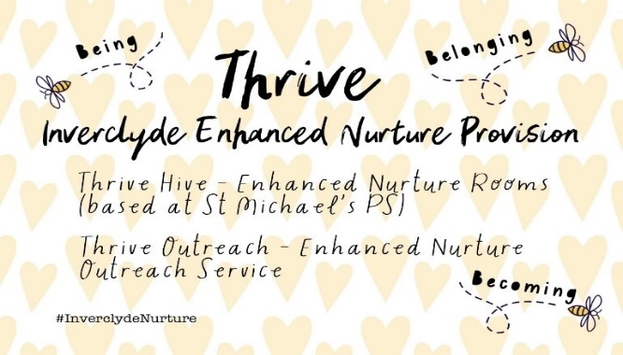

Thrive is an enhanced nurture provision in Inverclyde that supports children of primary school age with attachment, trauma or adversity-based difficulties who require specialised, short-term, and targeted interventions to address their social, emotional, and behavioural needs.

Marjory Boxall gave the following description of a Nurture Group:
“The emphasis is on emotional growth, focusing on offering broad-based experiences in an environment that promotes security, routines, clear boundaries and carefully planned, repetitive learning opportunities. The aim of the nurture group is to create the world of earliest childhood, build in the basic and essential learning experiences normally gained in the first three years of life and enable learners and young people to fully meet their potential in mainstream schools.”

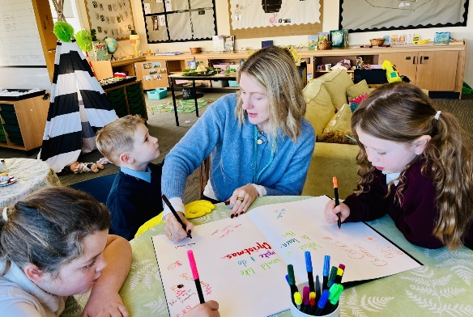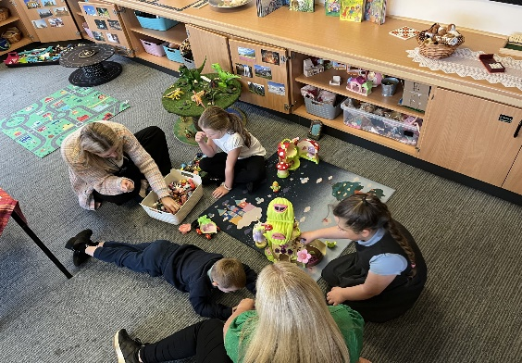

Whilst we are geographically situated within our own spaces (Thrive Hive) at St Michael’s Primary School, Port Glasgow, and are organisationally part of Lomond View Academy, we offer a shared placement for children from schools across the authority and work in partnership with the learner’s school, parents/carers, and partner agencies. We can also offer support and guidance to the learner’s base school through our Thrive Outreach service. The long-term goal will always be to find the most effective and appropriate way to allow the individual learner to access the curriculum within their mainstream class and school, with the child’s wellbeing at the centre.

The main responsibility of our Outreach service is early intervention and building capacity within a child’s base school. This may include, for example, signposting to other agencies or supports, coaching/modelling of inclusive approaches, support in creating/adapting developmentally appropriate spaces, providing advice and guidance, collaborative work with Psychological Services and other agencies to support school and family, or whatever is identified during a child’s placement.

Thrive has three overarching tenets-
Being: the child is accepted for who and where they are right now in terms of their development, interests, and achievements,
Belonging: the child is accepted as a valued part of Thrive Hive as well as their base school, and is always ‘kept in mind’ by both parties,
Becoming: by meeting the child where they are, we can plan responsively and intentionally to progress the child’s development and learning appropriately and sensitively.

For further information related to Thrive Enhanced Nurture Provision please contact:
Jane Aitken, Principal Teacher Enhanced Nurture
email: injaa622@glow.sch.uk
Louise Campbell, Thrive Nurture Teacher
email: gw15campbelllouise11@glow.sch.uk

X (Twitter):
@JaneA_Nurture @ThriveHive_inv
#InverclydeNurture #PlayInverclyde

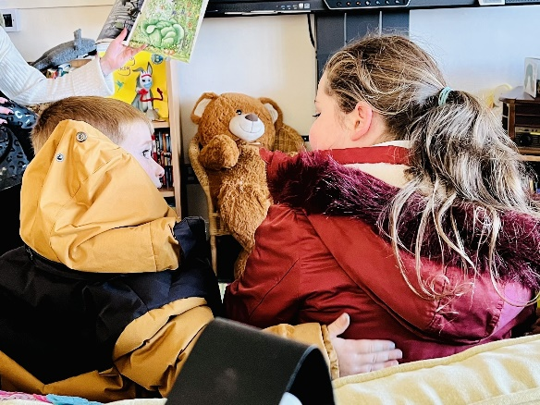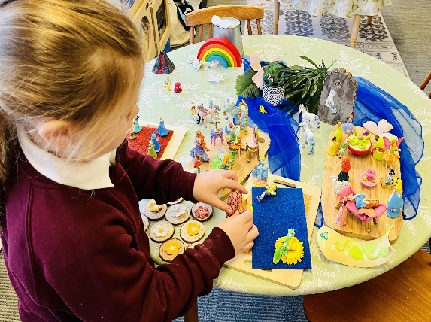

Curriculum
Curriculum For Excellence
The school has developed its curriculum in line with the Scottish Government’s Curriculum for Excellence initiative. The aims of Curriculum for Excellence are that every child and young person should –
- Know they are valued and will be supported to become a successful learner, an effective contributor, a confident individual and a responsible citizen.

- Experience a traditionally broad Scottish curriculum that develops skills for learning, skills for life and skills for work, with a sustained focus on literacy and numeracy, that encourages an active, healthy and environmentally sustainable lifestyle and builds an appreciation of Scotland and its place in the world.

No two young people have the exact same timetable due to the bespoke curriculum we offer. We work alongside schools to ensure the curriculum on offer is appropriate. This can mean young people complete courses in one school or across both, depending on what is most appropriate for them.

S1 – S3 (The Broad General Education)

Pupils in S1, S2 and S3 follow a broad, general education which provides the opportunity for all learners to overtake the experiences and outcome up to level 4. In S1-3 pupils cover a variety of subjects, tailored to suit their needs. We work closely with base schools to ensure that the subjects on offer build on the work young people are completing there. These core subjects will be completed across both schools.
At Lomond View, BGE pupils can expect to experience:

- English /Literacy
- Maths / Numeracy
- RMPS
- Geography
- Science
- Cookery
- Outdoor Learning
- Woodwork
- Wider Achievement

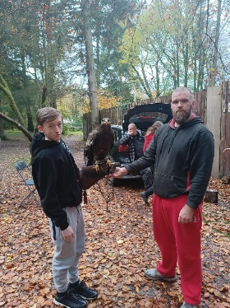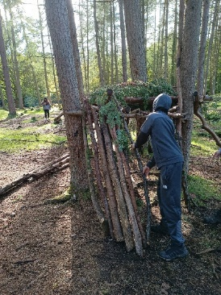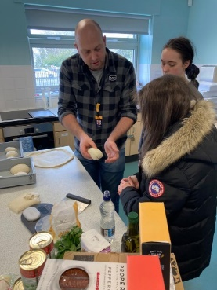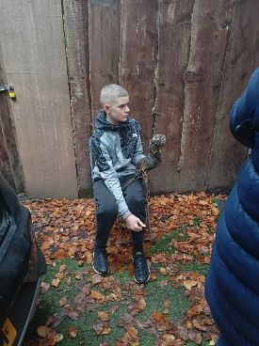

Curriculum

Senior Phase

At the beginning of S4 pupils enter their Senior Phase of secondary education. This supports levels of study at National 3, National 4, National 5 and Higher, as well as studying subjects at level 3,4,5 and 6 for short courses.

At Lomond View our S4 model delivers a hybrid of SQA full course awards, alongside National Progression Awards, and Wider achievement awards. Young people also have an opportunity to attend college for vocational courses one afternoon per week, as well as completing the YES (Your Employability Skills) programme with outreach staff from West College Scotland.

In S4 pupils can study
- English (N3/N4/N5)
- Applications of Maths (N3/N4/N5)
- Travel & Tourism (N4)
- People & Society (N4)
- Practical Woodwork (N4)
- Employability (N4)
- Mental Health Award (N4)
- Barista Skills (N4)
- Media (N4)
- Bakery (Level 4 NPA)
- Sports Coaching (Level 4/5)
- Prince’s Trust Award
- First Aid

More information about our awards can be found at the links below

SQA National 3-5 - https://www.sqa.org.uk/sqa/58062.3806.html

NPAs - https://www.sqa.org.uk/sqa/46552.html

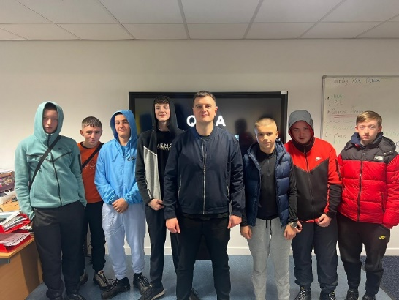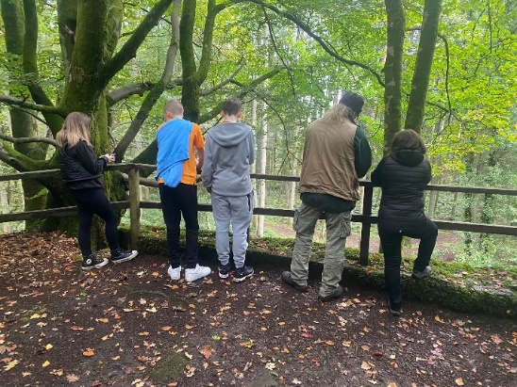

Assessment and Reporting
We have undergone a change of model for session 2023/24. We pride ourselves on having strong communication with home. As part of this process, S4 pupils receive a formal monthly report detailing their current working grades and long-term academic targets.

S1-3 pupils will receive at least 1 formal report per term and will have regular phone calls from staff highlighting areas of strength and also the next steps. BGE staff members link with the Clydeview Academy Cluster to ensure accurate moderation of levels in Literacy and Numeracy.

All our young people’s Wellbeing is regularly assessed using the Glasgow Motivation & Wellbeing Profile and Boxall Profile. This helps us assess progression and plan next steps for classes and young people.

Reports are always shared and discussed with base schools too; this helps ensure all staff working with a given young person have a clear idea of progress. When appropriate we work alongside our partner schools to prepare young people for any upcoming assessments they may have.

Transitions

Moving to Lomond View

A transition to Lomond View is entirely bespoke and dependent on the needs of the individual young people. Once a school has referred a young person for support through the ASG, (Authority Screening Group) a contextualised assessment will then be carried out to establish if Lomond View is the right support for the young person. If this then shows that Lomond view can offer appropriate support, and initial TAC meeting will then be held to discuss the transition process.

After this stage we begin planning for the young person engaging with Lomond View. This differs from young person to young person depending on their needs and wellbeing. Typically this will involve initial visits to meet staff before gradually building up time and visits until we have reached the desired amount. There is not a set time limit on this happening; we always strive to keep the young person at the centre of any transition.

We hold regularly Team Around the Child (TAC) Meetings to review progress and decide on actions to ensure a successful time in Lomond View.

Transition out of Lomond View

Transitions out of Lomond View look vastly different depending on the age and stage of the young person. Sometimes this would be a gradual return to their base school if appropriate or into a positive destination if they are of age. Wherever the destination the transition is planned well in advance with all relevant stakeholders involved.

Young People leaving school are given intensive input and guidance from or Developing the Young Workforce Coordinator Nicola Christie. This support is to help ensure that the positive destination is sustained long term. This support varies depending on the needs and wants of the young person.

Our Key Workers Kim and Maggie remain linked to pupils for a year after they leave to help ensure that the support is there if required.

Transitions

Post School

From S4 onwards all young people begin to pursue different options. At Lomond View we seek to support young people after S4 with a blend of school and college learning or work placement; some will plan to move on to university, college, training programme or to get a job.

Our Developing the Young Workforce coordinator Nicola Christie is in school on Mondays and Thursdays. She works on a 1-1 basis with our young people to find supportive work experience placements. She also assists them with college course applications and is on hand to link directly with our college partners regarding the individual needs of our young people.

In Lomond View, our young are supported in finding the best option for them. Extensive support from the pupil support team and partnership working with Skills Development Scotland, Careers Coaches, More Choices More Chances Team ensures that our young people receive the guidance required.

Skills Development Scotland bring together the knowledge and expertise of what were the Careers Service, Adult Guidance Networks, the Education Business Partnership and Lifelong Learning Partnerships. The services previously offered by these agencies have now been brought together in an integrated way. In Lomond View young people and their parents can access 1-1 time with the Careers Adviser through their weekly slots in school or by visiting their local Careers Centre. Kirsty Caldwell/Sky McEntail is the Careers Adviser/Work Coach and is in the school every Thursday All pupils are given basic information about careers and interviews are organized for individual pupils.

Kirsty works in partnership with other relevant agencies such as Social Work, Health Service, More Choices, More Chances (MCMC), etc. in order that all pupils can be given the best possible advice about the opportunities open to them.

More information can be obtained from the Skills Development Scotland website - www.skillsdevelopmentscotland.co.uk/

The More Choices, More Chances team support the school in ensuring that those young people at risk of missing out on a positive destination when they leave school are fully supported in finding an appropriate placement. Michelle Scott works very closely with Lomond View staff to support the needs of our senior phase pupils as they leave school. Maureen is invited to most reviews for S4 pupils and above.

Young people at Lomond View will have post school support from our youth support team for up to one year after leaving to assist with achieving a positive and sustained destination.

Additional Support Needs
Lomond View Academy is an Additional Support Needs school. Every young person with us has additional needs which require our input.

All children and young people need support to help them learn. The main source of support in the school are the staff who, through their normal practice, are able to meet a diverse range of needs. With good quality teaching and learning and an appropriate curriculum most children and young people are able to benefit from education without the need for additional support. The definition of additional support is a wide one and it is not possible to provide an exhaustive list of all possible forms of additional support. Every teacher has a responsibility to support the learning of all pupils in their class. The type of support offered will vary according to the needs of pupils. This includes consideration given to children who have a disability, children with social, emotional and behavioural difficulties, children with learning difficulties of a specific or general nature, children who are exceptionally able, those who demonstrate underachievement relating to gender issues, children whose learning has been interrupted through absence or illness, bilingual children who have English as an additional language, traveling children and those children whose family circumstances impact on attendance and learning.
All pupils with an Additional Support Need are supported in completing an Individual Education Programme. Pupils with Additional Support Needs also have regular progress meetings also involving their parents/carers. There will be many other examples besides these. Some additional support needs will be long term while others will be short term. The effect they have will vary from person to person. In all cases though, it is how these factors impact on the individual persons’ learning that is important and this will determine the level of support required. Additional supports can take the form of close monitoring by staff, provision of an Individual Education Plan (IEP), cooperative teaching or individual tutorial support.
Other, more specialised services are accessed in consultation with the educational psychologist. If a parent considers that his or her child has additional support needs and wishes to make enquiries on this they should contact Kerry McQuillan, Principal Teacher.
Arrangements for free transport are made for pupils with recorded Additional Support Needs.
Further information in relation to pupils support can be found at – http://www.scotland.gov.uk/Topics/People/Young-People/gettingitright
In addition to the information above, Inverclyde Council will provide:
(a) the authority’s policy in relation to provision for additional support needs A child or young person’s needs are identified at the earliest possible stage and can be met in a number of ways, for example by adaptations to the curriculum or learning environment, as well as input from the Support for Learning Teacher and on occasion support from visiting specialists. The appropriateness of the support is determined through a process of assessment, planning and monitoring, working jointly with parents and carers, and is regularly reviewed.
(b) the arrangements made by the authority in making appropriate arrangement for keeping under consideration the additional support needs of each such child and young person and the particular additional support needs of the children and young persons so identified. Learning outcomes for children and young people with additional support needs are set out in a plan and all educational establishments hold regular review meetings with parents and carers to determine needs and the most appropriate supports. Everyone’s views are equally important in order to consider what is currently working and how to determine next steps.
(c) the other opportunities available under this Act for the identification of children and young persons who –
(i) have additional support needs Children and young person’s needs are identified in a number of ways, and the process of assessment is an on-going, shared process with partnerships with parents and carers at the forefront. On some occasions health service staff or other partner agencies make children known to Education Services. Other additional support needs may be notified to Education Services by parents themselves or identified by one of a range of staff working closely with the child.
(ii) require, or would require, a co-ordinated support plan Some children and young people will have additional support needs arising from complex or multiple factors which require a high degree of co-ordination of support from both education and other agencies in order that their needs can be met. In these cases, the school will hold a meeting to decide whether the child or young person meets the criteria for a co-ordinated support plan. The coordinated support plan is a statutory document which ensures regular monitoring and review for those children and young people who have one.
(iii) the role of parents, children and young persons in the arrangements referred to in paragraph (ii)
You have the right to ask the education authority to establish whether your child needs a coordinated support plan. Your child can make this request themselves, if they are aged 16 or over. You and your child, if they want to, will attend a meeting with staff at their school. Other professionals from different agencies who may be involved in providing support for your child will also attend. If your child does not want to attend meetings or feels unable to, their views must still be sought and considered.
(d) the mediation services provided Inverclyde’s mediation service can be accessed by contacting Tony McEwan, Head of Culture, Communities & Educational Resources at the address below
(e) the officer or officers of the authority from whom parents of children having additional support needs, and young persons having such needs, can obtain advice and further information about provision for such needs.
For further advice please telephone 01475 712850 Or write to; Education Services Wallace Place GREENOCK PA15 1JB
Advice, further information and support to parents of children and young people with ASN:
(a) Children in Scotland: Working for Children and Their Families, trading as “Enquire – the Scottish advice and information service for additional support for learning”, a charitable body registered in Scotland under registration number SC003527;
(b) Scottish Independent Advocacy Alliance, a charitable body registered in Scotland
(c) Scottish Child Law Centre, a charitable body registered in Scotland under registration number
Additional Support Needs
At Lomond View Academy we are committed to providing a nurturing and inclusive learning environment for all students, with a diverse range of needs. Our dedicated staff recognise the unique challenges that our students may face and are committed to providing the necessary support to help them thrive academically, emotionally, and socially.

Each pupil has an individual pupil profile developed collaboratively with parents, teachers from both Lomond View and mainstream schools, and other relevant professionals. This plan will outline specific strategies and interventions tailored to meet the unique needs of each pupil. The pupil profile is regularly reviewed and updated to ensure its effectiveness and relevance.

Our staff undergo training to better understand and address the specific challenges that pupils may experience. This training equips teachers and support staff with the skills to create a positive and supportive learning environment. Our staff members are committed to fostering positive relationships with students and providing the emotional support they require.

Lomond View Academy employs Promoting Positive Behaviour (PPB) strategies to reinforce positive behaviour and discourage negative behaviours. This process includes understanding the function of a young person’s behaviour, providing immediate support to reduce stress and risk, and planning strategies to help the young person to gain the same response in a more positive and socially appropriate way. We recognise the value of crisis communication and active listening and understand the importance of de-escalation intervention strategies to promote safety, preserve relationships and facilitate communication.

In partnership with external bodies such as West College Scotland, Inverclyde Leisure, Finlaystone, Action for Children, Barnardos, Young Carers, Community Learning and Development and Active Schools, Lomond View Academy offers opportunities for young people to explore learning in different environments and develop their interests. These experiences and targeted strategies are designed to increase opportunities for attainment and promote emotional well-being, excellent relationships and positive behaviour.

At Lomond View Academy, we recognise the importance of developing the employability skills of our young people. Developing the Young Workforce (DYW) is a Scottish Government initiative aimed at better preparing young people for the world of work. The initiative emphasises collaboration between schools, businesses, and other partners to create opportunities for young people to develop the skills and experiences needed for employment. Nicola Christie is our DYW coordinator In LVA and she plays a crucial role in implementing and overseeing the DYW initiative. Nicola has the responsibility of building and maintaining relationships with local businesses and employers to create work-related learning opportunities for pupils, collaborating with teachers and educational staff to integrate employability skills into the school curriculum, organising work placements and work-based learning experiences for pupils and planning and organising events, workshops, and presentations that connect pupils with employers and industry professionals.

Open communication between school staff and parents/guardians is crucial for the success of our pupils. Regular meetings, progress reports, and updates on the student's well-being are provided to keep parents/guardians informed and involved in their young person’s education and support.
Through these comprehensive strategies, Lomond View Academy is dedicated to creating a safe, supportive, and enriching learning environment for all students, with their individual needs in mind.

Pupil Support
As part of the schools’ GIRFEC agenda, the aim of the Pupil Support staff is to provide a point of personal contact and support for pupils throughout their school career by monitoring their academic, personal, social and vocational development. Where necessary, the pupils’ educational environment is adapted to allow them maximum opportunity to fulfil their potential. The objectives of the staff are -

- To offer emotional support to students, providing a safe space for them to express their feelings and concerns.
- To develop strategies and interventions to address behavioural issues, working closely with students, parents, and other staff members to implement effective plans.

- To provide staff of the school and partner agencies with a known point of referral.
- To facilitate programs and activities aimed at improving social skills, fostering positive relationships, and promoting inclusivity within the school community.
- To create individual support plans tailored to each student's specific needs, collaborating with various professionals such as psychologists, social workers, CAMHS, Barnardo's and Action for Children.
- To work collaboratively with teachers, administrators, and external agencies to ensure there is a holistic approach to supporting students' overall well-being and academic progress.
- To act as an advocate for students, liaising between home and school to ensure a cohesive support system for their educational and emotional needs.
- To regularly monitor students' progress, assess the effectiveness of interventions, and make adjustments to support plans as needed.

- To establish a Careers programme in conjunction with Skills Development Scotland.

Pupil Support staff, along with subject teachers, provide important support for pupils at transition times. This will help to ensure that pupils are following the appropriate courses considering the pupil’s capacity and career aspirations. Kerry McQuillan is our Principal teacher who oversees pupil support and will be happy to discuss any aspect of a child’s education with parents/guardians.

Holiday support
Over many years Lomond View’s pupils have been fortunate to have the support of our Youth Service’s workers during holiday periods. Kim Fowler and Maggie Heron offer weekly support to young people to ensure maximum levels of wellbeing.

Positive Relationships
At Lomond View Academy, we recognise the significance of positive relationships in creating a supportive and nurturing environment for our students. We aim to cultivate an atmosphere where every individual feels respected, valued, and understood. Our school is founded on the principles of ambition, belonging, and resilience. We encourage students, staff, and families to embrace these values in their interactions, understanding that each person's uniqueness enriches our community.
We prioritise emotional well-being by providing a safe space for students to express themselves. Trained staff members offer guidance, active listening, and appropriate interventions to support emotional needs. We facilitate structured activities and group projects to encourage positive peer interactions. These initiatives aim to build empathy, teamwork, and communication skills among students. Our school promotes healthy conflict resolution strategies. We teach students how to manage conflicts constructively, emphasising empathy, active listening, and finding mutually agreeable solutions. Recognising and celebrating positive behaviours is essential. Our staff employs various methods, such as praise, reward systems, and acknowledgment ceremonies, to reinforce positive behaviour. Collaboration with families is integral. We encourage open communication and involvement in school activities, fostering a supportive network that extends beyond the classroom.
Our dedicated staff undergo continuous training in relationship-building techniques, conflict resolution, trauma-informed practice, and fostering a positive school culture. This ensures they are equipped to address the diverse needs of our students effectively. We seek to actively engage with the wider community, inviting guest speakers, organising community projects, and participating in events that promote understanding and acceptance of diverse perspectives. At Lomond View Academy, the cultivation of positive relationships is fundamental to our school. We believe that by nurturing an environment where respect, empathy, and inclusivity thrive, we empower our students to flourish academically, socially, and emotionally.

Inverclyde Educational Psychology Service
Inverclyde Educational Psychology Service aims to improve the wellbeing and education of children and young people through the application of psychology in practice. We do this by:
- providing training and coaching to educational staff with the goal of optimising the inclusion of all children and young people.
- using the latest research evidence in psychology to advise and consult with others. This helps to assess and plan for children and young people with Additional Support Needs.
- working with others to seek solutions that build on the existing strengths of children and families.
- ensuring that children and young people’s views are heard and included in any planning.
There are many more roles of the Educational Psychologist, you may find these on our website https://www.inverclyde.gov.uk/education-and-learning/inverclyde-educational-psychologyservice.

School Improvement
Standards and Quality Report
On an annual basis, we publish our Standards and Quality report. Copies from previous years are available on the school website. The Standards and Quality report will be used to highlight progress in key areas of school improvement.
The main achievements of our school over the last 12 months can be seen in the Standards and Quality Report on the school website.
Planning For Improvement
Our priorities for improvement are detailed in our School Improvement Plan . Any parent or carer seeking a copy of the Standards and Quality Report or Improvement Plan can contact the school office or check out our website.

Useful Addresses
Head of Education
Wallace Place
Greenock PA15 1JB
01475 712850

Community Learning & Development
1 Aberfoyle Road
Greenock
PA15 3DE
01475 714250

Skills Development Scotland
112 West Blackhall Street
Greenock
PA151XR
01475 745903

Local Councillors
Councillor Pam Armstrong
Councillor Colin Jackson
Councillor Michael McCormick

Although this information is correct at time of presenting, there could be changes affecting any of the matters dealt with in the document –
(a) before the commencement or during the course of the school year in question.
(b) in relation to subsequent years

