Lomond View Academy

Standards and Quality 2022/23
Context of the Establishment:

Our Establishment
Lomond View Academy is a specialist education provision supporting pupils within Inverclyde who have an identified social, emotional, and behavioural need that have struggled to maintain a fulltime mainstream educational provisions. We support pupils for S1 to S6 in both a full time and part time capacity.

During session 2022/23 access to Lomond View Academy was determined by the Additional Support Needs Forum. Throughout this session we have provided support to 20 secondary aged pupils with the following demographic.

Establishment priority 1: Improvements in attainment, particularly in literacy and numeracy
NIF Priority  Improvements in attainment, particularly in literacy and numeracy  -  NIF Driver  School Improvement  School leadership | HGIOS/ELC QIs  1.2 Leadership of learning  1.3 Leadership of change  2.2 Curriculum  2.3 Learning, teaching and assessment  UNCRC  Article 28: (Right to education):  Article 3 (Best interests of the child):
Outcome:
- By end of session Senior phase option choices will include Princes Trust Achieve and a selection of NPA courses.
- By end of session BGE curriculum will be designed with a shared delivery across all teaching staff with key staff having responsibility for curricular areas.
- All staff will engage with OSIRIS training by end of February
- By the summer term outdoor education with Men’s Shed will be established within curriculum and all BGE pupils will be developing their outdoor learning

Progress and impact of outcomes for learners:
- Throughout the session there has been an ongoing analysis of provision at Lomond View Academy. This has included a curriculum review of both senior phase and BGE. We have successfully implemented Princes Trust Achieve within the senior phase with 50% of staff fully in delivery. Staff have reported that they have found this course relevant for pupils and easily imbedded across the curriculum. 3 pupils have achieved a minimum of 2 units in this course. NPA offer is still being reviewed.
- BGE and Senior Phase offer has been reviewed. This included feedback from pupils, staff, parents, and an analysis of ASN forum and Authority screening group submissions. From this data it has been determined the following needs

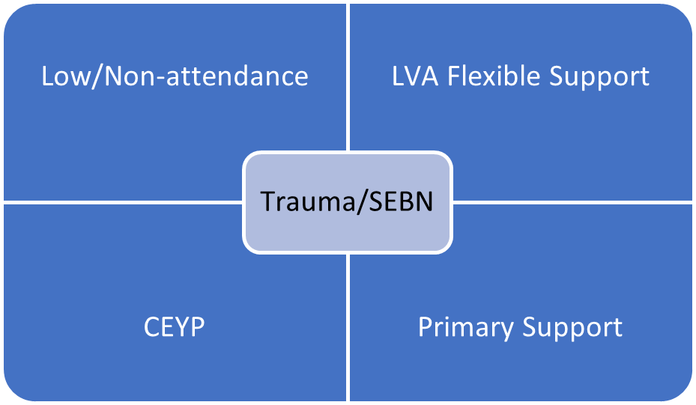

- All staff attended OSIRIS teaching and learning input at Inverclyde Academy to encourage effective questioning styles to support learning. Teaching staff reported that this was impactful. School Assistants did not fee this was entirely relevant to their role.
- Men’s shed have collaborated with school to install an orchard which is being maintained by staff and pupils.

Next steps:
- Develop new model approach for Lomond View Academy to support identified needs across the authority for pupils affected by Trauma/SEBN
- Develop clear tracking and monitoring system relating to attainment and achievement
- Develop quality calendar to support improvement in teaching and learning

Establishment priority 2: Closing the attainment gap between the most and least disadvantaged children and young people

NIF Priority  Closing the attainment gap between the most and least disadvantaged children and young people  -  NIF Driver  School leadership  Assessment of children's progress  Parental engagement | HGIOS/ELC QIs  1.3 Leadership of change  1.5 Management of resources to promote equity  2.5 Family learning  2.6 Transitions  UNCRC  Article 28: (Right to education):  Choose an item.
Outcome:
- Increase the number of children supported by LVA and measure increase of engagement with education (leuven scale)
- Increase number children maintaining positive post school destination
- Increase number of young people supported by Social Work outreach service
- All pupils to achieve 1 wider achievement qualification by June 23
- Create system to monitor engagement with PLP
Progress and impact of outcomes for learners:
- Over the session support offered by Lomond View Academy changed to include more pupils from the BGE. This was due to identified need throughout the additional support needs forum. This has allowed us to support a wider rage of pupils and change the focus to early intervention rather than senior phase support. Tracking and monitoring for engagement is still in development.
- Through improved links with MCMC and support from the DYW coordinator we have ensured that all pupils will be supported post school to a positive destination. This has included a range of activity agreements and supported college placements.
- To maintain a sustained positive destination Lomond View Academy offers support for 12 months via the social work youth outreach workers. Due to these ongoing connections, we can identify any potential areas of difficulty and provide targeted support where required.
- Princes Trust Achieved Award has been introduced this session and all senior pupils have achieved at least one module from this programme.
- The design of a system monitor PLP is still to be developed and this is also being reviewed at the ASN senior phase workstream.
Next steps:
- Develop new model approach for Lomond View Academy to support identified needs across the authority for pupils affected by Trauma/SEBN
- Develop clear criteria of support for social work youth outreach team.
- Implement moderation programme to support the delivery of SQA courses across all models.
- Improved partnership working to support implementation of new models in particular model four to six.

Establishment priority 3: Improvement in children and young people's health and wellbeing
NIF Priority  Improvement in children and young people's health and wellbeing  -  NIF Driver  Assessment of children's progress  Choose an item. | HGIOS/ELC QIs  2.4 Personalised support  3.1 Ensuring wellbeing, equality and inclusion  3.2 Securing Children's Progress  UNCRC  Article 3 (Best interests of the child):  Article 28: (Right to education):
Outcome
- All staff will be trauma aware by June 2023
- At least one staff member at LVA will be a PPB trainer by June 23
- Friday morning at LVA will have a focus on wellbeing
- All pupils will be working towards their wellbeing award
Progress and impact of outcomes for learners:
- All staff have completed the Level 1 of NHS trauma informed practice training. There has also been significant input from education psychology service to embed trauma informed practice and Nurture principles.
- 3 members of staff have completed the promoting positive behaviour training with a view t complete the train the trainer aspect of the course in the next term.
- This session a Friday morning has been used to support the health and wellbeing of staff and pupils. This has involved input from outside providers such as active schools and action for children. This has improved relationships within the school and encouraged engagement with outside providers.
- The Friday morning model has allowed an improvement in parental engagement. There was a successful Christmas carol event as well as a family pizza making event. All parents report an increase in positive relationship with education because of this.
- The wellbeing Award was not delivered as part of the senior phase; however, it is expected that it will be embedded within the new models in the coming session.
Next steps:
- Develop new model approach for Lomond View Academy to support identified needs across the authority for pupils affected by Trauma/SEBN
- All staff to be trained in PPB. At least 3 staff to be identified as trainers for this programme.
- All staff to be fully trained and demonstrating trauma informed practice
- Introduction of primary support for enhanced Nurture.

Establishment priority 4 Improvement in skills and sustained, positive school-leaver destinations for all young people

NIF Priority  Improvement in skills and sustained, positive school-leaver destinations for all young people  -  NIF Driver  School leadership  Teacher professionalism  Assessment of children's progress | HGIOS/ELC QIs  1.1 Self-evaluation for self-improvement  1.5 Management of resources to promote equity  2.4 Personalised support  3.3 Increasing creativity and employability  UNCRC  Article 3 (Best interests of the child):  Article 28: (Right to education):
Outcome
- All senior pupils will have engaged with either work placement or college placement by Jun 23
- HT will attend ASN workstream meetings to feedback findings to Lomond View
- All relevant senior phase pupils will be supported to a sustained positive destination by Jun 23
- Access to ASD non learning needs pilot will increase positive destination opportunities for pupils

Progress and impact of outcomes for learners:
- All senior pupils have had the opportunity to engage with work placement or college placement. This has enabled our leavers to engage with post school services to encourage a positive sustained destination.
- ASN workstream has established links with Inverclyde College to identify gaps in service to support pupils with ASN to engage with further education. This has resulted in the offer of extended transition.
- This session 7 pupils have left Lomond View Academy. All pupils have left to engage with a positive destination. This will be supported by the youth outreach workers to maintain this destination post school. 4 pupils have engaged with an activity agreement and 2 pupils have accessed college
- We have established a link with the Autism pilot programme to provide support for pupils diagnosed with ASD in a post schools service. The transition to this service began 3 months before leaving date and has an impact on supporting a pupil to appositive destination.

Next steps:
- Develop model four for Lomond View Academy. This will support senior phase pupils to sustained positive destinations post school.
- Increase partnership working to improve wellbeing and transition to post school.
- Continued attendance at the ASN workstream.

Key Strengths:

Impact of LVA
- This session Lomond View Academy has supported 20 Inverclyde pupils who were at significant risk of breakdown of educational placement. This has ensured that young people have remained within their community and are accessing education within a supportive and inclusive environment.
- 4 BGE pupils who were only attending for a limited number of hours per week within mainstream provisions have increased their engagement to 50% of the school week and have successfully maintained an educational placement without exclusion.
- Parental feedback would support the positive impact Lomond View Academy to support education for young people and their families. After transition to Lomond View all families report an increase in positive relationship with education and the ability to see attainment and achievement for the young people that was not a viable option within the mainstream environment, this is due to the ability to have a more flexible approach to education.
- There has been a strong relationship developed with the educational psychology department. They have supported the regeneration of Lomond View Academy and have engaged with staff to develop an understanding of the need for self-evaluation as well as a shared vision to support pupils and families.
- There has been a significant development of staff to engage with self-evaluation and improvement this session. All staff engaged with staff working groups to start the analysis of issues relating to: data gathering, vision, values and aims as well as staff and pupil wellbeing. Staff working groups highlighted areas of good practice as well as next steps to allow staff to continue to engage with quality improvement.
- A review of curriculum offers for all pupils was carried out over this session. Taking this data and combining with data from the additional support needs forum we were able to determine the gaps in service for the young people of Inverclyde. The service needs were identified related to care experienced young people, young people with trauma, primary sector, and young people with significant attendance issues.

Attainment/Attendance
- The average attendance figure for the year is 90.76% this is below the authority average. However, this is a positive attendance figure for all pupils attending the school as pupils identified to attend Lomond View Academy have all had significant truancy and attendance issues. Due to the high staff ratio and pastoral care offered from youth outreach workers there has been a 7.5% increase in attendance since last session.
- Five Senior Phase pupils were presented for qualifications this year presenting a total of 13 SQA qualifications. All senior pupils have gained a minimum of N3 in Literacy and Numeracy.

Key Priorities:

- Share evolution of Lomond View Academy with all schools to support equity of service
- Development for all new models at school to support pupils across Inverclyde and those placed out of authority
- Develop robust data collection to support self-evaluation for school improvement
- Self-evaluation practices to be embedded within school calendar to support all staff involvement in school improvement
- Curriculum development to support BGE and Senior Phase via the introduction of new models will be a priority to ensure pupils have access to all entitlements via the Lomond View Academy offer in conjunction with mainstream school.

National Improvement Framework Quality Indicators
1.3 Leadership of change Satisfactory
Key Strengths:

- Over the session most areas of this quality indicator have improved form weak to satisfactory according to data collection from all staff. This has been due to the introduction of a self-evaluation process and the involvement of staff in self-evaluation practices. There has been a journey to implement change within the senior management structure and this has been well received by all staff and it is hoped will give more stability for the upcoming session.
- The senior leadership team have introduced a culture where almost all staff have opportunity to engage with leadership to implement change. This has involved the introduction of staff working parties. Staff been given the opportunity to share good practice as well as been given the chance to take leadership of curriculum areas.
- Over the session significant work has been completed on data analysis of the shared vision and values for the school. The majority of staff have taken leadership opportunities to facilitate this and ensured views of all partners have been considered. This has helped form some of the analysis of the need to develop new delivery methods with the school and will be continued into the next session.
- There have been some opportunities for young people to influence change. This can be facilitated through the breakfast club which has formed an informal pupil council. During the soft start view and opinions of young people can be gathered and shared with relevant staff and stakeholders.

Key Priorities:
- The school needs to review the current approaches to self-evaluation and take account of a wider range of information and evidence to ensure that priorities for improvement are identified and lead to improved outcomes for learners
- Improvement in leadership at all levels to support all staff
- Vision and values to be to be reviewed, updated, and embedded

2.3 Learning, teaching and assessment Satisfactory
Key Strengths:
- SQA policy was developed and implemented during term 2. All staff received training on this and understood their roles relating to presentation of SQA qualifications. All senior phase pupils received a qualification in literacy and numeracy appropriate to their level.
- Throughout the session there has been an increase in the number of BGE pupils from 2 to 8. All pupils have engaged with an enhanced transition programme and are starting to engage positively with a bespoke educational package.

Key Priorities:

- Opportunities must be developed for moderation of all subject delivery at BGE and senior phase. This can be developed as part of cluster working.
- All staff must take ownership of curriculum areas as defined by school requirements and assigned by senior management
- A tracking and monitoring policy must be developed.
- Quality assurance calendar to be developed

3.1 Ensuring wellbeing, equity and inclusion Satisfactory
Key Strengths:
- All pupils who have transitioned into service this year report that the enhanced transition process has made the transition successful. This in turn has supported the increased attendance for BGE pupils from mainstream to bespoke educational package provided by Lomond View Academy.
- Almost all families have benefitted from significant family support provided by youth outreach workers. Families report hat this has been beneficial to understand the change in delivery for mainstream education to specialist provision.
- Almost all pupils have shown an increase in attendance and engagement since joining Lomond View Academy. This is often related to the bespoke wellbeing curriculum that has been offered.
- All staff took part in training regarding trauma informed practice and the implementation of the crisis curve. Most staff used this training to develop individual learning profiles for all pupils in term 3.

Key Priorities:
- Increase partnership working to support all new models
- Upgrade of learning environment using Nurture principles.
- Introduction of robust tracking and monitoring process for all stages

3.2 Raising attainment and achievement/Securing children’s progress Satisfactory
Key Strengths:
- This session all senior pupils have attained expected levels in literacy and numeracy. Some pupils have achieved at least one unit in the Princes Trust Achieve Award. All staff have been developing knowledge of wider achievement opportunities through NPA and external provision wider achievement awards.
- A curriculum for BGE is being developed to support the change of cohort from senior phase pupils to include S1-S3. All staff have been involved in a curriculum review to include appropriate differentiation and to deliver areas out with their subject specialism.
- A few young people accessed college on a part time basis utilising the PLP system. This was not a sustainable delivery for the young people. However, it did encourage independence and gave an understanding of the requirement of a post school college environment.
- A profile was created for each pupil to identify learning and behavioural needs. It is recognised that this should be a live document and utilised by all staff working with pupils in order to tailor appropriate support.

Key Priorities:

- Introduction of robust tracking and monitoring process for all stages
- Curriculum development for new models must have a clear rationale for literacy and numeracy
- Increase accreditation from external providers and SQA

Key Achievements of the Establishment

Lomond View Academy has had a full restructure of senior management and an inroduction of offers available to support pupils across Inverclyde. This has been developed to meet a need highlighted both with the schools itself and across the authority.

The new models that have been developed will be reviewed and embedded within the service over the coming 12 months. Staff, pupils, families and the authority have all worked together to identify the support required and introduce a service that should better fit the growing needs across Inverclyde.

This will be closely monitored and measured over the coming session to ensure effectiveness of delivery.

