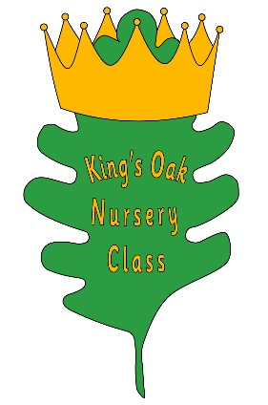
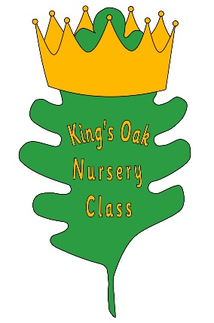
Welcome
to
King’s Oak Nursery Class

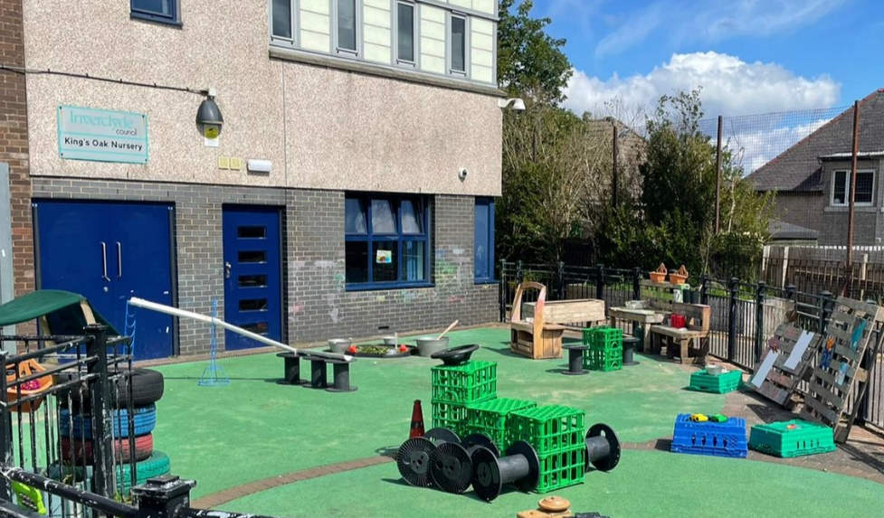

This booklet will provide you with information about your child starting nursery.

#Love of Learning
#King’s Oak Care
#Little Oakers

King’s Oak Nursery Vision
At King’s Oak, we believe ‘From Tiny Acorns, Mighty Oaks Grow’ and that in our pursuit of excellence and equity everyone can achieve.

King’s Oak Nursery Class Aims

- To provide a warm, stimulating, positive environment for children to grow and learn
- Nurture and encourage curiosity, wellbeing and respect
- To become more confident and independent, whilst learning and playing
- Encourage children to take responsibility for their learning and behaviour
- To provide an interactive partnership involving school, home, outside agencies and the community.

King’s Oak Nursey Values

Respect (UNCRC Articles 7 and 16)
Honesty (UNCRC Articles 12 and 13)
Kindness (UNCRC Article 12)
Safe (UNCRC Articles 5, 27 and 36)
Achieving (UNCRC Articles 28 and 29)

Welcome
King’s Oak Nursery Class has capacity for 24 children during term time. Session times operate between 9am and 3pm. Children must be three years of age before being allocated a place. All children aged 3 and over are entitled to an 1140 hours Early Learning placement as their core entitlement.

Meet Our Staff
Debbie
Early Years Education
& Childcare Support Assistant

Sarah
Early Years Education
& Childcare Officer

Eilish
Early Years Education
& Childcare Officer

Lorna
Early Years Education
& Childcare Officer

Anna
Peripatetic
Early Years Education
& Childcare Officer

Tracey
Equity and Excellence Leads
Depute Head of Centre
Vacancy

Our experienced staff all have a broad knowledge within early years and the curriculum. You and your child will have the opportunity to meet the staff when you come for the settling in period.
Settling In
In line with our settling in policy, we ask that parents/carers stay with their child on the first day for up to one hour. Staff will communicate with parents/carers to create a plan that is individual and unique to support your child's wellbeing. The nursery hours will gradually increase until your child is happy, settled and familiar within the setting. If you are not able to attend please give us a call.

Snack/Lunch
Every child will be provided daily with a hot/cold lunch option, soup and a piece of fruit, free of charge. Milk, water is also included. We provide a rolling lunch sitting where children choose when to access lunch. We hope that children continue to enjoy a sociable lunch with their friends, reinforce good hygiene practices and have opportunity to try new foods. The lunches will be served in the playroom and this will provide less interuptions to children’s learning.
You will be provided with our lunch menu prior to your child staying for lunch.

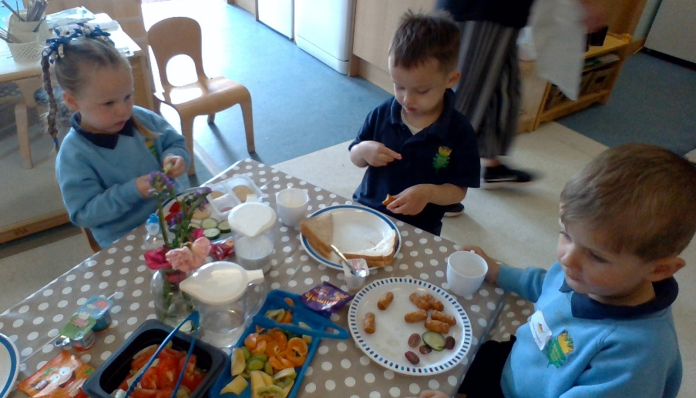

Healthy snacks will also be provided in the morning and afternoon. If you wish for your child to bring their own packed lunch with them please read our Oral Health Leaflet to help us promote healthy eating for children. No drinks are required as part of a packed lunch. We ask that parents and carers are mindful of healthy food options.

Clothing
We ask that your child wears comfortable and casual clothing when coming to nursery. Children are naturally curious and love to take part in messy play experiences. At King’s Oak Nursery Class we can guarantee your child will come home dirty! We do encourage children to wear aprons and outdoor protective clothing. Our nursery uniform is optional and can be purchased from Smiths of Greenock.

A Day in the Life of King’s Oak Nursery Class
You may wonder what your child is doing at nursery, and often they will say “nothing, I was playing.” At King’s Oak Nursery Class we have an active play - based approach to learning.
Your child will begin to learn by doing things for themselves, by exploring, investigating, watching, listening, creating. The list could go on, but in other words they are learning through play. Playing can be hard work and also very messy! Your child will be learning both indoors and outdoors with sand, water, soil and paint so please do not wear good clothing. Outdoor learning is a vital part of our curriculum and our children are out in all weathers daily. Children thrive in nature environments, it allows them to take risks, be curious and helps to improve their wellbeing.
Please dress your child appropriately — waterproof suits and welly boots can be stored in nursery for your child to wear daily if they wish to explore outdoors.

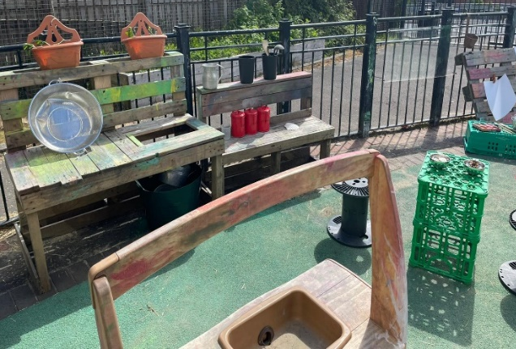
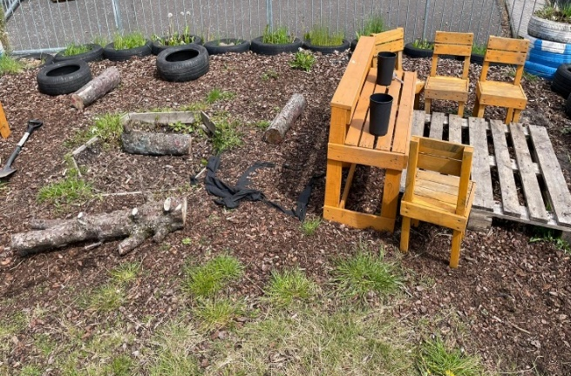

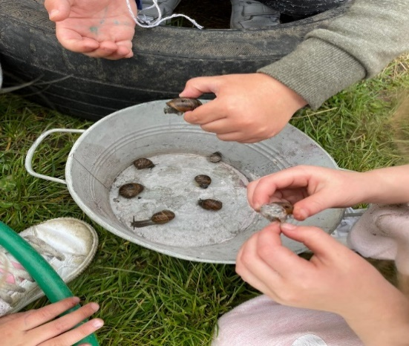

Learning Through Play
A Curriculum for Excellence by Education Scotland is the document we use to track your child’s development and plan possible next steps of learning. Nursery children access early level which then transitions to Primary 1 ensuring progression & continuity in your child’s learning journey. The Curriculum is split in to eight subject areas … Maths & Numeracy, English & Literacy, Health & Wellbeing, Science, Technology, Religious & Moral, Expressive Arts and Social Studies.

Staff are skilled to encourage children to find their own interests and engage in play initiated by the child. We are responsive to their needs and often ‘plan in the moment’. Children are more inclined to show high levels of engagement when they are able to explore their own interests within an enabling environment.

We aim to keep parents/carers actively involved through ‘Stay and Play’ which runs twice weekly. Your child will have their own personal learning profile, where the keyworker will record and track learning. This can be accessed electronically via Learning Journals. Please feel free to comment on your child’s learning or upload photographs from home to the learning journal.
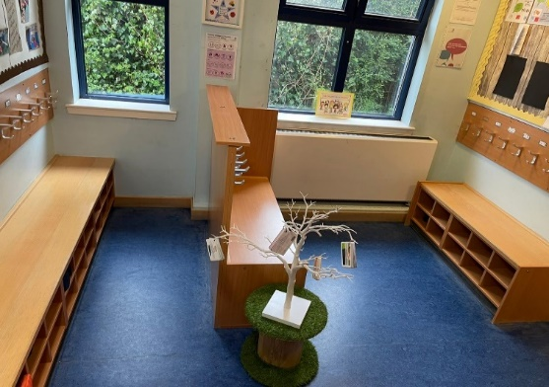

We have a wide range of learning displays throughout the nursery and door entry areas for you to follow what we have been doing and the skills we are learning. It also allows us to showcase the voice of the child.

Getting In Touch

When we have our settling in period we ask that you provide us with current and accurate contact details. We will communicate via phone calls and often use an app called group call. Groupcall is free of charge and will allow us to send direct messages via text or email. Anytime you change contact details, please inform us.

Attendance
At King’s Oak Nursery Class we believe that good attendance is essential for children to be happy and settled and to dully experience all the fun, learning and play experiences. Coming to nursery allows children to make friendships, become more independent, grow in confidence, access an inclusive curriculum and most importantly—have fun!

Absences
We understand that children can be absent from nursery for a number of reasons. We ask that you give us a quick call to let us know. The office is available from 8:15am on 01475 714680. If we don’t hear from you we will give you a courtesy call after 9.30am. Please do not bring your child to nursery if they are unwell. If your child has had sickness or diarrhoea we ask that you must keep at home for 48 hours since the last episode of sickness or diarrhoea.

Outings
We aim to provide the children with a wide variety of experiences. Often we go walks in our local area, nearby parks or short journeys on the train/bus. As we are responsive to the children’s interests and ideas and follow their lead, we can’t always tell you in advance as to when this may happen. During settling periods all parents/ carers will have the opportunity to fill in consent forms.

You can speak to any member of staff regarding any suggestions or concerns.

Nursery Telephone Number: 01475 - 714685

We look forward to having a wonderful learning journey with you at
King’s Oak Nursery Class

