Kilmacolm Primary School and
Nursery Class
School Handbook
2024-25

CONTENTS

INTRODUCTION
Welcome from the Head Teacher 3
The School Team 4
School Information/Contact Details 5
Parent Concerns/Complaints & Absence/Late-coming 6
Visiting the School 7
The Nursery Class 8
School Term Dates 9

PARENTAL INVOLVEMENT
Parents as Partners 10-12
- Parental Involvement Strategy
- Learning and Teaching
- A message from the Parent Partnership and PTF
- Home Learning
- Reporting

THE SCHOOL ETHOS
The School Vision, Values and Aims 13
Celebrating Success 14
Partnership Working & School Community 15

CHILD PROTECTION
EQUALITIES 16

THE CURRICULUM 17-22

ASSESSMENT 23

REPORTING 24

TRANSITIONS 25

SUPPORT FOR PUPILS 26-27

SCHOOL IMPROVEMENT 28

SCHOOL POLICIES AND PRACTICAL INFORMATION 29-32

CLOTHING 33

ADDRESSES
GDPR 34

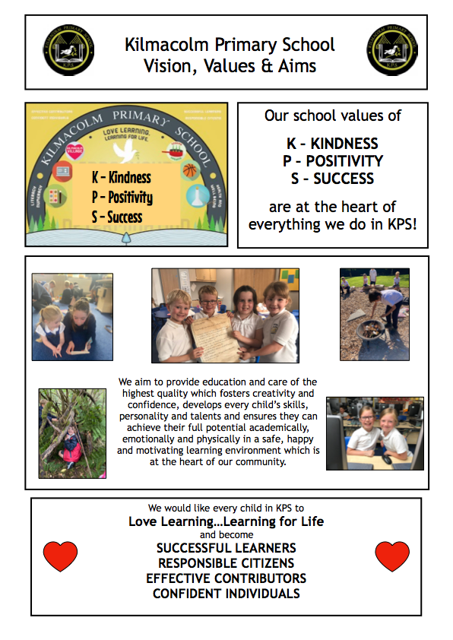

INTRODUCTION

Welcome from the Head Teacher

Dear Parents and Carers

A very warm welcome to Kilmacolm Primary School and Nursery Class. This handbook is designed to give you an insight into our school and nursery, our priorities, expectations and vision for the future and to provide you with useful and practical information. I hope you find it helpful and interesting.

We offer the pupils a variety of activities to help them become successful learners, confident individuals, effective contributors and responsible citizens. In KPS, we aim to offer all pupils the highest possible quality of education. We endeavour through our curriculum and our extra-curricular activities to foster academic and personal development in a caring and challenging environment so that each child can achieve their full potential.

We hope that your child’s journey with us will be a very happy and worthwhile experience. We hope that they will leave us with rich and happy memories of their time at Kilmacolm Primary and Nursery Class.

We are extremely proud of the Scottish Education Award we received in June 2018 for ‘Raising Attainment in Literacy’ and our Gold Sport Scotland Award (we received this in September 2019). More information about the #KPSLovesReading and #KPSLovesSport can be found on Twitter and on the school website.

Education is a partnership between school and home and by working together we can ensure that the children’s learning experience is of the highest quality. All at Kilmacolm Primary regard the partnership between home and school as vitally important and extremely beneficial to the education of your child.

At all times you will receive a warm welcome at the school and nursery and we will endeavour to assist you in any way we can. Please have a look at our school website, you will be able to access the School, Class and GOLD newsletters. Should you require further information please do not hesitate to contact the school/nursery to arrange a visit when I will be delighted to meet with you.

I look forward to working in partnership with you over the coming years.

Yours sincerely

Simone McCredie

Simone McCredie
Head Teacher

Page 3

School Information/Contact Details

KILMACOLM PRIMARY SCHOOL and NURSERY CLASS
Staff List
Session 2023/24

Simone McCredie HT
Lynn McPherson DHT

Class Teachers
P1 - Audrey O’Donnell
P2 - Laura White
P3/2 - Emma Nicholson
P3 - Zoe Boyle
P4 - Linda Isaksen
P5/4 - Emma Smith
P6/5 - Laura Griffin
P6 - Alison Gemmell
P7 - Stephanie Kretowicz

Recovery and RCCT Team - Christine Carruth, Wendy McKeegan, David Piggott, Vicki Addison and Karen Jamieson

Clerical Staff - Jan Johnston

Pupil Support Assistants - Hazel Colville, Isabel Docherty, Linda Gemmell, Jackie Hodge, Marie McGerr, Denise McParland, Frances Ritchie, Maria Baez and Isaac Dunning

Nursery Staff - Lisa Conway (Depute), Tracey O’Donnell (Senior EYECO), Laura McDonald, Rose Arthur, Rebecca Loughrey, Amy Woodcock, Gail McMenemy, Sean Coyle, (EYECOs), Mhari McNeil & Sam Brown(EYSAs)

Janitor - Alec Henderson

Catering Supervisor - Jackie Dunn

This is our staffing for 2023/24. This may change for session 2024/25.
Page 4

School Address:
Kilmacolm Primary School and Nursery Class
Churchill Road
Kilmacolm
PA13 4LH

Telephone: 01475 715812

E-mail: gw10mccrediesimone@glow.sch.uk

Website: http://kilmacolm.inverclyde.sch.uk

Twitter: @KilmacolmPS (school)
@kpsnurseryclass (nursery)
(all classes have a Twitter account - you can find details on the website)

Groupcall: The school/nursery will contact parents/carers via email/text using Groupcall

School App: We have a school app that keeps parents up to date with events, dates and news. If you would like to download the app, please contact the school office for the username and password.

The present roll of the school is 221 pupils in 9 classes from Primary 1 to Primary 7. We also have a nursery class which offers 56 places over a range of models. The school is non-denominational and co-educational.

Page 5

Concerns
If parents have any concerns relating to their child or any aspect of school we would ask that they contact the school office as soon as possible. If parents wish to speak to a class teacher, we will arrange an appointment at the earliest opportunity. We would ask that if at all possible, parents avoid coming in to speak to teachers first thing in the morning as this is a very busy time for teachers. If parents wish to speak to Mrs McCredie or Mrs McPherson please contact the school office and an appointment will be arranged as soon as possible. Alternatively, you can email Mrs McCredie (gw10mccrediesimone@glow.sch.uk). This will enable the school to deal with concerns promptly. The school can arrange later appointments to suit working parents.

Complaints
If parents are unhappy about any aspect of school, we would again ask that they contact the school office as soon as possible to arrange a meeting with Mrs McCredie or Mrs McPherson. It may help if when contacting the school, you give some details of the issue to allow prompt investigation.

We will arrange a meeting to hear your complaint and would hope that it will be resolved satisfactorily and quickly. If the complaint is found to be justified, we will endeavour where at all possible to put right what went wrong, to make adjustments to try to prevent a similar problem arising in the future and to offer an apology where appropriate.

If you are still unhappy with the service or with our response then you will have the right to take up the matter further with the Education Department. Complaints can be made in writing, by telephone or e-mail or by visiting the office in person.

Information about complaint handling procedures is available at:

www.inverclyde.gov.uk/council-and-government/complaint

Absence and Late-Coming
Please inform the school by telephone on the first morning of an absence. If pupils are absent from school with no reason, the school will make contact with parents to ensure that children are safe. If we are unable to contact the family, we will try emergency contacts. This contact will be made before 9.30am on the first morning of an absence and early after the restart after lunch in the case of an afternoon absence. If we are unable to make contact with a pupil’s family, it will be necessary to contact other agencies to ensure that pupils are safe and well.

If you require a longer period of absence for your child, then please write or email the HT.

Please keep the school informed of any changes of address or telephone numbers, both of your own and those of the emergency contacts.

Late coming
The school playground gate is locked at 9am. Therefore, if pupils arrive after the bell, they should enter by the main entrance door where they should report to the school office before going to class.

Page 6

Visiting the School
Parents of Primary One pupils are invited to visit the school at induction days in May and June. These days offer an opportunity to meet other parents, gain information on the Primary One school curriculum, meet staff, and have a tour of the school building and school grounds. Parents of children who are moving to the Kilmacolm catchment area and who wish to place their child here should contact the school to arrange an opportunity to meet with Mrs McCredie. At this meeting parents will have an opportunity to tour the school building. If a place is available and parents live within the school catchment area, parents will be invited to enrol their child, meet class teachers and arrange a starting date.

Getting to School
The Council has a policy of providing free transport to all primary pupils who live more than one mile from their local school by the recognised shortest walking route. This policy is more generous than the law requires. This means that the provision of transport could be reviewed at any time. Parents who consider they are eligible should obtain an application form from the school or:

Education Services
105 Dalrymple Street
Greenock
PA15 1HU

These forms should be completed and returned before the end of February for those pupils beginning school in August to enable the appropriate arrangements to be made. Applications may be submitted at any time throughout the year but may be subject to delay while arrangements are made. Children in the outlying areas of Kilmacolm, the country districts and Quarriers Village are transported by bus and taxi from appropriate pick-up points.

It is parent’s responsibility to ensure that their child arrives at the pick-up point in time. It is also the parent’s responsibility to ensure the child behaves in a safe and acceptable manner while boarding, travelling in and alighting from the vehicle. Misbehaviour could result in your child losing the right to free transport.

Parking around the school
The streets around the school can become very congested. We would ask that in the interests of pupil safety, parents decide whether bringing their car is a necessity. The school car park is strictly for staff/visitors to the school only. Parents are respectfully asked not to use the car park. We would also ask parents to be respectful of our neighbours and not obstruct driveways when dropping pupils off or collecting at the end of the day. We have agreed a voluntary one way system down Churchill Road at drop off and pick up times to ease congestion.

Walking and cycling to school
Whenever possible we would encourage our pupils to walk to school. Pupils should use the school crossing patrollers to cross the roads safely.

Pupils who wish to use their scooter/cycle to school, may leave their scooter/cycle in the bicycle shed. This is secured during the school day.

page 7
KILMACOLM NURSERY CLASS

Nursery Facilities
We are very lucky to have the most amazing facilities for the nursery childre. We have a playroom in the school, a brand new outdoor classroom and access the school grounds and Duchal Woods.

1140 Hours Pilot
The 1140 hours pilot began in the nursery class in December 2019. We have a range of attendance models on offer to parents. A school lunch is provided for all children, this is free of charge. The lunch menu is in the nursery section on the school website.

Admissions
To apply for a Early Learning and Childcare place, you should complete an application form, around the time your child turns two years old or before 31st January each year. The nursery application form can be found on the school website, the Inverclyde Council website or from the school office.

Page 8

When will your child become eligible for a nursery place?
BIRTHDAY DATES | INTAKE | INTAKE MONTH | ADMISSION TIMELINE
1st March - 31st August | 1 | August | At start of the school term in August and before the last day of August.
1st September - 31st December | 2 | January | At start of the school term in January and before the 3rd week of January.
1st January - last day in February | 3 | April | After the school Easter term before 1st May*  *This may change depending on when Easter falls

There is more information about our wonderful nursery class on the school website. Please contact the school office to make an appointment if you would like to come and visit!

PARENTAL INVOLVEMENT

Parents as Partners

Our parents are very much valued members of our school community. We value the importance of involving parents/carers in the life of the school and their engagement in their children’s learning. We have an ‘open door’ policy to parents. We aim to meet with parents who have a concern as soon as possible, and can arrange meetings later in the day to suit working parents. You can also contact the HT via email on gw10mccrediesimone@glow.sch.uk.

Scottish Schools (Parental Involvement) Act 2006 led to the establishment of Parent Councils in primary, secondary and special schools. The Act recognises the vital role that parents play in supporting their children’s learning. It places a duty on authorities to promote the involvement of parents in children’s education and the wider life of the school.

All parents who have a child attending the school are automatically members of the Parent Forum for our school. Membership of the forum allows parents to have a say in the local arrangements to enable their collective view to be represented on matters such as the quality and standards of education at the school and other matters of interest to parents. These views can be represented, as appropriate, to the head teacher of the school, the Council and HMIe.

Page 9

Please look at the school website for more information on Parental Engagement.

Parentzone Scotland
Parentzone Scotland is a unique website for parents and carers in Scotland, from early years to beyond school. The website provides up-to-date information about learning in Scotland, and practical advice and ideas to support children’s learning at home in literacy, numeracy, health and wellbeing and science. Information is also available on Parentzone Scotland regarding additional support needs, how parents can get involved in their child’s school and education.

Parentzone Scotland also has details about schools, including performance data for school leavers from S4-S6 and links to the national, local authority and school level data on the achievement of Curriculum for Excellence levels.

https://education.gov.scot/parentzone

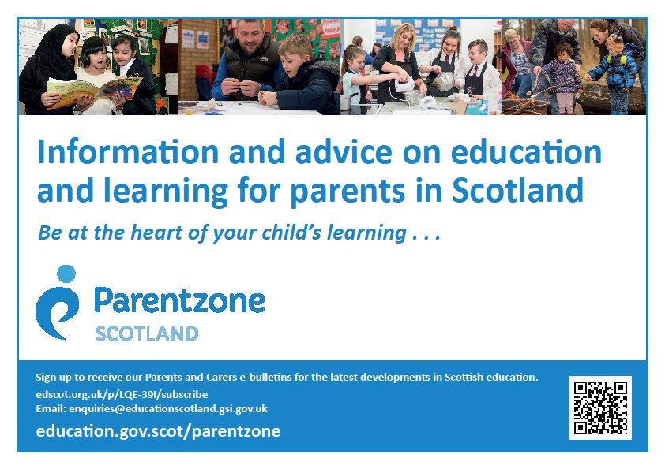
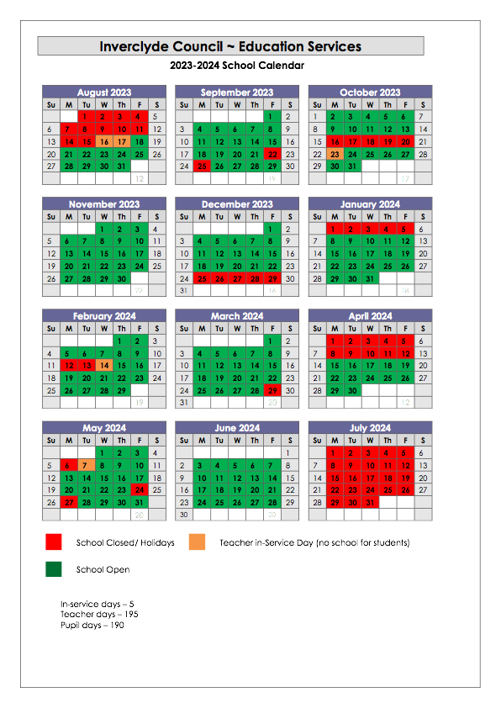
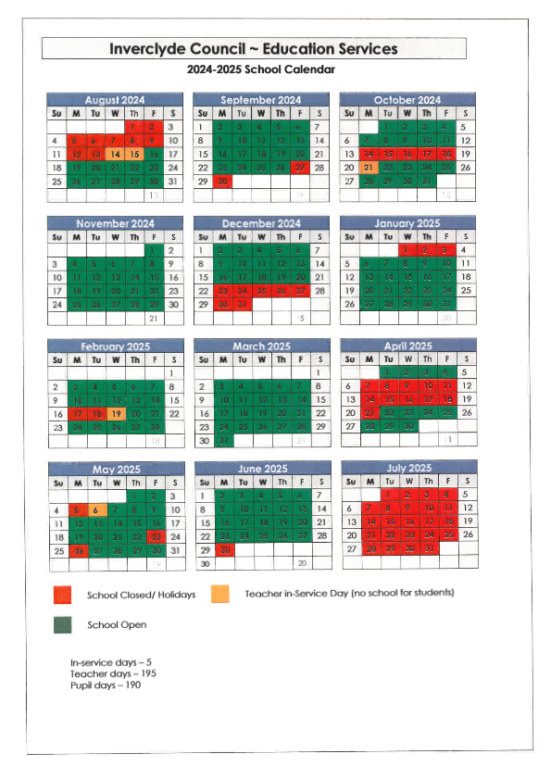
Page 10

Parental Involvement Strategy
We will strive to ensure that you are -
- Welcomed and involved in the life of the school
- Fully informed about your child’s education and learning
- Able to support learning at home
- Encouraged to express your views and take part in decision making
- Involved in forums for discussion and debate on educational policy

A copy of the KPS Parental Engagement Strategy can be found on the school website. This document was created in alongside the Parent Partnership and it was launched in September 2019.

Learning and Teaching
There are a number of ways parents can become more involved with learning and teaching in school -
- Input to school questionnaires
- Feedback following parent evenings / Termly Profiles
- Attendance at Parents Evenings
- Attendance at induction days / curriculum workshops
- Attendance at showcases events
- Attendance at school shows/ events
- Input to class topics
- Input to themed days/weeks

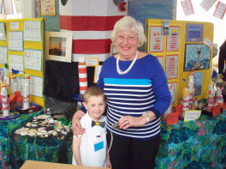
Home Learning
Home learning supports the development of independent learning skills and provides parents with an opportunity to take part in their child’s education.

It will -
• Allow children to practise and build upon what they have learned in school
• Encourage initiative and enable children to become independent learners
• Foster a partnership between home and school
• Give learners the opportunities to take more responsibility for their own learning
• Provide parents with an opportunity to be involved in their child’s learning

Home learning (homework) will often be the practice or revision of work which the pupil has been taught in class i.e. reading practice, number processes or the memorisation of spelling words, tables or number bonds. Topic research tasks either written or practical may be set by the teacher to encourage independent learning.

Pupils should be able to tackle home learning tasks with a reasonable degree of independence and within a short space of time. Parental interest is much appreciated both in ensuring that tasks are completed and in giving moderate help if required. By signing your child’s home learning you let us know that you are aware of the task set and consider that a suitable effort has been made. All teachers send home guidelines at the start of the session outlining the structure and pattern of home learning tasks for their particular class.

HOW CAN PARENTS SUPPORT OUR HOME LEARNING POLICY?
1. By ensuring home learning is done while your child is alert.
2. By trying to provide a calm atmosphere with as few distractions as possible.
3. By discussing the work with your child and working alongside him/her, especially at the early stages.
4. By checking that the quality and presentation is of an acceptable standard and signing the work.
5. By discussing any problems arising from home learning with the teacher (by appointment please).
6. By extending the work when appropriate perhaps by supplying a relevant book, visiting the library or a place of interest connected with the work.

Above all by showing interest and praising good efforts. Teachers would appreciate it if homework jotters were covered and kept in a clean and tidy condition i.e. no graffiti

Page 11

A Message from the Parent Partnership and PTF

Parent Forum, Parent Partnership and Parent Teacher Fundraiser committees:
As a parent with a child at our Nursery or Primary school you are a member of our Parent Forum – Welcome! Every school has a Parent Council; a committee that represents the voice of the parent forum. In some schools this committee also fundraise for the school. In our school we have two committees that perform these roles - the Parent Partnership and the Parent Teacher Fundraiser.

Parent Partnership: We represent you! We meet to discuss issues relating to school life - policy, teaching and learning including school, local authority and national initiatives. We represent the parent views on the issues of greatest importance to you, to our school, local authority and, where appropriate, other organisations such as Education Scotland. Members include parents, teaching staff and co-opted members. This team also do a huge amount to create opportunities to bring our community together and raise funds for our School to benefit our children! Again, you will be made most welcome at the PP meetings and help is always welcome in planning and helping at events!
Even if you are not on the committee you are most welcome to attend our meetings! The dates of the meetings are detailed on the monthly newsletters. From time to time, we will invite you to share your views by completing short surveys or attending open meetings. By engaging in this way you are making an important contribution to your child’s education and we are better equipped to represent you. If you have a particular issue that you would like to raise, please do let us know. Please note - we do not discuss individual cases at these meetings. If you have a concern relating to your child then please contact the School directly!

Email: kpparentpartnership@outlook.com web: http://Kilmacolm.inverclyde.sch.uk/parents/
Kilmacolm Primary School Parent Partnership @KPS_Partnership

Meetings:
Meeting dates are issued on newsletters, the parent section of our school web page, twitter, facebook and by text reminders. You can contact us at the email address above, by attending the meetings or by speaking to any one of us!

The team:
Parent Partnership Members:
Chair: Emma Bilsland & Finlay Campbell Secretary: Mike Pearsall Treasurer: Lisa Vitrano

Teacher members: Simone McCredie, Wendy McKeegan, Lynn McPherson

Co-opted Members: Helen Cook – Kilmacolm Community Council
We are also supported at our meetings by our local Councillors:
Cllr McCabe, Cllr Wilson and Cllr Curly.

Page 12

THE SCHOOL ETHOS
The School Vision, Values and Aims

Our Vision
LOVE LEARNING, LEARNING FOR LIFE

Our Values
K - Kindness
P - Positivity
S - Success

Our Aims
At Kilmacolm Primary School and Nursery Class we aim to provide education and care of the highest quality which:
- fosters creativity and confidence whilst developing every child’s skills, personality and talents
- ensures they can achieve their full potential academically, emotionally and physically
- provides a safe, happy and motivating learning environment, at the heart of our community

Celebrating Success
We value and celebrate each child’s attainment and achievement. We celebrate success and recognise the achievements of all our learners and provide opportunities for all our learners to achieve success! Personal achievement provides children not only with a sense of satisfaction but helps to build motivation, resilience and confidence and encourages them to remain engaged with education.

GOLD Assemblies
Every month during our GOLD Assemblies, we celebrate pupil achievements in school, at home and out in the community. The children are encouraged to share their successes with the whole school community - the awards are nominated by the staff and the parents/carers. Each class teacher also chooses ‘Shining Stars’ throughout the month who have demonstrated that they are a successful learner, effective contributor, responsible citizen or confident individual. The GOLD Newsletters can be found on the school website.

Competitions
We participate in many local and authority wide events and competitions including:
- Horticultural Society Flower Show
- Port Glasgow Bulb Show
- Kilmacolm Show
- Inverclyde Sporting Competitions and Events

Junior Leadership Team
Our school Junior Leadership Team (JLT) is a group of children from different classes who help make decisions about school life. They have been chosen by their classmates and their job is to discuss issues that are happening in the school that could affect the pupils. The pupils will tell the JLT representative if they have any issues or complaints. The JLT meet once a month. The JLT take forward projects and initiatives that are linked to the School Strategic Improvement Plan and they discuss themes from the Education Scotland document ‘How Good Is OUR School’ (wee HGIOS).

House System
We have four House Groups (chosen by the children) Arran, Bute, Cumbrae and Mull. Each House has a P7 House Captain. The House Captains have many responsibilities, they are in charge of counting the house points and organising the House treats.

Positive Behaviour and Relationships
We believe that effective learning and teaching is dependent on positive relationships established through positive interactions between staff and pupil and between pupils themselves. We expect all members of the Kilmacolm Primary community to show respect for others. We pride ourselves on knowing our pupils well. It is essential that teachers provide a curriculum which challenges and motivates pupils. Class rules are negotiated with pupils at the beginning of each session and displayed in classrooms.
Through the authority policies (Inverclyde Anti-Bullying Policy and Inverclyde Promoting Positive Relationships and Positive Behaviour Policy) we aim -
- To create an atmosphere of mutual respect, trust and responsibility.
- To promote a positive school ethos through positive behaviour strategies and celebrations of success.
- To raise standards of attainment, behaviour and attendance for all pupils
- To involve parents, pupils and staff in setting rules/standards of behaviour within the school.
- To get pupils to manage their own behaviour effectively while respecting the rights of others.
- To develop social and citizenship skills through a variety of school contexts.
- To inform parents and pupils of any sanctions that will be taken for negative behaviour.

Where any pupils are achieving difficulties with behaviour, we believe that a positive nurturing approach, putting the child at the centre, is essential. We work closely with parents and apply a restorative and solution oriented approach to ensure that children are supported and work together towards a positive outcome for all.
Page 13

READ, WRITE, COUNT

Read, Write, Count with the First Minister is a programme that aims to support parental engagement in literacy and numeracy. Gift bags are distributed annually to all Primary 2 and Primary 3 pupils in Scotland by Scottish Book Trust. The gift bags contain literacy and numeracy materials to support children’s learning, as well as advice and support to parents.

Studies show a direct link between a strong family learning environment and progress in reading, writing and counting. In addition to the activity booklet included in the bag Scottish Book Trust offers a range of hints, tips and advice to help parents engage in their child’s learning on the website.

BOOKBUG

Bookbug is Scotland’s universal early years book gifting programme and aims to inspire a love of stories, songs and rhymes from birth. Bookbug gives every child in Scotland four free bags of books as babies, toddlers, three and five year olds. The bags contain books and other resources for sharing songs and rhymes that are suited to their age. Gaelic Bookbug Bags are also available.

The Bookbug Explorer Bag is gifted to all 3 year olds at their childcare setting. It includes three lovely books, an activity book, pencils, and postcards to encourage mark making.

‘The Bookbug Primary 1 Family Bag encourages families to share books and activities to inspire a lifelong love of reading, writing and counting. These are gifted during Book Week Scotland in November every year!’

Check out the website for booklists, book sharing videos, activity ideas and much more.

Page 14
Partnership Working / Community Links

Malawi
Kilmacolm Primary School is in partnership with Phinda Primary School in Malawi.

Through this partnership we aim to develop our children's awareness and understanding of global citizenship.

We aim to -
- Challenge stereotypical beliefs and prejudices
- Improve children’s communication skills
- Add a global dimension to the curriculum and support the 4 capacities of the Curriculum for Excellence

(please look at the Malawi section on our website for more information)

School Community Links
We feel that it is very important for the school to play an active part in the life of the local community. As well as being available as a valuable resource, involvement with the community enhances the quality of teaching, learning, attainment and progress. It is vital that the school reaches out into the community in whatever ways possible in order to help the pupils develop skills, concepts and sensitivity.

Pupils are actively encouraged to participate in a variety of community competitions and activities including the Horticultural Society Flower Show, Agricultural Show, and providing entertainment at St Columba’s Church ‘Wednesday Club’, the ‘World Day of Prayer’, Residential Homes and the annual Kilmacolm Christmas Switch On.

As part of their project work, classes also make use of our community and the surrounding area by visiting places of interest in the village including Birkmyre Park, the local churches, shops, Duchal Woods and Kilmacolm Library. We have developed a positive partnership with local charity ‘The Haven’, they have helped build and maintain our school garden for our ‘Let’s Grow and Cook Together’ project.

Community Facilities
The school is occasionally used by Community Education and other members of the community during the evenings or at weekends.
Anyone interested in using the school facilities for meetings should contact:
Booking Office,
Inverclyde Leisure
Greenock Sport Centre
20d Nelson Street
Greenock
PA15 1QH
Telephone 01475 213131

Page 15

CHILD PROTECTION

Inverclyde Council Education Services has Child Protection Guidelines and Procedures which all schools and establishments are required to follow. Education Services work very closely with other agencies namely Strathclyde Police, Social Work Services, NHS Greater Glasgow and Clyde and the Children’s Reporter to support children. Common responsibilities of all staff are to protect children from abuse and exploitation, to respond appropriately when abuse is identified, and to ensure whenever possible that all children are able to exercise their right to be raised in a warm, stimulating and safe environment with the support of staff, their families and carers.

EQUALITIES

The Equality Statement for Inverclyde Establishments

‘Inverclyde Education Service is committed to ensuring that no children or members of staff or service users receive less favourable treatment on any ground including age, gender reassignment, pregnancy and maternity, race, disability, sex, sexual orientation, marriage and civil partnership, religion or belief. We have a moral, social and legal obligation to mainstream and put equality at the heart of everything we do. We aim to promote a culture in which equality of opportunity exists for all. We are opposed to all forms of discrimination, direct or indirect, and aim to eliminate all discriminatory practices. We will ensure that, in our schools and other educational establishments, equality permeates the curriculum and underpins all our policies and practices in terms of access to education. We must ensure that all our children achieve their full potential to develop physically, emotionally and academically. Finally, we believe that equality and inclusion should be a given right, where everyone is valued and treated with respect.

Page 16

THE CURRICULUM

The aims of Curriculum for Excellence are that every child and young person should:

- Know they are valued and will be supported to become a successful learner, an effective contributor, a confident individual and a responsible citizen.
- Experience a traditionally broad Scottish curriculum that develops skills for learning, skills for life and skills for work, with a sustained focus on Literacy and Numeracy, and one that encourages an active, healthy and environmentally sustainable lifestyle and builds an appreciation of Scotland and its place in the world.

The experiences and outcomes under Curriculum for Excellence are written at five levels, with progression to qualifications described under the senior phase. The curriculum is designed to ensure a seamless and progressive curriculum from 3-18.

Early Level - the pre-school years and P1or later for some
First level - to the end of P4, but earlier for some
Second level – to the end of P7, but earlier for some
Third and Fourth – S1 to S3, but earlier for some
Senior phase - S4-S6 and college or other means of study.

The curriculum has been divided into eight areas, Languages, Mathematics, Social Subjects, Religious and Moral Education, Expressive Arts, Health and Well Being, Sciences and Technologies.

- Curriculum for Excellence ensures that children are motivated and active in their learning. They are encouraged to show creativity and are involved in setting targets for their own learning.
- All children have opportunities for a broad range of experiences.
- Progression builds upon previous knowledge and experiences. Children progress at a rate which meets their needs and aptitudes.
- Our curriculum responds to individual needs and supports individual aptitudes and talents. Learning experiences are coherent and relevant.
- All children should experience a balanced curriculum in their seven years in primary school.
- The curriculum should also offer challenge and enjoyment, breadth, progression, depth, personalisation and choice , coherence and relevance.

More information on A Curriculum for Excellence is available from:

http://www.educationscotland.gov.uk/thecurriculum/whatiscurriculumforexcellence/index.asp

Page 17

Languages and Literacy
Language is at the core of thinking and at the centre of our learning. Through language our pupils gain much of their knowledge and many of their skills across the curriculum. The four main components of language are:
• Talking
• Listening
• Reading
• Writing
Curriculum for Excellence recognises the interdependency between these areas and strongly promotes that they are not taught in isolation.

Our core reading programme is Story Sparks and Oxford Reading Tree. We also use a range of class novels which develop the children’s core reading skills. The other resources we use are:
- Active Literacy at the early stages to develop children’s phonics and word attack skills.
- Nelson Spelling which involves teaching a weekly spelling rule and builds upon the work of Active Literacy in P1 and P2.
- Jolly Grammar in P3.
- Collins Primary Literacy is used from P2-P7 and covers reading, writing, listening and talking.
- Nelson Handwriting is used to enhance our handwriting programme.
- ‘The Big Write’ is an approach which provides a very clear structure for developing and assessing writing. This approach encourages children to develop their vocabulary, connectives, openers and punctuation (VCOP) through active learning.
- Class Novels are used to help further develop reading skills and as part of Interdisciplinary Learning eg The Boy In The Striped Pyjamas is used to enhance learning as part of the context of World War 2 in P7.
- The Book Fair visits the school twice each year, the children are given the opportunity to buy quality books from a good selection while at the same time allowing the school to purchase books for the class libraries with the commission raised.

Read, Write, Count
The Read, Write, Count programme aims to support parental engagement in literacy and numeracy. Gift bags are distributed annually to all P2 and P3 pupils in Scotland by Scottish Book Trust. The gift bags contain essential literacy and numeracy materials to support children’s learning, as well as advice and support to parents. Studies show a direct link between a strong family learning environment and progress in reading, writing and counting. In addition to the parent guide included in the gift bags, the Parent Club website offers a range of hints, tips and advice to help parents engage in their child’s learning.

First Minister’s Reading Challenge
The First Minister’s Reading Challenge is an inclusive, exciting programme for all children – fostering a love of reading for pleasure. Research shows that reading for pleasure is crucially important for children’s development. The Challenge is open to all local authority and independent primary and secondary schools across Scotland, as well as, libraries and community groups. You can find out more information on the Challenge and also how schools can register to take part here.

Modern Languages
At Kilmacolm Primary school we have a number of teachers who have been trained to teach French as part of the 1+2 MFL Platform. The teachers use many approaches including active learning, games, songs, role play and interactive whiteboard software to create relevant, coherent, enjoyable and successful learning experiences. The children in P5-7 are also learning about Spanish culture and key words.

Mathematics and Numeracy
Mathematics provides more than opportunities to calculate, it enables information to be handled and communicated and problems to be solved. Mathematics is used in all aspects of everyday life, allowing us to make sense of the world around us. Children need to be confident and competent in their numeracy skills to be able to function responsibly in everyday life and contribute effectively to society.

The mathematics outcomes in A Curriculum for Excellence are outlined within the following areas:
Number, money and measure
Shape, position and movement
Information Handling

The mathematics outcomes allow teachers scope to plan for a wide variety of experiences which will enable young people from age three onwards, to develop mathematical understanding, allowing them to solve problems, transfer knowledge to other curricular areas and develop mathematical thinking.
The teachers use a range of teaching strategies and resources to develop mathematical skills and improve mental agility. These include: SEAL Maths, Number Talks, Numicon, TJ Maths, Sumdog.

Page 18

Health and Wellbeing
Health and Wellbeing within Curriculum for Excellence is concerned with all aspects of mental, emotional, social and physical wellbeing now and in the future.

Health and Well Being is subdivided into the following areas:
• Mental, emotional, social and physical wellbeing
• Planning for choices and changes
• Physical education, physical activity and sport
• Food and health
• Substance misuse
• Relationships, sexual health and parenthood

Everyone within our school community, shares the responsibility for creating a positive ethos and climate of respect and trust - one in which everyone makes a positive contribution to the wellbeing of each child and adult within our school and the wider community. Our pupils should feel happy, safe, respected and included in the school environment and all staff should be proactive in promoting positive behaviour in the classroom, playground and the wider school community

Certain aspects of health and wellbeing will be taught through focussed programmes such as our personal and social education programme which includes our Anti-Bullying programme.
Other aspects such as Substance Misuse will be taught in partnership with other agencies such as school health. Every year our Primary seven pupils have a five day outdoor residential experience, this has taken place in Dalguise for the last two years. These experiences are an important part of our Health & Well Being programme and enable our learners to experience challenge in a safe and controlled setting.

Sex and Relationship Education is an integral part of a school’s health education programme. It focuses on the physical, emotional, moral and spiritual development of all children. Teachers are central to the delivery of sex education and relationships from Primary 1-7 and work in partnership with parents/carers and appropriate health professionals. Parents/carers will be fully informed and consulted on the content and purpose of sex and relationship education in schools prior to lessons commencing and will have the opportunity to raise concerns with school staff. On an occasion where a parent/carer wishes to exercise the right to withdraw his/her child from sex and relationship education they should discuss their concerns and alternative arrangements with school staff (as per Inverclyde Council’s policy “Sexual Health and Relationship Education”).

Physical Education
P.E. in the curriculum is a valued and important part of a child’s development. All children receive two hours of quality PE each week.

Our Active Schools coordinator Ross Stewart supports the school in organising a wide range of sports (curricular and lunchtime/after school clubs) eg rugby, football, netball, Tae Kwon Do and tennis. We also have excellent links with Port Glasgow High School and every week Sports Leaders visit the school to support the PE curriculum.

As part of their curriculum, Primary 4 pupils have swimming lessons at Port Glasgow Swimming Pool. We actively promote ‘Outdoor Learning’ as being outside brings many health benefits including increased physical activity, and improves emotional wellbeing and mental health. All children take part in the ‘Daily Mile’ - we call it the ‘MUGA Mile’.

Classes will be notified of their PE days at the beginning of the year and these days will be highlighted on the class newsletters which are on the school website. We would strongly ask parents to support us in delivering our PE lessons by encouraging children to bring their PE kits to school.

Kilmacolm Primary PE Kit:
• Navy Shorts
• School Polo Shirt or Cotton T-shirt
• Sand shoes/trainers (these can be used as the indoor shoes too)
*(a school gym kit is available from Smiths in Greenock - shorts and t-shirt with school badge)

Please note that the wearing of jewellery, including pierced earrings, in P.E. is strictly forbidden.

Page 19

Cycling
Each year Primary 6 pupils are given the opportunity to take part in the Cycling Proficiency Scheme.

Pupils who achieve their Bikeability Award are encouraged where possible to cycle to school. We would ask that other pupils who choose to cycle/scoot to school are supervised by a responsible adult. We have a bike shed in the playground which is secured during school hours. The bike shed is available to any pupils to secure scooters/bikes throughout the day.

Social Studies
Social Studies identifies three lines of development:
• People, past events and societies
• People, place and environment
• People in society, economy and business.

In social studies, effective learning and teaching will draw upon a variety of approaches including active learning, independent learning, cooperative learning, outdoors, field trips, visits and external contributors.

Active citizenship is a central feature of learning in social studies for children and young people, developing skills and knowledge to enable and encourage participation. Social studies offer opportunities for children and young people to become involved in their local community and the wider world and are therefore an important vehicle for opportunities to consider and develop their role as active and informed citizens.

Visits to places of educational interest are arranged whenever possible to allow the children the opportunity of seeing and experiencing things at first hand. Previous visits have included: Transport Museum, Bannockburn, Stirling Castle, Farm visit, Vikingar, Wallace Monument, Science Centre, Amazonia, and Scotland Street Museum

Local visits have included Lunderston Bay, our village shops, Birkmyre Park, the War Memorial and the local churches.

Sciences and Technologies
Curriculum for Excellence challenges us to ensure that all children must develop a secure understanding of important scientific concepts and that their experience of science in school should kindle a lifelong interest in science.

The science outcomes have been developed into seven areas:
• Planet Earth
• Energy in the Environment
• Communication
• Forces and Motion
• Life and Cells
• Materials
• Topical Science

The science outcomes are designed to stimulate children’s interest and motivation, and to support staff in planning challenging, engaging and enjoyable learning and teaching activities including active learning, problem solving and scientific enquiry, use of technology with much more emphasis on children explaining their understanding of concepts.

Technologies
Within the technologies, children can develop their creativity and entrepreneurial skills and be encouraged to become innovative and critical designers of the future.

Information & Communication Technology (ICT)
Being skilled in using ICT is essential if children and young people are to be effective contributors, and to communicate and interact on a global scale. We have a computer suite within school which houses 15 PCs and 16 laptops with internet access. All our classrooms have computers and interactive whiteboards.

Glow is the world’s first national intranet for education, developed exclusively for Scotland’s educational community.
What Glow Provides -
• A trusted and safe environment for pupils, practitioners and parents
• A variety of online tools to enhance learning experiences
• Virtual learning to share information and take part in a lesson
• Opportunities to engage and immerse young people in powerful and relevant learning experiences
• Motivation and support for individualised learning, personalisation and choice

Page 20

Expressive Arts
Learning in, through and about the expressive arts helps children recognise and appreciate their own and others’ creative and artistic abilities and enables children and young people to:
• express themselves in different ways and be creative
• experience enjoyment
• develop important skills specific to the expressive arts and also transferable skills
• develop an appreciation of aesthetic and cultural values, identities and ideas
• for some, prepare for advanced learning and future careers by building foundations for excellence in the expressive arts.

Expressive Arts covers the subjects -
• Art and design
• Dance
• Drama
- Music

Skills are developed at the Friday Masterclass sessions.

Art & Design
This plays a major role in the education of the pupils and also greatly enhances the appearance of the school. Pupils have a tremendous sense of pride when their creative work is displayed.

Drama
This is delivered in a variety of ways by the class teacher. Some use is made of radio/T.V. programmes and the drama lesson is often related to topic work using such techniques such as role-playing or an imaginative play.

Dance
Through dance children explore movement and rhythm and performance skills. Occasionally we have the opportunity to work with professional arts companies.

Music
Children at P5 also have the experience of working with a music teacher and all classes work with vocal instructor, Anne Lawrence. She delivers the ABC Music programme in the school.

Violin Tuition
Every child at P4 is given the opportunity of learning to play the violin / cello. They are assessed on their aptitude for music. Those who are successful are given a violin / cello on loan for the first two terms. After consultation with the music teacher the parents are then asked to purchase (or hire) a suitable instrument to allow the child to continue.

Brass Tuition: Mr Andrew Digger
A small group of children at P6 and P7 are given the opportunity to play trumpet or trombone. The same criterion applies as for those children taking violin tuition.

Religious and Moral Education
Religious and Moral Education helps children and young people to explore the world’s major religions and views which are independent of religious belief, and to be challenged by these different beliefs and values.

Our programme helps develop awareness and appreciation of the value of each individual in a diverse society, and helps our pupils develop responsible attitudes to other people.

Our programme of study is structured under the headings :
- Christianity
- Beliefs
- Values and issues
- Practices and traditions
- Other World religions

Page 21

Religious Observance
Religious Observance will provide experiences which will be meaningful to all pupils and staff, aiding their spiritual development.
Our school community comprises staff, pupils and families from a variety of faith backgrounds and worldviews. This diversity will be valued and considered when planning acts of Religious Observance.
Opportunities will be planned -
- to allow pupils and staff to engage in shared activities reflecting and expressing their spiritual needs and aspirations
- to celebrate important occasions in the life of the school and the community
- to involve pupils and staff in experiences which stimulate, challenge and extend their capacities for spiritual response to the world in which they live.

Withdrawal from Religious Observance
Under the terms of the Education (Scotland) Act 1980, parents have the right to ask for their child to be withdrawn from Religious Observance. In the past the school has dealt with such requests with sensitivity and understanding and this approach will continue. The Head Teacher will offer to meet with any parent wishing to withdraw their child to ensure that they are clear about the school policy on Religious Observance. In particular, parents should be reassured that the Religious Observance planned by the school adopts an open and respectful approach and does not seek to compromise the beliefs of any pupils or their families. Where a child is withdrawn from Religious Observance, suitable arrangements will be made for the pupil to participate in a worthwhile alternative activity.

Outdoor Learning
‘All aspects of the curriculum can be explored outside. The sights, sounds and smells of the outdoors, the closeness to nature, the excitement most children feel, the wonder and curiosity all serve to enhance and stimulate learning.’
Building the Curriculum 2: Active Learning in the Early Years, 2007

Outdoor Learning doesn't just mean learning about the outdoor environment, although that is an important part of it, rather it means simply taking learning outdoors. It provides relevance and depth to the curriculum in ways that are difficult to achieve indoors. Children see that learning is not something that is confined to the classroom and encourages them to link curriculum areas. This awareness promotes lifelong learning and develops critical thinking skills. Outdoor Learning is an ideal setting for multi-sensory learning and provides excellent opportunities to use a wide range of skills and abilities not always visible in the classroom. Outdoor Learning connects children and young people with the natural world and encourages lifelong involvement and activity in Scotland’s outdoors. Outdoor Learning enriches the curriculum makes learning fun, meaningful and relevant. Being outside has many health benefits, increases physical activity and improves emotional well-being and mental health.

We are so fortunate with our beautiful and spacious school grounds and with access to the local woods, we aim to make full use of them in our learning.

Extra Curricular Activities
We have a variety of extra-curricular clubs (lunchtime and after-school) that are organised throughout the school year either by Ross Stewart, our Active Schools Coordinator or the teaching staff. The sporting clubs participate in Inverclyde events throughout the year.

Page 22

ASSESSMENT

Assessment is an integral part of learning and teaching, helping to provide a picture of a child’s progress and achievements and to identify next steps in learning. Learning should show breadth, challenge and application of acquired skills in new and unfamiliar contexts.

Education Scotland advise that the dialogue is the most important factor when assessing the children’s learning. In Kilmacolm Primary we are equipping the children with the skills to talk about their learning and express what their next steps in learning are. This is done through a variety ways eg reflective dialogue, peer and self-assessment, Learner Conversations. It is very important that children are given the opportunity to talk about their successes and challenges.

Teachers use assessment evidence to provide useful feedback to learners and parents, to adapt learning and teaching approaches to meet their needs and to revisit areas where learning is not yet secure. Assessment takes place throughout the school year. Teachers assess constantly as part of daily learning and teaching, to see what children know, understand and are able to do.

Teachers assess in other ways eg written responses like tests; and evaluation of a final product e.g. a piece of artwork, report or a project; observations of pupils carrying out tasks like practical investigations; performances, presentations and discussions.

We also assess transitionally, at the end of a Curriculum for Excellence level. This would be a far more holistic type of assessment, drawing on a full range of assessment evidence and professional judgement, evaluating 'how much’ and 'how well' an individual has learned.

We carry out spelling assessments at the beginning and end of each session. This allows tracking of learner progress and allows teachers to develop and build on individual spelling skills.

Writing assessments are carried out four times a year. Again, these are used to track pupil progress and identify specific targets for individual learners.

Maths assessments are typically carried out at the end of a particular topic. These may take the form of a check-up or practical assignment.

Every child’s progress is tracked each term through the Tracking Meetings, which involve input from the HT, DHT, Class Teacher and Support for Learning Teacher.

Page 23

REPORTING

‘Reporting has two main purposes. Firstly, it provides clear, positive and constructive feedback about children’s and young people’s learning and progress, looking back on what has been achieved against standards and expectations. Secondly, it creates an agenda for discussions between learners and those teaching and supporting them about their next steps in learning.’
Building the Curriculum 5: A Framework for Assessment & Reporting

Here is an outline of our planned reporting activities this year -

September Meet the Teacher
November Parents Evening
December Termly Profile
May Parents Evening
June Termly Profile

There will be many opportunities for updates on your child's learning journey, progress and achievements throughout the school year. These include the school newsletters, the class newsletters, information on the school website and on Twitter and at showcase events. The children also receive recognition for their achievements at the monthly GOLD Assemblies and this information is recorded on the GOLD Newsletters.

Page 24
TRANSITIONS

Enrolment - Primary One
Enrolment for children starting in Primary 1 is in January. Parents should enrol their child in the first instance at the primary school for which they are zoned. There will be advertisements in local and national press intimating the dates for enrolment. We also send notices to each of the Nursery Schools as well as by regular home communication. The opportunity is always available for all prospective parents to visit and be shown round the school before any final decision is made.

Placing Requests
Under the Parents’ Charter, parents have the right to their choice of school for their child but should first register at their local school where they will receive information about making a Placing Request. If a parent wishes to consider a placing request, this should be discussed with the head teacher at enrolment and the head teacher will provide the necessary placing request forms and how to proceed with this request.

Induction Days
We have a very effective Induction Transition programme. New entrants are invited to take part in a variety of activities and events from January to June. Parent/carer visits take the form of informal afternoons when parents/carers are given information about the school and the curriculum offered, to have a look at some resources and the layout of the building. An opportunity is given to ask questions while the children are visiting their classroom and meeting their teachers.

Transfer from Primary School to Secondary School
Pupils are normally transferred between the ages of 11 1/2 and 12 1/2 years so that they will have the opportunity of completing at least 4 years of Secondary education. Port Glasgow High School hold an information evening for P6/7 pupils and parents in November where parents and pupils have an opportunity to visit the school and meet some of the staff. Prospective parents are welcome to call the school at any time to arrange a visit. Throughout the year, staff from Port Glasgow High School visit the school to meet with the pupils and to enhance the delivery of our curriculum. Induction days are arranged in June, when P7 pupils have the opportunity to visit the school for two days.

Transition Information
Staff from the receiving secondary schools visit and communicate with the primary seven teacher to discuss pupil progress and curriculum content to ensure progression. An important feature of the transition process is the pupil profile. Primary seven pupils develop their profile throughout the year detailing their best achievements and attainments. Parents will have an opportunity to see these profiles and contribute to them. The profiles will then be shared with the receiving secondary school. Staff also share important medical information.

If pupils have additional support needs, a transition meeting with be arranged to allow pupils, parents and staff to meet and prepare a smooth transition and ensure essential information is passed on.

Our Associated Secondary School is -
Port Glasgow High School
Marloch Avenue
PORT GLASGOW
PA14 6PP
Telephone: 01475 715200

Page 25

SUPPORT FOR PUPILS

Children and young person’s needs are identified in a number of ways, and the process of assessment is an ongoing, shared process with partnerships with parents and carers at the forefront. On some occasions health service staff or other partner agencies make children known to Education Services. Other additional support needs may be notified to Education Services by parents themselves or identified by one of a range of staff working closely with the child.

“As with all local authority schools in Scotland, this school operates under the terms of the Additional Support for Learning Act (2009) and it’s accompanying Code of Practice.
These procedures have been strengthened through the Children and Young People Act (2104).”

Every teacher has a responsibility to support the learning of all pupils in their class. The type of support offered will vary according to the needs of pupils. This includes consideration given to children who have a disability, children with social, emotional and behavioural difficulties, children with learning difficulties of a specific or general nature, children who are exceptionally able, those who demonstrate underachievement relating to gender issues, children whose learning has been interrupted through absence or illness, bilingual children who have English as an additional language, travelling children and those whose family circumstances impact on attendance and learning.

If a parent considers that his or her child has additional support needs and wishes to make enquiries about this, they should contact the Head Teacher.

Some children and young people will have additional support needs arising from complex or multiple factors which require a high degree of co-ordination of support from both education and other agencies in order that their needs can be met. In these cases, the school will hold a meeting to decide whether the child or young person meets the criteria for a Co-ordinated Support Plan. The coordinated support plan is a statutory document which ensures regular monitoring and review for those children and young people who have one.

You have the right to ask the education authority to establish whether your child needs a coordinated support plan. Your child can make this request themselves, if they are aged 16 or over. You and your child, if they want to, will attend a meeting with staff at their school. Other professionals from different agencies who may be involved in providing support for your child will also attend. If your child does not want to attend meetings or feels unable to, their views must still be sought and considered.

Inverclyde’s mediation service can be accessed by contacting -
Michael Roach
Head of Education, Communities and Organisational Development
Education Services
105 Dalrymple Street
GREENOCK PA15 1HU

Telephone: 01475 712842

Additional Support Needs in Kilmalcolm Primary – if you require any information or advice please contact:

Simone McCredie HT
ASN Coordinator - Lynn McPherson, DHT
Support for Learning Teacher - Karen Jamieson

Page 26

Getting It Right For Every Child underpins everything that we do in Kilmacolm Primary School.

Your child’s wellbeing is considered in terms of Safe, Healthy, Achieving, Nurtured, Active, Respected, Responsible and Included.

A child or young person’s needs are identified at the earliest possible stage and can be met in a number of ways, for example by adaptations to the curriculum or learning environment, as well as input from the Support for Learning Teacher and on occasion support from visiting specialists. The appropriateness of the support is determined through a process of assessment, planning and monitoring, working jointly with parents and carers, and is regularly reviewed. When a teacher or parent is concerned about any aspect of their child’s progress, a Wellbeing Assessment may be undertaken.
Learning outcomes for children and young people with additional support needs are set out in a plan and all educational establishments hold regular review meetings with parents and carers to determine needs and the most appropriate supports. Everyone’s views are equally important in order to consider what is currently working and how to determine next steps.

Further advice may be available from Enquire, the Scottish advice service for additional support for learning. Operated by Children in Scotland, Enquire offers independent, confidential advice and information on additional support needs.

telephone helpline - 0845 123 2303
email enquiry - info@enquire.org.uk

websites:

www.enquire.org.uk - for parents,
www.enquire.org.uk/yp - for children
www.siaa.org.uk www.sclc.org.uk/

Page 27

SCHOOL IMPROVEMENT

The information regarding the main achievements of the school is detailed in our Standards and Quality Report which is available to view on our school website. Details on how the school has improved standards for pupils in relation to Literacy, Numeracy and Health and Well-being are also included in our Standards and Quality Report.

Our plans for future improvement are detailed in our school Strategic Improvement Plan which is also available on our school website.

Here is a summary of our targets for Session 2023/24:

- Improvements in attainment, particularly in literacy and numeracy
- Close the gap between the most and least disadvantaged children
- Improvements in children and young people’s health and wellbeing
- Improvement in employability skills and sustained positive school leaver destinations for all young people

School website address:

http://kilmacolm.inverclyde.sch.uk

Our school was last inspected in November 2013. Details of the report can be obtained from the Education Scotland website:

www.educationscotland.gov.uk

Page 28

SCHOOL POLICIES AND PRACTICAL INFORMATION
Policies
Information on the following school/authority policies is available on the school website.
- Reporting
- Composite Classes
- Promoting Positive Relationships and Positive Behaviour
- Anti-Bullying Policy

Authority Policies
Information on the following authority policies is available from the Inverclyde Education website
- Admissions
- Complaints
- Promoting Gender Equality
- Promoting Race Equality

Or from - Inverclyde Council
Municipal Buildings
GREENOCK
PA15 1LY
Tel: 01475-717171

Practical Information

The School Day
School starts 9am
Interval 10:30-10:45am
Lunch 12:15-1pm
School Ends 3pm

Interval
At the interval and at lunchtime, pupils will be supervised in the playground by our support staff and by the janitor. We have wonderful school grounds allowing pupils lots of space to play and explore.

Classes have designated areas in the playground, ensuring our younger pupils are away from more energetic games such as football. We have a wildlife garden and sensory garden for children to explore, however it can get rather muddy and sometimes has to be out of bounds. Each class has a designated day where they can play on the MUGA.

As our intervals are often spoiled by bad weather, sometimes we have to have ‘wet plays’ indoors. At these times, pupils remain in class and are supervised by support staff and P7 monitors. We would also ask that parents do not give their children fizzy drinks or sugary snacks either as snacks or in their packed lunches. We also ask that parents do not send birthday cakes to school.

Page 29
Lunchtime
Catering Services aim to provide a menu system, freshly prepared, with health and cost a priority. Meals and snacks are prepared in the school kitchen by Catering Services. Parents should be aware that children with medical conditions requiring special diets can be catered for. Parents should supply a diet sheet if possible. Meals are compiled with Scottish Diet Action Plan as a priority; the choice of menu is run on a 3 week plan with meals changing every day. There is a set cost of £2.20 for which children can choose soup and a main course or, main course and pudding. A drink, salad and fruit are included in this cost. Menus are available to download from our website and are displayed in school. P1-5 children do not need to pay for their school lunch.

School lunches are paid for via an online payment system called Parent Pay. This system also allows parents to pay for other items online eg school trips, show tickets etc. The clerical assistant can issue parents with their activation code and give advice on how to set up an account.

Packed Lunches
Pupils bringing packed lunches to school are accommodated in the dining area. As we have children in the school with a peanut allergy, we would ask that parents are vigilant and do not send in nuts or nut products.

Home Lunches
Some pupils may prefer to go home for lunch. We would ask that pupils going home for lunch bring a note to inform the class teacher.

Free School Meals
Children of parents in receipt of one of the following benefits are entitled to a free lunch:
• Income Support
• Income-based Job Seeker’s Allowance
• Child Tax Credit, but not Working Tax Credit, and where income is less than £15,860 (as assessed by the Inland Revenue)
• an asylum seeker receiving support under Part VI of the Immigration and Asylum Act 1999
• Any income related element of Employment and Support Allowance
• Parent or carer is in receipt of Working Tax Credit with an income below the threshold for receipt of maximum Working Tax Credit (currently income below £6,420).

Information and application forms for free school meals may be obtained from schools and
Education Services
105 Dalrymple Street
Greenock, PA15 1HU.

Page 30

Wet Weather
Rain
When the weather is bad, the janitor will open all pupil entry doors at 8:45am. Pupils may enter the building and get ready for classes. Pupils should not enter classes until teachers are present.

Ice/Snow
When the playground is very icy/slippy, the janitor will grit a path from street to the main pupil entrance at the front of the school. All pupils will be directed to use this entrance.

Adverse Weather
Information in Emergencies
We make every effort to maintain a full education service, but on some occasions, circumstances arise which lead to disruption. Schools may be affected by, for example, severe weather or power failures. In such cases we shall do all we can to let you know about the details of closures and reopening. We shall keep you informed by text, letter, our school app, Twitter and the authority website. Announcements may also be made on local radio and in the press and on the Parent Partnership Facebook page.

School closure during the school day
Should the need arise to close the school during the school day; the school will contact all families, in the first instance by text message. This will also be announced via the Parent Partnership Facebook page.
Please note - Children will not be allowed to leave school to walk home without an adult as there may not be school crossing patrollers. If we are unable to contact parents, children will remain at school with a member of staff.
It is vital that in these circumstances the school has up to date contact details.

What to Bring to School
Children should bring
- soft shoes for wearing in the classroom (these can be gym shoes)
- water bottle
- pencil case with two sharp pencils, rubber & ruler
- PE kit on days when children have PE

We encourage our primary one children to buy a book bag for keeping their homework and reading book in and a gym bag for their gym kit.

Children should not bring
- expensive jewellery
- electronic items such as iPods, game consoles
- expensive toys
- toy guns / weapons

Mobile Phones - Parents may wish their child to bring a mobile phone to school so that they are contactable at the end of the day. We would ask that all mobile phones are switched off during class time and taken to the school office for safe storage. Pupils should not use phones to contact parents during the school day; all contact with parents during the day should be via the school office. Phones may not be used in the playground to take photographs at any time. Mobile phones are the pupils’ responsibility at all times.

Parents should note that the authority does not carry insurance to cover the loss of such items and any claims submitted are likely to be met only where the authority can be shown to have been negligent.

Page 31

Medical and Health Care

In primary one all pupils have their height, weight and vision checked. Any concerns are referred to child’s GP or school doctor. In primary seven all pupils are screened as in primary one. Parents will not be informed in advance before these routine checks in P1 and P7.

School health work in partnership with the school to deliver many aspects of the health/ wellbeing curriculum including puberty talks. Parents are informed in advance if their child is going to be examined by the Doctor. Parents will not be informed in advance when their child’s hearing, vision, height or weight are checked.
Every child is offered a flu vaccination by means of a nasal spray. Parents are informed beforehand and have the right to inform the school if they wish their child to withdraw from the programme.

Medication
Parents of children requiring medication during school hours are welcome to come in to administer the medication. Should this be impossible we require parents to complete a Medication Form (available from the school office). Please check with your doctor that the medicine must be given during school hours. Often these times are flexible. Schools may not administer the first dose of medication / application of cream or ointment. This is to ensure that children do not suffer an adverse reaction to medicine.

Inhalers
If your child has been prescribed an inhaler, please ensure that he/she has it with him/her at all times. This is very important when children are leaving the building to go on outings or to take part in sporting events. From time to time, please ask your child to bring their school inhaler home to allow you to check that it is still working properly and that it is still in date.

Emergency Contact
If a child is unwell or has had an accident the parent or emergency contact is informed and asked to collect the child. If no one can be contacted the child will be kept in the Medical Room or in real emergency taken to the local Doctor or Inverclyde Royal Hospital. It is very important that we have a local number as the emergency contact. School should be informed if the contact changes at any time.

Allergies/Peanut Free Zone
Some of our pupils are allergic to peanuts and peanut products and could suffer an anaphylactic reaction if exposed to them we ask that children do not bring peanuts/peanut products to school. The school is a ‘Nut Free Zone’, our leaflet is available on the school website.

Page 33

CLOTHING

The following is the official policy of Inverclyde Council regarding the need for suitable clothing to be worn:

There are forms of dress which are unacceptable in school, such as items of clothing which:

    - Potentially, encourage faction (such as football colours)

    - Could cause offence (such as anti-religious symbolism or political slogans)

    - Could cause health and safety difficulties such as loose fitting clothing, dangling earrings or clothing made from flammable material for example shell suits in practical classes

    - Could cause damage to flooring

    - Carry advertising, particularly for alcohol or tobacco and

    - Could be used to inflict damage on other pupils or be used to do so

The council is concerned at the level of claims being received regarding the loss of children’s’ clothing and/or personal belongings. Parents are asked to assist in this area by ensuring that valuable items and unnecessarily expensive items of clothing are not brought to the establishment. Parents should note that the authority does not carry insurance to cover the loss of such items and any claims submitted are likely to be met only where the authority can be shown to have been negligent.

Parents should note that the activities the children may become involved in may be restricted because health and safety requirements state that jewellery of any kind must not be worn where children are undertaking physical activities. This includes jewellery worn as a result of body piercing.

All of our parents support the wearing of school uniform, which helps to create a sense of pride and belonging to our school.

There are several options available-
Grey trousers or skirt/pinafore
Tartan pinafore/kilt
Navy school sweatshirt
Navy or grey sweater/cardigan
White shirt/polo shirt
School Tie
Navy blue school fleece
Plain or braided blazer

There is also a ‘relaxed uniform’ for PE and Outdoor Learning Days-
Navy blue joggers/leggings
White polo shirt
Navy sweatshirt
*no branded items please

Embroidered sweatshirts, polo shirts, blazers and jackets are available to buy from either www.schoolwearmadeeasy.com or from Smiths of Greenock throughout the school year.
Parents of children receiving one or the following benefits will normally be entitled to monetary grants for footwear and clothing for their children:
• Income Support
• Income-based Job Seeker’s Allowance
• Child Tax Credit, but not Working Tax Credit, and where income is less than £15,860 (as assessed by the Inland Revenue)
• an asylum seeker receiving support under Part VI of the Immigration and Asylum Act 1999
• Any income related element of Employment and Support Allowance
• Parent or carer is in receipt of Working Tax Credit with an income below
the threshold for receipt of maximum Working Tax Credit (currently income below £6,420).

Approval of any requests for such grants made by parents in different circumstances are at the discretion of the Corporate Director Of Education and Communities.
Information and application forms may be obtained from schools and from the:
Education Services & Social Care
105 Dalyrymple Street
Greenock
PA15 1HU.

Page 32

ADDRESSES

Ruth Binks
Corporate Director of Education, Communities & Organisational Development

Michael Roach
Head of Education, Communities and Organisational Development

Adam Stephenson
Quality Improvement Officer

Yvonne Gallagher
Pre 5 Development Manager

Education Services
Wallace Place
Greenock
PA15 1JB

Councillor Jim Clocherty
Convenor of the Education & Communities Committee
Inverclyde Council
Municipal Buildings
Greenock

Local Councillors
Mr S McCabe
Mr D Wilson
Mr C Curly
c/o Inverclyde District Council
Municipal Buildings
Greenock

GDPR

General Data Protection Regulations and Data Protection Act 2018

Information on children, parents and guardian is stored on a computer system and may be used for teaching, registration, assessment and other administrative duties. In processing personal information, Inverclyde Council must comply with the General Data Protection Regulation and Data Protection Act 2018.

For further information please refer to https://www.inverclyde.gov.uk/site-basics/privacy or click on the following: Privacy page link

Although this information is correct at time of presenting, there could be changes affecting any of the matters dealt with in the document –

- before the commencement or during the course of the school year in question.

- in relation to subsequent years.

Page 34

