STEM and Social Studies Digital Learning
All videos can be accessed via Youtube. Search for Mr DeMaio or Dr. Binocs.

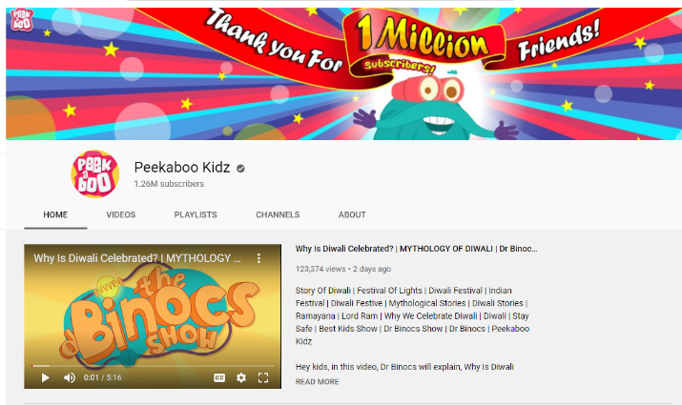
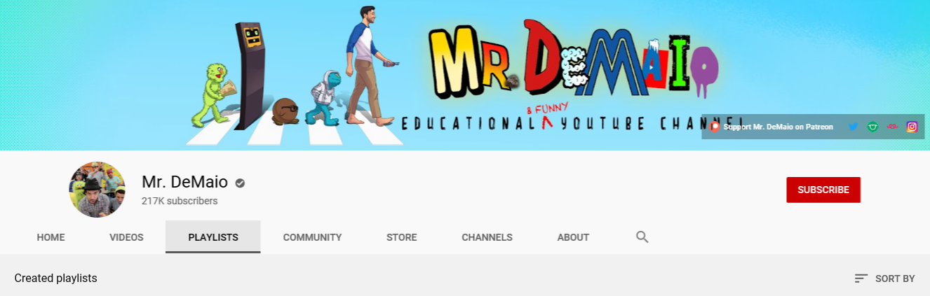
SCIENCE TECHNOLOGY ENGINEERING MATHS SOCIAL STUDIES

THE WEATHER
The Weather
Click the link above to learn about…
Thunder and Lightning
Clouds
Tornados
The Climate
Hurricanes
The Water Cycle
The Northern Lights

If you would like to learn more, search for Dr. Binocs Weather on Youtube and click the videos to start learning.

PLANETS AND THE SOLAR SYSTEM
If you are interested in learning about plants and the solar system you will enjoy watching these fun, educational and sometimes silly videos.
Space Video Playlist - Mr DeMaio (Youtube)
Dr. Binocs – Youtube
To learn more, search for Dr. Binocs Space Videos on Youtube.

NUMERACY
If you would like to improve your recall of times tables then sing along with these songs.
Multiplication Songs - Mr DeMaio (Youtube)
Other Numeracy Videos…
Shapes
Rounding
Days of the Week
Months of the Year
Borrowing/Exchanging in Subtraction

Suggested Activities
After watching your favourite videos why not show your teacher what you have learning by completing some of these activities…
Make a video and talk about what you have learned Create a mini project full of images and descriptions
Phone a friend and talk about your learning Design a fact sheet
Make a list of questions that you may still have and then try and find out the answers (Use the internet or books to help you)

