Home Learning Programme Primary __5___
Literacy
Reading  - Read a chapter in a book you have at home. Can you identify any words, which contain a prefix? How many did you find?  - Repeat the activity above for suffixes  - Use a recipe at home and pick out all of the ‘bossy’ verbs that you can find  - Re-write a passage (1 or 2 paragraphs) from a book you have at home. Swap a few of the words within the passage for ‘silly’ alternatives. Challenge an adult at home to find the silly words and suggest what should really be there  - Can you create 10 HOTS (high order thinking skills) questions that you could ask a classmate to answer about a book you have at home | Writing  - Write 5 boring sentences. Now up level them and make sure they each contain an example of VCOP  - Create an acrostic poem about the Corona Virus. Make sure you include information about your thoughts and feelings in the poem.  - Think of your favourite board game. Write a set of instructions that you could give to someone else your age, who has never played that game before. Don’t forget to include a list of equipment too!  - Write a letter to your teacher telling him/her about what you have been doing while you have been away from school. Make sure you lay the letter out in the correct style  - Watch the lunchtime news. Now write a few paragraphs, summarising all the main stories. Create an eye-catching headline for each main story too. | Spelling/Grammar  - Recap all of the spelling rules we have learned about this school year. Take one phoneme at a time and write down all the words you can think of which contain the following phonemes  oy oi  c k ck ch  j g dge  sh ti ch  ch tch t  - Ask an adult to dictate some sentences to you which contain some of your words  - Play ‘be the teacher’ and challenge an adult to spell some of your words – be sure to choose the trickiest ones!  - Use the following active spelling strategies to practise your words: hang-man, tennis, rainbow writing, pyramids, cut and stick letters, use your weak hand

Numeracy
- Practise the 4, 5, 6, 7, 8 and 9 times tables
- Write out the common multiples of the 3 and 4 times tables
- Write out the common multiples of the 6 and 8 times tables
- Write down the factors of 12, 18, 20 and 32
- Find fractions of as many whole numbers as you can using the times tables facts e.g. ¼ of 16 = 4, ½ of 40 = 20
- Can you think of any situations you may be in, where understanding what percentages are would help you?
- Write out as many percentages as you can as a fraction e.g. 50% = ½
- How many £1 are there in £20? How many 50p are there in £10? How many 20p are there in £2? How many 10p are there in £5?
- Think of your favourite meal. Can you work out how much it costs to buy all of the ingredients required for that meal? (Use tesco.com or an adult for help finding the cost of each item)
- Count up (and down) in 10s and then 20s to 200
- Mentally add the doubles of all the numbers from 1 to 100 e.g. 46 + 46 or 28 +28
- Mentally calculate what needs to be added to a 3 digit number to make the next multiple of 100 e.g. 245 + ? = 300 or 762 + ? = 800
- Practise mentally adding any pair of 2 digit numbers e.g. 16 + 33 or 57 + 81
- Practise telling the time using a digital and an analogue clock – don’t just stick to quarter past/to or half past/o’clock times!

Health and Wellbeing
- Can you make up a catchy, alliterative slogan that will help encourage people to keep their hands clean at all times?
- Make a list of all the things you have done in the past week that have contributed towards your wellbeing e.g. good night’s sleep, eating fruit every day
- Play a game of ‘Emotions Charades’ with an adult or sibling at home
- Write down all the ways you can exercise in your house without using any specialist equipment e.g. walking briskly up and down the stairs, using tins of beans as weights, star-jumps
- Challenge yourself to perform one of the activities you devised in the last task for at least 10 minutes each day
- Write down 10 different types of feelings/emotions. Now, beside the feeling, write a sentences about a time when you felt this way
- Make a list of all the talents that you have. Sometimes it can be tricky to get started, so ask someone who loves you to help if you get stuck
- Draw a picture of your best friend (or one of your best friends). Around the picture write as many adjectives as you can that describe your friend – use a different colour for each adjective.
- There are 54 UN Rights of the Child. Which of them can you remember and which do you think are the most important? Why?
- Write a list of your 10 favourite things to do. Can you change or alter your list slightly so that you don’t have to spend any money to achieve at least 5 things you really enjoy.
- Look at the second list you created in the last activity. Make a list of the people who you would take along with you on your favourite days out. Choose one of those people and plan a day that he or she would really enjoy. Begin with breakfast and end when you got to bed
- Go into to the largest room in your home. Take a note of how many steps it takes to cross it. Now repeat the task for jumps, hops, skips, side-steps, high knees and spins – be careful not to knock anything over!
- Lie down and listen to relaxing, calming music for 15 minutes

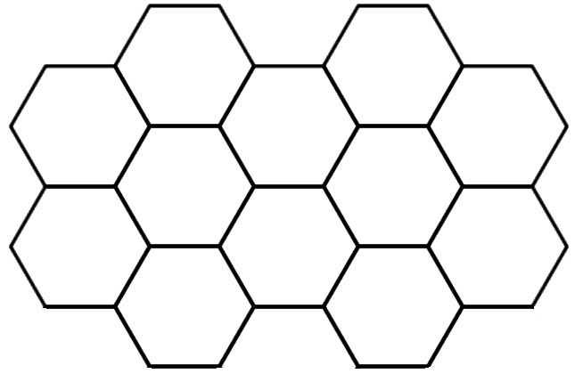
YouTube search
Mindfulness activities.
Increase the amount of water you drink throughout the day.
Create an anti-smoking poster / slogan.
Design your own Fitness Circuit
Set yourself a challenge
e.g How many jumps can you do in 60 secs?

Play Emotion Charades

Create a
healthy menu.
You will find lots of ideas and games here:
https://www.foodstandards.gov.scot/
Find the largest room in your house.
How many hops, jumps etc does it take you to travel across the room?
Teach your child a game you used to play as a child.
Step Up Challenge
e.g How many times can you step up your stairs in 60 secs?
YouTube activity
e.g. Cosmic Yoga, Just Dance
Create a handwashing poster

.
.

.
Learning Across the Curriculum
Use the following search engines to research your class topic:
https://www.google.com/
https://www.bing.com/
https://www.kiddle.co/
https://swiggle.org.uk/

If you find out any new information, you could share your learning by creating a PowerPoint presentation, a mind map, a poster or a solo talk.

Have a look at the following links that will help you practise what you have learned over the past few weeks in school:

http://www.mrcrammond.com/
https://nrich.maths.org/14536
https://www.literacyshed.com/home.html
https://www.topmarks.co.uk/
https://pages.sumdog.com/
https://www.bbc.co.uk/newsround
https://www.sciaf.org.uk/
https://www.fairtrade.org.uk/
https://www.globalgoals.org/
https://www.wateraid.org/uk/
https://www.bbc.co.uk/bitesize/primary
https://www.youtube.com/results?search_query=art+attack
https://hourofcode.com/uk
https://www.spanish-games.net/spanishlessons

Technologies
ICT
Have a go at the following games to develop your coding and maths skills.

Minecraft https://code.org/minecraft
Angry Birds https://hourofcode.com/code
Scratch https://hourofcode.com/scratchimagine
Create Your Own Sports Game https://hourofcode.com/athlete

Children have logins for the following websites and can access some activities and games
Children can also access GLOW https://sts.platform.rmunify.com/Account/SignIn/glow

Sumdog https://www.sumdog.com/user/sign_in

Other good resource can be found at :-

Topmarks https://www.topmarks.co.uk/
BBC Bitesize https://www.bbc.co.uk/bitesize/primary

Use Lego or other construction kits to make your own creation.

