Inverkip Primary School

&

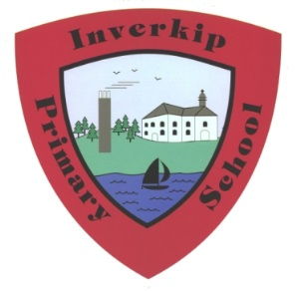
Nursery Class

Handbook

2026 2027


INVERKIP PRIMARY SCHOOL & NURSERY CLASS

Dear Parent or Guardian,

A very warm welcome to Inverkip Primary School and Nursery Class. This handbook is designed to give you an insight into our school and nursery, our priorities, expectations and vision for the future and to provide you with useful and practical information. We hope you will find the information in this handbook interesting and informative.

At Inverkip Primary all pupils are encouraged to develop positive attitudes to learning, to friendships and we aim to provide all pupils the highest possible quality of education. We endeavour through our curriculum and our extra-curricular activities to foster academic and personal development to help our children become successful learners, confident individuals, effective contributors and responsible citizens. We hope that your child’s journey with us will be a very happy and worthwhile experience and that our children leave us with precious and happy memories of their time at Inverkip Primary and Nursery Class.

The School’s learning philosophy is based on our ROAR school values where we encourage learners to build capacity, collaborate and make connections in their learning:
Respect, Optimism, Ambition and Resilience.

We enjoy close working relationships with other agencies and local primary and secondary schools. As key educators in your children’s lives, we believe that it is important that you feel you have a voice and that as a school we are approachable and actively listen to our parent community. You can be assured that we will continue to strive to create a school which provides an all-round educational experience in which everyone can flourish. Our strong partnership with parents enhances learning and teaching and we truly value and appreciate their involvement in the life of the school and assisting us in meeting the needs of all our learners.

We look forward to watching your children grow in confidence, knowledge and skills during their time at Inverkip Primary & Nursery Class and thank you in advance for your support. Our door is always open and we welcome your comments and suggestions to ensure that we: Get It Right for Every Child. At all times you will receive a warm welcome and we will endeavour to assist you in any way we can. More details can be found on our school website however, should you require further information please do not hesitate to contact the school or nursery to arrange a visit and I will be delighted to meet with you.

I look forward to working in partnership with you over the coming years.

Yours sincerely,

Mrs Una Nicolson

Mrs Una Nicolson, Head Teacher.





Contents Page | Page
Our Aims & Values | 4 - 6
Authority Strategic Statement | 7
School Information & Staffing List | 8 -9
Playgound | 10
School Hours & Holiday List | 11
Parental Concerns & Complaints | 12
Visits To School | 12
Communications | 12
Absence, Latecoming & Appointments | 13
Parental Involvement | 14
Parent Forum & Parent Council | 15
School Ethos, Celebrating Success & Wider Achievements | 16
Inclusion & Equalities | 17
Pupil Leadership & Committee Groups | 18
Curriculum, Assessment & Extra Curricular Activities | 19-25
Reporting | 26
Global Citizenship | 27
Enrolment | 28
Placing Requests | 26
Transfer From Primary School To Secondary School | 26-27
Support For Pupils | 28
School Improvement | 29
Policies | 29
Home And School Links | 29
Child Protection In Inverclyde | 30
Composite Classes | 31
Homework | 31
Clothing And Uniform | 32
School Meals | 33 - 34
Data Protection Act 2018 | 35
Practical Information:  Contact details/Medical Information/Mobile Phones/Nut Free Zone | 35-36
Useful Addresses | 37

Our Vision
Our vision is to ensure that we learn today for a better tomorrow where ‘Every child matters and every moment counts’. # Learning to Learn # Learning to Love # Learning to Lead
In Inverkip Primary & Nursery Class, we strive to provide the highest quality learning and teaching experiences to ensure that all children care about the world they live in and learn and develop the full range of skills to be citizens of the 21st century. Our ethos is a climate of teamwork, respect and trust, where all our children aspire to become successful learners, confident individuals, responsible citizens and effective contributors.
In line with the Inverclyde Education Service Plan, Inverkip Primary School & Nursery Class aims to offer education of the highest quality providing a stable, happy and enriching environment where children can most easily attain their full potential. The school community has identified the following values, which reflect the important principles on which we base all of our decisions.

Our Values:
Our ROAR values are:
R | 0 | A | R
Respect | Optimism | Ambition | Resilience

We believe that:
- Every pupil matters and every moment counts
- The highest levels of achievement should be open to all as we learn today for a better tomorrow
- all learners have the right to high quality teaching where pupils Learn to Learn, Learn to Love and Learn to Lead

Our Aims are to:
- To develop a restorative perspective as we navigate and develop a consistent approach that stimulates thinking and decisions as we collectively move forward learning to learn for a better tomorrow whilst embracing digital technology.
- To ensure that planning is values based and needs led where Recognition, Empathy, Safety, Trauma, Opportunity, Relationships and Engagement are at the heart of strategic approaches. (RESTORE) and highlight the importance of relationships for emotional wellbeing, resolving conflict, preventing harm and building resilient communities.
- To provide a nurturing, happy environment where all pupils feel safe, healthy, achieving, nurtured, active, respected, responsible and included.
- To develop positive relationships built on the 6 principles of nurture and respect for the rights of others.
- To provide high quality teaching & learning experiences, cultivating a love of learning and a sense of achievement in all our pupils by work together with parents and partners to build capacity for all pupils to achieve and attain.
- To ensure that there is equity of provision and resources across the school community so that learners are not disadvantaged against their peers, by providing opportunity and exploration alongside expectations.
- To provide a broad, balanced and transparent curriculum which is challenging, has breadth, depth, relevance coherence and is fun and enjoyable where each pupil has the opportunity to thrive emotionally, socially and physically.
- To address any gaps through explicit teaching of metacognitive strategies in conjunction with specific subject content, consulting and co-constructing of learning experiences. Empowering learners to review and reflect when developing an understanding of their individual learning styles.
- To encourage effective learners to achieve their fullest potential within and outwith school who can self-regulate, display resilience, enterprising attitudes, independence, skills for learning, skills for life and skills for work to positively impacting on the community in which they live.
- To foster high quality leadership at all levels through valuing and empowering all members of the school and nursery community. Pupils should consistently feel that their voice, opinions and ideas are listened to and acted upon.
Inverkip Primary School & Nursery Class is committed to delivering on its core business of 'learning' and is thrilled with the achievement gains to date. We are committed to building the necessary knowledge and competencies for pupils to thrive and succeed in learning and life. We have a supportive and active staff, community and partnerships who are open, committed and willing to do whatever it takes to ensure that each learner is stretched and experiences fulfilment in learning.
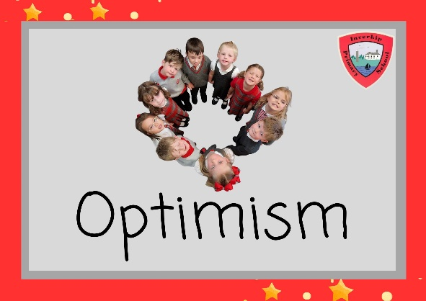
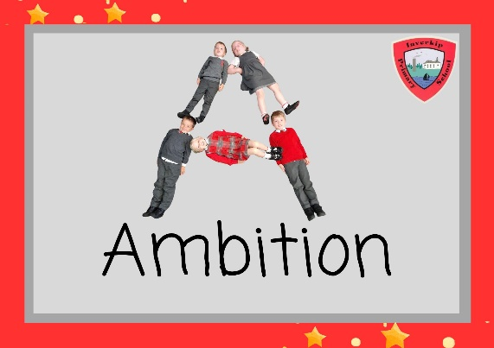

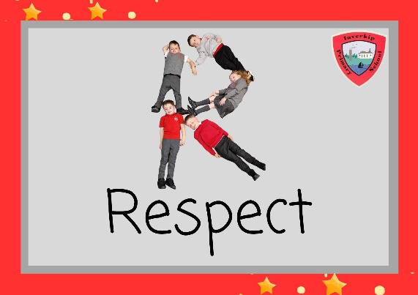
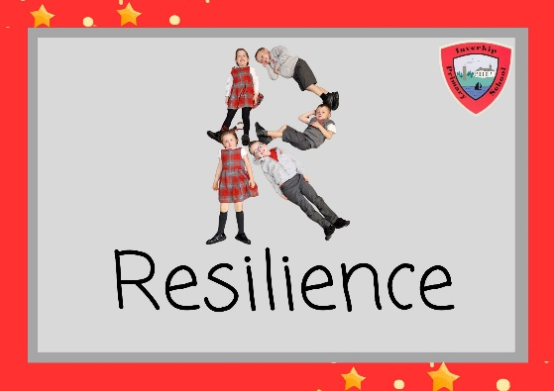

Authority Strategic Statement
- Building Inverclyde through excellence, ambition and regeneration.
- Our Authority Core values are: Respect, Honesty and Tolerance.
Our Authority vision for the children and young people of Inverclyde is that they should be ambitious for themselves and be successful learners, confident individuals, responsible citizens and effective contributors.
- Enhanced leadership at all levels will ensure that establishments are able to take forward and implement improvements that have a positive impact for learners.
- All children and young people benefit from high quality learning experiences.
- All children and young people benefit from strong partnerships having been developed with families and the wider community. The ongoing partnerships contribute directly to raising attainment and achievement, and to securing positive and sustained destinations.
- All children and young people make expected or better than expected progress in all learning, but especially in literacy and numeracy, regardless of their background. Young people in Inverclyde use the skills they develop in our schools to achieve positive and sustained destinations.
- All children and young people in Inverclyde experience a high quality curriculum that meets their needs.
- All children and young people feel safe and included in our schools and are achieving their potential.

To achieve our ambition of building Inverclyde through excellence, ambition and regeneration our children must be:

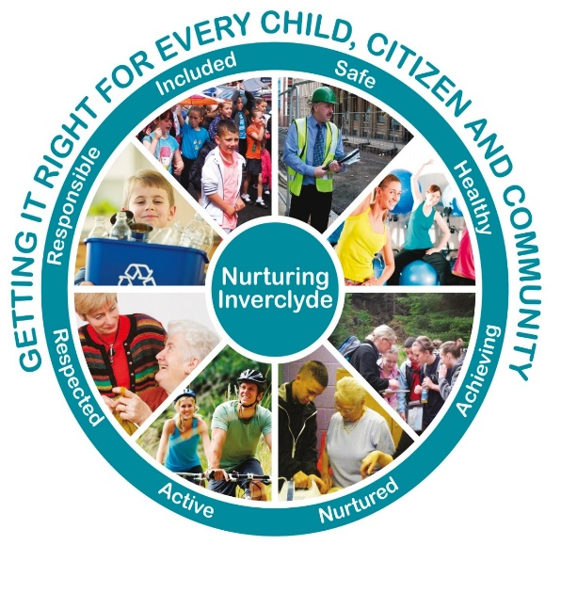
- Safe: protected from abuse, neglect and harm by others at home, school and in the community.
- Healthy: enjoy the highest attainable standards of physical and mental health, with access to healthy lifestyles.
- Achieving: have access to positive learning environments and opportunities to develop their skills, confidence and self-esteem to the fullest potential.
- Nurtured: educated within a supportive setting.
- Active: active with opportunities and encouragement to participate in play and recreation including sport.
- Respected and Responsible: involved in decisions that affect them, have their voices heard and be encouraged to play an active and responsible role in their communities.
- Included: have access to high quality services when required and should be assisted to overcome the social, educational, physical, environmental and economic barriers that create inequality.

The above indicators are sometimes known as the SHANARRI wheel. This is an acronym for:
Safe, Healthy, Achieving, Nurtured, Actice, Respected, Responsible & Included.

School Information
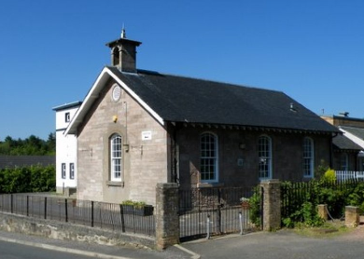
Address of School: Station Road, Inverkip PA16 0AY
Telephone Number: 01475 715745
Fax Number: 01475 522135
School Office Email: office@inverkip.inverclyde.sch.uk
School website: https://blogs.glowscotland.org.uk/in/inverkipps/
Follow our school Twitter: @InverkipPrimary

PC Facebook: Inverkip Primary School and Nursery Class Parent Council
Senior Leadership Team:
Head Teacher: Mrs Una Nicolson una.nicolson@inverkip.inverclyde.sch.uk
Depute Head Teacher: Mrs Pamela Bradley pamela.bradley@inverkip.inverclyde.sch.uk
Teachers:
- Ms Jacqui Milliner - Primary 1
- Ms Jennifer Lymburn – Primary 2/1
- Ms Hazel Thomson (NQT) - Primary 3
- Mrs Beth MacLeod - Primary 4
- Mr John McGregor – Primary 5a
- Ms Katie D’Souza – Primary 5b
- Mrs Rhona Findlay – Primary 6
- Mr Paul Giffney - Primary 7a
- Mrs Tory Chalmers + Ms Lynn Anderson (Reduced Class Contact)
- Mrs Antonia Carter (ASN/Recovery support)
Nursery:
- Mrs Megan Martin –Nursery Depute Head
- Mrs Lauren Mitchell - EYECO
- Miss Leanne Wilson – EYECO
- Mrs Leanne Cairns – EYECO (0.5)
- Miss Pauline Mitchell EYECO (0.5)
- Ms Brogan Shaw peripatetic EYECO (every two weeks)
- Miss Emma Wilson – Nursery Support Worker

Class responsibility shown is for this session only 2024 2025 and does not indicate the teacher's responsibility during session 2025 2026

Senior Clerical Assistant: Mrs Kirsten McInnes
Clerical Assistant: Mrs Amie McNeil
Pupil Support Assistants:
- Mrs Anne Marie Speirs (Mon, Tues)
- Mrs Rachel Nicol (Thurs + Fri)
- Mrs Laura McGregor (Wed – Fri)
- Mrs Sara Goyal (Mon – Wed)
- Mr Stephen McAuley (Mon – Fri)
- Mrs Rona Keogh (Mon – Wed)

Janitor: Mr Alan Deveney
Canteen Staff:
Mrs M Turner
Mrs L McHaffie
Mrs D Galvin
Mrs A Cowan
Mrs K Lemon

Cleaners: Mrs M Lee & Mrs L McHaffie
Stages: Nursery to Primary 7 inclusive

Present Roll 192 and 30 Nursery (Nov 2025)
Primary 1: 25
Primary 2/1: P1 8 + P2 15
Primary 3: 25
Primary 4: 22
Primary 5a: 18
Primary 5b: 17
Primary 6: 32
Primary 7: 30

Capacity of school: (All buildings) 350 - Current operational working capacity 299
- Parents should note that the working capacity of the school could vary dependent upon the number of pupils at each stage and the way in which the classes are organised.
- Inverkip Primary is a co-educational, multi-faith school. We welcome pupils of any race, faith or ethnic group.
- The school comprises of 10 classrooms, 1 ICT Suite, 2 gym halls (one which doubles as a dining hall), a staff resource room and a Nursery Class.

Our Playground:
Our playground offers the pupils space for outdoor education and includes areas for quiet play and outdoor sports. Our facilities can be let by contacting the Booking Office on 715559.
We are situated in a beautiful setting right in the heart of Inverkip Village. We have amazing woodland areas on our door step and a beautiful beach and we encourage our children to explore our local area as part of our outdoor learning approach.
Children learn through play. They learn to communicate, be friends, to think and change their mind. Play comes naturally to children. It’s instinctive and therapeutic. It is these understandings about the role of play in early childhood development, that we will develop our use of loose parts play to encourage curiosity and a sense of wonder in our children’s playground experience.

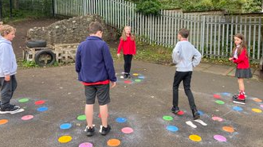
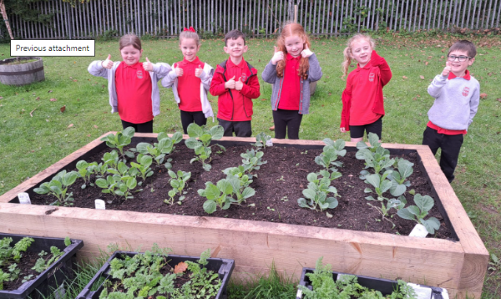
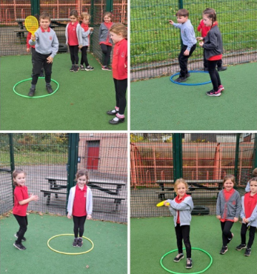
We have a Trim Trail in our playground and are looking to further develop our outdoor learning spaces over the coming year.

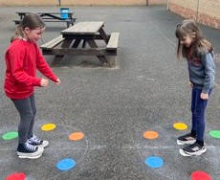
The playground is open for the children to play where they like. The only area we timetable is the MUGA. We have a quiet area within the playground where children can read and chat with friends and our green fingered children are able to develop their gardening skills with some planting boxes dotted throughout the outside space. We also have bench seating, an enclosed Muga pitch, our trim trail, grass/woodland area and a covered canapy with seating.
Our Health and Well-Being Committee are currently reviewing our playground space and we have started to introduce a variety of ‘Loose Parts’ play materials.

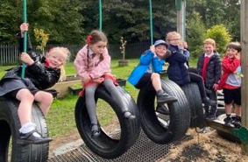
Disabilities:
Inverkip Primary & Nursery class promotes inclusion and celebrates diversity. All entrances to the school have disabled access and within the school we have four toilets suitably adapted for disabled pupils or adults.
Supervision Of Playgrounds:
An adult presence is provided in playgrounds at break times in terms of the Schools (Safety and Supervision of Pupils) (Scotland) Regulations, 1990

School Hours & Holidays 2025 2026

School Hours:
- 9.00 a.m. - 3.15 p.m.
(* please note our P1-3 exit at 3.10pm to alleviate congestion, however this is only a suggestion and the school can keep children until siblings leave or parents collect at 3.15pm)
- Interval 10.30 a.m. - 10.45 a.m.
- Lunch 12.15 p.m. - 1.15 p.m.
Dates have been approved by committee. Local holiday and in-service dates for consideration. Further staff in-service days will be announced when dates are available. Pupils do not attend school or nursery on staff in-service days. In order that the school can meet its attendance targets set by the Scottish Executive Education Department, please make every effort to refrain from taking family holidays during term time.
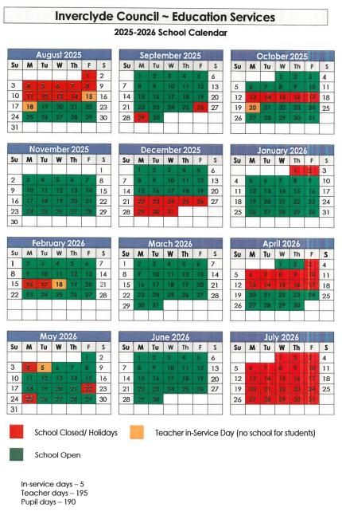

Concerns:

If you have any concerns or queries about any issues relating to your child’s education please do not hesitate to phone the school and speak to a member of the senior leadership team. We will endeavour to work with you and your child to solve any issues. We are here to listen and work in partnership and will endeavour to use a solution focussed approach.

If parents wish to speak to a class teacher, we will arrange an appointment at the earliest opportunity. If parents wish to speak to Mrs Nicolson or Mrs Bradley please contact the school office and an appointment will be arranged as soon as possible. Alternatively, you can email Mrs Nicolson (inunn621@glow.sch.uk). This will enable the school to deal with any concerns promptly.

Complaints:

If parents are unhappy about any aspect of school, we would again ask that they contact the school office as soon as possible to arrange a meeting with Mrs Nicolson or Mrs Bradley. It may help if when contacting the school, you give some details of the issue to allow prompt investigation. We will arrange a meeting to hear your complaint and would hope that it will be resolved satisfactorily and quickly. If the complaint is found to be justified, we will endeavour where at all possible to put right what went wrong, to make adjustments to try to prevent a similar problem arising in the future and to offer an apology where appropriate. If you are still unhappy with the service or with our response then you will have the right to take up the matter further with the Education Department. Complaints can be made in writing, by telephone or e-mail or by visiting the office in person. Information about complaint handling procedures is available at:
www.inverclyde.gov.uk/council-and-government/complaint

Visits To School:

Parents of Primary One pupils are invited to visit the school at induction days in May and June. These days offer an opportunity to meet other parents, gain information on the Primary One school curriculum, meet staff, and have a tour of the school building and school grounds.
Parents of children who are moving to the Inverkip catchment area and who wish to place their child here should contact the school to arrange an opportunity to meet with Mrs Nicolson. At this meeting parents will have an opportunity to tour the school building. If a place is available and parents live within the school catchment area, parents will be invited to enrol their child, meet class teachers and arrange a starting date. We will accommodate any parent who wishes to visit the school prior to their child starting school. Please phone the school office to arrange a suitable time.
Communications:
It is important for us to maintain strong home school links and we endeavour to keep our parent community informed and updated through regular communication. We send out a monthly newsletter via e-mail and each class also shares a termly Bulletin to keep parents up-todate with learning. Information can also be found on our school Twitter page and on our school website. We continuously seek the views of staff, parents and pupils to find out how we are doing and how we can improve the service we offer. Parents are welcome to come into the school at any time to discuss any ideas they have. We also have a ‘comments, compliments, complaints’ box at the reception desk. We have also developed a You-Tube channel where you can find a video introduction to our school and a 360 virtual tour of our learning spaces.

Absence:
Parents should inform the school by telephone on the first morning of an absence and provide a reason for the pupil's absence. The school will contact the pupil's family and thereafter other emergency contacts if no explanation is given for the pupil's absence. This contact will be made before 10.00 a.m. on the first morning of an absence and early after the restart after lunch in the case of an afternoon absence. Other agencies may be contacted if no contact with the pupil's family can be achieved and if there are continuing or emerging concerns about a pupil's safety or wellbeing.
- On the child's return to school parents should give the child a note with a reason for absence.
- Parents should keep the school informed of any changes of address, telephone numbers and email address, both their own and those of the emergency contacts.

Section 30 of the 1980 Education Act lays a duty on every parent of a child of 'school age' to ensure that their child attends school regularly. Attendance must be recorded twice a day, morning and afternoon.
Regulation 7 of The Education (School and Placing Information) (Scotland) Amendment, Regulations 1993 requires each child's absence from school to be recorded in the school SEEMIS system as authorised: i.e. approved by the authority and unauthorised: i.e. unexplained by the parent or temporarily excluded from school.
The Scottish Government has provided guidance on the management of attendance and absence in Scottish schools in its publication ‘Included, Engaged and Involved- part 1: Attendance in Scottish Schools.’

Every effort should be made to avoid family holidays during term time as this both disrupts the child's education and reduces learning time. It has been clarified that family holidays should not be recorded as authorised absence, except in exceptional domestic circumstances, where a family needs time together to recover from distress, or where a parent's employment is of a nature where school-holiday leave cannot be accommodated (e.g. armed services or emergency
Services). It is for local authorities and schools to judge when these circumstances apply and authorise absence, accordingly.

The categorisation of most term-time holidays as unauthorised absence has been a contentious issue for some families, many of whom are concerned at the higher cost of holidays during school holiday periods. The Scottish Government has no control over the pricing decisions of holiday companies or flight operators. Our main focus is to encourage parents and pupils to recognise the value of learning and the pitfalls of disrupting learning for the pupil, the rest of the class and the teacher.
Clearly where an absence occurs with no explanation from the parent, the absence is unauthorised. Schools investigate unexplained absence, and Education Services has the power to write to, interview or prosecute parents, or to refer pupils to the Children's Reporter, if necessary.

Late coming:
The school playground gate is locked at 9am. Therefore, if pupils arrive after the bell, they should enter by the main entrance door where they should report to the school office before going to class.

Appointments:
Should your child have an appointment that they need to attend within school hours then we ask that parents contact the school office so that this information can be recorded and the absence authorised.

Parentzone Scotland

Parentzone Scotland is a unique website for parents and carers in Scotland, from early years to beyond school. The website provides up-to-date information about learning in Scotland, and practical advice and ideas to support children’s learning at home in literacy, numeracy, health and wellbeing and science. Information is also available on Parentzone Scotland regarding additional support needs, how parents can get involved in their child’s school and education. Parentzone Scotland also has details about schools, including performance data for school leavers from S4-S6 and links to the national, local authority and school level data on the achievement of Curriculum for Excellence levels.

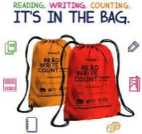
Read Write Count

Read Write Count with the First Minister is a National gifting programme, aiming to build parents' confidence and encourage families to include easy and fun reading, writing and counting activities in their everyday lives. Every Primary 2 and Primary 3 child in Scotland will receive a free bag with books, educational games and writing materials to be gifted during Book Week Scotland, in November. Resources for schools and extra activities for families to use at home can be found here.

First Minister’s Reading Challenge and reading Schools:
Inverkip Primary enjoys participating in this reading challenge. The First Minister’s Reading Challenge is an inclusive, exciting programme for all children – fostering a love of reading for pleasure. Research shows that reading for pleasure is crucially important for children’s development.
The First Minister’s Reading Challenge and Reading Schools programmes provides a range of options and support on how to build a love of reading and/or develop a reading culture in your setting. These programmes are brought to you by Scottish Book Trust. Both programmes are flexible to your setting and open to every stage of your reading journey. They have been proven to improve attainment in children and provide professional development opportunities. Whatever stage you are on your reading journey these programmes can support you to get to the next level.
The Challenge is open to all local authority and independent primary and secondary schools across Scotland, as well as, libraries and community groups. You can find out more information on the Challenge and also how schools can register to take part here: https://www.readingchallenge.scot/


Bookbug
Bookbug is Scotland’s universal early years book gifting programme and aims to inspire a love of stories, songs and rhymes from birth. Bookbug gives every child in Scotland four free bags of books as babies, toddlers, three and five year olds. The bags contain books and other resources for sharing songs and rhymes that are suited to their age. Gaelic Bookbug Bags are also available.The Bookbug Explorer Bag is gifted to all 3 year olds at their childcare setting. It includes three lovely books, an activity book, pencils, and postcards to encourage mark making.
Bookbug is Scotland's universal early years book gifting programme which supports families to read, sing, and play with their little ones from birth to give them the best start in life. Starting school is an exciting and challenging time for your child and your support at home makes a real difference to their learning. Look out for your Bookbug Primary 1 Family Bag, a free bag of books and activities your child will receive at school in November from Bookbug, to help support their reading, writing and counting skills. You will find films of the books being read aloud and more information about the P1 Bag here.

Parental Involvement: # Parents as Partners
Our parents are very much valued members of our school community. We value the importance of involving parents/carers in the life of the school and their engagement in their children’s learning. We have an ‘open door’ policy to parents. We aim to meet with parents who have a concern as soon as possible, and can arrange meetings later in the day to suit working parents. You can also contact the Head Teacher via email at una.nicolson@inverkip.inverclyde.sch.uk
We will strive to ensure that you are:
- Welcomed and involved in the life of the school
- Fully informed about your child’s education and learning
- Able to support learning at home
- Encouraged to express your views and take part in decision making
- Involved in forums for discussion and debate on educational policy

Learning and Teaching:
There are a number of ways parents can become more involved with learning and teaching in school:
- Input to school questionnaires
- Feedback following parent evenings / Termly Profiles
- Attendance at Parents Evenings
- Attendance at induction days / curriculum workshops
- Attendance at showcases events
- Attendance at school shows/ events
- Input to class topics
- Input to themed days/weeks

Parent Forum And Parent Council:
Scottish Schools (Parental Involvement) Act 2006 led to the establishment of Parent Councils in primary, secondary and special schools. The Act recognises the vital role that parents play in supporting their children’s learning. It places a duty on authorities to promote the involvement of parents in children’s education and the wider life of the school and aims to help parents be:
- Involved with their child's education and learning
- Welcomed as an active participant in the life of the school
- Encouraged to express their views on school education generally
All parents who have a child attending the school are automatically members of the Parent Forum for our school. Membership of the forum allows parents to have a say in the local arrangements to enable their collective view to be represented on matters such as the quality and standards of education at the school and other matters of interest to parents. These views can be represented, as appropriate, to the head teacher of the school, the Council and HMIe.

At Inverkip Primary School we have a proactive and supportive Parent Council. Our Parent council have their own FaceBook Page and work closely with the school to ensure that we meet the needs of our families.

A Message from our Parent Council: Mrs Sarah Barr
Welcome! We represent you! We meet to discuss issues relating to school life - policy, teaching and learning including school, local authority and national initiatives.
The Parent Council meet approximately every 6 weeks. Our primary role as The Parent Council is to represent the views and concerns of the parents/carers at the school. In addition, we provide support to the school management team, organise social and fundraising events and promote contact between all parents and the rest of the school community. With such a wide remit and range of activities, we currently have three sub-committees who meet at separate times and feedback at PC meetings. These committees focus on:
- Events Team - organise school discos, the Christmas Fayre plus lots of other fundraising events throughout the year.
- Communications Team – look after and maintain our PC Facebook page, Twitter site, email account and our PC Termly Newsletter.
- Learning and Teaching Team - work with our Head Teacher on matters relating to the curriculum, strategic improvement plan and school policy.
The PC welcome new members at our AGM at the start of each session in August/September. We are keen to have a good representation of parents from nursery to Pr7. If you have any questions, concerns, feedback or an interest in helping at any of our events then please feel free to contact us through our Parent Council:
- Twitter:@InverkipPrimaryPC
- Facebook: Inverkip Primary School and Nursery Class Parent Council
- or via email: inverkippc@gmail.com
Office Bearers of the Parent Council, at present, are as follows:-
- Mrs Sarah Barr - Chairperson
- Mrs Kat Stewart - Vice Chairperson
- Mrs Sharon Anderson - Treasurer
- Inverkip Office staff (Mrs McInnes and Mrs McNeil , Minute Secretary)

School Ethos:
We are a Gold status Rights Respecting School and we strive to be a very caring school where all pupils and staff work together to make sure everyone feels welcome and included. We aim to create an ethos where our children succeed within a climate of teamwork, respect and trust, where all our children aspire to become successful learners, confident individuals, responsible citizens and effective contributors. Children, staff and parents have an excellent understanding of the school’s values which reflect the principles on which we base all our decisions and use them to influence day-to-day practice.
Our ROAR values are:
R | 0 | A | R
Respect | Optimism | Ambition | Resilience

Positive Behaviour and Relationships:
We believe that effective learning and teaching is dependent on positive relationships established through positive interactions between staff and pupil and between pupils themselves. We expect all members of the Inverkip Primary & Nursery Class community to show respect for others. We pride ourselves on knowing our pupils well. It is essential that teachers provide a curriculum which challenges and motivates pupils. Class Charters are negotiated with pupils at the beginning of each session and displayed in classrooms. We have an anti-bullying policy and are proactive in ensuring the safety and happiness of all our pupils. Through the authority policies (Inverclyde Anti-Bullying Policy and Inverclyde Positive Relationships and Behaviour Policy) we aim:
- To create an atmosphere of mutual respect, trust and responsibility
- To promote a positive school ethos through positive behaviour strategies and celebrations of success
- To raise standards of attainment, behaviour and attendance for all pupils
- To involve parents, pupils and staff in setting rules/standards of behaviour within the school
- To get pupils to manage their own behaviour effectively while respecting the rights of others
- To develop social and citizenship skills through a variety of school contexts
- To inform parents and pupils of any sanctions that will be taken for negative behaviour
Where any pupils are achieving difficulties with self-regulating behaviour, we believe that a positive nurturing approach, putting the child at the centre, is essential. We work closely with parents and apply a restorative and solution oriented approach to ensure that children are supported and work together towards a positive outcome for all.

Celebrating success & Wider Achievement:
We value and celebrate each child’s attainment and achievement. We recognise the achievements of all our learners and provide opportunities for all our learners to achieve success! Personal achievement provides children not only with a sense of satisfaction but helps to build motivation, resilience and confidence and encourages them to remain engaged with education.
Pupils’ achievements both within and out with the school are recognised and celebrated at whole school award assemblies. Each classroom has an ‘Above & Beyond’ recognition board. Children are given an awards certificate monthly for going above and beyond to demonstrate our school values.
We recognise wider achievement at assesmblies and in our newsletters.

Inclusion and Equalities:
The Equality Statement for Inverclyde Schools outlines the Council’s commitment to ensuring an inclusive approach:
‘Inverclyde Education Service is committed to ensuring that no children or members of staff or service users receive less favourable treatment on any ground including age, gender reassignment, pregnancy and maternity, race, disability, sex, sexual orientation, marriage and civil partnership, religion or belief. We have a moral, social and legal obligation to mainstream and put equality at the heart of everything we do. We aim to promote a culture in which equality of opportunity exists for all. We are opposed to all forms of discrimination, direct or indirect, and aim to eliminate all discriminatory practices. We will ensure that, in our schools and other educational establishments, equality permeates the curriculum and underpins all our policies and practices in terms of access to education. We must ensure that all our children achieve their full potential to develop physically, emotionally and academically. Finally, we believe that equality and inclusion should be a given right, where everyone is valued and treated with respect.’

Inverclyde Council Education service aims to:
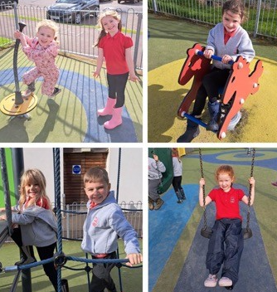
- Offer education of the highest quality to all young people within a developing culture of inclusion
- Endorse the principles of inclusion, entitlement and equality of opportunity in the development of best practice
- Value the diversity of interests, qualities and abilities of every learner
- Believe that every child and young person is entitled to educational opportunities which enable the achievement of success and further development of the individual’s learning potential within the least restrictive environment
- Affirm the right of all young people to have access to the highest quality of educational provision which is appropriate to learning needs, is supportive of the young person and is delivered in partnership with young people, parents and the wider community.
- In meeting the needs of all our pupils we will demonstrate no discrimination on the basis of race, gender, disability, sex, sexual orientation, religion or belief. This encompasses curricular, extra-curricular and playroom activities and is foremost in the attitudes which we develop in our pupils.

Child Protection:
Inverclyde Council Education Services has Child Protection Guidelines and Procedures which all schools and establishments are required to follow. Education Services work very closely with other agencies namely Strathclyde Police, Social Work Services, NHS Greater Glasgow and Clyde and the Children’s Reporter to support children. Common responsibilities of all staff are to protect children from abuse and exploitation, to respond appropriately when abuse is identified, and to ensure whenever possible that all children are able to exercise their right to be raised in a warm, stimulating and safe environment with the support of staff, their families and carers.

Child Protection and Safeguarding
At Inverkip Primary and Nursery, the safety and wellbeing of all children is our highest priority. Child protection is everyone’s responsibility, and all members of our school community - staff, parents, carers, visitors, and pupils – have a role to play in keeping children safe.
Who to speak to
If you are ever concerned about the safety or wellbeing of a child, you should speak to a member of our Child Protection team:
- Mrs Nicolson – Head Teacher and Child Protection Coordinator (CPC) and PREVENT lead
- Mrs Bradley – Depute Head Teacher and Depute Child Protection Coordinator (DCPC)
- Ms Martin – Nursery Depute and member of the Child Protection team
Posters with photographs and contact details of the CPC, DCPC, and PREVENT Lead are displayed at key points around the school and nursery. This ensures children, staff, parents, and visitors know exactly who to approach if they have a concern.

Visitors and safeguarding
All visitors are required to sign in at the school office and will be issued with a visitor badge. Badges contain important safeguarding and fire evacuation information. Office staff will also provide verbal information on fire procedures.
PREVENT Duty
As part of our safeguarding responsibilities, we are also committed to the PREVENT Duty, which is about safeguarding children and young people from the risk of radicalisation and extremism. Our staff are trained to recognise early signs of concern and know how to respond appropriately. This work sits alongside our wider child protection and safeguarding procedures.
Raising a concern
Children may not always be able to seek help for themselves. If you have a concern about a child attending our school or nursery, please contact a member of our Child Protection team immediately. If you believe a child is in immediate danger, you should contact the police without delay. Together, we act promptly, note concerns, and share as much detail as possible to ensure every child is safe, nurtured, and protected.

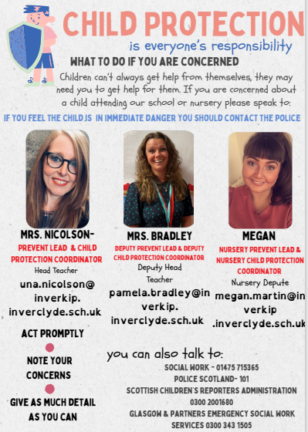

Pupil Leadership Groups:

Pupil voice is valued and listened to to ensure that it is at the heart of our decision. At Inverkip Primary we believe that children need to be active participants in their own education and to feel that their opinions will be heard within our school and the wider community. We seek ways to listen to the views of our pupils and involve them in decision-making, so that they are engaged as partners in the life of the school.
The opportunity for our pupils to share their opinions is a part of Inverkip school life and can happen in lots of ways. Learner Participation is embedded throughout the curriculum and by the use of a variety of pupil committees. We believe that our committees will enhance and develop positive pupil leadership skills and encourage a greater sense of responsibility throughout the school. This year we have given class responsibility for our committee groups. Each group then have responsibility for a key area of school inprovements:

- Our School & Community – Eco group/Gardening and Community
- Our Well-Being – our playground/clubs etc
- Our Successes and Achievements
- Our Relationships – Rights Respecting School and our Values
- Our Learning and Teaching – Literacy, Numeracy, JRSO and Young Leaders of learning


Eco Focus Group
We have now gained our FIFTH Green Flag for all the wonderful Eco work which goes on in the school. This is an area that is going from strength to strength. Last year we introduced termly community beach cleans and were the largest gathering in the whole of the UK for the ‘Great British Beach Clean’. What an achievement!


Young Leaders of Learning (YLL)
We have an active pupil leaders of learning group who meet once per month and represents the pupils’ voice in decision making in many areas. The group will focus on school improvements throiughout the year and will also visit other schools to moderate.


RSS Focus Group
We are very proud to have achieved Rights Respecting Schools GOLD Award since 2016 and achieved GOLD re-accreditation in May 2021.

Cluster leadership Group
We are also delighted to be in the early stages of establishing a cluster leadership group. This bsession they will be working on developing a cluster charter on ‘The promise’.

Curriculum And Assessment:
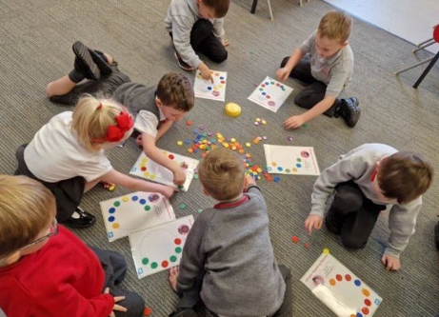
In our classrooms, teachers deliver the curriculum in a way that involves pupils in a variety of learning activities. We believe that learning should be fun.
The curriculum framework for all Scottish educational establishments 3-18, called Curriculum for Excellence, offers appropriate educational outcomes for all pupils.

The aims of Curriculum for Excellence are that every child and young person should:
- Know they are valued and will be supported to become a successful learner, an effective contributor, a confident individual and a responsible citizen;
- Experience a traditionally broad Scottish curriculum that develops skills for learning, skills for life and skills for work, with a sustained focus on literacy and numeracy that encourages an active, healthy and environmentally sustainable lifestyle and builds an appreciation of Scotland and its place in the world.
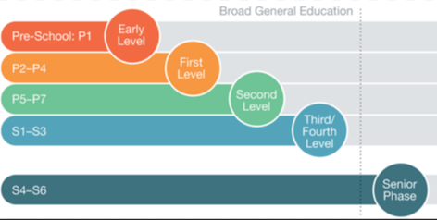
The experiences and outcomes under Curriculum for Excellence are written at five levels, with progression to qualifications described under the senior phase:
- Early level - the pre-school years and P1 or later for some
- First level - to the end of P4, but earlier for some
- Second level - to the end of P7, but earlier for some
- Third and Fourth - S1 to S3, but earlier for some
- Senior phase - S4-S6 and college or other means of study.

There are eight curricular areas at each level namely:
Literacy and English, Mathematics, Health and Wellbeing, Social Studies, Religious and Moral Education, Sciences, Technologies and Expressive Arts.

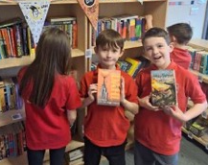
Literacy and English:
In Literacy and English the school strives to achieve a correct balance of listening, talking, reading and writing. Pupils are taught to listen carefully and competently, talk confidently and fluently, read with understanding and enthusiasm and write with expression and accuracy. Inverclyde Literacy and English Progression Pathways are in place to ensure all pupils are learning at the correct pace.
Our core Reading Schemes are Rigby Star and Literacy World. In addition to this we have a large variety of class novels. The other resources we use are:
- Active Literacy at the early stages to develop children’s phonics and word attack skills. Jolly Phonics in P1 & P2
- Jolly Grammar in P2 & P3
- Nelson Spelling which involves teaching a weekly spelling rule and builds upon the work of Active Literacy in P1 and P2.
- Accelerated Reading Scheme for Pr3-7 pupils to enhance reading and comprehension skills
- Nelson Handwriting is used to enhance our handwriting programme.
- ‘The Big Write’ is an approach which provides a very clear structure for developing and assessing writing. This approach encourages children to develop their vocabulary, connectives, openers and punctuation (VCOP) through active learning.
- Class Novels are used to help further develop reading skills and as part of Interdisciplinary Learning eg The Boy In The Striped Pyjamas is used to enhance learning as part of the context of World War 2 in P7.
- The Book Fair visits the school each year, the children are given the opportunity to buy quality books from a good selection while at the same time allowing the school to purchase books for the class libraries with the commission raised.

Mathematics and Numeracy:

Mathematics and Numeracy provides more than opportunities to calculate, it enables information to be handled and communicated and problems to be solved. Mathematics is used in all aspects of everyday life, allowing us to make sense of the world around us. Children need to be confident and competent in their numeracy skills to be able to function responsibly in everyday life and contribute effectively to society.
The mathematics outcomes in Curriculum for Excellence are outlined within the following areas:
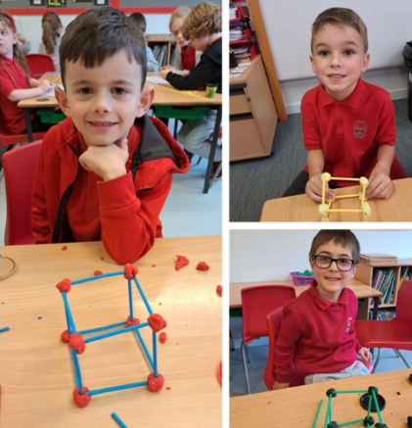

Number, money and measure
• Basic number processes
• Measure
• Patterns and relationships
• Expressions and equations

Shape, position and movement
• Properties of 2D shapes and 3D objects
• Angle, symmetry and transformation

Information Handling
• Data and analysis
• Ideas of chance and uncertainty

The mathematics outcomes allow teachers scope to plan for a wide variety of experiences which will enable young
people from age three onwards, to develop mathematical understanding, allowing them to solve problems, transfer knowledge to other curricular areas and develop mathematical thinking. The teachers use a range of teaching strategies and resources to develop mathematical skills and improve mental agility. These include: SEAL Maths, Number Talks, Numicon, TJ Maths, Heinemann Active and Sumdog.

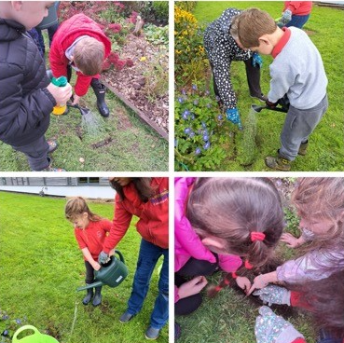
Social Studies:
Staff plan a variety of interdisciplinary contexts throughout the year. These are a series of lessons covering several curricular areas within one topic or context. We encourage an active approach to learning throughout the school.
Social Studies Social Studies identifies three lines of development:
- People, past events and societies
- People, place and environment
- People in society, economy and business.
In social studies, effective learning and teaching will draw upon a variety of approaches including active learning, independent learning, cooperative learning, outdoors, field trips, visits and external contributors. Active citizenship is a central feature of learning in social studies for children and young people, developing skills and knowledge to enable and encourage participation. Social studies offer opportunities for children and young people to become involved in their local community and the wider world and are therefore an important vehicle for opportunities to consider and develop their role as active and informed citizens. Visits to places of educational interest are arranged whenever possible to allow the children the opportunity of seeing and experiencing things at first hand. Previous visits have included: Transport Museum, Bannockburn, Stirling Castle, Farm visit, Vikingar, Wallace Monument, Science Centre, Amazonia, and Scotland Street Museum. We are keen to make the most of our village location and regularly visit Local visits Lunderston Bay, Ardgowan Estate and our local village shops.
We take every opportunity to develop skills for learning, skills for life and skills for work. On occasions we have invited parents and members of the local community into the school to talk about their jobs and the skills they need. Children learn to apply depth and knowledge of skills across different curriculm areas to ensure that learning takes place in a meaningful context.

Expressive Arts:
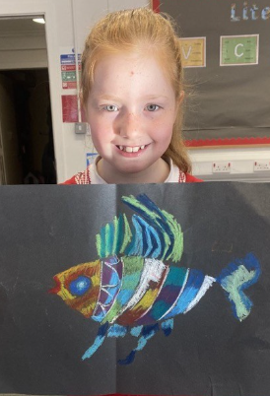
Expressive Arts covers the subjects: Art and design • Dance • Drama • Music
The expressive arts programme, incorporating, art, drama, music has evolved to take account of national advice. The programmes offer pupils a good range of skills and experiences.
Learning in, through and about the expressive arts helps children recognise and appreciate their own and others’ creative and artistic abilities and enables children and young people to:
- express themselves in different ways and be creative
- experience enjoyment
- develop important skills specific to the expressive arts and also transferable skills
- develop an appreciation of aesthetic and cultural values, identities and ideas
- for some, prepare for advanced learning and future careers by building foundations for excellence in the expressive arts.
Children at P5 also have the experience of working with a music teacher and all classes work with vocal instructor. The tutor delivers the ABC Music programme in the school.
- Every child at P4 is given the opportunity of learning to play the violin / cello. They are assessed on their aptitude for music. Those who are successful are given a violin / cello on loan for the first two terms. After consultation with the music teacher the parents are then asked to purchase (or hire) a suitable instrument to allow the child to continue.
- Brass Tuition: A small group of children at P6 and P7 are given the opportunity to play trumpet or trombone. The same criterion applies as for those children taking violin tuition.

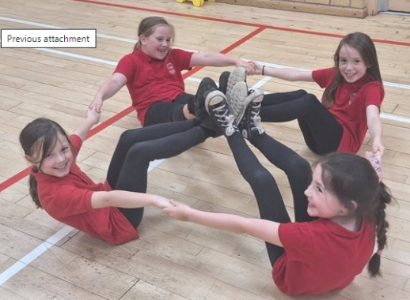
Health and Wellbeing:
Health and Wellbeing within Curriculum for Excellence is concerned with all aspects of mental, emotional, social and physical wellbeing now and in the future. Health and Well Being is subdivided into the following areas:
- Mental, emotional, social and physical wellbeing
- Planning for choices and changes
- Physical education, physical activity and sport
- Food and health
- Substance misuse
- Relationships, sexual health and parenthood
Our pupils enjoy 2 hours of high quality P.E. every week.
Everyone within our school community, shares the responsibility for creating a positive ethos and climate of respect and trust - one in which everyone makes a positive contribution to the wellbeing of each child and adult within our school and the wider community. Our pupils should feel happy, safe, respected and included in the school environment and all staff should be proactive in promoting positive behaviour in the classroom, playground and the wider school community.
Certain aspects of health and wellbeing will be taught through focussed programmes such as our personal and social education programme which includes our Anti-Bullying programme. Other aspects such as Substance Misuse will be taught in partnership with other agencies such as school health. Every year our Primary seven pupils have a five day outdoor residential experience. These experiences are an important part of our Health & Well Being programme and enable our learners to experience challenge in a safe and controlled setting.
Sex and Relationship Education is an integral part of a school’s health education programme. It focuses on the physical, emotional, moral and spiritual development of all children. Teachers are central to the delivery of sex education and relationships from Primary 1-7 and work in partnership with parents/carers and appropriate health professionals. Parents/carers will be fully informed and consulted on the content and purpose of sex and relationship education in schools prior to lessons commencing and will have the opportunity to raise concerns with school staff. On an occasion where a parent/carer wishes to exercise the right to withdraw his/her child from sex and relationship education they should discuss their concerns and alternative arrangements with school staff (as per Inverclyde Council’s policy “Sexual Health and Relationship Education”).

Sciences and Technologies:
Curriculum for Excellence challenges us to ensure that all children must develop a secure understanding of important scientific concepts and that their experience of science in school should kindle a lifelong interest in science. The science outcomes have been developed into seven areas:
- Planet Earth
- Energy in the Environment
- Communication
- Forces and Motion
- Life and Cells
- Materials
- Topical Science
The science outcomes are designed to stimulate children’s interest and motivation, and to support staff in planning challenging, engaging and enjoyable learning and teaching activities including active learning, problem solving and scientific enquiry, use of technology with much more emphasis on children explaining their understanding of concepts.

Technologies:
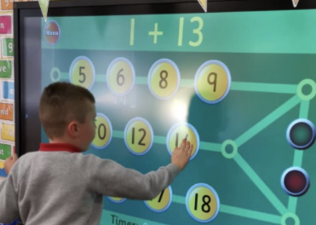
Within the technologies, children can develop their creativity and entrepreneurial skills and be encouraged to become innovative and critical designers of the future. Information & Communication Technology (ICT) Being skilled in using ICT is essential if children and young people are to be effective contributors, and to communicate and interact on a global scale. We have a computer suite within school which houses 28 laptops with internet access. All our classrooms have computers and interactive whiteboards. Glow is the world’s first national intranet for education, developed exclusively for Scotland’s educational community.
Within the technologies, children can develop their creativity and entrepreneurial skills and be encouraged to become innovative and critical designers of the future.

Religious & Moral Education (RME):
In RME pupils are encouraged to:
- Recognise religion as an important expression of human experience
- Be aware of the values, beliefs and practices of religious traditions within and beyond the Scottish community
- Reflect on the diversity of Christian practice
- Celebrate the major festivals
- Understand the similarities rather than the differences in other religions
- Involve parents and the wider community in our assemblies

Withdrawal from Religious Observance Under the terms of the Education (Scotland) Act 1980, parents have the right to ask for their child to be withdrawn from Religious Observance. In the past the school has dealt with such requests with sensitivity and understanding and this approach will continue. The Head Teacher will offer to meet with any parent wishing to withdraw their child to ensure that they are clear about the school policy on Religious Observance. In particular, parents should be reassured that the Religious Observance planned by the school adopts an open and respectful approach and does not seek to compromise the beliefs of any pupils or their families. Where a child is withdrawn from Religious Observance, suitable arrangements will be made for the pupil to participate in a worthwhile alternative activity.

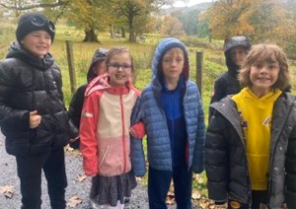
Outdoor Learning:
‘All aspects of the curriculum can be explored outside. The sights, sounds and smells of the outdoors, the closeness to nature, the excitement most children feel, the wonder and curiosity all serve to enhance and stimulate learning.’ Building the Curriculum 2: Active Learning in the Early Years, 2007

Outdoor Learning doesn't just mean learning about the outdoor environment, although that is an important part of it, rather it means simply taking learning outdoors. It provides relevance and depth to the curriculum in ways that are difficult to achieve indoors. Children see that learning is not something that is confined to the classroom and encourages them to link curriculum areas. This awareness promotes lifelong learning and develops critical thinking skills. Outdoor Learning is an ideal setting for multi-sensory learning and provides excellent opportunities to use a wide range of skills and abilities not always visible in the classroom. Outdoor Learning connects children and young people with the natural world and encourages lifelong involvement and activity in Scotland’s outdoors. Outdoor Learning enriches the curriculum makes learning fun, meaningful and relevant. Being outside has many health benefits, increases physical activity and improves emotional well-being and mental health. We are so fortunate with our beautiful and spacious school grounds and with access to the local woods, we aim to make full use of them in our learning. We have developed links with the Clydemuirshiel rangers and Blooming Inverkip who come and deliver outdoor learning sessions throughout the year.
We organise Curriculum days and evenings throughout the school year for parents to share learning experiences with their child and to help them understand how we plan for a range of experiences and outcomes.
More information about all aspects of Curriculum for Excellence can be found on Education Scotland website. www.educationscotland.gov.uk

Extra Curricular Activities:
We have a variety of extra-curricular clubs (lunchtime and after-school) that are organised throughout the school year either by Callum, our Active Schools Coordinator or the teaching staff. The sporting clubs participate in Inverclyde events throughout the year. We are extremely proud of our Athletic Club successes. Extra-curricular activities have included: football, netball, athletics & choir. Parents talented in any of these activities are encouraged to help. Throughout the session field visits and learning visits of educational value are made to places of interest.

Assessment:

Assessment is an integral part of learning and teaching, helping to provide a picture of a child’s progress and achievements and to identify next steps in learning. Learning should show breadth, challenge and application of acquired skills in new and unfamiliar contexts. Education Scotland advise that the dialogue is the most important factor when assessing the children’s learning. In Inverkip Primary we are equipping the children with the skills to talk about their learning and express what their next steps in learning are.

This is done through a variety ways eg reflective dialogue, peer and self-assessment, Learner Conversations. It is very important that children are given the opportunity to talk about their successes and challenges. Teachers use assessment evidence to provide useful feedback to learners and parents, to adapt learning and teaching approaches to meet their needs and to revisit areas where learning is not yet secure.

The class teachers carry out continuous assessment in all subjects. Most assessment takes place through formative assessment where the pupil is fully involved in the educational process. Children are assessed using the SNSA national assessment in literacy and numeracy at P1, P4 and P7 to identify progress made from their preceding years. Key learning experiences are tracked in literacy, numeracy and health and wellbeing for every child to allow us to clearly identify that progress is being made. A variety of other diagnostic tools are used to determine and support difficulties or challenges that arise for children at specific times in their education.

Assessment takes place throughout the school year. Teachers assess constantly as part of daily learning and teaching, to see what children know, understand and are able to do. Teachers assess in other ways eg written responses like tests; and evaluation of a final product e.g. a piece of artwork,
report or a project; observations of pupils carrying out tasks like practical investigations; performances, presentations and discussions.

We also assess transitionally, at the end of a Curriculum for Excellence level. This would be a far more holistic type of assessment, drawing on a full range of assessment evidence and professional judgement, evaluating 'how much’ and 'how well' an individual has learned:

- We carry out spelling assessments three times per year. This allows tracking of learner progress and allows teachers to develop and build on individual spelling skills.
- Writing assessments are carried out three times a year. Again, these are used to track pupil progress and identify specific targets for individual learners.
- Reading Assessments are carried out six times per year. This is an online assessment as part of the Accelerated Reading Scheme. This gives us information on pupil progress in reading and comprehension.
- Maths assessments are typically carried out at the end of a particular topic. These may take the form of a check-up or practical assignment. Every child’s progress is tracked each term through the Tracking Meetings, which involve input from the HT, DHT and Class Teacher.
- Termly, pupils are given learning targets in Literacy, Numeracy and Health & Wellbeing. These are shared with parents. Pupils can explain their targets and discuss their next steps in learning.

Reporting:
In October and May there are parents' nights which are always well attended and have been of mutual benefit to parents and staff. Wherever possible, parents are interviewed privately.
Pupil targets will be sent home at the beginning of each term and a report on progress will be sent home at the end of May.
We value opportunities to build good working relationships with all our parents and plan to have a number of ‘drop-in’ learning sessions where parents can join their child in class to share learning startegies and ideas.

Pupil targets in Literacy, Numeracy and HWB will be sent home on a fortnightly basis through our ‘Learning Journals’.
In Term 1 and Term 3 you will be invited to attend a Parents’ Evening with your child’s class teacher. An interim report will be issued in Term 2 and a further written report on your child’s progress will be sent home at the end of Term 4.

Global Citizenship:
Inverkip Primary School has been partnered with Malavi Primary School in the Chiradzulu district of Malawi since September 2007.
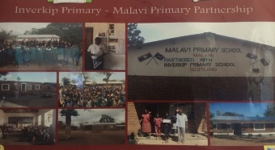

The partnership is based on the sharing of cultural and curricular links which has led to our pupils and staff being involved in many shared projects including:
- Sharing cultures – looking at life in Inverkip Primary compared to life in Malavi Primary
- Looking at sugar production in Malawi and following its journey to Greenock and how it is used in Buchanan’s factory
- Studying renewable energy: this involved the setting up of a chicken run in Malawi using solar panels to grow chicks and the building of an eco-greenhouse using plastic bottles in Inverkip

Enrolment:
IMPORTANT NOTICE
REGISTRATION INFORMATION FOR CHILDREN STARTING PRIMARY 1 IN AUGUST 2023

Inverclyde Council has changed the way in which children register for primary school. This process will now be undertaken by completing an online application form which can be found on the Inverclyde Council website at http://www.inverclyde.gov.uk/p1-registration.

It’s vitally important that parents follow the online registration process to register their child for a Primary 1 place in an Inverclyde school.

Children who reach the age of five years between 1 March 2023 and 28 February 2024 are due to start Primary 1 at the beginning of the new school term in August 2024. Parents are asked to register their child in their chosen denominational or non-denominational catchment primary school, from Monday 5th January 2026 - Friday 9th January 2026

Once parents have completed the Primary 1 registration, they will have the choice to complete a placing request application to a school other than the catchment primary (This includes Primary 1 Gaelic Medium education at Whinhill Primary School). A deferred entry application is also available to parents considering deferring their child’s entry to Primary 1 in August 2026.

No documents will be required at this stage; however, we may have to contact you, should we require further information.

Parents will be notified by 30 April 2026 confirming their child’s place in school and information regarding induction days will follow from the school after this date.

Parents who do not have internet access to apply online, are asked to contact their child’s current Early Years Establishment for assistance.

Where a parent wishes more information on the actual boundaries of the catchment area for the local school, he/she should enquire at the school where this information will be made available. If a placing request to another school is being considered then the head teacher should be informed at the time of enrolment. Names, addresses, telephone numbers and other relevant information relating to other schools in the authority are also available at your local school and on Inverclyde Council Website. www.inverclyde.gov.uk

Placing Requests:
Any parent wishing to make a placing request to a school outwith their local catchment area should, in the first instance, enrol their child at the primary school for which they are zoned. The school will then furnish the parent with the necessary information, forms etc.

Transfer From Primary School To Secondary School:
Pupils are normally transferred between the ages of 11½ and 12½, so that they will have the opportunity to complete at least 4 years of secondary education. Parents will be informed of the arrangements no later than December of the year preceding the date of transfer at the start of the new session.
Inverkip Primary to transfer to Inverclyde Academy, Cumberland Road, Greenock - telephone number 01475 715100. This is the school that your child will transfer to without the need for a placing request. It is, of course, the right of any parent to submit a placing request to any school in Inverclyde.
In December each year, primary schools will provide parents/carers with the name of the secondary school where a place has been reserved for their child.
There are no denominational primary schools within the areas of Quarriers Village, Kilmacolm, Inverkip and Wemyss Bay. Parents often choose to send their children to the local non-denominational primary school because of the travelling distance to their nearest denominational primary school. In such circumstances the following admission arrangements will apply:
- Only those children who have a certificate of baptism into the Roman Catholic faith before entry to primary school whose parents have selected to send their child to the nondenominational school serving the defined catchment area assigned to their address rather than to their assigned denominational primary school because of travelling distance, will have the choice at Primary 7 of seeking admission to the denominational school assigned to their address.
The Council’s policy in respect of school transport will apply. The amended policy reflecting the changes is available to view on the council website.
https://www.inverclyde.gov.uk/education-and-learning/schools/transferring-to-secondary
Please note that if evidence is not produced then a catchment place will be allocated at Inverclyde Academy. Pupils who do not meet the above criteria can still submit a placing request if they wish to transfer to a denominational/non-denominational secondary school and a placing request application must be submitted no later than 1 February 2021. Please be aware that in line with our school transport policy, free transport will not be provided where a placing request is approved.
If any school in Inverclyde is oversubscribed to pupils within the catchment area then parents will be informed and the policy to prioritise places will be put into place.
We have a comprehensive transition programme in place for all pupils who are moving onto secondary education. This involves visits to the school, information evenings for parents and pupils and induction days for pupils. We liaise closely with secondary schools to ensure they have all the necessary information about the pupils. Secondary school staff are invited to a transition review for all pupils who have additional support for learning needs.

Support For Pupils: Getting It Right For Every Child
Every teacher has a responsibility to support the learning of all pupils in their class. The type of support offered will vary according to the needs of pupils. This includes consideration given to children who have a disability, children with social, emotional and behavioural difficulties, children with learning difficulties of a specific or general nature, children who are exceptionally able, children whose learning has been interrupted through absence or illness, bilingual children who have English as an additional language, travelling children and those children whose family circumstances impact on attendance and learning.
Some children and young people will have additional support needs arising from complex or multiple factors which require a high degree of co-ordination of support from both education and other agencies in order that their needs can be met. In these cases, the school will hold a meeting to decide whether the child or young person meets the criteria for a Co-ordinated Support Plan. The coordinated support plan is a statutory document which ensures regular monitoring and review for those children and young people who have one. You have the right to ask the education authority to establish whether your child needs a coordinated support plan. Your child can make this request themselves, if they are aged 16 or over. You and your child, if they want to, will attend a meeting with staff at their school. Other professionals from different agencies who may be involved in providing support for your child will also attend. If your child does not want to attend meetings or feels unable to, their views must still be sought and considered. Inverclyde’s mediation service can be accessed by contacting:

Michael Roach
Head of Education, Communities and Organisational Development
Education Services
105 Dalrymple Street
GREENOCK PA15 1HU
Telephone: 01475 712842

If a parent considers that his or her child has additional support needs and wishes to make enquiries on this, they should contact the school:
- Mrs Una Nicolson, Head Teacher
- ASN Coordinator, Mrs Pam Bradley, Depute Head Teacher

Pupils who at times experience difficulties with their work are catered for within their class programmes of study. Work is differentiated where appropriate to allow pupils to work at his/her level. The school is supported by a member of staff with a specific remit for support for learning 2 and ½ days per week whose specialist training allows them to work with children who have specific difficulties and co-ordinates the work with the class teachers. Steps are taken to ensure that parents are consulted and kept informed at appropriate intervals.

We work closely with a variety of other agencies to ensure all pupils receive the help they need to reach their potential. If a child has a specific difficulty further advice may be sought from Psychological Services after parents have been consulted.

Getting it Right for Every Child:
In line with National policy ‘Getting it Right for Every Child’ underpins all that we do at Inverkip Primary School. For more information please look at the following website

www.scotland.gov.uk/Topics/People/Young-People/gettingitright

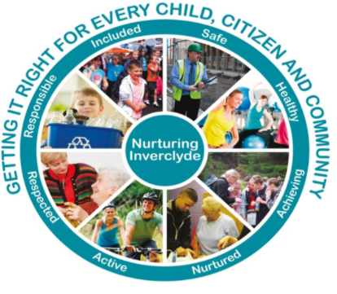

A child or young person’s needs are identified at the earliest possible stage and can be met in a number of ways, for example by adaptations to the curriculum or learning environment, as well as input from the Support for Learning Teacher, ASN Auxiliary, SMT or support from visiting specialists. The appropriateness of the support is determined through a process of assessment, planning and monitoring, working jointly with parents and carers, and is regularly reviewed.
Learning outcomes for children and young people with additional support needs are set out in a plan and all educational establishments hold regular review meetings with parents and carers to determine needs and the most appropriate supports. Everyone’s views are equally important in order to consider what is currently working and how to determine next steps
Children and young person’s needs are identified in a number of ways, and the process of assessment is an ongoing, shared process with partnerships with parents and carers at the forefront. On some occasions, health service staff or other partner agencies make children known to Education Services. Other additional support needs may be notified to Education Services by parents themselves or identified by one of a range of staff working closely with the child.

As with all local authority schools in Scotland, this school operates under the terms of the Additional Support for Learning Act (2009) and it’s accompanying code of practice. These procedures have been strengthened through the Children and Young People Act (2014)

The following websites contain information of organisations which provide advice, further information and support to parents of children and young people with ASN. These organisations are identified under The Additional Support for Learning (Sources of Information) (Scotland) Amendment Order 2011 as:

(a) Children in Scotland: Working for Children and Their Families, trading as “Enquire – the Scottish advice and information service for additional support for learning”, a charitable body registered in Scotland under registration number SC003527;

(b) Scottish Independent Advocacy Alliance, a charitable body registered in Scotland under registration number SC033576;

(c) Scottish Child Law Centre, a charitable body registered in Scotland under registration number SCO12741.”

www.enquire.org.uk

www.siaa.org.uk

www.sclc.org.uk/

School Improvement:
Details of our main achievements in the past session can be found in our Standards and Quality Report. You can access a copy of this on school website or request a copy from school office.
We have a detailed three year Strategic Improvement Plan which identifies our current position and our aims for each year. This is regularly reviewed by staff, parents and pupils. These can also be found on the school website and copies can be obtained from the school office.
Ongoing self-evaluation by all stakeholders gives us a clear picture of any areas for development. These can sometimes be tackled by a short term action plan or, if more work is required, they will be added to a future improvement plan.
Here is a summary of our targets for Session 2024 -2025:
1. Improvements in attainment, particularly in literacy and numeracy
2. Close the gap between the most and least disadvantaged children
3. Improvements in children and young people’s health and wellbeing
4. Improvement in employability skills and sustained positive school leaver destinations for all young people

HMIe Inspection:
Follow the link below to read our most recent HMIe school inspection report.
http://www.educationscotland.gov.uk/inspectionandreview/reports/school/primsec/InverkipPrimarySchoolInverclyde.asp

School Accreditation:
In Inverkip Primary we have gained
- Gold Rights Respecting Schools Award
- Fairtrade Status
- Health Promoting School Status
- Gold School Sports Award for our many and varying sports clubs available to all pupils
- Five Eco Green Flags

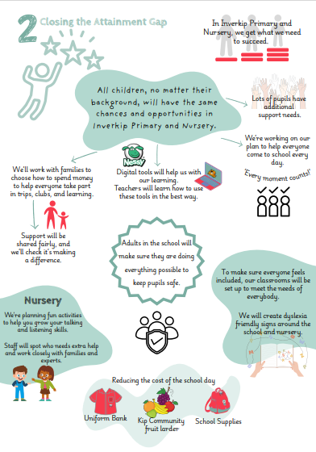
Here is a summary of our Child Friendly Improvement Plan for 2025 2026
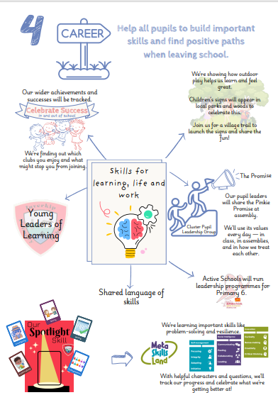
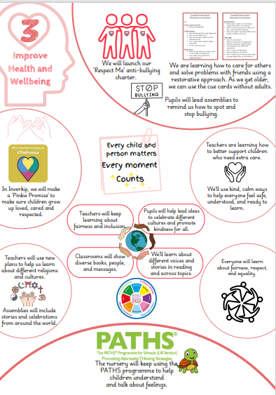
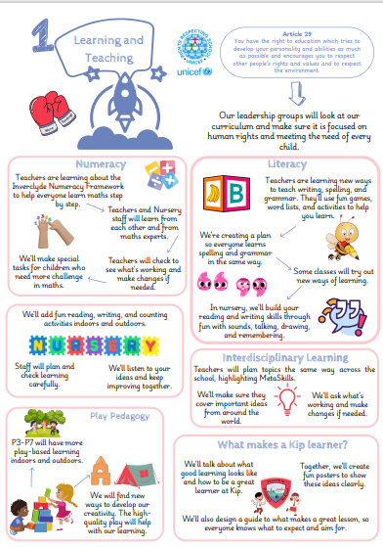
Policies:
A copy of available Inverclyde policies can be found on Inverclyde Council Website. http://www.inverclyde.gov.uk/education-and-learning/policies/
Policies Information on the following is available on the following areas:
- Reporting
- Composite Classes
- Promoting Positive Relationships and Positive Behaviour
- Anti-Bullying Policy
- Admissions
- Complaints
- Promoting Gender Equality
- Promoting Race Equality

Home And School Links:
Parents are welcome to call at the school to discuss any difficulties or problems with the head teacher or DHT. A regular newsletter is published at the end of each month keeping parents informed of events and activities happening in the ongoing life of the school. Look out for newsletters on our school website. Twitter updates and reminders are sent daily.

Child Protection In Inverclyde:
Inverclyde Council Education Services has Child Protection Guidelines and Procedures which all schools are required to follow. Education Services work very closely with other agencies namely Police Scotland and Health and Social Care Partnership (HSPC) and the Children's Reporter to support children. Common responsibilities of all staff are to protect children from abuse and exploitation, to respond appropriately when abuse is identified, and to ensure whenever possible that all children are able to exercise their right to be raised in a warm, stimulating and safe environment with the support of staff, their families and carers. Further information can be obtained on Inverclyde Child Protection Website.
http://www.inverclydechildprotection.org/

Composite Classes:
Some children are never part of a composite class whilst others, particularly in rural schools, never experience anything else. You should be confident that the professionalism of the staff at Inverkip Primary School will ensure that your child will always work within a programme appropriate for his / her age, ability and aptitude. At both school level and education authority level quality control procedures exist to ensure that your child is making good progress within the nationally agreed curriculum guidelines.
The recently issued national guidelines on the curriculum indicate that pupils should proceed through learning experiences tailored to fit their personal level of attainment. This means that pupils in all classes will follow programmes constructed to help them progress at their own level. This applies to all pupils regardless of whether or not they are in a composite or single year stage class. In addition, the school will make every effort to involve pupils of any one year group in activities which bring the whole year group together. In this way pupils will be able to
continue to identify with children of the same age especially at important times such as transfer to secondary school. At the same time the school will also try to ensure that the natural identity of each primary class group is maintained.

Homework:
At Inverkip Primary, we believe homework is valuable for creating partnership between home and school. Most children will have reading and possibly spelling or related language work on at least two or three nights per week, although some of the homework given may involve research or topic work. In the early stages the time spent each evening on work at home should not exceed 15 minutes, gradually increasing to an average of not more than 30 minutes in P6 and P7.
We believe that homework is important in the forging of home/school links. Therefore, parents are requested to sign work done at home, including “reading record booklets” in order to:
- be aware of the quality of the work being produced by their child
- confirm that the work has been done at home
- discuss the work with their child and give support by being involved in the learning process by monitoring and helping to correct any errors which may have been made.
At the beginning of each school session at the Curriculum Meeting the class teacher will provide parents with a brief written statement of the type of homework which is likely to be given, procedures to be followed, and ways in which parents can help to achieve good standards of work.

School Uniform:
Given that there is substantial parental and public approval of uniform, schools in Inverclyde are free to encourage the wearing of school uniform. At Inverkip we believe that children learn best when they are comfortable so we have a very flexible approach. In encouraging the wearing of uniform account is taken in any proposals to prevent any direct or indirect discrimination . Any proposals will be the subject of widespread consultation with parents and pupils. Against this background it should be noted that it is the policy of the Education and Lifelong Learning Committee not to insist on pupils wearing uniform or having specialist items of clothing as a prerequisite of their attending and engaging in all of the activities of the curriculum.
Many parents do, however, wish their child to wear uniform at Inverkip School and the items are listed below.
- Grey pinafore, skirt or trousers (some children wear a tartan skirt/pinafore)
- White shirt or blouse
- School Tie
- Grey socks or grey tights
- Grey/Red cardigan or pullover
- Grey school sweatshirt worn with red polo shirt
- Red/Black rain jacket embroidered with school badge
- PE kit – red school polo shirt, red shorts
There are forms of dress which are unacceptable in school, such as items of clothing which:
- Potentially, encourage faction (such as football colours);
- Could cause offence (such as anti-religious symbolism or political slogans);
- Could cause health and safety difficulties such as loose fitting clothing, dangling earrings or clothing made from flammable material for example shell suits in practical classes
- Could cause damage to flooring;
- Carry advertising, particularly for alcohol or tobacco;
- Could be used to inflict damage on other pupils or be used to do so.

The council is concerned at the level of claims being received regarding the loss of children’s’ clothing and/or personal belongings. Parents are asked to assist in this area by ensuring that valuable items and unnecessarily expensive items of clothing are not brought to the establishment. Parents should note that the authority does not carry insurance to cover the loss of such items and any claims submitted are likely to be met only where the authority can be shown to have been negligent.

Uniform Recycling:
In Inverkip Primary we have our Uniform Recycling initiative which is very popular. Open daily to parents, you can pop into school and search any uniform items you require all of which are free of charge. There is a uniform collection tub at the chool office for drop off.
There are forms of dress which are unacceptable in school, such as items of clothing which:-
- potentially, encourage faction (such as football colours)
- could cause offence (such as anti-religious symbolism or political slogans)
- could cause health and safety difficulties, such as loose fitting clothing or clothing made from flammable material
- could cause damage to flooring
- carry advertising, particularly for alcohol or tobacco
The council is concerned at the level of claims being received regarding the loss of children’s clothing and /or personal belongings. Parents are asked to assist in this area by ensuring that valuable items and unnecessarily expensive items of clothing are not bought to the establishment. Parents should note that the authority does not carry insurance to cover the loss of such items and any claims submitted are likely to be met only where the authority can be shown to have been negligent.

Jewellery/False Nails:
Parents should note that the activities the children may become involved in may be restricted because health and safety requirements state that jewellery of any kind must not be worn where children are undertaking physical activities. This includes jewellery worn as a result of body piercing. It should be noted that false nails are not permitted during any physical activity.

Parents of children receiving one of the following benefits will normally be entitled to monetary grants for footwear and clothing for their children:

- Income Support
- Income-based Job Seeker's Allowance
- Child Tax Credit, but not Working Tax Credit, and where income is less than £16,105 in 2019/20 (as assessed by the Inland Revenue)
- An asylum seeker receiving support under Part VI of the Immigration and Asylum Act 1999
- Any income related element of Employment and Support Allowance
- Parent or carer is in receipt of Working Tax Credit with an income below the threshold for receipt of maximum Working Tax Credit (currently income below £11,288).
- Universal Credit – where your maximum monthly income from employment does not exceed £915, as shown on your monthly Universal Credit Statement.

Approval of requests for such grants made by parents in different circumstances is at the discretion of the Corporate Director Education and Social Care. Information and application forms may be obtained from schools and from Education Services, Wallace Place, Greenock, PA15 1JB or via the Inverclyde Council website link: http://www.inverclyde.gov.uk/education-and-learning/schools/clothing-grant-and-free-school-meals

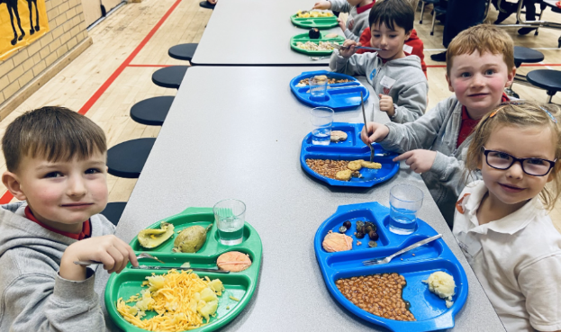
School Meals And Milk:
Delicious school meals are available from our own school kitchen. Payment for school meals is made via the Parent Pay scheme. This involves parents topping up their child’s account from home and saves money changing hands in school. This can be used for school lunches, trips etc. Provision is made for those who prefer to bring packed lunches. Special diets are available but medical evidence will be required to ensure that dietary needs are being met. The school supports the guidance given to it in the Education Services Health Policies. Through cross curricular topics on health and support given to healthy eating initiatives, Inverkip School, embraces the promotion of the Health Promoting School ethos. Pupils are encouraged to have greater health awareness, to be involved in the numerous physical activities offered and to become discerning in their diet. Free school meals are available each day for all pupils in P1-7.
Otherwise, parents of children receiving one of the following benefits will normally be entitled to a free midday meal:

- Income Support
- Income-based Job Seeker's Allowance
- Child Tax Credit, but not Working Tax Credit, and where income is less than £16,105 (as assessed by the Inland Revenue)
- An asylum seeker receiving support under Part VI of the Immigration and Asylum Act 1999
- Any income related element of Employment and Support Allowance
- Parent or carer is in receipt of Working Tax Credit with an income below the threshold for receipt of maximum Working Tax Credit (currently income below £11,288).

Information and application forms may be obtained from schools and from Education Services, Wallace Place, Greenock, PA15 1JB

Data Protection Act 2018:

General Data Protection Regulations and Data Protection Act 2018. Information on children, parents and guardian is stored on a computer system and may be used for teaching, registration, assessment and other administrative duties. In processing personal information, Inverclyde Council must comply with the General Data Protection Regulation and Data Protection Act 2018.
For further information please refer to https://www.inverclyde.gov.uk/site-basics/privacy or click on the following: Privacy page link


Some Practical Information:

The School Day School
- Starts 9am
- Interval 10:30-10:45am
- Lunch 12:15-1.15pm
- School Ends 3.15pm
When the weather is bad, the janitor will open all pupil entry doors at 8:45am. Pupils may enter the building and get ready for classes. When the playground is very icy/slippy, the janitor will grit a path from street to the main pupil entrance at the front of the school. All pupils will be directed to use this entrance.

Fizzy Drinks:
We would also ask that parents do not give their children fizzy drinks or sugary snacks either as snacks or in their packed lunches. We actively encourage pupils to drink water throughout the day to stay hydrated.

Allergy Aware Zone: Nut, Egg, Pulses and Lentils
We have children in the school with a severe peanut allergies and egg, pulses and lentil allergies, we would ask that parents are vigilant and do not send in nuts or nut products. Please avoid sending in homemade lentil soup in packed lunches.

Home Lunches
Some pupils may prefer to go home for lunch. We would ask that pupils going home for lunch bring a note to inform the class teacher.

Adverse Weather Information in Emergencies
We make every effort to maintain a full education service, but on some occasions, circumstances arise which lead to disruption. Schools may be affected by, for example, severe weather or power failures. In such cases we shall do all we can to let you know about the details of closures and reopening. We shall keep you informed by email, social media, the parent whatapp groups, X (Twitter) and the authority website. Announcements may also be made on local radio and in the press and on the Parent Council Facebook page.

School closure during the school day:
Should the need arise to close the school during the school day; the school will contact all families, in the first instance by email and on our X (Twitter) page. This will also be announced via the Parent Council Facebook page. Please note - Children will not be allowed to leave school to walk home without an adult as there may not be school crossing patrollers. If we are unable to contact parents, children will remain at school with a member of staff. It is vital that in these circumstances the school has up to date contact details.

What to Bring to School Children should bring:
- A smile!
- A water bottle
- A pencil case with two sharp pencils, rubber & ruler
- PE kit on days when children have PE
We encourage our primary one children to buy a book bag for keeping their homework and reading book in and a gym bag for their gym kit.

Children should not bring:
- expensive jewellery
- electronic items such as iPods, game consoles
- expensive toys
- toy guns / weapons

Mobile Phones:
Parents may wish their child to bring a mobile phone to school so that they are contactable at the end of the day. We would ask that all mobile phones are switched off during class time and taken to the school office for safe storage.
Pupils should not use phones to contact parents during the school day; all contact with parents during the day should be via the school office. Phones may not be used in the playground to take photographs at any time. Mobile phones are the pupils’ responsibility at all times. Parents should note that the authority does not carry insurance to cover the loss of such items and any claims submitted are likely to be met only where the authority can be shown to have been negligent.

Medical and Health Care:
If your child is unwell then we advice that they stay home until feeling better. We ask that parents check with NHS inform on the recommended time at home especially if contagious. For example a ‘sickness’ bug has a recommended 48 hours at home. We know that our parents will use a common sense approach when making a decision if a child is well enough to attend. Shoulld a child become unwell during the day then the school office will call to advice.
In primary one all pupils have their height, weight and vision checked. Any concerns are referred to child’s GP or school doctor. In primary seven all pupils are screened as in primary one. Parents will not be informed in advance before these routine checks in P1 and P7.
School health work in partnership with the school to deliver many aspects of the health/ wellbeing curriculum. Parents are informed in advance if their child is going to be examined by the Doctor. Parents will not be informed in advance when their child’s hearing, vision, height or weight are checked. Every child is offered a flu vaccination by means of a nasal spray. Parents are informed beforehand and have the right to inform the school if they wish their child to withdraw from the programme.

Medication:
Parents of children requiring medication during school hours are welcome to come in to administer the medication. Should this be impossible we require parents to complete a Medication Form (available from the school office). Please check with your doctor that the medicine must be given during school hours. Often these times are flexible. Schools may not administer the first dose of medication / application of cream or ointment. This is to ensure that children do not suffer an adverse reaction to medicine.

Inhalers:
If your child has been prescribed an inhaler, please ensure that he/she has it with him/her at all times. This is very important when children are leaving the building to go on outings or to take part in sporting events. From time to time, please ask your child to bring their school inhaler home to allow you to check that it is still working properly and that it is still in date.

Emergency Contacts:
If a child is unwell or has had an accident the parent or emergency contact is informed and asked to collect the child. If no one can be contacted the child will be kept in the Medical Room or in real emergency taken to the local Doctor or Inverclyde Royal Hospital. It is very important that we have a local number as the emergency contact. School should be informed if the contact changes at any time.

Useful Contacts: Education Services Wallace Place Greenock PA15 1JB
- Ruth Binks: Corporate Director of Education, Communities & Organisational Development
- Michael Roach: Head of Education Communities and Organisational Development
- Alison McLellan: Quality Improvement Officer
- Yvonne Gallache:r Pre 5 Development Manager
- Councillor Stephen McCabe: Convenor of the Education & Communities Committee

Local Councillors: Inverclyde South West - Ward 6
- Mr P Cassidy
- Mr I Nelson
- Mr J Daisley
c/o Inverclyde District Council
Municipal Buildings
Greenock

Although this information is correct at time of presenting, there could be changes affecting any of the matters dealt with in the document:
- before the commencement or during the course of the school year in question.
- in relation to subsequent years.

