Inverkip Primary & Nursery Class



Maximising Attendance and Minimising Absence Policy

Created June 2025 (to be reviewed June 2026)

**Maximising Attendance and Minimising Absence Policy**

In Inverkip Primary & Nursery Class, we strive to provide the highest quality learning and teaching experiences to ensure that all children care about the world they live in to learn and develop the full range of skills to be citizens of the 21st century. We are developing our full potential and inspiring others to succeed within a climate of teamwork, respect and trust, where all our children aspire to become successful learners, confident individuals, responsible citizens and effective contributors.

We believe that: ‘Every Child and Person Matters and that Every Moment Counts’

Our new ROAR values are: Respect, Optimism, Ambition and Resilience

At Inverkip Primary & Nursery Class we aim to provide education and care of the highest quality which:

* Provides a nurturing, happy, motivating environment where all pupils feel safe, healthy, achieving, nurtured, active, respected, responsible and included at the heart of our village community
* Fosters creativity and confidence whilst developing every child’s skills, personality and talents
* Ensures they can achieve their full potential academically, emotionally and physically cultivating a love of learning

### **Rationale**

Attendance at school is an increasing challenging issue in Scotland. We are working hard to address the problems it presents, including its impact on attainment, achievement and wellbeing of our young people. We hope we can work together to ensure all our young people are attending school.

#### **Purpose and Aim**

* Inverkip Primary & Nursery Class, in line with council policy aims to promote good attendance at school. This is necessary to help learners become confident individuals, effective contributors, responsible citizens and successful learners.
* The purpose of this policy is to provide all stakeholders with a framework which offers guidance and strategy to maximise pupil attendance. Our aim is to promote good attendance at school. Absence from school, whatever the cause, disrupts learning.
* We expect all members of our school community to contribute to a positive school ethos which encourages and supports excellent attendance.
* It is the responsibility of all pupils, parents and staff to ensure that our school community provides a safe, welcoming, interesting and enjoyable learning environment that encourages excellent attendance. This will promote high attainment, positive sustained destinations and support the safeguarding and wellbeing of our pupils.
* It is a legal and contractual responsibility that all staff and the school maintain accurate attendance records for all pupils. Inverkip Primary & Nursery Class aims to adopt pro-active strategies and processes to promote good attendance.

**Principles**

The principles of Maximising Attendance within Inverkip Primary & Nursery Class are:

* We will promote positive relationships amongst all members of our school community and ensure everyone feels safe in a nurturing environment
* We will provide opportunity for all pupils to be included, engaged and involved in their learning
* We will work in partnership with pupils, parents and other agencies to eliminate barriers to promote excellent attendance and positive outcomes for all pupils as necessary
* We are committed to providing an appropriate education for young people of secondary school age and will support pupils and parents to maximise attendance in accordance with law (Education (Scotland) Act 1980)
* We respect the rights of children and young people as paramount (Children and Young People (Scotland) Act 2014)
* We respect the rights of children and young people with additional support needs (The Education (Additional Support for Learning) (Scotland) Act 2004 (as amended)
* We will support effective communication, including sharing relevant and proportionate information, where appropriate, in accordance with the Data Protection Act 1998 and Human Rights Act 1998
* We will share information where appropriate and work jointly to make sure we are co-ordinated and cohesive in all that we do
* We are committed to providing an appropriate education for young people of secondary school age and will support pupils and parents/carers to maximise attendance in accordance with law (Education Scotland Act 1980)

#### **Attendance in Early Learning and Childcare**

Children in Early Learning and Childcare (ELC) settings across Scotland attend a variety of settings in different ways. The guidance within this document focuses on the statutory nature of attendance for children attending school and although attendance in ELC is not statutory, there are still steps that can be taken to support children and families to attend their ELC settings. Our Nursery DHT and practitioners within our nursery class will reflect on children’s attendance. Absence could be for family holidays or spending time with grandparents, for example and will not always be viewed as a negative occurrence. It is important we work with families to identify and monitor the reasons for absence, which will allow the appropriate supports to be put in place, if this is required.

* Although attendance is not statutory in ELC, from a wellbeing and child protection point of view, processes for recording attendance will be aligned to child protection and safeguarding guidance. This will allow practitioners to identify children who are regularly not attending or have an unexpected instance of absence. Appropriate steps can then be taken to understand why this is the case and action taken to support the child and family in a way that meets their needs.
* Reviewing attendance records will help our nursery class to check if we are meeting the needs of families.
* Our nursery class work extremely hard to build positive relationships with children and their families throughout their time in our setting. At points of transition that ELC leaders we will work together with our primary setting and school placements. This is a key opportunity for us to share what has worked in supporting any children and families who don’t attend on a regular basis, or who may have been identified as being at risk of not attending school regularly.

#### **The Education (Scotland) Act**

The Education (Scotland) Act 1980 creates a duty on Inverkip Primary & Nursery Class to provide adequate education and guidance to young people of primary school age. The act also places a duty on parents to provide education for their children along with a justifiable explanation for non-attendance within 48 hours of an absence from school. Where appropriate, we have a duty to work with other authority agencies, namely Social Work, to ensure all pupils attend school.

In accordance with the Education (Scotland) Act (2016), Inverclyde Academy, working with the authority, the pupil and parents, may reduce the prescribed 27 hours of learning each week, if found to adversely affect the extent to which the pupil is or would be: Safe, Healthy, Achieving, Nurtured, Active, Respected, Responsible and Included.

#### **Authorised Absence**

In Inverkip Primary & Nursery Class, we may authorise absence when we are satisfied by a legitimate reason provided by the parent or carer via a note, email or phone call. Some reasons which may be accepted include:

* Illness – short term where no further provision is required
* Medical or dental appointments
* Meetings prior to, and in, court
* Attendance at, or in connection with, a Children’s Hearing or Care Review or
* appointment with another service provider, e.g. social work
* Religious observance
* Bereavement
* Weddings or funerals of those close to the family
* Arranged absence in relation to children in Gypsy/Traveller families
* Participation in non-school debates, sports, musical or drama activities agreed by the school
* Exceptional domestic circumstances;
* Period of exclusion
* Parental holidays – but only as agreed by the school in exceptional circumstances.

#### **Unauthorised Absence**

We will record absence accurately, in particular, in situations where no satisfactory reason has been provided absence will be recorded as unauthorised. Examples are likely to include:

* Most family holidays – unless there are exceptional circumstances as outlined previously
* Parent/Carer condoned absence where the school does not agree that there is a satisfactory reason
* Truancy, with or without parental/carer knowledge
* All other unexplained absence
* Longer-term exceptional domestic carer circumstances where support has been provided
* During disputes, such as relating to the return of a pupil after an exclusion.

**Providing for pupils during long-term illness**

In accordance with the Education (Scotland) Act 1980 and amended Standards in Scotland’s Schools Act 2000, we will work to access outreach teaching or home tuition where appropriate. We will maintain contact with the pupil and their family and will provide appropriate work to be completed at home, either in hard copy or via Microsoft Teams.

#### **Looked After and Vulnerable Pupils**

We will work closely with a range of internal and external services to ensure the needs of LAC and vulnerable pupils are met to enable them to attend school. We will protect pupil dignity by being discreet about supports in place and through being mindful of the impact of when and where meetings/hearings take place. As part of our commitment to nurture we will relentlessly attempt to build positive relationships with pupils as we recognise that positive adult and peer relationships along with recognising and supporting their talents and potential can lead to increased self-esteem, resulting in improved attendance and ultimately better achievement.

Targeted pupils with historical poor attendance and their families will work with us to identify barriers and build positive home-school partnership which will enable supports in place to bring about improved attendance. We will also work closely with Corporate Parenting Team teaching staff to support LAC pupils with their learning and attendance.

***Truancy***

Any pupil who is identified as being truanting will have a discussion with the SLT team and a call home. When a pupil is truanting a meeting/discussion will take place with the pupil and parent/carer to establish reasons and concerns regarding this.

**Late Coming**

* When a pupil arrives late to school after 9.00am they should report directly to the office and their attendance will be updated accordingly on Seemis.
* Pupils arriving late will be marked as LATE on the Seemis system. This should be done by the teacher during registration in the morning and after lunch. This will allow SLT to see the pattern of a pupil’s timekeeping.
* SLT will monitor pupils arriving late to school during their weekly attendance checks and will then take appropriate action. Actions surrounding late coming may include: contact with home/meetings with parents/carers or home visits where appropriate.
* Late pick up of a pupil at the end of the school day will be noted and parent/carers contacted if this is a recurring event.

#### **Senior Leadership Team’s responsibility**

* Encourage maximum attendance and good timekeeping at all times for all pupils
* Liaise with all staff in school and external agencies as appropriate
* Reinforce the message of good attendance and timekeeping at assemblies, parental/carer contacts and parent/carer consultations
* Agree appropriate strategies for improving the attendance of pupils returning after a prolonged absence i.e. phased return
* Consider alternative curriculum or other external provision for specific pupils with ASN e.g. poor attenders, school refusers
* SLT will liaise closely with the class teachers to monitor attendance and late coming. Quality assurance process will be in place to strategically monitor attendance on a weekly basis.

#### **Responsibilities of Office Staff**

* Record attendance alterations as requested by SLT i.e. curricular visits, other attendance outside of school and other requirements.
* Record attendance alterations as advised by parent/carer via phone, email or parent portal. This will be logged on Seemis and relevant PTPS alerted.
* Call or send an absence email (by 10am) to all pupils who have been marked as TBC.
* Update registration codes based on returns from PTPS and SLT.
* SLT and office staff will liaise weekly to track and monitor attendance using a spreadsheet with identifies/tracks pupils of concern. Pupils will then be tracked for a period of 6 weeks until an increase is noted.
* This is maintained and monitored via a centralised spreadsheet.
* Pupils for whom there are attendance concerns are highlighted weekly and discussed with SLT.
* Letters will be issued to parents/carers and interventions put in place (see Staged Intervention Process)

#### **Class Teacher Responsibilities**

There is a statutory duty placed on all staff to record pupil attendance accurately:

* Class teachers are required to record their class attendance in the morning, after lunch break. It is a legal requirement that this takes place each as failure to do so creates anomalies in individual pupil’s attendance figures.
* Pupils who are absent from class should be marked as TBC and office staff will alter attendance codes as appropriate.
* On any occasion when Seemis is unavailable, classroom teachers should complete a paper register and send this to the school office
* Registers should be completed within the first 10 minutes of a lesson. Staff should overwrite TBC code to LATE if a pupil subsequently arrives late.
* This will be monitored by the office staff who will alert SLT of any pupils who are truanting or missing from class without permission. If a pupil arrives late to class, the class teacher should change the registration mark LATE on Seemis.
* Classroom teachers must highlight any concerns to SLT as they arise to aid early intervention.
* To encourage positive attendance, teachers are expected to build positive relationships with all pupils regardless of previous experience. Teachers should create a positive learning environment by welcoming pupils into the class and encouraging them to succeed by expecting the best from every pupil.
* Teachers will be nurturing in their approach to pupils. Lessons will be interesting, engaging and differentiated to meet learner needs
* Teachers will have learning conversations to promote improvement and can discuss attendance concerns impacting on potential attainment.

#### **Pupil responsibilities**

* Pupils have a responsibility to attend school on time.
* Pupils who are feeling unwell should report to the school office. If the pupil needs to be sent home, a member of the office staff will contact home to arrange for pupils to be collected from school.
* Pupils should not leave school without permission, nor should they text parents themselves to request collection from school. This must be done through the school office.
* Pupils have a responsibility to be at school on time in the morning and after lunch.

##### **Parental/Carer responsibilities**

* Parents/Carers have a responsibility to ensure their child attends school on time. This includes prompt pick up at the end of the school day.
* Parents/Carers have a responsibility to check the school holiday calendar available on our school website. Consideration should then be made when booking any family holidays or trips to avoid any unnecessary absence from school.
* Parents/Carers will actively encourage positive attendance and not condone absence through minor ailments in line with a ‘work approach’ to attendance. For example, absence due to birthdays.
* It is the responsibility of the parent/carer to inform the school of their child’s absence giving the reason for absence on the first day of absence, preferably before 9am and each subsequent day thereafter.
* This can be done by telephone call (01475 715745) or email (office@inverkip.inverclyde.sch.uk)
* We also encourage Parents/Carers to record absence through the Parent Portal App
* Pupil appointments during the school day should be minimised as much as possible. If an appointment is necessary, contact should be made with the school and the time recorded as a permission (PER). If the young person is going to be absent for the whole day to attend this appointment, this should be recorded as Medical or Dental Appointment Whole Opening (PWO).

**Staged Intervention Process**

Rigorous daily tracking and monitoring systems in place regarding attendance, This enable the school, to identify early concerns with attendance, An attendance summary will be attached to all letters issued.

|  |  |  |  |
| --- | --- | --- | --- |
|  | **Attendance Percentage** | **Assessment/Intervention** | **Action** |
|  | Ongoing weekly tracking – office staff and SLT, | * Monitor of attendance through SEEMIS and attendance spreadsheet * Daily absence calls * SLT immediately informed if no reply to phone calls/email regarding attendance | * Identification of patterns of non-attendance noted and cause determined * Pastoral notes used to record concerns with absence * SLT discussion of possible risk factors – school, individual, family * Parent/young person discussion with SLT regarding attendance |
| Stage 1 | below 90% | * Monitor of attendance through SEEMIS and attendance spreadsheet. Pupils below 90% identified and discussed with SLT. * Identified pupils/trends tracked | * Phone call and an Early Intervention Letter **A** issued |
| Stage 2 | 85% or below | * Monitor of attendance through SEEMIS and attendance spreadsheet. Pupils below 85% identified and discussed with SLT. * Identified pupils/trends tracked. * SLT check in weekly with parents and pupils | * Clear communication and planning between parents/carer, school and child/young person * Encourage parents/carers to return child to school as soon as possible * Phone call and a Maximising Attendance Letter **B**. * Parents encouraged to meet with SLT should the absence be impacted on more than legitimate heath reasons. * Single Agency Plan created with appropriate actions identified. |
| Stage 3 | Lack of improvement or no sustained improvement since Stage 2 intervention. | * Monitor of attendance through SEEMIS and attendance spreadsheet. % increase/decrease noted for identified pupils and discussed with SLT. * SLT check in weekly with parents and pupils * Formal attendance meeting arranged. | * Phone call and an SLT Maximising Attendance Meeting Letter **C** issued to Parent/Carer with a request attendance at a formal meeting to discuss attendance. * Strategies implemented and additional support sought if necessary. * At this stage, pupils’ health and well-being will be tracked and monitored using well-being tools that will help to plan interventions that will meet their needs and this will be tracked termly and updated. |
| Stage 4 | No sustained improvement from Stage 3 despite interventions. | * Analysis of attendance spreadsheet shows no sustained improvement since Attendance Support Meeting or nonattendance at Attendance Support Meeting * SLT request Wellbeing Information from staff. | * Letter **D** Referral to Reporter (version 1 or 2) sent and Request For Assistance to Social Work explored. * Initial call to Social Work prior to referral. * Referral to Children’s Reporter if no resolution or co-operation from parent/carer. |

#### **Decision Making Tree for Unexplained Absence**

**I**f a parent has not advised the school that the pupil will be absent then it must be assumed that the parents are unaware of the absence and that the child is missing or truanting. If the school has been unable to establish contact with the parents, action must be taken to satisfy the school and the education authority that the child or young person is safe and well. Included, engaged and involved 2019

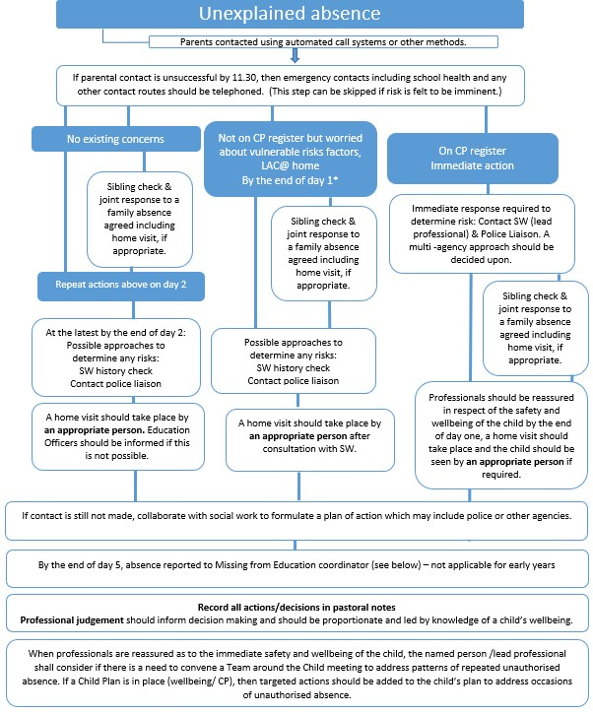

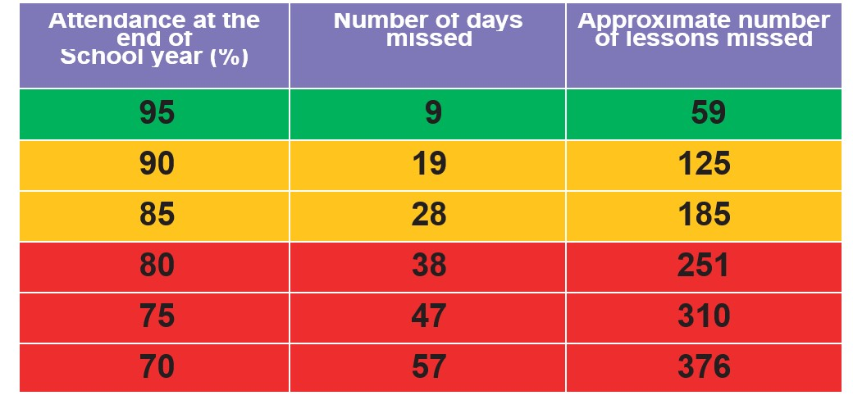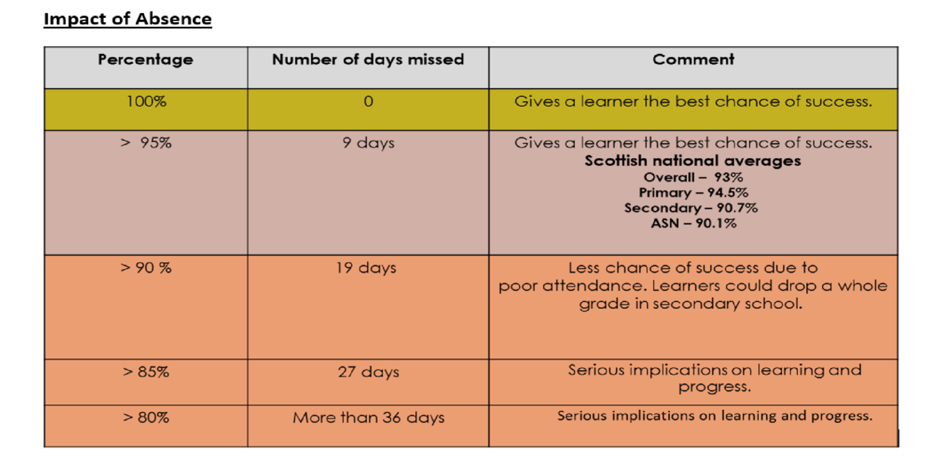

**Emotional Base School Avoidance**

Emotional Based School Avoidance (EBSA) is a broad umbrella term used to describe a group of children and young people who have severe difficulty in attending school due to emotional factors, often resulting in prolonged absences from school. The impact of EBSA on young people and schools is far reaching. Outcomes for young people who display EBSA include poor academic attainment, reduced social opportunities and limited employment opportunities.

Further support information available o[n: https://westsussex.local-offer.org/information_pages/460emotionally-based-school-avoidance](https://westsussex.local-offer.org/information_pages/460-emotionally-based-school-avoidance)

